Proposal for consortium managed housing solution

Commercially sensitive & Confidential
V1 16/02/2026



- Prototype built and ready to view at https://socialhomes.ai
- Built for smaller housing associations that do not have a modern solution fit for purpose
- Build and maintenance costs reduced by 40% using agentic AI built with Yantra Framework
- Work is supervised, quality assured, and security assured by experienced engineers offshore
- All data held within EU
- Aim to pilot with 10 housing associations over a 18-24 month period
- Roadmap and priorities will be managed jointly by a Board chaired by a Housing CEO, with standing members from Yantra Works and 3C
- Original members will have licence in perpetuity for the product built at the end of the pilot, but will not be able to sublicence to organisations outside of their own
- Member ordinations will have to agree on singular processes and will work together SOPs
- Member organisations will have contribute nominally to the build in instalments
- Member organisations will have to have a senior lead and a success champion (expect CEO) that will work to ensure the solution is successfully rolled out
- All parties will work in good faith and in true partnership to be jointly successful
- IP for the product will be help by Yantra Works
- Yantra Works and 3C will work with various grant funding bodies, such as Innovate UK, to raise capital; failing that, will approach private funding
- Solution can be self-managed and hosted by each organisation at no extra costs. Full documentation will be provided. There is also the option for paid support and hosting at a discounted rate for the initial three years by Yantra Works
- Software that is cocreated at the end of the 18-24 month period will be held in GitHub (a software repository/storage), accessible by all members, indefinitely for assurance.

Few future benefits
- Agentic AI can we invoked to deal with safe actions autonomously. This is currently possible, but it is prudent to focus of core elements and have “human in the loop” in the initial phase. This has the potential to bring down costs significantly and increase customer satisfaction
- Control over suppliers and costs. Once such an application is used by enough organisations, it becomes big enough to get the attention that only large providers currently receive, that is not just limited to software but also business suppliers such as tier 1 maintenance providers
- Once the application becomes successful beyond the founding group with paying organisations, everyone benefits by continually development of the application without capital outlay by a single organisation.

Future vision
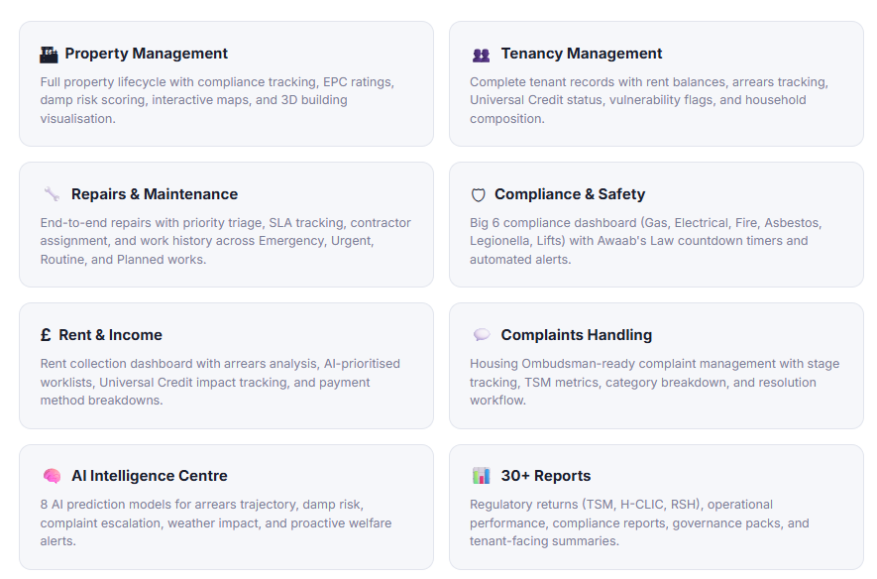

Main features

Main features
Socialhome.ai:
- is natively cloud based and AI integrated, unlike other systems which were built before the cloud and have AI as bolt-ons
- uses publicly available data along with organisation specific data. For example, looking at vulnerability data for an area and comparing it with internal data, the application will be able to flag that there may be a gap (full list of potential data import in appendix 2)
- Data structure is HACT data compliant

Operational features
Start Every Day Informed
Each user receives a personalised daily briefing scoped to their role.
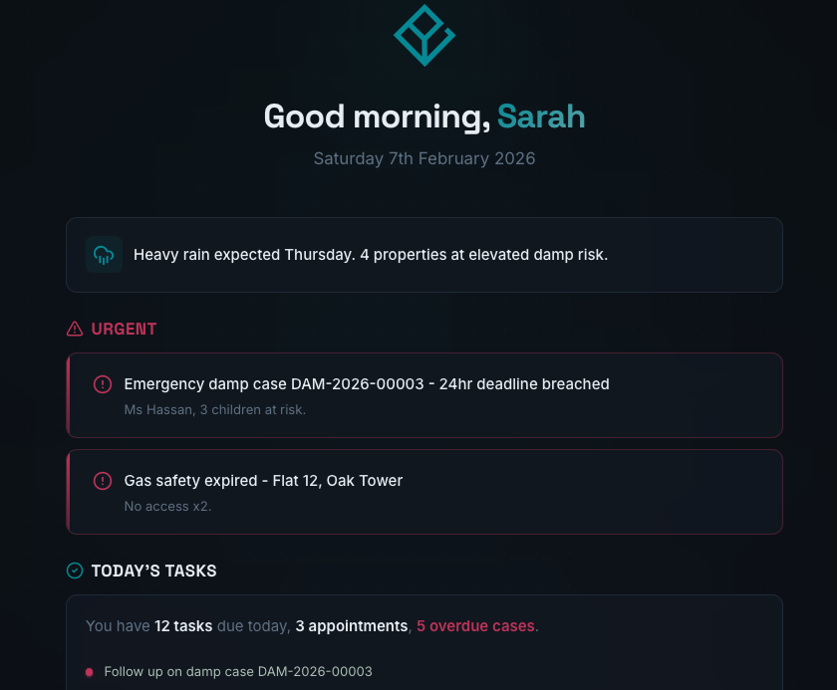

Organisation-Wide Intelligence
A real-time operational dashboard with KPIs, rent collection trends, repairs by priority, Big 6 compliance gauges, Awaab's Law active cases, AI insights, and recent activity — all persona-scoped.
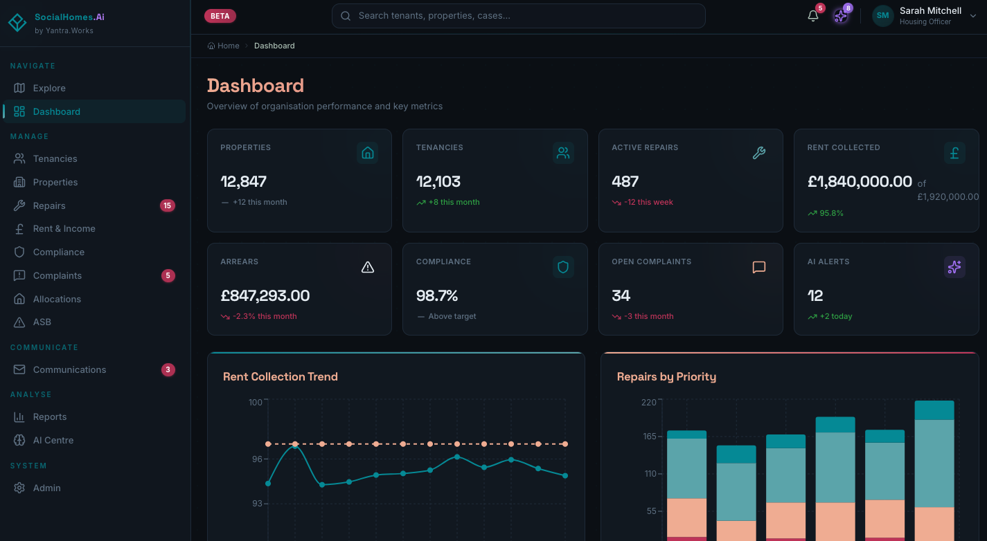
AI powered Resident Records
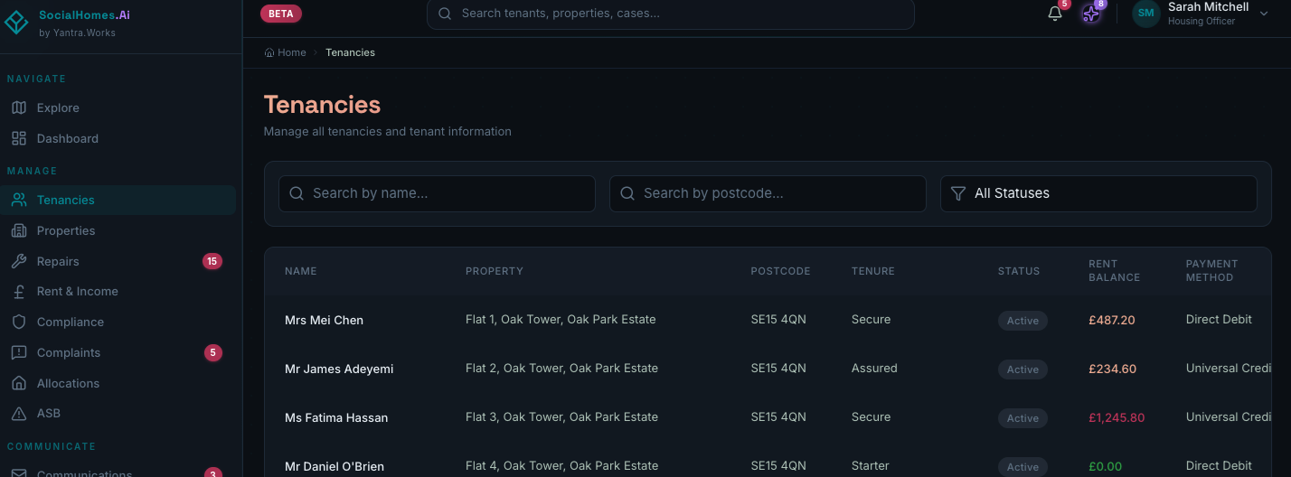
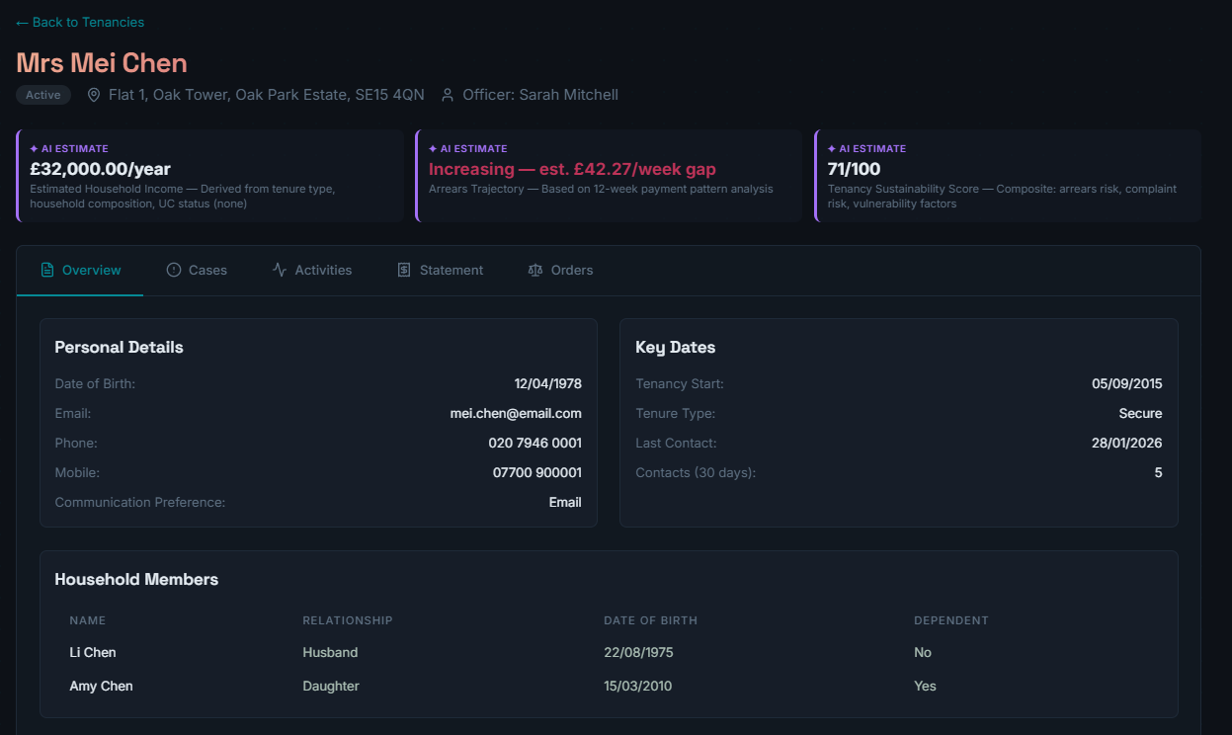
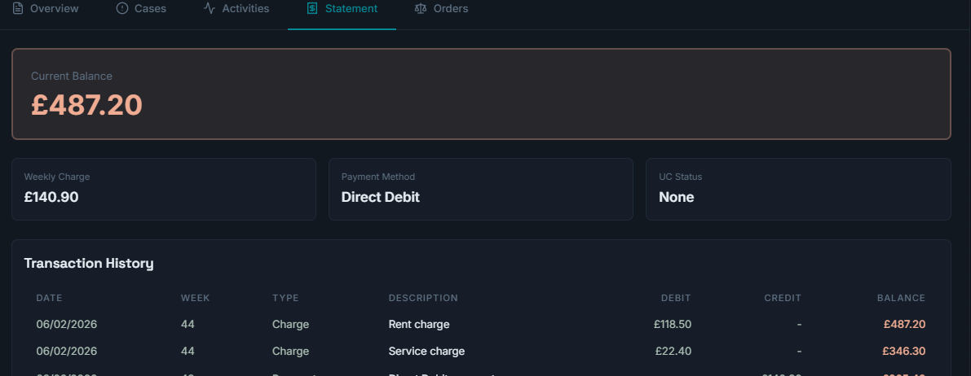
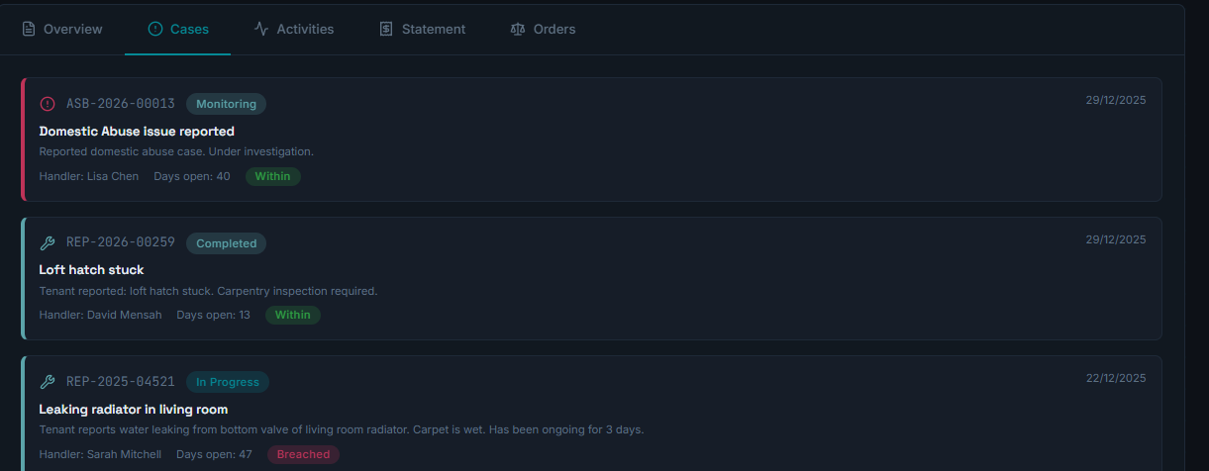

AI Powered Property Records
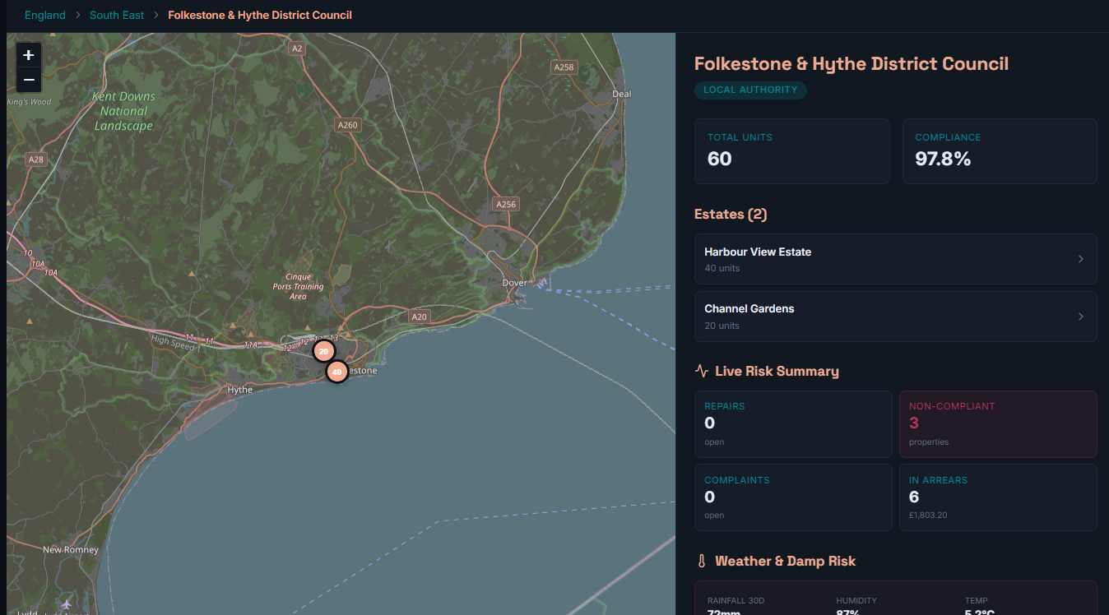
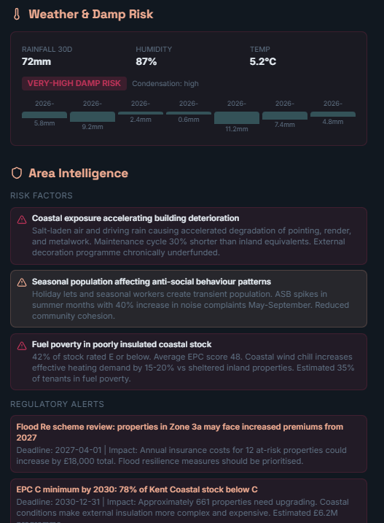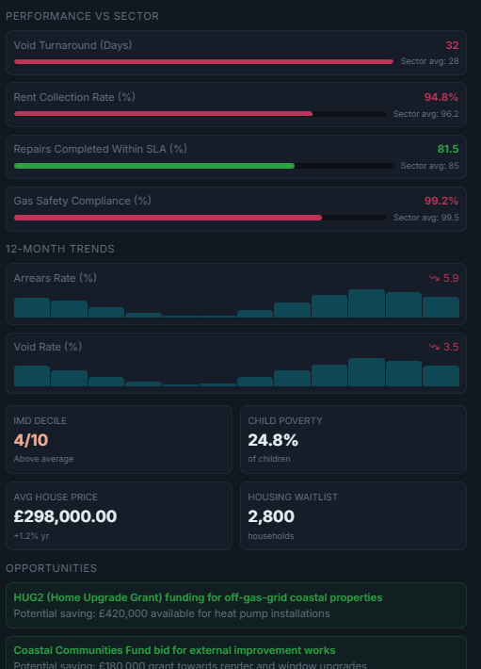
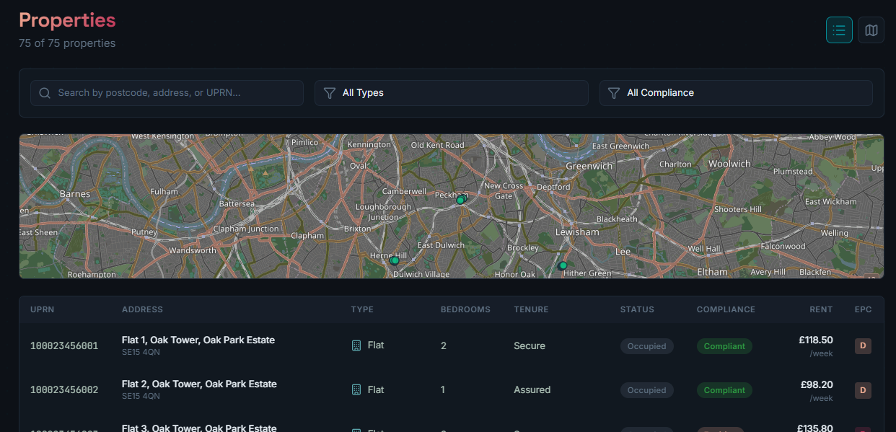
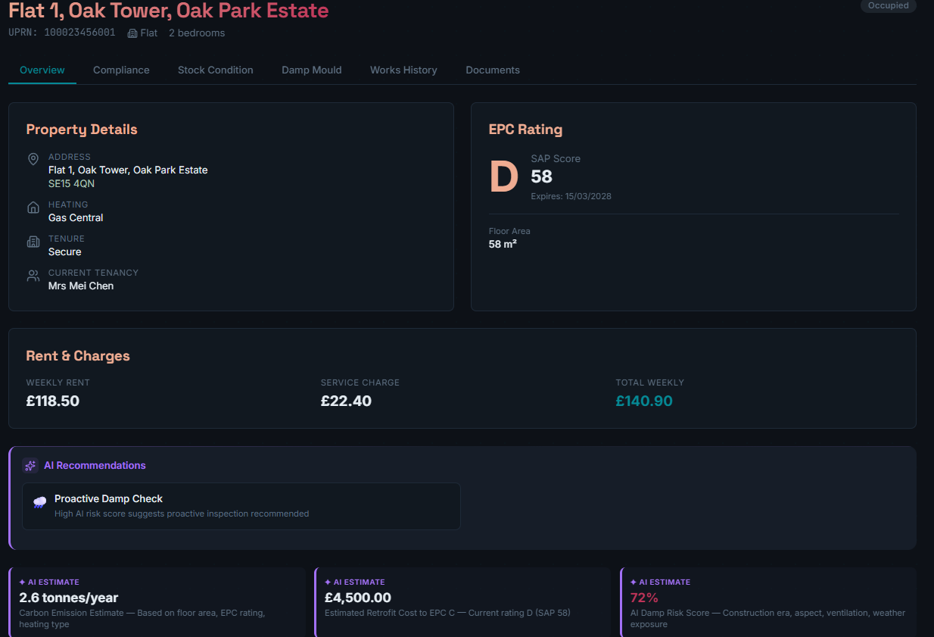
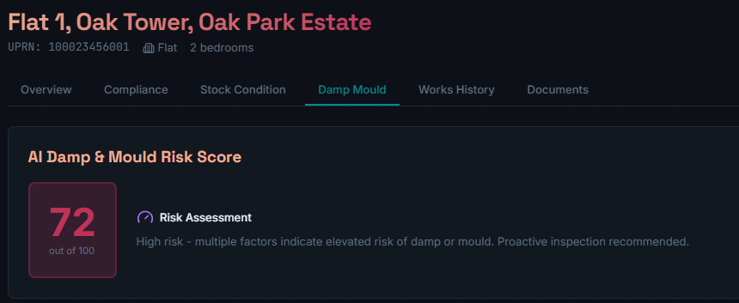
AI Powered Repairs
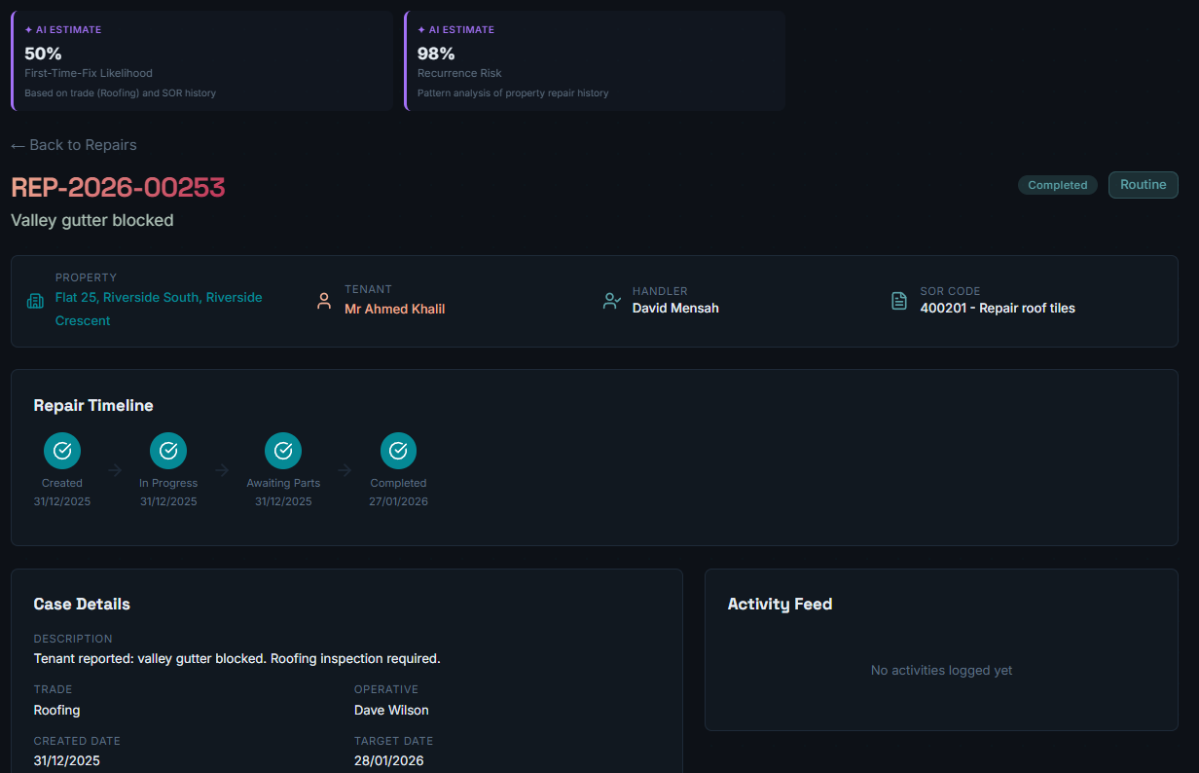
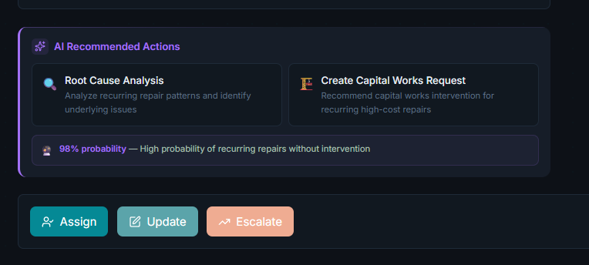

AI prioritised arrears collection
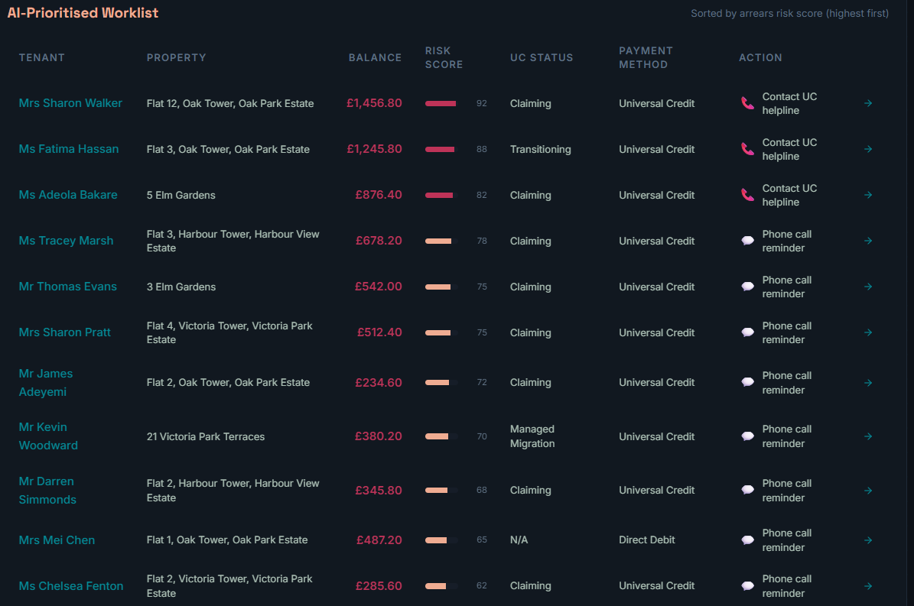

Out of the box reporting
