**To add a custom inquiry form to the single product page in WooCommerce, below the "Add to Cart" button, and automatically fetch the product title and category, you can follow these steps:**

[**https://chat.openai.com/c/80634f9c-93ae-4c07-a4d9-82185e28733a**](https://chat.openai.com/c/80634f9c-93ae-4c07-a4d9-82185e28733a)

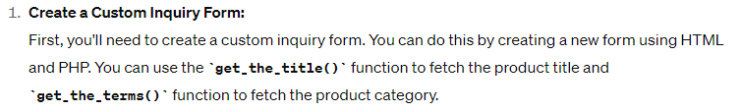

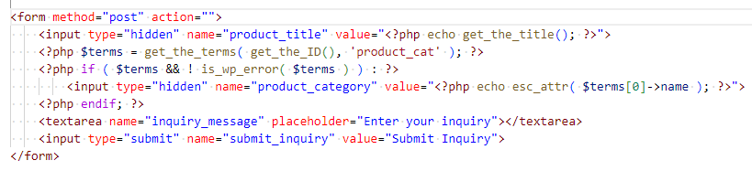

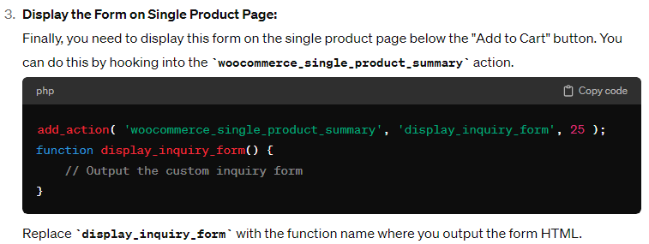

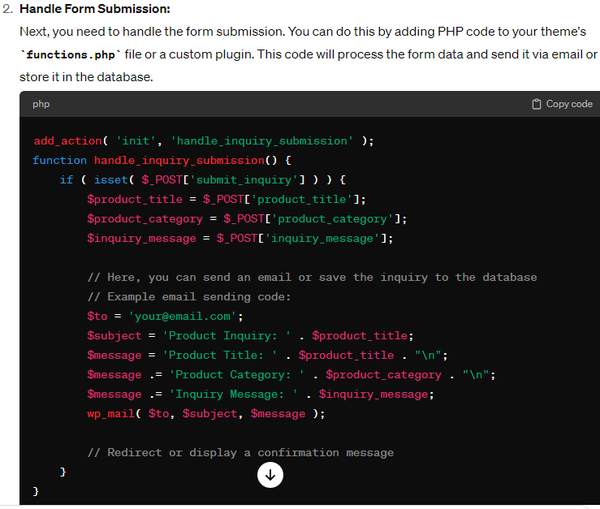

**Custom AJAX contact form in WordPress involves several steps.**

[**https://chat.openai.com/c/6868949b-8962-434d-b488-56f8156bff6f**](https://chat.openai.com/c/6868949b-8962-434d-b488-56f8156bff6f)

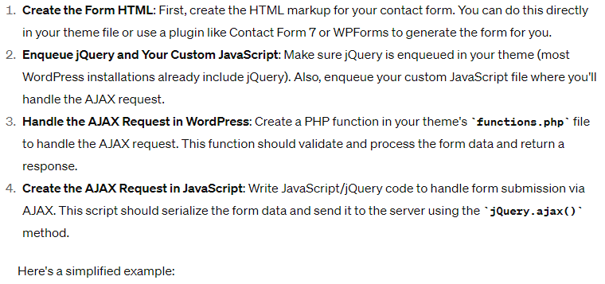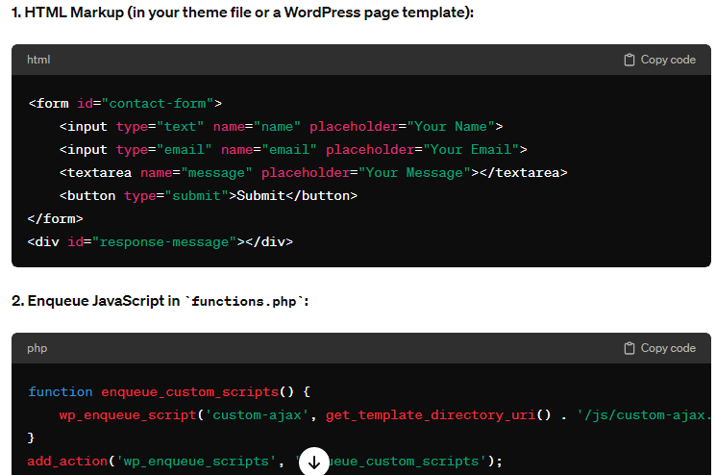

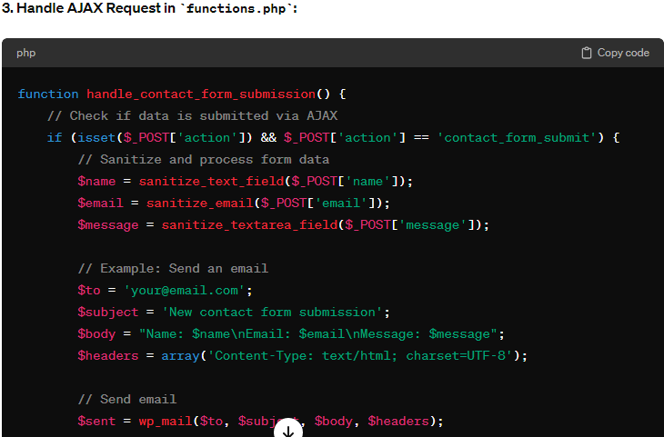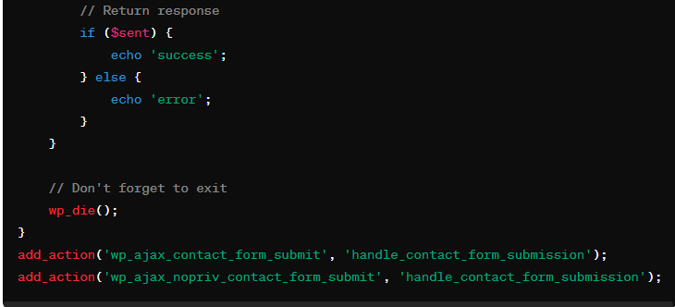

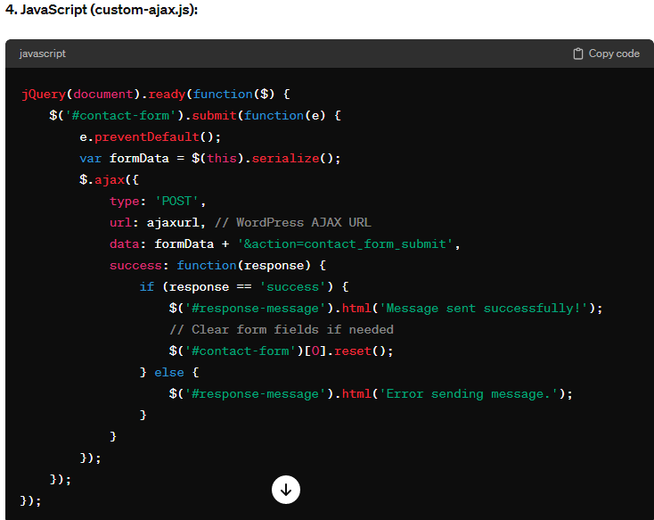

**To create a sample contact form in WordPress with fields for state and city, where the city options are dynamically populated based on the selected state, you can follow these steps:**

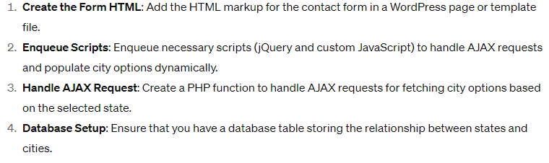

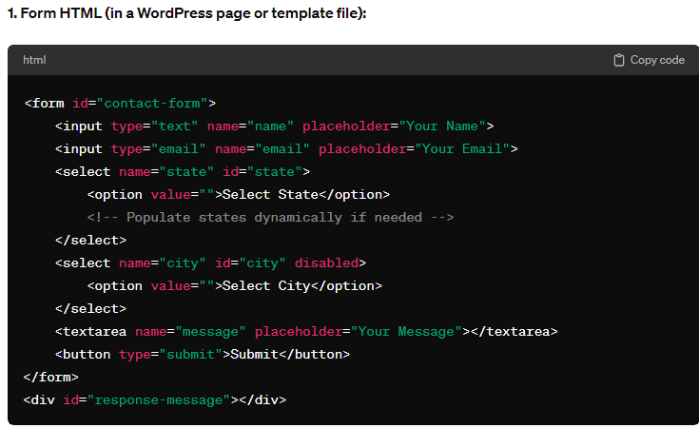

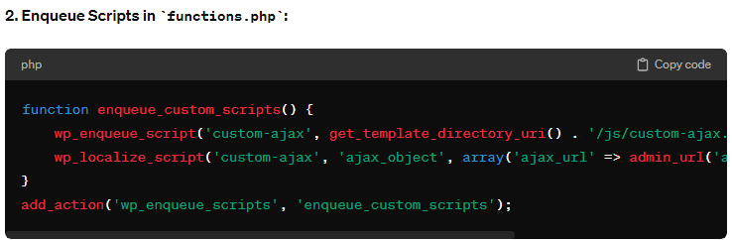



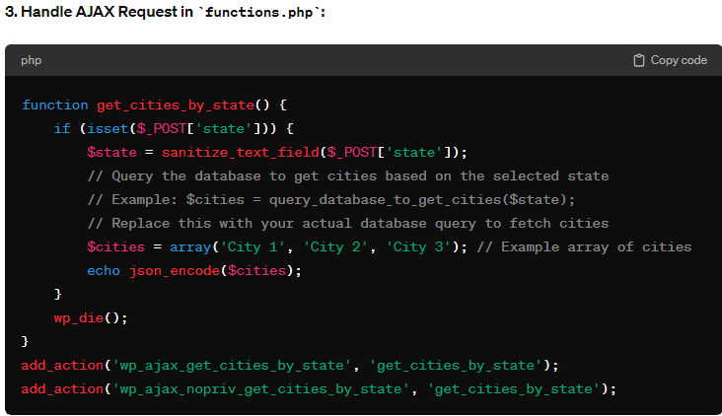

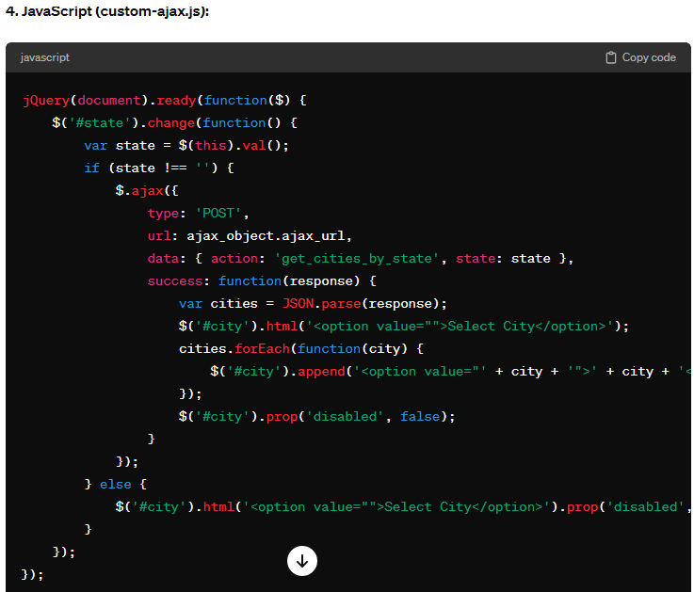





**Form in PHP with fields for state and city, where the city options are dynamically populated based on the selected state.**

[**https://chat.openai.com/c/6868949b-8962-434d-b488-56f8156bff6f**](https://chat.openai.com/c/6868949b-8962-434d-b488-56f8156bff6f)

<!DOCTYPE html>

<html lang="en">

<head>

    <meta charset="UTF-8">

    <meta name="viewport" content="width=device-width, initial-scale=1.0">

    <title>Contact Form</title>

</head>

<body>

    <h2>Contact Form</h2>

    <form action="process_form.php" method="POST">

        <input type="text" name="name" placeholder="Your Name" required><br><br>

        <input type="email" name="email" placeholder="Your Email" required><br><br>

        <select name="state" id="state" required>

            <option value="">Select State</option>

            <?php

            // Include your database connection

            $db_connection = mysqli_connect("localhost", "username", "password", "database");

            $query = "SELECT * FROM states";

            $result = mysqli_query($db_connection, $query);

            while ($row = mysqli_fetch_assoc($result)) {

                echo "<option value='".$row['id']."'>".$row['state_name']."</option>";

            }

            ?>

        </select><br><br>

        <select name="city" id="city" required>

            <option value="">Select City</option>

        </select><br><br>

        <textarea name="message" placeholder="Your Message" required></textarea><br><br>

        <button type="submit">Submit</button>

    </form>

    <script src="https://ajax.googleapis.com/ajax/libs/jquery/3.5.1/jquery.min.js"></script>

    <script>

        $(document).ready(function() {

            $('#state').change(function() {

                var state_id = $(this).val();

                $.ajax({

                    url: 'get_cities.php',

                    type: 'POST',

                    data: {state_id: state_id},

                    success: function(response) {

                        $('#city').html(response);

                    }

                });

            });

        });

    </script>

</body>

</html>

