TASK1 – The execution of task 1 is below. Here are the required packages.

Using classification trees to analyze the Carseats data set.Sales is a continuous variable, and so we begin by recoding it as a binary variable.

summary (tree.carseats )

##   
## Classification tree:  
## tree(formula = High ~ . - Sales, data = Carseats)  
## Variables actually used in tree construction:  
## [1] "ShelveLoc" "Price" "Income" "CompPrice" "Population"   
## [6] "Advertising" "Age" "US"   
## Number of terminal nodes: 27   
## Residual mean deviance: 0.4575 = 170.7 / 373   
## Misclassification error rate: 0.09 = 36 / 400

plot(tree.carseats )  
text(tree.carseats ,pretty =0)

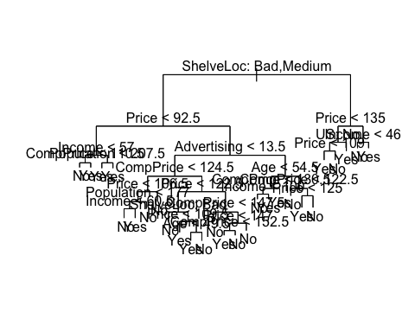

tree.carseats

## node), split, n, deviance, yval, (yprob)  
## * denotes terminal node  
##   
## 1) root 400 541.500 No ( 0.59000 0.41000 )   
## 2) ShelveLoc: Bad,Medium 315 390.600 No ( 0.68889 0.31111 )   
## 4) Price < 92.5 46 56.530 Yes ( 0.30435 0.69565 )   
## 8) Income < 57 10 12.220 No ( 0.70000 0.30000 )   
## 16) CompPrice < 110.5 5 0.000 No ( 1.00000 0.00000 ) *  
## 17) CompPrice > 110.5 5 6.730 Yes ( 0.40000 0.60000 ) *  
## 9) Income > 57 36 35.470 Yes ( 0.19444 0.80556 )   
## 18) Population < 207.5 16 21.170 Yes ( 0.37500 0.62500 ) *  
## 19) Population > 207.5 20 7.941 Yes ( 0.05000 0.95000 ) *  
## 5) Price > 92.5 269 299.800 No ( 0.75465 0.24535 )   
## 10) Advertising < 13.5 224 213.200 No ( 0.81696 0.18304 )   
## 20) CompPrice < 124.5 96 44.890 No ( 0.93750 0.06250 )   
## 40) Price < 106.5 38 33.150 No ( 0.84211 0.15789 )   
## 80) Population < 177 12 16.300 No ( 0.58333 0.41667 )   
## 160) Income < 60.5 6 0.000 No ( 1.00000 0.00000 ) *  
## 161) Income > 60.5 6 5.407 Yes ( 0.16667 0.83333 ) *  
## 81) Population > 177 26 8.477 No ( 0.96154 0.03846 ) *  
## 41) Price > 106.5 58 0.000 No ( 1.00000 0.00000 ) *  
## 21) CompPrice > 124.5 128 150.200 No ( 0.72656 0.27344 )   
## 42) Price < 122.5 51 70.680 Yes ( 0.49020 0.50980 )   
## 84) ShelveLoc: Bad 11 6.702 No ( 0.90909 0.09091 ) *  
## 85) ShelveLoc: Medium 40 52.930 Yes ( 0.37500 0.62500 )   
## 170) Price < 109.5 16 7.481 Yes ( 0.06250 0.93750 ) *  
## 171) Price > 109.5 24 32.600 No ( 0.58333 0.41667 )   
## 342) Age < 49.5 13 16.050 Yes ( 0.30769 0.69231 ) *  
## 343) Age > 49.5 11 6.702 No ( 0.90909 0.09091 ) *  
## 43) Price > 122.5 77 55.540 No ( 0.88312 0.11688 )   
## 86) CompPrice < 147.5 58 17.400 No ( 0.96552 0.03448 ) *  
## 87) CompPrice > 147.5 19 25.010 No ( 0.63158 0.36842 )   
## 174) Price < 147 12 16.300 Yes ( 0.41667 0.58333 )   
## 348) CompPrice < 152.5 7 5.742 Yes ( 0.14286 0.85714 ) *  
## 349) CompPrice > 152.5 5 5.004 No ( 0.80000 0.20000 ) *  
## 175) Price > 147 7 0.000 No ( 1.00000 0.00000 ) *  
## 11) Advertising > 13.5 45 61.830 Yes ( 0.44444 0.55556 )   
## 22) Age < 54.5 25 25.020 Yes ( 0.20000 0.80000 )   
## 44) CompPrice < 130.5 14 18.250 Yes ( 0.35714 0.64286 )   
## 88) Income < 100 9 12.370 No ( 0.55556 0.44444 ) *  
## 89) Income > 100 5 0.000 Yes ( 0.00000 1.00000 ) *  
## 45) CompPrice > 130.5 11 0.000 Yes ( 0.00000 1.00000 ) *  
## 23) Age > 54.5 20 22.490 No ( 0.75000 0.25000 )   
## 46) CompPrice < 122.5 10 0.000 No ( 1.00000 0.00000 ) *  
## 47) CompPrice > 122.5 10 13.860 No ( 0.50000 0.50000 )   
## 94) Price < 125 5 0.000 Yes ( 0.00000 1.00000 ) *  
## 95) Price > 125 5 0.000 No ( 1.00000 0.00000 ) *  
## 3) ShelveLoc: Good 85 90.330 Yes ( 0.22353 0.77647 )   
## 6) Price < 135 68 49.260 Yes ( 0.11765 0.88235 )   
## 12) US: No 17 22.070 Yes ( 0.35294 0.64706 )   
## 24) Price < 109 8 0.000 Yes ( 0.00000 1.00000 ) *  
## 25) Price > 109 9 11.460 No ( 0.66667 0.33333 ) *  
## 13) US: Yes 51 16.880 Yes ( 0.03922 0.96078 ) *  
## 7) Price > 135 17 22.070 No ( 0.64706 0.35294 )   
## 14) Income < 46 6 0.000 No ( 1.00000 0.00000 ) *  
## 15) Income > 46 11 15.160 Yes ( 0.45455 0.54545 ) *

set.seed (2)  
train = sample (1: nrow( Carseats ), 200)  
Carseats.test= Carseats [-train ,]  
High.test=High[-train ]  
tree.carseats =tree (High~.-Sales , Carseats , subset =train )  
tree.pred = predict ( tree.carseats , Carseats.test ,type ="class")  
table ( tree.pred ,High.test)

## High.test  
## tree.pred No Yes   
## No 86 27  
## Yes 30 57

set.seed (3)  
cv.carseats =cv.tree(tree.carseats ,FUN = prune.misclass )  
names (cv.carseats )

## [1] "size" "dev" "k" "method"

cv.carseats

## $size  
## [1] 19 17 14 13 9 7 3 2 1  
##   
## $dev  
## [1] 55 55 53 52 50 56 69 65 80  
##   
## $k  
## [1] -Inf 0.0000000 0.6666667 1.0000000 1.7500000 2.0000000  
## [7] 4.2500000 5.0000000 23.0000000  
##   
## $method  
## [1] "misclass"  
##   
## attr(,"class")  
## [1] "prune" "tree.sequence"

par ( mfrow =c(1 ,2) )  
plot(cv.carseats$size ,cv.carseats$dev , type ="b")  
plot(cv.carseats$k ,cv.carseats$dev , type ="b")

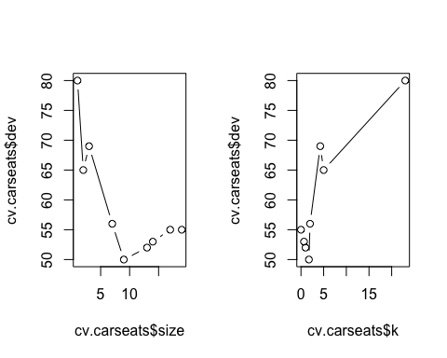

prune.carseats = prune.misclass ( tree.carseats , best =9)  
plot( prune.carseats )  
text( prune.carseats , pretty =0)

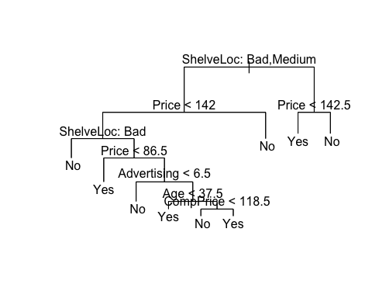

tree.pred = predict ( prune.carseats , Carseats.test , type ="class")  
table ( tree.pred ,High.test)

## High.test  
## tree.pred No Yes   
## No 94 24  
## Yes 22 60

prune.carseats = prune.misclass ( tree.carseats , best =15)  
plot( prune.carseats )  
text( prune.carseats , pretty =0)

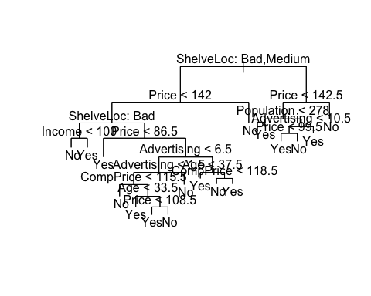

tree.pred = predict ( prune.carseats , Carseats.test , type ="class")  
table ( tree.pred ,High.test)

## High.test  
## tree.pred No Yes   
## No 86 22  
## Yes 30 62