TASK Lab 1 : Chapter 10 Lab 1: Principal Components Analysis

names(USArrests)

## [1] "Murder" "Assault" "UrbanPop" "Rape"

apply(USArrests, 2, mean)

## Murder Assault UrbanPop Rape   
## 7.788 170.760 65.540 21.232

apply(USArrests, 2, var)

## Murder Assault UrbanPop Rape   
## 18.97047 6945.16571 209.51878 87.72916

pr.out=prcomp(USArrests, scale=TRUE)

names(pr.out)

## [1] "sdev" "rotation" "center" "scale" "x"

pr.out$center

## Murder Assault UrbanPop Rape   
## 7.788 170.760 65.540 21.232

pr.out$scale

## Murder Assault UrbanPop Rape   
## 4.355510 83.337661 14.474763 9.366385

pr.out$rotation

## PC1 PC2 PC3 PC4  
## Murder -0.5358995 0.4181809 -0.3412327 0.64922780  
## Assault -0.5831836 0.1879856 -0.2681484 -0.74340748  
## UrbanPop -0.2781909 -0.8728062 -0.3780158 0.13387773  
## Rape -0.5434321 -0.1673186 0.8177779 0.08902432

dim(pr.out$x)

## [1] 50 4

biplot (pr.out , scale =0)

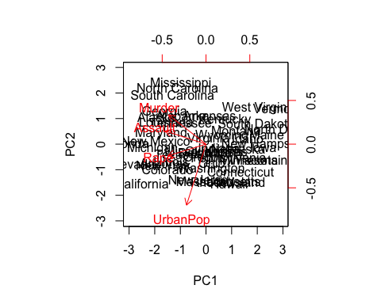

pr.out$rotation=-pr.out$rotation  
pr.out$x=-pr.out$x  
biplot(pr.out, scale=0)

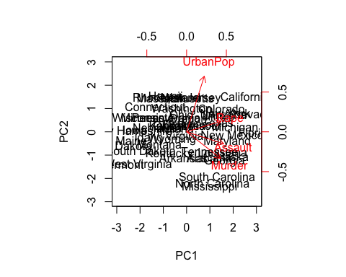

pr.out$sdev

## [1] 1.5748783 0.9948694 0.5971291 0.4164494

pr.var=pr.out$sdev^2  
pr.var

## [1] 2.4802416 0.9897652 0.3565632 0.1734301

pve=pr.var/sum(pr.var)  
pve

## [1] 0.62006039 0.24744129 0.08914080 0.04335752

plot(pve, xlab="Principal Component", ylab="Proportion of Variance Explained", ylim=c(0,1),type='b')

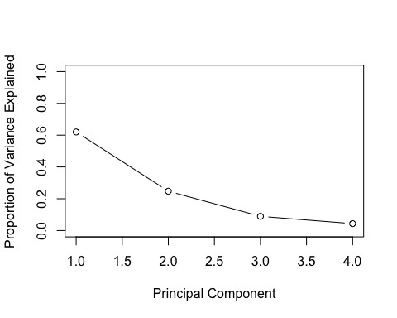

plot(cumsum(pve), xlab="Principal Component", ylab="Cumulative Proportion of Variance Explained", ylim=c(0,1),type='b')

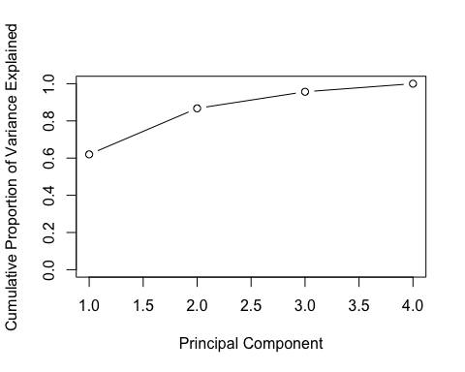

a=c(1,2,8,-3)  
cumsum(a)

## [1] 1 3 11 8