TASK 2 Chapter 10 Lab 2: Clustering

K-Means Clustering

set.seed(2)  
x=matrix(rnorm(50*2), ncol=2)  
x[1:25,1]=x[1:25,1]+3  
x[1:25,2]=x[1:25,2]-4

km.out=kmeans(x,2,nstart=20)

km.out$cluster

## [1] 2 2 2 2 2 2 2 2 2 2 2 2 2 2 2 2 2 2 2 2 2 2 2 2 2 1 1 1 1 1 1 1 1 1 1  
## [36] 1 1 1 1 1 1 1 1 1 1 1 1 1 1 1

plot(x, col=(km.out$cluster +1), main="K-Means Clustering  
Results with K=2", xlab="", ylab="", pch=20, cex=2)

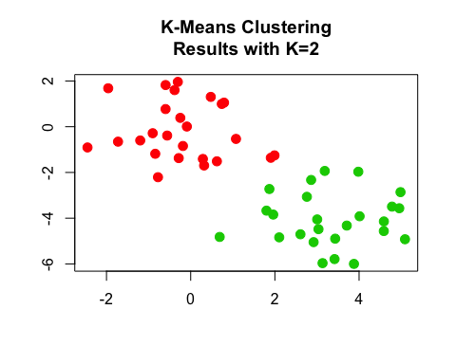

set.seed(4)  
km.out=kmeans(x,3,nstart=20)  
km.out

## K-means clustering with 3 clusters of sizes 10, 23, 17  
##   
## Cluster means:  
## [,1] [,2]  
## 1 2.3001545 -2.69622023  
## 2 -0.3820397 -0.08740753  
## 3 3.7789567 -4.56200798  
##   
## Clustering vector:  
## [1] 3 1 3 1 3 3 3 1 3 1 3 1 3 1 3 1 3 3 3 3 3 1 3 3 3 2 2 2 2 2 2 2 2 2 2  
## [36] 2 2 2 2 2 2 2 2 1 2 1 2 2 2 2  
##   
## Within cluster sum of squares by cluster:  
## [1] 19.56137 52.67700 25.74089  
## (between_SS / total_SS = 79.3 %)  
##   
## Available components:  
##   
## [1] "cluster" "centers" "totss" "withinss"   
## [5] "tot.withinss" "betweenss" "size" "iter"   
## [9] "ifault"

plot(x, col=(km.out$cluster+1), main="K-Means Clustering Results with K=3", xlab="", ylab="", pch=20, cex=2)

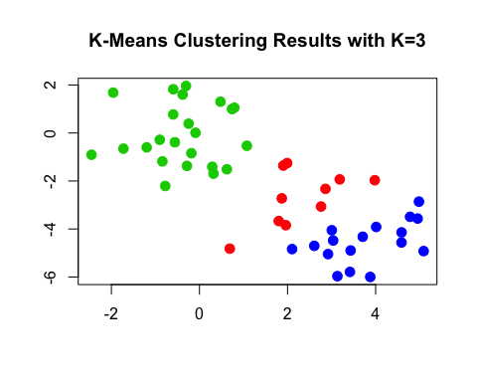

set.seed(3)  
km.out=kmeans(x,3,nstart=1)  
km.out$tot.withinss

## [1] 104.3319

km.out=kmeans(x,3,nstart=20)  
km.out$tot.withinss

## [1] 97.97927

Hierarchical Clustering

hc.complete=hclust(dist(x), method="complete")

hc.average=hclust(dist(x), method="average")  
hc.single=hclust(dist(x), method="single")

par(mfrow=c(1,3))  
plot(hc.complete,main="Complete Linkage", xlab="", sub="", cex=.9)  
plot(hc.average, main="Average Linkage", xlab="", sub="", cex=.9)  
plot(hc.single, main="Single Linkage", xlab="", sub="", cex=.9)

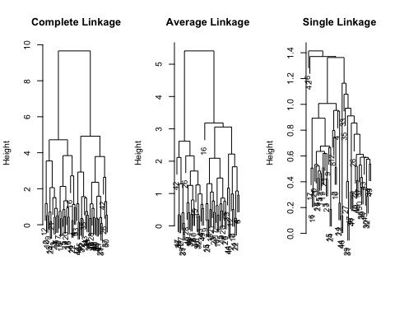

cutree(hc.complete, 2)

## [1] 1 1 1 1 1 1 1 1 1 1 1 1 1 1 1 1 1 1 1 1 1 1 1 1 1 2 2 2 2 2 2 2 2 2 2  
## [36] 2 2 2 2 2 2 2 2 2 2 2 2 2 2 2

cutree(hc.average, 2)

## [1] 1 1 1 1 1 1 1 1 1 1 1 1 1 1 1 1 1 1 1 1 1 1 1 1 1 2 2 2 2 2 2 2 1 2 2  
## [36] 2 2 2 2 2 2 2 2 1 2 1 2 2 2 2

cutree(hc.single, 2)

## [1] 1 1 1 1 1 1 1 1 1 1 1 1 1 1 1 2 1 1 1 1 1 1 1 1 1 1 1 1 1 1 1 1 1 1 1  
## [36] 1 1 1 1 1 1 1 1 1 1 1 1 1 1 1

cutree(hc.single, 4)

## [1] 1 1 1 1 1 1 1 1 1 1 1 1 1 1 1 2 1 1 1 1 1 1 1 1 1 3 3 3 3 3 3 3 3 3 3  
## [36] 3 3 3 3 3 3 4 3 3 3 3 3 3 3 3

xsc=scale(x)  
plot(hclust(dist(xsc), method="complete"), main="Hierarchical Clustering with Scaled Features")

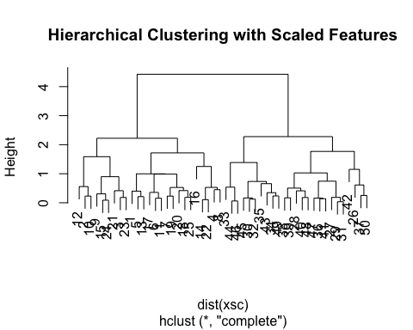

x=matrix(rnorm(30*3), ncol=3)  
dd=as.dist(1-cor(t(x)))  
plot(hclust(dd, method="complete"), main="Complete Linkage with Correlation-Based Distance", xlab="", sub="")

