TASK 3 Chapter 10 Lab 3: NCI60 Data Example

The NCI60 data

library(ISLR)  
nci.labs=NCI60$labs  
nci.data=NCI60$data

dim(nci.data)

## [1] 64 6830

nci.labs[1:4]

## [1] "CNS" "CNS" "CNS" "RENAL"

table(nci.labs)

## nci.labs  
## BREAST CNS COLON K562A-repro K562B-repro LEUKEMIA   
## 7 5 7 1 1 6   
## MCF7A-repro MCF7D-repro MELANOMA NSCLC OVARIAN PROSTATE   
## 1 1 8 9 6 2   
## RENAL UNKNOWN   
## 9 1

PCA on the NCI60 Data

pr.out=prcomp(nci.data, scale=TRUE)

Cols=function(vec){  
 cols=rainbow(length(unique(vec)))  
 return(cols[as.numeric(as.factor(vec))])  
 }

par(mfrow=c(1,2))  
plot(pr.out$x[,1:2], col=Cols(nci.labs), pch=19,xlab="Z1",ylab="Z2")  
plot(pr.out$x[,c(1,3)], col=Cols(nci.labs), pch=19,xlab="Z1",ylab="Z3")

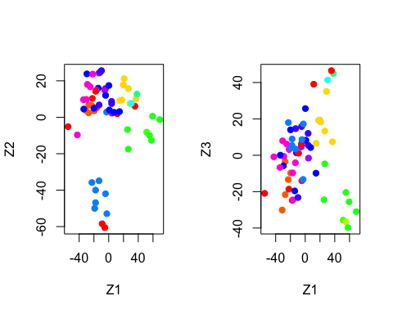

summary(pr.out)

## Importance of components:  
## PC1 PC2 PC3 PC4 PC5  
## Standard deviation 27.8535 21.48136 19.82046 17.03256 15.97181  
## Proportion of Variance 0.1136 0.06756 0.05752 0.04248 0.03735  
## Cumulative Proportion 0.1136 0.18115 0.23867 0.28115 0.31850  
## PC6 PC7 PC8 PC9 PC10  
## Standard deviation 15.72108 14.47145 13.54427 13.14400 12.73860  
## Proportion of Variance 0.03619 0.03066 0.02686 0.02529 0.02376  
## Cumulative Proportion 0.35468 0.38534 0.41220 0.43750 0.46126  
## PC11 PC12 PC13 PC14 PC15  
## Standard deviation 12.68672 12.15769 11.83019 11.62554 11.43779  
## Proportion of Variance 0.02357 0.02164 0.02049 0.01979 0.01915  
## Cumulative Proportion 0.48482 0.50646 0.52695 0.54674 0.56590  
## PC16 PC17 PC18 PC19 PC20  
## Standard deviation 11.00051 10.65666 10.48880 10.43518 10.3219  
## Proportion of Variance 0.01772 0.01663 0.01611 0.01594 0.0156  
## Cumulative Proportion 0.58361 0.60024 0.61635 0.63229 0.6479  
## PC21 PC22 PC23 PC24 PC25 PC26  
## Standard deviation 10.14608 10.0544 9.90265 9.64766 9.50764 9.33253  
## Proportion of Variance 0.01507 0.0148 0.01436 0.01363 0.01324 0.01275  
## Cumulative Proportion 0.66296 0.6778 0.69212 0.70575 0.71899 0.73174  
## PC27 PC28 PC29 PC30 PC31 PC32  
## Standard deviation 9.27320 9.0900 8.98117 8.75003 8.59962 8.44738  
## Proportion of Variance 0.01259 0.0121 0.01181 0.01121 0.01083 0.01045  
## Cumulative Proportion 0.74433 0.7564 0.76824 0.77945 0.79027 0.80072  
## PC33 PC34 PC35 PC36 PC37 PC38  
## Standard deviation 8.37305 8.21579 8.15731 7.97465 7.90446 7.82127  
## Proportion of Variance 0.01026 0.00988 0.00974 0.00931 0.00915 0.00896  
## Cumulative Proportion 0.81099 0.82087 0.83061 0.83992 0.84907 0.85803  
## PC39 PC40 PC41 PC42 PC43 PC44  
## Standard deviation 7.72156 7.58603 7.45619 7.3444 7.10449 7.0131  
## Proportion of Variance 0.00873 0.00843 0.00814 0.0079 0.00739 0.0072  
## Cumulative Proportion 0.86676 0.87518 0.88332 0.8912 0.89861 0.9058  
## PC45 PC46 PC47 PC48 PC49 PC50  
## Standard deviation 6.95839 6.8663 6.80744 6.64763 6.61607 6.40793  
## Proportion of Variance 0.00709 0.0069 0.00678 0.00647 0.00641 0.00601  
## Cumulative Proportion 0.91290 0.9198 0.92659 0.93306 0.93947 0.94548  
## PC51 PC52 PC53 PC54 PC55 PC56  
## Standard deviation 6.21984 6.20326 6.06706 5.91805 5.91233 5.73539  
## Proportion of Variance 0.00566 0.00563 0.00539 0.00513 0.00512 0.00482  
## Cumulative Proportion 0.95114 0.95678 0.96216 0.96729 0.97241 0.97723  
## PC57 PC58 PC59 PC60 PC61 PC62  
## Standard deviation 5.47261 5.2921 5.02117 4.68398 4.17567 4.08212  
## Proportion of Variance 0.00438 0.0041 0.00369 0.00321 0.00255 0.00244  
## Cumulative Proportion 0.98161 0.9857 0.98940 0.99262 0.99517 0.99761  
## PC63 PC64  
## Standard deviation 4.04124 2.148e-14  
## Proportion of Variance 0.00239 0.000e+00  
## Cumulative Proportion 1.00000 1.000e+00

plot(pr.out)

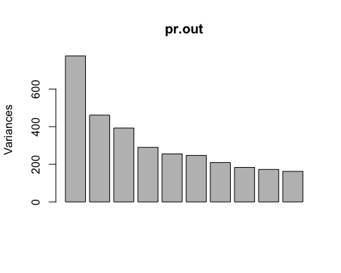

pve=100*pr.out$sdev^2/sum(pr.out$sdev^2)  
par(mfrow=c(1,2))  
plot(pve, type="o", ylab="PVE", xlab="Principal Component", col="blue")  
plot(cumsum(pve), type="o", ylab="Cumulative PVE", xlab="Principal Component", col="brown3")

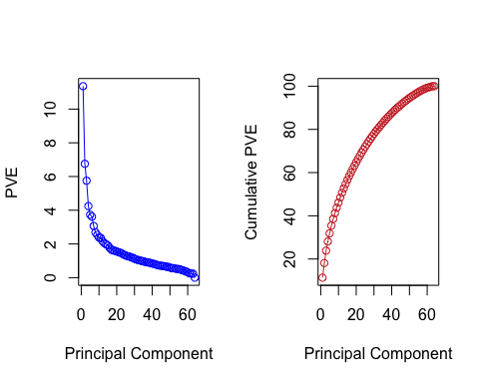

Clustering the Observations of the NCI60 Data

sd.data=scale(nci.data)

par(mfrow=c(1,3))  
data.dist=dist(sd.data)  
plot(hclust(data.dist), labels=nci.labs, main="Complete Linkage", xlab="", sub="",ylab="")  
plot(hclust(data.dist, method="average"), labels=nci.labs, main="Average Linkage", xlab="", sub="",ylab="")  
plot(hclust(data.dist, method="single"), labels=nci.labs, main="Single Linkage", xlab="", sub="",ylab="")

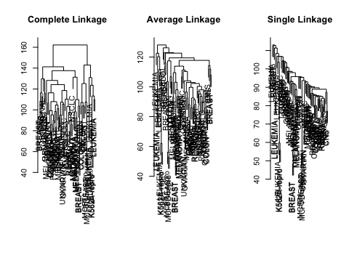

hc.out=hclust(dist(sd.data))  
hc.clusters=cutree(hc.out,4)  
table(hc.clusters,nci.labs)

## nci.labs  
## hc.clusters BREAST CNS COLON K562A-repro K562B-repro LEUKEMIA MCF7A-repro  
## 1 2 3 2 0 0 0 0  
## 2 3 2 0 0 0 0 0  
## 3 0 0 0 1 1 6 0  
## 4 2 0 5 0 0 0 1  
## nci.labs  
## hc.clusters MCF7D-repro MELANOMA NSCLC OVARIAN PROSTATE RENAL UNKNOWN  
## 1 0 8 8 6 2 8 1  
## 2 0 0 1 0 0 1 0  
## 3 0 0 0 0 0 0 0  
## 4 1 0 0 0 0 0 0

par(mfrow=c(1,1))  
plot(hc.out, labels=nci.labs)  
abline(h=139, col="red")

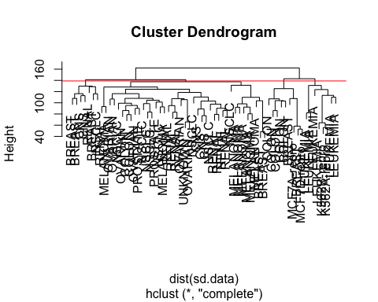

hc.out

##   
## Call:  
## hclust(d = dist(sd.data))  
##   
## Cluster method : complete   
## Distance : euclidean   
## Number of objects: 64

set.seed(2)  
km.out=kmeans(sd.data, 4, nstart=20)  
km.clusters=km.out$cluster  
table(km.clusters,hc.clusters)

## hc.clusters  
## km.clusters 1 2 3 4  
## 1 11 0 0 9  
## 2 0 0 8 0  
## 3 9 0 0 0  
## 4 20 7 0 0

hc.out=hclust(dist(pr.out$x[,1:5]))  
plot(hc.out, labels=nci.labs, main="Hier. Clust. on First Five Score Vectors")

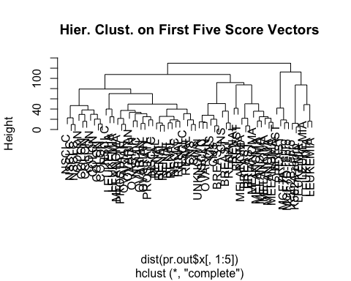

table(cutree(hc.out,4), nci.labs)

## nci.labs  
## BREAST CNS COLON K562A-repro K562B-repro LEUKEMIA MCF7A-repro  
## 1 0 2 7 0 0 2 0  
## 2 5 3 0 0 0 0 0  
## 3 0 0 0 1 1 4 0  
## 4 2 0 0 0 0 0 1  
## nci.labs  
## MCF7D-repro MELANOMA NSCLC OVARIAN PROSTATE RENAL UNKNOWN  
## 1 0 1 8 5 2 7 0  
## 2 0 7 1 1 0 2 1  
## 3 0 0 0 0 0 0 0  
## 4 1 0 0 0 0 0 0