CSE574 Introduction to Machine Learning
Programming Assignment 3 (in R-Studio)
‘Unsupervised Learning’
Project Report
Name : Rajiv Ranjan
Ub id: 50249099
Ubit: rajivran

This is the project report for PA3 of CSE 574. Below is the output for Task1 lab1, Task2 lab2, Task3 Lab 3.

TASK Lab 1 : Chapter 10 Lab 1: Principal Components Analysis
names(USArrests)
## [1] "Murder" "Assault" "UrbanPop" "Rape"
apply(USArrests, 2, mean)
## Murder Assault UrbanPop Rape
## 7.788 170.760 65.540 21.232
apply(USArrests, 2, var)
## Murder Assault UrbanPop Rape
## 18.97047 6945.16571 209.51878 87.72916
pr.out=prcomp(USArrests, scale=TRUE)
names(pr.out)
## [1] "sdev" "rotation" "center" "scale" "x"
pr.out$center
## Murder Assault UrbanPop Rape
## 7.788 170.760 65.540 21.232
pr.out$scale
## Murder Assault UrbanPop Rape
## 4.355510 83.337661 14.474763 9.366385
pr.out$rotation
## PC1 PC2 PC3 PC4
## Murder -0.5358995 0.4181809 -0.3412327 0.64922780
## Assault -0.5831836 0.1879856 -0.2681484 -0.74340748
## UrbanPop -0.2781909 -0.8728062 -0.3780158 0.13387773
## Rape -0.5434321 -0.1673186 0.8177779 0.08902432
dim(pr.out$x)
## [1] 50 4
biplot (pr.out , scale =0)
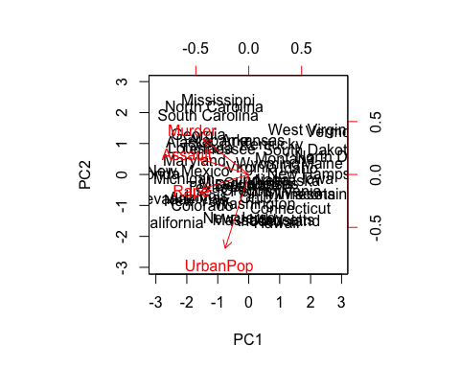
pr.out$rotation=-pr.out$rotation
pr.out$x=-pr.out$x
biplot(pr.out, scale=0)
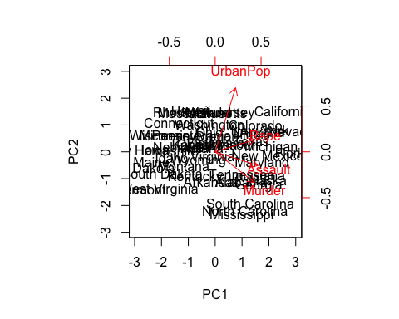
pr.out$sdev
## [1] 1.5748783 0.9948694 0.5971291 0.4164494
pr.var=pr.out$sdev^2
pr.var
## [1] 2.4802416 0.9897652 0.3565632 0.1734301
pve=pr.var/sum(pr.var)
pve
## [1] 0.62006039 0.24744129 0.08914080 0.04335752
plot(pve, xlab="Principal Component", ylab="Proportion of Variance Explained", ylim=c(0,1),type='b')
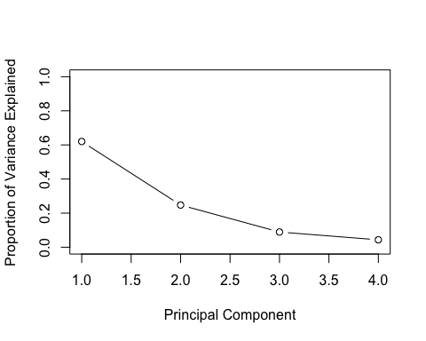
plot(cumsum(pve), xlab="Principal Component", ylab="Cumulative Proportion of Variance Explained", ylim=c(0,1),type='b')
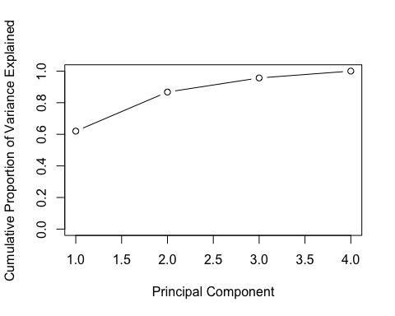
a=c(1,2,8,-3)
cumsum(a)
## [1] 1 3 11 8
TASK 2 Chapter 10 Lab 2: Clustering
K-Means Clustering
set.seed(2)
x=matrix(rnorm(50*2), ncol=2)
x[1:25,1]=x[1:25,1]+3
x[1:25,2]=x[1:25,2]-4
km.out=kmeans(x,2,nstart=20)
km.out$cluster
## [1] 2 2 2 2 2 2 2 2 2 2 2 2 2 2 2 2 2 2 2 2 2 2 2 2 2 1 1 1 1 1 1 1 1 1 1
## [36] 1 1 1 1 1 1 1 1 1 1 1 1 1 1 1
plot(x, col=(km.out$cluster +1), main="K-Means Clustering
Results with K=2", xlab="", ylab="", pch=20, cex=2)
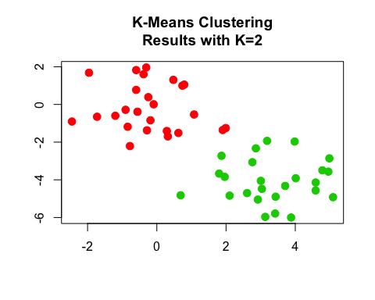
set.seed(4)
km.out=kmeans(x,3,nstart=20)
km.out
## K-means clustering with 3 clusters of sizes 10, 23, 17
##
## Cluster means:
## [,1] [,2]
## 1 2.3001545 -2.69622023
## 2 -0.3820397 -0.08740753
## 3 3.7789567 -4.56200798
##
## Clustering vector:
## [1] 3 1 3 1 3 3 3 1 3 1 3 1 3 1 3 1 3 3 3 3 3 1 3 3 3 2 2 2 2 2 2 2 2 2 2
## [36] 2 2 2 2 2 2 2 2 1 2 1 2 2 2 2
##
## Within cluster sum of squares by cluster:
## [1] 19.56137 52.67700 25.74089
## (between_SS / total_SS = 79.3 %)
##
## Available components:
##
## [1] "cluster" "centers" "totss" "withinss"
## [5] "tot.withinss" "betweenss" "size" "iter"
## [9] "ifault"
plot(x, col=(km.out$cluster+1), main="K-Means Clustering Results with K=3", xlab="", ylab="", pch=20, cex=2)
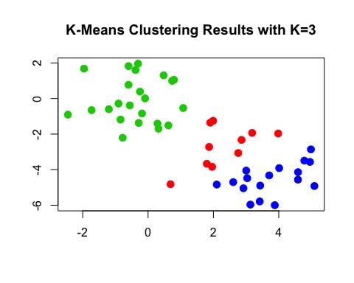
set.seed(3)
km.out=kmeans(x,3,nstart=1)
km.out$tot.withinss
## [1] 104.3319
km.out=kmeans(x,3,nstart=20)
km.out$tot.withinss
## [1] 97.97927
Hierarchical Clustering
hc.complete=hclust(dist(x), method="complete")
hc.average=hclust(dist(x), method="average")
hc.single=hclust(dist(x), method="single")
par(mfrow=c(1,3))
plot(hc.complete,main="Complete Linkage", xlab="", sub="", cex=.9)
plot(hc.average, main="Average Linkage", xlab="", sub="", cex=.9)
plot(hc.single, main="Single Linkage", xlab="", sub="", cex=.9)
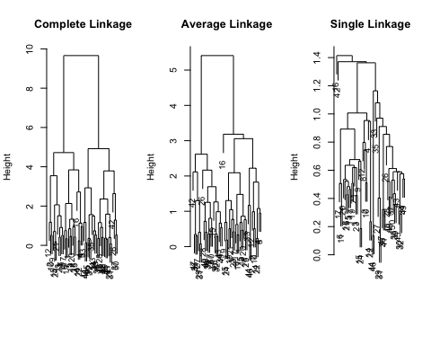
cutree(hc.complete, 2)
## [1] 1 1 1 1 1 1 1 1 1 1 1 1 1 1 1 1 1 1 1 1 1 1 1 1 1 2 2 2 2 2 2 2 2 2 2
## [36] 2 2 2 2 2 2 2 2 2 2 2 2 2 2 2
cutree(hc.average, 2)
## [1] 1 1 1 1 1 1 1 1 1 1 1 1 1 1 1 1 1 1 1 1 1 1 1 1 1 2 2 2 2 2 2 2 1 2 2
## [36] 2 2 2 2 2 2 2 2 1 2 1 2 2 2 2
cutree(hc.single, 2)
## [1] 1 1 1 1 1 1 1 1 1 1 1 1 1 1 1 2 1 1 1 1 1 1 1 1 1 1 1 1 1 1 1 1 1 1 1
## [36] 1 1 1 1 1 1 1 1 1 1 1 1 1 1 1
cutree(hc.single, 4)
## [1] 1 1 1 1 1 1 1 1 1 1 1 1 1 1 1 2 1 1 1 1 1 1 1 1 1 3 3 3 3 3 3 3 3 3 3
## [36] 3 3 3 3 3 3 4 3 3 3 3 3 3 3 3
xsc=scale(x)
plot(hclust(dist(xsc), method="complete"), main="Hierarchical Clustering with Scaled Features")
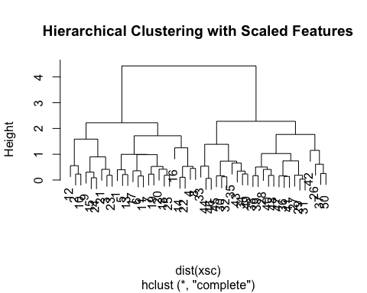
x=matrix(rnorm(30*3), ncol=3)
dd=as.dist(1-cor(t(x)))
plot(hclust(dd, method="complete"), main="Complete Linkage with Correlation-Based Distance", xlab="", sub="")
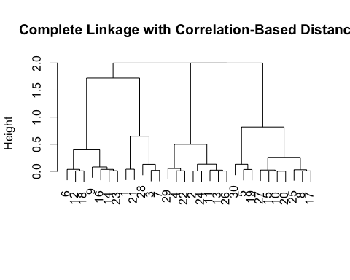
TASK 3 Chapter 10 Lab 3: NCI60 Data Example
The NCI60 data
library(ISLR)
nci.labs=NCI60$labs
nci.data=NCI60$data
dim(nci.data)
## [1] 64 6830
nci.labs[1:4]
## [1] "CNS" "CNS" "CNS" "RENAL"
table(nci.labs)
## nci.labs
## BREAST CNS COLON K562A-repro K562B-repro LEUKEMIA
## 7 5 7 1 1 6
## MCF7A-repro MCF7D-repro MELANOMA NSCLC OVARIAN PROSTATE
## 1 1 8 9 6 2
## RENAL UNKNOWN
## 9 1
PCA on the NCI60 Data
pr.out=prcomp(nci.data, scale=TRUE)
Cols=function(vec){
cols=rainbow(length(unique(vec)))
return(cols[as.numeric(as.factor(vec))])
}
par(mfrow=c(1,2))
plot(pr.out$x[,1:2], col=Cols(nci.labs), pch=19,xlab="Z1",ylab="Z2")
plot(pr.out$x[,c(1,3)], col=Cols(nci.labs), pch=19,xlab="Z1",ylab="Z3")
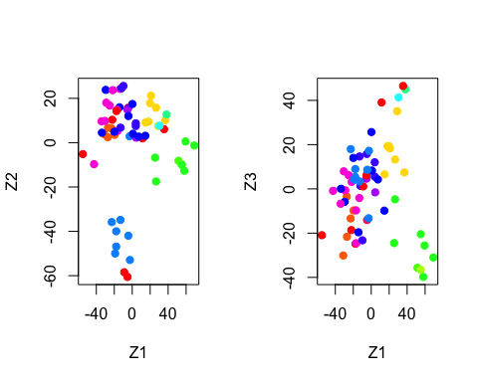
summary(pr.out)
## Importance of components:
## PC1 PC2 PC3 PC4 PC5
## Standard deviation 27.8535 21.48136 19.82046 17.03256 15.97181
## Proportion of Variance 0.1136 0.06756 0.05752 0.04248 0.03735
## Cumulative Proportion 0.1136 0.18115 0.23867 0.28115 0.31850
## PC6 PC7 PC8 PC9 PC10
## Standard deviation 15.72108 14.47145 13.54427 13.14400 12.73860
## Proportion of Variance 0.03619 0.03066 0.02686 0.02529 0.02376
## Cumulative Proportion 0.35468 0.38534 0.41220 0.43750 0.46126
## PC11 PC12 PC13 PC14 PC15
## Standard deviation 12.68672 12.15769 11.83019 11.62554 11.43779
## Proportion of Variance 0.02357 0.02164 0.02049 0.01979 0.01915
## Cumulative Proportion 0.48482 0.50646 0.52695 0.54674 0.56590
## PC16 PC17 PC18 PC19 PC20
## Standard deviation 11.00051 10.65666 10.48880 10.43518 10.3219
## Proportion of Variance 0.01772 0.01663 0.01611 0.01594 0.0156
## Cumulative Proportion 0.58361 0.60024 0.61635 0.63229 0.6479
## PC21 PC22 PC23 PC24 PC25 PC26
## Standard deviation 10.14608 10.0544 9.90265 9.64766 9.50764 9.33253
## Proportion of Variance 0.01507 0.0148 0.01436 0.01363 0.01324 0.01275
## Cumulative Proportion 0.66296 0.6778 0.69212 0.70575 0.71899 0.73174
## PC27 PC28 PC29 PC30 PC31 PC32
## Standard deviation 9.27320 9.0900 8.98117 8.75003 8.59962 8.44738
## Proportion of Variance 0.01259 0.0121 0.01181 0.01121 0.01083 0.01045
## Cumulative Proportion 0.74433 0.7564 0.76824 0.77945 0.79027 0.80072
## PC33 PC34 PC35 PC36 PC37 PC38
## Standard deviation 8.37305 8.21579 8.15731 7.97465 7.90446 7.82127
## Proportion of Variance 0.01026 0.00988 0.00974 0.00931 0.00915 0.00896
## Cumulative Proportion 0.81099 0.82087 0.83061 0.83992 0.84907 0.85803
## PC39 PC40 PC41 PC42 PC43 PC44
## Standard deviation 7.72156 7.58603 7.45619 7.3444 7.10449 7.0131
## Proportion of Variance 0.00873 0.00843 0.00814 0.0079 0.00739 0.0072
## Cumulative Proportion 0.86676 0.87518 0.88332 0.8912 0.89861 0.9058
## PC45 PC46 PC47 PC48 PC49 PC50
## Standard deviation 6.95839 6.8663 6.80744 6.64763 6.61607 6.40793
## Proportion of Variance 0.00709 0.0069 0.00678 0.00647 0.00641 0.00601
## Cumulative Proportion 0.91290 0.9198 0.92659 0.93306 0.93947 0.94548
## PC51 PC52 PC53 PC54 PC55 PC56
## Standard deviation 6.21984 6.20326 6.06706 5.91805 5.91233 5.73539
## Proportion of Variance 0.00566 0.00563 0.00539 0.00513 0.00512 0.00482
## Cumulative Proportion 0.95114 0.95678 0.96216 0.96729 0.97241 0.97723
## PC57 PC58 PC59 PC60 PC61 PC62
## Standard deviation 5.47261 5.2921 5.02117 4.68398 4.17567 4.08212
## Proportion of Variance 0.00438 0.0041 0.00369 0.00321 0.00255 0.00244
## Cumulative Proportion 0.98161 0.9857 0.98940 0.99262 0.99517 0.99761
## PC63 PC64
## Standard deviation 4.04124 2.148e-14
## Proportion of Variance 0.00239 0.000e+00
## Cumulative Proportion 1.00000 1.000e+00
plot(pr.out)
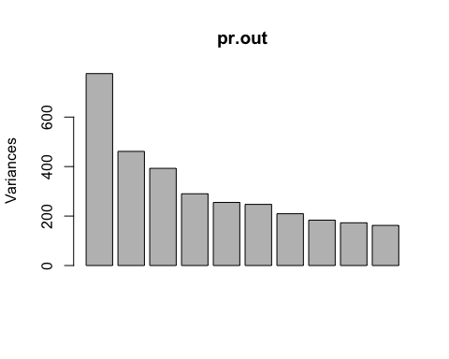
pve=100*pr.out$sdev^2/sum(pr.out$sdev^2)
par(mfrow=c(1,2))
plot(pve, type="o", ylab="PVE", xlab="Principal Component", col="blue")
plot(cumsum(pve), type="o", ylab="Cumulative PVE", xlab="Principal Component", col="brown3")
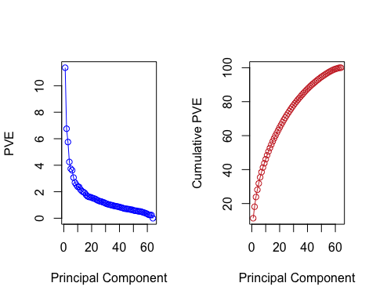
Clustering the Observations of the NCI60 Data
sd.data=scale(nci.data)
par(mfrow=c(1,3))
data.dist=dist(sd.data)
plot(hclust(data.dist), labels=nci.labs, main="Complete Linkage", xlab="", sub="",ylab="")
plot(hclust(data.dist, method="average"), labels=nci.labs, main="Average Linkage", xlab="", sub="",ylab="")
plot(hclust(data.dist, method="single"), labels=nci.labs, main="Single Linkage", xlab="", sub="",ylab="")
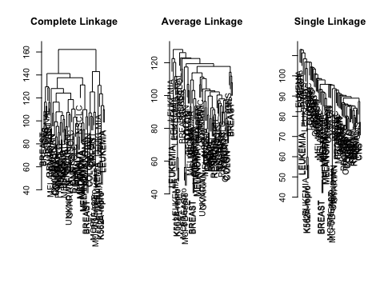
hc.out=hclust(dist(sd.data))
hc.clusters=cutree(hc.out,4)
table(hc.clusters,nci.labs)
## nci.labs
## hc.clusters BREAST CNS COLON K562A-repro K562B-repro LEUKEMIA MCF7A-repro
## 1 2 3 2 0 0 0 0
## 2 3 2 0 0 0 0 0
## 3 0 0 0 1 1 6 0
## 4 2 0 5 0 0 0 1
## nci.labs
## hc.clusters MCF7D-repro MELANOMA NSCLC OVARIAN PROSTATE RENAL UNKNOWN
## 1 0 8 8 6 2 8 1
## 2 0 0 1 0 0 1 0
## 3 0 0 0 0 0 0 0
## 4 1 0 0 0 0 0 0
par(mfrow=c(1,1))
plot(hc.out, labels=nci.labs)
abline(h=139, col="red")
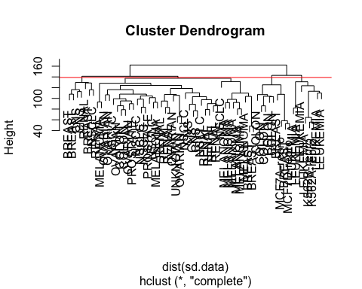
hc.out
##
## Call:
## hclust(d = dist(sd.data))
##
## Cluster method : complete
## Distance : euclidean
## Number of objects: 64
set.seed(2)
km.out=kmeans(sd.data, 4, nstart=20)
km.clusters=km.out$cluster
table(km.clusters,hc.clusters)
## hc.clusters
## km.clusters 1 2 3 4
## 1 11 0 0 9
## 2 0 0 8 0
## 3 9 0 0 0
## 4 20 7 0 0
hc.out=hclust(dist(pr.out$x[,1:5]))
plot(hc.out, labels=nci.labs, main="Hier. Clust. on First Five Score Vectors")
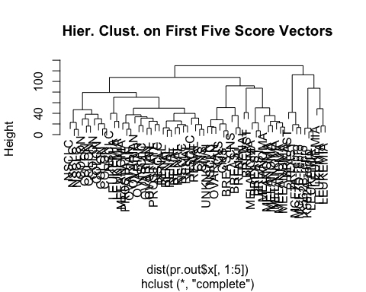
table(cutree(hc.out,4), nci.labs)
## nci.labs
## BREAST CNS COLON K562A-repro K562B-repro LEUKEMIA MCF7A-repro
## 1 0 2 7 0 0 2 0
## 2 5 3 0 0 0 0 0
## 3 0 0 0 1 1 4 0
## 4 2 0 0 0 0 0 1
## nci.labs
## MCF7D-repro MELANOMA NSCLC OVARIAN PROSTATE RENAL UNKNOWN
## 1 0 1 8 5 2 7 0
## 2 0 7 1 1 0 2 1
## 3 0 0 0 0 0 0 0
## 4 1 0 0 0 0 0 0
TASK 4 Summary 10 points Report time required for homework, difficulties encountered, and collaborators.

Report time required for homework: The whole time taken for this project including the time spent on understanding the concepts and executing them along with the different variations possible was 10 days.

Difficulties Encountered: Working on R studio with R code has been relatively easy now given we have already done some projects on it.
However, the main challenge was to understand the project and the various aspects of it.
Also, it is very important to understand the execution and the syntax of R to understand it for various ways different parts of a code could be altered and modified to get desired results.

Collaborators: Not required as the explanation in book is self sufficient.

