We can use the **Remote Desktop Connection** (mstsc.exe) or Microsoft Remote Desktop app to Connect to and control your Windows PC from a remote device.

1. Press the **Win+R** keys to open Run, type mstsc into Run, and click on **OK** to open the Remote Desktop Connection(RDC) client

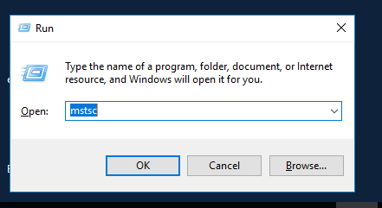

1. Select the computer you want to save its connection settings for, and click on **Connect** in the Remote Desktop Connection client.

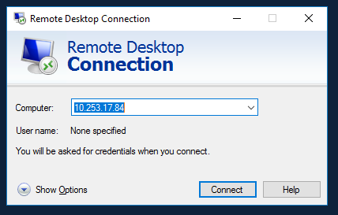

1. Enter the credentials to connect remotely to the computer, and click on **OK**.

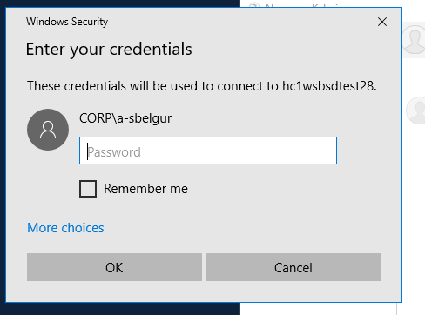

1. Inside the VM >Settings > Update & Security >For Developers from Left Side bar switch to Developer mode(Select the radio button next to “Developer mode”)

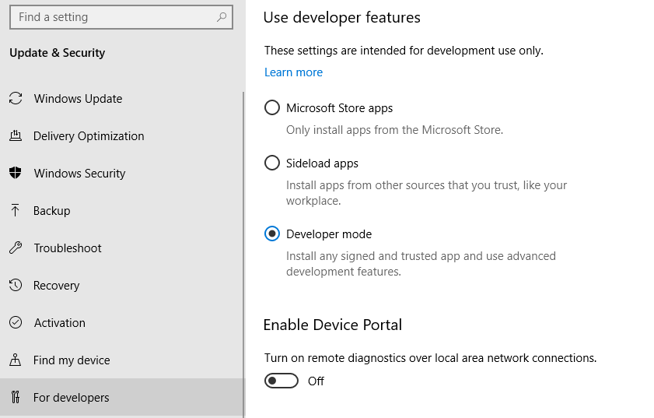

1. **Open Start Menu and type ‘Computer Management’**

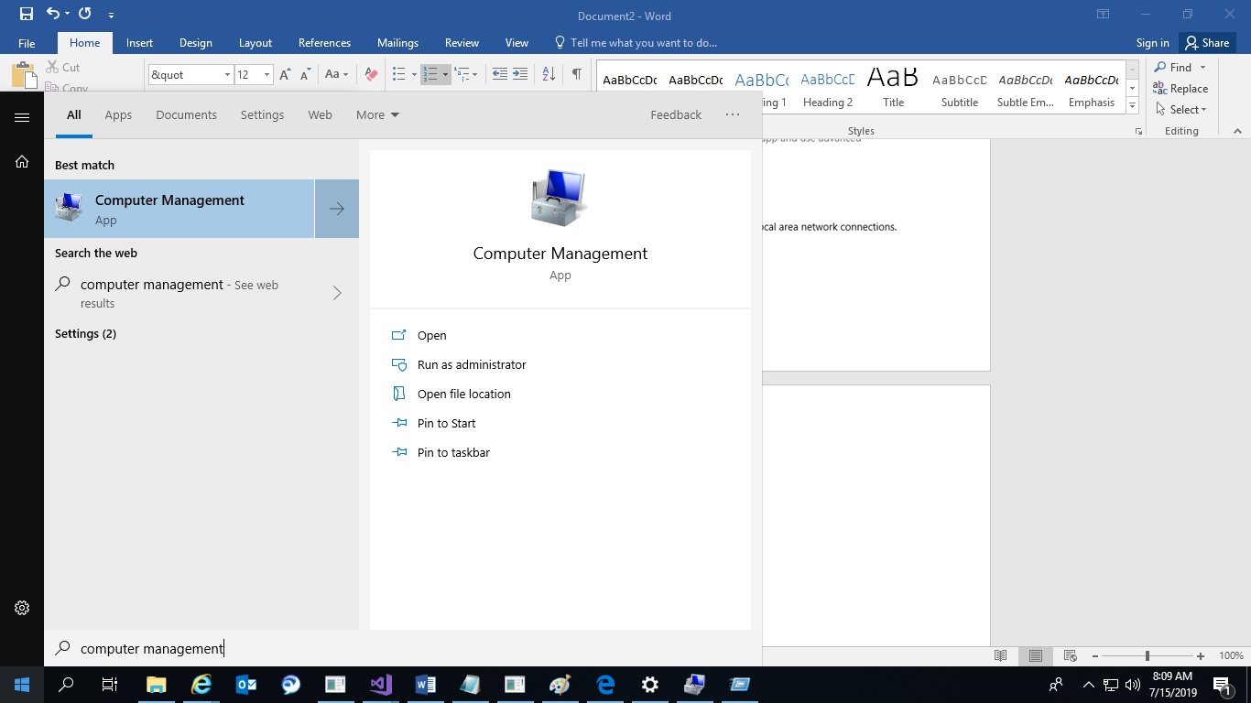

1. Select ‘Groups’ from left navigation and add the user as ‘Administrator’ (For the first time)

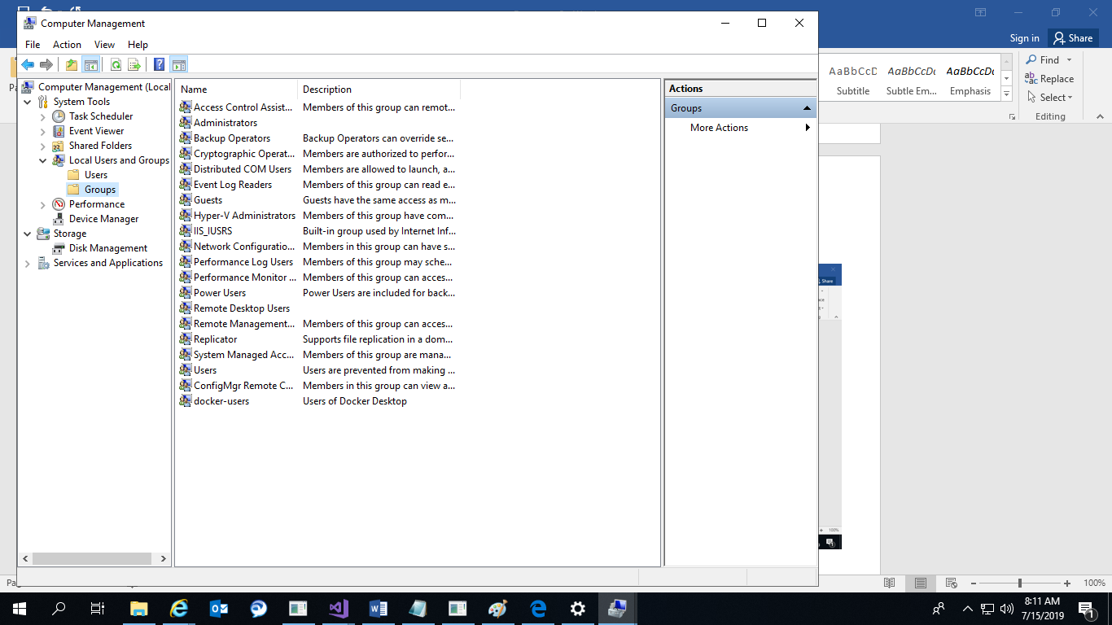

1. To download WinAppDriver
2. Download Windows Application Driver stable installer( not RC) from <https://github.com/Microsoft/WinAppDriver/releases>

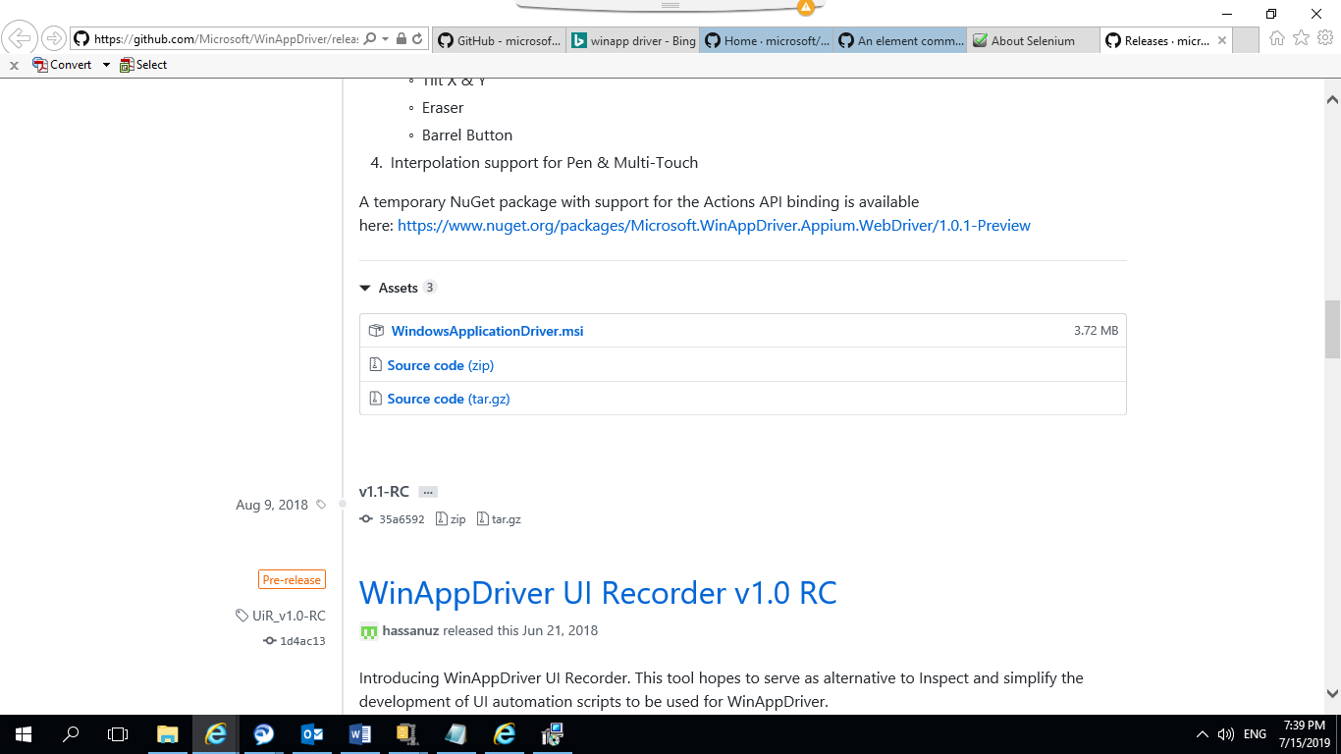

1. Run the installer on a Windows 10 machine where your application under test is installed and will be tested

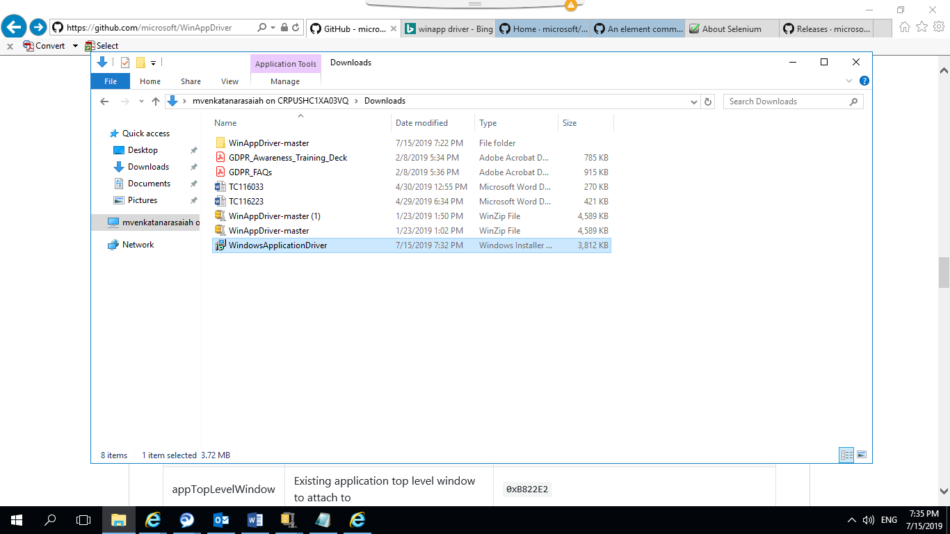

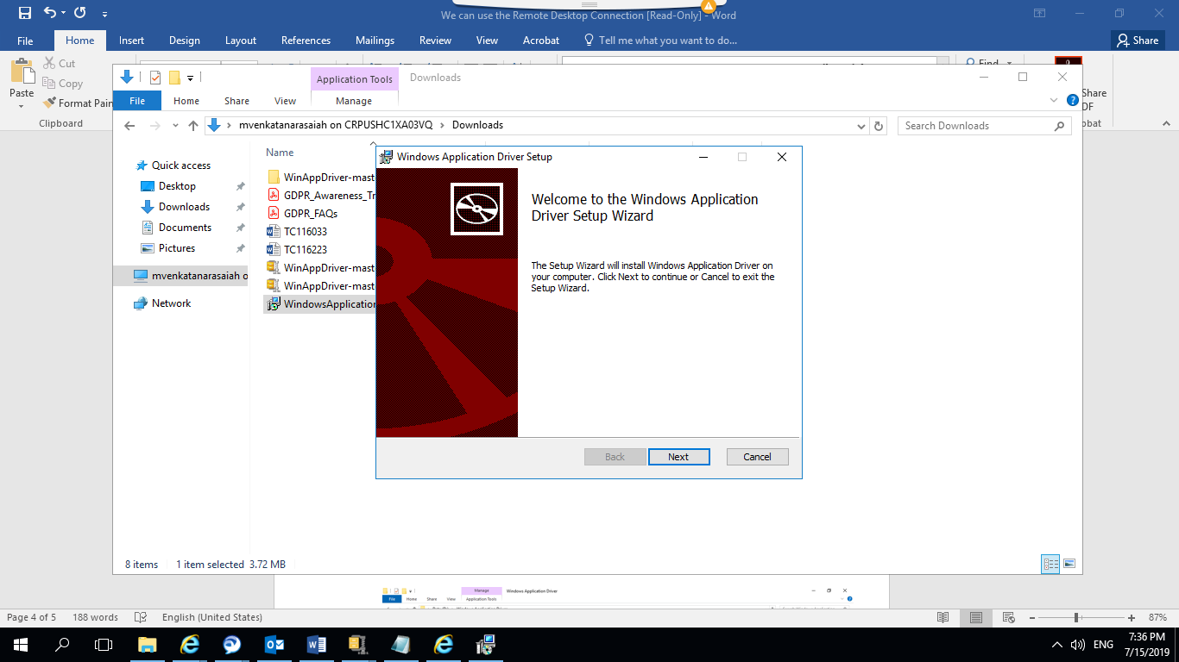

1. Go to WinAppDriver and Run as administrator

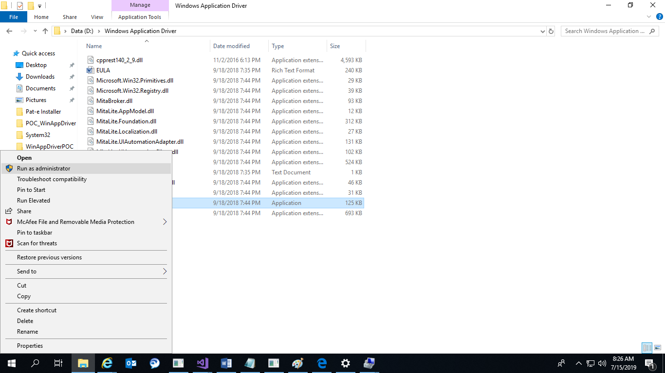

1. Make sure the driver is up and running in the specified port

