Python Script for Checking New GitHub Commits

Overview
This script checks for new commits in a specified branch of a GitHub repository using the GitHub API. If a new commit is found, it triggers a deployment by running a script. The script is flexible, allowing the user to specify the branch to check, and defaults to the main branch if no branch is provided.
For this task we are using GitHub repo: https://github.com/rajivsharma92/ci-cd-project/tree/master

Requirements
- Python 3.x
- requests module (can be installed via pip)
- GitHub repository with an accessible API
- A deployment script to trigger (optional, but assumed in this case)
- Create venv for python file and give permissions to it by using chmod command

Steps to Set Up and Use the Script

1. Install Python and requests Module
Ensure that Python 3 and the requests module are installed on your system. You can install the requests module with the following command:

pip install requests

2. Clone the Script
Create a directory for your project and create a Python file called check_commits.py inside it.

mkdir my_git_checker
cd my_git_checker
touch check_commits.py

3. Update the Script
Replace the placeholders in the script with your actual GitHub repository details. Below is the full script with necessary explanations:
python

import requests
import json
import os
import sys

# Replace with your GitHub repository details
REPO_NAME = "yourusername/your-repo" # Update this to your GitHub username and repository name

# Accepts branch name from command-line argument, default is 'main'
BRANCH_NAME = sys.argv[1] if len(sys.argv) > 1 else "main" # Default to 'main' if no branch specified

# Construct the GitHub API URL to fetch commits for the given branch
GITHUB_API_URL = f"https://api.github.com/repos/{REPO_NAME}/commits?sha={BRANCH_NAME}"

# Path to the file where the last commit hash will be stored
LAST_COMMIT_FILE = "/path/to/last_commit.txt"

def get_latest_commit():
"""
Fetch the latest commit from the specified branch using the GitHub API.
"""
response = requests.get(GITHUB_API_URL)
if response.status_code == 200:
commits = json.loads(response.text)
if commits: # Check if there are any commits
latest_commit = commits[0]['sha']
return latest_commit
else:
print("No commits found on this branch.")
return None
else:
print(f"Error fetching commits: {response.status_code} - {response.text}")
return None

def save_last_commit(commit_hash):
"""
Save the latest commit hash to a file.
"""
with open(LAST_COMMIT_FILE, "w") as file:
file.write(commit_hash)

def read_last_commit():
"""
Read the last saved commit hash from a file.
"""
if os.path.exists(LAST_COMMIT_FILE):
with open(LAST_COMMIT_FILE, "r") as file:
return file.read().strip()
return None

def main():
"""
Main function that checks for new commits and triggers deployment if needed.
"""
latest_commit = get_latest_commit()
if not latest_commit:
print("Error retrieving latest commit.")
return

last_commit = read_last_commit()
if last_commit != latest_commit:
print("New commit found! Deploying...")
save_last_commit(latest_commit)
os.system("/path/to/deploy.sh") # Trigger deployment script
else:
print("No new commit.")

if __name__ == "__main__":
main()

4. Configuration

a. GitHub Repository and Branch
- REPO_NAME: Replace "yourusername/your-repo" with the actual username and repository name of your GitHub project.
- BRANCH_NAME: The branch is passed as a command-line argument. If not provided, it defaults to the main branch.

b. Last Commit File
- LAST_COMMIT_FILE: This file stores the latest commit hash. Update the path to a valid location on your system. For example:

LAST_COMMIT_FILE = "/home/user/my_git_checker/last_commit.txt"

c. Deployment Script
- Deployment Trigger: The script uses the following command to trigger the deployment process:

os.system("/path/to/deploy.sh")
Replace "/path/to/deploy.sh" with the actual path to your deployment script (e.g., to restart a server or update your project). Make sure this script has executable permissions.

5. Run the Script

a. Check the Default Branch (main)
To check the main branch of your repository for new commits:

python3 check_commits.py

b. Check a Specific Branch
To check a specific branch, such as develop or master, pass the branch name as an argument:

python3 check_commits.py develop
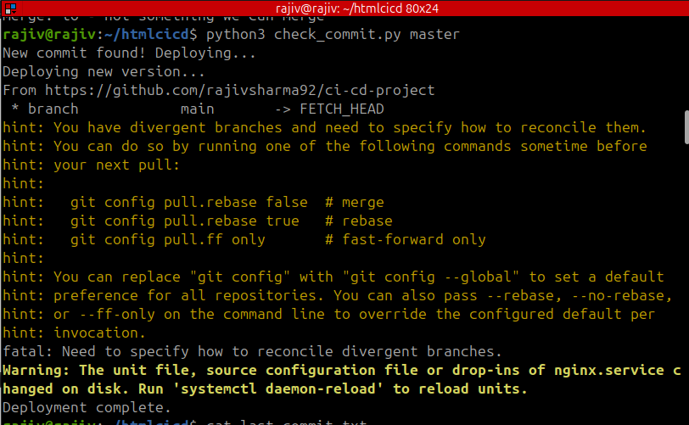

6. Setting Up a Cron Job for Automation
To automate the process of checking for new commits, you can set up a cron job that runs this script periodically.

a. Open Crontab Editor

crontab -e

b. Add a Cron Job Entry
For example, to run the script every 5 minutes:

*/5 * * * * /usr/bin/python3 /path/to/check_commits.py main >> /path/to/logfile.log 2>&1
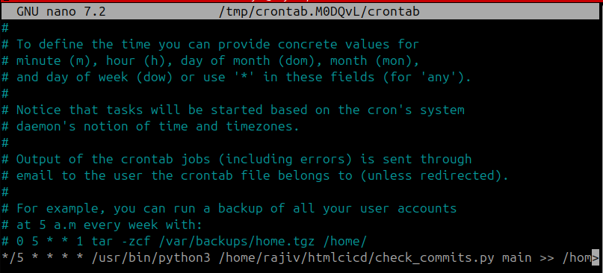
Make sure to adjust the path to your Python binary and the script file accordingly.

7. Testing the Setup
- Make a new commit to the specified branch on your GitHub repository.
- The script will automatically detect the new commit, run the deployment process, and update the last_commit.txt file.

Script Overview

Main Components:
- Branch Flexibility: You can check any branch of your GitHub repository by passing the branch name as a command-line argument.
- Deployment Process: Upon detecting a new commit, the script runs a deployment process (via a script).
- Commit Hash Tracking: The script tracks the last processed commit using a file, so it doesn't repeatedly deploy the same code.

Error Handling:
- The script handles errors related to the GitHub API, such as invalid branch names or repository issues.
- If no new commit is found, the script simply outputs that there is no new commit and skips the deployment process.

Conclusion
This Python script automates the process of checking for new commits on a specific branch of a GitHub repository and triggering a deployment when new commits are found. It offers flexibility by allowing branch selection and automates the deployment pipeline efficiently.

