Task 1: Deploy a Website on Localhost Using Apache2

Step-by-Step Documentation
Objective: Deploy a simple HTML website on localhost using either Apache2 or Nginx and configure a custom DNS name rajivtest.

Prerequisites:
- A working Ubuntu installation via WSL, VirtualBox, or a native installation.
- Basic understanding of HTML and web servers.

Option 1: Deploying with Apache2

Step 1: Install Apache2
Open your terminal and install Apache2 using the following command:
> sudo apt update
> sudo apt install apache2 -y

Step 2: Configure Apache2
After installation, ensure Apache is running:
> sudo systemctl start apache2
To ensure Apache2 runs on startup, enable it:
> sudo systemctl enable apache2

Step 3: Create a Simple HTML Website
Create a directory for your website and an HTML file:
> sudo mkdir -p /var/www/rajivtest
> sudo nano /var/www/rajivtest/index.html
Inside index.html, add your HTML code:
Eg code:

<!DOCTYPE html>
<html lang="en">
<head>
<meta charset="UTF-8">
<meta name="viewport" content="width=device-width, initial-scale=1.0">
<title>Apache2 test deployment</title>
</head>
<body>
<h1>Hello Rajiv!</h1>
<p>This is a simple HTML page hosted on Apache2.</p>
</body>
</html>

Step 4: Configure Virtual Host
Create a new virtual host configuration file for your website:

> sudo nano /etc/apache2/sites-available/rajivtest.conf
Add the following configuration to the file:

<VirtualHost *:80>
ServerAdmin webmaster@localhost
ServerName rajivtest
DocumentRoot /var/www/rajivtest

<Directory /var/www/rajivtest>
Options Indexes FollowSymLinks
AllowOverride All
Require all granted
</Directory>

ErrorLog ${APACHE_LOG_DIR}/error.log
CustomLog ${APACHE_LOG_DIR}/access.log combined
</VirtualHost>

Step 5: Enable the Site
Enable the website and restart Apache:
> sudo a2ensite rajivtest
> sudo systemctl reload apache2

Step 6: Configure DNS
Add rajivtest to your local DNS by editing the /etc/hosts file:
> sudo nano /etc/hosts
Add the following entry:
127.0.0.1 rajivtest

Step 7: Access the Website
Open your browser and go to http://rajivtest. You should see your website.

Task 2: Python Script to Monitor Subdomain Status

Script Overview
This Python script will check the status of subdomains (UP or DOWN) by pinging them every minute and display the results in a table.

Step 1: Install Dependencies
You will need the requests library to check the status of each subdomain:
pip install requests

Step 2: Write the Python Script
Create a Python script subdomain_checker.py:
python
Copy code
import requests
import time
from prettytable import PrettyTable

# Subdomains to check
subdomains = ['http://sub1.example.com', 'http://sub2.example.com']

def check_status():
table = PrettyTable(['Subdomain', 'Status'])
for subdomain in subdomains:
try:
response = requests.get(subdomain)
if response.status_code == 200:
table.add_row([subdomain, 'UP'])
else:
table.add_row([subdomain, 'DOWN'])
except requests.exceptions.RequestException:
table.add_row([subdomain, 'DOWN'])
print(table)

if __name__ == '__main__':
while True:
print("\nChecking status of subdomains...\n")
check_status()
time.sleep(60)

Step 3: Run the Script
Run the script to check subdomains every minute:
python3 subdomain_checker.py
Output:
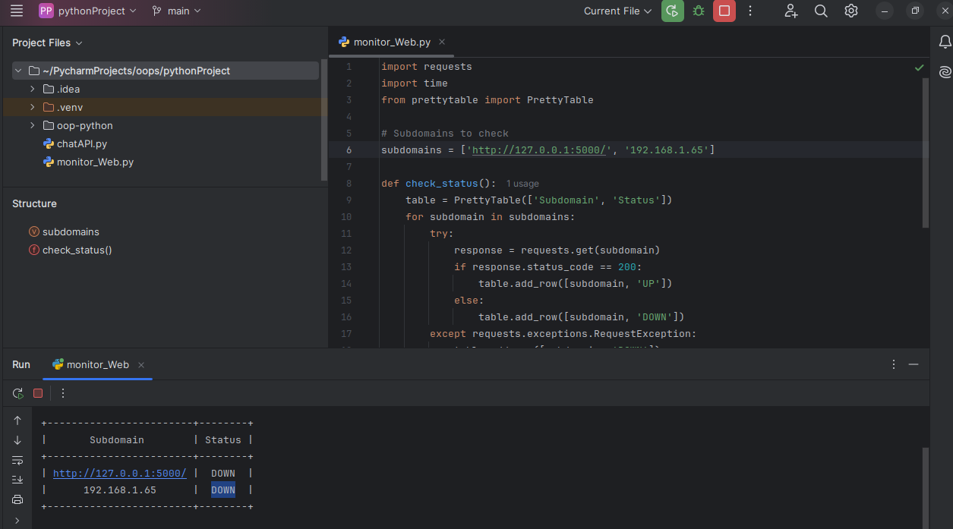

Task 3: Virtual Machine Overview and Nmap Scan

Task Overview:
- Install a virtual machine using Oracle VirtualBox.
- Use Ubuntu 22.04 as the guest OS.
- Install Nginx inside the Ubuntu VM and host a website.
- Scan the VM using Nmap from the host machine and observe open ports.

Step 1: Install VirtualBox

1.1 Download VirtualBox
- Go to the VirtualBox website.
- Click on Downloads.
- Select the package for your operating system (Windows, macOS, or Linux).

1.2 Install VirtualBox
- For Windows:
  - Run the downloaded .exe file.
  - Follow the installation prompts to complete the setup.
- For macOS:
  - Open the .dmg file and run the VirtualBox installer.
- For Ubuntu/Linux:
  - Open the terminal and install the downloaded .deb package:
bash
Copy code
sudo dpkg -i <VirtualBox_package_name>.deb
  - Resolve any dependencies using:
bash
Copy code
sudo apt --fix-broken install

1.3 Add User to vboxusers Group (For Linux Users)
After installing VirtualBox, run the following command to add your user to the vboxusers group:
bash
Copy code
sudo usermod -aG vboxusers $USER
Then reboot your system to apply changes.

Step 2: Download and Set Up Ubuntu 22.04 VM

2.1 Download Ubuntu Image
- Go to OSBoxes.
- Download the Ubuntu 22.04 image for VirtualBox.

2.2 Import the VM into VirtualBox
- Open VirtualBox and click on File > Import Appliance.
- Select the downloaded .ova file and proceed with the import process.

2.3 Configure Network Adapter
- Go to the Settings of the VM.
- Under the Network tab, ensure that Adapter 1 is set to Bridged Adapter (this will allow the VM to obtain its own IP address).
- If you are using wifi select Name to wlp13s0

Step 3: Install Nginx and Host a Website on the VM

3.1 Start the VM and Update Ubuntu
- Start the Ubuntu VM.
- Open a terminal inside the VM and update the system:
> sudo apt update
> sudo apt upgrade -y

3.2 Install Nginx
- Install Nginx on the Ubuntu VM:
> sudo apt install nginx -y
- Verify that Nginx is installed and running:
> sudo systemctl status nginx
- If Nginx is not running, start it:
> sudo systemctl start nginx

3.3 Host a Website
- Create a simple HTML page to host on Nginx:
> sudo nano /var/www/html/index.html
Add the following HTML content:
<!DOCTYPE>
<html>
<head>
<title>Welcome to My Website</title>
</head>
<body>
<h1>Hello, this is rajiv’s website hosted on an Ubuntu VM!</h1>
</body>
</html>
- Save the file and exit.
- Restart Nginx to apply changes:
bash
Copy code
sudo systemctl restart nginx
- Find the IP address of the VM using:
ip a
Look for the bridged network interface (typically eth0 or ens33), and note the IP address.

3.4 Test Website from Host
- Open a browser on your host machine and navigate to the VM’s IP address:
http://<vm-ip-address>

- You should see the HTML page you created.

Step 4: Scan the VM Using Nmap from the Host Machine

4.1 Install Nmap (If Not Already Installed)
On the host machine, install Nmap:
- Ubuntu/Linux:
> sudo apt install nmap -y
- Windows: Download Nmap for Windows.

4.2 Scan the VM for Open Ports
Run an Nmap scan against the VM’s IP address from the host machine:
> nmap <vm-ip-address>

4.3 Interpret the Output
The Nmap scan will show you the open ports on the VM. Look for the following typical open ports:
- Port 80: HTTP (Nginx web server).
- Other ports related to services that might be running.

Example Output:
Starting Nmap 7.80 ( https://nmap.org ) at 2024-10-03 15:32 UTC
Nmap scan report for 192.168.1.10
Host is up (0.00057s latency).
Not shown: 998 closed ports
PORT STATE SERVICE
22/tcp open ssh
80/tcp open http
MAC Address: 08:00:27:5A:3B:E4 (Oracle VirtualBox virtual NIC)

- Port 22: SSH is open, meaning the VM allows SSH connections.
- Port 80: HTTP is open, meaning Nginx is serving the website.

Step 5: Document the Process and Scan Results

5.1 Documentation Structure
- Introduction:
  - Overview of the task, including the purpose of using a VM, Nginx, and Nmap.
- VirtualBox Installation:
  - Mention the steps to install VirtualBox on the host machine.
- Setting up the Ubuntu VM:
  - Steps to download, import, and configure the Ubuntu 22.04 VM in VirtualBox.
  - Include screenshots of network settings.
- Installing and Configuring Nginx:
  - Steps to install and configure Nginx on the VM.
  - Steps to create and host a simple HTML page.
- Scanning the VM Using Nmap:
  - Instructions for installing Nmap on the host machine.
  - The command used for scanning the VM.
  - Example output from Nmap showing the open ports.
- Observations:
  - Mention the ports that were open (e.g., port 80 for HTTP).
  - Include any other insights, such as security implications of open ports.

Example Nmap Scan Report Documentation

Nmap Scan Results:
- Target: Ubuntu VM at IP 192.168.1.10
- Host Status: Host is up
- Open Ports:
  - 22/tcp: SSH
  - 80/tcp: HTTP (Nginx web server)
These open ports indicate that the VM is accessible over SSH, and the website hosted on Nginx is reachable via HTTP.

Step 6: Final Notes
- Ensure that your host and VM are on the same network and that no firewalls are blocking the connection.
- Double-check the network settings if the host cannot communicate with the VM.
Output image:
