Twice Told
Software Requirements Specification · Version 2.1
A discovery-first e-reader for free short stories, essays and classics — with an AI build crew, human gates, and a full user story board.
September 26, 2026 · Draft for Gate G0
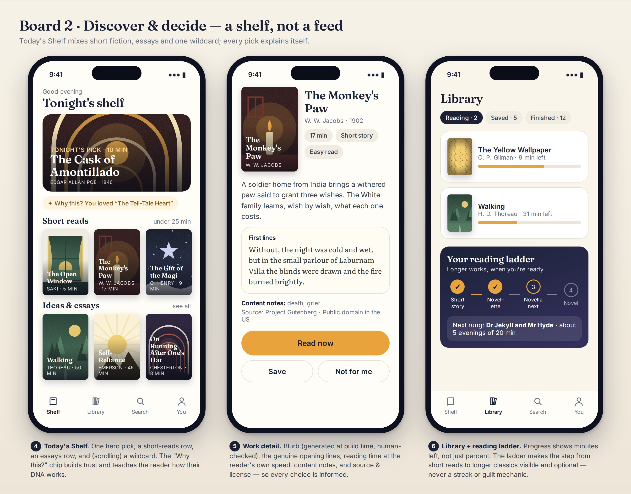
Your Shortlist, work detail and reading ladder (mock-ups, Part 3.4)

Document control
Item | Value
Document | Twice Told — Software Requirements Specification (SRS), version 2.1
Date | September 26, 2026
Status | Draft for Gate G0 (Charter), version 2.1. You confirmed D1 (16+), D2 (Antigravity), D4 (private repository — on Gitea) and D6 (Standard Ebooks) on September 26, 2026; the other decisions are recommended defaults.
Supersedes | LuminaRead SRS v1 (Lumina_read_SRS.docx)
Prepared by | Claude (Anthropic), using four role-based review passes: Product Management, UX/UI, Architecture, AI implementation
Independent reviewer | Gemini 3.1 Pro via your Google AI Pro plan (prompts P1–P2, Part 11)
Agent-readable twin | luminaread-starter-kit.zip → docs/SRS.md, docs/stories/, docs/use-cases/, TASKS.md, AGENTS.md

How to use this document
This SRS has two audiences. You (the product owner) read it to understand, decide and approve. The AI agents read its twin — the Markdown files in the starter kit — to build the product on their own between your approvals. Both come from the same source, so they always match.
If you want to… | Read
Get Gemini on its best model and run the independent review | Part 1.1 and prompts P1–P2
Understand the product in ten minutes | Part 1.2, Part 2, the mockups in Part 3.4
See what changed from v1 and what you must decide | Parts 1.3 and 1.4
Understand agents, skills and gates | Part 9
Set everything up, step by step | Part 10 (no technical background assumed)
Copy a prompt | Part 11 — every prompt says which tool it goes into
Review the build plan in detail | Parts 4–8

Contents
Document control 2
How to use this document 2
Contents 2
Part 1 — Start here 5
1.1 Before you begin: make sure Gemini is on its most advanced model 5
1.2 Twice Told in plain English 5
1.3 What changed from v1, and why 6
1.4 Decisions you need to make 7
Part 2 — Product 9
2.1 Vision and problem 9
2.2 Goals and success metrics 9
2.3 Personas 9
2.4 Scope and releases 10
2.5 Content strategy and sources 11
2.6 How the four reviewers re-examined the plan 12
Part 3 — Experience (UX/UI) 14
3.1 Experience principles 14
3.2 Key flows 14
3.3 Design system 14
3.4 Mock-ups 15
3.5 What we borrow from existing e-readers 20
3.6 Accessibility requirements 20
Part 4 — Architecture 21
4.1 Principles 21
4.2 System context 21
4.3 Runtime architecture 23
4.4 Content Factory 25
4.5 Data model on the device 27
4.6 Recommendation engine 28
4.7 Reader engine decision (ADR-0002, to confirm at G2) 30
4.8 Cover art pipeline 30
4.9 Deployment and CI/CD 31
4.10 Security and privacy 32
4.11 Technology stack 32
Part 5 — AI implementation 33
5.1 Where AI runs 33
5.2 Can a lightweight free local model be bundled? 33
5.3 Evaluation plan (bake-off, EN-801) 34
5.4 Guardrails 34
Part 6 — Requirements 36
6.1 Functional requirements 36
6.2 Non-functional requirements 36
Part 7 — Epics, features and use cases 38
7.1 Epics 38
7.2 Key sequences 38
7.3 Use cases (fully dressed) 42
Part 8 — User story board 52
8.1 How to read the story map 52
8.2 Story cards 55
Part 9 — The AI build crew: agents, skills and gates 67
9.1 The crew 67
9.2 Skills, explained 68
9.3 Which of Matt Pocock's skills to use, and when 69
9.4 Twice Told's own skills (in the kit) 70
9.5 The gated pipeline 71
9.6 The sprint assembly line 72
9.7 Why Gitea instead of GitHub 75
9.8 How agent-homelab fits now 75
Part 10 — Step-by-step setup (no technical background needed) 76
10.1 Accounts and apps you need 76
10.2 Install the tools 76
10.3 Start your private Gitea server 77
10.4 Create the Twice Told repository 78
10.5 Open the project in Antigravity 78
10.6 Connect Cloudflare (when the architect asks) 78
10.7 Install Matt Pocock's skills 78
10.8 Set up your Gemini reviewer 79
10.9 Your first session: Gate G0 79
10.10 Then: G1–G3, content, and sprints 79
10.11 Alternative track: Claude Code 79
10.12 Troubleshooting and safety 79
Part 11 — Prompt library 81
Part 12 — Risks, assumptions, glossary and references 84
12.1 Risks and mitigations 84
12.2 Assumptions 84
12.3 Glossary 85
12.4 References (checked September 2026) 85
Appendix — What is in the starter kit 86

If the contents list is empty, right-click it in Word and choose Update Field.

Part 1 — Start here

1.1 Before you begin: make sure Gemini is on its most advanced model
On Google AI Pro, the most capable model you can choose in the Gemini app is Gemini 3.1 Pro, labeled simply Pro in the model picker. Google announced Gemini 3.5 Pro at I/O in May 2026, but as of late September 2026 it has not been broadly released; when it arrives it is expected to sit behind the same Pro option. Deep Think is an Ultra-only mode and is not part of AI Pro.
- Open gemini.google.com (or the Gemini app) and sign in with the Google account that pays for AI Pro. Your account or plan area should show Google AI Pro; if not, you are in the wrong account.
- Start a new chat and open the model picker (the model name near the prompt box). Choose Pro — not Fast or Thinking.
- Before a long review, check the picker again. When a paid plan reaches its Pro allowance, Gemini can continue on a lighter model; if that happens, wait for the allowance to reset.
- Attach the file with the + button. AI Pro's large context window easily holds this SRS.
NOTE · Who wrote this document
This SRS was produced by Claude (Anthropic), not Gemini. To honor your instruction that your most advanced Google model reviews the instructions, the pipeline builds in a Gemini 3.1 Pro review at every planning gate. Prompts P1 (a reusable "Twice Told Reviewer" Gem) and P2 (a full review of this SRS) are in Part 11.

IMPORTANT · Gemini CLI no longer works with AI Pro
On June 18, 2026 Google stopped serving Gemini CLI for AI Pro and Ultra personal accounts. Its successor is Antigravity (a desktop app and a CLI), which keeps Agent Skills, hooks and subagents and uses Gemini 3.1 Pro by default. Your build crew runs in Antigravity (Part 10).

1.2 Twice Told in plain English
Twice Told is a free reading app that learns what you like and serves you great free reading — starting with short stories and essays you can finish in one sitting, then gradually mixing in longer classics when you are ready. Everything it learns about you stays on your own phone.
- Tell it your taste. Pick a few moods and react to eight quick "taste cards". Optionally add books you have loved, even modern ones.
- Get a shortlist. Each visit shows a small shortlist: one hero pick, a row of short reads, a row of essays and one wildcard. Every pick says why it was chosen.
- Read. A built-in reader with comfortable fonts, themes, time-left estimates, word definitions and read-aloud.
- React. One tap when you finish ("Loved it", "It was OK", "Not for me"). The app also notices what you finish or abandon.
- Grow. Once you are enjoying short works, longer ones appear on a "reading ladder" — novelettes, then novellas, then novels — at your pace.
Behind the scenes, a "Content Factory" prepares the library once: it collects public-domain texts the way the libraries ask, splits anthologies into single stories, writes honest blurbs and content notes, computes a compact "taste fingerprint" for each work, and generates cover art in one consistent style. You approve samples. An AI build crew then writes and tests the app, and you approve its work at a handful of gates.

1.3 What changed from v1, and why
Four role-based reviews re-examined every v1 suggestion. The table lists each change and which reviewer raised it.
v1 plan | v2 decision | Why | Raised by
Runtime calls to the public Gutendex API and on-the-fly Pollinations images | A build-time Content Factory publishes a static, versioned catalog with precomputed blurbs, vectors and covers | The public Gutendex instance is meant for testing and has had outages; Pollinations' anonymous tier is rate-limited and may watermark. Core flows should not depend on third parties. | Architect
App downloads books directly from gutenberg.org | Curated texts mirrored on our own static host with Project Gutenberg license handling | Project Gutenberg blocks automated access to its website and asks for mirrors and offline catalogs. | Architect
Whole books only | Short-first catalog: anthologies split into single stories and essays; non-fiction essays and articles added; longer works via a reading ladder | This is what you asked for — short reads first, longer works later. | Product Manager
Each phone embeds 10–20 summaries at runtime | Catalog vectors precomputed once; phones only do vector arithmetic | Faster, cheaper on battery, deterministic, and works offline. | AI Engineer
A local AI model auto-downloads on first open | No model needed for the core app. Optional "Explain (Labs)" with tiers: browser built-in AI → opt-in small model → glossary | Hundreds of MB on first open hurts the first impression and mobile data; small models must earn their place in a bake-off. | UX/UI + AI Engineer
epub.js / react-reader | foliate-js (MIT) behind a ReaderEngine adapter; Readium ts-toolkit as plan B; decided by a bake-off | epub.js has had no release since February 2022. | Reader Researcher
@xenova/transformers | @huggingface/transformers v4 | The old package name is superseded (v2.17.2, 2024 vs v4.3.0, Sept 2026). | AI Engineer
LocalForage key-value store | Dexie (IndexedDB with schema and migrations) behind typed stores | LocalForage's last release was 2021; we need queries and migrations. | Architect
Next.js with webpack tweaks on Vercel | Vite + React + TypeScript PWA on Cloudflare Pages | Client-only app needs no server framework; recent Next.js versions default to Turbopack, so webpack tweaks may not apply. Same stack Lovable uses, if you prototype there. | Architect
Swipe cards showing summaries | Taste cards with cover, one-line hook, genuine first line, reading time; buttons plus swipe | Faster taste signal; accessible to people who cannot swipe. | UX/UI
A top-3 gallery in a masonry layout | Your Shortlist: hero, short reads, essays, wildcard — each with "Why this?" | More choice without a feed; explanations build trust. | UX/UI
Feedback = swipe and add-to-library | Explicit reactions with reasons + implicit signals (progress, finish, abandon) in an on-device event log with time decay | Better learning, explainable, editable, and privacy-preserving. | AI Engineer
Cover images generated per user at runtime | Covers generated once at build time, human-approved, text-free art with app-rendered titles; procedural fallback | Consistent quality, no runtime dependency, correct titles. | UX/UI
Middle-school persona | MVP audience 16+ with content notes; younger-reader mode deferred | Children's-privacy law and content suitability need dedicated work. | Product Manager
No success metrics | Activation, first-read completion, hit rate, return, ladder progression, cost | You cannot steer what you do not measure. | Product Manager
Storage risk not addressed | Persistent-storage request, install prompt, export/import | Browsers can evict website storage; Safari limits storage for sites not added to the Home Screen. | Architect
No accessibility requirements | WCAG 2.2 AA baseline, dyslexia-friendly and high-legibility fonts, read-aloud, CI checks | A reading app must work for everyone. | UX/UI
Single "agent handoff" step | A gated pipeline with a named agent crew, skills, and an agent-readable starter kit | You asked to be involved only at gates. | Product Manager
GitHub as the code host (implied) | Self-hosted Gitea: private repository, Gitea Actions CI, enforced branch protection | Your decision D4; free enforced protection on private repos; agent-homelab's native forge; code stays on your machine. | Architect
Claude Code as the build harness | Antigravity with Gemini 3.1 Pro, a Claude-model reviewer, and Gemini-app reviews at planning gates | Your decision D2; included in Google AI Pro. | Product Manager
Human involvement throughout the build | Sprint assembly line: humans gate only the plan (G4) and the promotion (G5); a machine gate (review + CI) blocks bad merges; auto-rollout to test | The pipeline you shared; fewer interruptions for you. | Product Manager
Gutenberg-only content | Plus Standard Ebooks, Wikisource, Library of Congress newspapers, The Conversation extracts, LibriVox audio | Richer non-fiction and audio, each with explicit license handling. | Content Curator

1.4 Decisions you need to make
You confirmed D1, D2, D4 and D6 on September 26, 2026. The rest have recommended defaults so the agents can proceed; confirm or change them in the G0 interview (/kickoff).
ID | Decision | Recommendation | Why it matters | When
D1 | Audience for the first release | Confirmed: adults and older teens (16+). Younger-reader mode later. | Under-13 users bring children's-privacy (COPPA) duties and content-suitability work; public-domain texts include dated and offensive material. | Confirmed
D2 | Main build harness | Confirmed: Google Antigravity with Gemini 3.1 Pro as the builder; the reviewer agent runs on a Claude model inside Antigravity for cross-model review; the Gemini app reviews planning gates. Claude Code is an optional alternative track. | Included in your Google AI Pro plan; supports agent skills, workflows, rules and subagents. | Confirmed
D3 | Usage limits | Keep sprints small (≤ 6 stories); consider a higher Google plan only if limits interrupt sprints. | Parallel agents use allowance faster. | G0
D4 | Repository | Confirmed: private repository, hosted on your own Gitea server. | Gitea enforces branch protection on private repositories at no cost (GitHub Free does not); it is also the forge agent-homelab was built and run on. | Confirmed
D5 | MVP catalog size | ≈300 short works (≈200 stories, ≈100 essays/articles) + ≈60 longer works. | Enough variety for learning; small enough to review samples and generate covers on free tiers. | G3
D6 | Standard Ebooks Patrons Circle | Confirmed: yes — small donation for feed access. | Feeds and bulk downloads for software use are a Patrons Circle benefit. | Confirmed
D7 | CC BY-SA content (e.g., Wikipedia) | Not in R1; consider in R2 with an attribution panel. | Share-alike and attribution add UI and compliance work. | G3
D8 | Cover art style | "Risograph modern": text-free illustration, limited palette, app-rendered titles. | Consistent and legible; avoids garbled AI text in images. | G1
D9 | Product name | Keep "Twice Told" as the working name; trademark search before public launch. | Similar names exist in the app ecosystem. | Before launch
D10 | Hosting | Cloudflare Pages, deployed from Gitea Actions with Wrangler (Direct Upload). | Cloudflare's automatic Git integration supports only GitHub and GitLab; Direct Upload still gives branch URLs for dev and test. | G2
D11 | Analytics | None by default; opt-in, reader-initiated metrics summary (US-1006). | Privacy promise; you still need beta metrics. | G0
D12 | Where Gitea runs | Start in Docker on your computer; move to an always-on small device (mini PC, NAS) if you want CI while the laptop sleeps. | Simplest start; CI and the merge queue pause when the host is off. | G2
D13 | Extra content sources | Add Library of Congress historic newspapers (R2), The Conversation extracts with link-out (R2), LibriVox audio (R3), and evaluate Internet Archive scans (R3). Exclude sources that rely on non-US public-domain rules. | Richer non-fiction and audio while staying license-safe. | G3

Part 2 — Product

2.1 Vision and problem
Vision: make great free writing irresistible — one well-chosen short read at a time — until readers are happily finishing classics they would never have picked up.
Problem: public-domain libraries hold tens of thousands of free works, but they are hard to enjoy: catalogs are search-driven, works come as whole books, great short pieces are buried inside anthologies, covers are dated, nothing is personalized, and most readers do not know where to start.
- Short first. Complete, satisfying reads in 5–30 minutes build the habit.
- Explain every pick. Trust comes from transparency.
- Calm, not compulsive. No infinite feed, no streak guilt.
- Private by design. Your reading life stays on your device.
- Beautiful by default. Typography and art worthy of the works.
- Zero running cost. Static hosting and free tiers at MVP scale.
- Agents build, humans decide. You approve at gates; agents do the rest.

2.2 Goals and success metrics
Goal | Metric | MVP target | How measured
Activation | New readers who reach their first shortlist | ≥ 80% | Beta summaries (US-1006)
Fast value | Median time from first open to first read | ≤ 2 min | Scripted usability tests
Great first picks | Short works started in session 1 that are finished | ≥ 60% | Beta summaries
Recommendation quality | Opened picks rated Loved/OK or finished | ≥ 50% by week 2 | Beta summaries; persona simulation
Habit | 7-day / 30-day return of beta readers | ≥ 35% / ≥ 20% | Beta summaries
Growth to longer works | Active readers finishing a work over 7,500 words within 30 days | ≥ 25% | Beta summaries
Helpful AI (Labs) | Explanations rated helpful in the blind sample | ≥ 70% | G2 bake-off
Trust & quality | License violations; serious accessibility violations | 0 / 0 | CI validators
Cost | Monthly infrastructure spend at MVP scale | $0 | Hosting dashboards

Because Twice Told collects no analytics, metrics come from beta readers who choose to share an aggregate summary (US-1006), plus scripted tests and simulations.

2.3 Personas
Persona | Context | Needs | What Twice Told does
Maya, the commute sampler (29) | Reads on her phone in 10–20 minute gaps | Complete, satisfying reads; no half-finished books | Short-reads row, minutes on every card, offline library
Daniel, the lapsed reader (45) | Used to read novels; now scrolls instead | A gentle way back; classics feel intimidating | Taste cards, "Why this?", reading ladder
Priya, the curious learner (22) | Grad student who loves ideas | Essays and non-fiction; help with archaic language | Essays row, glossary, Explain (Labs)
Grace, the comfort reader (67) | Low vision; loves mysteries | Large text, high contrast, read-aloud | Atkinson Hyperlegible, Night/Black themes, read-aloud
Leo, 13 (future) | Middle-school student (from v1) | Age-appropriate works | Deferred: younger-reader mode after MVP (decision D1)

2.4 Scope and releases
In scope for the MVP (R0 + R1): onboarding and Reading DNA, a short-first catalog of stories and essays, Your Shortlist with explanations, the feedback loop, the built-in reader essentials, generated covers, offline library, privacy controls, accessibility and performance budgets, and the gated agent pipeline.
Out of scope for the MVP: accounts and cloud sync, social features, copyrighted or modern books, DRM, audiobooks (read-aloud uses device voices), payments or ads, readers under 13, languages other than English, server-side analytics.
Release | Goal | Highlights | Exit gate
R0 Walking skeleton | Prove the pipeline end to end | Scaffold, CI, test and production sites, design tokens, storage layer, 25-work sample catalog, basic reader, reader-engine bake-off | G5 for R0
R1 Short-reads MVP | Delight with short reads | Onboarding, Your Shortlist, Why this?, feedback loop, reader essentials, covers, offline library, privacy controls, local-model bake-off | G5 + beta launch
R2 Mixed reads | Grow into longer works | Your Long List row, reading ladder, mix control, DNA insights, highlights, read-aloud, recaps, history import, Explain (Labs) | G5
R3 Native & smarter | Reach and depth | Android/iOS wrappers, personal re-ranker, Ask-the-book, optional encrypted sync | G5

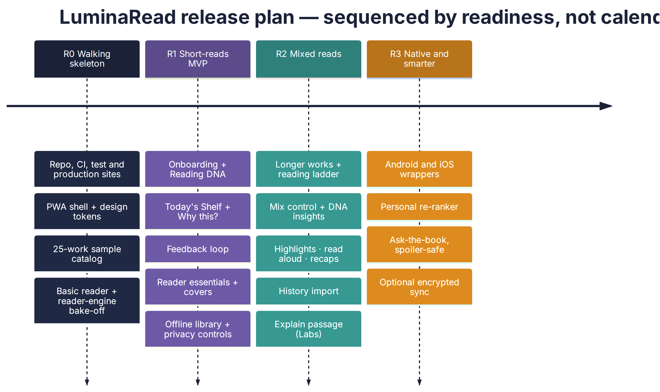
Figure 1 — Release plan (sequenced by readiness, not dates)

2.5 Content strategy and sources
Source | What we use | License basis | How we access it | When
Project Gutenberg | Stories, essays, novellas, novels | Public domain in the US; Project Gutenberg license and trademark terms | Offline RDF catalog + mirror downloads, ≥ 2 s apart; never crawl the website | R0–R1
Standard Ebooks | Carefully produced editions | Public-domain texts; Standard Ebooks' own work dedicated to the public domain (CC0) | Patrons Circle feeds (confirmed, D6) | R1
Wikisource | Essays, speeches, historical articles | Public-domain texts (verify per item) | Per item with provenance | R1
Library of Congress — Chronicling America | Historic newspaper articles and features (pre-1930) | Public domain | loc.gov JSON API (the legacy Chronicling America API was retired in 2025) or bulk OCR data; OCR cleanup + human QA | R2
The Conversation | Contemporary expert essays | CC BY-ND 4.0 with republishing guidelines (no edits, credit, page-view counter for full republishing, no systematic republishing) | Hand-picked extracts with a "Read the full article" link — no tracking counter | R2
LibriVox | Volunteer-narrated audiobooks of public-domain works | Recordings dedicated to the public domain | Stream per work with attribution ("Listen" option) | R3
Internet Archive / Open Library | Public-domain scans; metadata for books readers loved | Public domain for pre-1930 scans; in-copyright lending is not usable | Open Library search API (R2, reader-initiated); scan quality evaluated first (EN-212) | R2 / R3
Wikipedia featured articles | Modern non-fiction | CC BY-SA 4.0 — attribution and share-alike | Per article with attribution block | R2 (D7)
US federal works (e.g., NASA) | Science non-fiction | US government works are public domain (third-party images excepted) | Per item | R2 option

Not recommended: Project Gutenberg Australia and Faded Page (Canada) publish works that are public domain under their countries' rules but often still copyrighted in the US; HathiTrust limits full downloads for non-members; aggregators (ManyBooks, Feedbooks and similar) repackage primary sources — use the originals. Hugging Face corpora built from these sources (e.g., PG-19, US-PD-Newspapers) are handy for experiments and finding candidates, but shipped texts always come from the primary source with provenance.
- Public domain means US public domain. Works published in 1930 or earlier are generally public domain in the US as of 2026; status differs in other countries. State this in About and get a quick legal review before public launch.
- Project Gutenberg texts: either keep Project Gutenberg's full license with each text or remove all Project Gutenberg references and marks (the rule is chosen in ADR-0001).
- Our own words: blurbs, hooks and summaries are written fresh by the Content Factory and labeled as generated; source text is never paraphrased or altered.
- Historical content: many older works contain racism, violence and other harms. Content notes and filters let readers choose.
Length class | Words | Typical reading time* | Role in Twice Told
Flash / short story | under 7,500 | under ~30 min | The core of R1
Novelette | 7,500 – 17,499 | ~30–75 min | First rung of the ladder
Novella | 17,500 – 39,999 | ~1.2–2.8 h | Second rung
Novel | 40,000+ | 3 h and up | Top rung

*At a default 238 words per minute, then personalized to each reader's measured speed. Length classes follow common genre-award conventions.

2.6 How the four reviewers re-examined the plan
Reviewer | Focus | Biggest insight
Product Manager | Goals, audience, scope, metrics | The v1 plan was book-first; your goal is short-first with a path to longer works. Split anthologies and add essays.
UX/UI Designer | First-run, trust, reading comfort, accessibility | Get to a first story in two minutes; explain every pick; never auto-download a model on first open.
Architect | Reliability, cost, privacy, maintainability | Move all heavy work to build time; no runtime dependency on third-party APIs; replace unmaintained libraries.
AI Engineer | Where AI adds value and where it does not | Recommendations need maths, not a language model. Use small models only where a bake-off proves they help.

Part 3 — Experience (UX/UI)

3.1 Experience principles
- First story in under two minutes. No account, no download, no questionnaire.
- Explain every pick with a one-line reason.
- Short first, long when ready — never pushed.
- Calm, not compulsive: a shortlist, not an infinite feed; stats without guilt.
- Typography first: reading comfort beats decoration.
- Accessible by default in every flow.
- Show privacy, don't just claim it: an inventory of what is stored.

3.2 Key flows
Onboarding: welcome → mood board → taste cards → reading context → first shortlist. Daily loop: shortlist → detail → read → check-in → updated shortlist. Growth loop: positive finishes → longer reads row → ladder rung → recap on return. The state diagram shows how a single work moves for a reader.
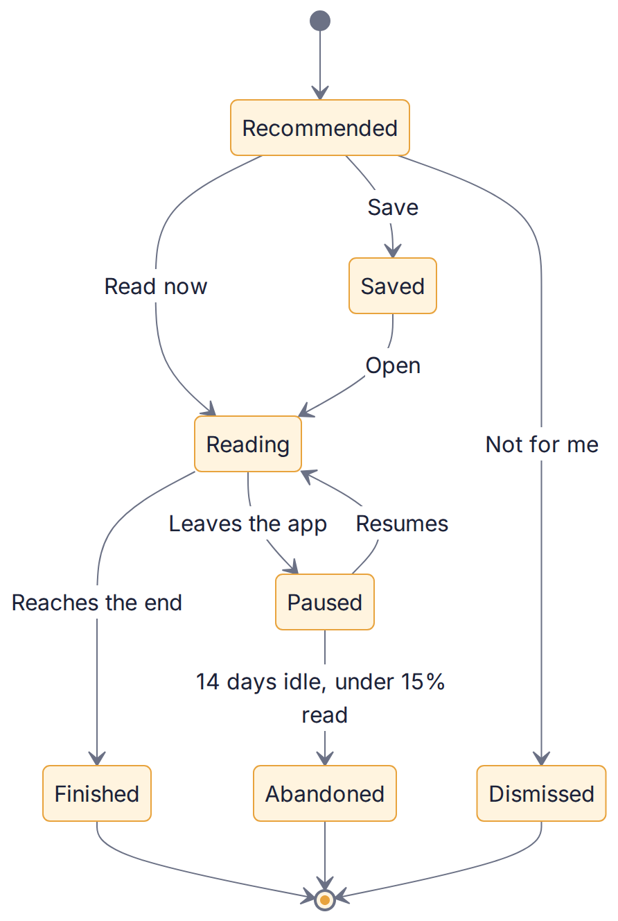
Figure 2 — Lifecycle of a work for one reader

3.3 Design system
Token | Value | Use
Ink | #1B2238 | Primary text, dark surfaces, primary navigation
Lumen amber | #E8A33D | Primary actions, progress, highlights
Parchment | #FAF5EA | App background (light)
Dusk violet | #5B4B8A | Secondary accents, exploration
Sage | #5E8C6A | Success, privacy reassurance
Coral | #D8674F | Warnings, destructive actions, gates
Teal | #2F7F7A | Links, AI and agent accents
Slate | #3A4152 | Secondary text

Role | Font (all SIL Open Font License) | Notes
Display & titles | Fraunces | Also used for cover title overlays
Reading text | Literata | Designed for long-form screen reading
Interface | Inter | Labels, buttons, metadata
Accessibility options | Atkinson Hyperlegible, OpenDyslexic | Selectable in the Aa panel

Reading theme | Background | Text | Contrast target
Paper | #FBF6EA | #2B2A26 | ≥ 7:1
Sepia | #F1E4C8 | #3B2F1E | ≥ 7:1
Night | #15171E | #D9D3C3 | ≥ 7:1
Black (OLED) | #000000 | #CFCFCF | ≥ 7:1

Spacing uses a 4-point scale (4, 8, 12, 16, 24, 32, 48). Corner radii: 8 (covers), 14–18 (cards), 26 (buttons, sheets). Motion is short (150–250 ms) and disabled under reduced-motion settings. Tokens live in docs/design/tokens.json in the kit.

3.4 Mock-ups
Twelve high-fidelity screens across four boards. Cover art in these mock-ups is procedurally drawn to show the "risograph modern" house style; real covers come from the cover pipeline. Titles are always rendered by the app, never baked into images.

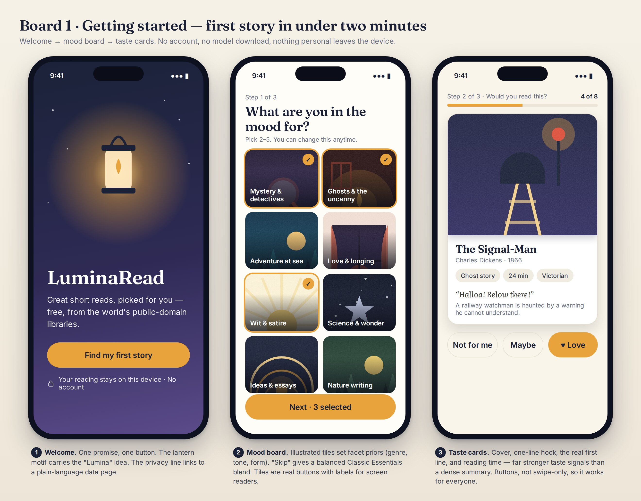
Board 1 — Getting started: welcome, mood board, taste cards

Board 2 — Discover & decide: Your Shortlist, work detail, library and reading ladder

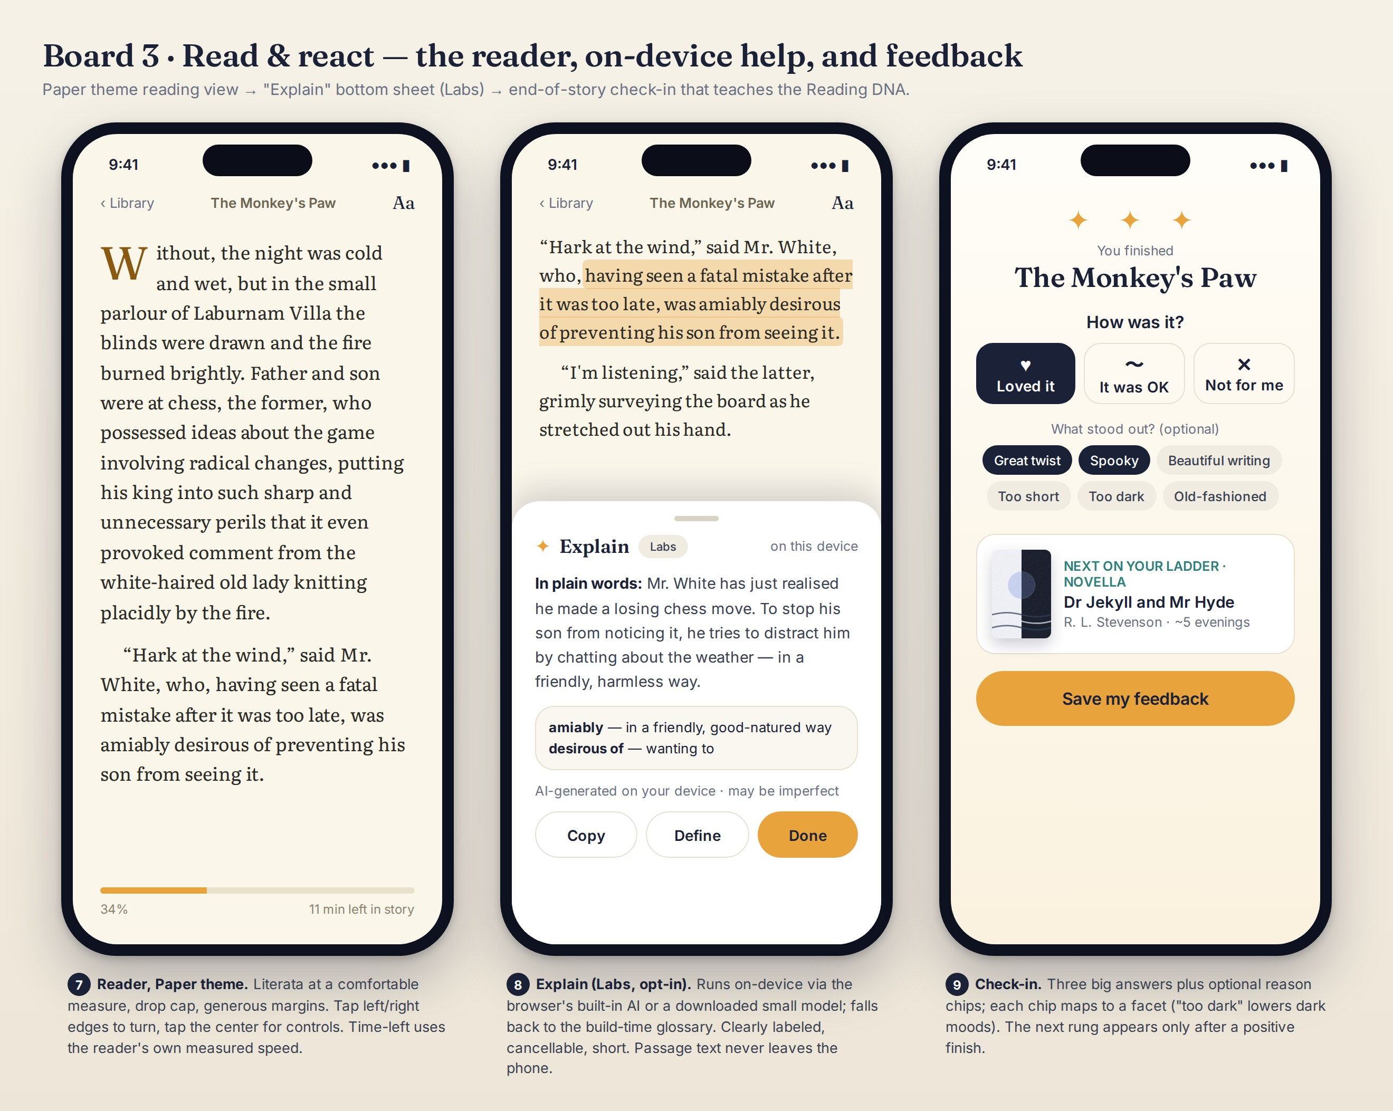
Board 3 — Read & react: reader, Explain (Labs), end-of-story check-in

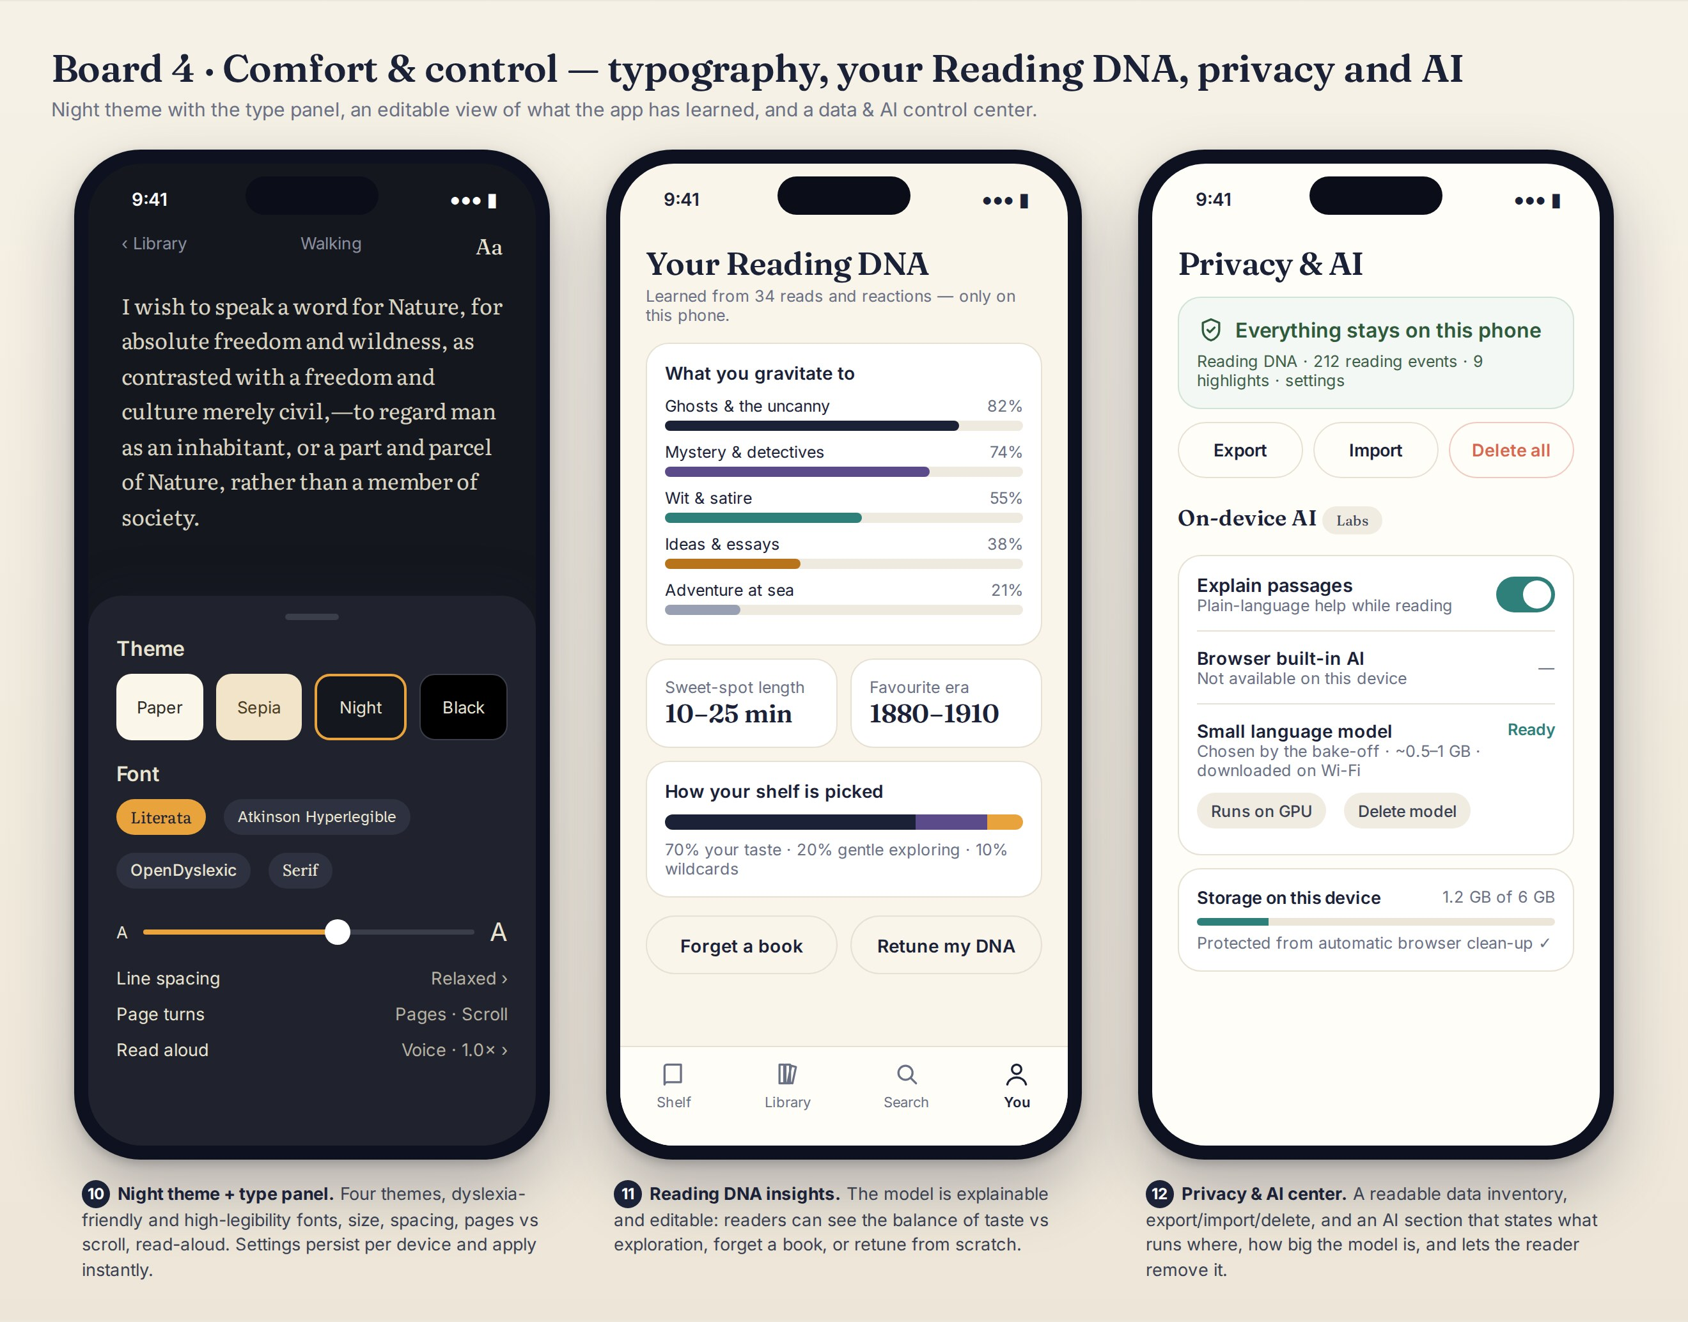
Board 4 — Comfort & control: Night theme and type panel, Reading DNA insights, Privacy & AI

3.5 What we borrow from existing e-readers
The Reader Researcher agent studies established readers for proven patterns. Copyleft projects such as KOReader (AGPL-3.0) are studied for UX only; no code is copied. Open-source engines are evaluated in the bake-off (Part 4.7).
Pattern | Seen in | Our decision | Release
Edge tap zones, centre tap for controls | Kindle, Apple Books, KOReader | Adopt, plus labeled buttons | R1
Pages vs scroll | Apple Books, Readest, Moon+ Reader | Adopt | R0–R1
Time left in chapter/book | Kindle | Adopt, using the reader's own speed | R1
Themes and typography controls | Apple Books, Kobo, KOReader | 4 themes, 4 fonts, size, spacing, margins | R1
Dictionary on long-press | Kindle, Apple Books, Kobo | Build-time glossary first, dictionary second | R1
Highlights, notes, export | Kindle, Kobo, Readwise | Adopt; Markdown export | R2
Read aloud with sentence highlight | Apple Books, Readest | Device voices via Web Speech API | R2
"Previously…" recaps | Kindle Recaps (series level) | Chapter-level, spoiler-safe | R2
Inline hints for hard words | Kindle Word Wise | Consider as glossary hints | R3
Reading stats | Kobo | Gentle stats, no streak penalties | R2
Sync across devices | Kindle, Readest | Export/import now; optional encrypted sync later | R1 / R3

3.6 Accessibility requirements
- WCAG 2.2 AA across the app; reading text at 7:1 contrast or better in every theme.
- Every control reachable by keyboard and labeled for VoiceOver, TalkBack and NVDA; no swipe-only actions.
- Touch targets at least 44 × 44 px; text scalable to 200% without loss.
- Respect reduced-motion and high-contrast settings.
- Dyslexia-friendly and high-legibility fonts; read-aloud.
- Automated axe checks in CI plus a manual checklist at every G5.

Part 4 — Architecture

4.1 Principles
- Edge-first and static. The product is a static website plus the reader's device. There is no application server to run or secure.
- Intelligence at build time. Heavy AI work runs once in the Content Factory, with human sampling. Phones do light maths.
- No runtime third-party dependency for core flows (discovery, reading, feedback).
- Private by default. Personal data never leaves the device unless the reader exports it.
- Deep modules with small interfaces (ReaderEngine, RecEngine, Stores, AIService) so agents can work in parallel and parts can be swapped.
- Everything testable by agents. Every story has automated acceptance tests.

4.2 System context
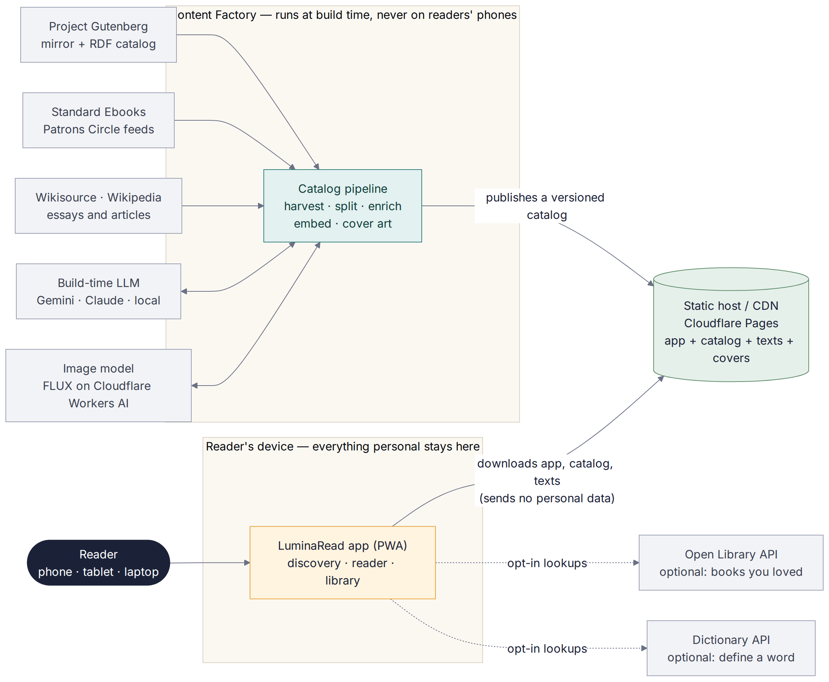
Figure 3 — System context
The reader's device downloads the app, catalog, texts and covers from a static host and sends nothing personal back. Optional lookups (Open Library search, dictionary) happen only when the reader asks. The Content Factory runs on your computer or in CI, never on readers' phones.

4.3 Runtime architecture
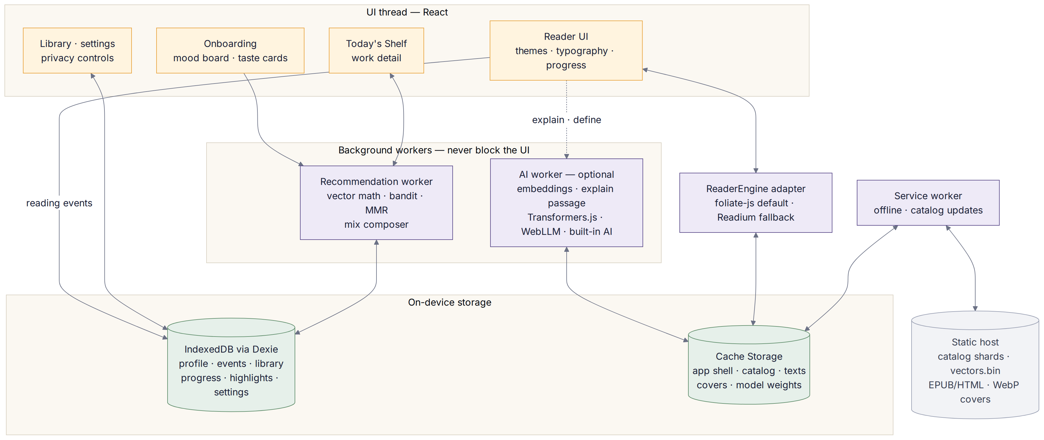
Figure 4 — Runtime architecture inside the reader's device

Module | Responsibility | Interface (sketch)
app/ (shell) | Routing, layout, theme, install prompt | React routes
features/onboarding, shelf, detail, reader, library, settings | Screens and flows | React components using stores and engines only
engine/rec (worker) | Scoring, beliefs, MMR, slots, mix composer, explanations | recommend(slots), updateProfile(events), explain(workId)
engine/reader | ReaderEngine adapter over foliate-js (or Readium) | open(work, locator), next(), prev(), goTo(), onLocation(), highlight()
services/ai (worker) | Embeddings and Explain tiers | capabilities(), embed(text), explain(passage, glossary)
stores/ | Dexie-backed typed stores with migrations | ProfileStore, EventLog, LibraryStore, ProgressStore, HighlightStore, SettingsStore
catalog/ | Load shards and vectors, search index, updates | getWork(id), vectors(), search(query, filters)
pwa/ | Service worker: offline, cache, catalog updates | Workbox via vite-plugin-pwa
scripts/ (build time) | Content Factory and covers | npm run catalog:build, covers:generate, catalog:validate

4.4 Content Factory
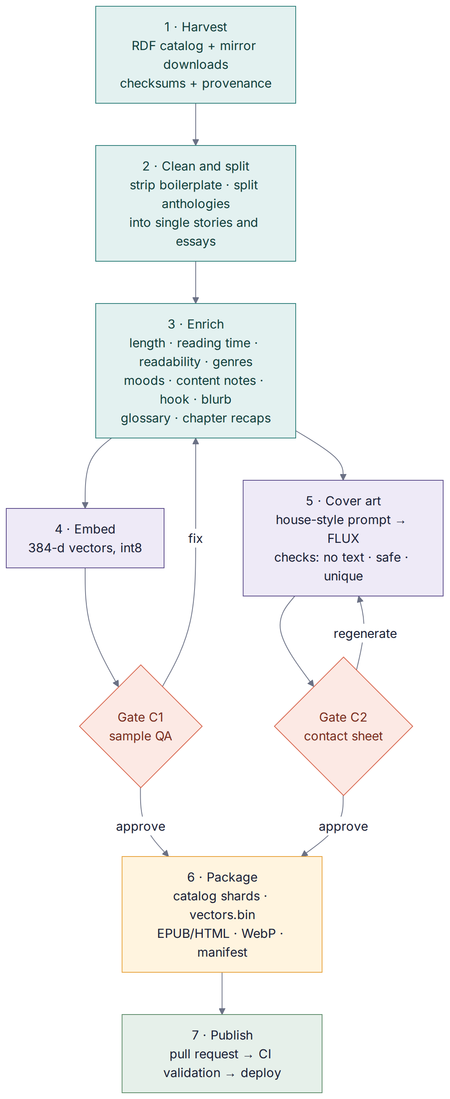
Figure 5 — Content Factory pipeline with human gates C1 and C2
Catalog field | Example | Produced by
id, title, author, year | pg-1234-s03, "The Monkey's Paw", W. W. Jacobs, 1902 | Harvest + split
form, lengthClass, wordCount, readingMinutes | fiction, short, 4,000, 17 | Deterministic scripts
readability | Grade 8 | Deterministic formula
firstLine | Genuine opening sentence | Extracted verbatim
hook, blurb | ≤ 20 and ≤ 60 words, no spoilers | Build-time LLM, human-sampled
genres, moods, contentNotes | horror; eerie; death, grief | Build-time LLM, human-sampled
glossary, chapterSummaries | Archaic words; recap per chapter | Build-time LLM
vector | 384 numbers (int8) | Embedding model
cover, coverAlt, coverPrompt, coverModel | WebP set + alt text | Cover pipeline, C2-approved
provenance: sourceName, sourceUrl, license, retrievedAt, sha256 | Project Gutenberg mirror URL, checksum | Harvester

How enrichment runs without extra cost: by default the Content Curator and AI Engineer agents do the enrichment inside your Antigravity sessions (Gemini 3.1 Pro, included in AI Pro), in batches. Alternatives: a scripted run on the Gemini API free tier (Flash models), or a local model via Ollama for a fully offline pipeline.

4.5 Data model on the device
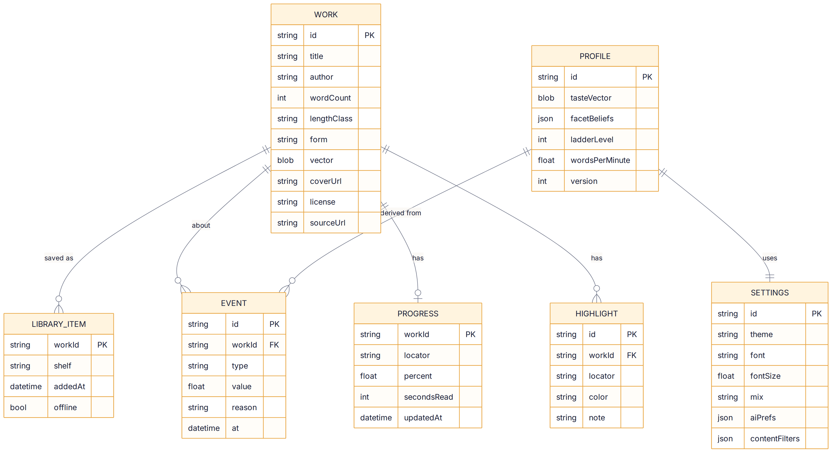
Figure 6 — On-device data model (WORK is the read-only catalog; everything else lives in IndexedDB)

- The event log is the source of truth; the profile is a cache that can be rebuilt from it at any time. This makes "forget a signal" and import/export exact.
- The app requests persistent storage on first profile creation and prompts readers to install the app and export backups, because browsers can clear website storage — Safari in particular limits storage for sites not added to the Home Screen.
- Export is a versioned JSON file containing profile, events, library, progress, highlights and settings.

4.6 Recommendation engine
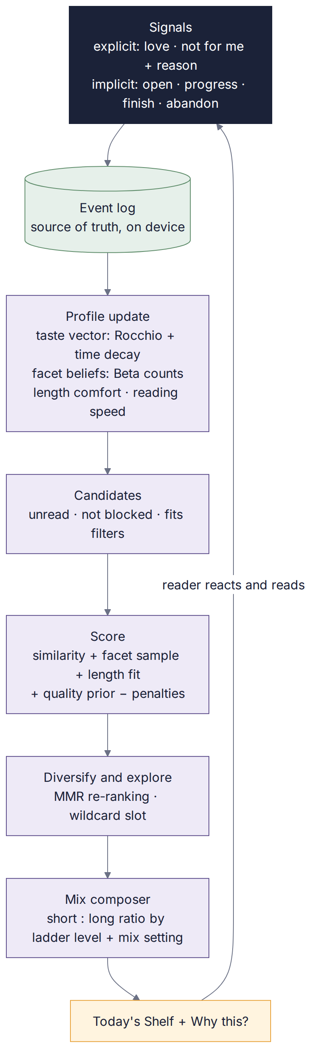
Figure 7 — The feedback loop that powers recommendations
Representations. Each work has a unit-length vector (from the embedding model) and facet values (genre, mood, era band, form, length class, readability band). The reader has a taste accumulator a; the taste vector is t = a / |a|. Onboarding seeds a from the chosen mood tiles (each tile maps to a build-time centroid) and the taste-card reactions.
Update rule. For each event with weight w on a work with vector e: a ← a · 0.5^(Δdays/90) + w · e. This gives a 90-day half-life and is exactly reproducible by replaying the log.
Event | Weight w | Facet belief update
Love (card or check-in) | +1.0 | success +1 on the work's facets
It was OK | +0.3 | success +0.5, failure +0.5
Not for me | −0.5 | failure +1, plus the reason rule below
Finished with no rating | +0.6 | success +1
Read ≥ 50% then stopped | +0.2 | —
Abandoned (< 15% read, idle 14 days) | −0.3 | failure +0.5
Dog-eared | +0.2 | —
Highlight or note | +0.1 each (max +0.3 per work) | —
Opened detail only; used Explain | 0 | — (difficulty is never penalized)
Onboarding: Love / Maybe / Not for me | +1.0 / +0.3 / −0.5 | as above

Reason rules: "Too long" lowers length comfort by one class (no taste penalty); "Too old-fashioned" adds failure to the era facet; "Too dark" adds double failure to dark moods; "Not my genre" adds double failure to the genre; "Already read" marks the work read with weight 0.
Facet beliefs. Each facet value has a Beta(α, β) belief starting at (1, 1); a selected mood tile adds 2 to α. At each refresh the engine draws a sample from each belief (Thompson sampling), so uncertain facets get explored naturally.
Score. s = 0.55·cos(t, e) + 0.20·facetSample + 0.10·lengthFit + 0.10·qualityPrior + 0.05·novelty − penalties. The quality prior comes from curator picks, Standard Ebooks inclusion and download-popularity percentiles. Works that are blocked by filters, finished or dismissed are excluded; works shown three times without a tap lose 0.15.
Diversify and slot. Maximal Marginal Relevance (λ = 0.7) re-ranks for variety, with at most one work per author per shortlist. Slots: hero (best that fits a typical session), 4 short stories, 2 essays, 1 wildcard (drawn from the most uncertain facet or an unexplored cluster).
Ladder level | Longer works on a 7–8 item shortlist | Level up | Level down
0 (start) | 0 | 3 positive finishes of short works | —
1 | 1 novelette | 3 positive finishes at level | 2 abandoned longer works in a row
2 | 1–2 novelettes/novellas | same | same
3 | 2 novellas/novels | same | same
4 | 2–3 | — | same

Mix settings modify the table: Mostly short caps longer works at 1; Balanced uses the table; Mostly long adds 1; Surprise me samples within the table with higher exploration. Why this? shows the template for the largest scoring term (e.g., "Because you loved …", "A theme you enjoy: …", "Wildcard: a little outside your usual", "Next rung on your ladder").
Evaluation. Offline, the engine is tested against five synthetic personas with known tastes (hit rate in the top 5 at least 2× random; catalog coverage ≥ 30%). In beta, hit rate and completion come from shared summaries. Performance: 5,000 × 384 int8 dot products run in a Web Worker well inside the 150 ms budget.

4.7 Reader engine decision (ADR-0002, to confirm at G2)
Criterion | foliate-js | Readium ts-toolkit | epub.js / react-reader
License | MIT | BSD-3-Clause | BSD-2 (epub.js), ISC (react-reader)
Maintenance (checked Sept 2026) | Active; author states the API is not yet stable; used by Foliate and Readest | Active; @readium/navigator 2.10.3 released Sept 2026 | epub.js last released Feb 2022
Formats | EPUB, MOBI/KF8, FB2, CBZ; PDF experimental | EPUB via a publication manifest | EPUB
Integration | Plain ES modules; opens .epub in the browser; include as a pinned git submodule | Needs a Readium publication manifest (can be generated at build time) | Simple React wrapper
Verdict | Default, behind the ReaderEngine adapter | Plan B if accessibility or stability fall short | Not recommended

Because we control the catalog, the Content Factory normalizes every work to clean EPUB 3 at build time, which simplifies whichever engine wins.

4.8 Cover art pipeline
- House style (decision D8): "risograph modern" — bold shapes, limited palette per genre, subtle grain, 2:3 portrait, no text. Titles are overlaid by the app in Fraunces, so they are always correct, legible and screen-readable.
- Generation: FLUX.1 [schnell] (Apache-2.0) via Cloudflare Workers AI. The free allocation is 10,000 "neurons" a day; at the published per-tile and per-step rates that is roughly 150 covers a day (estimate). Alternatives: Pollinations with a registered key (the anonymous tier is limited to about one request per 15 seconds and may watermark), or a local GPU.
- Automatic checks: OCR rejects any image containing text; a safety check rejects unsafe content; perceptual hashing rejects near-duplicates.
- Human gate C2: you approve on an HTML contact sheet; rejected works are regenerated or get the procedural fallback cover.
- Transparency: "Art notes" state that illustrations are AI-generated and which model made them. Identifiable real people are never depicted.
WHERE: Cover prompt template (docs/content/house-style.md in the kit)
Illustrated book-cover artwork, risograph-modern style: bold flat shapes,
limited palette of {palette}, subtle paper grain, strong silhouette, calm
negative space in the lower third for a title overlay.
Scene: {scene_from_blurb}. Mood: {mood}. Era cues: {era}.
No text, no letters, no logos, no signatures, no real identifiable people.
Portrait 2:3.

4.9 Deployment and CI/CD
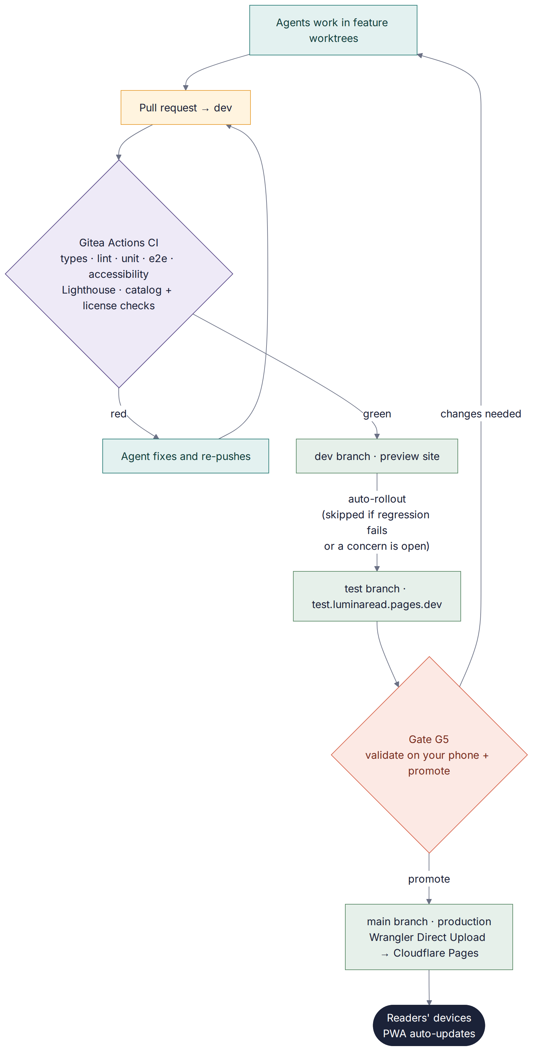
Figure 8 — From pull request to production, with Gate G5
Service | Used for | Cost at MVP scale
Gitea (self-hosted, private repo) | Code, pull requests, Gitea Actions CI, enforced branch protection, merge queue | Free (open source)
Docker Desktop | Runs Gitea and its CI runner on your computer | Free for personal use
Cloudflare Pages | Production (main), test site (test), preview (dev) | Free tier
Cloudflare Workers AI | Cover generation at build time | Free daily allocation
Google AI Pro | Antigravity build crew (Gemini 3.1 Pro; Claude models available inside Antigravity) and Gemini-app reviews | Your existing subscription
Claude (optional) | Alternative Claude Code track | Optional
Standard Ebooks Patrons Circle | Feed access for ingest | Small donation (optional)

4.10 Security and privacy
- EPUB content renders in a sandboxed frame with scripts disabled and a strict Content-Security-Policy; the app self-hosts fonts and loads no third-party scripts.
- Supply chain: lockfile, Dependabot, npm audit in CI, pinned foliate-js commit, model downloads from pinned URLs with checksum verification.
- Secrets (Cloudflare token, feed credentials) live only in a git-ignored .env or Gitea Actions secrets; never pasted into chats.
- An automated network-allowlist test proves no personal data leaves the device.
- The export file is plain JSON; the app warns readers it contains their reading history.

4.11 Technology stack
Layer | Choice | Version checked (Sept 2026) | Why
UI | React + TypeScript | react 19.3.0 | Mainstream, agent-friendly
Build | Vite | vite 8.3.1 | Fast static builds
PWA | vite-plugin-pwa (Workbox) | 1.3.0 | Offline, install, updates
Styling | Tailwind CSS with design tokens | current | Consistent UI
Storage | Dexie (IndexedDB) | dexie 4.4.6 | Schema, queries, migrations
Reader engine | foliate-js (pinned commit) | 1.0.1 on npm; use git | MIT, multi-format
Reader plan B | Readium ts-toolkit | @readium/navigator 2.10.3 | Industrial-grade
On-device ML | Transformers.js | @huggingface/transformers 4.3.0 | Embeddings, small LLMs on WebGPU
Alternative LLM runtime | WebLLM | @mlc-ai/web-llm 0.2.85 | Prebuilt small models
Search | MiniSearch | 7.2.0 | Tiny on-device full-text index
Tests | Vitest, Playwright, axe-core, Lighthouse CI | current | Agents verify their own work
Forge & CI | Gitea + Gitea Actions (act_runner) | gitea 1.x (Docker image) | Private repo, enforced protection, Actions-compatible YAML
Hosting | Cloudflare Pages (Direct Upload via Wrangler) + Workers AI | — | Free tiers, branch URLs

Part 5 — AI implementation

5.1 Where AI runs
Task | Where | Approach | Why
Blurbs, hooks, tags, content notes, glossary, chapter recaps | Build time | Gemini 3.1 Pro in Antigravity (or a Claude model) + human sampling | Quality matters; done once
Splitting anthologies | Build time | Heuristics + LLM boundary check, verbatim slices only | Accuracy, no invented text
Catalog vectors | Build time | Small open embedding model via Transformers.js in Node | Same weights as on device
Cover art | Build time | FLUX.1 [schnell] via Cloudflare Workers AI | Free tier, consistent style
Recommendations and learning | Device | Maths, not a model: vectors, Beta beliefs, MMR | Instant, private, explainable
Free-text taste input | Device (lazy) | Same embedding model, tens of MB | Private
Explain a passage | Device (opt-in) | Tiers: built-in browser AI → small open LLM → glossary | Private; honest limits

5.2 Can a lightweight free local model be bundled?
Yes, with care — and the core app does not need one. Recommendations and learning are handled by fast arithmetic, so the only on-device models are (1) a small embedding model for free-text taste input and (2) an optional small language model for "Explain". In a web app, "bundling" means downloading once on demand and caching; a future native app (R3) can ship the small embedding model inside the package, but a language model should remain an optional download because of size.
Candidate | Approx. download class | Runtime | Role
Browser built-in AI (Chrome Prompt API) | Managed by the browser | Chrome desktop only; needs lots of free disk and GPU memory | Tier 1 where available
Qwen3 0.6B | ~0.35 GB | WebLLM | Smallest general candidate
Qwen3.5 0.8B / 2B | ~0.5 / ~1 GB class | Transformers.js v4 (WebGPU) | Main contenders
Gemma 3 1B | ~0.5–0.7 GB class | WebLLM / WebGPU | Contender
Gemma 4 E2B | ~1–2 GB class | Transformers.js v4 (onnx-community) | Quality ceiling; likely too big as default
bge-small-en-v1.5 or all-MiniLM-L6-v2 (embeddings) | tens of MB | Transformers.js | Taste input; catalog vectors

Sizes are approximate classes; the bake-off measures exact download size, memory and speed. Check each model card's license before shipping. WebGPU is available in current Chrome/Edge (desktop and Android) and Safari 26; some GPU and driver combinations have produced garbled output with certain kernels, so the device matrix and an output sanity check are mandatory.
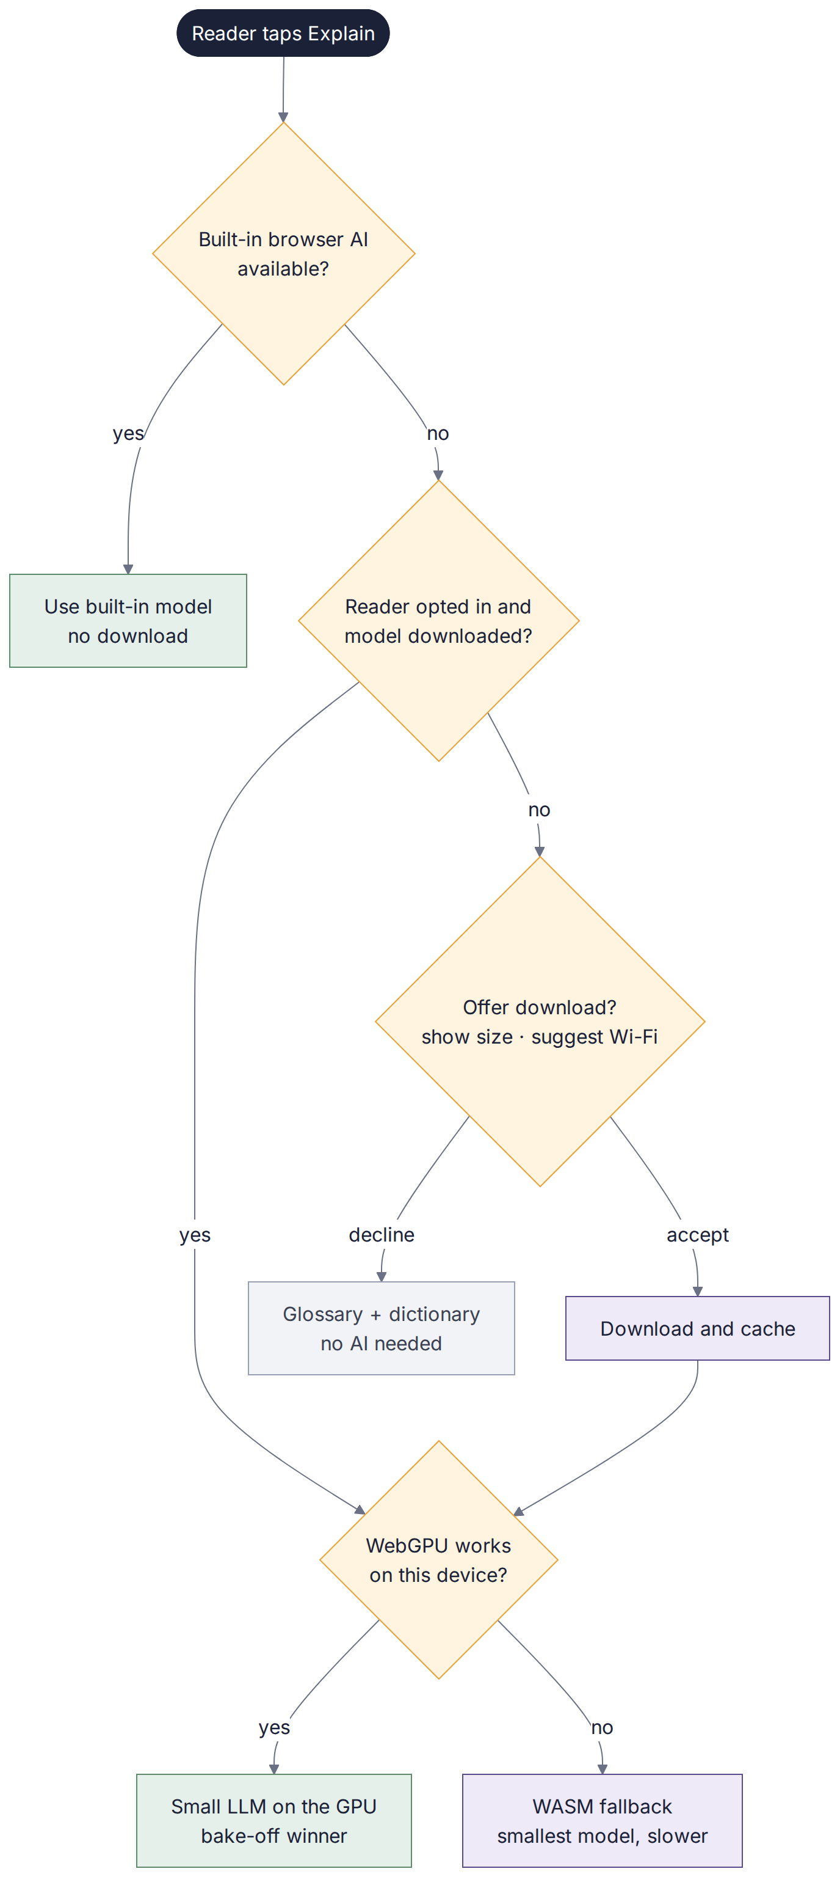
Figure 9 — Which tier answers "Explain"

5.3 Evaluation plan (bake-off, EN-801)
- Eval set: 30 real passages from the catalog across eras and genres, plus 10 hard cases (dialect, archaic vocabulary, irony). No invented passages.
- Rubric (0–8): accuracy 0–2, clarity 0–2, faithfulness (nothing invented) 0–2, brevity 0–1, safety 0–1. Pass: mean ≥ 6 and invented facts in under 10% of answers.
- Speed: time to first token ≤ 3 s and at least 8 tokens per second on a mid-range phone.
- Device matrix: an Android phone (Chrome), an iPhone (Safari 26), a Windows laptop (Chrome/Edge, including an NVIDIA GPU if available), a Mac.
- Human check: a blind sample of outputs is rated by you at G2; the AI Engineer prepares it.

5.4 Guardrails
WHERE: Explain prompt template (docs/ai/eval-plan.md in the kit)
You explain passages from public-domain literature to a modern reader.
Use ONLY the passage and glossary below. If you are unsure, say so.
Answer in 2–4 plain sentences. Do not continue the story, invent events,
or reveal anything beyond the passage.
PASSAGE: {passage}
GLOSSARY: {glossary_entries}

- Outputs are labeled "AI-generated on your device", can be cancelled instantly, and are never sent anywhere.
- The feature is off until G2 approves a model; readers opt in and can delete the model.
- Build-time generated fields carry generatedBy and reviewed flags; humans sample every batch.

Part 6 — Requirements

6.1 Functional requirements
Functional requirements are expressed as the 80 user stories and enablers in Part 8; each one is testable and traceable to a use case. The summary below groups them by epic.
FR | Requirement | Stories
FR-01 | Onboarding & Reading DNA. Get a new reader from first open to a first great short read in under two minutes, and capture their taste. | US-101, US-102, US-103, US-104, US-105, US-106, US-107, US-108
FR-02 | Content Factory & catalog. Build a legal, well-described, short-first catalog at build time, with provenance for every work. | EN-201, EN-202, EN-203, EN-204, EN-205, EN-206, EN-207, EN-208, EN-209, EN-210, EN-211, EN-212
FR-03 | Discovery & recommendations. Serve a daily shortlist that fits the reader's taste, explains itself, and keeps exploring. | US-301, US-302, US-303, US-304, US-305, US-306, EN-307, EN-308
FR-04 | Feedback & learning loop. Learn from explicit reactions and reading behaviour, on the device, in an explainable and editable way. | US-401, US-402, US-403, US-404, US-405, US-406, US-407
FR-05 | Mixed reads & reading ladder. Introduce longer works when the reader is ready, and let them control the short/long mix. | US-501, US-502, US-503, US-504, EN-505
FR-06 | Built-in e-reader. A comfortable, accessible reader that borrows the best patterns of established e-readers. | EN-601, US-602, US-603, US-604, US-605, US-606, US-607, US-608, US-609, US-610, US-611, US-612
FR-07 | Covers & visual identity. A cohesive, beautiful look: design tokens, generated text-free cover art, typographic overlays. | EN-701, EN-702, US-703, US-704, US-705
FR-08 | On-device AI assist. Private, optional AI help while reading, with honest limits and graceful fallbacks. | EN-801, US-802, US-803, US-804, EN-805, US-806
FR-09 | Library & offline. Keep reading anywhere: library shortlists, offline copies, installable app. | US-901, US-902, US-903, US-904
FR-10 | Privacy & control. Readers own their data: see it, move it, delete it, filter content. | US-1001, US-1002, US-1003, US-1004, US-1005, US-1006
FR-11 | Accessibility & performance. WCAG 2.2 AA, fast on mid-range phones, enforced by CI. | EN-1101, EN-1102, US-1103, US-1104
FR-12 | Platform & delivery pipeline. Scaffold, storage, CI/CD, hosting and the agent operating files. | EN-1201, EN-1202, EN-1203, EN-1204, EN-1205, EN-1206, EN-1207, EN-1208, EN-1209

6.2 Non-functional requirements
ID | Category | Requirement | Target | Verified by
NFR-01 | Performance | Largest Contentful Paint on a mid-range phone (Lighthouse mobile) | ≤ 2.5 s | Lighthouse CI (EN-1102)
NFR-02 | Performance | Recommendation refresh for ≤ 5,000 works | < 150 ms, off the UI thread | Benchmark test (EN-307)
NFR-03 | Performance | Open a cached work / turn a page | < 1.5 s / < 100 ms perceived | e2e timing (US-602)
NFR-04 | Size | JavaScript shipped on first load (gzipped) | ≤ 300 KB, excluding catalog | Lighthouse CI budget
NFR-05 | Offline | Shortlist, search and saved works without network | 100% of core flows | Offline e2e (UC-08)
NFR-06 | Privacy | Personal data sent off the device by default | None; network allowlist enforced | Allowlist e2e (US-1001)
NFR-07 | Accessibility | WCAG 2.2 AA; reading text contrast | AA; body text ≥ 7:1; targets ≥ 44 px | axe in CI + manual G5 checklist
NFR-08 | Compatibility | Browsers | Current Chrome, Edge, Safari (iOS/macOS), Firefox; AI features degrade gracefully | Playwright on Chromium, WebKit, Firefox
NFR-09 | Licensing | Provenance and license per work | 100% of works | catalog:validate (EN-201)
NFR-10 | Security | EPUB content isolation; dependency hygiene | Sandboxed rendering, strict CSP, no known high CVEs | CI audit + e2e
NFR-11 | Reliability | Runtime third-party dependencies for core flows | None | Architecture review at G2
NFR-12 | AI | On-device AI transparency and control | Opt-in, labeled, cancellable, deletable, size shown | e2e (UC-07) + G2
NFR-13 | Maintainability | Unit coverage of engines and stores; CI green to merge | ≥ 80% lines in engine/ and stores/ | Coverage report
NFR-14 | Cost | Monthly infrastructure at MVP scale | $0 on free tiers (subscriptions you already have aside) | G2 cost check

Part 7 — Epics, features and use cases

7.1 Epics
Epic | Goal | Stories | Releases | Lead agent
E1 Onboarding & Reading DNA | Get a new reader from first open to a first great short read in under two minutes, and capture their taste. | 8 | R1, R2 | UX/UI Designer
E2 Content Factory & catalog | Build a legal, well-described, short-first catalog at build time, with provenance for every work. | 12 | R0, R1, R2, R3 | Content Curator
E3 Discovery & recommendations | Serve a daily shortlist that fits the reader's taste, explains itself, and keeps exploring. | 8 | R1, R2 | AI Engineer
E4 Feedback & learning loop | Learn from explicit reactions and reading behaviour, on the device, in an explainable and editable way. | 7 | R1, R2 | AI Engineer
E5 Mixed reads & reading ladder | Introduce longer works when the reader is ready, and let them control the short/long mix. | 5 | R2 | Product Manager
E6 Built-in e-reader | A comfortable, accessible reader that borrows the best patterns of established e-readers. | 12 | R0, R1, R2, R3 | Reader Researcher
E7 Covers & visual identity | A cohesive, beautiful look: design tokens, generated text-free cover art, typographic overlays. | 5 | R0, R1, R2 | Cover Artist
E8 On-device AI assist | Private, optional AI help while reading, with honest limits and graceful fallbacks. | 6 | R1, R2, R3 | AI Engineer
E9 Library & offline | Keep reading anywhere: library shortlists, offline copies, installable app. | 4 | R1, R2 | Architect
E10 Privacy & control | Readers own their data: see it, move it, delete it, filter content. | 6 | R1 | Architect
E11 Accessibility & performance | WCAG 2.2 AA, fast on mid-range phones, enforced by CI. | 4 | R0, R1 | UX/UI Designer
E12 Platform & delivery pipeline | Scaffold, storage, CI/CD, hosting and the agent operating files. | 9 | R0, R1, R3 | Architect

7.2 Key sequences
Three sequences show how the main use cases move through the system.

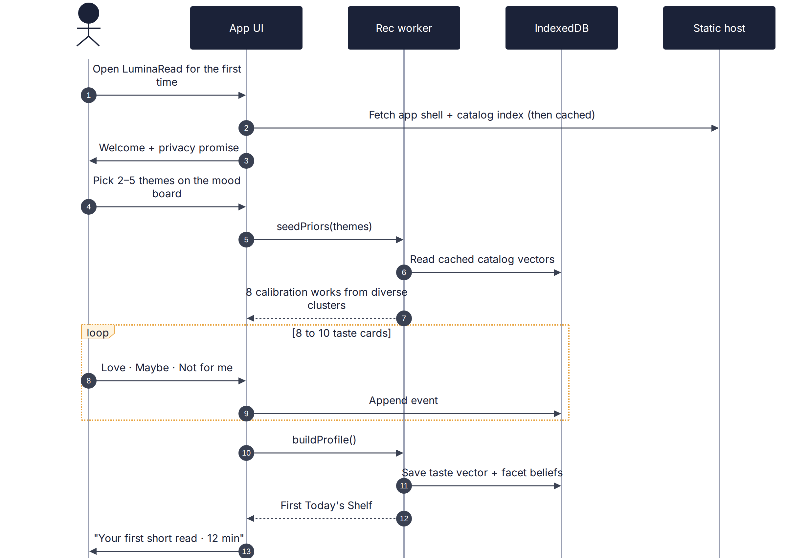
Figure 10 — UC-01 onboarding sequence

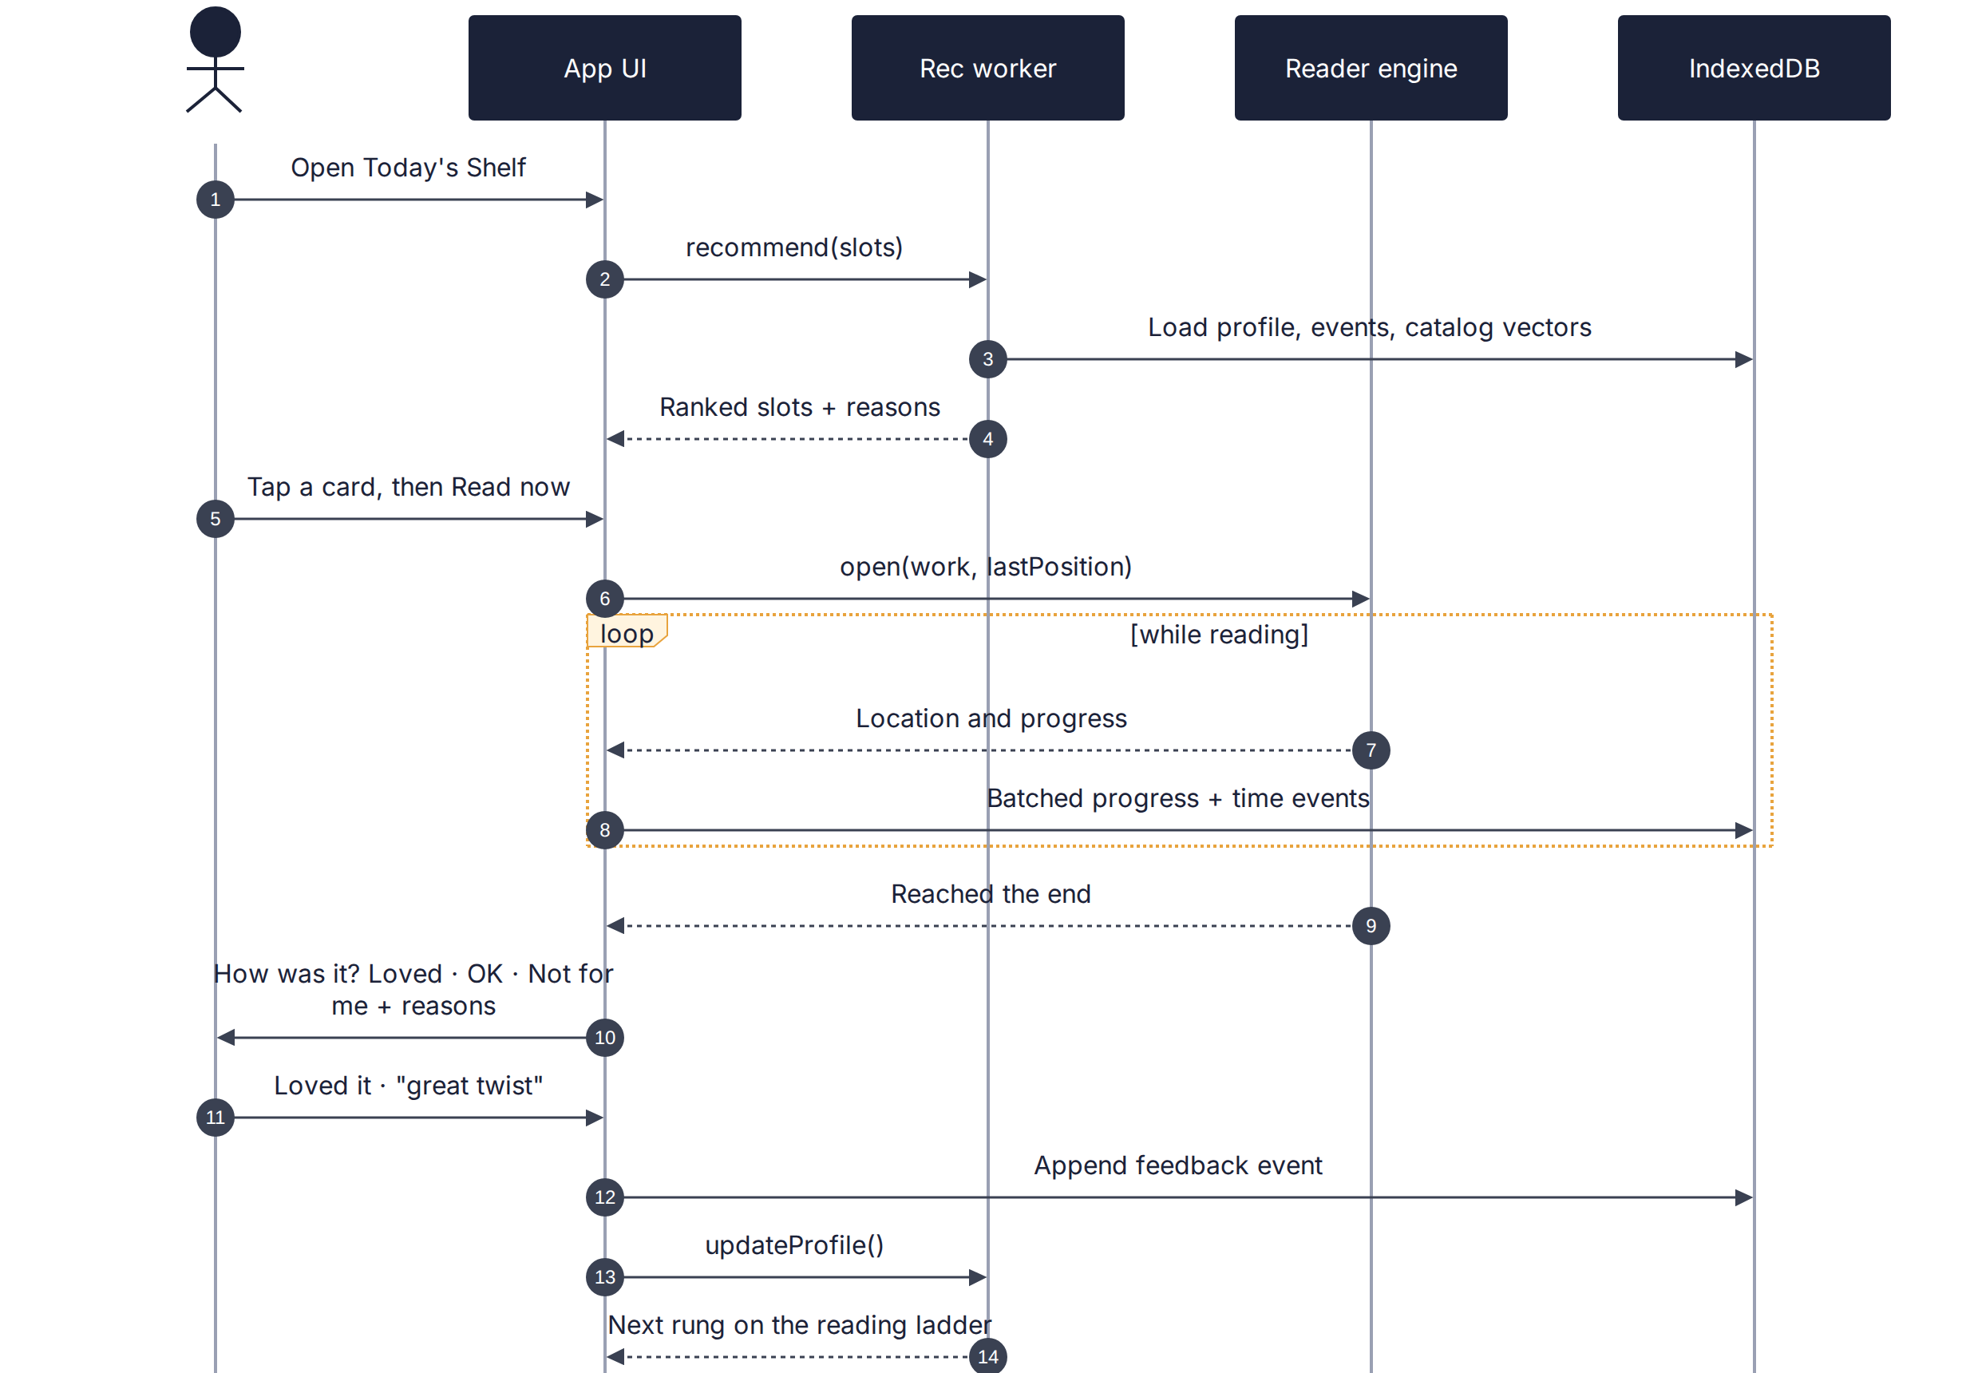
Figure 11 — UC-03/UC-04 discovery and feedback sequence

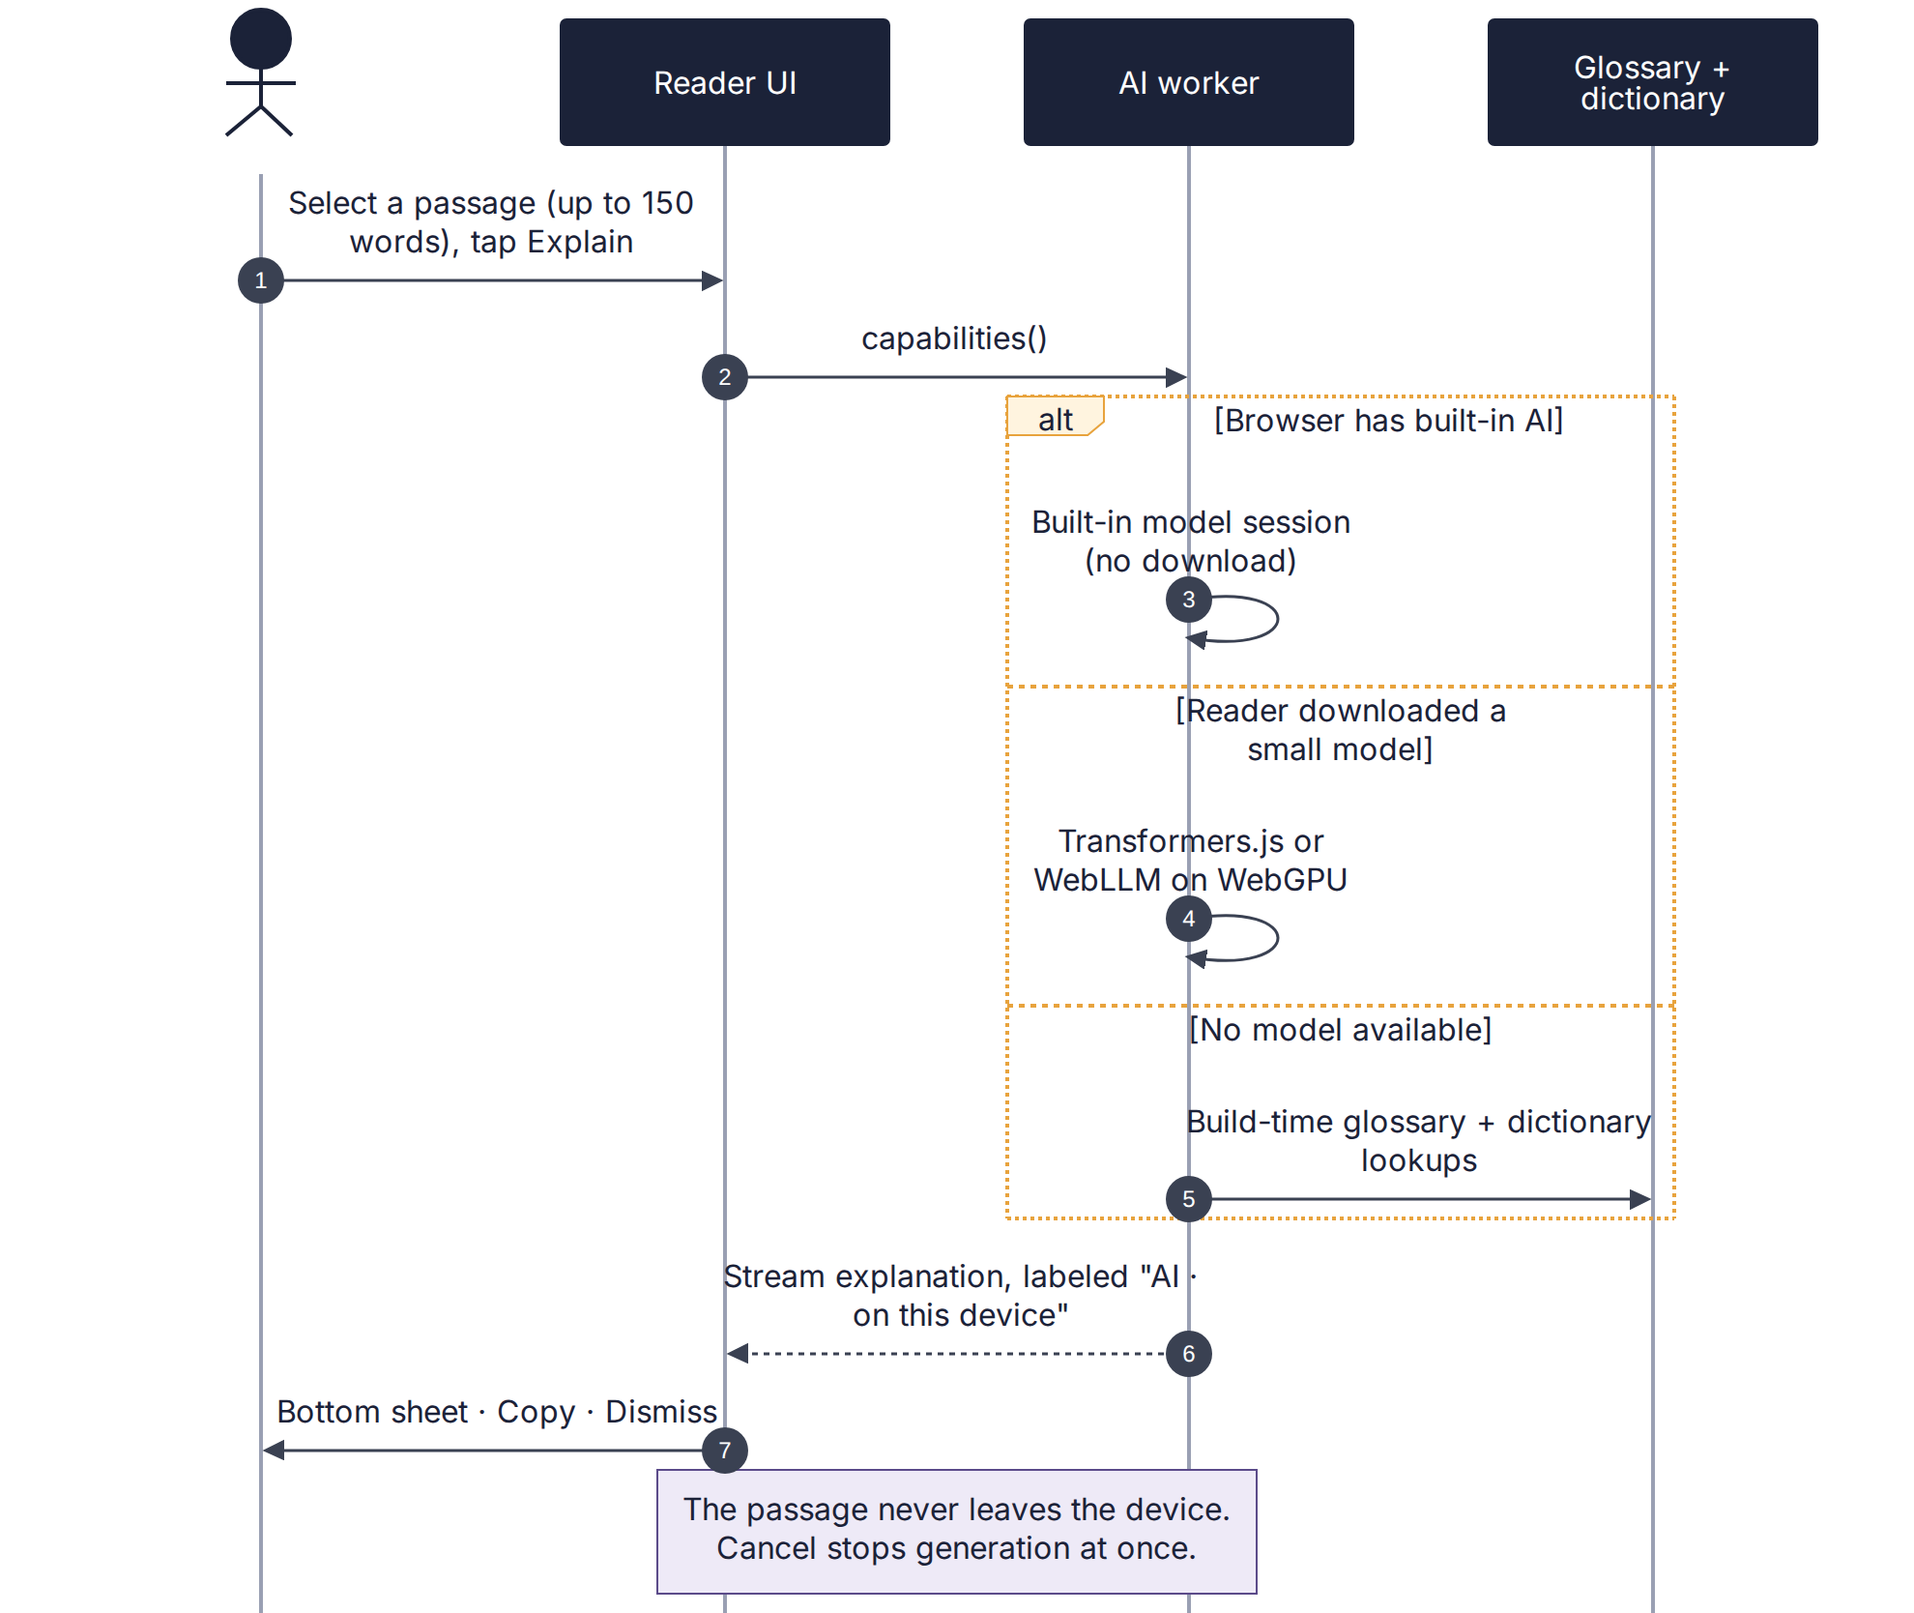
Figure 12 — UC-07 explain-passage sequence with tiered fallback

7.3 Use cases (fully dressed)
Each use case ends with an Agent handoff: the lead agent, the acceptance-test file it must make pass, and the definition of done. The same text is in docs/use-cases/UC-xx.md in the kit so agents can complete them on their own.

UC-01 · Discover my Reading DNA (first run)
Field | Detail
Primary actor | New reader
Level | User goal
Stakeholders & interests | Reader — wants a fast, fun start and privacy.  Product owner — wants high activation and a useful first profile.  Content curators — want fair exposure across the catalog.
Preconditions | The app has been loaded once online, so the catalog index is cached.
Success guarantee | A Reading DNA (taste vector + facet beliefs + reading context) is saved on the device.  Your Shortlist is shown with a highlighted first short read.
Minimal guarantee | No half-built profile is saved; progress through the cards is kept so the reader can resume.
Trigger | The reader opens Twice Told for the first time (or chooses Retune).
Main success scenario | 1. Reader opens the app.  2. App shows the welcome and the privacy promise.  3. Reader taps "Find my first story".  4. App shows the mood board.  5. Reader selects 2–5 moods and taps Next.  6. App seeds facet priors and selects 8 calibration works from diverse clusters.  7. Reader reacts to each taste card (Love / Maybe / Not for me).  8. App asks when the reader reads and the preferred mix (optional).  9. App builds the Reading DNA in the recommendation worker.  10. App shows Your Shortlist and highlights a first short read with its reading time.
Extensions | 3a. Reader opens "How your privacy works": app shows the data page; reader returns to step 3.  5a. Reader taps Skip: app applies the Classic Essentials prior; continue at step 6.  7a. Reader leaves mid-way: app saves card progress; on return, resumes at the next card.  7b. Reader marks every card "Not for me": app offers a broader set of moods and 4 more cards.  9a. Storage is unavailable (e.g., private browsing): app warns that the profile will not persist, continues for this session only, and suggests installing.
Special requirements | Median time from first open to first shortlist ≤ 2 minutes.  Fully operable without swipe gestures; screen-reader labels on every control.  Works offline after the first load.
Frequency | Once per device, plus occasional retunes.
Stories | US-101, US-102, US-103, US-104, US-105, US-108
Agent handoff | Lead: UX/UI Designer · Support: AI Engineer  Acceptance test: e2e/UC-01.spec.ts  Definition of done: All linked stories done; the main scenario and extensions 5a, 7a and 9a pass as Playwright tests; axe reports no serious violations; median onboarding time from the scripted test ≤ 60 s of simulated taps.

UC-02 · Bring my reading history
Field | Detail
Primary actor | Reader
Level | User goal
Stakeholders & interests | Reader — wants past favourites (including modern books) to count, without exposing their history.  Product owner — wants better first recommendations.
Preconditions | A Reading DNA exists (UC-01) or the reader is in onboarding step 3.
Success guarantee | Selected books are blended into the Reading DNA and reasons such as "Because you loved …" can appear.
Minimal guarantee | Nothing is sent except the text the reader typed into search; imported files never leave the device.
Trigger | Reader opens "Books you've loved" or "Import a reading log".
Main success scenario | 1. Reader opens "Books you've loved".  2. App explains that only typed search text is sent to Open Library.  3. Reader searches and adds up to 10 books.  4. App fetches each book's subjects and description.  5. App embeds them on the device and blends them into the taste vector.  6. App shows an updated shortlist with history-based reasons.
Extensions | 1a. Reader chooses Import: app parses the CSV locally, shows a preview with ratings, and the reader confirms rows to include; continue at step 5.  4a. Device is offline: search is disabled with an explanation; imported CSV still works.  5a. Embedding model not yet downloaded: app offers a one-time ~30 MB download or keyword-based mapping.  1b. CSV is malformed: app lists the columns it needs and stops without changes.
Special requirements | No account, no upload of the history file.  Embedding uses the same model as the catalog build (ADR-0004).
Frequency | Rare — typically once.
Stories | US-106, US-107, EN-805
Agent handoff | Lead: AI Engineer · Support: Architect  Acceptance test: e2e/UC-02.spec.ts  Definition of done: Search and import paths pass with network assertions (only openlibrary.org receives the typed query); vector-space parity test ≥ 0.99.

UC-03 · Get Your Shortlist and choose what to read
Field | Detail
Primary actor | Reader
Level | User goal
Stakeholders & interests | Reader — wants a few great, well-explained options.  Product owner — wants a high hit rate and discovery beyond the obvious.
Preconditions | A Reading DNA exists.
Success guarantee | Reader starts, saves or dismisses at least one work; the choice is logged.
Minimal guarantee | If recommendation fails, a curated "Staff picks" shortlist is shown.
Trigger | Reader opens the app or taps Shortlist.
Main success scenario | 1. Reader opens Your Shortlist.  2. App loads the profile, events and catalog vectors in the recommendation worker.  3. App fills the hero, short-reads, essays and wildcard slots with reasons.  4. Reader browses and taps a card.  5. App shows the work detail with blurb, first lines, reading time, content notes and license.  6. Reader taps Read now (continue with UC-05), Dog-ear, or Not for me (UC-04).
Extensions | 2a. A new catalog version is downloading: app keeps using the current version until the new one is complete.  3a. Filters exclude too many works: app relaxes the least important filter and says so.  4a. Reader taps "Something different": app raises exploration for one refresh.  2b. The worker errors: app shows the curated fallback shortlist and logs the error locally.
Special requirements | Shortlist visible within 1 s of navigation on a mid-range phone, including offline.  No more than one work per author per shortlist.
Frequency | Several times a week per active reader.
Stories | US-301, US-302, US-303, US-304, US-305, US-306, EN-307, US-703
Agent handoff | Lead: AI Engineer · Support: UX/UI Designer  Acceptance test: e2e/UC-03.spec.ts  Definition of done: Persona simulation targets met (EN-307); shortlist e2e passes online and offline; reasons displayed for 100% of cards.

UC-04 · Tell Twice Told what I think
Field | Detail
Primary actor | Reader
Level | User goal
Stakeholders & interests | Reader — wants effortless feedback that visibly matters.  Product owner — wants reliable signals without nagging.
Preconditions | Reader has seen or read a recommended work.
Success guarantee | Feedback is stored in the event log; the profile updates; the next shortlist reflects it.
Minimal guarantee | Dismissing any prompt never blocks the reader; implicit signals are still recorded.
Trigger | Reader finishes a work, dismisses a card, or returns after abandoning a work.
Main success scenario | 1. Reader reaches the end of a work.  2. App shows the check-in: Loved it / It was OK / Not for me.  3. Reader picks an answer and optional reason chips.  4. App appends a feedback event and updates the profile per the weight table.  5. App suggests the next rung if the reader loved it.  6. Next shortlist reflects the new profile.
Extensions | 2a. Reader dismisses the check-in: only implicit "finished" is recorded.  3a. Reader selects "Already read": the work is marked read with no taste penalty.  1a. Reader taps Not for me on a card: optional reason picker; card animates away; continue at step 4.  1b. Work was abandoned under 15% for 7 days: one gentle follow-up on next open (at most once per work).
Special requirements | Profile rebuild from the event log must equal incremental updates (determinism).  No feedback data leaves the device.
Frequency | After most reading sessions.
Stories | US-401, US-402, US-403, US-404, US-405, US-406, US-407
Agent handoff | Lead: AI Engineer · Support: UX/UI Designer  Acceptance test: e2e/UC-04.spec.ts + src/engine/rec/__tests__/weights.test.ts  Definition of done: Every weight-table row has a unit test; rebuild-equals-incremental property test passes; check-in flows pass e2e.

UC-05 · Read a work in the built-in reader
Field | Detail
Primary actor | Reader
Level | User goal
Stakeholders & interests | Reader — wants comfort, speed and accessibility.  Content sources — want faithful presentation and attribution.
Preconditions | The work is cached or the device is online.
Success guarantee | Reader reads with preferred settings; position and reading time are saved.
Minimal guarantee | Reading position is never lost, even if the app is killed.
Trigger | Reader taps Read now or resumes from the Library.
Main success scenario | 1. Reader opens the work.  2. App opens it at the last position via the ReaderEngine.  3. Reader turns pages (tap zones, keys or buttons) or scrolls.  4. Reader adjusts typography or theme as needed.  5. Reader long-presses a word to define it (optional).  6. App logs progress and active reading time locally.  7. Reader reaches the end; continue with UC-04.
Extensions | 1a. Work not cached and device offline: app explains and offers "Save for offline" for next time.  4a. Font change: app re-anchors position and highlights.  3a. Screen reader active: controls are exposed as labeled buttons; page turns announce progress.  5a. Word not in glossary and dictionary lookup not yet consented: app asks once.
Special requirements | Open from cache < 1.5 s; page turn < 100 ms perceived.  EPUB content rendered sandboxed with scripts disabled.  Body text contrast ≥ 7:1 in every theme.
Frequency | Daily for active readers.
Stories | EN-601, US-602, US-603, US-604, US-605, US-606, US-607, US-608, US-609, US-610, US-1103, US-612
Agent handoff | Lead: Reader Researcher · Support: UX/UI Designer  Acceptance test: e2e/UC-05.spec.ts  Definition of done: Reader flows pass on Chromium, WebKit and mobile emulation; position-restore test after forced reload passes; axe clean.

UC-06 · Grow from short reads to longer works
Field | Detail
Primary actor | Reader
Level | User goal
Stakeholders & interests | Reader — wants to try longer classics without being overwhelmed.  Product owner — wants ladder progression.
Preconditions | Reader has finished at least 3 works with positive feedback.
Success guarantee | Reader starts a longer work that fits their session pattern; the ladder shows progress.
Minimal guarantee | Readers who prefer short works are never pushed; the mix setting always wins.
Trigger | Readiness threshold is met, or the reader changes the mix setting.
Main success scenario | 1. App detects readiness and adds a Your Long List row.  2. App shows each longer work with estimated sessions at the reader's typical session length.  3. Reader chooses a novelette or novella.  4. Reader reads across several sessions (UC-05).  5. On return after 3+ days, app offers a spoiler-safe "Previously…" recap.  6. Reader finishes; app records the rung and suggests the next.
Extensions | 1a. Mix is "Mostly short": at most one longer work is shown.  4a. Reader abandons two longer works in a row: ladder level decreases and fewer longer works are suggested.  3a. Reader chooses "Surprise me": composer uses higher exploration within the ratio table.
Special requirements | Composer never exceeds the ratio table.  Recaps never include content past the furthest position.
Frequency | Weekly for engaged readers.
Stories | US-501, US-502, US-503, US-504, EN-505, US-611
Agent handoff | Lead: Product Manager · Support: AI Engineer  Acceptance test: e2e/UC-06.spec.ts + src/engine/rec/__tests__/composer.test.ts  Definition of done: Composer property tests pass for all ladder levels and mix settings; persona simulation shows level up/down rules.

UC-07 · Understand a difficult passage (on-device AI)
Field | Detail
Primary actor | Reader
Level | User goal
Stakeholders & interests | Reader — wants quick, private help.  Product owner — wants helpful, honest AI with no privacy risk.
Preconditions | Labs "Explain" is enabled in Settings (off by default until Gate G2 approves the model).
Success guarantee | Reader gets a short, clearly labeled explanation; nothing leaves the device.
Minimal guarantee | If no AI tier is available, glossary and dictionary help is shown instead.
Trigger | Reader selects up to 150 words and taps Explain.
Main success scenario | 1. Reader selects a passage and taps Explain.  2. App checks available tiers: built-in browser AI, downloaded small model, glossary.  3. App runs the best available tier in the AI worker with the guarded prompt.  4. App streams the explanation into a bottom sheet labeled "AI-generated on your device".  5. Reader reads, copies or dismisses.
Extensions | 2a. No model and reader agrees to download: app shows size and Wi-Fi advice, downloads, then continues at step 3.  2b. Reader declines: glossary and dictionary results are shown.  3a. WebGPU fails: app retries on the WASM runtime with the smallest model or falls back to glossary.  4a. Output is empty or fails the sanity check: app says it could not explain and offers word definitions.  4b. Reader taps Cancel: generation stops immediately.
Special requirements | Time to first token < 3 s on supported devices.  The passage never leaves the device (asserted in e2e).  Outputs are 2–4 sentences, no spoilers beyond the passage.
Frequency | Occasional; more with older texts.
Stories | EN-801, US-802, US-803, US-804, US-806
Agent handoff | Lead: AI Engineer · Support: Architect  Acceptance test: e2e/UC-07.spec.ts (uses a mocked model tier) + docs/ai/results/*.md  Definition of done: Bake-off report approved at G2; tier fallback matrix passes; network assertions pass.

UC-08 · Keep my library and read offline
Field | Detail
Primary actor | Reader
Level | User goal
Stakeholders & interests | Reader — wants reliability anywhere.
Preconditions | At least one work is saved or in progress.
Success guarantee | Dog-eared works open and read offline; the Library reflects current progress.
Minimal guarantee | If storage is full, the app explains and offers to remove offline copies.
Trigger | Reader saves a work or opens the Library.
Main success scenario | 1. Reader saves a work.  2. App caches the text and cover.  3. Reader opens the Library and sees Reading, Dog-eared and Finished.  4. Reader goes offline and opens a saved work.  5. App opens it from cache.
Extensions | 2a. Quota exceeded: app shows storage usage and offers to remove older copies.  3a. App not installed after the first finished work: app shows the install prompt (at most monthly).
Special requirements | Offline behaviour verified by e2e with the network disabled.
Frequency | Daily.
Stories | EN-308, US-901, US-902, US-903, US-904, EN-1206
Agent handoff | Lead: Architect · Support: UX/UI Designer  Acceptance test: e2e/UC-08.spec.ts  Definition of done: Offline e2e passes on Chromium and WebKit; storage usage view matches actual cache size within 5%.

UC-09 · Control my data and preferences
Field | Detail
Primary actor | Reader
Level | User goal
Stakeholders & interests | Reader — wants transparency and control.  Product owner — wants trust and low compliance risk.
Preconditions | None.
Success guarantee | Reader can see, export, import, filter or delete their data.
Minimal guarantee | Destructive actions always require explicit confirmation.
Trigger | Reader opens Privacy & AI or Settings.
Main success scenario | 1. Reader opens Privacy & AI.  2. App shows the data inventory with counts.  3. Reader exports a JSON backup.  4. Reader sets content filters or blocked authors.  5. App applies them to recommendations and search immediately.
Extensions | 3a. Reader imports a backup on a new device: app validates and restores.  3b. Reader deletes everything by typing DELETE: app wipes data and returns to the welcome.  2a. Persistent storage not granted: app explains and suggests install or regular exports.
Special requirements | Export schema is versioned and documented.  No analytics; network allowlist test in CI.
Frequency | Rare.
Stories | US-1001, US-1002, US-1003, US-1004, US-1005, US-1006, US-406, US-407, US-803, US-1104, EN-1204
Agent handoff | Lead: Architect · Support: Product Manager  Acceptance test: e2e/UC-09.spec.ts  Definition of done: Export → wipe → import round-trip reproduces the same shortlist; allowlist test passes.

UC-10 · Build and publish the catalog (Content Factory)
Field | Detail
Primary actor | Content Curator agent
Level | System (behind the scenes)
Stakeholders & interests | Product owner — wants a legal, high-quality catalog and approves samples at Gate C1.  Readers — want accurate blurbs and content notes.  Source libraries — want their rules respected.
Preconditions | Sources and license rules are documented in docs/content/sources.md; ADR-0001 and ADR-0004 are accepted.
Success guarantee | A new catalog version passes validation, is approved at Gate C1, and is deployed through the normal pipeline.
Minimal guarantee | No unlicensed, unverified or invented text is ever packaged.
Trigger | A release needs more or better works, or the product owner requests a refresh.
Main success scenario | 1. Content Curator agent harvests candidates from the offline catalogs and mirrors, recording provenance.  2. Agent cleans texts and splits anthologies into single works (verbatim slices only).  3. AI Engineer agent enriches works (metrics, blurbs, tags, content notes, glossary, recaps).  4. AI Engineer agent computes embeddings.  5. Agent assembles a Gate C1 packet: a random sample with source links and generated fields.  6. Product owner reviews the sample and approves or requests fixes.  7. Agent packages the catalog and opens a pull request.  8. CI validates schema, licenses and checksums; the change ships through Gate G5.
Extensions | 1a. A source is unavailable: agent stops that source and reports; it never synthesizes text.  1b. License is unclear: work is excluded and listed in the report.  3a. LLM quota exhausted: steps are idempotent; the agent resumes later from the last completed item.  6a. Owner rejects: agent fixes the flagged items and re-samples.
Special requirements | Respect Project Gutenberg's robot policy (mirrors, ≥ 2 s between requests).  Every generated field is labeled and sampled by a human.
Frequency | Per release, plus small top-ups.
Stories | EN-201, EN-202, EN-203, EN-204, EN-205, EN-206, EN-207, EN-208, EN-209, EN-210, EN-211, EN-212
Agent handoff | Lead: Content Curator · Support: AI Engineer  Acceptance test: npm run catalog:validate + scripts/__tests__/*.test.ts  Definition of done: Validator green; C1 decision recorded in docs/gates/decisions/; provenance present for 100% of works.

UC-11 · Generate and approve cover art
Field | Detail
Primary actor | Cover Artist agent
Level | System (behind the scenes)
Stakeholders & interests | Product owner — approves the contact sheet at Gate C2.  Readers — want beautiful, appropriate covers.
Preconditions | House style approved at Gate G1; Cloudflare Workers AI token in .env.
Success guarantee | Approved covers are packaged with alt text and provenance.
Minimal guarantee | Works without approved art get a procedural fallback cover.
Trigger | New works lack approved covers.
Main success scenario | 1. Agent builds a scene prompt per work from its blurb, following the house style.  2. Agent generates 2–4 candidates per work, recording model, seed and prompt.  3. Automatic checks reject text, unsafe content and near-duplicates.  4. Agent produces an HTML contact sheet.  5. Product owner approves, rejects or asks for regeneration.  6. Agent packages approved images (WebP/AVIF, 3 sizes, alt text).
Extensions | 2a. Free daily allowance used up: agent pauses and resumes the next day (or uses a configured alternative such as a registered Pollinations key).  3a. All candidates fail: fallback procedural cover is used and the work is flagged.  5a. Owner rejects the style: agent proposes a revised house-style prompt for approval, then regenerates.
Special requirements | Never render titles inside images; the app overlays real text.  Avoid depicting identifiable real people.
Frequency | Per catalog batch.
Stories | EN-702, US-703, US-704, US-705
Agent handoff | Lead: Cover Artist · Support: UX/UI Designer  Acceptance test: scripts/covers/__tests__/*.test.ts  Definition of done: Contact sheet approved; zero text-detected images packaged; alt text present for 100% of covers.

UC-12 · Deliver stories through the sprint assembly line
Field | Detail
Primary actor | Product owner with the agent crew
Level | Development (summary)
Stakeholders & interests | Product owner — wants progress with minimal effort, deciding only at gates.  Agents — need clear specs, tests and permissions.
Preconditions | Gates G0–G3 passed; Gitea and its runner are up; stories are READY (spec, testable ACs, deps done).
Success guarantee | The story is live in production after human verification on the test site.
Minimal guarantee | Nothing reaches production without a green CI run and the G5 human decision.
Trigger | Product owner runs /sprint (or /story <id> for a single story).
Main success scenario | 1. Product owner types /sprint in Antigravity.  2. Release-manager agent reads TASKS.md, groups READY stories by dependency and writes PLAN-<group>.md files.  3. Workflow stops for plan approval (human gate G4); product owner approves.  4. For each group, a developer agent works in an isolated git worktree using TDD against the acceptance criteria.  5. A tester agent verifies, then a reviewer agent (ideally on a different model) reviews code, spec fit, security and fabricated material.  6. Release-manager opens a Gitea pull request per group; merges run one at a time and only when required CI checks pass and the reviewer approves (machine gate).  7. Regression agent runs the full suite on dev; docs agent updates docs and release notes.  8. Workflow auto-rolls dev → test, unless regression failed or a concern is open.  9. Product owner validates the test site on a phone (human gate G5) and types promote; test merges to main and production deploys.
Extensions | 6a. CI fails: the owning developer fixes and re-pushes; after 3 failed attempts the group is parked with a diagnosis.  6b. Reviewer requests changes: the group returns to its developer; nothing merges.  8a. Regression failed or a concern is open: auto-rollout skips itself and the sprint summary explains why.  4a. An agent lacks an input (credential, source file): it stops and asks — never invents it.  9a. Product owner finds a problem: it becomes a new task with the owner's notes; nothing is promoted.  1a. Parallel subagents unavailable: groups run one after another with the same gates.
Special requirements | Human decisions are recorded in docs/gates/decisions/.  Agents never approve gates on the owner's behalf.
Frequency | Every sprint.
Stories | EN-1208, EN-1209, EN-1201, EN-1202, EN-1203, EN-1207, EN-1101, EN-1102, EN-1205
Agent handoff | Lead: Product Manager · Support: Architect  Acceptance test: Gitea Actions runs + docs/gates/decisions/*.md  Definition of done: One full cycle (G4 → machine gate → auto-rollout → G5 → promote) completes for an R0 story.

Part 8 — User story board

8.1 How to read the story map
Columns are the reader's journey (activities), left to right. Rows are releases: everything in a row is shipped together. The coloured stripe on each card shows its epic, and the label on the right is its MoSCoW priority. "Behind the scenes" columns hold enablers the reader never sees but everything depends on. Every card is a file in docs/stories/ and a line in TASKS.md.
Release | Items | Must | Should | Could | TASKS.md priority
R0 | 15 | 15 | 0 | 0 | P1
R1 | 44 | 30 | 13 | 1 | P2
R2 | 23 | 3 | 10 | 10 | P3
R3 | 4 | 0 | 0 | 4 | P4

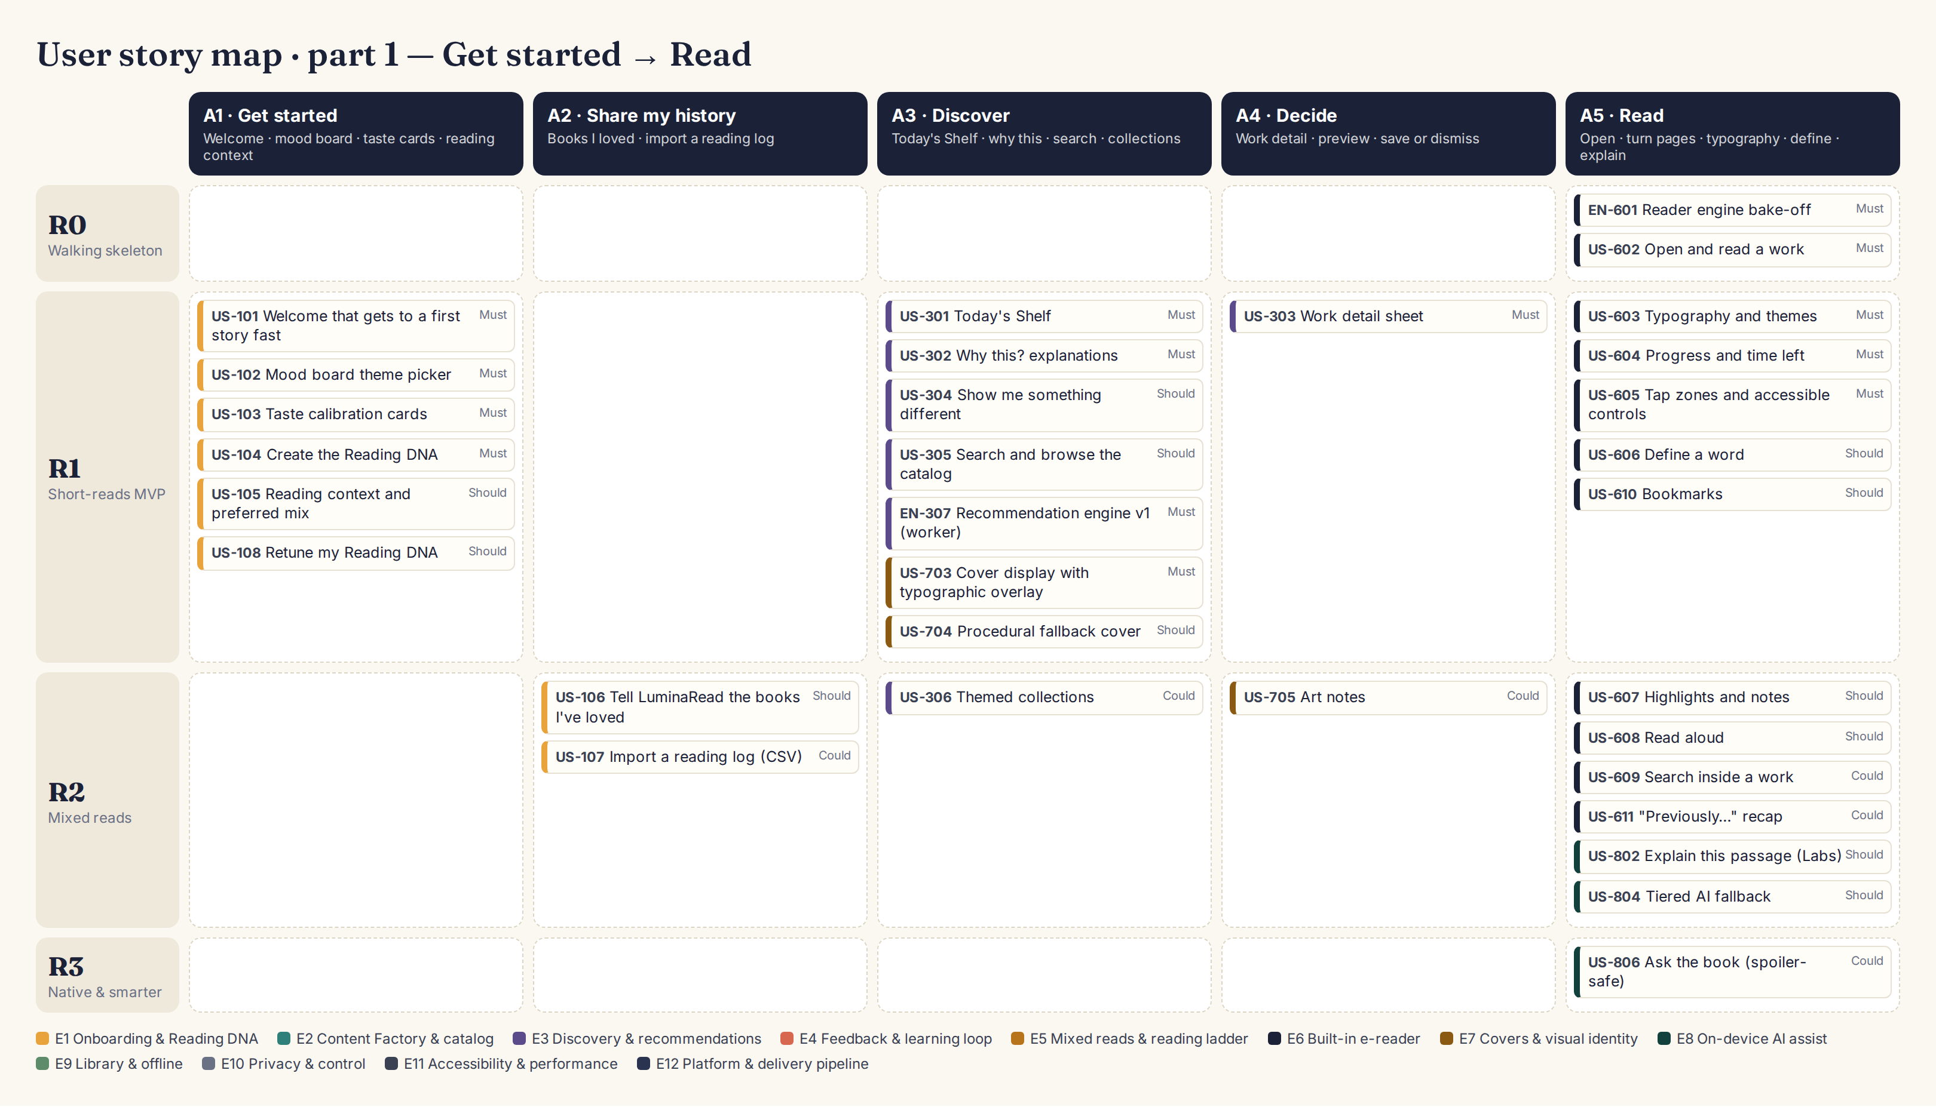
Story map, part 1 — Get started → Read

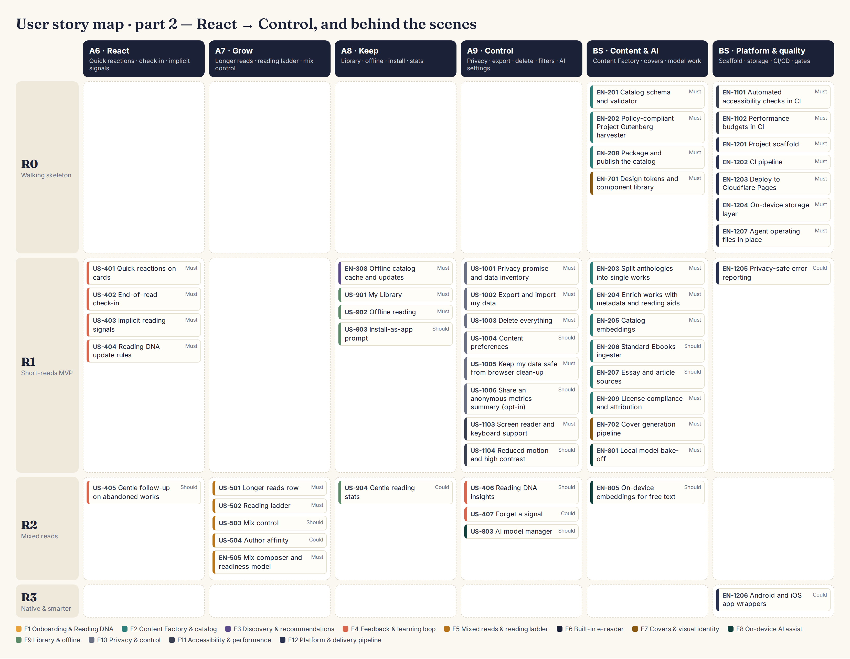
Story map, part 2 — React → Control, and behind the scenes

8.2 Story cards
Acceptance criteria are written as Given/When/Then so agents can turn each one into an automated test. Size: S ≈ one agent session, M ≈ two or three, L ≈ four or more.

E1 · Onboarding & Reading DNA
ID | Story | Acceptance criteria | Release | Lead · deps
US-101  User story | Welcome that gets to a first story fast  As a new reader, I want a short, friendly welcome that explains Twice Told in one screen, so that I can start reading within two minutes. | AC1. Given a first-time visitor, when the app loads, then the welcome shows the value proposition, one primary "Find my first story" button and a privacy link, and no request is made to any host other than the app's own static host (asserted from the e2e network log).  AC2. Given the welcome screen, when I open "How your privacy works", then a plain-language page lists what is stored on the device and states that nothing personal is sent anywhere.  AC3. Given a returning reader with a saved profile, when the app loads, then the welcome is skipped and Your Shortlist opens. | R1 · Must  Size S | UX/UI Designer  Deps: EN-1201, EN-701
US-102  User story | Mood board theme picker  As a new reader, I want to pick a few moods and themes from illustrated tiles, so that my first recommendations feel like me. | AC1. Given the mood board, when it renders, then 8–16 illustrated theme tiles are shown, each a labeled button reachable by keyboard and screen reader.  AC2. Given I select 2–5 tiles, when I tap Next, then the selections are saved as facet priors and step 2 opens; with fewer than 2 selected, Next is disabled and a hint explains why.  AC3. Given I tap Skip, then a balanced "Classic Essentials" prior is applied and step 2 opens. | R1 · Must  Size M | UX/UI Designer  Deps: US-101, EN-1204
US-103  User story | Taste calibration cards  As a new reader, I want to react to a handful of real works with one tap, so that the app learns my taste quickly without a questionnaire. | AC1. Given step 2, when cards load, then 8 works are shown one at a time with cover, title, author, year, reading time, a one-line hook and the work's genuine first line taken from the catalog text (never generated).  AC2. Given a card, when I choose Love, Maybe or Not for me (button, swipe or keyboard), then an event is appended to the event log and the next card appears within 150 ms.  AC3. Given the 8 calibration works, then they come from at least 5 different taste clusters and include at least 1 essay/article and 1 work under 10 minutes. | R1 · Must  Size M | UX/UI Designer  Deps: US-102, EN-307, EN-205
US-104  User story | Create the Reading DNA  As a new reader, I want my choices turned into a taste profile immediately, so that my first shortlist is already personal. | AC1. Given completed calibration, when buildProfile() runs in the recommendation worker, then a normalized taste vector and facet beliefs are saved to IndexedDB in under 200 ms on a mid-range phone CPU profile.  AC2. Given identical calibration answers, when the profile is built twice, then the resulting vectors are identical (deterministic).  AC3. Given the profile exists, then Your Shortlist opens with at least 6 recommendations, none of which I marked "Not for me". | R1 · Must  Size M | AI Engineer  Deps: US-103, EN-307
US-105  User story | Reading context and preferred mix  As a new reader, I want to say when I usually read and whether I want short or long works, so that recommendations fit my time. | AC1. Given step 3, when I choose when I read (quick breaks / evenings / weekends) and my preferred mix (mostly short / balanced / mostly long), then both are saved in settings and used by the mix composer.  AC2. Given I skip step 3, then the defaults are "evenings" and "mostly short". | R1 · Should  Size S | Product Manager  Deps: US-104
US-106  User story | Tell Twice Told the books I've loved  As a reader, I want to add a few books I loved, including modern ones, so that my history shapes recommendations from day one. | AC1. Given the "Books you've loved" screen, when I type a title or author and tap Search, then results come from the Open Library search API, and a note explains that only the typed text is sent.  AC2. Given I add up to 10 books, when I tap Done, then each book's subjects and description are embedded on the device and blended into the taste vector with weight +0.5 each.  AC3. Given the embedding model is unavailable, then subjects are mapped to facets by keyword rules and the flow still completes. | R2 · Should  Size M | AI Engineer  Deps: EN-805, US-104
US-107  User story | Import a reading log (CSV)  As a reader who tracks books elsewhere, I want to import my Goodreads or StoryGraph export, so that I don't have to re-enter my history. | AC1. Given a Goodreads or StoryGraph CSV export, when I import it, then it is parsed entirely on the device and a preview lists recognized books with their ratings.  AC2. Given the preview, when I confirm, then ratings of 4–5 become positive signals, 1–2 negative and 3 neutral, and I can exclude any row first.  AC3. Given a malformed file, then a friendly error explains which columns are needed (title, author, rating). | R2 · Could  Size M | AI Engineer  Deps: US-106
US-108  User story | Retune my Reading DNA  As a reader whose taste has changed, I want to run the calibration again, so that recommendations catch up with me. | AC1. Given Settings → Retune, when I confirm, then the calibration flow runs again and the new profile replaces the old one while the event log is preserved.  AC2. Given I cancel midway, then the previous profile is unchanged. | R1 · Should  Size S | Product Manager  Deps: US-104

E2 · Content Factory & catalog
ID | Story | Acceptance criteria | Release | Lead · deps
EN-201  Enabler | Catalog schema and validator  As the content pipeline, I want a strict schema for every catalog record, so that bad or unlicensed records can never ship. | AC1. Given docs/content/catalog.schema.json, when `npm run catalog:validate` runs, then every record is validated and CI fails on any error.  AC2. Given any record, then provenance fields (sourceName, sourceUrl, license, retrievedAt, sha256) are required.  AC3. Given a record whose license is not on the allow-list, then validation fails and names the record id. | R0 · Must  Size S | Architect  Deps: EN-1201
EN-202  Enabler | Policy-compliant Project Gutenberg harvester  As the content pipeline, I want to collect candidate texts the way Project Gutenberg asks, so that we are never blocked and every file is traceable. | AC1. Given Project Gutenberg's offline RDF catalog, when the harvester runs, then it selects candidates by language, subject and length without crawling gutenberg.org web pages.  AC2. Given selected ids, when texts are downloaded, then downloads come from a Project Gutenberg mirror with at least 2 seconds between requests, and each file's sha256 and source URL are recorded.  AC3. Given a download fails, then the item is skipped and reported; the pipeline never substitutes, paraphrases or invents text. | R0 · Must  Size M | Content Curator  Deps: EN-201
EN-203  Enabler | Split anthologies into single works  As the content pipeline, I want each story or essay inside a collection to become its own work, so that readers can be recommended one short piece at a time. | AC1. Given a collection, when the splitter runs, then each story or essay becomes its own work with a title, parent collection id and character offsets into the source file.  AC2. Given the split results, then 100% of each work's text is a verbatim slice of the source file (verified by substring check).  AC3. Given a random sample of 20 splits reviewed at Gate C1, then at least 19 have correct boundaries. | R1 · Must  Size L | Content Curator  Deps: EN-202
EN-204  Enabler | Enrich works with metadata and reading aids  As a reader, I want every work to have an honest blurb, reading time, level and content notes, so that I can choose well. | AC1. Given a work, then wordCount, readingMinutes (at 238 words per minute), lengthClass, readability grade and firstLine are computed deterministically from the text.  AC2. Given a work, when the build-time LLM step runs, then hook (≤ 20 words), blurb (≤ 60 words), genres, moods, content notes and a glossary of archaic words are produced from the actual text and stored with generatedBy and reviewed=false.  AC3. Given a blurb, then it does not reveal the ending (LLM self-check plus Gate C1 sampling). | R1 · Must  Size L | AI Engineer  Deps: EN-203
EN-205  Enabler | Catalog embeddings  As the recommendation engine, I want a compact vector for every work computed once at build time, so that phones only do fast arithmetic. | AC1. Given enriched works, when embeddings are computed with the model chosen in ADR-0004, then vectors are L2-normalized, int8-quantized and written to vectors.bin with an ids index.  AC2. Given the same inputs, then the output is byte-identical across runs.  AC3. Given the output, then vectors take no more than 1 MB per 2,500 works. | R1 · Must  Size M | AI Engineer  Deps: EN-204
EN-206  Enabler | Standard Ebooks ingester  As the content pipeline, I want to include beautifully produced Standard Ebooks editions, so that the catalog has the best available texts. | AC1. Given Patrons Circle feed access configured in .env, when the ingester runs, then it reads the feed, downloads selected EPUBs and records provenance; credentials never appear in logs or commits.  AC2. Given no credentials, then the step is skipped with a warning and the pipeline still succeeds. | R1 · Should  Size M | Content Curator  Deps: EN-202
EN-207  Enabler | Essay and article sources  As a curious reader, I want non-fiction essays and articles alongside stories, so that I can read ideas as well as fiction. | AC1. Given the curated source list in docs/content/sources.md, when the ingester runs, then essays and articles from Project Gutenberg and Wikisource are added with form=nonfiction.  AC2. Given any CC BY-SA item (e.g., Wikipedia), then an attribution block (title, authors link, license, changes) is stored and shown in the reader; such items are excluded unless enabled in config. | R1 · Should  Size M | Content Curator  Deps: EN-202
EN-208  Enabler | Package and publish the catalog  As the app, I want a versioned, sharded catalog with checksums (vectors are added once EN-205 lands), so that updates are small, atomic and verifiable. | AC1. Given approved works, when `npm run catalog:build` runs, then it outputs catalog shards (≤ 500 KB each), vectors.bin, texts and covers, plus a manifest with version and checksums.  AC2. Given a new catalog version, when the app next starts online, then it downloads only changed shards and keeps the previous version until the new one is complete. | R0 · Must  Size M | Architect  Deps: EN-201
EN-209  Enabler | License compliance and attribution  As a product owner, I want every text to comply with its source license, so that Twice Told is safe to publish. | AC1. Given any Project Gutenberg text, then either the full Project Gutenberg license is kept with it or all Project Gutenberg references and trademarks are removed, following the rule chosen in ADR-0001.  AC2. Given any work, then the detail sheet shows source, license and a link to the original.  AC3. Given About → Sources, then all sources and licenses are listed. | R1 · Must  Size S | Content Curator  Deps: EN-208
EN-210  Enabler | Historic newspaper articles (Library of Congress)  As a curious reader, I want short historic articles and features from old American newspapers, so that I get vivid non-fiction from the past. | AC1. Given the loc.gov API (or the bulk OCR data) for Chronicling America, when the ingester runs, then pre-1930 articles are selected by topic and saved with provenance.  AC2. Given OCR text, then cleanup only fixes recognition errors against the page image and every changed word is logged; articles below a quality threshold are excluded.  AC3. Given a sample of 20 articles at Gate C1, then at least 18 read cleanly. | R2 · Could  Size M | Content Curator  Deps: EN-207
EN-211  Enabler | Contemporary essays as extracts with link-out  As a curious reader, I want occasional modern essays alongside the classics, so that my non-fiction mix is not only historical. | AC1. Given a hand-picked list of The Conversation articles, then the app shows only the opening paragraphs, author, institution and a "Read the full article on The Conversation" link, following its republishing guidelines.  AC2. Given the privacy rule, then no tracking counter or third-party script is loaded; full reading happens on the publisher's site. | R2 · Could  Size S | Content Curator  Deps: EN-207
EN-212  Enabler | Evaluate Internet Archive / Open Library public-domain scans  As a product owner, I want to know whether scanned public-domain books can fill catalog gaps, so that we only add sources that meet our quality bar. | AC1. Given 20 candidate public-domain titles missing from Project Gutenberg and Standard Ebooks, then a report compares OCR quality, license clarity and effort, and recommends go or no-go. | R3 · Could  Size M | Content Curator  Deps: EN-202

E3 · Discovery & recommendations
ID | Story | Acceptance criteria | Release | Lead · deps
US-301  User story | Your Shortlist  As a reader, I want a small, curated shortlist each time I open the app, so that I can pick something good without scrolling forever. | AC1. Given a profile, when I open Your Shortlist, then I see 1 hero pick, a Short reads row (≥ 4), an Ideas & essays row (≥ 2) and 1 wildcard, each with cover, title, author and minutes.  AC2. Given the shortlist, then it renders within 1 second of navigation on a mid-range phone profile, including offline.  AC3. Given I have dismissed or finished a work, then it does not appear on the shortlist again. | R1 · Must  Size M | UX/UI Designer  Deps: US-104, EN-307, US-703
US-302  User story | Why this? explanations  As a reader, I want to see why each work was picked for me, so that I trust the recommendations and understand my DNA. | AC1. Given any recommended card, then a one-line reason is shown, generated from the top-scoring factor (similar to a loved work, a liked theme, the wildcard, or the next rung).  AC2. Given the wildcard, then the reason says it is intentionally outside my usual picks. | R1 · Must  Size S | AI Engineer  Deps: EN-307
US-303  User story | Work detail sheet  As a reader, I want the key facts about a work before I start, so that I choose confidently. | AC1. Given a card, when I tap it, then the detail sheet shows cover, title, author, year, reading time at my speed, length class, reading level, blurb, the genuine first lines, content notes, and source & license.  AC2. Given the detail sheet, then Read now, Dog-ear and Not for me are available and each records an event. | R1 · Must  Size M | UX/UI Designer  Deps: US-301, EN-209
US-304  User story | Show me something different  As a reader, I want to ask for a fresh, more adventurous shortlist, so that I can break out of a rut. | AC1. Given the shortlist, when I tap "Something different", then exploration is raised for one refresh and at least half of the new picks come from clusters I have not engaged with.  AC2. Given this action, then my taste vector is not changed. | R1 · Should  Size S | AI Engineer  Deps: EN-307
US-305  User story | Search and browse the catalog  As a reader, I want to find a specific author, title or theme, so that I can read what I already have in mind. | AC1. Given the Search tab, when I type 2+ characters, then matching titles and authors appear within 100 ms from an on-device index.  AC2. Given filters for length, form, era and mood, when applied, then results update instantly and work offline. | R1 · Should  Size M | Architect  Deps: EN-208
US-306  User story | Themed collections  As a reader, I want hand-curated themed rows, so that I discover great works around a mood. | AC1. Given curated collections in the catalog (e.g., "Ghost stories for a rainy night"), then the shortlist can show one collection row ordered by my taste. | R2 · Could  Size S | Product Manager  Deps: US-301
EN-307  Enabler | Recommendation engine v1 (worker)  As a reader, I want recommendations computed privately and instantly on my device, so that the app feels smart without sending my data anywhere. | AC1. Given the algorithm specified in SRS §4.6, then the worker exposes recommend(slots), updateProfile(events) and explain(workId) behind one module interface.  AC2. Given 5 synthetic personas with known preferences simulated for 30 sessions, then each persona's liked-rate in the top 5 is at least 2× a random baseline and catalog coverage stays at or above 30%.  AC3. Given 5,000 catalog items, then recommend() completes in under 150 ms on a mid-range mobile CPU profile. | R1 · Must  Size L | AI Engineer  Deps: EN-205, EN-1204
EN-308  Enabler | Offline catalog cache and updates  As a reader, I want the shortlist and search to work without a connection, so that I can read on a plane or a train. | AC1. Given the app has loaded once online, when the device is offline, then the shortlist, search and all saved works function.  AC2. Given a new catalog manifest, then the service worker updates in the background and switches atomically on the next launch. | R1 · Must  Size M | Architect  Deps: EN-208, EN-1201

E4 · Feedback & learning loop
ID | Story | Acceptance criteria | Release | Lead · deps
US-401  User story | Quick reactions on cards  As a reader, I want to dismiss a pick with an optional reason, so that the app stops showing me similar things. | AC1. Given a card or detail sheet, when I tap Not for me, then an optional reason picker (too long, not my genre, too old-fashioned, too dark, already read) appears and can be skipped.  AC2. Given a reaction, then it is appended to the event log with a timestamp and the card animates away. | R1 · Must  Size S | UX/UI Designer  Deps: US-301
US-402  User story | End-of-read check-in  As a reader, I want a quick "How was it?" when I finish, so that the next picks get better. | AC1. Given I reach the end of a work, then a check-in asks "How was it?" with Loved it / It was OK / Not for me plus optional reason chips, and it can be dismissed.  AC2. Given I answer, then the feedback event is saved and the next shortlist reflects it.  AC3. Given I loved it and a next rung exists, then the next rung is suggested. | R1 · Must  Size M | UX/UI Designer  Deps: US-602, US-404
US-403  User story | Implicit reading signals  As a reader, I want the app to notice what I finish or abandon without asking me, so that I get better picks with no extra effort. | AC1. Given reading activity, then open, start, progress (every 10%), finish, abandon and active reading seconds are logged locally in batches and never sent over the network.  AC2. Given more than 2 minutes without interaction, then that time is not counted as reading. | R1 · Must  Size M | Architect  Deps: US-602, EN-1204
US-404  User story | Reading DNA update rules  As a reader, I want my profile to update from my feedback in a predictable way, so that recommendations improve and can be explained. | AC1. Given the weight table in SRS §4.6, when events arrive, then the taste vector and facet beliefs update exactly as specified (unit-tested per row).  AC2. Given events older than 90 days, then their influence is halved (half-life of 90 days).  AC3. Given the event log, when the profile is rebuilt from scratch, then it equals the incrementally updated profile within 1e-6. | R1 · Must  Size M | AI Engineer  Deps: EN-307
US-405  User story | Gentle follow-up on abandoned works  As a reader, I want to be asked once, kindly, why I stopped, so that the app learns without nagging. | AC1. Given a work was started, is under 15% read and untouched for 7 days, when I next open the app, then one gentle prompt asks why (including a "Just busy" option) and appears at most once per work. | R2 · Should  Size S | UX/UI Designer  Deps: US-403
US-406  User story | Reading DNA insights  As a reader, I want to see and edit what the app has learned about my taste, so that I stay in control. | AC1. Given a profile, then the insights page shows top themes, sweet-spot length, favourite era and the taste / explore / wildcard split.  AC2. Given I remove a theme or forget a book, then the profile is rebuilt without it and the next shortlist reflects the change. | R2 · Should  Size M | UX/UI Designer  Deps: US-404
US-407  User story | Forget a signal  As a reader, I want to remove a work from my history, so that one odd choice doesn't skew my recommendations. | AC1. Given my history list, when I choose "Forget this", then the related events are deleted, the profile is recomputed and the work may be recommended again. | R2 · Could  Size S | Architect  Deps: US-404

E5 · Mixed reads & reading ladder
ID | Story | Acceptance criteria | Release | Lead · deps
US-501  User story | Your Long List row  As a reader who is enjoying short works, I want longer works suggested when I seem ready, so that I can grow into novellas and novels. | AC1. Given readiness (at least 3 positively rated finished works), then the shortlist adds a Your Long List row of novelettes, novellas or novels, each showing estimated sessions at my typical session length.  AC2. Given my mix setting is "Mostly short", then at most 1 longer work appears. | R2 · Must  Size M | AI Engineer  Deps: EN-505, US-602
US-502  User story | Reading ladder  As a reader, I want a clear, optional path from short stories to longer classics, so that longer books feel approachable. | AC1. Given I finish and love a short work, then a "next rung" (a longer work by the same author or the closest cluster) is suggested.  AC2. Given the Library, then the ladder card shows completed rungs and the next rung. | R2 · Must  Size M | Product Manager  Deps: US-501
US-503  User story | Mix control  As a reader, I want to choose Mostly short, Balanced, Mostly long or Surprise me, so that the shortlist matches my mood and time. | AC1. Given Settings or the shortlist header, when I choose a mix, then the next shortlist follows the ratio table in SRS §4.6. | R2 · Should  Size S | UX/UI Designer  Deps: EN-505
US-504  User story | Author affinity  As a reader, I want more from authors I love, especially their longer works, so that I can follow a voice I enjoy. | AC1. Given I loved 2 or more works by an author, then that author's longer works get a score boost and the reason "More from <author>". | R2 · Could  Size S | AI Engineer  Deps: EN-505
EN-505  Enabler | Mix composer and readiness model  As the recommendation engine, I want a policy that balances short and long works, so that longer works appear at the right pace. | AC1. Given ladder level and mix setting, then the composer fills slots per the ratio table and never shows more longer works than the table allows.  AC2. Given simulated personas, then the ladder level only increases after positive finishes and decreases after two consecutive abandoned longer works. | R2 · Must  Size M | AI Engineer  Deps: EN-307

E6 · Built-in e-reader
ID | Story | Acceptance criteria | Release | Lead · deps
EN-601  Enabler | Reader engine bake-off  As a product owner, I want evidence for which open-source reading engine to build on, so that the reader is solid and maintainable. | AC1. Given candidates foliate-js, Readium ts-toolkit and epub.js/react-reader, when each renders the same 5 test works on Chrome Android, iOS Safari and a desktop browser, then a scored matrix (pagination, reflow, locators, highlights, TTS hooks, accessibility, bundle size, maintenance, license) is written to docs/research/reader-engines.md.  AC2. Given the matrix, then ADR-0002 is updated with a recommendation and a ReaderEngine interface proposal for Gate G2. | R0 · Must  Size M | Reader Researcher  Deps: EN-1201
US-602  User story | Open and read a work  As a reader, I want to open a work and read it comfortably, so that reading feels natural. | AC1. Given a work, when I tap Read now, then it opens at my last position (or the start) in under 1.5 s from cache.  AC2. Given paginated mode, then tapping the right/left edges or pressing arrow keys turns pages; a scroll mode is also available.  AC3. Given the work has a table of contents, then I can jump to any chapter. | R0 · Must  Size L | Reader Researcher  Deps: EN-601
US-603  User story | Typography and themes  As a reader, I want to adjust fonts, size, spacing and colour theme, so that reading is comfortable for my eyes. | AC1. Given the Aa panel, then I can choose Literata, Atkinson Hyperlegible, OpenDyslexic or a system serif; size (10 steps); line spacing (3); margins (3); and Paper, Sepia, Night or Black themes.  AC2. Given any change, then it applies instantly without losing my place and persists across sessions.  AC3. Given each theme, then body text contrast is at least 7:1. | R1 · Must  Size M | UX/UI Designer  Deps: US-602, EN-701
US-604  User story | Progress and time left  As a reader, I want to see how much time is left in the story or chapter, so that I know if I can finish now. | AC1. Given reading, then a progress bar shows percent and minutes left in the story or chapter, using my measured words per minute (default 238).  AC2. Given my speed changes over sessions, then estimates update using a rolling median. | R1 · Must  Size S | Architect  Deps: US-602, US-403
US-605  User story | Tap zones and accessible controls  As a reader, I want familiar gestures plus accessible buttons, so that anyone can navigate. | AC1. Given reading, then the left and right 25% of the screen turn pages, the centre toggles controls, and every action is also available as a labeled button for assistive technology. | R1 · Must  Size S | UX/UI Designer  Deps: US-602
US-606  User story | Define a word  As a reader of older texts, I want to look up unfamiliar or archaic words, so that I keep reading without friction. | AC1. Given I long-press or double-tap a word, then a card shows its definition from the work's build-time glossary if present, otherwise from the dictionary API after a one-time consent note.  AC2. Given I am offline, then glossary definitions still work and dictionary lookups show a friendly offline message. | R1 · Should  Size M | Content Curator  Deps: US-602, EN-204
US-607  User story | Highlights and notes  As a reader, I want to highlight passages and add notes, so that I can keep what moved me. | AC1. Given a text selection, then I can highlight in 4 colours and add a note; highlights persist and re-anchor correctly after font changes.  AC2. Given the highlights list, then I can export all highlights of a work as Markdown. | R2 · Should  Size M | Reader Researcher  Deps: US-602
US-608  User story | Read aloud  As a reader, I want to listen to a work with the text highlighted, so that I can read with my ears or rest my eyes. | AC1. Given Read aloud, then text is spoken with the device's built-in voices (Web Speech API), the current sentence is highlighted, and speed can be set from 0.75× to 2×.  AC2. Given I pause or the screen locks, then my position is remembered. | R2 · Should  Size M | Reader Researcher  Deps: US-602
US-609  User story | Search inside a work  As a reader, I want to search within the text, so that I can find a passage again. | AC1. Given a query, then all matches are listed with surrounding context and tapping one navigates there. | R2 · Could  Size S | Reader Researcher  Deps: US-602
US-610  User story | Bookmarks  As a reader, I want to bookmark places, so that I can return to them. | AC1. Given reading, when I tap Bookmark, then the location is saved and listed, and tapping it navigates back. | R1 · Should  Size S | Reader Researcher  Deps: US-602
US-611  User story | "Previously…" recap  As a reader returning to a longer work, I want a spoiler-safe reminder of what happened, so that I can pick up the thread. | AC1. Given I return to a longer work after 3 or more days, then a recap of chapters already read is offered, drawn from build-time chapter summaries.  AC2. Given any recap, then it never includes content beyond my furthest reading position. | R2 · Could  Size M | AI Engineer  Deps: US-602, EN-204
US-612  User story | Listen to a human-narrated recording  As a reader, I want to switch to a volunteer-narrated public-domain audiobook when one exists, so that I can listen on a walk. | AC1. Given a work with a matching LibriVox recording, then a Listen button plays it with chapter navigation and remembers position; recordings are streamed from the source with attribution. | R3 · Could  Size M | Reader Researcher  Deps: US-608

E7 · Covers & visual identity
ID | Story | Acceptance criteria | Release | Lead · deps
EN-701  Enabler | Design tokens and component library  As an UI-building agent, I want one set of tokens and components, so that every screen looks consistent. | AC1. Given docs/design/tokens.json, then colours, type scale, spacing, radii, elevation and motion are available as CSS variables and Tailwind theme values.  AC2. Given the component gallery page, then buttons, chips, cards, sheets, tabs and toggles render in all 4 themes and pass axe checks. | R0 · Must  Size M | UX/UI Designer  Deps: EN-1201
EN-702  Enabler | Cover generation pipeline  As a reader, I want every work to have beautiful, consistent cover art, so that browsing is a pleasure. | AC1. Given a work, when `npm run covers:generate -- --ids …` runs, then 2–4 candidates are generated with the house-style prompt (docs/content/house-style.md) via Cloudflare Workers AI, recording prompt, seed and model.  AC2. Given candidates, then automatic checks reject any image with detected text (OCR), unsafe content or near-duplicates (perceptual hash).  AC3. Given passing candidates, then an HTML contact sheet is produced for Gate C2, and only approved images are packaged as WebP/AVIF in 3 sizes with alt text. | R1 · Must  Size L | Cover Artist  Deps: EN-204
US-703  User story | Cover display with typographic overlay  As a reader, I want titles that are always legible and correct on covers, so that covers look great and are accessible. | AC1. Given a cover image, then the app overlays title and author in Fraunces over a legibility gradient; the text is real text (screen-readable), never baked into the image.  AC2. Given images load slowly, then a blurred placeholder or procedural cover shows first and the layout does not shift. | R1 · Must  Size S | UX/UI Designer  Deps: EN-701, EN-702
US-704  User story | Procedural fallback cover  As a reader, I want a good-looking cover even when art is missing, so that the shortlist never looks broken. | AC1. Given no approved art for a work, then a deterministic SVG cover (seeded by work id and genre palette) is shown in the house style. | R1 · Should  Size S | UX/UI Designer  Deps: EN-701
US-705  User story | Art notes  As a reader, I want to know how a cover was made, so that the use of AI imagery is transparent. | AC1. Given a work detail, when I open Art notes, then I see that the illustration is AI-generated, the model used, and a short description of the scene. | R2 · Could  Size S | Cover Artist  Deps: US-703

E8 · On-device AI assist
ID | Story | Acceptance criteria | Release | Lead · deps
EN-801  Enabler | Local model bake-off  As a product owner, I want measured evidence about which small model (if any) should run on devices, so that we ship AI help only where it is genuinely good. | AC1. Given docs/ai/eval-plan.md, when the candidates (browser built-in AI where available plus 3–4 small open models) run on 30 real passages from the catalog, then quality (rubric), latency, download size, memory and failure rate are recorded per device class.  AC2. Given the results, then a report and an ADR-0005 update recommend a default model, a fallback, and a go/no-go for "Explain (Labs)" at Gate G2. | R1 · Must  Size M | AI Engineer  Deps: EN-204
US-802  User story | Explain this passage (Labs)  As a reader of older or difficult texts, I want a plain-language explanation of a passage, so that I understand without leaving the story. | AC1. Given Labs is on and a model tier is available, when I select up to 150 words and tap Explain, then an explanation streams into a bottom sheet with time-to-first-token under 3 s on a supported device.  AC2. Given generation is running, when I tap Cancel or close the sheet, then it stops immediately.  AC3. Given any output, then it is labeled "AI-generated on your device" and no passage text leaves the device (asserted by e2e network checks). | R2 · Should  Size M | AI Engineer  Deps: EN-801, US-803
US-803  User story | AI model manager  As a reader, I want to see, download and delete on-device AI models, so that I control storage and data use. | AC1. Given Settings → AI, then I see available tiers, model name, download size and storage used; I can download on demand (with a Wi-Fi reminder where detectable) and delete the model.  AC2. Given insufficient storage quota, then the download is blocked with an explanation. | R2 · Should  Size S | Architect  Deps: EN-801
US-804  User story | Tiered AI fallback  As a reader on any device, I want Explain to work as well as my device allows, so that nobody is left with a broken button. | AC1. Given capability detection, then Explain uses built-in browser AI if available, else the downloaded model, else glossary plus dictionary, and the sheet says which tier answered. | R2 · Should  Size S | AI Engineer  Deps: US-802
EN-805  Enabler | On-device embeddings for free text  As a reader, I want free-text taste input understood on my device, so that my history can be used privately. | AC1. Given the embedding model chosen in ADR-0004, when it is loaded lazily in the AI worker, then free text is embedded into the same vector space as the catalog: cosine similarity between device and build-time vectors for 20 sample works is at least 0.99. | R2 · Should  Size M | AI Engineer  Deps: EN-205
US-806  User story | Ask the book (spoiler-safe)  As a reader of a long work, I want to ask questions about what I have read so far, so that I can keep track of characters and plot. | AC1. Given a longer work, when I ask a question, then the answer uses only chapters I have read (spoiler-safe) and cites the passage it relied on. | R3 · Could  Size L | AI Engineer  Deps: US-802

E9 · Library & offline
ID | Story | Acceptance criteria | Release | Lead · deps
US-901  User story | My Library  As a reader, I want one place for what I am reading, saved and finished, so that I can pick up where I left off. | AC1. Given saved, reading and finished works, then the Library shows them in three tabs with cover, progress and minutes left, sorted by last opened.  AC2. Given a work in Reading, when I tap it, then it resumes at the last position. | R1 · Must  Size M | UX/UI Designer  Deps: US-602, EN-1204
US-902  User story | Offline reading  As a reader, I want saved works to be readable without a connection, so that I can read anywhere. | AC1. Given I save a work, then its text and cover are cached, and with the network off it opens and reads normally.  AC2. Given Settings → Storage, then I see the space used and can remove offline copies. | R1 · Must  Size M | Architect  Deps: EN-308
US-903  User story | Install-as-app prompt  As a reader, I want to be told why and how to install the app, so that my data is safer and the app works offline. | AC1. Given I have finished 1 work and the app is not installed, then a dismissible prompt explains installing (offline use; keeps data safer from browser clean-up on iPhone) with platform-specific steps, shown at most once per 30 days. | R1 · Should  Size S | UX/UI Designer  Deps: EN-1201
US-904  User story | Gentle reading stats  As a reader, I want to see my reading over time, so that I feel good about my progress. | AC1. Given reading history, then I can see minutes read, works finished and my short/long mix per month, with no streak penalties or guilt messages. | R2 · Could  Size S | UX/UI Designer  Deps: US-403

E10 · Privacy & control
ID | Story | Acceptance criteria | Release | Lead · deps
US-1001  User story | Privacy promise and data inventory  As a reader, I want to see exactly what the app stores, so that I can trust it. | AC1. Given the Privacy page, then it lists every data type stored on the device with counts and states that no analytics or personal data is sent.  AC2. Given an automated e2e run of all core flows, then no request goes to any host except the app's static host (plus opt-in lookups only when explicitly used). | R1 · Must  Size S | Architect  Deps: EN-1204
US-1002  User story | Export and import my data  As a reader, I want to move my Reading DNA and library to another device, so that I don't lose anything. | AC1. Given Export, then a single JSON file with schema version, profile, events, library, progress, highlights and settings downloads.  AC2. Given Import on another device, then the file is validated and restored, and the shortlist matches the original device's shortlist for the same catalog version. | R1 · Must  Size M | Architect  Deps: EN-1204
US-1003  User story | Delete everything  As a reader, I want to erase all my data in one step, so that I can leave cleanly. | AC1. Given Delete all, when I confirm by typing DELETE, then IndexedDB, caches (except the app shell) and model files are removed and the app returns to the welcome screen. | R1 · Must  Size S | Architect  Deps: EN-1204
US-1004  User story | Content preferences  As a reader, I want to hide works with certain content or authors, so that recommendations respect my boundaries. | AC1. Given content-note filters (e.g., graphic violence, racism, suicide, sexual content) and blocked authors, when set, then matching works never appear in recommendations or search results. | R1 · Should  Size S | Product Manager  Deps: EN-204, EN-307
US-1005  User story | Keep my data safe from browser clean-up  As a reader, I want my data protected against automatic deletion, so that my Reading DNA is not lost. | AC1. Given first profile creation, then the app requests persistent storage and records whether it was granted.  AC2. Given storage is not persistent and the app is not installed, then a gentle monthly reminder suggests exporting or installing. | R1 · Must  Size S | Architect  Deps: EN-1204
US-1006  User story | Share an anonymous metrics summary (opt-in)  As a beta reader, I want to share aggregate reading stats if I choose, so that the team can measure success without tracking me. | AC1. Given Settings → Help improve Twice Told, when I tap "Share a summary", then a preview shows only aggregate counts (no titles, no text, no ids) and nothing is sent unless I choose how to share it myself. | R1 · Should  Size S | Product Manager  Deps: US-403

E11 · Accessibility & performance
ID | Story | Acceptance criteria | Release | Lead · deps
EN-1101  Enabler | Automated accessibility checks in CI  As a product owner, I want accessibility regressions caught automatically, so that every release stays usable by everyone. | AC1. Given CI, then axe-core runs on every core screen in Playwright and fails the build on any serious or critical violation. | R0 · Must  Size S | UX/UI Designer  Deps: EN-1202
EN-1102  Enabler | Performance budgets in CI  As a reader on a mid-range phone, I want the app to stay fast as it grows, so that it always feels instant. | AC1. Given CI, then Lighthouse CI with mobile emulation enforces LCP ≤ 2.5 s, CLS ≤ 0.1, total JavaScript ≤ 300 KB gzipped, and PWA installability. | R0 · Must  Size S | Architect  Deps: EN-1202
US-1103  User story | Screen reader and keyboard support  As a reader who uses assistive technology, I want every core flow to work with my screen reader or keyboard, so that Twice Told works for me. | AC1. Given VoiceOver, TalkBack or NVDA, then onboarding, shortlist, detail, reader controls, check-in and settings are completable; verified by automated role/label assertions and a scripted manual checklist at Gate G5. | R1 · Must  Size M | UX/UI Designer  Deps: EN-1101
US-1104  User story | Reduced motion and high contrast  As a reader sensitive to motion or low contrast, I want the interface to respect my system settings, so that reading is comfortable. | AC1. Given prefers-reduced-motion, then non-essential animations are disabled.  AC2. Given the high-contrast option, then all text meets 7:1 contrast and focus indicators are at least 3 px. | R1 · Should  Size S | UX/UI Designer  Deps: EN-701

E12 · Platform & delivery pipeline
ID | Story | Acceptance criteria | Release | Lead · deps
EN-1201  Enabler | Project scaffold  As a build agent, I want a clean, conventional project skeleton, so that every later story has a solid base. | AC1. Given the repo, then a Vite + React + TypeScript + Tailwind app with vite-plugin-pwa, Dexie, Vitest and Playwright exists, with npm scripts dev, build, test, e2e, lint and typecheck.  AC2. Given the scaffold, then the folder structure matches the module table in SRS §4.3 and `npm run build` produces a static site. | R0 · Must  Size M | Architect  No deps
EN-1202  Enabler | CI on Gitea Actions  As a product owner, I want every pull request checked automatically by Gitea Actions, so that I only look at work that already passes. | AC1. Given a pull request into dev, test or main, then Gitea Actions (act_runner) runs typecheck, lint, unit, e2e, accessibility, Lighthouse and catalog validation and reports a status on the PR.  AC2. Given the repository has no package.json yet (docs-only phase), then CI passes with a "docs-only" notice instead of failing.  AC3. Given the workflow, then AGENTS.md lists the exact status-check names that branch protection requires (the machine gate). | R0 · Must  Size M | Architect  Deps: EN-1201, EN-1208
EN-1203  Enabler | Deploy to Cloudflare Pages via Direct Upload  As a product owner, I want test and production sites that update automatically, so that I can verify work on my phone. | AC1. Given a push to dev, test or main, then a Gitea Actions job builds the site and runs wrangler pages deploy dist --project-name=luminaread --branch=<branch>; main is production, and test and dev get the branch aliases test.luminaread.pages.dev and dev.luminaread.pages.dev.  AC2. Given the Cloudflare token and account id, then they are stored only as Gitea Actions secrets and never printed in logs.  AC3. Given the URLs, then they are recorded in AGENTS.md for the assembly line and Gate G5. | R0 · Must  Size S | Architect  Deps: EN-1201, EN-1208
EN-1204  Enabler | On-device storage layer  As a build agent, I want typed stores with migrations behind small interfaces, so that data is safe and features stay independent. | AC1. Given Dexie, then ProfileStore, EventLog, LibraryStore, ProgressStore, HighlightStore and SettingsStore expose typed interfaces with versioned migrations and unit tests.  AC2. Given the codebase, then no other module accesses IndexedDB directly (enforced by a lint rule). | R0 · Must  Size M | Architect  Deps: EN-1201
EN-1205  Enabler | Privacy-safe error reporting  As a product owner, I want to learn about crashes without collecting personal data, so that I can fix problems. | AC1. Given an error, then it is stored in a local ring buffer (last 50) with no reading content, and Settings → Report a problem composes a pre-filled message the reader can review and send themselves. | R1 · Could  Size S | Architect  Deps: EN-1204
EN-1206  Enabler | Android and iOS app wrappers  As a reader, I want Twice Told from the app stores, so that installation is familiar. | AC1. Given Capacitor, then Android and iOS builds run the same web app offline with the embedding model bundled, and pass store pre-launch checks. | R3 · Could  Size L | Architect  Deps: US-902
EN-1207  Enabler | Agent operating files in place  As a product owner, I want the agents, skills, gates and backlog installed and verified, so that the crew can work autonomously between gates. | AC1. Given the starter kit, then AGENTS.md, CONTEXT.md, .agents/rules, .agents/skills, .agents/workflows and .agents/agents are present and Antigravity lists them.  AC2. Given /gate G0, then a gate packet is produced; given /sprint in dry-run mode, then a plan is printed without changing any branch. | R0 · Must  Size S | Product Manager  No deps
EN-1208  Enabler | Private Gitea server and Actions runner  As a product owner, I want a private code home with enforced branch protection at no cost, so that agents can only change dev, test and main through pull requests. | AC1. Given Docker, when docker compose up -d runs in infra/gitea, then Gitea is reachable on port 3000 with an admin account and a registered act_runner.  AC2. Given scripts/forge/gitea-init.sh luminaread, then a private repository with branches dev, test and main exists and all three reject direct pushes.  AC3. Given a pull request with a trivial change, then a hello-world workflow runs on the runner and reports success.  AC4. Given the Gitea data folder, then a nightly backup copy is documented (and optionally a push mirror to a second host). | R0 · Must  Size M | Architect  No deps
EN-1209  Enabler | Sprint assembly line in Antigravity  As a product owner, I want a sprint pipeline where I only approve the plan and the promotion, so that the agents do everything else on their own. | AC1. Given READY tasks in TASKS.md, when I run /sprint, then written plans (PLAN-<group>.md) are produced and the workflow stops for my plan approval (G4).  AC2. Given approval, then each group runs developer → tester → reviewer in its own git worktree (in parallel where Antigravity allows, otherwise one after another).  AC3. Given a reviewed group, then a Gitea pull request is opened and merged only when the required CI checks pass and the reviewer verdict is "approve" (machine gate); merges happen one at a time (merge queue).  AC4. Given all merges, then regression and docs steps run on dev, and the workflow auto-rolls dev → test unless regression failed or a concern is open, in which case it stops and reports.  AC5. Given the test site, then the workflow stops for Gate G5; only promote typed by me merges test → main. | R0 · Must  Size L | Product Manager  Deps: EN-1208, EN-1207, EN-1202

Part 9 — The AI build crew: agents, skills and gates

9.1 The crew
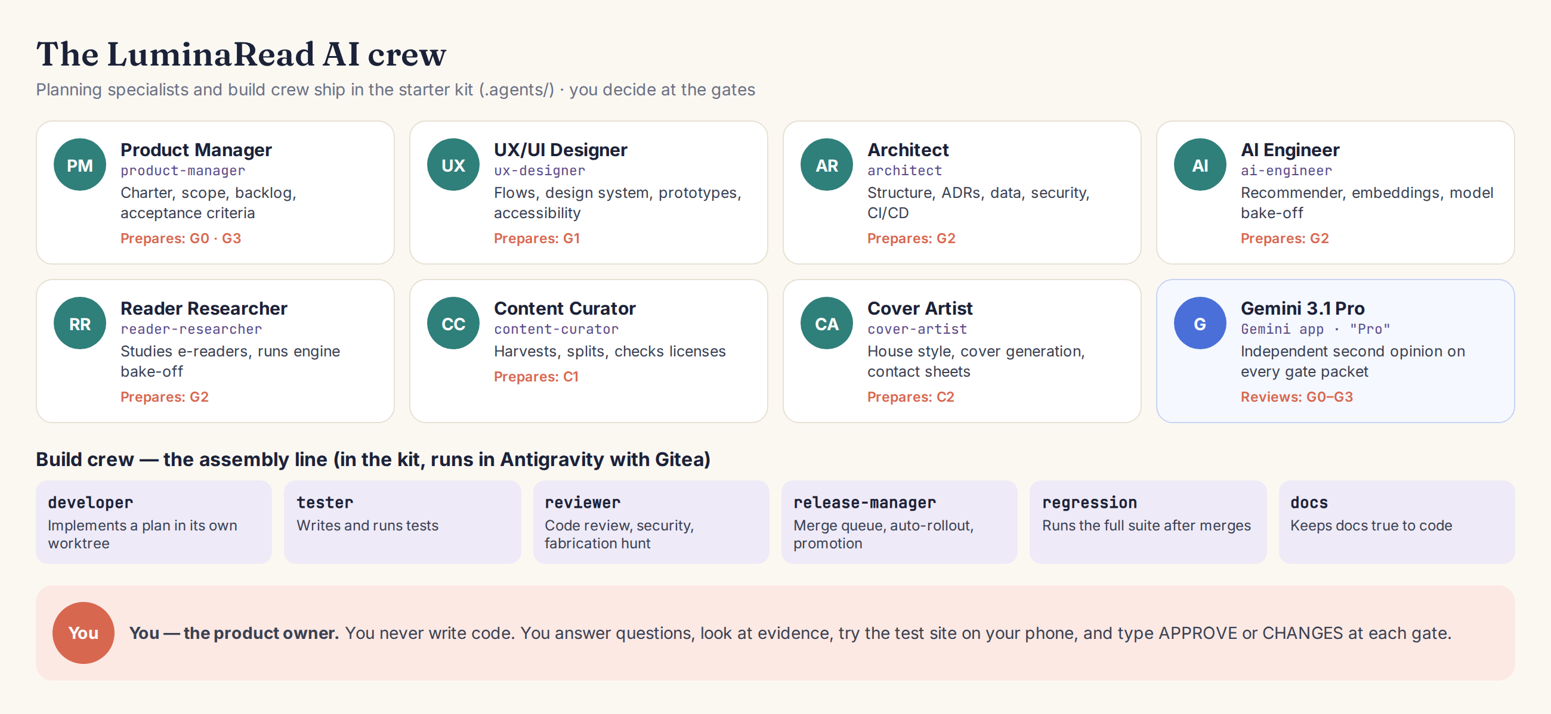
Figure 13 — Who does what
Agent (file) | In plain English | Main outputs | Gates | Skills it leans on
Product Manager  product-manager | Owns the why and the what: charter, scope, backlog, acceptance criteria, release plans. Runs interviews with you. | charter.md, TASKS.md, docs/stories | G0, G3 | grill-me, to-spec, to-tickets, gate-review
UX/UI Designer  ux-designer | Designs flows and screens, keeps the design system, builds throwaway prototypes, guards accessibility. | prototypes, tokens.json, design-system.md | G1 | prototype, design-system, gate-review
Architect  architect | Owns structure, module boundaries, data, security/privacy, CI/CD and hosting; writes ADRs. | docs/adr, module map, CI workflow | G2 | domain-modeling, codebase-design, improve-codebase-architecture
AI Engineer  ai-engineer | Owns the recommender, embeddings, enrichment prompts, the local-model bake-off and AI guardrails. | engine/rec, docs/ai, eval results | G2, C1 | recsys, local-ai-eval, tdd, research
Reader Researcher  reader-researcher | Studies existing e-readers and engines; runs the reader bake-off; owns the ReaderEngine adapter. | docs/research/reader-engines.md, ADR-0002 | G2 | reader-engine, research, prototype
Content Curator  content-curator | Runs the compliant harvest, splitting and license checks. Never invents or paraphrases source text. | catalog records, provenance, sample sheets | C1 | content-pipeline
Cover Artist  cover-artist | Keeps the cover house style, generates and checks candidates, builds contact sheets. | covers, house-style.md, contact sheets | C2 | cover-art

The seven planning specialists and the six-member build crew all ship in the starter kit as Antigravity custom agents (.agents/agents/), mirrored into .claude/agents/ for the optional Claude Code track. The build crew is our own, written for this project and inspired by agent-homelab's pipeline:
Build agent | Job | Gate role
Release Manager  release-manager | Runs the assembly line: plans, worktrees, merge queue, auto-rollout, promotion. | G4, G5
Developer  developer | Implements one plan group test-first in its own worktree. | —
Tester  tester | Adds missing tests and verifies every acceptance criterion. | —
Reviewer  reviewer | Reviews spec fit, code quality, security and fabricated material; ideally on a different model. | Machine gate
Regression  regression | Runs the full suite on dev after merges; raises concerns instead of hiding failures. | Auto-rollout rule
Docs  docs | Keeps AGENTS.md, CONTEXT.md, ADRs and release notes true to the code. | —

9.2 Skills, explained
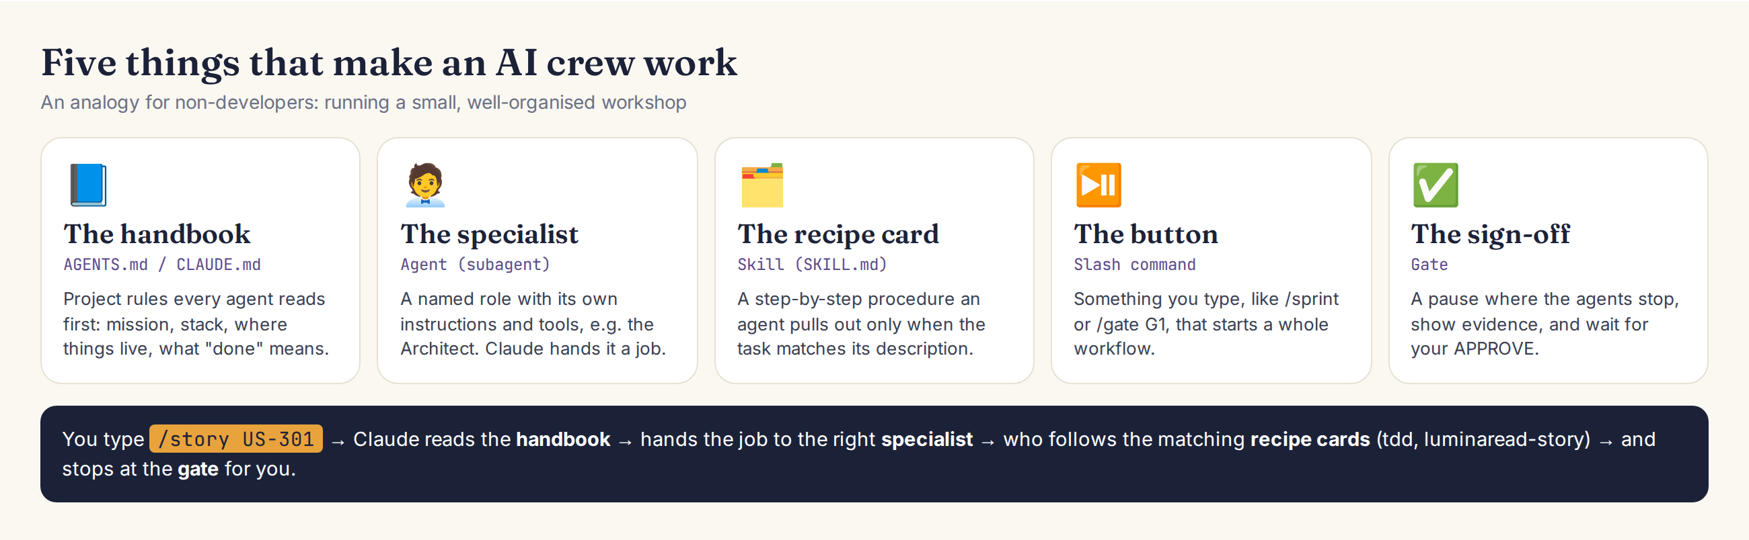
Figure 14 — Handbook, specialists, recipe cards, buttons and sign-offs
A skill is a folder containing a SKILL.md file: a short name, a one-line description of when to use it, and step-by-step instructions (optionally with scripts and templates). The agent always sees every skill's name and description, but reads the full instructions only when a task matches. So you can install many skills without cluttering the agent's attention.
WHERE: Anatomy of a skill (.agents/skills/gate-review/SKILL.md)
---
name: gate-review
description: Prepare a gate packet for the human product owner and record their decision. Use when running /gate or when any agent reaches a gate.
---
# Gate review
1. Read docs/gates/README.md for this gate's checklist.
2. Collect evidence (links, test results, screenshots) into docs/gates/<GATE>-packet.md.
3. Write the Gemini review prompt at the end of the packet.
4. STOP. Wait for "APPROVE <GATE>" or "CHANGES <GATE>" from the human.

- User-invoked skills run only when you type them (e.g., /grill-me); model-invoked skills are picked up automatically when the task fits (e.g., tdd). This split comes from Matt Pocock's repository.
- Where skills live: for Antigravity, in the project's .agents/skills/ folder (with rules in .agents/rules/, workflows in .agents/workflows/ and custom agents in .agents/agents/); the kit mirrors them into .claude/ for the Claude Code track. Some Antigravity versions use .agent/ (singular); the architect agent checks at setup.
- Skills are portable. They follow the open Agent Skills format, which Claude Code and Antigravity both support.
- Safety: skills can contain scripts. Read a third-party skill before installing it; the two repos in this plan are well known, readable Markdown.

9.3 Which of Matt Pocock's skills to use, and when
Skill | What it does | When in Twice Told | Triggered by
/grill-me, /grill-with-docs | Interviews you relentlessly about a plan; the docs version also updates CONTEXT.md and ADRs | G0 charter interview; any time a plan feels fuzzy | You
/to-spec | Turns the conversation into a spec in your tracker | After a G0/G1 discussion | You
/to-tickets | Breaks a plan into small tickets with blocking links | G3 backlog refinement (mirror into TASKS.md) | You
/implement | Builds from a spec or tickets, using /tdd and finishing with /code-review | Inside /story for a single story | You or /story
/wayfinder | Maps a huge piece of work as decision tickets | Planning R2/R3 | You
/triage | Moves bug reports through triage roles and writes agent-ready briefs | After G5 feedback | You
/improve-codebase-architecture | Scans for "deepening" opportunities and reports visually | Every 2–3 sprints | You
tdd | Red-green-refactor loop | Every implementation story | Agents automatically
prototype | Throwaway prototypes to answer design questions | G1 screens; reader bake-off | Agents automatically
research | Investigates primary sources and writes a cited Markdown file | Reader engines, model candidates, licenses | Agents automatically
domain-modeling, codebase-design | Shared vocabulary (CONTEXT.md), ADRs, deep modules | G2 and ongoing | Agents automatically
code-review | Two-axis review: standards and spec | Before every merge | Agents automatically
diagnosing-bugs | Disciplined debug loop | When something breaks | Agents automatically
wizard | Generates an interactive script to walk you through steps only you can do | Cloudflare and GitHub dashboard steps | Agents automatically
/handoff, /wait-what | Hand work to a fresh session; re-explain a confusing message in plain English | Long sessions; whenever a reply does not land | You
git-guardrails-claude-code | Hooks that block destructive git commands | Install once at setup | You (once)

Install them with the skills installer (Part 10.7), choosing Antigravity if it is listed, and run /setup-matt-pocock-skills once. Choose local files as the tracker and docs/ as the docs location; the Product Manager agent mirrors any tickets into TASKS.md, which stays the single backlog the assembly line reads. Matt's skills also rely on CONTEXT.md (a shared glossary) and ADRs — both are pre-filled in the kit.

9.4 Twice Told's own skills (in the kit)
Skill | Purpose | Used by | Key rules
luminaread-story | Take one story from TASKS.md to a merged pull request: read spec, use case and ADRs; test first; verify every acceptance criterion; update docs. | All build agents | Never mark done without passing acceptance tests; stop and ask if an input is missing.
gate-review | Assemble a gate packet (what changed, evidence, risks, checklist, questions) and the Gemini review prompt; record your decision. | Product Manager, all leads | Agents never approve a gate; only "APPROVE <gate>" from you counts.
content-pipeline | Harvest, clean, split, enrich and package the catalog with provenance. | Content Curator, AI Engineer | Mirrors only, ≥ 2 s between requests; verbatim text only; license allow-list.
cover-art | Generate covers in the house style, run automatic checks, build the contact sheet, package approved art. | Cover Artist | No text in images; no real identifiable people; record prompt, seed, model.
recsys | The recommendation maths: vectors, weights, Beta beliefs, MMR, slots, mix composer, persona simulation. | AI Engineer, developer | Deterministic; rebuild-from-log equals incremental; all in the worker.
reader-engine | How to use the ReaderEngine adapter, locators, pagination tests and EPUB sandboxing. | Reader Researcher, developer | UI never imports the engine directly; scripts disabled in content.
local-ai-eval | Run the on-device model bake-off: eval set, rubric, device matrix, report. | AI Engineer | Real catalog passages only; blind human sample at G2.
design-system | Tokens, components, typography and accessibility rules for any UI work. | UX/UI Designer, developer | Use tokens only; 44 px targets; 7:1 body text contrast.
assembly-line | Run a sprint: plans → G4 → isolated worktrees (developer → tester → reviewer) → merge queue with machine gate → regression → docs → auto-rollout → G5. | Release-manager, build crew | Humans gate only the plan and the promotion; never merge red; auto-rollout skips on failure or open concern.
gitea-forge | Open pull requests, post reviews, check statuses, merge when checks succeed, protect branches — via scripts/forge/gitea.sh. | Release-manager, architect | Token read from a file, never printed; PR-only changes to dev, test and main.

9.5 The gated pipeline
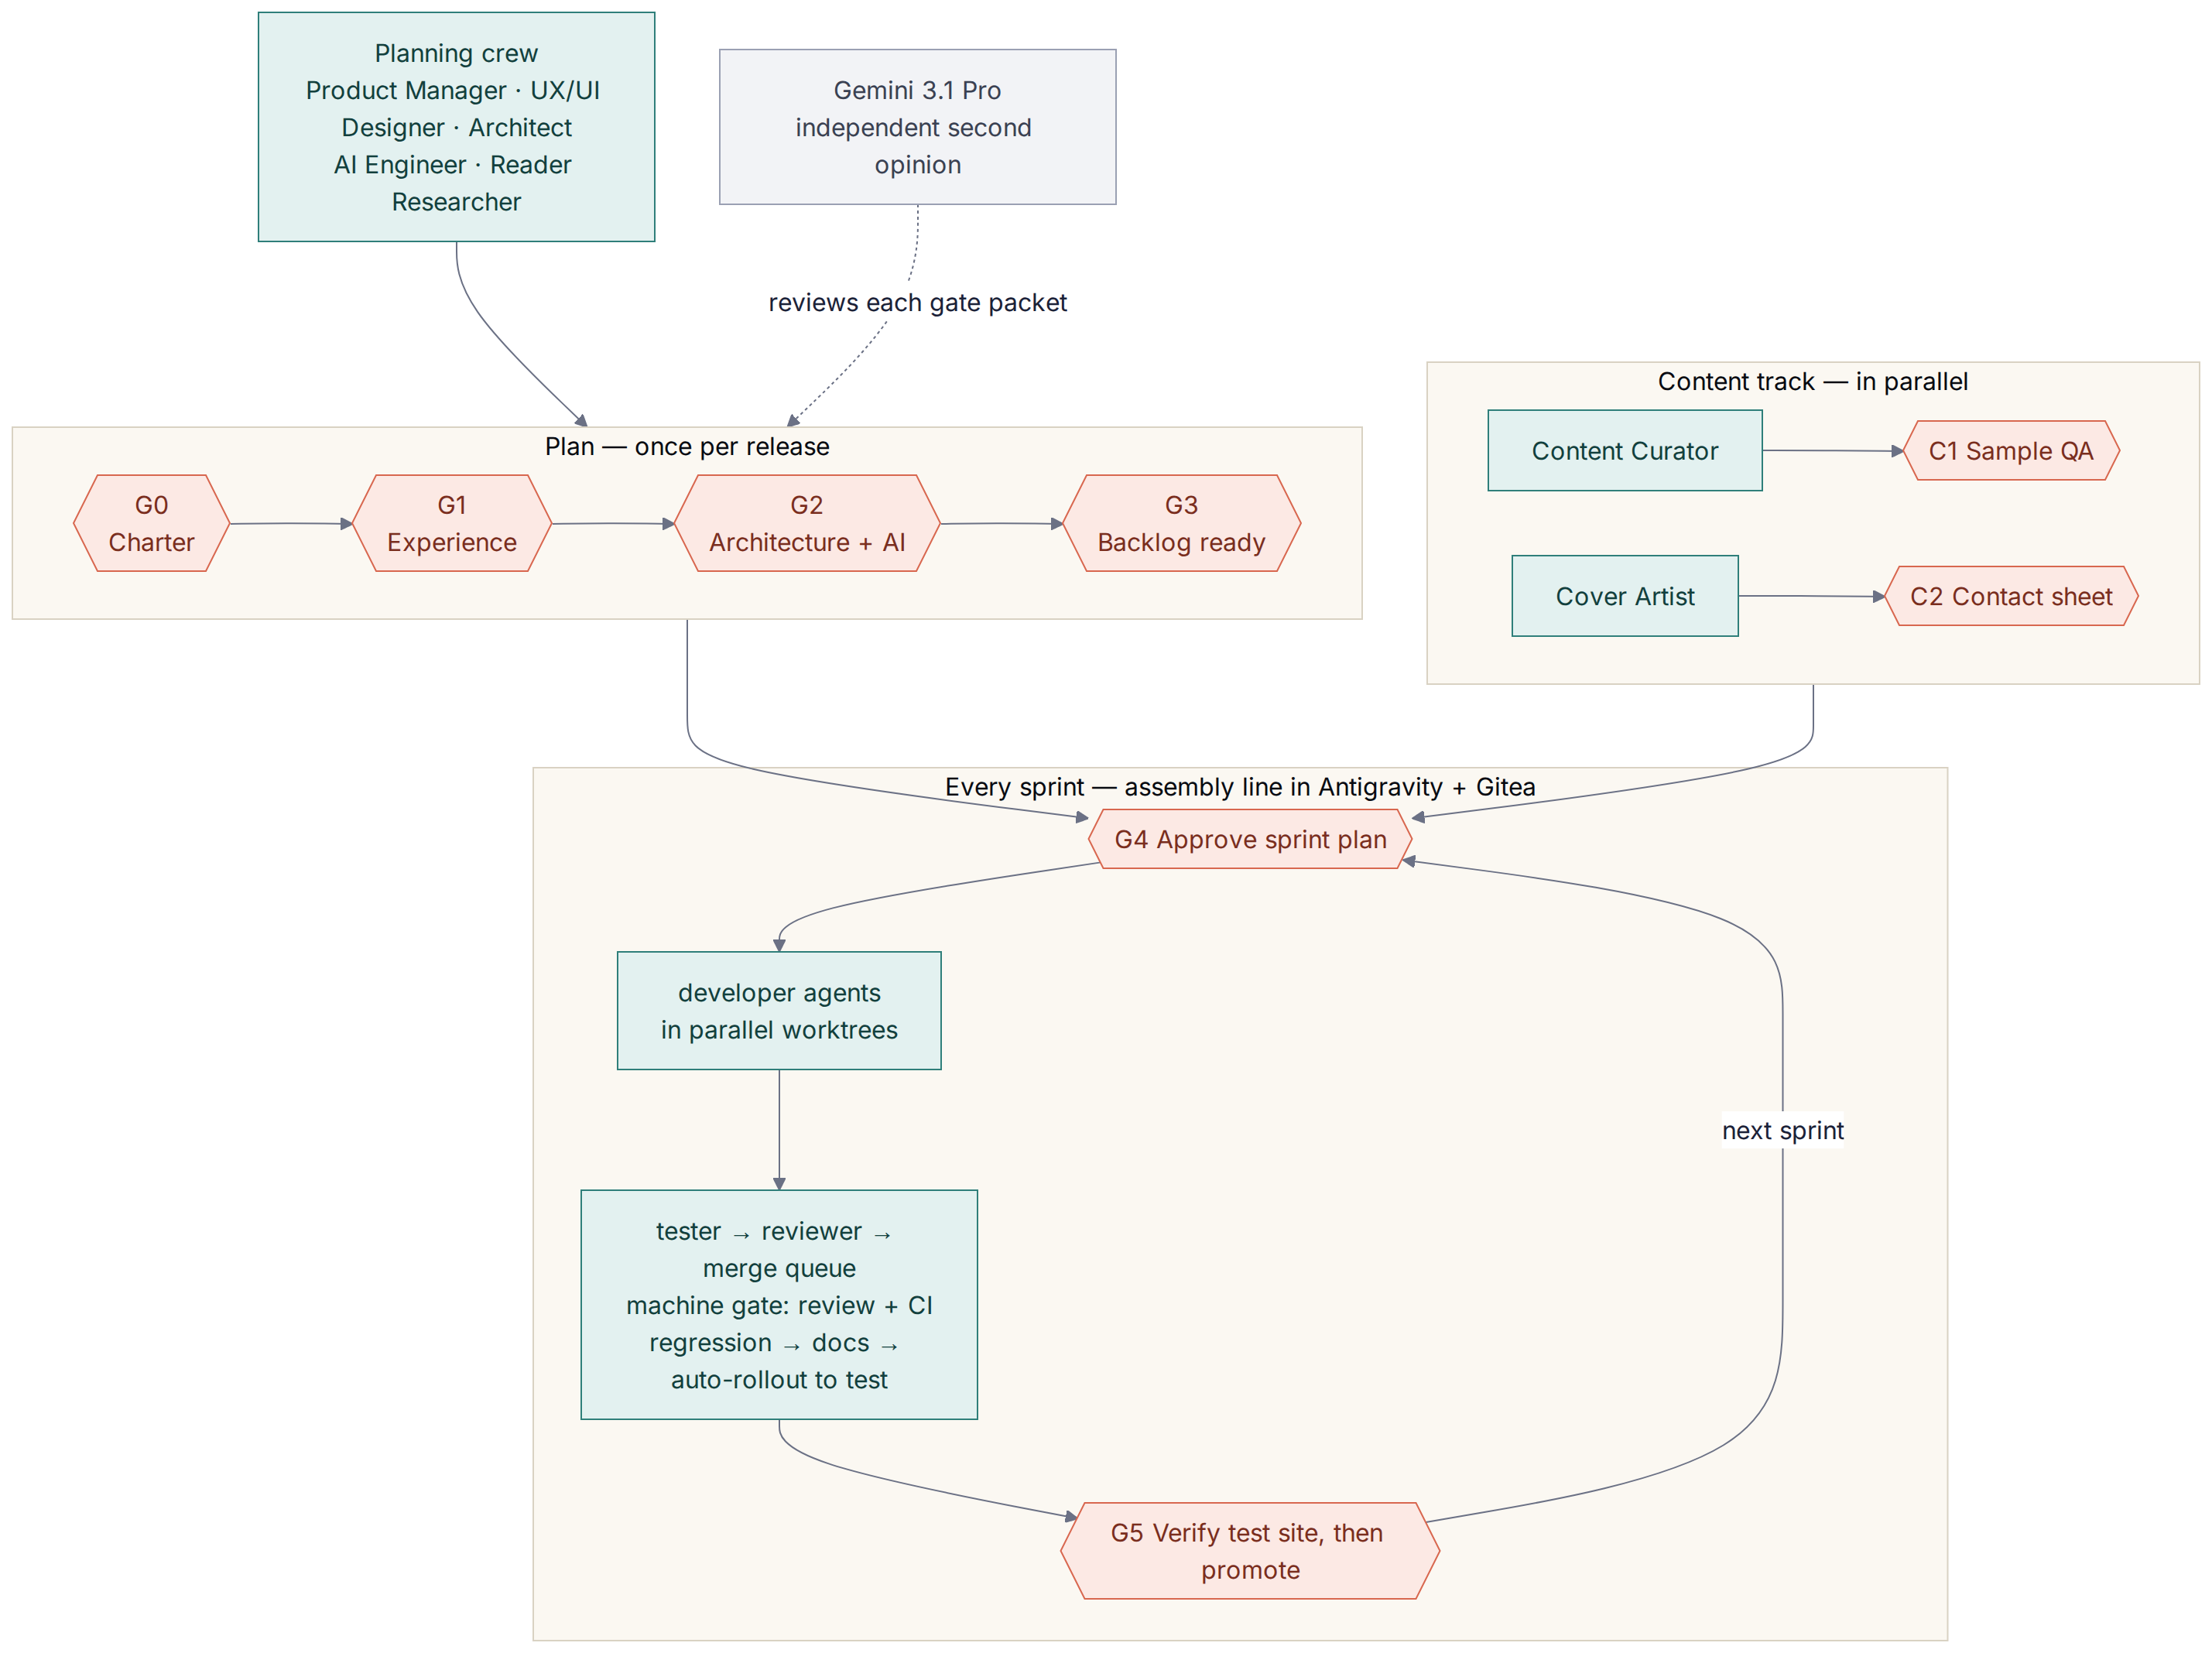
Figure 15 — Planning gates, content gates and the sprint loop

Gate | Name | Prepared by | What you check | Evidence in the packet | Your time
G0 | Charter | Product Manager (with you, via /kickoff) | Vision, audience, success metrics, scope and non-goals; decisions D1–D11 | docs/charter.md, decisions table, Gemini review notes | 30–45 min
G1 | Experience | UX/UI Designer | Clickable prototype of the core screens on your phone; design tokens; cover house style | Prototype link, tokens.json, house-style samples, accessibility notes | 30 min
G2 | Architecture & AI | Architect + AI Engineer + Reader Researcher | ADRs; reader-engine and local-model bake-off results; privacy and cost check | docs/adr/*, docs/research/reader-engines.md, docs/ai/results | 45 min
G3 | Backlog ready | Product Manager | Release scope, story order, acceptance criteria are testable | TASKS.md, docs/stories/*, story map | 30 min
C1 | Content sample | Content Curator + AI Engineer | Random sample: text boundaries, blurbs (no spoilers), content notes, licenses | Sample sheet with source links | 20–30 min per batch
C2 | Cover contact sheet | Cover Artist | Covers fit the house style, contain no text, are appropriate | HTML contact sheet | 10–20 min per batch
G4 | Plan approval | Release-manager agent (/sprint) | Groupings and PLAN files make sense; nothing you did not ask for | PLAN-*.md files | 10 min per sprint
G5 | Validate + promote | Release-manager agent (after auto-rollout to test) | Try the test site on your phone with the story checklists; then type "promote" | Test URL, CI results, sprint summary | 15–20 min per sprint

At every gate, the agents stop. You read the packet, optionally run the Gemini review (prompts P2/P4), and type APPROVE G1 or CHANGES G1 — … in Antigravity's agent chat. The decision is saved in docs/gates/decisions/. Agents are forbidden from approving gates for you.

9.6 The sprint assembly line
This implements the pipeline from the talk you photographed: humans gate only the plan and the promotion. Everything between is automated, and a machine gate stops anything that fails review or CI from merging.
Station | Who | What happens | Stops when
Backlog → written plans | Release Manager | Picks READY tasks from TASKS.md, groups them by dependency, writes PLAN-<group>.md with files, tests and sources | —
Plan approval (G4) | You | Read the plans; type APPROVE G4 or CHANGES G4 | Always — human gate
Isolated worktrees | Developer → Tester → Reviewer, per group | Each group gets its own git worktree and branch; test-first implementation; independent review | Reviewer requests changes (loops back, max 3)
Merge queue | Release Manager | One Gitea pull request per group, merged one at a time on top of the latest dev | —
Machine gate | Gitea | Branch protection requires green CI checks and the reviewer's approval; merges use "merge when checks succeed" | Any red check or missing approval
Regression → docs | Regression, Docs | Full test suite on dev; docs and release notes updated | Real bugs are logged as open concerns
Auto-rollout → test | Release Manager | Merges dev into test automatically; Gitea Actions deploys the test site | Skips itself if regression failed or a concern is open
Validate + promote (G5) | You | Try the test site on your phone with the story checklists; type promote | Always — human gate
PROD | Gitea Actions | test merges to main; Wrangler deploys production | —

- Parallel work: Antigravity 2.0 supports subagents and background tasks, so groups can run in parallel worktrees. If your version cannot, the workflow runs groups one after another with the same gates.
- Model mix: planner and developers on Gemini 3.1 Pro; tester on a faster Flash model; reviewer on a Claude model inside Antigravity, so a different model family checks the work.
- Where it lives: .agents/workflows/sprint.md and promote.md, the six build agents in .agents/agents/, the assembly-line and gitea-forge skills, scripts/forge/gitea.sh, and .gitea/workflows/ for CI and deploys.

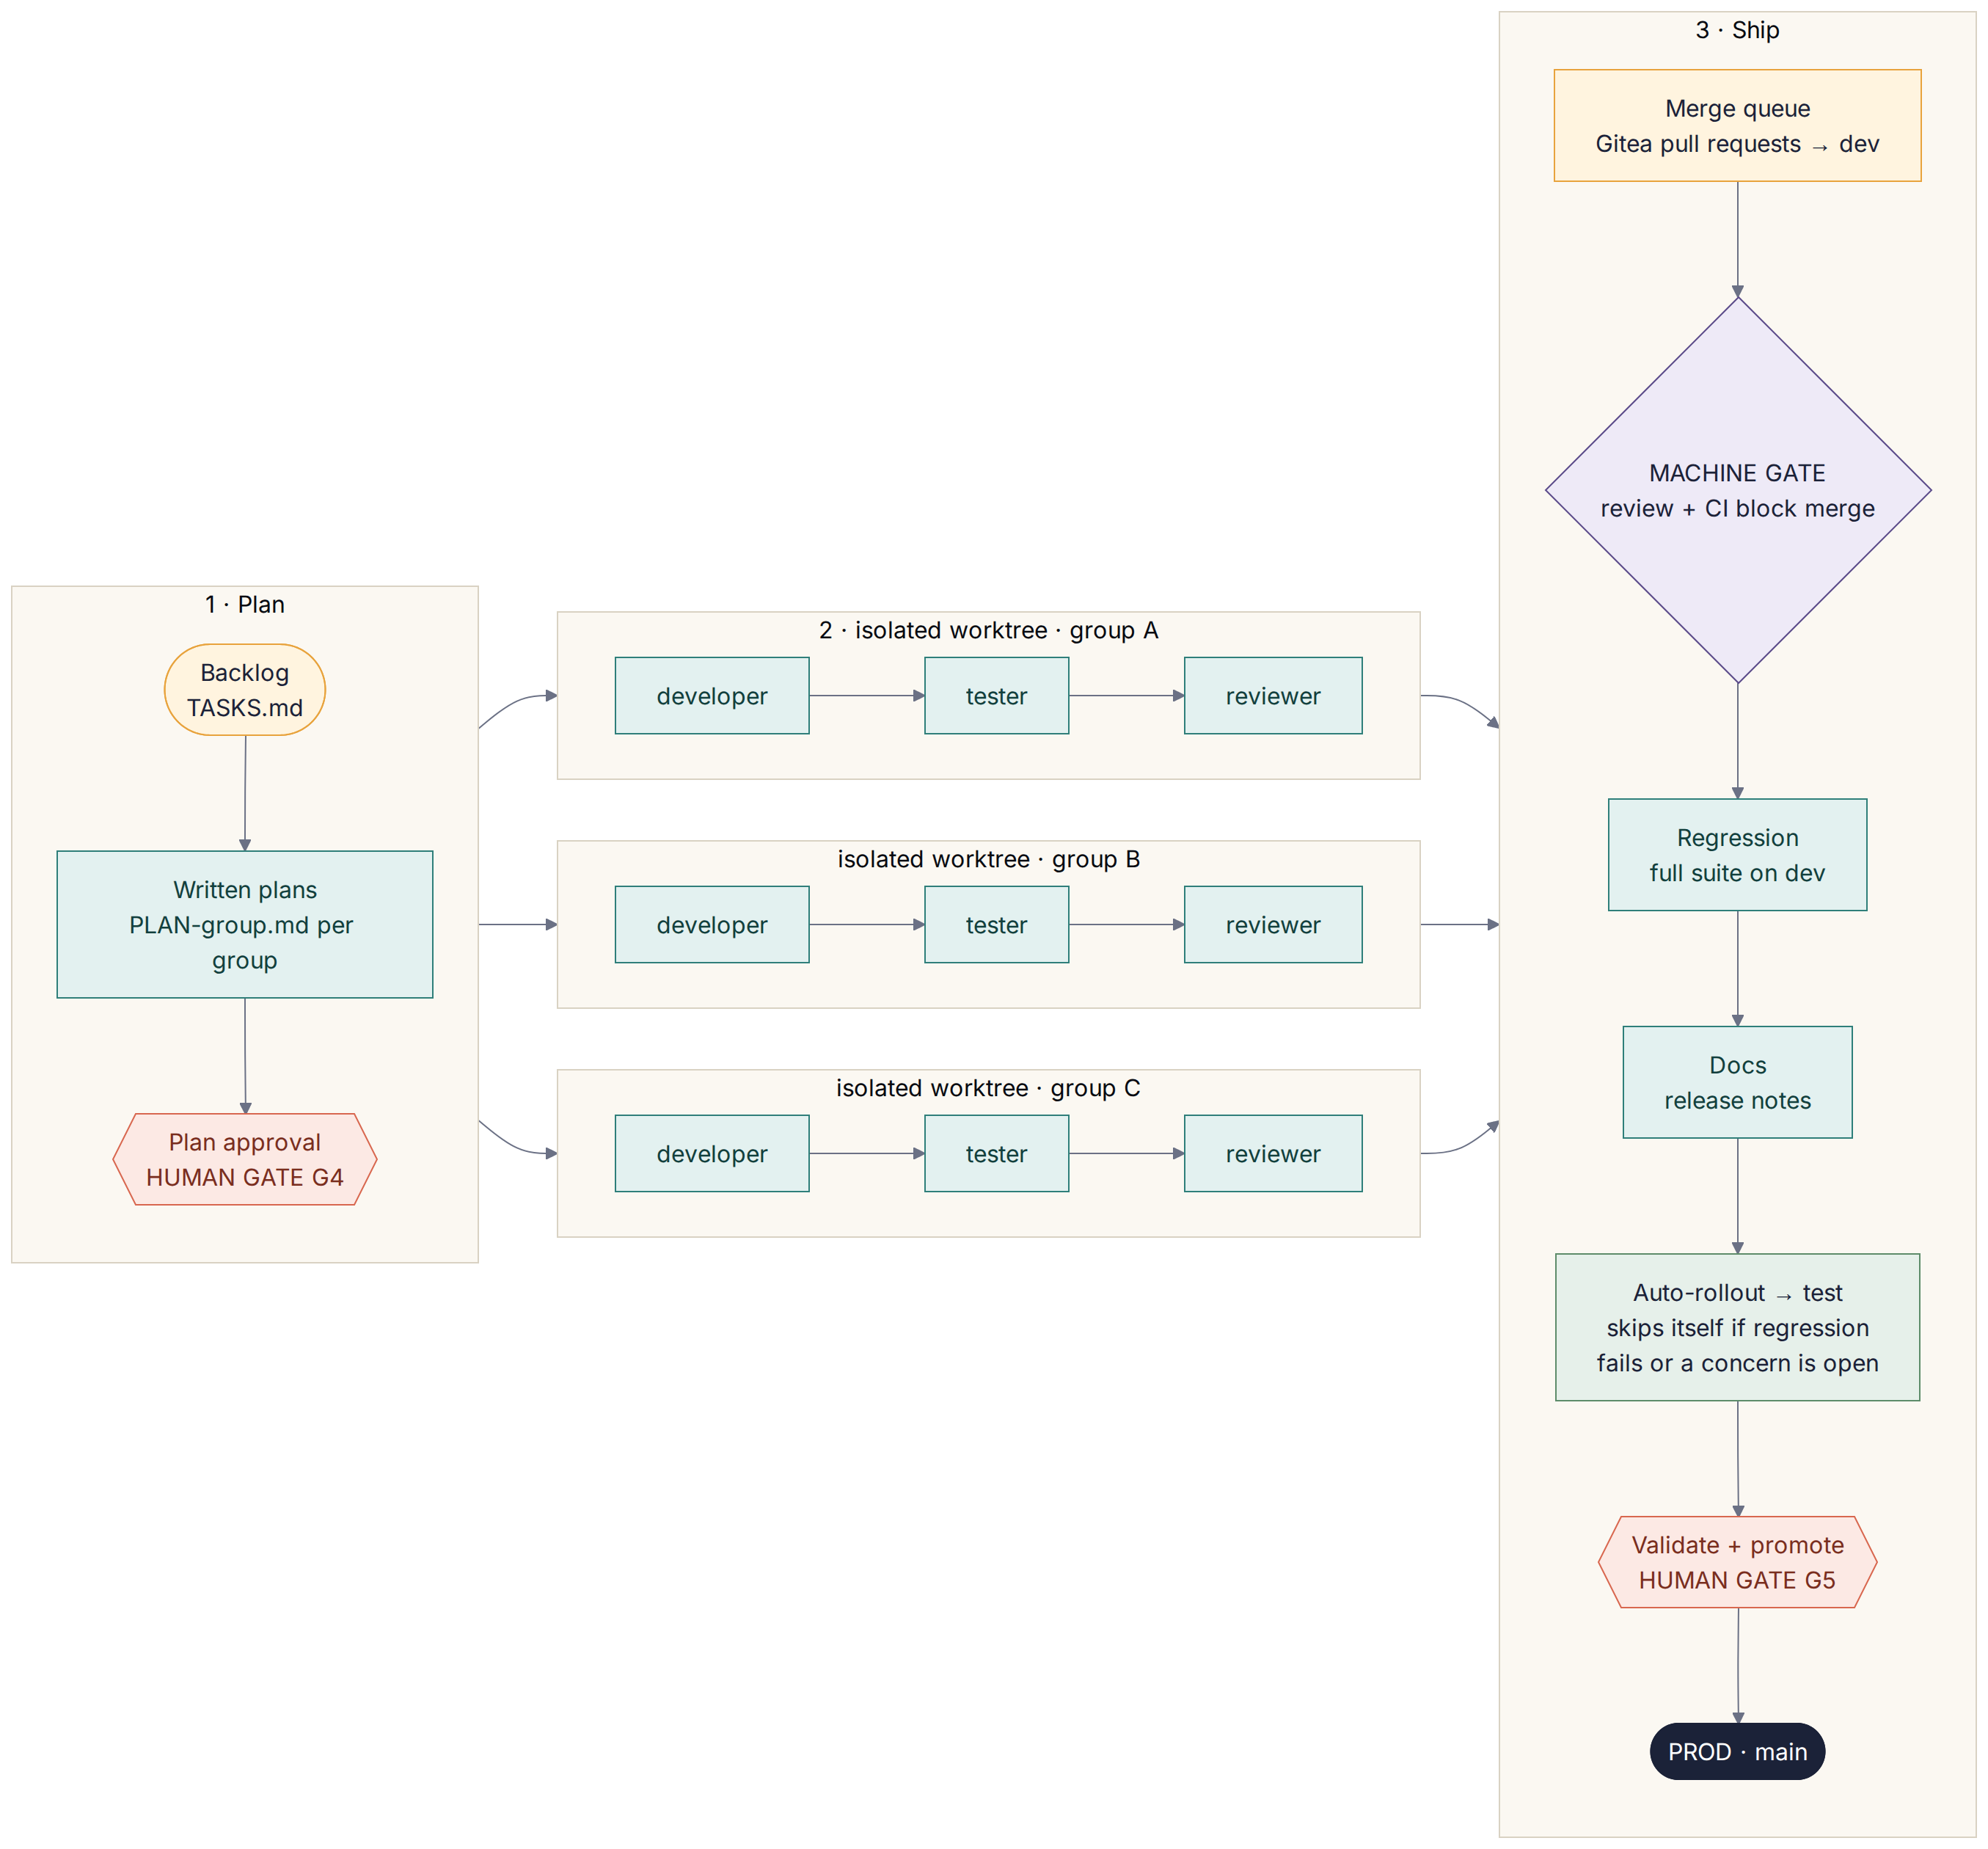
Figure 16 — The sprint assembly line: two human gates, one machine gate

9.7 Why Gitea instead of GitHub
- Private and protected for free. Gitea enforces branch protection and required checks on private repositories at no cost; on GitHub's free plan that enforcement needs a public repository (your decision D4 was private).
- It is agent-homelab's home forge. agent-homelab defaults to Gitea, and its README notes the GitHub path was only dry-run tested — so Gitea is the better-trodden path for this style of pipeline.
- Familiar CI. Gitea Actions uses GitHub-Actions-style YAML and runs on a small runner (act_runner) next to Gitea.
- Your code stays with you. Everything runs in Docker on your computer.
- Trade-offs: you run it (Docker), CI pauses when the computer sleeps, and you must back up its data folder. Cloudflare Pages cannot auto-connect to self-hosted Git, so Gitea Actions deploys with Wrangler's Direct Upload — branch URLs such as test.luminaread.pages.dev still work.
Where to run Gitea | Pros | Cons | Recommendation
Docker on your computer | Free, 15-minute setup, private | Pauses when asleep; back up regularly | Start here (D12)
Always-on mini PC / NAS | CI runs anytime; still private | Small hardware cost; some admin | Move here once sprints are routine
Gitea Cloud (managed) | No maintenance | Paid | If you never want to run servers
Codeberg (Forgejo) | Free hosting | Intended for free/open-source projects | Not for a private repo

9.8 How agent-homelab fits now
- Concept source. The assembly line follows agent-homelab's pipeline shape: plan approval, parallel worktrees, reviewer before merge, regression, auto-rollout to test, human promotion.
- Written fresh for Antigravity. agent-homelab's files are Claude Code-specific and its repository has no license file, so the kit's workflows, agents and Gitea scripts are original and do not copy its text.
- Alternative track. If you ever use Claude Code, agent-homelab can run directly against the same Gitea server (KIT_FORGE=gitea, KIT_GITEA_URL, a token in ~/.gitea-token) — installed from source into your own ~/.claude folder.

Part 10 — Step-by-step setup (no technical background needed)
Plan about two to three hours for first-time setup. Every command says where to type it. Words in this style are typed exactly. If anything fails, paste the error into Antigravity's agent chat and ask what to do — that is normal.
TIP · Six words you will see
Terminal — a window where you type commands. Docker — runs small self-contained servers on your computer. Gitea — your private code home (like GitHub, but yours). Branch — a parallel version of the project (dev, test, main). Pull request (PR) — a proposed change waiting to merge. Agent — an AI worker with one job.

10.1 Accounts and apps you need
Service | Why | Cost | Action
Google AI Pro | Antigravity (the build crew) and Gemini reviews | Your subscription | Nothing new
Google Antigravity | Where the agents work | Included with AI Pro | Download from antigravity.google and sign in
Docker Desktop | Runs Gitea and its CI runner | Free for personal use | Download from docker.com
Cloudflare | Hosting (Pages) and cover art (Workers AI) | Free tier | Create an account (needed at story EN-1203)
Standard Ebooks Patrons Circle | Feed access for the catalog | Small donation | Join before Gate C1 (D6 confirmed)

10.2 Install the tools

On a Mac
- Install Docker Desktop and Antigravity from their websites (drag to Applications, open each once, sign in to Antigravity with your AI Pro Google account).
- Open Terminal (Cmd + Space, type Terminal). Install Homebrew, then the tools:
WHERE: Terminal (Mac)
/bin/bash -c "$(curl -fsSL https://raw.githubusercontent.com/Homebrew/install/HEAD/install.sh)"

Run the two "Next steps" lines Homebrew prints, then:
WHERE: Terminal (Mac)
brew install git node jq
git config --global credential.helper osxkeychain

On Windows
Install Docker Desktop (it will switch on WSL2, Windows' built-in Linux) and Antigravity. Then open PowerShell (Admin) and run wsl --install if Ubuntu is not installed yet; restart and create a username (rajiv). In the Ubuntu terminal, install Homebrew with the same command as the Mac, run its "Next steps", then:
WHERE: Ubuntu terminal (Windows WSL2)
sudo apt update && sudo apt install -y build-essential unzip
brew install git node jq
git config --global credential.helper store

Check everything works
WHERE: Terminal (Mac) or Ubuntu terminal (Windows)
git --version
node --version
jq --version
docker --version

10.3 Start your private Gitea server
Download luminaread-starter-kit.zip from this chat and unzip it. Copy its infra/gitea folder somewhere permanent outside the project, then start Gitea:
WHERE: Terminal (Mac) or Ubuntu terminal (Windows)
mkdir -p ~/lumina-infra
cp -R ~/Downloads/luminaread-starter-kit/infra/gitea ~/lumina-infra/
cd ~/lumina-infra/gitea && docker compose up -d gitea

- Open http://host.docker.internal:3000 in your browser. (On a Mac, if it does not load, run echo "127.0.0.1 host.docker.internal" | sudo tee -a /etc/hosts in Terminal and try again.)
- On the first-run page keep the defaults (SQLite database), scroll to Administrator Account Settings, create your admin user, and click Install Gitea.
- Create an access token: your avatar → Settings → Applications → Generate New Token; give it read and write access to repository, user and organization; copy it.
- Save the token where the scripts expect it (commands below), then register the CI runner: Site Administration → Actions → Runners → Create new runner, copy the registration token, and put it in ~/lumina-infra/gitea/.env as RUNNER_TOKEN=….
WHERE: Terminal (Mac) or Ubuntu terminal (Windows)
mkdir -p ~/.config/luminaread && chmod 700 ~/.config/luminaread
printf '%s' 'PASTE-YOUR-GITEA-TOKEN' > ~/.config/luminaread/gitea-token && chmod 600 ~/.config/luminaread/gitea-token
cd ~/lumina-infra/gitea && cp .env.example .env && nano .env
docker compose up -d runner

In nano, paste the runner token after RUNNER_TOKEN=, press Ctrl+O, Enter, Ctrl+X. The runner should appear as Idle under Site Administration → Actions → Runners.

10.4 Create the Twice Told repository
WHERE: Terminal (Mac) or Ubuntu terminal (Windows)
mkdir -p ~/code
bash ~/Downloads/luminaread-starter-kit/scripts/forge/gitea-init.sh luminaread

This creates a private repository on your Gitea with branches dev, test and main, loads the starter kit as the first commit, protects all three branches, and makes three folders: ~/code/luminaread/luminaread-dev (where work happens), -test and -prod. On Windows, your Downloads folder inside Ubuntu is /mnt/c/Users/<YourWindowsName>/Downloads.

10.5 Open the project in Antigravity
- In Antigravity choose Open Folder and select ~/code/luminaread/luminaread-dev (on Windows, the folder inside Ubuntu).
- Open the agent chat and set the model to Gemini 3.1 Pro.
- Check that Antigravity sees the kit: its customization or settings area should list the Twice Told rules, skills, workflows (kickoff, gate, sprint, promote, story) and agents. If they are missing, your version may expect .agent/ instead of .agents/ — ask the agent to check and rename.
- Optional but recommended: set the reviewer agent to a Claude model for cross-model review.

10.6 Connect Cloudflare (when the architect asks)
Not needed until story EN-1203. Then use prompt P16: the Architect agent walks you through creating the Pages project luminaread as a Direct Upload project (production branch main), creating an API token with Cloudflare Pages edit and Workers AI permissions, and adding CLOUDFLARE_API_TOKEN and CLOUDFLARE_ACCOUNT_ID as Actions secrets in your Gitea repository (repository Settings → Actions → Secrets). For cover generation, the same two values also go into luminaread-dev/.env. Never paste tokens into a chat.

10.7 Install Matt Pocock's skills
WHERE: Terminal (Mac) or Ubuntu terminal (Windows)
cd ~/code/luminaread/luminaread-dev
npx skills@latest add mattpocock/skills

Choose Antigravity if it is offered (otherwise choose a generic/.agents option, or install for Claude Code and copy the chosen folders into .agents/skills/). Pick at least: setup-matt-pocock-skills, grill-me, grilling, to-spec, to-tickets, tdd, prototype, research, domain-modeling, codebase-design, code-review, diagnosing-bugs, wizard, handoff, wait-what. Then, in Antigravity:
PASTE INTO: Antigravity — agent chat in the luminaread-dev folder (model: Gemini 3.1 Pro)
/setup-matt-pocock-skills
Use local files as the tracker and docs/ as the docs location. TASKS.md stays our main backlog.

10.8 Set up your Gemini reviewer
- In the Gemini app, open Explore Gems → New Gem, name it Twice Told Reviewer and paste prompt P1 as its instructions.
- Add this SRS (docx) and, later, AGENTS.md and CONTEXT.md as the Gem's knowledge files.
- Whenever you use it, set the model picker to Pro.

10.9 Your first session: Gate G0
PASTE INTO: Antigravity — agent chat in the luminaread-dev folder (model: Gemini 3.1 Pro)
/kickoff

The Product Manager agent interviews you on the open decisions, writes docs/charter.md, and prepares the G0 packet. Upload the packet to your Gemini Gem (P2 or the per-gate prompt), bring the findings back (P4), then type APPROVE G0.

10.10 Then: G1–G3, content, and sprints
- G1 — prompt P7. G2 — prompt P8. G3 — prompt P9.
- Content — prompts P10 and P11 (they can run alongside G1–G3).
- Build — type /sprint (P12). Approve the plan (G4). The assembly line runs; you are free until it reports that the test site is ready.
- Open the test-site link on your phone, walk through the checklist, and type promote (P13).
- If a sprint misbehaves, use /story <id> (P14) one story at a time — the same gates apply.
- First sprint tip: run it on one small R0 story as a rehearsal.

10.11 Alternative track: Claude Code
The kit mirrors every agent, skill and workflow into .claude/ (workflows become commands), and CLAUDE.md points to AGENTS.md. If you ever switch, install Claude Code, open luminaread-dev, and type /kickoff (P17). agent-homelab can also run against your Gitea (Part 9.8).

10.12 Troubleshooting and safety
Situation | What to do
Gitea page does not load | Make sure Docker Desktop is running; run docker compose ps in ~/lumina-infra/gitea; add the hosts line from 10.3.
CI never starts | Check the runner is Idle under Site Administration → Actions → Runners; restart it with docker compose restart runner.
CI cannot check out the code | The runner's jobs must reach Gitea at host.docker.internal:3000; ask the architect agent to diagnose (it owns EN-1208).
Nothing happens while your laptop sleeps | Expected: Gitea and CI pause. Keep it awake during sprints, or move Gitea to an always-on device (D12).
The agent asks permission to run a command | Read it. Approve ordinary project commands (npm, git, scripts/forge) in luminaread-dev. Refuse anything outside the project, deleting data, or revealing tokens.
An agent says it is blocked on a missing file or credential | Good — the anti-fabrication rule is working. Provide it, or tell it to skip that item.
Usage limit reached | Let the agent write a handoff note (handoff skill) and continue later.
You pasted a secret by mistake | Revoke it in that service immediately and create a new one.
Backups | Weekly (or nightly) copy of ~/lumina-infra/gitea/data to cloud storage or an external drive.

Part 11 — Prompt library
Every prompt says exactly which tool it goes into. Replace anything in <angle brackets>.

P1
PASTE INTO: Gemini app → Explore Gems → New Gem (name it "Twice Told Reviewer")
You are an independent senior reviewer for Twice Told, a privacy-first e-reader that recommends free public-domain short stories and essays and learns from feedback. Other AI agents produced the plans; your job is to find what they got wrong or missed.
For every review:
1. List findings as a numbered table: ID, severity (Blocker / Major / Minor), section, finding, evidence or reasoning, recommended change.
2. Check factual claims about tools, versions, licenses and pricing. If you cannot verify something, say so rather than guessing.
3. Flag anything a non-technical product owner could not follow.
4. End with: the 3 changes you would make first, and anything you agree is well done.
Be direct. Do not rewrite the whole document.

P2
PASTE INTO: Gemini app → your "Twice Told Reviewer" Gem → model picker set to Pro → attach Twice Told_SRS_v2.docx
Review the attached Twice Told SRS v2.1 end to end. Focus on: (a) whether the product plan matches the goal of short reads first, then a mix with longer works, with feedback loops; (b) the build-time Content Factory, the on-device recommender and the local-model plan; (c) the Antigravity + Gitea sprint assembly line and its human and machine gates; (d) whether the setup guide is truly followable by a non-technical person; (e) licensing and privacy risks, including the added content sources; (f) gaps in the epics, use cases and user stories. Use the finding table format.

P3
PASTE INTO: Antigravity — agent chat in the luminaread-dev folder (model: Gemini 3.1 Pro)
/kickoff

P4
PASTE INTO: Antigravity — agent chat in the luminaread-dev folder (model: Gemini 3.1 Pro) — after a Gemini review
Here is Gemini 3.1 Pro's review of gate <GATE>:
<paste Gemini's findings table>
Triage every finding: accept, partially accept or reject, with one line of reasoning each. Apply accepted changes to the docs, list what changed, then run /gate <GATE> again so I can decide.

P5
PASTE INTO: Antigravity — agent chat in the luminaread-dev folder (model: Gemini 3.1 Pro) — approve a gate
APPROVE <GATE> — notes: <anything you want recorded>

P6
PASTE INTO: Antigravity — agent chat in the luminaread-dev folder (model: Gemini 3.1 Pro) — send a gate back
CHANGES <GATE> — <what you want changed>

P7
PASTE INTO: Antigravity — agent chat in the luminaread-dev folder (model: Gemini 3.1 Pro) — Gate G1 (experience)
Use the ux-designer agent. Build the G1 clickable prototype of the 12 core screens described in docs/SRS.md Part 3 using docs/design/tokens.json and the mock-ups in docs/design/mockups, include 3 cover house-style samples, tell me how to open it on my phone, then run /gate G1.

P8
PASTE INTO: Antigravity — agent chat in the luminaread-dev folder (model: Gemini 3.1 Pro) — Gate G2 (architecture and AI)
Use the reader-researcher agent to run EN-601 (reader engine bake-off) and the ai-engineer agent to run EN-801 (local model bake-off), then have the architect agent update ADRs 0001–0008 from the evidence and confirm the Gitea + Cloudflare setup (D10, D12). Run /gate G2 when done.

P9
PASTE INTO: Antigravity — agent chat in the luminaread-dev folder (model: Gemini 3.1 Pro) — Gate G3 (backlog ready)
Use the product-manager agent. Re-check TASKS.md and docs/stories against the approved G0–G2 decisions, make every story independently testable, confirm the R0 and R1 order, and run /gate G3.

P10
PASTE INTO: Antigravity — agent chat in the luminaread-dev folder (model: Gemini 3.1 Pro) — content batch (Gate C1)
Use the content-curator agent with the content-pipeline skill. Build a first batch of 25 works (15 short stories, 7 essays, 3 longer works) from the sources in docs/content/sources.md, prepare the C1 sample sheet, and run /gate C1.

P11
PASTE INTO: Antigravity — agent chat in the luminaread-dev folder (model: Gemini 3.1 Pro) — covers batch (Gate C2)
Use the cover-artist agent with the cover-art skill. Generate covers for the works approved at C1, produce the contact sheet, and run /gate C2.

P12
PASTE INTO: Antigravity — agent chat in the luminaread-dev folder (model: Gemini 3.1 Pro) — start a sprint (the assembly line)
/sprint

P13
PASTE INTO: Antigravity — agent chat in the luminaread-dev folder (model: Gemini 3.1 Pro) — after you have checked the test site on your phone (Gate G5)
promote

P14
PASTE INTO: Antigravity — agent chat in the luminaread-dev folder (model: Gemini 3.1 Pro) — single-story fallback
/story EN-1201

P15
PASTE INTO: Antigravity — agent chat in the luminaread-dev folder (model: Gemini 3.1 Pro) — when something breaks
Something went wrong: <paste what you saw>. Diagnose it step by step (use the diagnosing-bugs skill if installed), explain the cause in plain English, and propose the smallest fix. Do not change anything until I say go.

P16
PASTE INTO: Antigravity — agent chat in the luminaread-dev folder (model: Gemini 3.1 Pro) — connect Cloudflare (when the architect asks)
Use the architect agent and the wizard skill to walk me, one step at a time, through creating the Cloudflare Pages project "luminaread" (Direct Upload, production branch main), creating the API token, and adding CLOUDFLARE_API_TOKEN and CLOUDFLARE_ACCOUNT_ID as Gitea Actions secrets. Wait for me to confirm each step.

P17
PASTE INTO: Claude Code (alternative track) — in luminaread-dev
/kickoff

Part 12 — Risks, assumptions, glossary and references

12.1 Risks and mitigations
Risk | Likelihood | Impact | Mitigation
The assembly line is a new port of agent-homelab's ideas to Antigravity | Medium | High | First sprint: one small R0 story as a dry run; /story fallback; short, explicit workflow steps.
Gitea runs on your laptop: CI pauses while it sleeps; disk loss loses history | Medium | High | Nightly backup of the Gitea data folder; optional push mirror; move to an always-on device later (D12).
Antigravity folder conventions change (e.g., .agent vs .agents) | Medium | Low | The architect agent verifies discovery at setup (EN-1207); the kit notes both names.
The same model builds and reviews (shared blind spots) | Medium | Medium | Reviewer agent on a Claude model inside Antigravity; Gemini-app reviews at planning gates.
Usage limits interrupt long agent sprints | Medium | Medium | Small sprints; /handoff; stagger content and code work; consider a higher plan tier.
Small on-device models give wrong explanations of archaic prose | High | Medium | Bake-off with go/no-go; glossary grounding; short outputs; "Labs" label; feedback button.
Public-domain status differs outside the US | Medium | High | US-PD basis stated in About; lawyer review before public launch; option to geo-limit later.
Generated blurbs spoil endings or misstate content | Medium | Medium | Self-check prompt; human sampling at C1; reviewed flag; easy correction path.
Offensive historical content surprises readers | High | Medium | Content notes, filters (US-1004), 16+ audience, curator exclusions.
Browser storage eviction wipes a reader's DNA | Medium | High | persist(), install prompt, export reminders (US-1005).
foliate-js API changes | Medium | Medium | Pin a commit; ReaderEngine adapter; Readium plan B.
Free-tier limits change (Cloudflare, Pollinations, Gemini API) | Medium | Low | Build-time only; resumable pipelines; alternatives documented.
WebGPU driver quirks produce garbage output on some GPUs | Medium | Medium | Device matrix in bake-off; sanity check on output; WASM or glossary fallback.
Agents fabricate "source" material or test fixtures | Low | High | Anti-fabrication rule in AGENTS.md; code_quality hunts for it; provenance checksums.
Scope creep from the agents | Medium | Medium | G4 plan approval; stories must trace to TASKS.md; /review-plan.
Secrets committed to the repo | Low | High | .env ignored; secret scanning; git guardrails; never paste tokens into chat.
Name conflict / trademark | Medium | Medium | Trademark search before launch (D9).

12.2 Assumptions
- Decisions D1–D11 hold as recommended until you change them at G0.
- You have Google AI Pro (Antigravity and Gemini 3.1 Pro); a Claude subscription is optional.
- Docker Desktop can run on your computer, and it is awake during sprints.
- Your computer is a Mac (macOS 13+) or Windows 10/11 able to run WSL2, with at least 8 GB RAM.
- Free tiers named here remain broadly as described (checked September 2026); pipelines are resumable if limits change.
- English-language catalog for the MVP; US public-domain basis.

12.3 Glossary
Term | Meaning
Reading DNA | The reader's on-device taste profile: taste vector, facet beliefs, reading context.
Work | One readable item: a story, essay, novella or novel.
Shortlist / slot | The curated set of picks; each position (hero, short reads, essays, wildcard) is a slot.
Reading ladder / rung | The optional path from short stories to novels; each length class is a rung.
Signal / event | Anything the reader does that teaches the app (explicit or implicit), stored in the event log.
Facet | A property of a work used for learning (genre, mood, era, form, length, level).
Content Factory | The build-time pipeline that prepares the catalog.
Provenance | Where a text came from, its license, retrieval date and checksum.
Embedding / vector | A list of numbers representing meaning; similar works have similar vectors.
PWA | Progressive Web App — a website that installs and works offline like an app.
Agent / subagent | An AI worker with a role, instructions and tools.
Skill | A folder with a SKILL.md recipe an agent loads when relevant.
Gate | A human decision point where agents stop and wait.
Worktree | A separate folder for one branch, so agents can work in parallel.
ADR | Architecture Decision Record — a short note of one decision and why.
MoSCoW | Must, Should, Could, Won't — a priority scale.

12.4 References (checked September 2026)
- Gemini release notes — gemini.google/release-notes
- Gemini 3.5 Pro status — eesel.ai/blog/gemini-3-5-pro
- Gemini CLI to Antigravity transition — developers.googleblog.com
- Claude Code setup — code.claude.com/docs/en/getting-started
- agent-homelab — github.com/jhjacobson/agent-homelab
- Matt Pocock's skills — github.com/mattpocock/skills
- Project Gutenberg robot access policy — gutenberg.org/policy/robot_access.html
- Project Gutenberg offline catalogs — gutenberg.org/ebooks/offline_catalogs.html
- Standard Ebooks bulk downloads — standardebooks.org/bulk-downloads
- Cloudflare Workers AI pricing — developers.cloudflare.com/workers-ai/platform/pricing
- foliate-js — github.com/johnfactotum/foliate-js
- Transformers.js v4 demos — huggingface.co/collections/webml-community/transformersjs-v4-demos
- Gemma 4 E2B for Transformers.js — huggingface.co/onnx-community/gemma-4-E2B-it-ONNX
- Antigravity rules, skills and workflows — kdnuggets.com
- Cloudflare Pages Git integration and Direct Upload — developers.cloudflare.com/pages/get-started/direct-upload
- The Conversation republishing guidelines — theconversation.com/us/republishing-guidelines
- Chronicling America and the loc.gov API — chroniclingamerica.loc.gov/about/api

Appendix — What is in the starter kit
Path | What it is
README.md | Start here, in plain English
AGENTS.md | The handbook every agent reads first (CLAUDE.md and GEMINI.md point to it)
CONTEXT.md | Shared glossary (ubiquitous language) used by agents and Matt Pocock's skills
TASKS.md | The backlog in agent-homelab format (80 items)
docs/SRS.md | This document in Markdown
docs/stories/*.md | One file per story with acceptance criteria and handoff
docs/use-cases/*.md | The 12 fully dressed use cases
docs/story-map.md, docs/epics.md | Story map and epics as text
docs/gates/ | Gate checklists; decisions/ records your approvals
docs/adr/ | Eight proposed architecture decisions for G2
docs/diagrams/*.mmd | All diagrams as editable Mermaid source
docs/design/ | Tokens, design-system notes, mock-up images
docs/content/ | Sources and license rules, cover house style, catalog schema
docs/ai/eval-plan.md | Local-model bake-off plan and prompt
docs/prompts/ | Gemini review prompts
.agents/agents/ | 13 Antigravity custom agents: 7 specialists + 6 build crew
.agents/skills/ | 10 Twice Told skills
.agents/workflows/ | /kickoff, /gate, /sprint, /promote, /story
.agents/rules/ | Always-on project rules
.claude/ | Mirror of agents, skills and workflows for the Claude Code track
.gitea/workflows/ | CI (the machine gate) and Cloudflare deploys
infra/gitea/ | Docker Compose for Gitea + runner
scripts/forge/ | gitea.sh helpers and gitea-init.sh

