**ABOUT ME**

Recently Computer science graduate with a passion for developing scalable web application &working across the full stack.i m looking to join the technologies to continue to grow my skill set.”smarter,and happier.”

**CONTACT ME**



**Address**

Rajgurungar, Pune

Maharashtra.

  

**Phone**

+91 7743807472

+91 9881208082

✓

**Web**

razzakshaikh8800@gmail.com

[rahilllshaikh77@gmail.com](mailto:rahilllshaikh77@gmail.com)

**In** [www.linkedin.com/in/rajjak-](http://www.linkedin.com/in/rajjak-)shaikh-271216243

Github https://github.com/rajjakShaikh

**HOBBIES**



Movie



Travel

✪

Photography



Music



Books

**EDUCATION**

“**BACHELOR OF COMPUTER SCIENCE**”

**PUNE UNIVERSITY**

* **DR.D.Y PATIL INSTITUTE of Technology COLLEGE PIMPRI,PUNE**

**Degree Passing Year APRIL (2022)**

**CGPA : 8.25/10 GRADE : A+**

* **Ad.R.J.K. COLLEGE- 12th**

Percentage 58%(sci)

* **K.B.patil school- 10th**

Percentage 82%

Percentage 58(sci)

Percentage 58(sci)

**LANGUAGES**

**COURSES**

**TECHNOSCRIPT INSTITUTE PUNE**

**MERN STACK DEVOLOPER**

**Other skills:  
 Team Working**

**Good Communication**

**Decision Making**

**SKILLS**

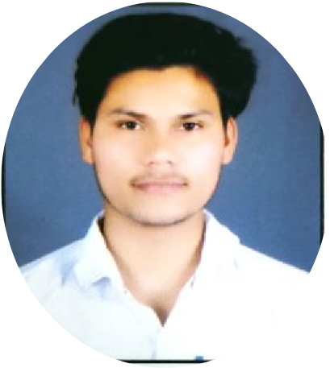

**Rajjak shaikh**

**MERN STACK**

**WEB DEVELOPER**