Write a program to accept time in hours and minutes in two different instances and displaying instances and

Displaying the total time by passing instances as an argumentin other class method(pass the instances

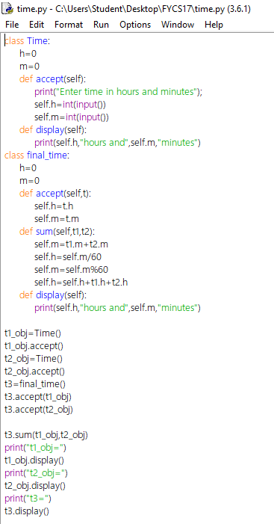

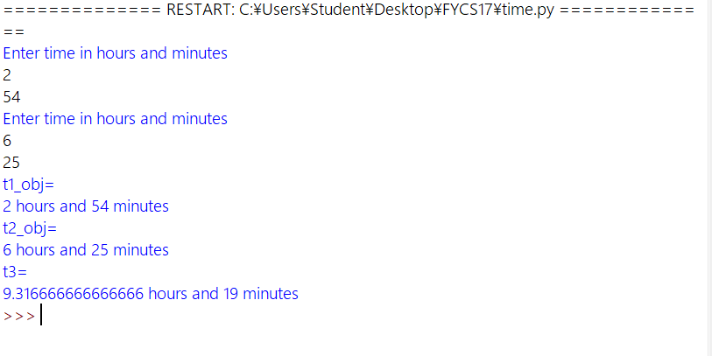

Define a class employee to accept information such as company name, address, emp-id, name, qualification, designation, basic salary. Calculate the next salary using the info (ta=70%of basic DA=70%of basic,HRA=25%of basic, Epf=10%of basic, net salary=basic+ta+da+hra-epf)

