The Research Lifecycle in Three Supply Chain Shortage Studies

[Student Name]
College of Business, Bellevue University
[Course Number]: [Course Name]
[Instructor Name]
October 11, 2026

The Research Lifecycle in Three Supply Chain Shortage Studies
The research lifecycle runs from identifying a problem through design, data collection, analysis, interpretation, and dissemination, with ethical obligations carried through every stage. This paper traces that lifecycle in three studies of supply chain shortage and access, a topic central to my proposed study, Mitigation of Supply Chain Uncertainties Caused by Material Shortage During Ramp-Up, which examines semiconductor manufacturing equipment providers and their suppliers. The qualitative approach is illustrated by the document review and group interview strand of Namisango et al. (2017), the quantitative approach by the analytical model of Kouvelis et al. (2023), and the mixed methods approach by Asamoah et al. (2021). Two further studies, Singh et al. (2026) and Bimha et al. (2019), provide supporting comparisons. Table 1 and Figure 1 summarize the three lifecycles.
Qualitative Approach: Namisango et al. (2017)
Research Problem, Purpose, and Questions
Namisango et al. (2017) addressed the problem that patients in Southern Africa lack reliable access to opioids for clinical pain management despite clear medical need. The purpose was to identify country-specific and regional barriers to opioid access and administration and to generate recommendations for improving pain management. The guiding questions asked how practices, legislation, the supply chain, and regulation restrict availability. Consistent with exploratory inquiry, the qualitative strand stated no hypotheses.
Methodology and Design
The overall study used a parallel mixed methods design across Mozambique, Swaziland, and Zimbabwe, and this paper examines its qualitative strand. That strand fit the problem because the barriers were embedded in laws, institutional practices, and stakeholder experience rather than in measurable variables. The design was multi-sectoral and cross-national, drawing stakeholders from across the opioid supply chain in each country (Namisango et al., 2017).
Research Instruments and Analysis
The qualitative instruments were a structured review of national regulatory and policy documents and group interview guides used with stakeholders. Documents and interview data were analyzed to identify barriers at each level of the supply chain, and the results were compared across the three countries and with a parallel key informant survey (Namisango et al., 2017).
Key Findings
The study identified overly restrictive controlled-medicines laws, stigmatizing language in key documents, inaccurate estimation of opioid consumption, knowledge gaps about distribution, storage, and prescribing, a critical shortage of prescribers, and high out-of-pocket costs for patients (Namisango et al., 2017). The authors recommended updating policies and laws and addressing barriers at every level of the supply chain (see Figure 2).
Ethical and Legal Implications
Group interviews with officials and clinicians require ethical clearance, informed consent, and protection of participants who may criticize their own institutions; because group members hear one another, confidentiality can only be partly assured. The legal implications are central: national narcotics laws and international drug control obligations shaped the supply chain itself, so the researchers had to report legal barriers accurately without encouraging noncompliance.
Quantitative Approach: Kouvelis et al. (2023)
Research Problem, Purpose, Questions, and Hypotheses
Kouvelis et al. (2023) addressed material shortages in project supply chains, where an engineer-to-order or make-to-order firm depends on a contract supplier for a key material while facing uncertain activity times and uncertain material consumption. The purpose was to determine how the firm should combine inventory, time buffers, and supplier flexibility. The research questions asked how the firm should jointly set its promised due date and advance material order, and how contract terms allocate shortage risk between firm and supplier. In place of statistical hypotheses, the analytical model produced formal propositions about optimal decisions.
Methodology and Design
The methodology was quantitative and deductive. The design was an analytical stochastic model of a project firm and its supplier operating under a flexible wholesale price contract with a discounted advance order price and a higher expedite price (Kouvelis et al., 2023). Singh et al. (2026) illustrate the same quantitative logic in a humanitarian setting by building a shortage mechanism and realistic constraints directly into an optimization model.
Research Instruments and Analysis
In modeling research, the instrument is the mathematical model: decision variables (due date and order quantity), random variables (activity time and material consumption, which may be positively or negatively correlated), and cost parameters such as late-delivery penalties. Kouvelis et al. (2023) analyzed the model by deriving optimal policies and examining how they change as uncertainty, penalties, and contract prices change (see Figure 3).
Key Findings
The due date and the material order generally act as substitutes, so a longer time buffer can replace inventory and the reverse. Greater uncertainty always increases material orders but may lengthen or shorten the due date. The discounted advance price shifts inventory risk to the firm, while the expedite price leads the supplier to hold safety stock (Kouvelis et al., 2023).
Ethical and Legal Implications
Modeling studies involve no human participants, but they carry ethical duties of transparency: assumptions, parameter values, and limits must be stated so that managers do not over-apply results. Legally, the findings depend on contract terms such as penalty clauses and expedite pricing, which must be enforceable and fairly negotiated, particularly when the supplier has more bargaining power.
Mixed Methods Approach: Asamoah et al. (2021)
Research Problem, Purpose, and Questions
Asamoah et al. (2021) addressed gaps in how health care providers maintain the vaccine cold chain, where temperature failures destroy supply and endanger patients. The purpose was to assess providers' knowledge, attitudes, practices, and challenges in cold chain management. The questions asked what providers know and believe, how they practice, whether knowledge and attitudes are related, and what obstacles they face.
Methodology and Design
The methodology was mixed methods with a concurrent design at 12 health facilities in the Sekyere Central District of Ghana (Asamoah et al., 2021). Quantitative and qualitative data were collected in the same period and integrated at interpretation. Bimha et al. (2019) used a comparable concurrent parallel design to study supply chain management practices and competitiveness in the Zimbabwean petroleum industry, choosing it for its robustness in complex supply chain settings.
Research Instruments and Analysis
The instruments were a survey questionnaire completed by 86 providers, an observation checklist applied at 12 cold chain sites, and interview guides for 11 key informants (see Figure 4). Quantitative data were analyzed with descriptive statistics and correlation analysis, and interview data were coded inductively into themes (Asamoah et al., 2021).
Key Findings
Most participants showed good knowledge (68.6%) and good attitudes (67.4%), but the relationship between knowledge and attitudes was weak. Interviews identified inadequate personnel, erratic power supply, logistical constraints, and transportation difficulties as major challenges, and the authors recommended continuing education, adequate resources, and stronger monitoring (Asamoah et al., 2021).
Ethical and Legal Implications
Studying health workers requires ethical approval, informed consent, and assurance that findings about poor practice will not be used against individuals. Observation raises added duties to avoid disrupting care and to report unsafe storage. Legally, vaccine handling is governed by national immunization regulations, so findings imply compliance gaps that facilities must address.
Comparative Synthesis and Implications for the Proposed Study
The research lifecycle changes with methodology. Namisango et al. (2017) built understanding inductively from documents and stakeholders, Kouvelis et al. (2023) deduced optimal decisions from a formal model, and Asamoah et al. (2021) combined measurement with lived experience. The findings converge: shortages arise from weak estimation and visibility, rigid rules, limited capacity, and fragile logistics, and they are reduced by buffers, flexible supplier terms, and monitoring.
For my proposed qualitative case study, Namisango et al. (2017) offer a model for combining document review with stakeholder interviews; Kouvelis et al. (2023) and Singh et al. (2026) provide constructs and analytics for interpreting inventory, time buffers, and supplier flexibility during ramp-up; and Asamoah et al. (2021) show how observation can verify what participants report. Because semiconductor firms operate under nondisclosure agreements and export controls, IRB approval, informed consent, de-identification of firms, and careful screening of proprietary documents will be essential. The Appendix translates these findings into a shortage risk-scoring algorithm.
Table 1
Comparison of the Research Lifecycle Across the Three Studies
Element | Namisango et al. (2017) | Kouvelis et al. (2023) | Asamoah et al. (2021)
Method | Qualitative strand of a parallel mixed methods study | Quantitative (analytical modeling) | Mixed methods (concurrent)
Problem | Barriers to opioid access and supply in Southern Africa | Material shortages in engineer-to-order project supply chains | Gaps in vaccine cold chain practice
Questions / hypotheses | How practices, law, supply chain, and regulation limit access; no hypotheses | Optimal due date and material order; formal propositions | Knowledge, attitudes, practices, challenges; relationship tests
Design | Multi-sectoral, cross-national (3 countries) | Stochastic model of firm and contract supplier | Concurrent design at 12 facilities
Instruments | Policy document review, group interview guides | Mathematical model and parameters | Survey (86), observation checklist (12 sites), interviews (11)
Analysis | Document and interview analysis by supply chain level | Derivation of optimal policies; sensitivity | Descriptive statistics, correlation, thematic coding
Key findings | Restrictive laws, poor estimation, prescriber shortage, high costs | Time and inventory buffers substitute; contract terms shift risk | 68.6% good knowledge; staffing, power, transport gaps
Ethics / legal | Consent, partial confidentiality, narcotics law | Transparency of assumptions; contract law | Consent, observation duties, immunization rules
Note. Compiled by the author from Namisango et al. (2017), Kouvelis et al. (2023), and Asamoah et al. (2021). Column colors match Figure 1: blue = qualitative, orange = quantitative, green = mixed methods.
Figure 1
Research Lifecycle Stages in the Qualitative, Quantitative, and Mixed Methods Studies
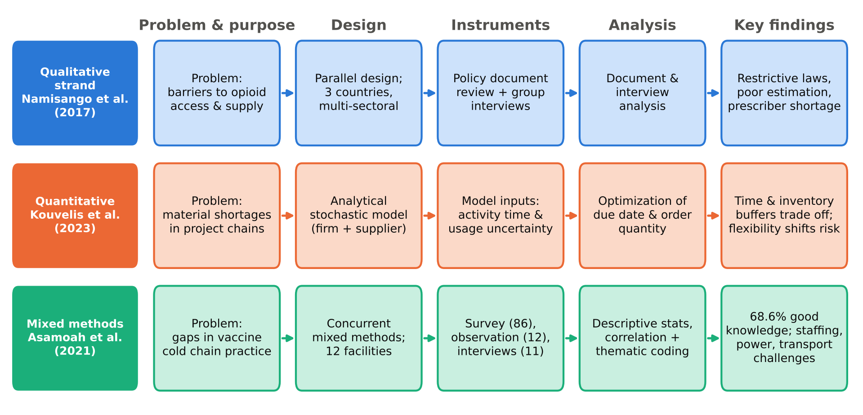
Note. Each row traces one study from problem to findings. Compiled from Namisango et al. (2017), Kouvelis et al. (2023), and Asamoah et al. (2021).
Figure 2
Barriers to Opioid Availability Mapped to Supply Chain Stages
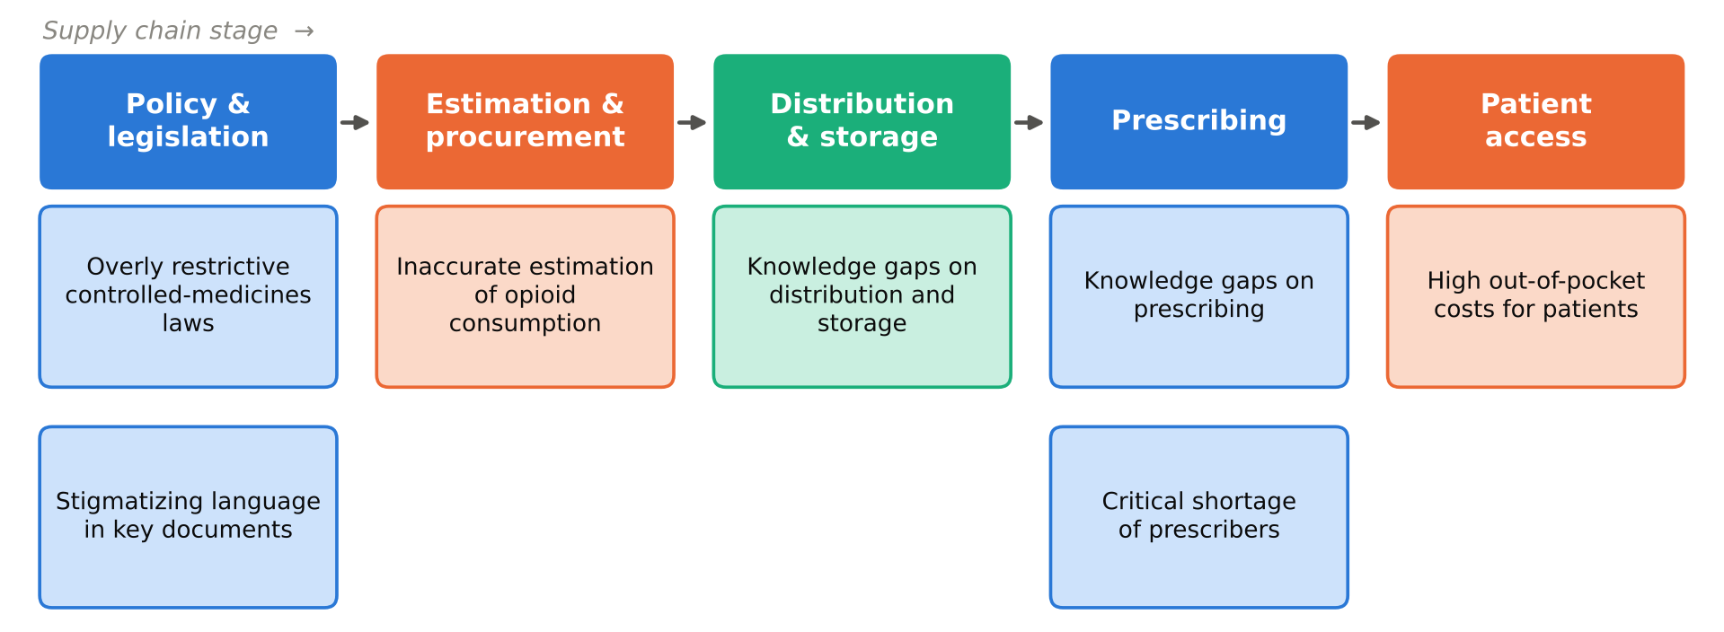
Note. Barriers reported by Namisango et al. (2017), arranged by the author along the supply chain from policy to the patient.
Figure 3
Structure and Key Results of the Project Supply Chain Shortage Model
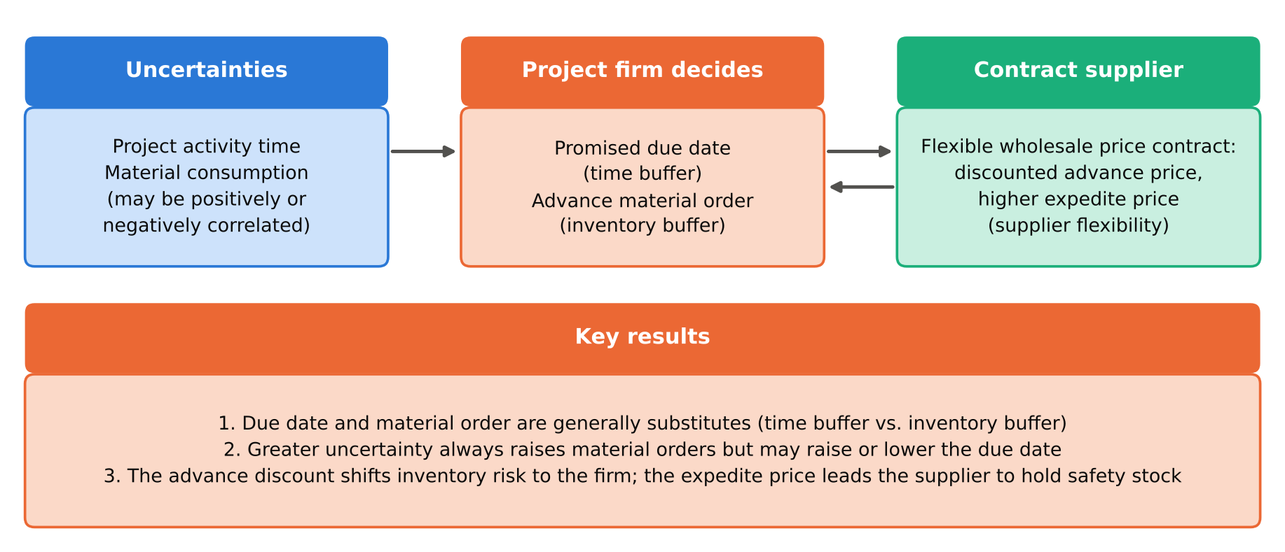
Note. Summarized from Kouvelis et al. (2023). The three buffers in the model, inventory, time, and supplier flexibility, correspond to mitigation strategies in the proposed study.
Figure 4
Concurrent Data Strands and Survey Results in a Mixed Methods Cold Chain Study
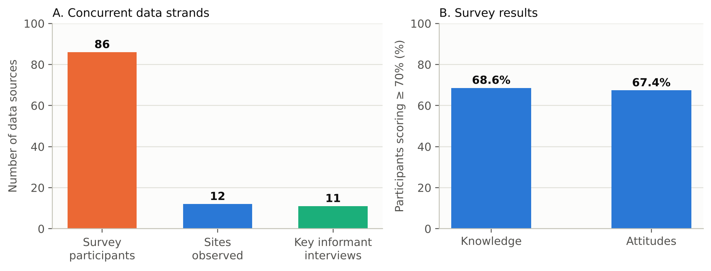
Note. Panel A shows the three data sources collected concurrently across 12 facilities; Panel B shows the share of survey participants with good cold chain knowledge and attitudes. Data from Asamoah et al. (2021).
Appendix
Material Shortage Risk-Scoring and Mitigation Selection Algorithm
Algorithm A1 operationalizes the proposed framework. It applies the buffering levers that Kouvelis et al. (2023) identify (inventory, time buffers, and supplier flexibility), builds a shortage mechanism into the calculation as Singh et al. (2026) do, and adds the estimation and monitoring safeguards highlighted by Namisango et al. (2017) and Asamoah et al. (2021). Figure A1 summarizes the steps, and Table A1 and Figure A2 apply the algorithm to illustrative data. The weights are starting assumptions to be calibrated with interview and performance data collected in the proposed study.
Algorithm A1
Material Shortage Risk Scoring (MSRS) for Ramp-Up Planning
Input: for each critical part i in the ramp-up bill of materials:
D_i ramp-up demand over horizon H (weeks)
I_i on-hand inventory S_i confirmed open supply (POs)
SS_i strategic safety stock L_i supplier lead time (weeks)
n_i qualified sources u_i supplier capacity utilization (0-1)
Weights w = (0.35, 0.25, 0.20, 0.20)
Output: risk score R_i, status, and mitigation action for every part

1 for each part i do
2 C_i <- (I_i + S_i) / (D_i + SS_i) // projected coverage
3 G_i <- max(0, D_i + SS_i - I_i - S_i) // shortage gap (units)
4 V_i <- w1(1 - min(C_i,1)) + w2 min(L_i/H,1)
+ w3(1/n_i) + w4 u_i // vulnerability index
5 R_i <- round(100 * V_i)
6 if R_i >= 70 then status <- CRITICAL
7 action <- reserve capacity, expedite, qualify alternate source
8 elif R_i >= 50 then status <- SERIOUS
9 action <- multi-source, raise strategic safety stock
10 elif R_i >= 30 then status <- WARNING
11 action <- weekly supplier capacity review, collaboration
12 else status <- GOOD; action <- maintain lean / JIT replenishment
13 if R_i - R_i(previous cycle) >= 10 then raise EARLY WARNING
14 end for
15 sort parts by R_i (descending) and escalate CRITICAL parts to the
cross-functional ramp-up review
16 repeat every planning cycle with refreshed demand and supplier data
Note. PO = purchase order; JIT = just-in-time. Developed by the author for the proposed study.
Figure A1
Flow of the Material Shortage Risk-Scoring Algorithm
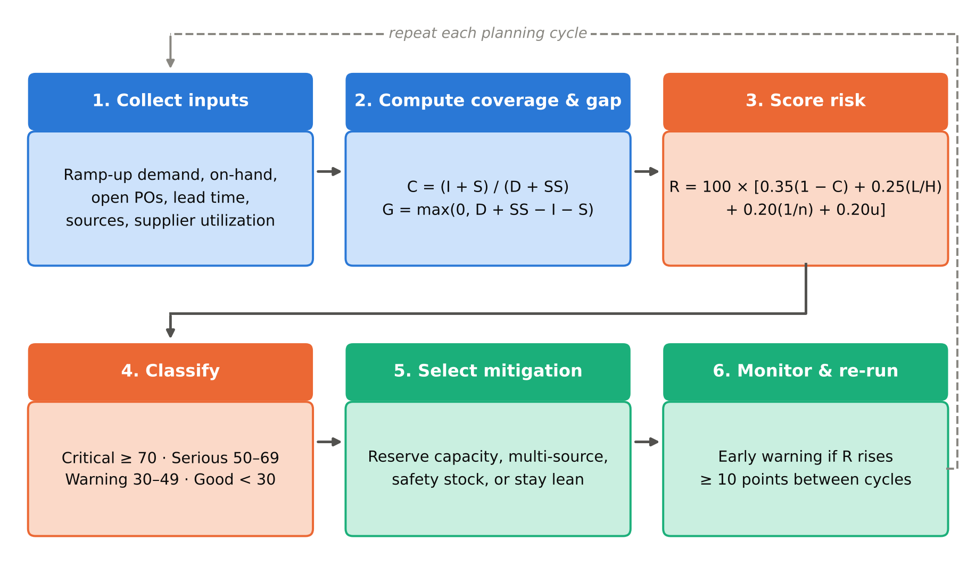
Note. Blue steps prepare data, orange steps score and classify risk, and green steps act and monitor. C = coverage; G = gap; L/H = lead time relative to the planning horizon; n = qualified sources; u = supplier utilization.
Table A1
Illustrative Application of Algorithm A1 to Six Ramp-Up Parts (Hypothetical Data)
Part | D | I | S | SS | L | n | u | C | G | R | Status | Mitigation
RF generator | 120 | 20 | 40 | 15 | 26 | 1 | 0.95 | 0.44 | 75 | 83 | Critical | Capacity reservation, expedite, qualify alternate source
Ceramic chuck | 90 | 15 | 45 | 10 | 20 | 1 | 0.85 | 0.60 | 40 | 76 | Critical | Capacity reservation, expedite, qualify alternate source
Vacuum valve | 300 | 80 | 150 | 30 | 14 | 2 | 0.80 | 0.70 | 100 | 62 | Serious | Multi-source and raise strategic safety stock
Quartz liner | 200 | 60 | 120 | 20 | 10 | 2 | 0.70 | 0.82 | 40 | 50 | Serious | Multi-source and raise strategic safety stock
Power supply | 150 | 70 | 90 | 15 | 8 | 3 | 0.60 | 0.97 | 5 | 35 | Warning | Weekly supplier capacity review and collaboration
Fastener kit | 800 | 600 | 400 | 50 | 3 | 4 | 0.40 | 1.18 | 0 | 19 | Good | Maintain lean / just-in-time replenishment
Note. All values are hypothetical and were created only to demonstrate the calculation; they are not data from any firm or study. H = 13 weeks. D = ramp-up demand; I = on-hand; S = confirmed open supply; SS = safety stock; L = lead time in weeks; n = qualified sources; u = utilization; C = coverage; G = gap in units; R = risk score.
Figure A2
Illustrative Shortage Risk Scores by Part (Hypothetical Data)
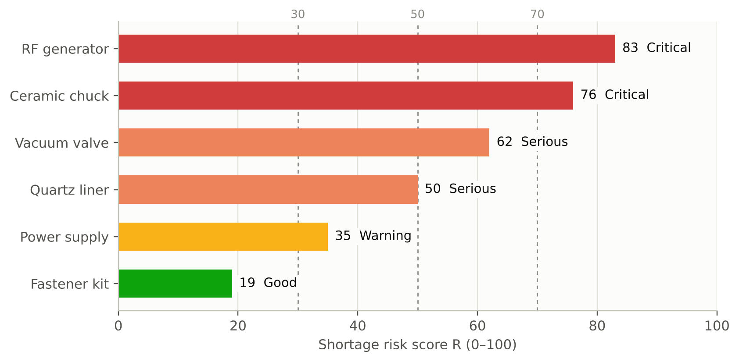
Note. Dashed lines mark the status thresholds at 30, 50, and 70. Bars are colored by status (red = critical, coral = serious, amber = warning, green = good), and each bar is also labeled with its status so meaning does not depend on color alone. Values are computed from Table A1.
References
Asamoah, A., Enyan, N. I. E., Diji, A. K., & Domfeh, C. (2021). Cold chain management by healthcare providers at a district in Ghana: A mixed methods study. BioMed Research International, 2021(1), 7559984. https://doi.org/10.1155/2021/7559984
Bimha, H., Hoque, M., & Munapo, E. (2019). The impact of supply chain management practices on industry competitiveness: A mixed-methods study on the Zimbabwean petroleum industry. African Journal of Science, Technology, Innovation and Development, 12(1), 97–109. https://doi.org/10.1080/20421338.2019.1613785
Kouvelis, P., Chen, X., & Xia, Y. (2023). Managing material shortages in project supply chains: Inventories, time buffers, and supplier flexibility. Production and Operations Management, 32(11), 3717–3735. https://doi.org/10.1111/poms.14059
Namisango, E., Allsop, M. J., Powell, R. A., Friedrichsdorf, S. J., Luyirika, E. B., Kiyange, F., Mukooza, E., Ntege, C., Garanganga, E., Ginindza-Mdluli, M. N., Mwangi-Powell, F., Mondlane, L. J., & Harding, R. (2017). Investigation of the practices, legislation, supply chain, and regulation of opioids for clinical pain management in Southern Africa: A multi-sectoral, cross-national, mixed methods study. Journal of Pain and Symptom Management, 55(3), 851–863. https://doi.org/10.1016/j.jpainsymman.2017.11.010
Singh, J., Jaggi, C. K., & Singh, M. (2026). An integrated humanitarian supply chain optimization model incorporating shortage mechanism and realistic constraints. Process Integration and Optimization for Sustainability. https://doi.org/10.1007/s41660-026-00723-y

