**Database Proposal**

**Team Members**

1. Dronadula Ramtej - <https://github.com/DronadulaRamtej>
2. Kapil Ramkrishna Parsodkar - <https://github.com/kapilparsodkar>
3. Ralin Wilson Tuscano - <https://github.com/ralintuscano>
4. Savil Robert Dsouza - <https://github.com/savildsouza>
5. Charan Raj Kandula - <https://github.com/rajkandula>

**Online Courses Website**

The collection of data on Online Courses Website will contain all the instructor profile data with his added course list and all registered user details.

**Instructor Database proposal**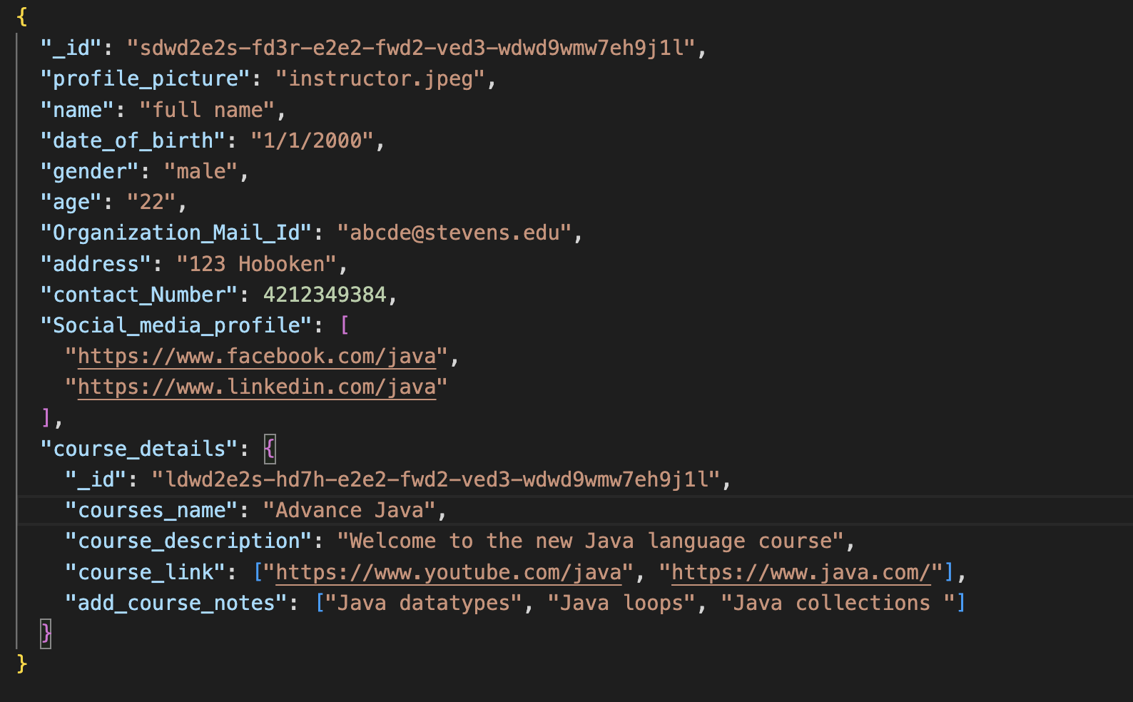

**Instructor**

All the instructor’s information stored in database, and instructor can insert multiple data into social media profile and course details fields.

|  |  |  |
| --- | --- | --- |
| **Name** | **Type** | **Description** |
| _id | ObjectId | Globally Unique Identifier |
| profile_picture | Image | Upload persons image |
| Name | String | Name of the Person |
| date_of_birth | Date | Persons date of birth |
| gender | String | Name the person gender |
| age | Number | Age of the person |
| Organization_Mail_Id | String | Person organization mail id |
| address | String | Address of the person |
| contact_number | Number | Persons contact number |
| Social_media_profile | Array | Persons social media details |
| Course_details | Array | Persons course details |

**Users**

The user collection will store all users’ details. Users will be able to create personal profile data, Users can insert multiple data into social media profile and select course fields.

**User database proposal:**

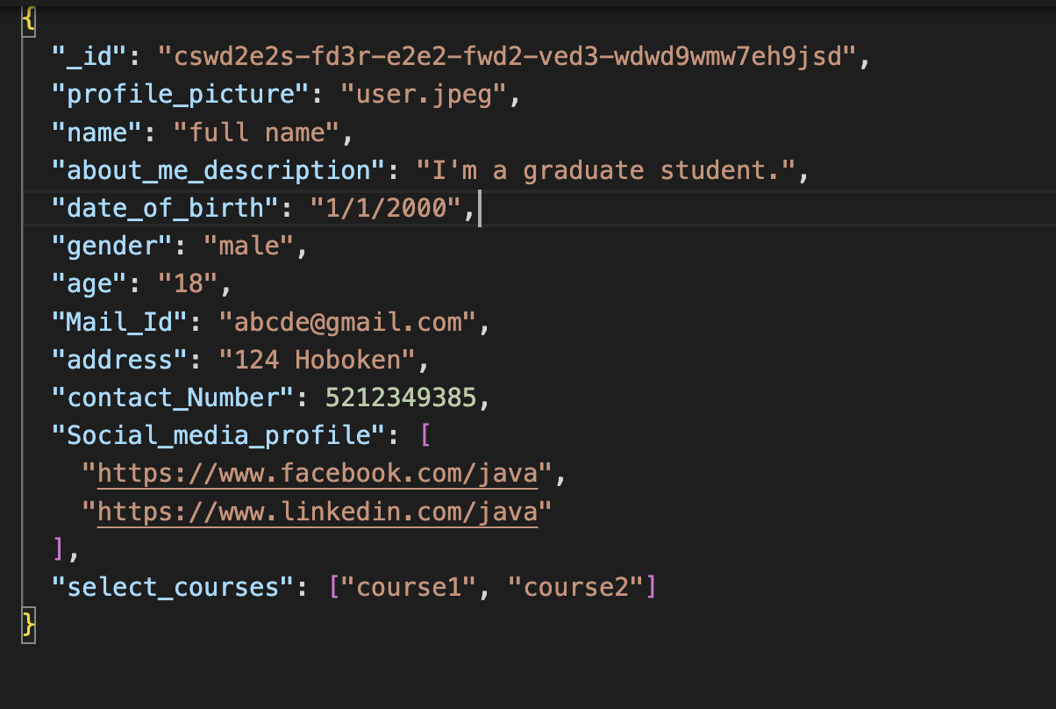

|  |  |  |
| --- | --- | --- |
| **Name** | **Type** | **Description** |
| _id | ObjectId | Globally Unique Identifier |
| profile_piture | Image | Upload persons image |
| name | String | Name of the Person |
| about_me_description | String | Person’s introduction |
| date_of_birth | Date | Person’s date of birth |
| gender | String | Name the person gender |
| age | Number | Age of the person |
| Mail_Id | String | Person mail id |
| address | String | Address of the person |
| contact_number | Number | Persons contact number |
| Social_media_profile | Array | Persons social media details |
| select_courses | Array | Persons course details |

**Instructor Course Details**

The course details data field stores all the instructor course related information with a unique id.

|  |  |  |
| --- | --- | --- |
| **Name** | **Type** | **Description** |
| _id | ObjectId | Globally Unique Identifier |
| courses_name | String | Persons course name |
| courses_description | String | Persons course information |
| course_link | Array | Persons course available links |
| add_course_notes | Array | Providing persons course available notes |

**Users Course Selection**

The course selection data field stores all the users course selected related course information.



|  |  |  |
| --- | --- | --- |
| **Name** | **Type** | **Description** |
| Select_courses | Array | Persons course selection |