1. What are the names of all the countries in the databases which start with the letter "B"

(sorted by their names) ?

**Ans.**

**Query :-** select country from country where country like 'b%'order by country ;

**Result :-**

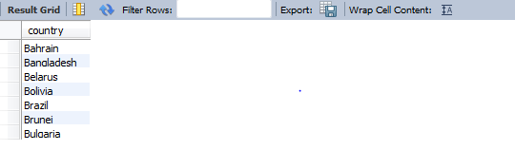

2. Return the first names (sorted) of all the actors with the last name "berry".

**Ans.**

**Query :-** select first_name from actor where last_name = 'berry' order by first_name ;

**Result :-**

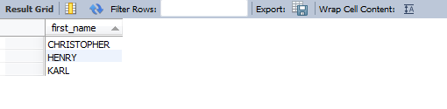

3. Find all the films whose length is more than 184 (inclusive). Order the results by the length

(and for films with the same length order them by their name). Return their title and the length.

**Ans.**

**Query :-** select title , length from film where length > 183 order by length ;

**Result :-**

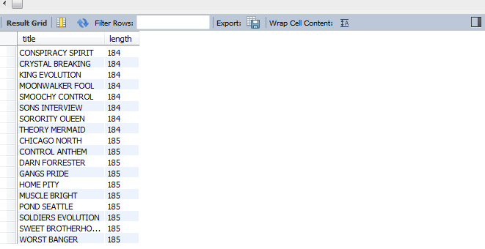

**Assumptions** :- for films with the same length no need to sort them as the data entered into table in alphabetic order of their name .