**Problem​ ​Statement**

This assignment is for visualization using matplotlib:

data to use:

https://raw.githubusercontent.com/Geoyi/Cleaning-Titanic-Data/master/titanic_origina

l.csv'

titanic = pd.read_csv(url)

Charts to plot:

1. Create a pie chart presenting the male/female proportion

**Code**

import matplotlib.pyplot as plt

import pandas as pd

import numpy as np

df = pd.read_csv("C:/Users/rajka/Desktop/DA 3/titanic_original.csv")

df["sex"].value_counts().plot.pie()

plt.show()

**Screenshot**

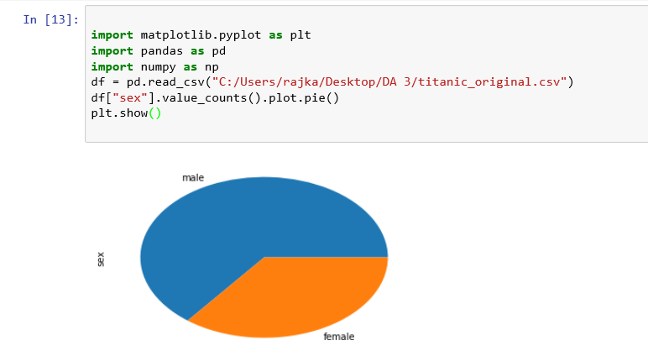

2. Create a scatterplot with the Fare paid and the Age, differ the plot color by gender

**Code**

import matplotlib.pyplot as plt

import pandas as pd

import numpy as np

df = pd.read_csv("C:/Users/rajka/Desktop/DA 3/titanic_original.csv")

df = df.drop(['survived', 'pclass','name', 'sibsp', 'parch', 'ticket', 'cabin', 'embarked', 'boat', 'body', 'home.dest'], axis=1, inplace=False)

colors = ["b", "g"]

plt.scatter(df['age'], df['fare'], s=60, c=colors, marker='o')

plt.show()

**Screeshot**

