**Problem Statement​ ​1:**

Write a Python Program to implement your own myreduce() function which works exactly

like Python's built-in function reduce()

**Code**

def myreduce(a):

bisn = a.split(",")

product = 1

for num in bisn:

product = product * int(num)

print (product)

mystr = input ("enter the no. you want to multiply ")

myreduce(mystr)

**Screenshot**

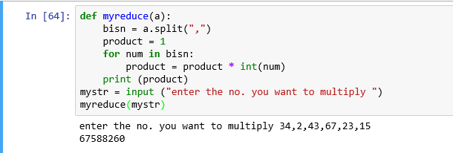

**Problem Statement​ ​2:**

Write a Python program to implement your own myfilter() function which works exactly

like Python's built-in function filter().

**Code**

def myfilter(number_list):

less_than_zero =[]

for n in number_list:

if n < 0:

less_than_zero.append(n)

print(less_than_zero)

a =range(-8, 5)

myfilter(a)

**Screenshot**

