**Problem​ ​Statement**

Write a Python Program(with class concepts) to find the area of the triangle using the below

formula.

area = (s*(s-a)*(s-b)*(s-c)) ** 0.5

Function to take the length of the sides of triangle from user should be defined in the parent

class and function to calculate the area should be defined in subclass.

**Code**

class triangle():

def __init__(self,a,b,c):

self.a=a

self.b=b

self.c=c

def area(self):

s = (a + b + c) / 2

return(s*(s-a)*(s-b)*(s-c)) ** 0.5

a=int(input("Enter a : "))

b=int(input("Enter b : "))

c=int(input("Enter c : "))

obj=triangle(a,b,c)

print("Area of triangle:",obj.area())

print()

**Screenshot**

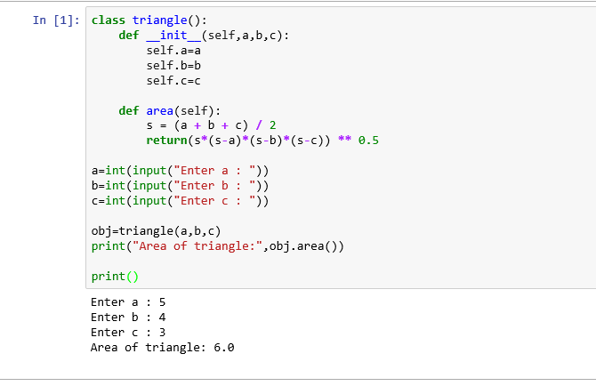

**Problem​ ​Statement**

Write a function filter_long_words() that takes a list of words and an integer n and returns the list

of words that are longer than n.

**Code**

def longest_word(words_list, x):

word_len = []

for n in words_list:

if len(n)> x:

word_len.append((len(n), n))

word_len.sort()

return word_len

print(longest_word(["PHP", "python", "java","facebook","orkut"],3))

**Screenshot**

