**Problem​ ​Statement​ ​1:**

Write a Python program using function concept that maps list of words into a list of integers

representing the lengths of the corresponding words.

**Code**

def calling(a):

bisn = a.split(",")

word_len = []

for n in bisn:

word_len.append(len(n))

print (word_len)

mystr = input ("enter the string")

calling(mystr)

**Screenshot**

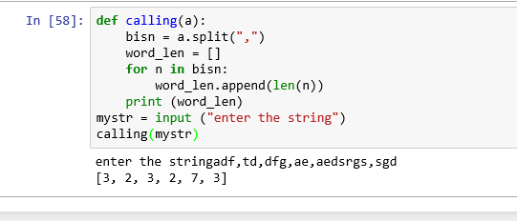

**Problem​ ​Statement​ ​2:**

Write a Python function which takes a character (i.e. a string of length 1) and returns True if it is

a vowel, False otherwise.

**Code**

def vowel (a):

if a in "aeiou":

print ("vowel")

else:

print ("consonant")

original = input('Enter a alphabet:')

vowel(original)

**Screenshot**

