**SCHOOL OF COMPUTING (SoC)**

**ST0503 Back-end Web Development**

**2022/2023 SEMESTER 2**

**ASSIGNMENT 2**

**Instructions and Guidelines:**

1. The assignment **source code** must be submitted before 6th Feb 2023, 8am. You are required to submit your source codes to the Brightspace. Remember to provide your Class, Group, Admission Number(s) and Name(s) on the softcopy.
2. A word document showing the additional APIs or modifications should be included in the submission.
3. You are required to **clearly** provide instructions on how to setup the project on the lecturer's laptop in a text file that is to be included in the softcopy submission.
4. Students are to work in individually
5. The assignment will account for **30%** of your final grade*.*
6. The assignment should be implemented using Node JS, Express and MySQL.
7. The interview will be conducted during the lessons in the week of 6**th Feb 2023**. You are expected to explain the program logic and modify the program during the interview. **If you are absent, you will be awarded zero mark for the assignment.**
8. **No marks will be awarded**, if the work is copied or you have allowed others to copy your work. Warning: Plagiarism means passing off as one's own the ideas, works, writings, etc., which belong to another person. In accordance with this definition, you are committing plagiarism if you copy the work of another person and turning it in as your own, even if you would have the permission of that person. Plagiarism is a serious offence and disciplinary action will be taken against you. If you are guilty of plagiarism, you may fail all modules in the semester, or even be liable for expulsion.
9. 50% of the marks will be deducted for assignments that are received within ONE (1) calendar day after the submission deadline. No marks will be given thereafter.

Exceptions to this policy will be given to students with valid LOA on medical or

compassionate grounds. Students will need to inform the lecturer as soon as reasonably possible. Students are not to assume on their own that their deadline has been extended.

# Assignment 2

Assignment 2 is built on-top of the DVD API you built in assignment 1.

## Assignment Requirements

You are required to fulfil the following basic requirements:

* Front-end for the web application (You are allowed to use open source templates downloaded from the internet)
* Persistent login (and logout)
* Search dvds by title OR category. Max rental rate can be empty which implies no budget. You can assume required search fields would be filled up. (General Public)
* View dvd details (including dvd info like rating,actors in one page)

(General Public)

* Add Actor(First Name and Last Name) (Only for **Admins**)
* Add new customer (Only for **Admins**)
* Ensure necessary JWT checking for access rights for relevant web api is done

You can add in more APIs or modify your existing APIs or the database structure to satisfy the requirements of the app.

You can produce your own design for your web app.

Some example web pages are shown below just for reference. Your design/implementation can be different:

1. Login Page for admins

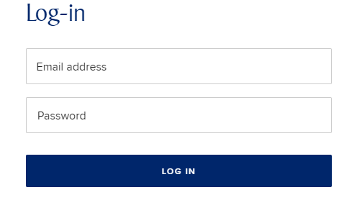

1. Home page

The home page contains a search form for users to search for dvd listings.  
  
Users can search by title (using a substring of the actual title) OR by category. Only title OR category would be supplied by user.

For Category, you need to dynamically list the available category name retrieved from database for users to select.

Users can also set a max rental rate to filter dvds that fall below the max rental rate.

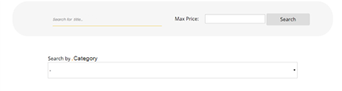

1. Search results page

The search results page should contain matching results for the search fields from the search page. Brief info on the matching dvds (title, release year and rating) should be shown. Upon clicking on the dvd, then the dvd details would be shown in a new page.

1. SP DVD Details Page

This page should show the dvd details, including title, category, release year, description, rating, actors).

**Title:**

**AGENT TRUMAN**

**Category:**

Foreign

**Release Year:**

2006

**Description:**A Intrepid Panorama of a Robot And a Boy who must Escape a Sumo Wrestler in Ancient China

**Rating:**

**….**

**Actors:**

**…..**

1. SP DVD Add new Actor (Admin only):

Page to enter all fields (firstname and lastname) and submit to add new actor in database.

Note that admin can also click log out to log out of the page.

1. **SP Add new customer (Admin only)**

Page to enter all required fields and submit to add new customer in database. The store address should be displayed as a dropdown for store selection in the webpage.

Note that admin can also click log out to log out of the page.

**Grading Guidelines**

The assignment will be assessed based on the following criteria:

* Demonstrate the requirements stated above correctly and effectively (75%)
* Graphical User Interface and user friendliness: (10%)
* Advanced Features (15%)
* Amount of individual contribution to the project
* Question & Answer during the interview

**Bonus Requirements for the web application(You can suggest useful functions for the web app too)**

* Provide add dvd functionality and upload of actual image for dvds when creating new dvds
* Shopping Cart functionality to rent dvd and then confirm payment details and check out with data saved to database
* Allow users to review dvd and provide score and comments. Public can then view the reviews for dvd in details page.