**WEB PROGRAMMING**

**MINI PROJECT**

***Submitted by***

**RAJKARAN PREET SINGH - RA1711003010801**

**PRANAV SHARMA - RA1711003010781**

*Under the guidance of*

**MS. G.K SANDHIA(100772)**



S.R.M. Nagar, Kattankulathur, Kanchipuram District

**SRM INSTITUTE OF SCIENCE AND TECHNOLOGY**

(Under Section 3 of UGC Act, 1965)

**BONAFIDE CERTIFICATE**

Certified that this mini project done on DEPARTMENT PORTAL **is** the bonafide work of RAJKARAN PREET SINGH **[Reg. No.: RA1711003010801] and** PRANAV SHARMA **[RA1711003010781],** who carried out the work under my supervision. Certified further, that to the best of my knowledge the work reported herein does not form any other report.

**SIGNATURE**

MS G.K SANDHIA

**FACULTY INCHARGE**

**TABLE OF CONTENTS**

**ACKNOWLEDGEMENT**

1 INTRODUCTION

2 ABSTRACT

3 TOOLS AND TECHNOLOGY USED

4 CODE SEGMENT

5 SCREENSHOT

6 CONCLUSION

**ACKNOWLEDGEMENT**

We express our humble gratitude to **MS G.K SANDHIA,** associate professor, SRM Institute of Science and Technology, for the facilities extended for the project work and her continued support. Department of Computer Science and Engineering, SRM Institute of Science and Technology, for providing me an opportunity to pursue my project under his/her mentorship. She provided us the freedom and support to explore the research topics of my interest. Her passion for solving the real problems and making a difference in the world has always been inspiring. We sincerely thank staff and students of the Computer Science and Engineering Department, SRM Institute of Science and Technology, for their help. Finally, we would like to thank my parents, our family members and our friends for their unconditional love, constant support and encouragement

**RAJKARAN PREET SINGH(RA1711003010801)**

**PRANAV SHARMA (RA1711003010781)**

**DEPARTMENT PORTAL**

The proposed system is to make an online web portal for Computer Science Department, so that everyone can register in the department. Records of every student &amp; faculty can stored easily and efficiently in database from their registration. The proposed system could be accessed from any corner of the world on net. This will be one stop solution for all student &amp; faculties of the entire department. Academia is the Official Student/Parent Portal of our college which aims at providing a better experience to the students to access the academic web services. The portal is a gateway to your academic information such as attendance, internal marks, timetable, etc. The proposed system will help us to make an online web portal for Computer Science Department, so that everyone can get information about department, students can easily communicate with teachers from anywhere. Teachers can easily communicate with the students,and can keep records of every student easily and efficiently. The proposed system could be accessed from any corner of the world on net.

**FEATURES**

* Provides registration &amp; validation for students &amp; faculties.
* It gives profile information of all the faculties.
* Anyone can contact to these faculties by their detail provided.
* Reading material &amp; other notes.
* They can post notices to the students and can also view the notices from the administrator.
* Provide information about courses &amp; online courses helpful for students.
* Department info like research, achievements, blogs to keep students &amp; faculties updated about the department

**TOOLS AND TECHNOLOGY USED**

* HTML

**Hypertext Markup Language** (**HTML**) is the standard [markup language](https://en.wikipedia.org/wiki/Markup_language" \o "Markup language) for documents designed to be displayed in a [web browser](https://en.wikipedia.org/wiki/Web_browser" \o "Web browser). It can be assisted by technologies such as [Cascading Style Sheets](https://en.wikipedia.org/wiki/Cascading_Style_Sheets" \o "Cascading Style Sheets) (CSS) and [scripting languages](https://en.wikipedia.org/wiki/Scripting_language" \o "Scripting language) such as [JavaScript](https://en.wikipedia.org/wiki/JavaScript" \o "JavaScript).

[Web browsers](https://en.wikipedia.org/wiki/Web_browser" \o "Web browser) receive HTML documents from a [web server](https://en.wikipedia.org/wiki/Web_server" \o "Web server) or from local storage and [render](https://en.wikipedia.org/wiki/Browser_engine" \o "Browser engine) the documents into multimedia web pages. HTML describes the structure of a [web page](https://en.wikipedia.org/wiki/Web_page" \o "Web page) [semantically](https://en.wikipedia.org/wiki/Semantic_Web" \o "Semantic Web) and originally included cues for the appearance of the document.

* CSS

**Cascading Style Sheets** (**CSS**) is a [style sheet language](https://en.wikipedia.org/wiki/Style_sheet_language" \o "Style sheet language) used for describing the [presentation](https://en.wikipedia.org/wiki/Presentation_semantics" \o "Presentation semantics) of a document written in a [markup language](https://en.wikipedia.org/wiki/Markup_language" \o "Markup language) such as [HTML](https://en.wikipedia.org/wiki/HTML" \o "HTML).[[1]](https://en.wikipedia.org/wiki/CSS" \l "cite_note-1) CSS is a cornerstone technology of the [World Wide Web](https://en.wikipedia.org/wiki/World_Wide_Web" \o "World Wide Web), alongside HTML and [JavaScript](https://en.wikipedia.org/wiki/JavaScript" \o "JavaScript).[[2]](https://en.wikipedia.org/wiki/CSS" \l "cite_note-2)

CSS is designed to enable the separation of presentation and content, including [layout](https://en.wikipedia.org/wiki/Page_layout" \o "Page layout), [colors](https://en.wikipedia.org/wiki/Color" \o "Color), and [fonts](https://en.wikipedia.org/wiki/Typeface" \o "Typeface).[[3]](https://en.wikipedia.org/wiki/CSS" \l "cite_note-3) This separation can improve content [accessibility](https://en.wikipedia.org/wiki/Accessibility" \o "Accessibility), provide more flexibility and control in the specification of presentation characteristics, enable multiple [web pages](https://en.wikipedia.org/wiki/Web_page" \o "Web page) to share formatting by specifying the relevant CSS in a separate .css file which reduces complexity and repetition in the structural content as well as enabling the .css file to be [cached](https://en.wikipedia.org/wiki/Cache_(computing)" \o "Cache (computing)) to improve the page load speed between the pages that share the file and its formatting.

* JAVASCRIPT

**JavaScript** is a [programming language](https://en.wikipedia.org/wiki/Programming_language" \o "Programming language) that conforms to the [ECMAScript](https://en.wikipedia.org/wiki/ECMAScript" \o "ECMAScript) specification.[[7]](https://en.wikipedia.org/wiki/JavaScript" \l "cite_note-tc39-7) JavaScript is [high-level](https://en.wikipedia.org/wiki/High-level_programming_language" \o "High-level programming language), often [just-in-time compiled](https://en.wikipedia.org/wiki/Just-in-time_compilation" \o "Just-in-time compilation), and [multi-paradigm](https://en.wikipedia.org/wiki/Programming_paradigm" \o "Programming paradigm). It has [curly-bracket syntax](https://en.wikipedia.org/wiki/List_of_programming_languages_by_type" \l "Curly-bracket_languages" \o "List of programming languages by type), [dynamic typing](https://en.wikipedia.org/wiki/Dynamic_typing" \o "Dynamic typing), [prototype-based](https://en.wikipedia.org/wiki/Prototype-based_programming" \o "Prototype-based programming) [object-orientation](https://en.wikipedia.org/wiki/Object-oriented_programming" \o "Object-oriented programming), and [first-class functions](https://en.wikipedia.org/wiki/First-class_function" \o "First-class function).

Alongside [HTML](https://en.wikipedia.org/wiki/HTML" \o "HTML) and [CSS](https://en.wikipedia.org/wiki/CSS" \o "CSS), JavaScript is one of the core technologies of the [World Wide Web](https://en.wikipedia.org/wiki/World_Wide_Web" \o "World Wide Web).[[8]](https://en.wikipedia.org/wiki/JavaScript" \l "cite_note-8) JavaScript enables interactive [web pages](https://en.wikipedia.org/wiki/Web_page" \o "Web page) and is an essential part of [web applications](https://en.wikipedia.org/wiki/Web_application" \o "Web application). The vast majority of [websites](https://en.wikipedia.org/wiki/Website" \o "Website) use it for [client-side](https://en.wikipedia.org/wiki/Client-side" \o "Client-side) page behavior,[[9]](https://en.wikipedia.org/wiki/JavaScript" \l "cite_note-deployedstats-9) and all major [web browsers](https://en.wikipedia.org/wiki/Web_browser" \o "Web browser) have a dedicated [JavaScript engine](https://en.wikipedia.org/wiki/JavaScript_engine" \o "JavaScript engine) to execute it.

* PHP

**PHP** is a [general-purpose](https://en.wikipedia.org/wiki/General-purpose_programming_language" \o "General-purpose programming language) [scripting language](https://en.wikipedia.org/wiki/Scripting_language" \o "Scripting language) especially suited to [web development](https://en.wikipedia.org/wiki/Web_development" \o "Web development).[[6]](https://en.wikipedia.org/wiki/PHP" \l "cite_note-6) It was originally created by Danish-Canadian [programmer](https://en.wikipedia.org/wiki/Programmer" \o "Programmer) [Rasmus Lerdorf](https://en.wikipedia.org/wiki/Rasmus_Lerdorf" \o "Rasmus Lerdorf) in 1994.[[7]](https://en.wikipedia.org/wiki/PHP" \l "cite_note-History_of_PHP-7) The PHP [reference implementation](https://en.wikipedia.org/wiki/Reference_implementation" \o "Reference implementation) is now produced by The PHP Group.[[8]](https://en.wikipedia.org/wiki/PHP" \l "cite_note-about_PHP-8) PHP originally stood for *Personal Home Page*,[[7]](https://en.wikipedia.org/wiki/PHP" \l "cite_note-History_of_PHP-7) but it now stands for the [recursive initialism](https://en.wikipedia.org/wiki/Recursive_initialism" \o "Recursive initialism) *PHP: Hypertext Preprocessor*.[[9]](https://en.wikipedia.org/wiki/PHP" \l "cite_note-9)

PHP code is usually processed on a [web server](https://en.wikipedia.org/wiki/Web_server" \o "Web server) by a PHP [interpreter](https://en.wikipedia.org/wiki/Interpreter_(computing)" \o "Interpreter (computing)) implemented as a [module](https://en.wikipedia.org/wiki/Plugin_(computing)" \o "Plugin (computing)), a [daemon](https://en.wikipedia.org/wiki/Daemon_(computing)" \o "Daemon (computing)) or as a [Common Gateway Interface](https://en.wikipedia.org/wiki/Common_Gateway_Interface" \o "Common Gateway Interface) (CGI) executable. On a web server, the result of the interpreted and executed PHP code – which may be any type of data, such as generated [HTML](https://en.wikipedia.org/wiki/HTML" \o "HTML) or binary image data – would form the whole or part of an [HTTP](https://en.wikipedia.org/wiki/Hypertext_Transfer_Protocol" \o "Hypertext Transfer Protocol) response. Various [web template systems](https://en.wikipedia.org/wiki/Web_template_system" \o "Web template system), web [content management systems](https://en.wikipedia.org/wiki/Content_management_system" \o "Content management system), and [web frameworks](https://en.wikipedia.org/wiki/Web_framework" \o "Web framework) exist which can be employed to orchestrate or facilitate the generation of that response. Additionally, PHP can be used for many programming tasks outside of the web context, such as standalone [graphical applications](https://en.wikipedia.org/wiki/Graphical_user_interface" \o "Graphical user interface)[[10]](https://en.wikipedia.org/wiki/PHP" \l "cite_note-10) and robotic [drone](https://en.wikipedia.org/wiki/Unmanned_aerial_vehicle" \o "Unmanned aerial vehicle) control.[[11]](https://en.wikipedia.org/wiki/PHP" \l "cite_note-11) Arbitrary PHP code can also be interpreted and executed via [command-line interface](https://en.wikipedia.org/wiki/Command-line_interface" \o "Command-line interface) (CLI).

* MYSQL

**MySQL** is an [open-source](https://en.wikipedia.org/wiki/Open-source_software" \o "Open-source software) [relational database management system](https://en.wikipedia.org/wiki/Relational_database_management_system" \o "Relational database management system) (RDBMS).[[5]](https://en.wikipedia.org/wiki/MySQL" \l "cite_note-whatismysql-5)[[6]](https://en.wikipedia.org/wiki/MySQL" \l "cite_note-6) Its name is a combination of "My", the name of co-founder [Michael Widenius](https://en.wikipedia.org/wiki/Michael_Widenius" \o "Michael Widenius)'s daughter,[[7]](https://en.wikipedia.org/wiki/MySQL" \l "cite_note-7) and "[SQL](https://en.wikipedia.org/wiki/SQL" \o "SQL)", the abbreviation for [Structured Query Language](https://en.wikipedia.org/wiki/Structured_Query_Language" \o "Structured Query Language). A [relational database](https://en.wikipedia.org/wiki/Relational_database" \o "Relational database) organizes data into one or more data tables in which data types may be related to each other; these relations help structure the data. SQL is a language programmers use to create, modify and extract data from the relational database, as well as control user access to the database. In addition to relational databases and SQL, an RDBMS like MySQL works with an [operating system](https://en.wikipedia.org/wiki/Operating_system" \o "Operating system) to implement a relational database in a computer's storage system, manages users, allows for network access and facilitates testing database integrity and creation of backups.

* XAMPP

**XAMPP**  is a [free and open-source](https://en.wikipedia.org/wiki/Free_and_open-source" \o "Free and open-source) [cross-platform](https://en.wikipedia.org/wiki/Cross-platform" \o "Cross-platform) [web server](https://en.wikipedia.org/wiki/Web_server" \o "Web server) [solution stack](https://en.wikipedia.org/wiki/Solution_stack" \o "Solution stack) package developed by Apache Friends,[[3]](https://en.wikipedia.org/wiki/XAMPP" \l "cite_note-kaiseidlerinterview-3) consisting mainly of the [Apache HTTP Server](https://en.wikipedia.org/wiki/Apache_HTTP_Server" \o "Apache HTTP Server), [MariaDB](https://en.wikipedia.org/wiki/MariaDB" \o "MariaDB) [database](https://en.wikipedia.org/wiki/Database" \o "Database), and [interpreters](https://en.wikipedia.org/wiki/Interpreter_(computing)" \o "Interpreter (computing)) for scripts written in the [PHP](https://en.wikipedia.org/wiki/PHP" \o "PHP) and [Perl](https://en.wikipedia.org/wiki/Perl" \o "Perl) [programming languages](https://en.wikipedia.org/wiki/Programming_language" \o "Programming language).[[4]](https://en.wikipedia.org/wiki/XAMPP" \l "cite_note-x_mariadb-4)[[5]](https://en.wikipedia.org/wiki/XAMPP" \l "cite_note-5) Since most actual web server deployments use the same components as XAMPP, it makes transitioning from a local test server to a live server possible.

* PHPMYADMIN

**phpMyAdmin** is a [free and open source](https://en.wikipedia.org/wiki/Free_and_open_source" \o "Free and open source) administration tool for [MySQL](https://en.wikipedia.org/wiki/MySQL" \o "MySQL) and [MariaDB](https://en.wikipedia.org/wiki/MariaDB" \o "MariaDB). As a portable [web application](https://en.wikipedia.org/wiki/Web_application" \o "Web application) written primarily in [PHP](https://en.wikipedia.org/wiki/PHP" \o "PHP), it has become one of the most popular MySQL administration tools, especially for [web hosting services](https://en.wikipedia.org/wiki/Web_hosting_service" \o ").

**CODE SEGMENT**

The below image shows all the included in the folder and rest are the screenshot of the code segments.

**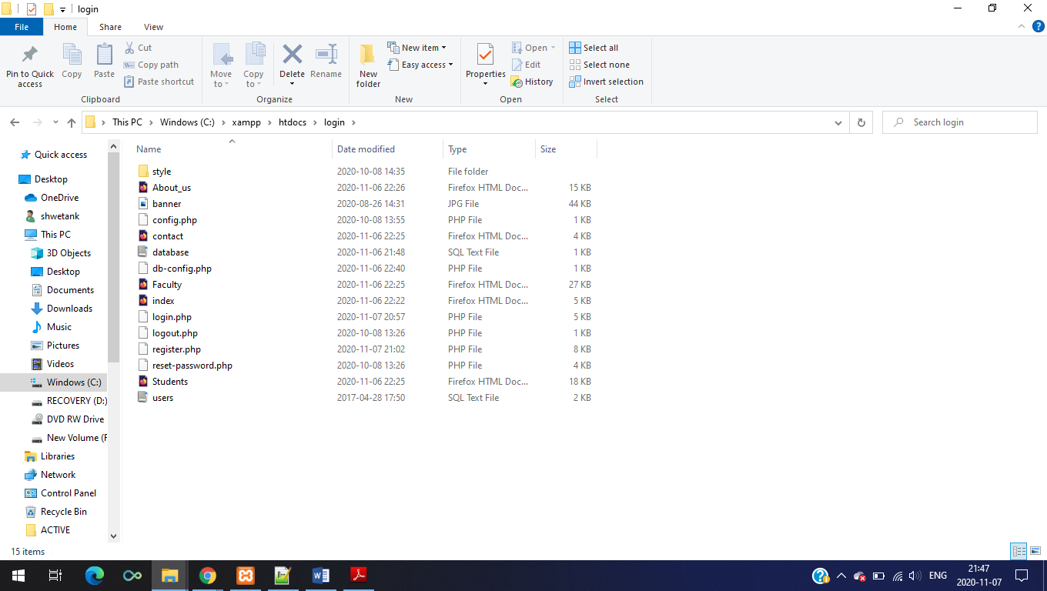**

**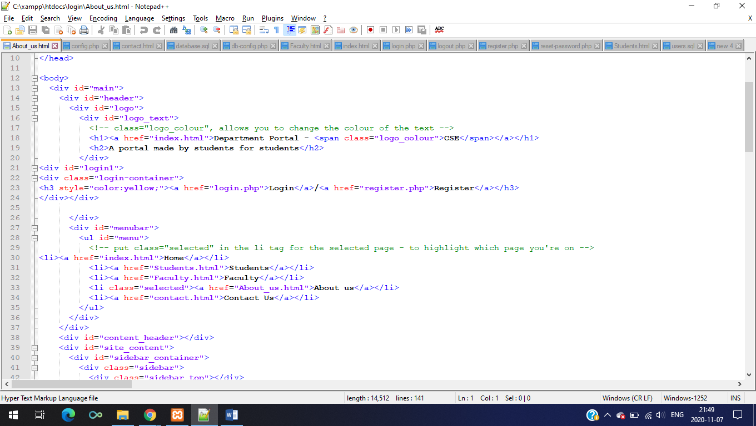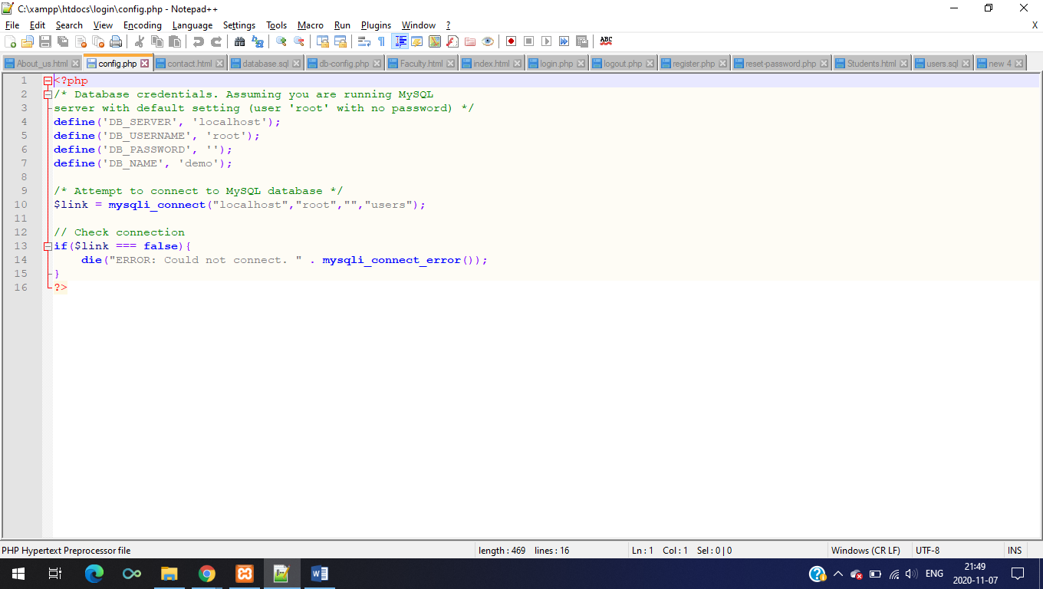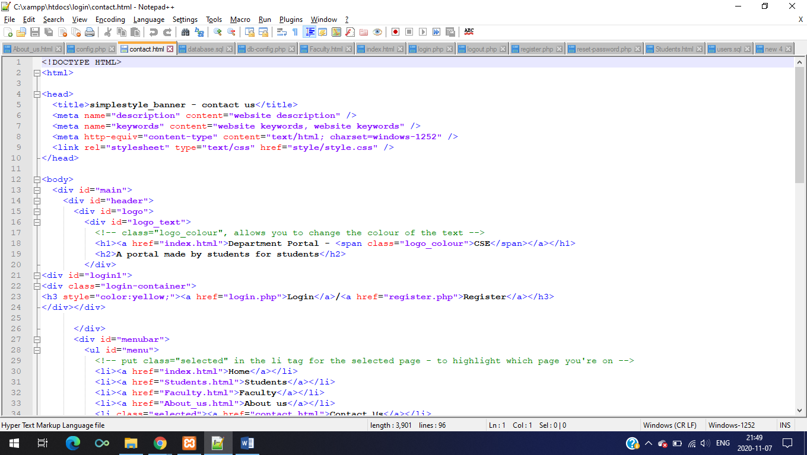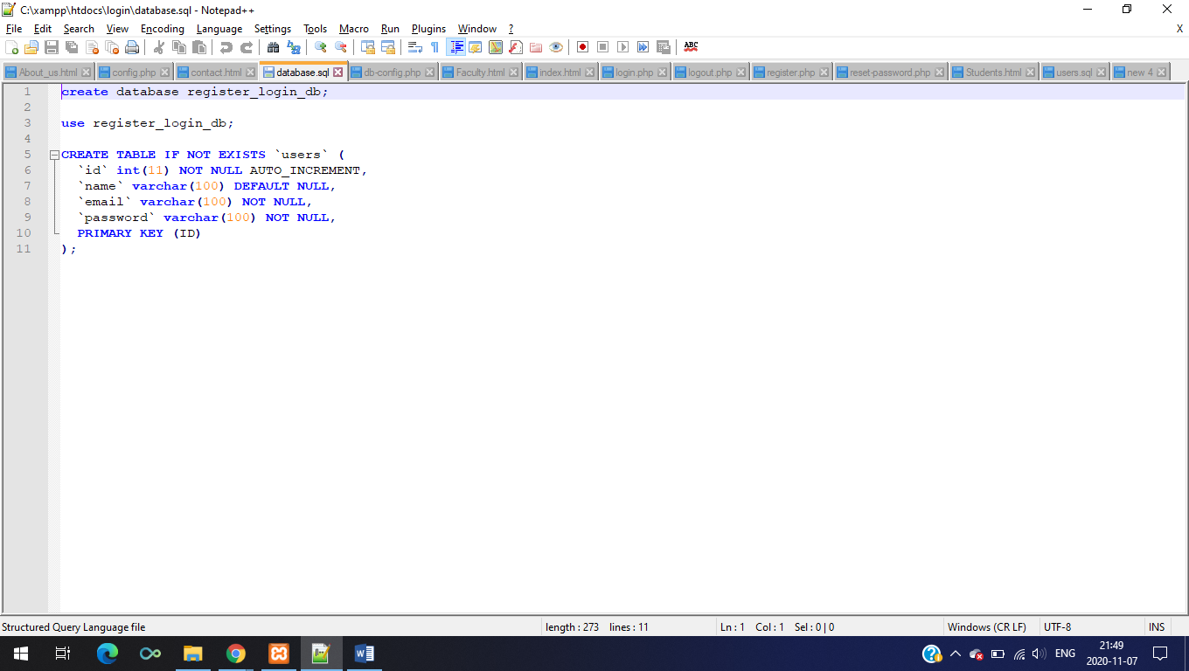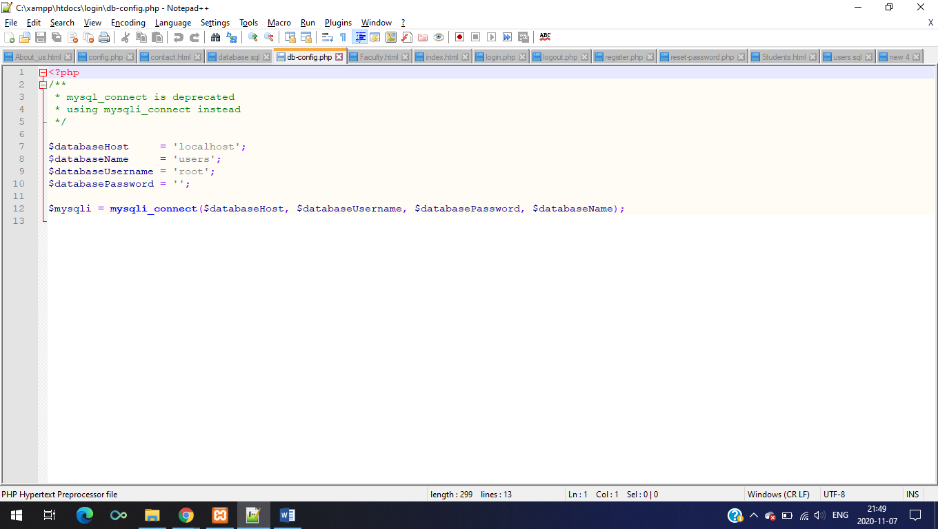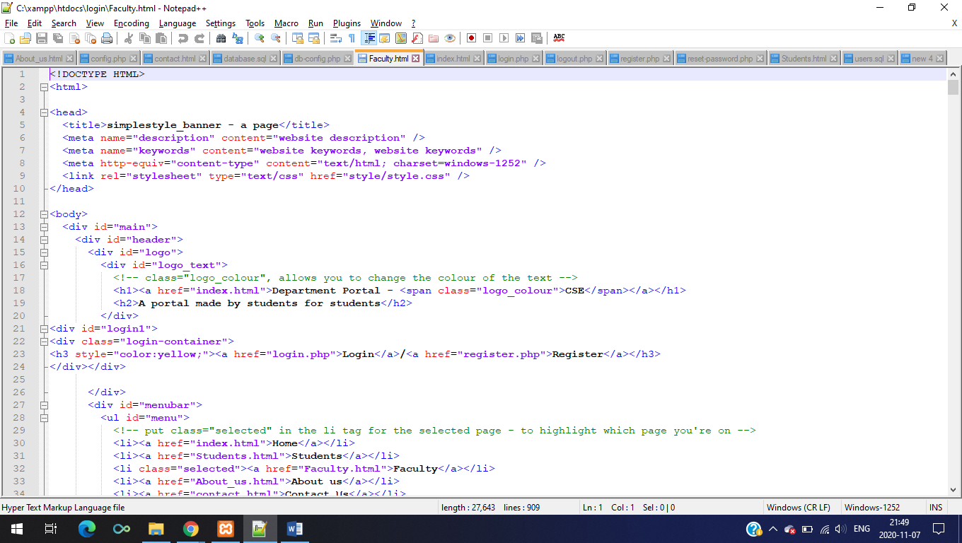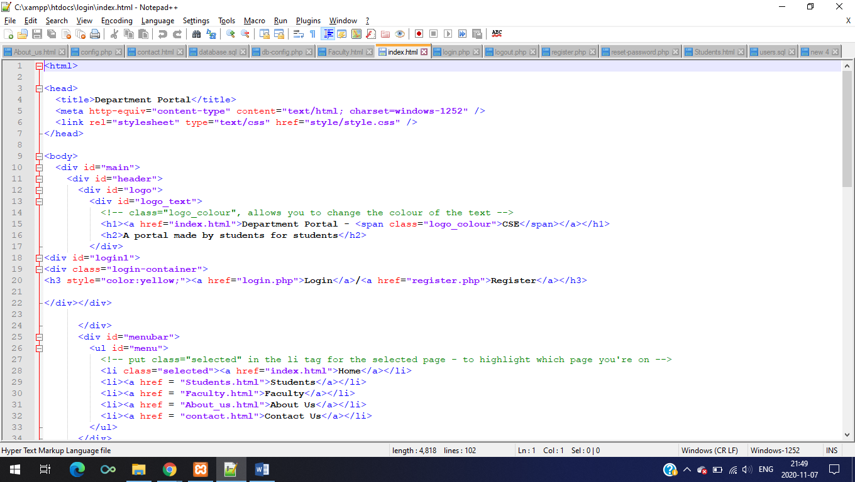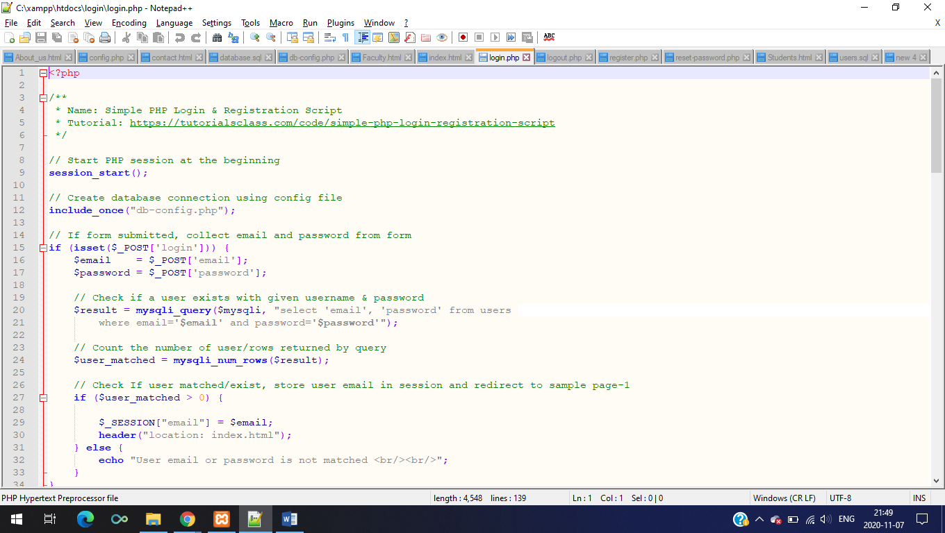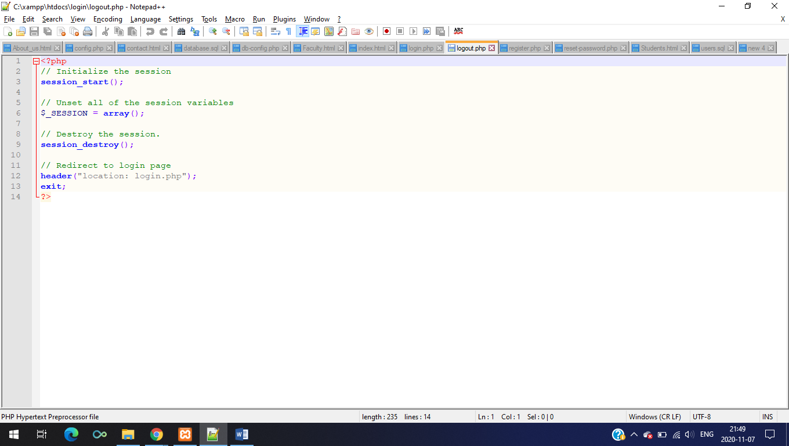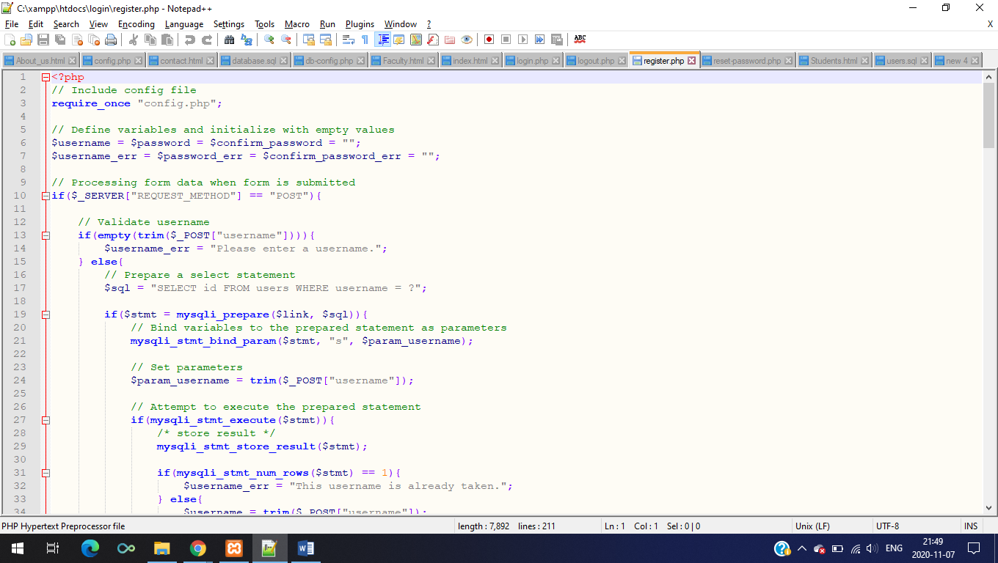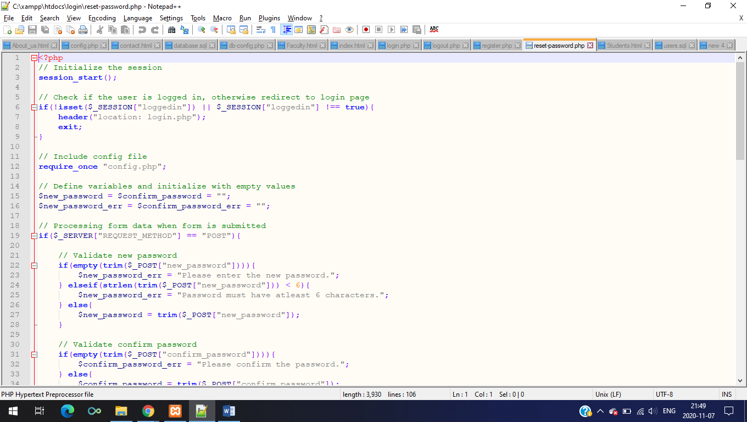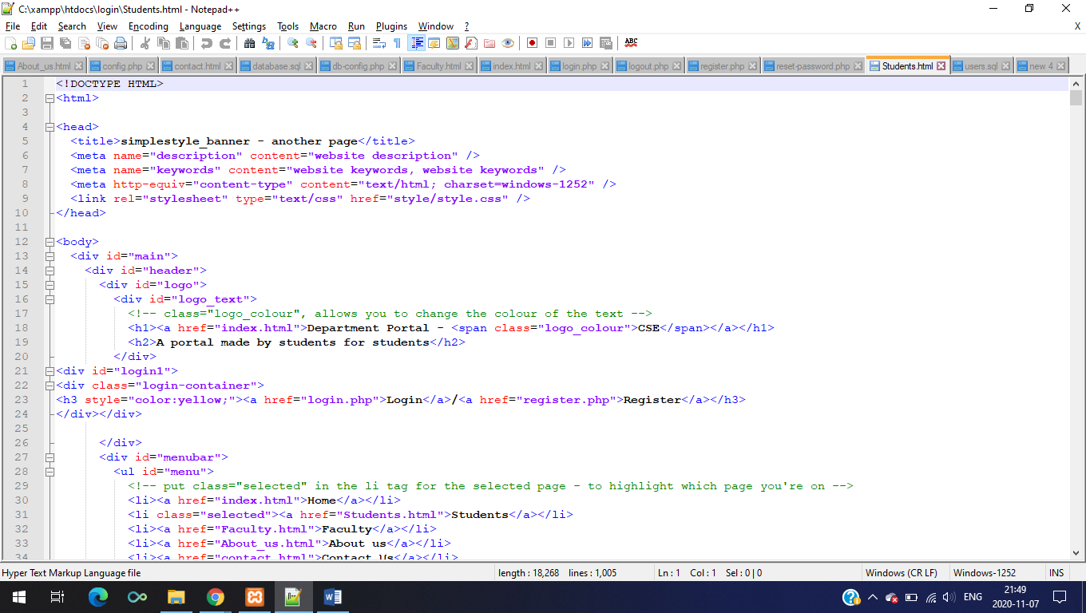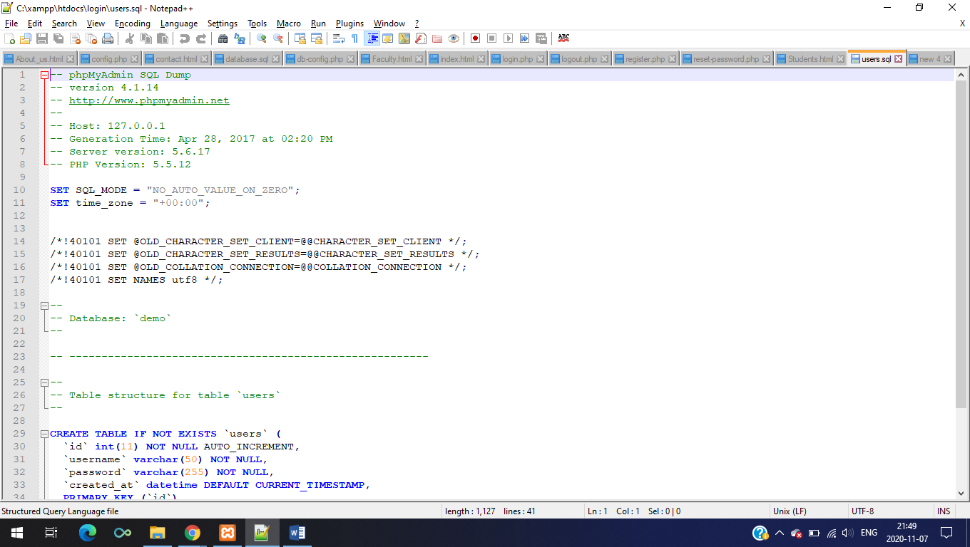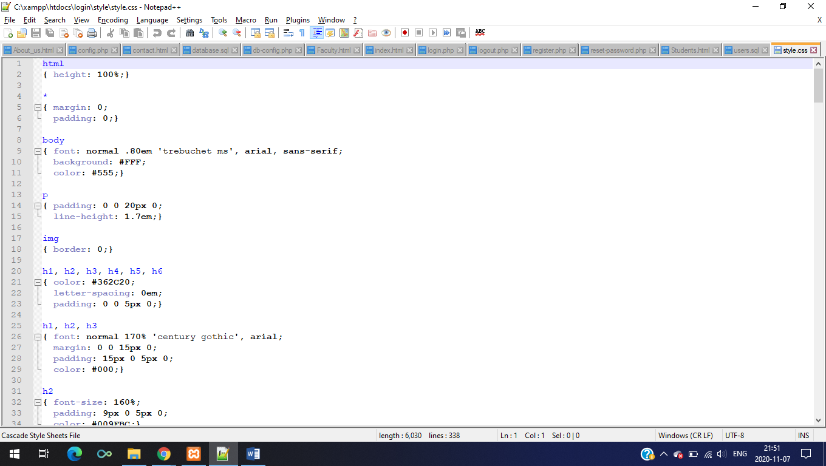**

**WEBSITE IMAGES**

The below images are the website images which shows different section of the website like home,students,faculty ,login etc.

**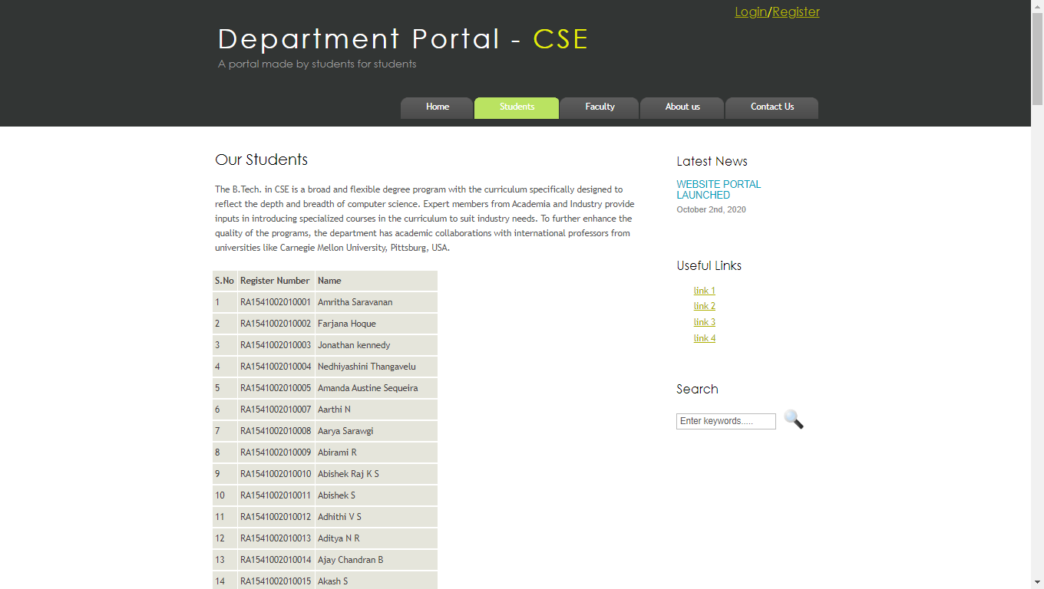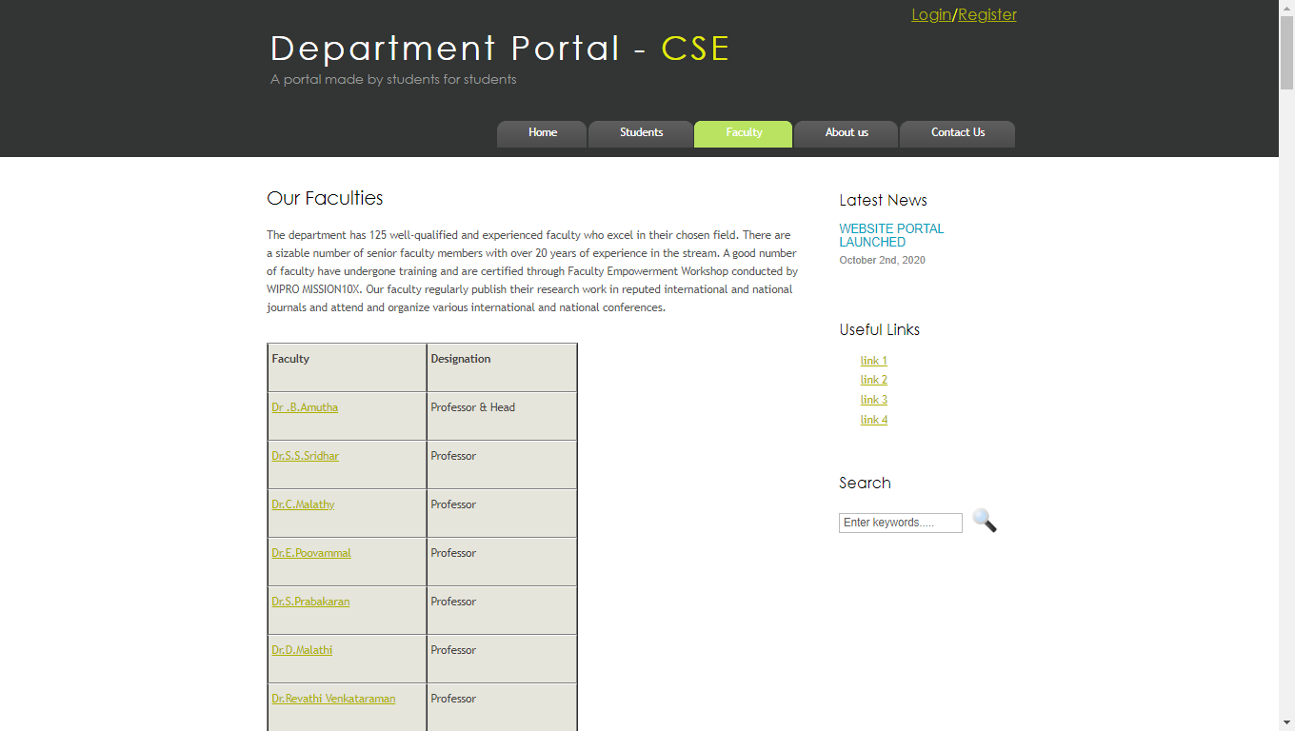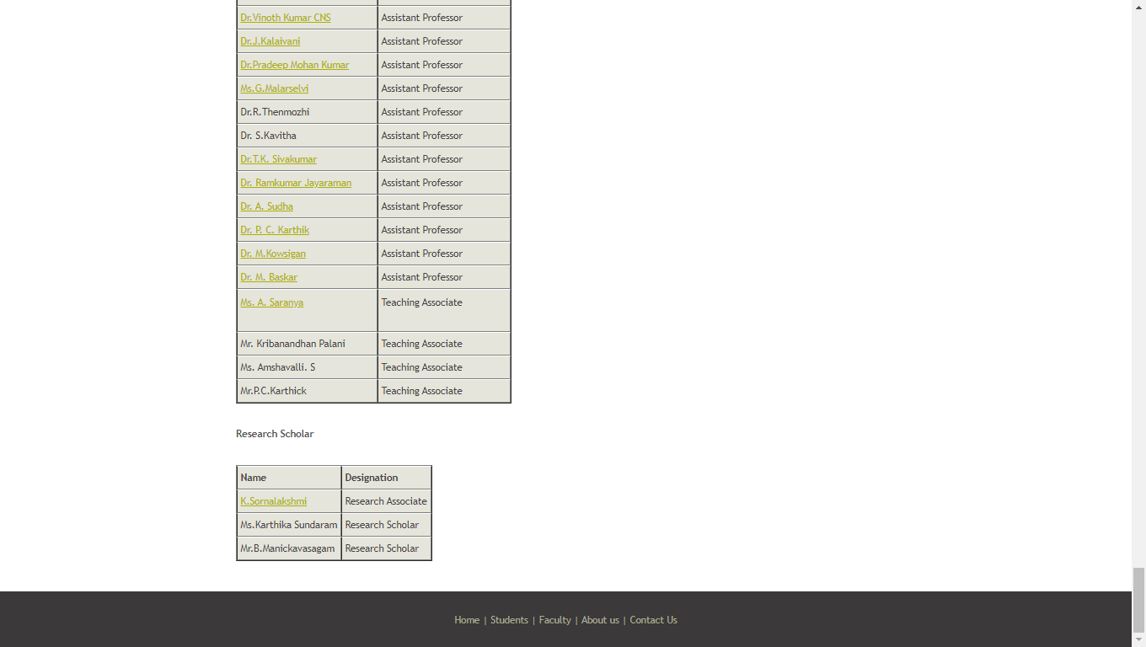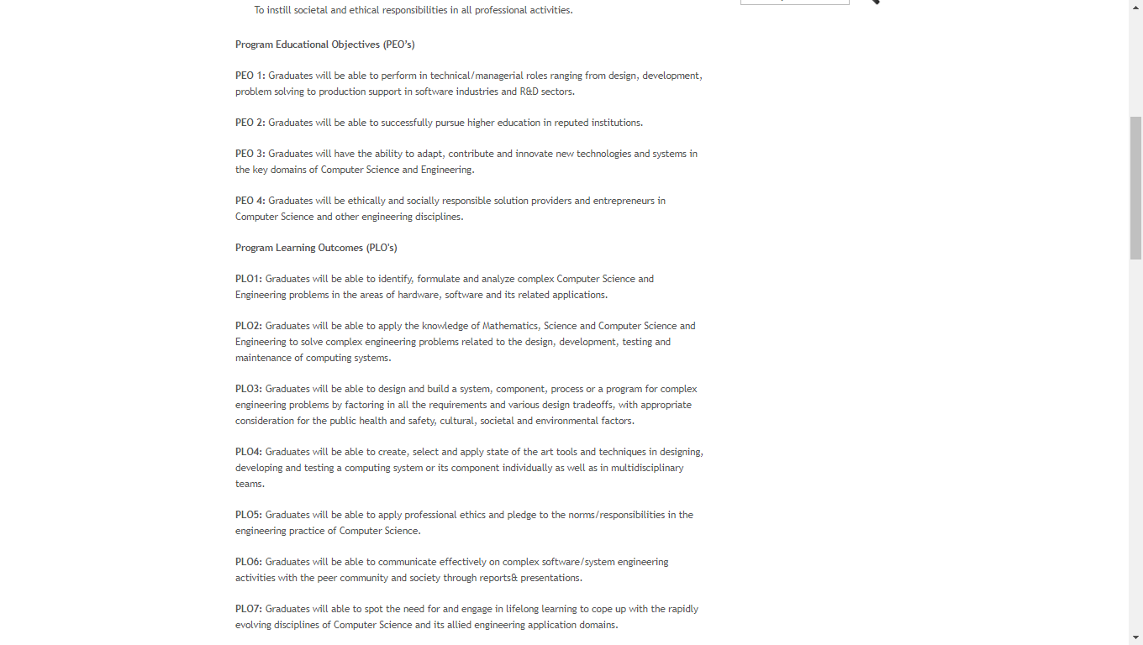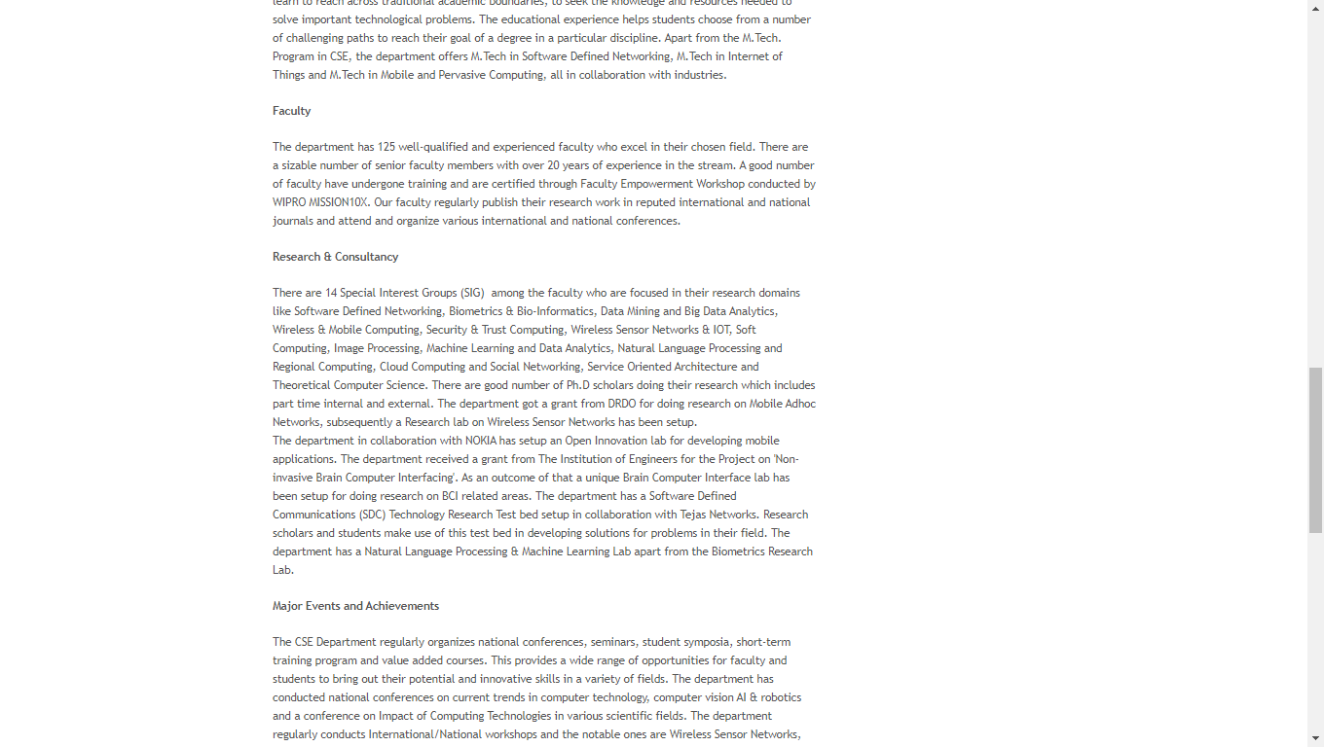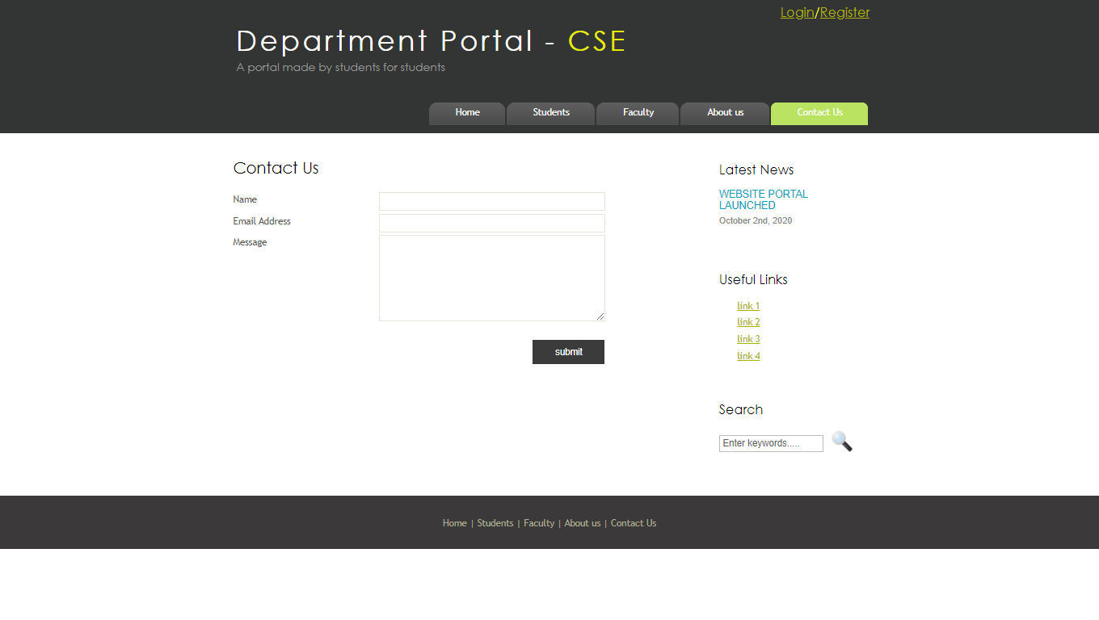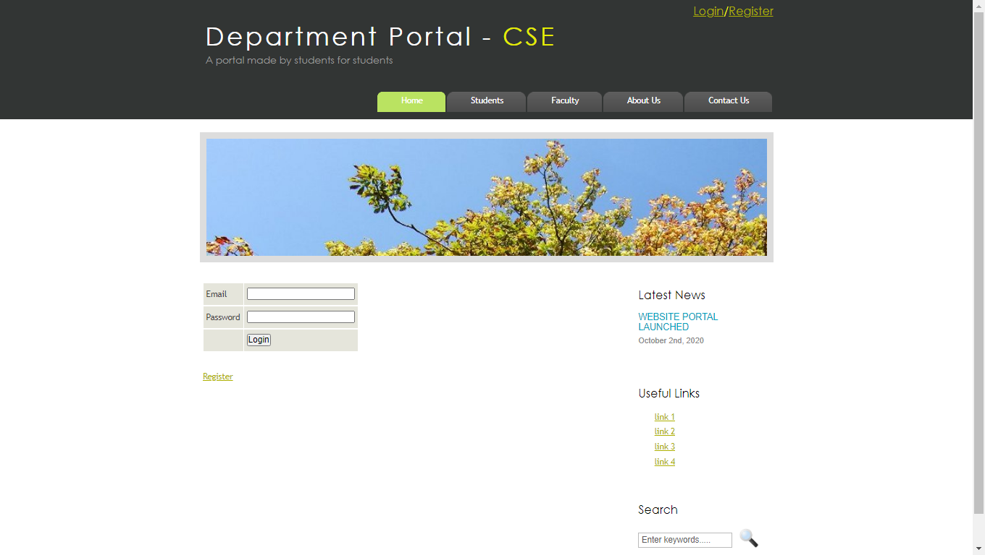**

**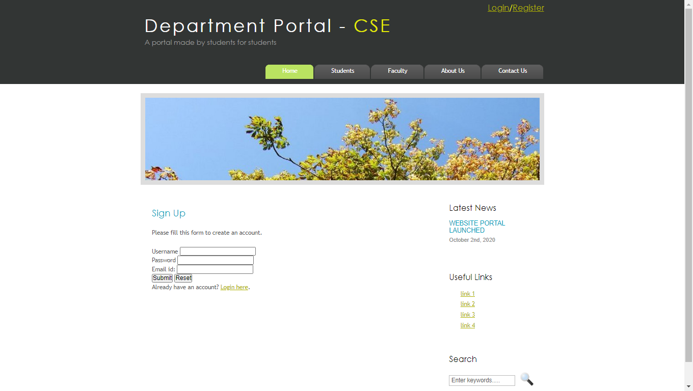**

**DATABASE IMAGE**

The database was created using phpmyadmin .

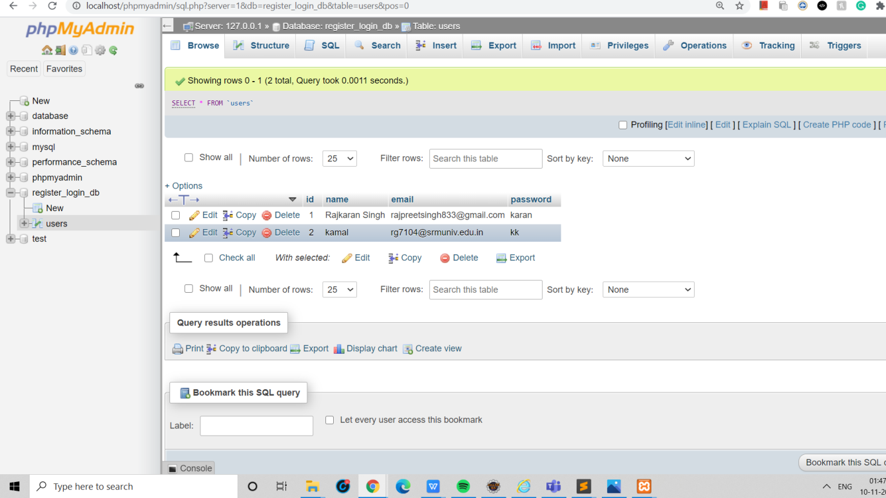

**CONCLUSION**

The proposed system of an online web portal for Computer Science Department, was created so that everyone can register in the department. Records of every student faculty can stored easily and efficiently in database from their registration. The proposed system could be accessed from any corner of the world on net. This will be one stop solution for all student faculties of the entire department.