import torch
from PIL import Image
from transformers import Qwen2VLForConditionalGeneration, AutoProcessor

model = Qwen2VLForConditionalGeneration.from_pretrained(
"Qwen/Qwen2-VL-2B-Instruct",
device_map="cpu"
)

processor = AutoProcessor.from_pretrained("Qwen/Qwen2-VL-2B-Instruct")

# Example image
image = Image.open("motivation.jpg")

messages = [
{
"role": "user",
"content": [
{"type": "image", "image": image},
{"type": "text", "text": "Describe the image."}
]
}
]

text = processor.apply_chat_template(
messages,
tokenize=False,
add_generation_prompt=True,
)

inputs = processor(
text=[text],
images=[image],
return_tensors="pt",
)

def hook(name):
def fn(module, inputs, outputs):
if isinstance(outputs, torch.Tensor):
print(f"{name:60s} {tuple(outputs.shape)}")
return fn

hooks = []
for name, module in model.named_modules():
hooks.append(module.register_forward_hook(hook(name)))

with torch.no_grad():
model(**inputs)

for h in hooks:
h.remove()


actual output shape of every executed module.
1080*1240
1080/14 ~= 78
1240/14 ~= 88
smart_resize =
<vision_start> vision tokens <vision_end> text tokens
1716 +
2 (<vision_start>, <vision_end>) +
23 (text prompt)
-----
1741

{'input_ids': tensor([[151644, 8948, 198, ..., 151644, 77091, 198]]), 'attention_mask': tensor([[1, 1, 1, ..., 1, 1, 1]]), 'mm_token_type_ids': tensor([[0, 0, 0, ..., 0, 0, 0]]), 'pixel_values': tensor([[-0.5076, 0.1493, -0.4346, ..., -1.4660, -1.4660, -1.3949],
[-1.6609, -1.7631, -1.7777, ..., -0.5133, -1.0110, -1.2385],
[-0.6390, 0.4413, 0.4267, ..., -1.4802, -1.2811, -0.5701],
...,
[-1.7777, -1.7777, -1.7777, ..., -1.4376, -1.4376, -1.4376],
[-1.7777, -1.7777, -1.7777, ..., -1.4802, -1.4802, -1.4802],
[-1.7777, -1.7777, -1.7777, ..., -1.4802, -1.4802, -1.4802]]), 'image_grid_thw': tensor([[ 1, 88, 78]])}

model.visual.patch_embed.proj (6864, 1280, 1, 1, 1)
Conv3d( in_channels=3, out_channels=1280, kernel_size=(2,14,14), stride=(2,14,14) )

model.language_model.embed_tokens (1, 1741, 1536)
model.visual.patch_embed.proj (6864, 1280, 1, 1, 1)
model.visual.patch_embed (6864, 1280)
model.visual.rotary_pos_emb (6864, 40)
model.visual.blocks.0.norm1 (6864, 1280)
model.visual.blocks.0.attn.qkv (6864, 3840)
model.visual.blocks.0.attn.proj (6864, 1280)
model.visual.blocks.0.attn (6864, 1280)
model.visual.blocks.0.norm2 (6864, 1280)
model.visual.blocks.0.mlp.fc1 (6864, 5120)
model.visual.blocks.0.mlp.act (6864, 5120)
model.visual.blocks.0.mlp.fc2 (6864, 1280)
model.visual.blocks.0.mlp (6864, 1280)
model.visual.blocks.0 (6864, 1280)
model.visual.blocks.1.norm1 (6864, 1280)
model.visual.blocks.1.attn.qkv (6864, 3840)
model.visual.blocks.1.attn.proj (6864, 1280)
model.visual.blocks.1.attn (6864, 1280)
model.visual.blocks.1.norm2 (6864, 1280)
model.visual.blocks.1.mlp.fc1 (6864, 5120)
model.visual.blocks.1.mlp.act (6864, 5120)
model.visual.blocks.1.mlp.fc2 (6864, 1280)
model.visual.blocks.1.mlp (6864, 1280)
model.visual.blocks.1 (6864, 1280)
model.visual.blocks.2.norm1 (6864, 1280)
model.visual.blocks.2.attn.qkv (6864, 3840)
model.visual.blocks.2.attn.proj (6864, 1280)
model.visual.blocks.2.attn (6864, 1280)
model.visual.blocks.2.norm2 (6864, 1280)
model.visual.blocks.2.mlp.fc1 (6864, 5120)
model.visual.blocks.2.mlp.act (6864, 5120)
model.visual.blocks.2.mlp.fc2 (6864, 1280)
model.visual.blocks.2.mlp (6864, 1280)
model.visual.blocks.2 (6864, 1280)
model.visual.blocks.3.norm1 (6864, 1280)
model.visual.blocks.3.attn.qkv (6864, 3840)
model.visual.blocks.3.attn.proj (6864, 1280)
model.visual.blocks.3.attn (6864, 1280)
model.visual.blocks.3.norm2 (6864, 1280)
model.visual.blocks.3.mlp.fc1 (6864, 5120)
model.visual.blocks.3.mlp.act (6864, 5120)
model.visual.blocks.3.mlp.fc2 (6864, 1280)
model.visual.blocks.3.mlp (6864, 1280)
model.visual.blocks.3 (6864, 1280)
model.visual.blocks.4.norm1 (6864, 1280)
model.visual.blocks.4.attn.qkv (6864, 3840)
model.visual.blocks.4.attn.proj (6864, 1280)
model.visual.blocks.4.attn (6864, 1280)
model.visual.blocks.4.norm2 (6864, 1280)
model.visual.blocks.4.mlp.fc1 (6864, 5120)
model.visual.blocks.4.mlp.act (6864, 5120)
model.visual.blocks.4.mlp.fc2 (6864, 1280)
model.visual.blocks.4.mlp (6864, 1280)
model.visual.blocks.4 (6864, 1280)
model.visual.blocks.5.norm1 (6864, 1280)
model.visual.blocks.5.attn.qkv (6864, 3840)
model.visual.blocks.5.attn.proj (6864, 1280)
model.visual.blocks.5.attn (6864, 1280)
model.visual.blocks.5.norm2 (6864, 1280)
model.visual.blocks.5.mlp.fc1 (6864, 5120)
model.visual.blocks.5.mlp.act (6864, 5120)
model.visual.blocks.5.mlp.fc2 (6864, 1280)
model.visual.blocks.5.mlp (6864, 1280)
model.visual.blocks.5 (6864, 1280)
model.visual.blocks.6.norm1 (6864, 1280)
model.visual.blocks.6.attn.qkv (6864, 3840)
model.visual.blocks.6.attn.proj (6864, 1280)
model.visual.blocks.6.attn (6864, 1280)
model.visual.blocks.6.norm2 (6864, 1280)
model.visual.blocks.6.mlp.fc1 (6864, 5120)
model.visual.blocks.6.mlp.act (6864, 5120)
model.visual.blocks.6.mlp.fc2 (6864, 1280)
model.visual.blocks.6.mlp (6864, 1280)
model.visual.blocks.6 (6864, 1280)
model.visual.blocks.7.norm1 (6864, 1280)
model.visual.blocks.7.attn.qkv (6864, 3840)
model.visual.blocks.7.attn.proj (6864, 1280)
model.visual.blocks.7.attn (6864, 1280)
model.visual.blocks.7.norm2 (6864, 1280)
model.visual.blocks.7.mlp.fc1 (6864, 5120)
model.visual.blocks.7.mlp.act (6864, 5120)
model.visual.blocks.7.mlp.fc2 (6864, 1280)
model.visual.blocks.7.mlp (6864, 1280)
model.visual.blocks.7 (6864, 1280)
model.visual.blocks.8.norm1 (6864, 1280)
model.visual.blocks.8.attn.qkv (6864, 3840)
model.visual.blocks.8.attn.proj (6864, 1280)
model.visual.blocks.8.attn (6864, 1280)
model.visual.blocks.8.norm2 (6864, 1280)
model.visual.blocks.8.mlp.fc1 (6864, 5120)
model.visual.blocks.8.mlp.act (6864, 5120)
model.visual.blocks.8.mlp.fc2 (6864, 1280)
model.visual.blocks.8.mlp (6864, 1280)
model.visual.blocks.8 (6864, 1280)
model.visual.blocks.9.norm1 (6864, 1280)
model.visual.blocks.9.attn.qkv (6864, 3840)
model.visual.blocks.9.attn.proj (6864, 1280)
model.visual.blocks.9.attn (6864, 1280)
model.visual.blocks.9.norm2 (6864, 1280)
model.visual.blocks.9.mlp.fc1 (6864, 5120)
model.visual.blocks.9.mlp.act (6864, 5120)
model.visual.blocks.9.mlp.fc2 (6864, 1280)
model.visual.blocks.9.mlp (6864, 1280)
model.visual.blocks.9 (6864, 1280)
model.visual.blocks.10.norm1 (6864, 1280)
model.visual.blocks.10.attn.qkv (6864, 3840)
model.visual.blocks.10.attn.proj (6864, 1280)
model.visual.blocks.10.attn (6864, 1280)
model.visual.blocks.10.norm2 (6864, 1280)
model.visual.blocks.10.mlp.fc1 (6864, 5120)
model.visual.blocks.10.mlp.act (6864, 5120)
model.visual.blocks.10.mlp.fc2 (6864, 1280)
model.visual.blocks.10.mlp (6864, 1280)
model.visual.blocks.10 (6864, 1280)
model.visual.blocks.11.norm1 (6864, 1280)
model.visual.blocks.11.attn.qkv (6864, 3840)
model.visual.blocks.11.attn.proj (6864, 1280)
model.visual.blocks.11.attn (6864, 1280)
model.visual.blocks.11.norm2 (6864, 1280)
model.visual.blocks.11.mlp.fc1 (6864, 5120)
model.visual.blocks.11.mlp.act (6864, 5120)
model.visual.blocks.11.mlp.fc2 (6864, 1280)
model.visual.blocks.11.mlp (6864, 1280)
model.visual.blocks.11 (6864, 1280)
model.visual.blocks.12.norm1 (6864, 1280)
model.visual.blocks.12.attn.qkv (6864, 3840)
model.visual.blocks.12.attn.proj (6864, 1280)
model.visual.blocks.12.attn (6864, 1280)
model.visual.blocks.12.norm2 (6864, 1280)
model.visual.blocks.12.mlp.fc1 (6864, 5120)
model.visual.blocks.12.mlp.act (6864, 5120)
model.visual.blocks.12.mlp.fc2 (6864, 1280)
model.visual.blocks.12.mlp (6864, 1280)
model.visual.blocks.12 (6864, 1280)
model.visual.blocks.13.norm1 (6864, 1280)
model.visual.blocks.13.attn.qkv (6864, 3840)
model.visual.blocks.13.attn.proj (6864, 1280)
model.visual.blocks.13.attn (6864, 1280)
model.visual.blocks.13.norm2 (6864, 1280)
model.visual.blocks.13.mlp.fc1 (6864, 5120)
model.visual.blocks.13.mlp.act (6864, 5120)
model.visual.blocks.13.mlp.fc2 (6864, 1280)
model.visual.blocks.13.mlp (6864, 1280)
model.visual.blocks.13 (6864, 1280)
model.visual.blocks.14.norm1 (6864, 1280)
model.visual.blocks.14.attn.qkv (6864, 3840)
model.visual.blocks.14.attn.proj (6864, 1280)
model.visual.blocks.14.attn (6864, 1280)
model.visual.blocks.14.norm2 (6864, 1280)
model.visual.blocks.14.mlp.fc1 (6864, 5120)
model.visual.blocks.14.mlp.act (6864, 5120)
model.visual.blocks.14.mlp.fc2 (6864, 1280)
model.visual.blocks.14.mlp (6864, 1280)
model.visual.blocks.14 (6864, 1280)
model.visual.blocks.15.norm1 (6864, 1280)
model.visual.blocks.15.attn.qkv (6864, 3840)
model.visual.blocks.15.attn.proj (6864, 1280)
model.visual.blocks.15.attn (6864, 1280)
model.visual.blocks.15.norm2 (6864, 1280)
model.visual.blocks.15.mlp.fc1 (6864, 5120)
model.visual.blocks.15.mlp.act (6864, 5120)
model.visual.blocks.15.mlp.fc2 (6864, 1280)
model.visual.blocks.15.mlp (6864, 1280)
model.visual.blocks.15 (6864, 1280)
model.visual.blocks.16.norm1 (6864, 1280)
model.visual.blocks.16.attn.qkv (6864, 3840)
model.visual.blocks.16.attn.proj (6864, 1280)
model.visual.blocks.16.attn (6864, 1280)
model.visual.blocks.16.norm2 (6864, 1280)
model.visual.blocks.16.mlp.fc1 (6864, 5120)
model.visual.blocks.16.mlp.act (6864, 5120)
model.visual.blocks.16.mlp.fc2 (6864, 1280)
model.visual.blocks.16.mlp (6864, 1280)
model.visual.blocks.16 (6864, 1280)
model.visual.blocks.17.norm1 (6864, 1280)
model.visual.blocks.17.attn.qkv (6864, 3840)
model.visual.blocks.17.attn.proj (6864, 1280)
model.visual.blocks.17.attn (6864, 1280)
model.visual.blocks.17.norm2 (6864, 1280)
model.visual.blocks.17.mlp.fc1 (6864, 5120)
model.visual.blocks.17.mlp.act (6864, 5120)
model.visual.blocks.17.mlp.fc2 (6864, 1280)
model.visual.blocks.17.mlp (6864, 1280)
model.visual.blocks.17 (6864, 1280)
model.visual.blocks.18.norm1 (6864, 1280)
model.visual.blocks.18.attn.qkv (6864, 3840)
model.visual.blocks.18.attn.proj (6864, 1280)
model.visual.blocks.18.attn (6864, 1280)
model.visual.blocks.18.norm2 (6864, 1280)
model.visual.blocks.18.mlp.fc1 (6864, 5120)
model.visual.blocks.18.mlp.act (6864, 5120)
model.visual.blocks.18.mlp.fc2 (6864, 1280)
model.visual.blocks.18.mlp (6864, 1280)
model.visual.blocks.18 (6864, 1280)
model.visual.blocks.19.norm1 (6864, 1280)
model.visual.blocks.19.attn.qkv (6864, 3840)
model.visual.blocks.19.attn.proj (6864, 1280)
model.visual.blocks.19.attn (6864, 1280)
model.visual.blocks.19.norm2 (6864, 1280)
model.visual.blocks.19.mlp.fc1 (6864, 5120)
model.visual.blocks.19.mlp.act (6864, 5120)
model.visual.blocks.19.mlp.fc2 (6864, 1280)
model.visual.blocks.19.mlp (6864, 1280)
model.visual.blocks.19 (6864, 1280)
model.visual.blocks.20.norm1 (6864, 1280)
model.visual.blocks.20.attn.qkv (6864, 3840)
model.visual.blocks.20.attn.proj (6864, 1280)
model.visual.blocks.20.attn (6864, 1280)
model.visual.blocks.20.norm2 (6864, 1280)
model.visual.blocks.20.mlp.fc1 (6864, 5120)
model.visual.blocks.20.mlp.act (6864, 5120)
model.visual.blocks.20.mlp.fc2 (6864, 1280)
model.visual.blocks.20.mlp (6864, 1280)
model.visual.blocks.20 (6864, 1280)
model.visual.blocks.21.norm1 (6864, 1280)
model.visual.blocks.21.attn.qkv (6864, 3840)
model.visual.blocks.21.attn.proj (6864, 1280)
model.visual.blocks.21.attn (6864, 1280)
model.visual.blocks.21.norm2 (6864, 1280)
model.visual.blocks.21.mlp.fc1 (6864, 5120)
model.visual.blocks.21.mlp.act (6864, 5120)
model.visual.blocks.21.mlp.fc2 (6864, 1280)
model.visual.blocks.21.mlp (6864, 1280)
model.visual.blocks.21 (6864, 1280)
model.visual.blocks.22.norm1 (6864, 1280)
model.visual.blocks.22.attn.qkv (6864, 3840)
model.visual.blocks.22.attn.proj (6864, 1280)
model.visual.blocks.22.attn (6864, 1280)
model.visual.blocks.22.norm2 (6864, 1280)
model.visual.blocks.22.mlp.fc1 (6864, 5120)
model.visual.blocks.22.mlp.act (6864, 5120)
model.visual.blocks.22.mlp.fc2 (6864, 1280)
model.visual.blocks.22.mlp (6864, 1280)
model.visual.blocks.22 (6864, 1280)
model.visual.blocks.23.norm1 (6864, 1280)
model.visual.blocks.23.attn.qkv (6864, 3840)
model.visual.blocks.23.attn.proj (6864, 1280)
model.visual.blocks.23.attn (6864, 1280)
model.visual.blocks.23.norm2 (6864, 1280)
model.visual.blocks.23.mlp.fc1 (6864, 5120)
model.visual.blocks.23.mlp.act (6864, 5120)
model.visual.blocks.23.mlp.fc2 (6864, 1280)
model.visual.blocks.23.mlp (6864, 1280)
model.visual.blocks.23 (6864, 1280)
model.visual.blocks.24.norm1 (6864, 1280)
model.visual.blocks.24.attn.qkv (6864, 3840)
model.visual.blocks.24.attn.proj (6864, 1280)
model.visual.blocks.24.attn (6864, 1280)
model.visual.blocks.24.norm2 (6864, 1280)
model.visual.blocks.24.mlp.fc1 (6864, 5120)
model.visual.blocks.24.mlp.act (6864, 5120)
model.visual.blocks.24.mlp.fc2 (6864, 1280)
model.visual.blocks.24.mlp (6864, 1280)
model.visual.blocks.24 (6864, 1280)
model.visual.blocks.25.norm1 (6864, 1280)
model.visual.blocks.25.attn.qkv (6864, 3840)
model.visual.blocks.25.attn.proj (6864, 1280)
model.visual.blocks.25.attn (6864, 1280)
model.visual.blocks.25.norm2 (6864, 1280)
model.visual.blocks.25.mlp.fc1 (6864, 5120)
model.visual.blocks.25.mlp.act (6864, 5120)
model.visual.blocks.25.mlp.fc2 (6864, 1280)
model.visual.blocks.25.mlp (6864, 1280)
model.visual.blocks.25 (6864, 1280)
model.visual.blocks.26.norm1 (6864, 1280)
model.visual.blocks.26.attn.qkv (6864, 3840)
model.visual.blocks.26.attn.proj (6864, 1280)
model.visual.blocks.26.attn (6864, 1280)
model.visual.blocks.26.norm2 (6864, 1280)
model.visual.blocks.26.mlp.fc1 (6864, 5120)
model.visual.blocks.26.mlp.act (6864, 5120)
model.visual.blocks.26.mlp.fc2 (6864, 1280)
model.visual.blocks.26.mlp (6864, 1280)
model.visual.blocks.26 (6864, 1280)
model.visual.blocks.27.norm1 (6864, 1280)
model.visual.blocks.27.attn.qkv (6864, 3840)
model.visual.blocks.27.attn.proj (6864, 1280)
model.visual.blocks.27.attn (6864, 1280)
model.visual.blocks.27.norm2 (6864, 1280)
model.visual.blocks.27.mlp.fc1 (6864, 5120)
model.visual.blocks.27.mlp.act (6864, 5120)
model.visual.blocks.27.mlp.fc2 (6864, 1280)
model.visual.blocks.27.mlp (6864, 1280)
model.visual.blocks.27 (6864, 1280)
model.visual.blocks.28.norm1 (6864, 1280)
model.visual.blocks.28.attn.qkv (6864, 3840)
model.visual.blocks.28.attn.proj (6864, 1280)
model.visual.blocks.28.attn (6864, 1280)
model.visual.blocks.28.norm2 (6864, 1280)
model.visual.blocks.28.mlp.fc1 (6864, 5120)
model.visual.blocks.28.mlp.act (6864, 5120)
model.visual.blocks.28.mlp.fc2 (6864, 1280)
model.visual.blocks.28.mlp (6864, 1280)
model.visual.blocks.28 (6864, 1280)
model.visual.blocks.29.norm1 (6864, 1280)
model.visual.blocks.29.attn.qkv (6864, 3840)
model.visual.blocks.29.attn.proj (6864, 1280)
model.visual.blocks.29.attn (6864, 1280)
model.visual.blocks.29.norm2 (6864, 1280)
model.visual.blocks.29.mlp.fc1 (6864, 5120)
model.visual.blocks.29.mlp.act (6864, 5120)
model.visual.blocks.29.mlp.fc2 (6864, 1280)
model.visual.blocks.29.mlp (6864, 1280)
model.visual.blocks.29 (6864, 1280)
model.visual.blocks.30.norm1 (6864, 1280)
model.visual.blocks.30.attn.qkv (6864, 3840)
model.visual.blocks.30.attn.proj (6864, 1280)
model.visual.blocks.30.attn (6864, 1280)
model.visual.blocks.30.norm2 (6864, 1280)
model.visual.blocks.30.mlp.fc1 (6864, 5120)
model.visual.blocks.30.mlp.act (6864, 5120)
model.visual.blocks.30.mlp.fc2 (6864, 1280)
model.visual.blocks.30.mlp (6864, 1280)
model.visual.blocks.30 (6864, 1280)
model.visual.blocks.31.norm1 (6864, 1280)
model.visual.blocks.31.attn.qkv (6864, 3840)
model.visual.blocks.31.attn.proj (6864, 1280)
model.visual.blocks.31.attn (6864, 1280)
model.visual.blocks.31.norm2 (6864, 1280)
model.visual.blocks.31.mlp.fc1 (6864, 5120)
model.visual.blocks.31.mlp.act (6864, 5120)
model.visual.blocks.31.mlp.fc2 (6864, 1280)
model.visual.blocks.31.mlp (6864, 1280)
model.visual.blocks.31 (6864, 1280)
model.visual.merger.ln_q (6864, 1280)
model.visual.merger.mlp.0 (1716, 5120)
model.visual.merger.mlp.1 (1716, 5120)
model.visual.merger.mlp.2 (1716, 1536)
model.visual.merger.mlp (1716, 1536)
model.visual.merger (1716, 1536)
model.language_model.layers.0.input_layernorm (1, 1741, 1536)
model.language_model.layers.0.self_attn.q_proj (1, 1741, 1536)
model.language_model.layers.0.self_attn.k_proj (1, 1741, 256)
model.language_model.layers.0.self_attn.v_proj (1, 1741, 256)
model.language_model.layers.0.self_attn.o_proj (1, 1741, 1536)
model.language_model.layers.0.post_attention_layernorm (1, 1741, 1536)
model.language_model.layers.0.mlp.gate_proj (1, 1741, 8960)
model.language_model.layers.0.mlp.act_fn (1, 1741, 8960)
model.language_model.layers.0.mlp.up_proj (1, 1741, 8960)
model.language_model.layers.0.mlp.down_proj (1, 1741, 1536)
model.language_model.layers.0.mlp (1, 1741, 1536)
model.language_model.layers.0 (1, 1741, 1536)
model.language_model.layers.1.input_layernorm (1, 1741, 1536)
model.language_model.layers.1.self_attn.q_proj (1, 1741, 1536)
model.language_model.layers.1.self_attn.k_proj (1, 1741, 256)
model.language_model.layers.1.self_attn.v_proj (1, 1741, 256)
model.language_model.layers.1.self_attn.o_proj (1, 1741, 1536)
model.language_model.layers.1.post_attention_layernorm (1, 1741, 1536)
model.language_model.layers.1.mlp.gate_proj (1, 1741, 8960)
model.language_model.layers.1.mlp.act_fn (1, 1741, 8960)
model.language_model.layers.1.mlp.up_proj (1, 1741, 8960)
model.language_model.layers.1.mlp.down_proj (1, 1741, 1536)
model.language_model.layers.1.mlp (1, 1741, 1536)
model.language_model.layers.1 (1, 1741, 1536)
model.language_model.layers.2.input_layernorm (1, 1741, 1536)
model.language_model.layers.2.self_attn.q_proj (1, 1741, 1536)
model.language_model.layers.2.self_attn.k_proj (1, 1741, 256)
model.language_model.layers.2.self_attn.v_proj (1, 1741, 256)
model.language_model.layers.2.self_attn.o_proj (1, 1741, 1536)
model.language_model.layers.2.post_attention_layernorm (1, 1741, 1536)
model.language_model.layers.2.mlp.gate_proj (1, 1741, 8960)
model.language_model.layers.2.mlp.act_fn (1, 1741, 8960)
model.language_model.layers.2.mlp.up_proj (1, 1741, 8960)
model.language_model.layers.2.mlp.down_proj (1, 1741, 1536)
model.language_model.layers.2.mlp (1, 1741, 1536)
model.language_model.layers.2 (1, 1741, 1536)
model.language_model.layers.3.input_layernorm (1, 1741, 1536)
model.language_model.layers.3.self_attn.q_proj (1, 1741, 1536)
model.language_model.layers.3.self_attn.k_proj (1, 1741, 256)
model.language_model.layers.3.self_attn.v_proj (1, 1741, 256)
model.language_model.layers.3.self_attn.o_proj (1, 1741, 1536)
model.language_model.layers.3.post_attention_layernorm (1, 1741, 1536)
model.language_model.layers.3.mlp.gate_proj (1, 1741, 8960)
model.language_model.layers.3.mlp.act_fn (1, 1741, 8960)
model.language_model.layers.3.mlp.up_proj (1, 1741, 8960)
model.language_model.layers.3.mlp.down_proj (1, 1741, 1536)
model.language_model.layers.3.mlp (1, 1741, 1536)
model.language_model.layers.3 (1, 1741, 1536)
model.language_model.layers.4.input_layernorm (1, 1741, 1536)
model.language_model.layers.4.self_attn.q_proj (1, 1741, 1536)
model.language_model.layers.4.self_attn.k_proj (1, 1741, 256)
model.language_model.layers.4.self_attn.v_proj (1, 1741, 256)
model.language_model.layers.4.self_attn.o_proj (1, 1741, 1536)
model.language_model.layers.4.post_attention_layernorm (1, 1741, 1536)
model.language_model.layers.4.mlp.gate_proj (1, 1741, 8960)
model.language_model.layers.4.mlp.act_fn (1, 1741, 8960)
model.language_model.layers.4.mlp.up_proj (1, 1741, 8960)
model.language_model.layers.4.mlp.down_proj (1, 1741, 1536)
model.language_model.layers.4.mlp (1, 1741, 1536)
model.language_model.layers.4 (1, 1741, 1536)
model.language_model.layers.5.input_layernorm (1, 1741, 1536)
model.language_model.layers.5.self_attn.q_proj (1, 1741, 1536)
model.language_model.layers.5.self_attn.k_proj (1, 1741, 256)
model.language_model.layers.5.self_attn.v_proj (1, 1741, 256)
model.language_model.layers.5.self_attn.o_proj (1, 1741, 1536)
model.language_model.layers.5.post_attention_layernorm (1, 1741, 1536)
model.language_model.layers.5.mlp.gate_proj (1, 1741, 8960)
model.language_model.layers.5.mlp.act_fn (1, 1741, 8960)
model.language_model.layers.5.mlp.up_proj (1, 1741, 8960)
model.language_model.layers.5.mlp.down_proj (1, 1741, 1536)
model.language_model.layers.5.mlp (1, 1741, 1536)
model.language_model.layers.5 (1, 1741, 1536)
model.language_model.layers.6.input_layernorm (1, 1741, 1536)
model.language_model.layers.6.self_attn.q_proj (1, 1741, 1536)
model.language_model.layers.6.self_attn.k_proj (1, 1741, 256)
model.language_model.layers.6.self_attn.v_proj (1, 1741, 256)
model.language_model.layers.6.self_attn.o_proj (1, 1741, 1536)
model.language_model.layers.6.post_attention_layernorm (1, 1741, 1536)
model.language_model.layers.6.mlp.gate_proj (1, 1741, 8960)
model.language_model.layers.6.mlp.act_fn (1, 1741, 8960)
model.language_model.layers.6.mlp.up_proj (1, 1741, 8960)
model.language_model.layers.6.mlp.down_proj (1, 1741, 1536)
model.language_model.layers.6.mlp (1, 1741, 1536)
model.language_model.layers.6 (1, 1741, 1536)
model.language_model.layers.7.input_layernorm (1, 1741, 1536)
model.language_model.layers.7.self_attn.q_proj (1, 1741, 1536)
model.language_model.layers.7.self_attn.k_proj (1, 1741, 256)
model.language_model.layers.7.self_attn.v_proj (1, 1741, 256)
model.language_model.layers.7.self_attn.o_proj (1, 1741, 1536)
model.language_model.layers.7.post_attention_layernorm (1, 1741, 1536)
model.language_model.layers.7.mlp.gate_proj (1, 1741, 8960)
model.language_model.layers.7.mlp.act_fn (1, 1741, 8960)
model.language_model.layers.7.mlp.up_proj (1, 1741, 8960)
model.language_model.layers.7.mlp.down_proj (1, 1741, 1536)
model.language_model.layers.7.mlp (1, 1741, 1536)
model.language_model.layers.7 (1, 1741, 1536)
model.language_model.layers.8.input_layernorm (1, 1741, 1536)
model.language_model.layers.8.self_attn.q_proj (1, 1741, 1536)
model.language_model.layers.8.self_attn.k_proj (1, 1741, 256)
model.language_model.layers.8.self_attn.v_proj (1, 1741, 256)
model.language_model.layers.8.self_attn.o_proj (1, 1741, 1536)
model.language_model.layers.8.post_attention_layernorm (1, 1741, 1536)
model.language_model.layers.8.mlp.gate_proj (1, 1741, 8960)
model.language_model.layers.8.mlp.act_fn (1, 1741, 8960)
model.language_model.layers.8.mlp.up_proj (1, 1741, 8960)
model.language_model.layers.8.mlp.down_proj (1, 1741, 1536)
model.language_model.layers.8.mlp (1, 1741, 1536)
model.language_model.layers.8 (1, 1741, 1536)
model.language_model.layers.9.input_layernorm (1, 1741, 1536)
model.language_model.layers.9.self_attn.q_proj (1, 1741, 1536)
model.language_model.layers.9.self_attn.k_proj (1, 1741, 256)
model.language_model.layers.9.self_attn.v_proj (1, 1741, 256)
model.language_model.layers.9.self_attn.o_proj (1, 1741, 1536)
model.language_model.layers.9.post_attention_layernorm (1, 1741, 1536)
model.language_model.layers.9.mlp.gate_proj (1, 1741, 8960)
model.language_model.layers.9.mlp.act_fn (1, 1741, 8960)
model.language_model.layers.9.mlp.up_proj (1, 1741, 8960)
model.language_model.layers.9.mlp.down_proj (1, 1741, 1536)
model.language_model.layers.9.mlp (1, 1741, 1536)
model.language_model.layers.9 (1, 1741, 1536)
model.language_model.layers.10.input_layernorm (1, 1741, 1536)
model.language_model.layers.10.self_attn.q_proj (1, 1741, 1536)
model.language_model.layers.10.self_attn.k_proj (1, 1741, 256)
model.language_model.layers.10.self_attn.v_proj (1, 1741, 256)
model.language_model.layers.10.self_attn.o_proj (1, 1741, 1536)
model.language_model.layers.10.post_attention_layernorm (1, 1741, 1536)
model.language_model.layers.10.mlp.gate_proj (1, 1741, 8960)
model.language_model.layers.10.mlp.act_fn (1, 1741, 8960)
model.language_model.layers.10.mlp.up_proj (1, 1741, 8960)
model.language_model.layers.10.mlp.down_proj (1, 1741, 1536)
model.language_model.layers.10.mlp (1, 1741, 1536)
model.language_model.layers.10 (1, 1741, 1536)
model.language_model.layers.11.input_layernorm (1, 1741, 1536)
model.language_model.layers.11.self_attn.q_proj (1, 1741, 1536)
model.language_model.layers.11.self_attn.k_proj (1, 1741, 256)
model.language_model.layers.11.self_attn.v_proj (1, 1741, 256)
model.language_model.layers.11.self_attn.o_proj (1, 1741, 1536)
model.language_model.layers.11.post_attention_layernorm (1, 1741, 1536)
model.language_model.layers.11.mlp.gate_proj (1, 1741, 8960)
model.language_model.layers.11.mlp.act_fn (1, 1741, 8960)
model.language_model.layers.11.mlp.up_proj (1, 1741, 8960)
model.language_model.layers.11.mlp.down_proj (1, 1741, 1536)
model.language_model.layers.11.mlp (1, 1741, 1536)
model.language_model.layers.11 (1, 1741, 1536)
model.language_model.layers.12.input_layernorm (1, 1741, 1536)
model.language_model.layers.12.self_attn.q_proj (1, 1741, 1536)
model.language_model.layers.12.self_attn.k_proj (1, 1741, 256)
model.language_model.layers.12.self_attn.v_proj (1, 1741, 256)
model.language_model.layers.12.self_attn.o_proj (1, 1741, 1536)
model.language_model.layers.12.post_attention_layernorm (1, 1741, 1536)
model.language_model.layers.12.mlp.gate_proj (1, 1741, 8960)
model.language_model.layers.12.mlp.act_fn (1, 1741, 8960)
model.language_model.layers.12.mlp.up_proj (1, 1741, 8960)
model.language_model.layers.12.mlp.down_proj (1, 1741, 1536)
model.language_model.layers.12.mlp (1, 1741, 1536)
model.language_model.layers.12 (1, 1741, 1536)
model.language_model.layers.13.input_layernorm (1, 1741, 1536)
model.language_model.layers.13.self_attn.q_proj (1, 1741, 1536)
model.language_model.layers.13.self_attn.k_proj (1, 1741, 256)
model.language_model.layers.13.self_attn.v_proj (1, 1741, 256)
model.language_model.layers.13.self_attn.o_proj (1, 1741, 1536)
model.language_model.layers.13.post_attention_layernorm (1, 1741, 1536)
model.language_model.layers.13.mlp.gate_proj (1, 1741, 8960)
model.language_model.layers.13.mlp.act_fn (1, 1741, 8960)
model.language_model.layers.13.mlp.up_proj (1, 1741, 8960)
model.language_model.layers.13.mlp.down_proj (1, 1741, 1536)
model.language_model.layers.13.mlp (1, 1741, 1536)
model.language_model.layers.13 (1, 1741, 1536)
model.language_model.layers.14.input_layernorm (1, 1741, 1536)
model.language_model.layers.14.self_attn.q_proj (1, 1741, 1536)
model.language_model.layers.14.self_attn.k_proj (1, 1741, 256)
model.language_model.layers.14.self_attn.v_proj (1, 1741, 256)
model.language_model.layers.14.self_attn.o_proj (1, 1741, 1536)
model.language_model.layers.14.post_attention_layernorm (1, 1741, 1536)
model.language_model.layers.14.mlp.gate_proj (1, 1741, 8960)
model.language_model.layers.14.mlp.act_fn (1, 1741, 8960)
model.language_model.layers.14.mlp.up_proj (1, 1741, 8960)
model.language_model.layers.14.mlp.down_proj (1, 1741, 1536)
model.language_model.layers.14.mlp (1, 1741, 1536)
model.language_model.layers.14 (1, 1741, 1536)
model.language_model.layers.15.input_layernorm (1, 1741, 1536)
model.language_model.layers.15.self_attn.q_proj (1, 1741, 1536)
model.language_model.layers.15.self_attn.k_proj (1, 1741, 256)
model.language_model.layers.15.self_attn.v_proj (1, 1741, 256)
model.language_model.layers.15.self_attn.o_proj (1, 1741, 1536)
model.language_model.layers.15.post_attention_layernorm (1, 1741, 1536)
model.language_model.layers.15.mlp.gate_proj (1, 1741, 8960)
model.language_model.layers.15.mlp.act_fn (1, 1741, 8960)
model.language_model.layers.15.mlp.up_proj (1, 1741, 8960)
model.language_model.layers.15.mlp.down_proj (1, 1741, 1536)
model.language_model.layers.15.mlp (1, 1741, 1536)
model.language_model.layers.15 (1, 1741, 1536)
model.language_model.layers.16.input_layernorm (1, 1741, 1536)
model.language_model.layers.16.self_attn.q_proj (1, 1741, 1536)
model.language_model.layers.16.self_attn.k_proj (1, 1741, 256)
model.language_model.layers.16.self_attn.v_proj (1, 1741, 256)
model.language_model.layers.16.self_attn.o_proj (1, 1741, 1536)
model.language_model.layers.16.post_attention_layernorm (1, 1741, 1536)
model.language_model.layers.16.mlp.gate_proj (1, 1741, 8960)
model.language_model.layers.16.mlp.act_fn (1, 1741, 8960)
model.language_model.layers.16.mlp.up_proj (1, 1741, 8960)
model.language_model.layers.16.mlp.down_proj (1, 1741, 1536)
model.language_model.layers.16.mlp (1, 1741, 1536)
model.language_model.layers.16 (1, 1741, 1536)
model.language_model.layers.17.input_layernorm (1, 1741, 1536)
model.language_model.layers.17.self_attn.q_proj (1, 1741, 1536)
model.language_model.layers.17.self_attn.k_proj (1, 1741, 256)
model.language_model.layers.17.self_attn.v_proj (1, 1741, 256)
model.language_model.layers.17.self_attn.o_proj (1, 1741, 1536)
model.language_model.layers.17.post_attention_layernorm (1, 1741, 1536)
model.language_model.layers.17.mlp.gate_proj (1, 1741, 8960)
model.language_model.layers.17.mlp.act_fn (1, 1741, 8960)
model.language_model.layers.17.mlp.up_proj (1, 1741, 8960)
model.language_model.layers.17.mlp.down_proj (1, 1741, 1536)
model.language_model.layers.17.mlp (1, 1741, 1536)
model.language_model.layers.17 (1, 1741, 1536)
model.language_model.layers.18.input_layernorm (1, 1741, 1536)
model.language_model.layers.18.self_attn.q_proj (1, 1741, 1536)
model.language_model.layers.18.self_attn.k_proj (1, 1741, 256)
model.language_model.layers.18.self_attn.v_proj (1, 1741, 256)
model.language_model.layers.18.self_attn.o_proj (1, 1741, 1536)
model.language_model.layers.18.post_attention_layernorm (1, 1741, 1536)
model.language_model.layers.18.mlp.gate_proj (1, 1741, 8960)
model.language_model.layers.18.mlp.act_fn (1, 1741, 8960)
model.language_model.layers.18.mlp.up_proj (1, 1741, 8960)
model.language_model.layers.18.mlp.down_proj (1, 1741, 1536)
model.language_model.layers.18.mlp (1, 1741, 1536)
model.language_model.layers.18 (1, 1741, 1536)
model.language_model.layers.19.input_layernorm (1, 1741, 1536)
model.language_model.layers.19.self_attn.q_proj (1, 1741, 1536)
model.language_model.layers.19.self_attn.k_proj (1, 1741, 256)
model.language_model.layers.19.self_attn.v_proj (1, 1741, 256)
model.language_model.layers.19.self_attn.o_proj (1, 1741, 1536)
model.language_model.layers.19.post_attention_layernorm (1, 1741, 1536)
model.language_model.layers.19.mlp.gate_proj (1, 1741, 8960)
model.language_model.layers.19.mlp.act_fn (1, 1741, 8960)
model.language_model.layers.19.mlp.up_proj (1, 1741, 8960)
model.language_model.layers.19.mlp.down_proj (1, 1741, 1536)
model.language_model.layers.19.mlp (1, 1741, 1536)
model.language_model.layers.19 (1, 1741, 1536)
model.language_model.layers.20.input_layernorm (1, 1741, 1536)
model.language_model.layers.20.self_attn.q_proj (1, 1741, 1536)
model.language_model.layers.20.self_attn.k_proj (1, 1741, 256)
model.language_model.layers.20.self_attn.v_proj (1, 1741, 256)
model.language_model.layers.20.self_attn.o_proj (1, 1741, 1536)
model.language_model.layers.20.post_attention_layernorm (1, 1741, 1536)
model.language_model.layers.20.mlp.gate_proj (1, 1741, 8960)
model.language_model.layers.20.mlp.act_fn (1, 1741, 8960)
model.language_model.layers.20.mlp.up_proj (1, 1741, 8960)
model.language_model.layers.20.mlp.down_proj (1, 1741, 1536)
model.language_model.layers.20.mlp (1, 1741, 1536)
model.language_model.layers.20 (1, 1741, 1536)
model.language_model.layers.21.input_layernorm (1, 1741, 1536)
model.language_model.layers.21.self_attn.q_proj (1, 1741, 1536)
model.language_model.layers.21.self_attn.k_proj (1, 1741, 256)
model.language_model.layers.21.self_attn.v_proj (1, 1741, 256)
model.language_model.layers.21.self_attn.o_proj (1, 1741, 1536)
model.language_model.layers.21.post_attention_layernorm (1, 1741, 1536)
model.language_model.layers.21.mlp.gate_proj (1, 1741, 8960)
model.language_model.layers.21.mlp.act_fn (1, 1741, 8960)
model.language_model.layers.21.mlp.up_proj (1, 1741, 8960)
model.language_model.layers.21.mlp.down_proj (1, 1741, 1536)
model.language_model.layers.21.mlp (1, 1741, 1536)
model.language_model.layers.21 (1, 1741, 1536)
model.language_model.layers.22.input_layernorm (1, 1741, 1536)
model.language_model.layers.22.self_attn.q_proj (1, 1741, 1536)
model.language_model.layers.22.self_attn.k_proj (1, 1741, 256)
model.language_model.layers.22.self_attn.v_proj (1, 1741, 256)
model.language_model.layers.22.self_attn.o_proj (1, 1741, 1536)
model.language_model.layers.22.post_attention_layernorm (1, 1741, 1536)
model.language_model.layers.22.mlp.gate_proj (1, 1741, 8960)
model.language_model.layers.22.mlp.act_fn (1, 1741, 8960)
model.language_model.layers.22.mlp.up_proj (1, 1741, 8960)
model.language_model.layers.22.mlp.down_proj (1, 1741, 1536)
model.language_model.layers.22.mlp (1, 1741, 1536)
model.language_model.layers.22 (1, 1741, 1536)
model.language_model.layers.23.input_layernorm (1, 1741, 1536)
model.language_model.layers.23.self_attn.q_proj (1, 1741, 1536)
model.language_model.layers.23.self_attn.k_proj (1, 1741, 256)
model.language_model.layers.23.self_attn.v_proj (1, 1741, 256)
model.language_model.layers.23.self_attn.o_proj (1, 1741, 1536)
model.language_model.layers.23.post_attention_layernorm (1, 1741, 1536)
model.language_model.layers.23.mlp.gate_proj (1, 1741, 8960)
model.language_model.layers.23.mlp.act_fn (1, 1741, 8960)
model.language_model.layers.23.mlp.up_proj (1, 1741, 8960)
model.language_model.layers.23.mlp.down_proj (1, 1741, 1536)
model.language_model.layers.23.mlp (1, 1741, 1536)
model.language_model.layers.23 (1, 1741, 1536)
model.language_model.layers.24.input_layernorm (1, 1741, 1536)
model.language_model.layers.24.self_attn.q_proj (1, 1741, 1536)
model.language_model.layers.24.self_attn.k_proj (1, 1741, 256)
model.language_model.layers.24.self_attn.v_proj (1, 1741, 256)
model.language_model.layers.24.self_attn.o_proj (1, 1741, 1536)
model.language_model.layers.24.post_attention_layernorm (1, 1741, 1536)
model.language_model.layers.24.mlp.gate_proj (1, 1741, 8960)
model.language_model.layers.24.mlp.act_fn (1, 1741, 8960)
model.language_model.layers.24.mlp.up_proj (1, 1741, 8960)
model.language_model.layers.24.mlp.down_proj (1, 1741, 1536)
model.language_model.layers.24.mlp (1, 1741, 1536)
model.language_model.layers.24 (1, 1741, 1536)
model.language_model.layers.25.input_layernorm (1, 1741, 1536)
model.language_model.layers.25.self_attn.q_proj (1, 1741, 1536)
model.language_model.layers.25.self_attn.k_proj (1, 1741, 256)
model.language_model.layers.25.self_attn.v_proj (1, 1741, 256)
model.language_model.layers.25.self_attn.o_proj (1, 1741, 1536)
model.language_model.layers.25.post_attention_layernorm (1, 1741, 1536)
model.language_model.layers.25.mlp.gate_proj (1, 1741, 8960)
model.language_model.layers.25.mlp.act_fn (1, 1741, 8960)
model.language_model.layers.25.mlp.up_proj (1, 1741, 8960)
model.language_model.layers.25.mlp.down_proj (1, 1741, 1536)
model.language_model.layers.25.mlp (1, 1741, 1536)
model.language_model.layers.25 (1, 1741, 1536)
model.language_model.layers.26.input_layernorm (1, 1741, 1536)
model.language_model.layers.26.self_attn.q_proj (1, 1741, 1536)
model.language_model.layers.26.self_attn.k_proj (1, 1741, 256)
model.language_model.layers.26.self_attn.v_proj (1, 1741, 256)
model.language_model.layers.26.self_attn.o_proj (1, 1741, 1536)
model.language_model.layers.26.post_attention_layernorm (1, 1741, 1536)
model.language_model.layers.26.mlp.gate_proj (1, 1741, 8960)
model.language_model.layers.26.mlp.act_fn (1, 1741, 8960)
model.language_model.layers.26.mlp.up_proj (1, 1741, 8960)
model.language_model.layers.26.mlp.down_proj (1, 1741, 1536)
model.language_model.layers.26.mlp (1, 1741, 1536)
model.language_model.layers.26 (1, 1741, 1536)
model.language_model.layers.27.input_layernorm (1, 1741, 1536)
model.language_model.layers.27.self_attn.q_proj (1, 1741, 1536)
model.language_model.layers.27.self_attn.k_proj (1, 1741, 256)
model.language_model.layers.27.self_attn.v_proj (1, 1741, 256)
model.language_model.layers.27.self_attn.o_proj (1, 1741, 1536)
model.language_model.layers.27.post_attention_layernorm (1, 1741, 1536)
model.language_model.layers.27.mlp.gate_proj (1, 1741, 8960)
model.language_model.layers.27.mlp.act_fn (1, 1741, 8960)
model.language_model.layers.27.mlp.up_proj (1, 1741, 8960)
model.language_model.layers.27.mlp.down_proj (1, 1741, 1536)
model.language_model.layers.27.mlp (1, 1741, 1536)
model.language_model.layers.27 (1, 1741, 1536)
model.language_model.norm (1, 1741, 1536)
lm_head (1, 1741, 151936)

1. Standard RoPE rotation matrix
For one pair of dimensions $\left(x_{2i} , x_{2i+1}\right)$, the rotation is
$$R(θ_{i})=\left[\begin{matrix}\cos{θ_{i}} & -sin⁡θ_{i} \\ \sin{θ_{i}} & \cos{θ_{i}}\end{matrix}\right].$$
Applied to the vector:
$$\left[\begin{aligned}x_{2i}^{'} \\ x_{2i+1}^{'}\end{aligned}\right]=R(θ_{i})\left[\begin{aligned}x_{2i} \\ x_{2i+1}\end{aligned}\right].$$

2. Standard RoPE for one attention head
Suppose the head dimension is 12 (6 rotary pairs). The full rotation matrix is block diagonal:
$$R=\left[\begin{matrix}R(θ_{0}) & 0 & 0 & 0 & 0 & 0 \\ 0 & R(θ_{1}) & 0 & 0 & 0 & 0 \\ 0 & 0 & R(θ_{2}) & 0 & 0 & 0 \\ 0 & 0 & 0 & R(θ_{3}) & 0 & 0 \\ 0 & 0 & 0 & 0 & R(θ_{4}) & 0 \\ 0 & 0 & 0 & 0 & 0 & R(θ_{5})\end{matrix}\right].$$
Nothing changes here in mRoPE or Interleaved mRoPE.

3. Qwen2-VL mRoPE
Suppose head_dim = 12
The six rotation pairs are assigned like
Pair | Position source
0 | time
1 | time
2 | height
3 | height
4 | width
5 | width
Therefore
$$R_{\text{mRoPE}}=diag⁡\left(R(θ_{t}^{0}),R(θ_{t}^{1}),R(θ_{h}^{0}),R(θ_{h}^{1}),R(θ_{w}^{0}),R(θ_{w}^{1})\right)$$
4. Qwen3-VL Interleaved mRoPE
Pair | Position source
0 | time
1 | height
2 | width
3 | time
4 | height
5 | width
The block diagonal matrix becomes
$$R_{\text{I-mRoPE}}=diag⁡\left(R(θ_{t}^{0}),R(θ_{h}^{0}),R(θ_{w}^{0}),R(θ_{t}^{1}),R(θ_{h}^{1}),R(θ_{w}^{1})\right)$$
Mathematical definition
Let
- $R_{i}(θ)$denote the $i$-th 2×2 rotation block.
- $a(i)∈\{t,h,w\}$denote the axis assigned to pair $i$.
Then
$$R=diag⁡\left(R_{0}(θ_{a(0)}),R_{1}(θ_{a(1)}),…,R_{m-1}(θ_{a(m-1)})\right).$$
The only difference between the two schemes is the axis assignment function $a(i)$:
- mRoPE (Qwen2-VL):
$$a(i)=\left\{\begin{matrix}t, & 0≤i<m/3 \\ h, & m/3≤i<2m/3 \\ w, & 2m/3≤i<m.\end{matrix}\right.$$
- Interleaved mRoPE (Qwen3-VL):
$$a(i)=\left\{\begin{matrix}t, & i mod 3=0 \\ h, & i mod 3=1 \\ w, & i mod 3=2.\end{matrix}\right.$$
So the 2×2 rotation matrices are unchanged; the innovation is purely in how those rotation blocks are mapped to temporal and spatial positional coordinates across the hidden dimensions. This distributes information from all three axes more uniformly throughout each attention head.

https://rocm.blogs.amd.com/artificial-intelligence/qwen-vl/README.html
Visual Module Architecture
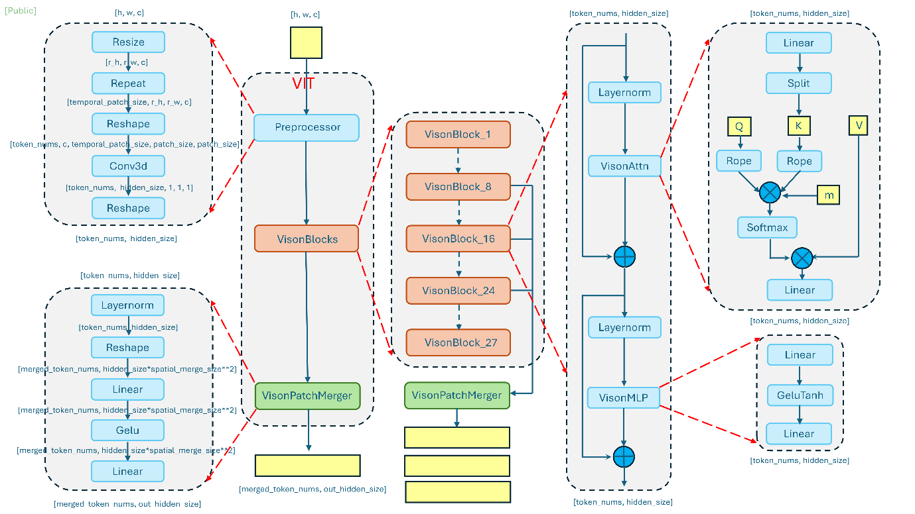
Preprocessor: The preprocessor is responsible for converting raw visual inputs—such as images or video frames—into a standardized tensor representation
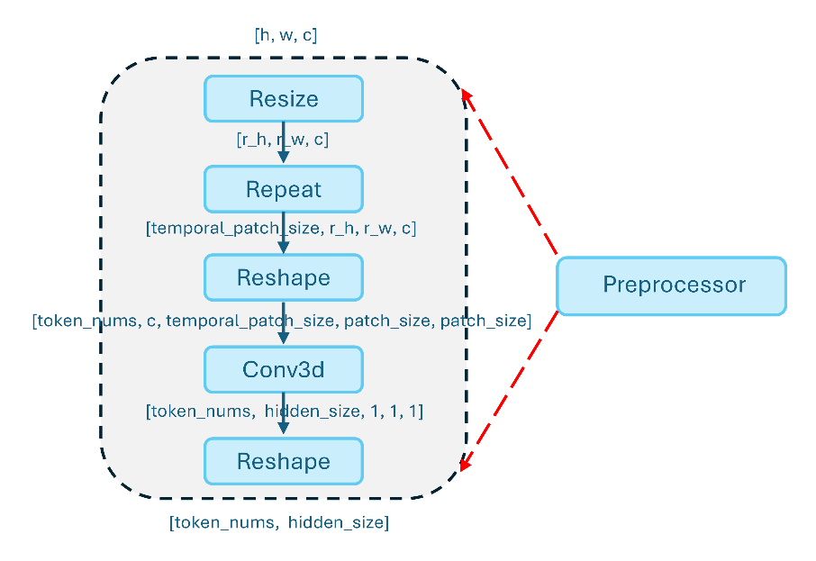
Vision blocks: visual tokens are passed through a sequence of vision blocks that form the core of visual feature extraction
These blocks typically consist of multi-head self-attention and feed-forward layers, enabling the model to capture both local spatial patterns and global semantic relationships across patches. Through progressive transformation, the vision blocks refine low-level visual signals into higher-level representations that are aligned with downstream multimodal reasoning tasks.

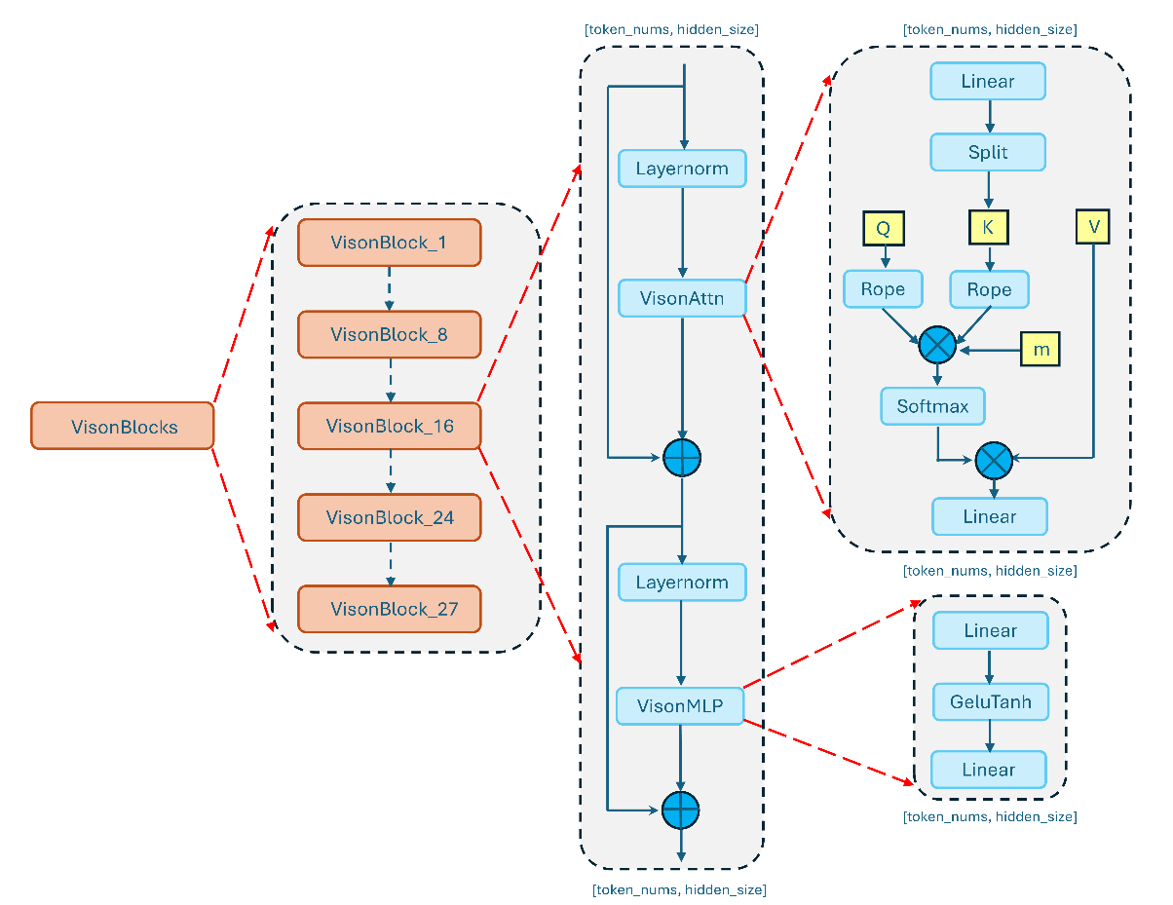
Patch merger
The patch merger serves as the interface between the visual encoder and the language model. Given the potentially large number of visual tokens produced by the vision blocks, this component reduces and aggregates patch-level features into a more compact representation. By merging spatially or semantically related patches, the patch merger effectively balances representational richness with computational efficiency, making large-scale multimodal inference practical in production settings. The detailed structure is shown in Figure 4.
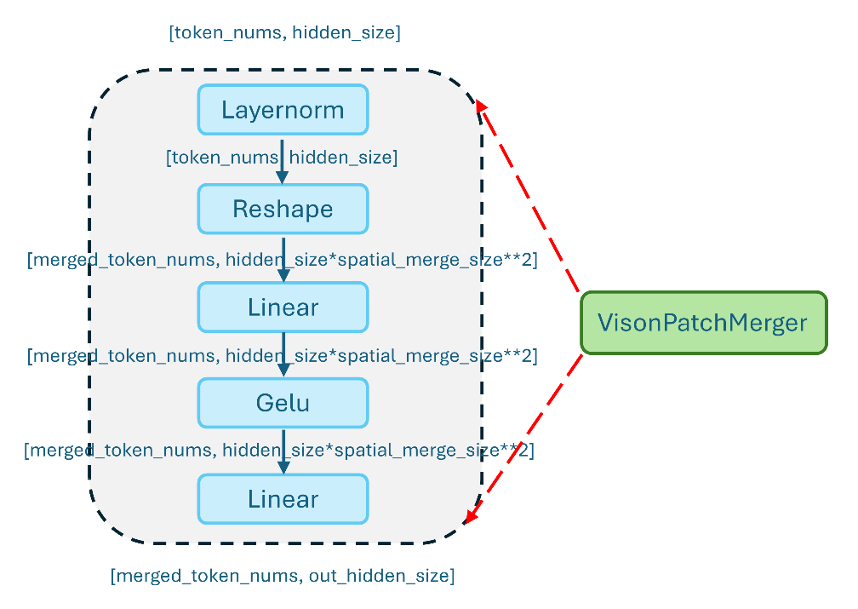
For syntax
https://medium.com/data-science-collective/qwen2-vl-a-hands-on-code-walkthrough-c5a4e073e9b3

