E-Commerce API Design
  - Requirements Analysis and Backend Implementation Roadmap
Program | Role | Task | Date
YuvaIntern | Junior Backend Developer | Week 1 of 5 | 4 October 2026

Executive summary
This report defines a versioned REST API for a simple e-commerce system before implementation. It identifies customer and administrator capabilities, specifies products, users, orders, and inventory as core resources, and documents endpoint methods, inputs, outputs, authentication, validation, and error behavior. The accompanying OpenAPI 3.0.3 file is the machine-readable contract. Two diagrams show resource relationships and the transactional order flow.
The proposed implementation target is Java with Spring Boot and PostgreSQL. Week 1 delivers the design package; the backend itself belongs to a later implementation stage. The first release uses INR prices as integer paise, reserves stock when an order is placed, and preserves order and inventory history for auditability.
Design decision | Choice
API contract | REST over HTTPS, JSON, versioned at /api/v1; OpenAPI 3.0.3
Implementation target | Java with Spring Boot; PostgreSQL relational database
Identity and access | JWT bearer token; CUSTOMER and ADMIN roles
Money and order behavior | INR integer paise; server-calculated price snapshots; atomic stock reservation

1. Purpose and scope
The API supports a small online shop with a public product catalog and authenticated customer accounts. Customers can register, sign in, browse active products, place orders, review their own orders, update editable delivery details before processing, and cancel eligible orders. Administrators can maintain the catalog, manage accounts, inspect orders, and manage inventory.
Products, users, orders, and inventory are the core resources. Order line items are modeled as a child resource so each order preserves what was purchased if a product is later renamed or repriced.
Payment-provider integration, shipping-carrier integration, storefront UI, tax calculation, promotions, and automated fulfillment are outside this first API version and can be considered later.

Design assumptions
The current contract assumes an initial India launch: product prices use INR in integer paise, and delivery addresses use country code IN. These are explicit first-version choices, not requirements stated in the assignment, and should be changed if the intended market differs.
PostgreSQL supports the related order and stock records. Reserve stock and save the order in one transaction; roll back and return 409 if stock is insufficient.

2. Requirements analysis

Functional requirements
ID | Requirement | Acceptance condition
FR-01 | Account access | A visitor can register and log in; credentials never appear in responses.
FR-02 | Product catalog | Anyone can list and view active products; administrators can create, replace, and archive products.
FR-03 | Account management | Customers manage their own profile; administrators list and manage accounts.
FR-04 | Order placement | An authenticated customer orders active products and provides a delivery address.
FR-05 | Order history | Customers see their orders only; administrators can review all orders.
FR-06 | Order changes | A customer can change editable delivery details while PLACED and cancel an eligible order.
FR-07 | Inventory visibility | Administrators review stock, reservations, availability, and low-stock records.
FR-08 | Stock maintenance | Administrators initialize stock and record auditable positive or negative adjustments.
FR-09 | Data integrity | Order placement reserves all requested stock in one transaction or stores no order.
FR-10 | API discoverability | OpenAPI documents paths, methods, parameters, schemas, security, and errors.

Actors and permissions
Actor | Allowed actions | Restrictions
Visitor | Browse active products; register; log in. | Cannot create orders or access private account data.
Customer | Manage own profile; create, list, view, edit eligible, and cancel own orders. | Cannot set role, inspect other customers, or manage catalog or stock.
Administrator | Manage products, accounts, and inventory; inspect all orders. | Role assignment uses trusted administration, never public registration.

Non-functional and security requirements
- Use HTTPS in deployed environments. Requests and successful responses use JSON with explicit content types.
- Validate types, lengths, ranges, required fields, identifiers, and business rules at the API boundary; reject unknown write fields.
- Store only an adaptive one-way password hash; never log plaintext passwords or bearer tokens.
- Check both role and resource ownership on protected requests. Derive the order owner from the token, not a request-body userId.
- Use database transactions for order creation, stock reservation, cancellation, and stock adjustments. Use an idempotency key for order-create retries.
- Paginate collections with a stable opaque cursor and a maximum page size of 100; index normalized email, SKU, foreign keys, status, and creation time.
- Log a correlation ID, actor ID when authenticated, route, status, and duration; exclude tokens, passwords, and sensitive address details.

3. Resource model
Resources use UUID identifiers and UTC timestamps. Products describe saleable items; inventory tracks physical and reserved quantities. Orders belong to users and contain immutable item snapshots. A product can be archived without deleting order history.
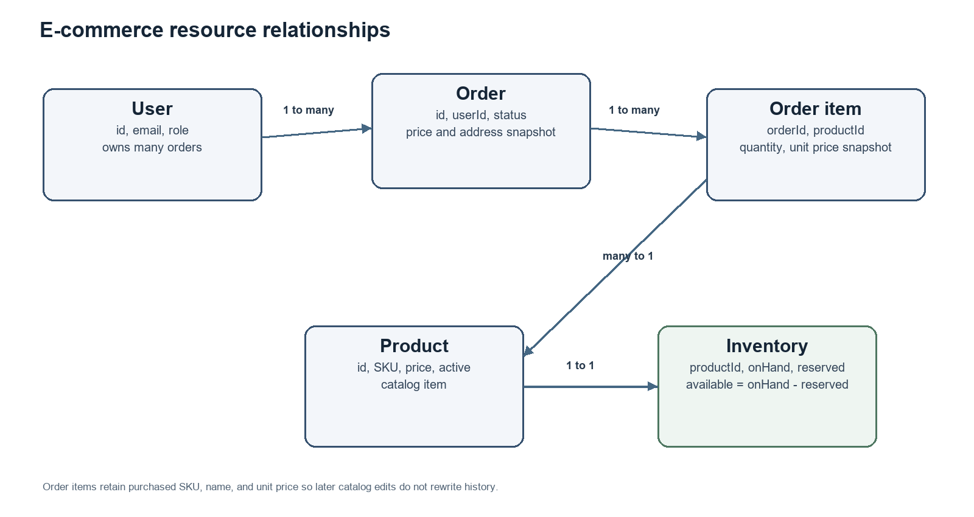
Figure 1. Core resource relationships and the order-item price snapshot.
Resource | Important fields and invariants
User | id, unique normalized email, private password hash, fullName, role, active, timestamps. Public registration creates CUSTOMER only.
Product | id, unique SKU, name, description, category, pricePaise, currency=INR, active, timestamps. Price is positive integer paise.
Order | id, orderNumber, userId, status, item snapshots, subtotalPaise, currency, shippingAddress, customerNote, timestamps.
Order item | orderId, productId, SKU/name snapshot, quantity, unitPricePaise, lineTotalPaise. Preserve snapshots after catalog edits.
Inventory | productId, onHandQuantity, reservedQuantity, derived availableQuantity, reorderPoint. Require onHand >= reserved >= 0.

Inventory formula: availableQuantity = onHandQuantity - reservedQuantity. Placing an order increases reservedQuantity; cancellation releases the reservation. Stock adjustments change onHandQuantity and cannot make it lower than reservedQuantity. Physical fulfillment, which would reduce both quantities, is outside this first API version.

4. API conventions and security
Convention | Definition
Base path | /api/v1. OpenAPI uses http://localhost:8080/api/v1 locally; deployed use requires HTTPS.
Media types | Requests and successful responses use application/json. Errors use application/problem+json.
Identifiers | UUID path identifiers and ISO 8601 UTC date-time timestamps.
Pagination | limit defaults to 20 and ranges from 1 to 100; cursor is opaque. Responses return items and nullable nextCursor.
Authentication | Authorization: Bearer <JWT>. Login issues a short-lived token; protected routes derive the caller from token claims.
Roles | CUSTOMER and ADMIN. Registration cannot create ADMIN; customers are limited to their own profile and orders.
Price | INR uses integer paise to avoid floating-point rounding. The server calculates order prices.
Deletion | Products/users are archived or deactivated. Orders are cancelled on DELETE. Inventory removal requires no dependent history.

Validation and error handling
Every error has a consistent JSON body with type, title, status, code, detail, instance, and optional fieldErrors containing field and message. Validation errors identify fields without returning stack traces. An order owned by another customer returns 404 to avoid exposing its existence.
HTTP status | Use
400 | Malformed JSON, invalid UUID, unsupported parameter, or field validation failure.
401 | Missing, expired, or invalid token; invalid login credentials.
403 | Authenticated caller lacks the required administrator role.
404 | Missing resource, public view of archived product, or resource not visible to caller.
409 | Duplicate email/SKU, insufficient stock, invalid order state, or unsafe inventory deletion.
422 | Well-formed request violates a business rule.
429 | Rate limit exceeded; include Retry-After when practical.
500 | Unexpected failure with correlation ID; never expose stack traces.

Example: {"type":"about:blank","title":"Validation failed","status":400,"code":"VALIDATION_ERROR","detail":"One or more fields are invalid.","instance":"/api/v1/products","fieldErrors":[{"field":"pricePaise","message":"must be greater than zero"}]}

5. Endpoint catalog
Paths below are relative to /api/v1. ADMIN operations require a valid bearer token and the ADMIN role.
Resource | Methods and paths | Access
Authentication | POST /auth/login | Public
Users | POST /users; GET /users; GET, PUT, DELETE /users/{userId} | Public registration; ADMIN list; owner or ADMIN for item
Products | GET /products; GET /products/{productId} | Public
Products | POST /products; PUT, DELETE /products/{productId} | ADMIN
Orders | GET, POST /orders; GET, PUT, DELETE /orders/{orderId} | Customer owner or ADMIN
Inventory | GET, POST /inventory; GET, PUT, DELETE /inventory/{productId} | ADMIN
Adjustments | GET, POST /inventory/{productId}/adjustments | ADMIN

Endpoint specifications

Authentication and users
Endpoint | Inputs and access | Success response and rules
POST /auth/login | Public. JSON: email, password. | 200 AuthToken. 400 malformed; 401 invalid credentials; 429 rate limit. Use same 401 message for unknown email and wrong password.
POST /users | Public. JSON: email, password (12–128 chars), fullName. Role not accepted. | 201 User without credential fields. 409 duplicate normalized email; 400/422 invalid fields. Creates CUSTOMER.
GET /users | ADMIN. Query: limit, cursor. | 200 UserPage. 401/403/429 as applicable; never expose password data.
GET /users/{userId} | Owner or ADMIN. UUID path. | 200 User. 401 missing token; 403 policy violation; 404 missing or hidden target.
PUT /users/{userId} | Owner or ADMIN. JSON: email, fullName; role/status excluded from customer input. | 200 updated User. 409 email collision; 400/422 invalid values.
DELETE /users/{userId} | Owner or ADMIN. UUID path. | 204 soft-deactivate; retain order history. 409 if unresolved obligations block deactivation.

Products
Endpoint | Inputs and access | Success response and rules
GET /products | Public. Query: limit, cursor, q, category, inStock. | 200 ProductPage with active products and inStock boolean. 400 invalid filters; 429 throttled.
POST /products | ADMIN. JSON: sku, name, description, category, pricePaise. | 201 Product with generated ID, INR currency, timestamps. 409 duplicate SKU; 400/422 invalid fields.
GET /products/{productId} | Optional bearer token: public can read active; ADMIN can inspect archived. Invalid token returns 401. | 200 Product. 404 missing or not visible.
PUT /products/{productId} | ADMIN. UUID path; complete ProductWriteRequest. | 200 updated Product. 404 missing; 409 SKU collision; 400/422 invalid data.
DELETE /products/{productId} | ADMIN. UUID path. | 204 archive, never physically delete history. 409 if business policy prevents archive.

Orders
Endpoint | Inputs and access | Success response and rules
GET /orders | Customer or ADMIN. Query: limit, cursor, status. Customer scope comes from token. | 200 OrderPage. Customer sees own records; ADMIN can see all. 401 unauthenticated.
POST /orders | Customer. JSON: items[{productId,quantity}], shippingAddress, optional note; required Idempotency-Key. | 201 Order with server price snapshots. Reserve all stock atomically. 404 unknown product; 409 stock conflict; 422 invalid quantity. Same key/body returns original.
GET /orders/{orderId} | Customer owner or ADMIN. UUID path. | 200 Order with item snapshots. 404 absent or owned by another customer.
PUT /orders/{orderId} | Customer owner or ADMIN. JSON: shippingAddress and customerNote. | 200 Order. Only while PLACED; items, price, and owner are immutable. Invalid state returns 409.
DELETE /orders/{orderId} | Customer owner or ADMIN. UUID path. | 204 changes PLACED to CANCELLED and releases stock transactionally. Repeated cancellation is idempotent; invalid state returns 409.

Inventory
Endpoint | Inputs and access | Success response and rules
GET /inventory | ADMIN. Query: limit, cursor, lowStockOnly. | 200 InventoryPage; lowStockOnly filters availableQuantity below reorderPoint.
POST /inventory | ADMIN. JSON: productId, onHandQuantity, reorderPoint. | 201 Inventory. 404 unknown product; 409 existing record; counts cannot be negative.
GET /inventory/{productId} | ADMIN. Product UUID. | 200 stock, reserved, derived available, and reorder point. 404 if no record.
PUT /inventory/{productId} | ADMIN. JSON: reorderPoint; stock count excluded. | 200 Inventory. Quantity changes use adjustments or order workflow. 404 missing; 422 invalid threshold.
DELETE /inventory/{productId} | ADMIN. Product UUID. | 204 only if quantities/reservations are zero and no history depends on it; otherwise 409.
GET /inventory/{productId}/adjustments | ADMIN. Product UUID; query: limit, cursor. | 200 AdjustmentPage newest-first. 404 product or record missing.
POST /inventory/{productId}/adjustments | ADMIN. JSON: non-zero deltaQuantity, reason, optional reference. | 201 adjustment and resulting Inventory. 409 if onHand would fall below reserved; actor/time are audited.

6. Shared request and response shapes

Product response
{"id":"uuid","sku":"MUG-001","name":"Ceramic Mug","description":"350 ml stoneware mug","category":"Kitchen","pricePaise":79900,"currency":"INR","active":true,"inStock":true,"createdAt":"2026-10-04T10:00:00Z","updatedAt":"2026-10-04T10:00:00Z"}

Order creation request
{"items":[{"productId":"uuid","quantity":2}],"shippingAddress":{"recipientName":"Asha Rao","line1":"12 Lake Road","city":"Bengaluru","state":"Karnataka","postalCode":"560001","countryCode":"IN"},"customerNote":"Leave at reception"}
The body has no userId, status, price, stock, or total. Those values come from the authenticated customer, catalog, inventory, and order workflow.

Order response
{"id":"uuid","orderNumber":"YI-2026-000001","userId":"uuid","status":"PLACED","items":[{"productId":"uuid","sku":"MUG-001","productName":"Ceramic Mug","quantity":2,"unitPricePaise":79900,"lineTotalPaise":159800}],"subtotalPaise":159800,"currency":"INR","shippingAddress":{"recipientName":"Asha Rao","line1":"12 Lake Road","city":"Bengaluru","state":"Karnataka","postalCode":"560001","countryCode":"IN"},"customerNote":"Leave at reception","createdAt":"2026-10-04T10:10:00Z","updatedAt":"2026-10-04T10:10:00Z"}
Creation returns 201 Created with Location set to /api/v1/orders/{orderId}. Repeating a request with the same Idempotency-Key and body returns the original result; using the key with a different body returns 409.

7. Data integrity and order flow
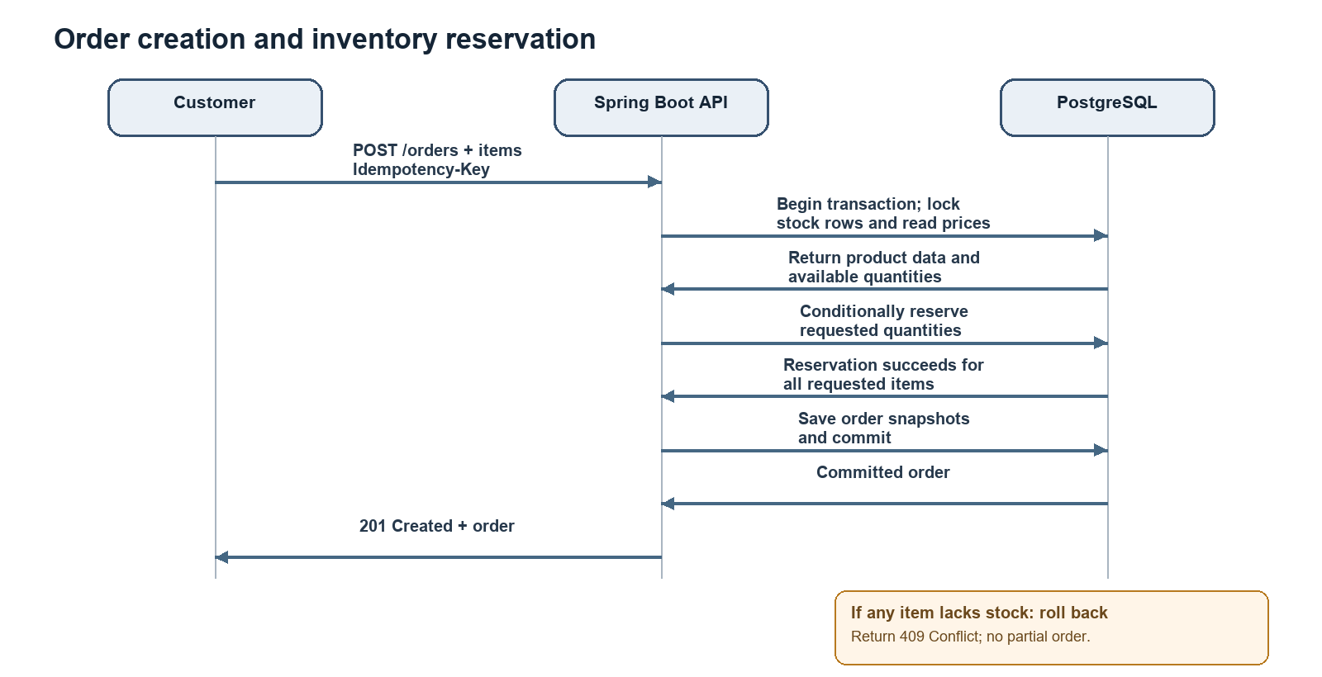
Figure 2. Atomic order creation and stock reservation.
- Load active products and inventory; calculate totals on the server; reserve requested units within one database transaction.
- If stock is insufficient or a concurrent request wins, roll back and return 409. Do not store partial orders or reservations.
- Enforce unique idempotency keys per customer, unique SKU, and unique normalized email.
- Store product ID plus SKU, product name, and price snapshots on each order line.
- Cancellation changes status and releases remaining reservations in the same transaction; retries have no additional stock effect.
Step | Action | Result
1 | Customer submits order lines and address with bearer token and idempotency key. | API derives customer identity from token.
2 | API validates input and loads products and inventory. | Server computes authoritative prices and quantities.
3 | Database transaction locks or conditionally updates stock rows. | Concurrent requests cannot reserve the same available units.
4 | API writes order, item snapshots, and reservation changes, then commits. | All writes succeed together or all roll back.
5 | API returns 201 and order representation. | Client retrieves order from its Location URI.

8. Implementation roadmap
Phase | Work | Completion evidence
1. Contract | Review requirements, schemas, access rules, and OpenAPI contract. | Approved API contract and design report.
2. Foundation | Create Spring Boot REST app, PostgreSQL connection, migrations, profiles, and error handling. | App starts locally; schema migrations apply.
3. Identity/catalog | Implement registration/login, password hashing, JWT, roles, product CRUD, validation. | Endpoints follow contract.
4. Orders/inventory | Implement transactional placement/cancellation, stock adjustment, snapshots, idempotency. | Concurrent orders do not oversell; retries do not duplicate.
5. Verification/release | Add unit and integration coverage, security review, API docs, and CI. | Automated checks and release config documented.

Recommended implementation structure
Package | Responsibility
controller | HTTP routing, DTO binding, status codes.
service | Business rules, ownership checks, transactional order and stock workflows.
repository | PostgreSQL access and transaction-friendly queries.
domain | Entities, enums, and invariants for core resources.
dto / validation | Request and response contracts with field validation.
security | Token handling, password hashing, role and ownership checks.
exception | Consistent safe problem responses.

Week 1 completion checklist
- Functional requirements and actors are identified.
- Products, users, orders, items, and inventory have defined fields and relationships.
- CRUD-oriented endpoint coverage and lifecycle-safe deletion are documented.
- Methods, paths, inputs, outputs, authentication, validation, and error cases are specified.
- OpenAPI 3.0.3 and two diagrams accompany the report.
- Security, data integrity, and backend implementation roadmap are described.

9. Summary
This design provides a coherent first-version contract for a simple e-commerce API. It covers the required resources and CRUD operations, documents customer and administrator access, defines request and response data, and handles validation, authorization, conflicts, and server errors. The order workflow preserves historical prices and reserves inventory atomically to prevent overselling. The OpenAPI contract is the implementation reference for the proposed Java Spring Boot and PostgreSQL backend.
The package contains this Word report, machine-readable OpenAPI, diagrams and editable diagram sources, and a project README. Payment and fulfillment integrations can be considered after the API contract is reviewed.

