Week 2 Backend API Development and Database Integration
Blog platform implementation report | 4 October 2026

Project summary
This submission turns the Week 2 brief into a runnable blog backend. It provides user registration, post and comment CRUD, relational persistence, input validation, consistent error responses, and ownership checks for edits and deletes. Java 21 and Spring Boot 4.1.1 are used with Spring MVC, Spring Data JPA, Flyway, Spring Security, and BCrypt. The default profile uses a file-backed H2 database for a quick local start; an optional PostgreSQL profile is included.

Requirements covered
Week 2 requirement | Implementation
User registration | Public registration endpoint; normalized username and email; BCrypt password hash; response excludes the hash.
Posts and comments | Create, read, update, and delete endpoints, with foreign keys linking authors and comments to posts.
Relational database | Flyway migration creates users, posts, and comments; H2 runs locally and PostgreSQL can be selected by profile.
Validation and errors | Request constraints plus consistent 400, 401, 403, 404, 409, and safe 500 JSON responses.
Setup and testing | README includes run steps and cURL examples; integration tests cover CRUD, validation, security, and not-found cases.

Design and data relationships
The API is organized into controllers, services, repositories, request/response records, and JPA entities. Flyway owns schema creation; Hibernate checks that the mapped entities match the migrated schema. The diagram shows how user, post, and comment rows relate. Deleting a post cascades to its comments, while user references are protected from accidental deletion.
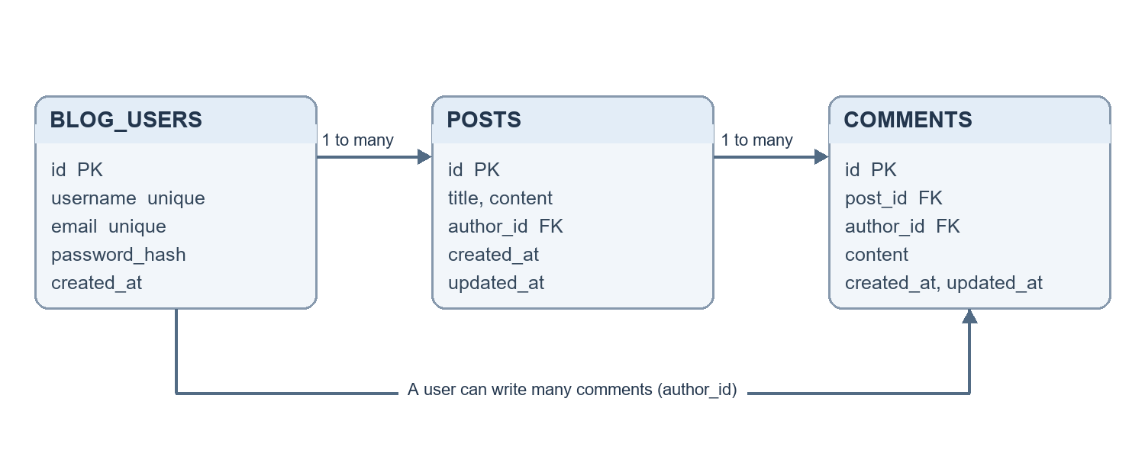
Figure 1. Blog database relationships
Table | Main fields | Relationships
blog_users | id, username, email, password_hash, created_at | One user can author many posts and comments.
posts | id, title, content, author_id, created_at, updated_at | Each post has one author and can have many comments.
comments | id, post_id, author_id, content, created_at, updated_at | Each comment belongs to one post and one author.

API endpoint summary
All routes are versioned under /api/v1 and use JSON request and response bodies. Public reads and registration are open. Writes require HTTP Basic authentication; update and delete operations are limited to the resource owner.
Method | Endpoint | Access | Purpose
POST | /users | Public | Register an account.
GET | /posts | Public | List posts, newest first.
GET | /posts/{id} | Public | Read a post.
POST | /posts | Signed in | Create a post for the current user.
PUT | /posts/{id} | Owner | Replace the post title and content.
DELETE | /posts/{id} | Owner | Delete a post and its comments.
GET | /posts/{postId}/comments | Public | List comments for a post.
POST | /posts/{postId}/comments | Signed in | Add a comment to a post.
GET | /comments/{id} | Public | Read a comment.
PUT | /comments/{id} | Owner | Edit the comment content.
DELETE | /comments/{id} | Owner | Delete a comment.

Validation, authentication, and errors
Usernames are 3–50 letters, digits, or underscores. Email addresses must be valid. Passwords are 10–72 characters. Titles are limited to 160 characters, post content to 10,000 characters, and comment content to 2,000 characters; blank or whitespace-only values are rejected. Usernames and emails are normalized to lowercase before storage. Unique constraints prevent duplicate usernames and email addresses.
Passwords are stored as BCrypt hashes and are never included in API responses. HTTP Basic authentication is stateless. A user may edit or delete only their own posts and comments. The error response contains a timestamp, status, error name, safe message, request path, and field-level validation messages when applicable. Statuses include 400 for invalid input, 401 for missing or invalid credentials, 403 for a non-owner, 404 for a missing resource, 409 for a duplicate account value, and 500 for unexpected failures.

Run and test
With Java 21 installed, start the API from the week-02-blog-api directory using .\mvnw.cmd spring-boot:run on Windows. The first run creates the local data/blogdb file and applies the Flyway migration. Run the automated suite with .\mvnw.cmd test. For PostgreSQL, start the included Compose database and run with the postgres profile; see the README for environment variables and commands.
Verification completed: all 4 integration tests passed with 0 failures and 0 errors on in-memory H2. They cover registration and duplicate handling, invalid requests, public reads, authentication, post and comment CRUD, owner-only changes, and missing resources. A separate live cURL smoke check against the file-backed H2 application confirmed registration (201), post creation (201), public comment listing (200), comment update (200), and comment deletion (204). The PostgreSQL profile is documented but was not run because PostgreSQL and Docker were not available in the local environment.

Scope and next steps
This is a small learning API rather than a production deployment. HTTP Basic is kept for the exercise; a public deployment should use HTTPS, managed secrets, rate limiting, and a production authentication approach. Listing endpoints currently return the full collection, so pagination is a sensible next improvement. The code, tests, database migration, and run instructions are in week-02-blog-api/.

