

**USER MANUAL**

Paperplane Website



**Preface**

The User Manual contains all essential information for the user to make full use of the web application. The goal of this document is to give a broad overview of the main functions in the application. This manual includes a description of the system functions and capabilities, contingencies and alternate modes of operation, simplified diagrams and step-by-step procedures for system access and use. Use graphics where possible in this manual. The manual format may be altered if another format is more suitable for the particular project.

This guide contains description of the application and all the information required to use the application and resolve the issues that may occur.

The language used is matched to the intended audience, with jargon kept to a minimum or explained thoroughly.

**Table of Contents**

**1.** **Introduction** 1

**1.1.** **Purpose** 1

**1.2.** **Definitions, Acronyms, and Abbreviations** 1

**1.3.** **Description** 1

**1.4.** **System requirements** 1

**2.** **Structure and Navigation** 2

**3.** **Getting Started** 3

**3.1.** **Registration** 3

**3.2.** **Login** 4

**3.3.** **Plan** 5

**3.4.** **Itinerary Generation** 5

**3.5.** **Contact Us** 6

**3.6.** **Top Places to Visit** 7

**3.7.** **Subscription to Newsletter** 8

**3.8.** **Testimonials** 8

**3.9.** **Settings** 8

**4. Troubleshooting** 10

**4.1.** **Possible Errors in Registration** 10

**4.2.** **Possible Errors in Login** 10

**4.3.** **Possible Errors in Contact Us** 10

**5.** **Glossary** 11

# **Introduction**

## **Purpose**

Paperplane website aims to provide travel planning service to users across the world.

## **Definitions, Acronyms, and Abbreviations**

Itinerary: A planned route or journey that include activities and duration of each day.

## **Description**

Paperplane is an intuitive travel planning app that allows you to plan a trip with just a few simple taps. Pick a destination and enter the duration of stay, your itinerary will come up automatically.

Paperplane website is used to anyone who love to travel and who went to any place for vacation. The aim of Paperplane website is to provide a detailed itinerary for a traveler who desired to travel. This website creates itinerary with important places to be visited in a place and route map to those places.

The home page looks like in Fig 1.0

## **System Requirements**

Paperplane website is fully responsive. User can access the website through mobile, PC or tablet.

To access this website, the user must need any updated internet browser (google chrome, Mozilla Firefox, safari, Internet Explorer 10 etc.)



Fig 1.0: Home page

# **Structure and Navigation**

The overall structure of the application is relatively simple, as shown in the following diagram.

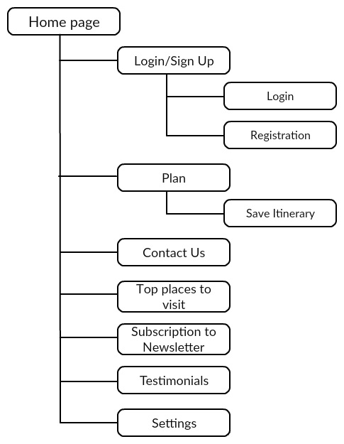

Fig 2.0: Structure

There are seven primary elements on the site, and each of these may be accessed directly from the main page.

**Navigation:**

The user can navigate to all the major elements directly from the home page.

# **Getting Started**

Go to Home page and click on menu for side navigation bar, where the user can find the menu items.

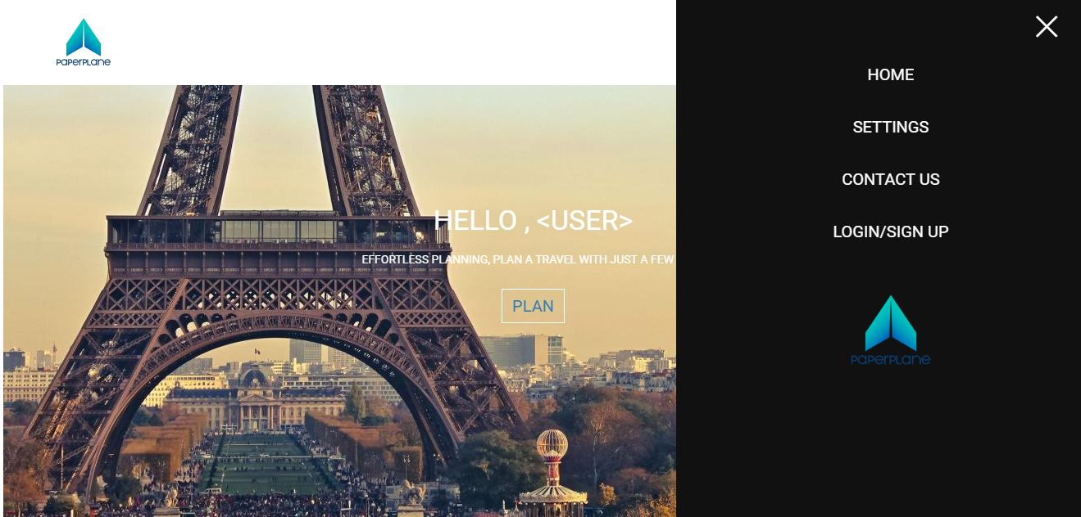

Fig 3.0: Menu

## **Registration**

If the user is first time to Paperplane he/she must register. Registered user can save itinerary for future use and the user will be benefited by getting other user’s itinerary who also visited that particular place.

For registration:

1. Go to Home page and click on the Menu button on top right corner of the **Home page** as in Fig 1.0
2. Click the **Login/Sign Up** button in the top right corner of the home page. The **Login/Sign Up** page displays as shown in Fig 3.1
3. Fill all the credentials and click **Register** button.
4. If the user has Facebook account, then he/she can directly login using Facebook without registration.

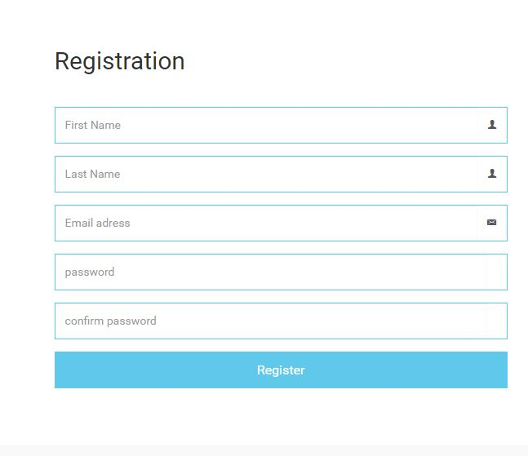

Fig 3.1: Registration

## **Login**

If the user is already registered with Paperplane he/she can use username and password to login.

For Login:

1. Go to Home page and click on the Menu button on top right corner of the **Home page** as in Fig 1.0
2. Click the **Login/Sign Up** button in the top right corner of the home page. The **Login/Sign Up** page displays as shown in Fig 3.0

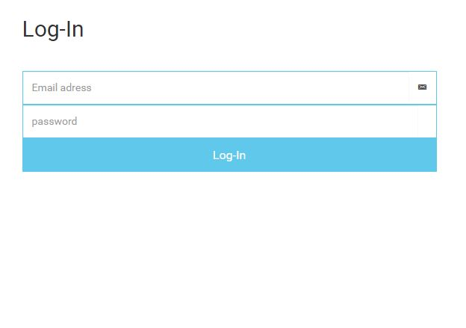

Fig 3.2: Login

1. Enter **Username** and **Password** and click **Login**.
2. If the user has Facebook account, then user can login using Facebook.

## **Plan**

Paperplane reduces traveler effort by preparing their trip itinerary. It allows you to plan a trip with just a few simple taps. Pick a destination and enter the duration of stay, your itinerary will come up automatically.

Steps to start planning:

1. Go to Home page and click on the Plan button at the center of the **Home page** as in Fig 1.0
2. Click **“Plan”** button to start your planning.
3. Enter your travel location in **“Enter a location”**.
4. Select your arrival date in **Arrival field**.
5. Select your departure date in **Departure field**.
6. Click **“Search”** button as in Fig: 3.3, this will navigate the user to the itinerary page.

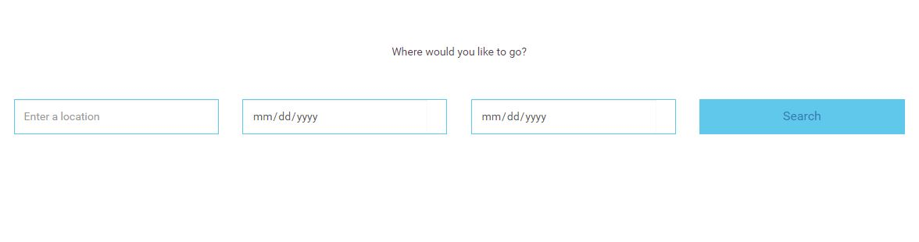

Fig 3.3: Start planning

## **Itinerary Generation**

After select desired location and travel dates Paperplane automatically generates an itinerary.

1. The itinerary page looks similar as in Fig 3.4
2. Route map and places can be edited according to the user convenience. By just click and drag the places on the map.
3. Places will be displayed for all the days that the user selected for the trip.

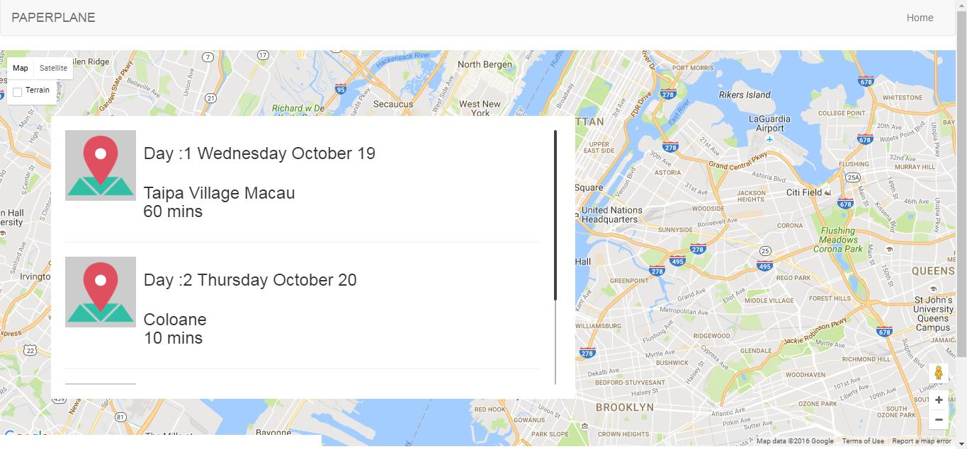

Fig 3.4: Route map

## **Contact Us**

User can contact the support team for any help or support issues by entering details and message in Contact Us form.

Steps:

1. Go to Home page and click on the Menu button on top right corner of the **Home page** as in Fig 1.0
2. Select Contact Us menu item in the menu as in Fig 3.0
3. Enter Name, Email, Phone number and message.
4. Click on **send message** button to send the message to the Paperplane team.

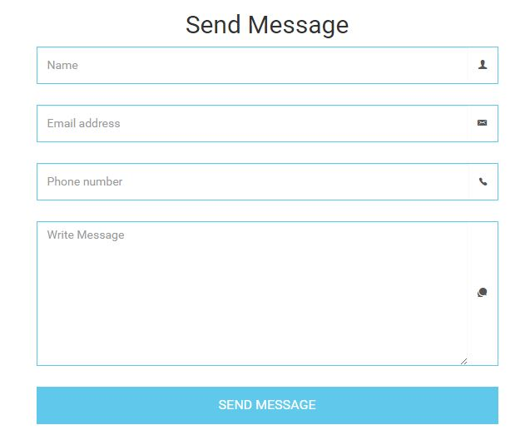

Fig 3.5: Contact us

## **Top Places to Visit**

All the top places were displayed in this section. User can Edit this section and select his favorite place in the list.

1. Go to Home page and scroll down to top places to visit section where list of places will be displayed as in Fig 3.6.
2. Click on menu item on the image to delete or update the place.

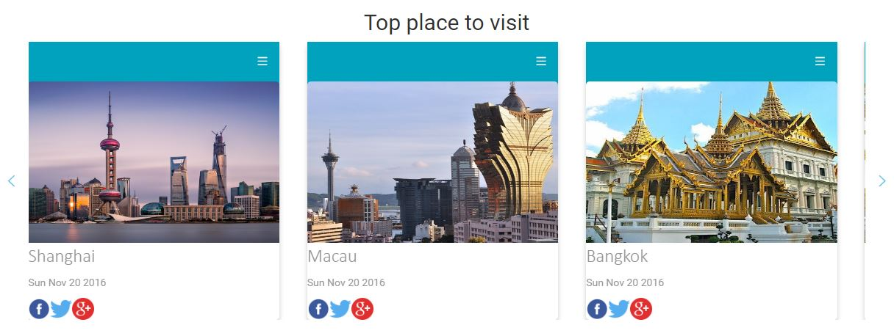

Fig 3.6: Top places to visit

## **Subscription to Newsletter**

User can subscribe with an email id to get notifications and all latest updates.

1. Go to Home page and scroll down to Newsletter subscription section as in Fig 3.7.
2. User can enter email id to get notifications.



Fig 3.7: Subscribe to Newsletter

## **Testimonials**

All the list of users who provide feedback will be displayed here. Their profile photo and their feedback message will be displayed.

1. Go to Home page and scroll down to Testimonials section where list of places will be displayed.

## **Settings**

Paperplane allows the user to manage some options like currency, time format and trip timings. User can also choose his preferences, the trip will be planned based on the user preferences.

1. Once the user gets log in as in section 3.2, the user can find settings option on the home page.
2. In settings page, user can see all the options that can manage. User can change the time format, start and end time of the trip, currency as in Fig 2.5

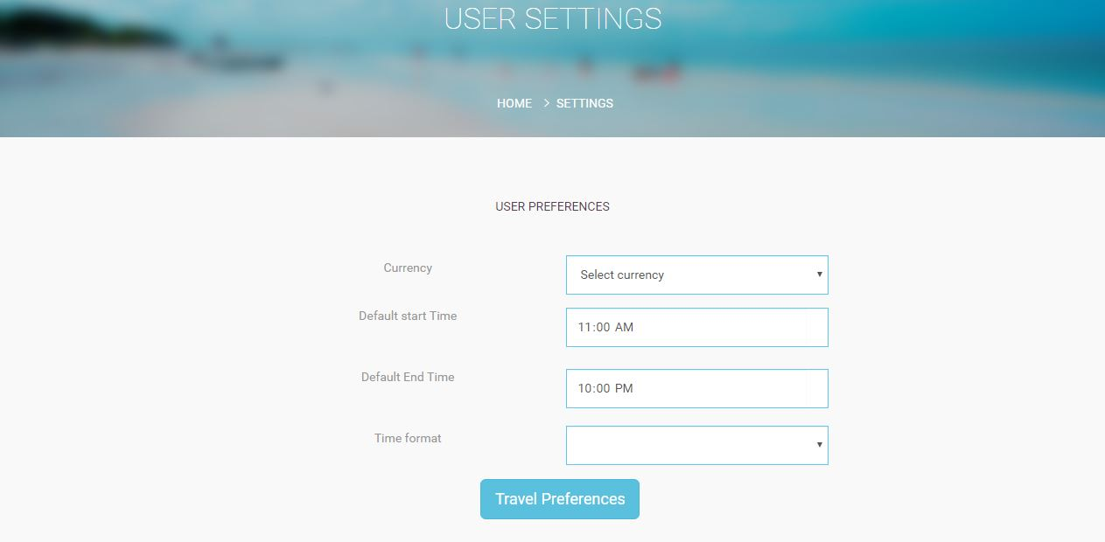Fig 3.9: Settings

1. User can set his travel preferences by clicking on the travel preferences button as in Fig 3.9. A popup will be raised once the user click on the button as in Fig 3.10.
2. User can choose the level of interest in the travel preferences, based on the interest level the trip will be planned accordingly.

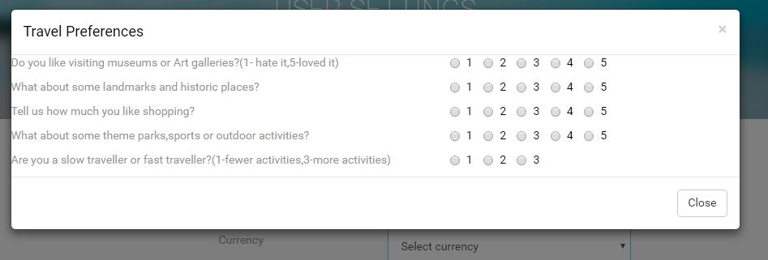

Fig 3.10: Travel Preferences

# **4. Troubleshooting**

This section mains describes the possible errors that the user may face in the application.

## **Possible Errors in Registration**

The user may face some errors in the registration page.

To avoid them,

1. Enter First name, last Name, Valid Email Id with ‘@’ and ‘.com’ (example: traveluser@paperplane.com), password with a minimum length of 6 characters, re-enter the same password again.

## **Possible Errors in Login**

To avoid errors in the login section,

The user need to enter authorized email address/username (example: [traveluser@paperplane.com](mailto:traveluser@paperplane.com)) and password.

If the user not registered yet, then get register in the registration section.

## **Possible Errors in Contact Us**

In contact us section, the user need to enter Name, Email Address (example: traveluser@paperplane.com), Phone Number, Message.

# **Glossary**

**B**

Bootstrap- Bootstrap is the most popular HTML, CSS, and JavaScript framework for developing responsive, mobile-first web sites

**C**

CSS - Cascading Style Sheet

**H**

HTML - Hyper Text Markup Language

**I**

Itinerary- A planned route or journey

**J**

JS - JavaScript