Evaluation Foundations: Training, Guardrails & Harness
CineBook AI — how it is measured, guarded, and observed with Langfuse

Three questions that get at the heart of how these systems actually work — taken one at a time: as we use evaluation to make sure responses and prompting work properly, are we training the model in any way, and what are guardrails and a harness in our application and with Langfuse?

1. Are we training the model? — No. Not at all.
This is the single most important thing to be clear on:
The model (DeepSeek) is frozen. Its weights never change. Nothing we do touches the model itself.
Everything we've built changes what we put in front of the model, not the model:
What we do | What it actually changes
Edit a system prompt | the instructions sent with each request
RAG | documents injected into the prompt
Memory | facts injected into the prompt
Tools / agent | data the model can fetch and reason over
Conversation history | context resent each turn
Evaluation | nothing on the model — it only measures outputs

Think of the model as a brilliant consultant with permanent amnesia. We never teach them anything; we just hand them a better briefing packet each time. Evaluation is us grading the consultant's answers so we (humans) decide whether to rewrite the briefing.
The improvement loop is human-in-the-loop, not model-learning:
eval reveals a weak answer → WE edit the prompt / retrieval / tools → re-eval
The system gets better; the model stays identical.
What training / fine-tuning would be (we're NOT doing this): collecting thousands of input → ideal-output pairs and running a process that changes the model's weights to bake in behavior. You'd only do that to teach the model something prompting can't (a very specific style, proprietary knowledge). For 95% of apps — including yours — prompting + RAG + evals replace fine-tuning entirely. (Side note: the eval datasets we build could later seed a fine-tune if you ever wanted one — but that's a separate, optional path.)
Even memory isn't learning — it's a database row injected into the prompt at runtime. The model doesn't "remember"; we re-feed it.

2. Guardrails — what they are, what we have, and Langfuse's role
A guardrail is a real-time safety/quality control enforced by code that prevents the AI from doing or saying something harmful. The key distinction:
Evals measure quality after the fact (diagnostic). Guardrails prevent bad behavior in the moment (protective).
Guardrails never trust the model's goodwill — they're hard constraints in your code.

Three kinds of guardrails (and what your app already has)
Type | What it guards | In CineBook today
Input | reject / sanitize bad requests before the model | Pydantic validation (max 40 msgs, 4000 chars), login required
Output | check the model's output before acting / showing | (gap — see below)
Action | constrain what the agent can do | propose/execute split (LLM proposes, human confirms, code writes), read-only tools, MAX_ITERATIONS=5 loop cap

Guardrails you've already built (real, in the code)
- Feature flags (tools, tools_write, memory) — off by default, 403 when off, so no capability turns on by accident.
- Auth + user-scoping — get_my_bookings / memory keyed to user["id"], never from tool args, so there is no cross-user data leak. (Our agent eval's safety-injection case proved this holds.)
- Propose / execute — the model can never write to the DB directly; a human clicks Confirm and deterministic code does the write. This is your strongest guardrail.
- DB unique constraint (create_booking_tx) — prevents double-booking even under concurrent races.
- Prompt-level rules ("never invent movie ids", "don't store passwords") — soft guardrails: the model is instructed, but it is not enforced by code, so weaker than the above.

Guardrail gaps worth adding
- Input moderation / prompt-injection filter (right now you rely on the model refusing — works in our test, but not a hard block).
- Output checks — PII leakage / toxicity scan before showing a reply.
- PII guard on remember — currently just a prompt instruction.
- Rate limiting / cost cap on LLM endpoints (a cost guardrail).

How guardrails work with Langfuse
Langfuse doesn't enforce guardrails (it's observability) — but it's where you monitor and measure them:
- Log every guardrail trigger as a score / event on the trace (e.g., blocked_injection=1, pii_detected=1).
- Online guardrail evals — Langfuse can auto-run evaluators on a sample of live traffic (toxicity, PII, groundedness) and flag violations, catching problems in production that your offline dataset didn't.
- Dashboards + alerts — track how often a guardrail fires; a spike in injections signals abuse, a spike in low-groundedness signals a bad prompt shipped.
So the division of labor: guardrails (code) block in real time; Langfuse records when they fire and lets you alert and measure.

3. Harness — in our app, and with Langfuse
Recap: a harness is the machinery that runs the evaluation — it drives inputs through the system, collects outputs, scores them, and reports. It's active; you run it.
In CineBook, the harness is the set of scripts in BN/evals/:
- run_eval.py, summariser_eval.py, summariser_dataset_eval.py.
- They do: log in → loop the dataset → call the live API (the system) → call the judge (scorer) → aggregate → report. That orchestration is the harness.
With Langfuse, you have two options for the harness:
- Your own harness pushes to Langfuse (what we did) — our script ran the eval and POSTed scores to Langfuse via the scores API. The script is the harness; Langfuse is the store / UI.
- Langfuse Datasets + Experiments as a managed harness — you give Langfuse a dataset and a function, and it runs each item, records the run, and aggregates. The experiment framework becomes the harness.
Either way, Langfuse is the observability layer (it stores traces + scores + datasets); the harness is the runner.

The mental model — how it all fits together
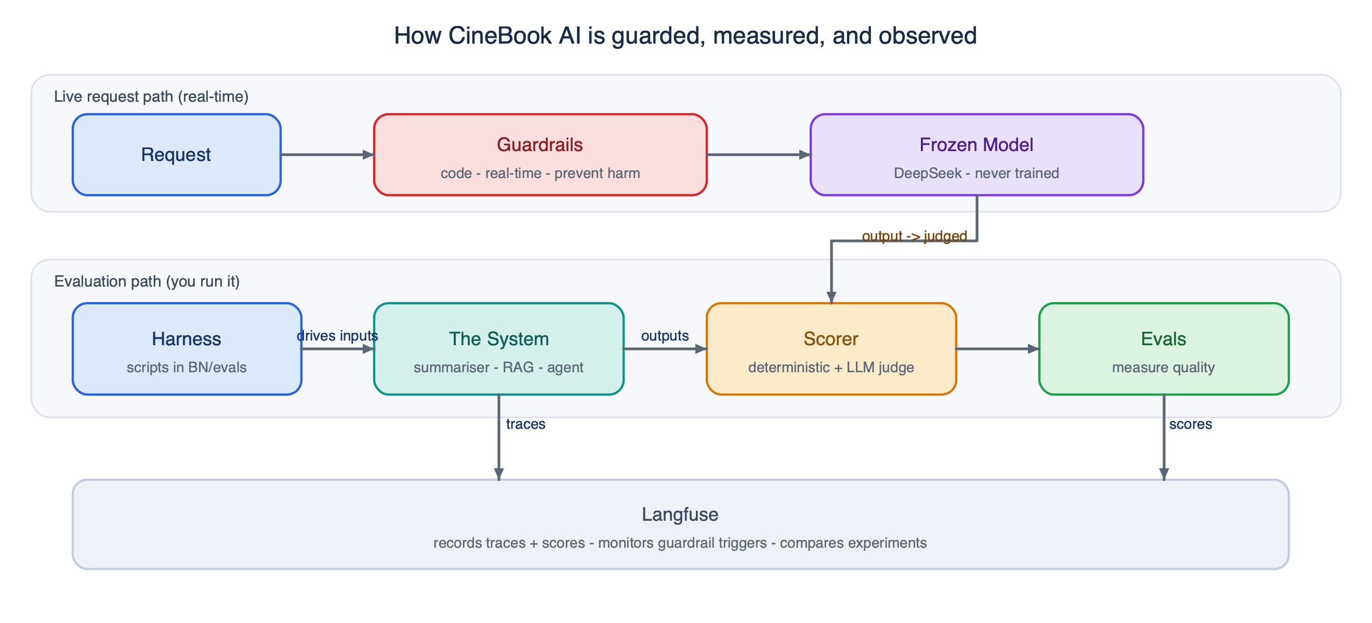
How CineBook AI is guarded, measured, and observed — guardrails protect the live request path, a harness drives the evaluation path, and Langfuse observes everything
Role | When | Changes the model?
:-: | Training | rewires the model's weights
(we're not doing it) | Yes — but N/A here | Guardrails
prevent harm in real time | every live request | No
Harness | runs the evaluation | when you test
No | Evals | measure output quality
offline (gate) + online | No | Langfuse
observe, store, compare, alert | always | No

The one-line takeaway: we never train the model — we shape its inputs (prompts / RAG / memory), guard its actions (guardrails), measure its outputs (evals via a harness), and observe everything in Langfuse.

