//EXECUTION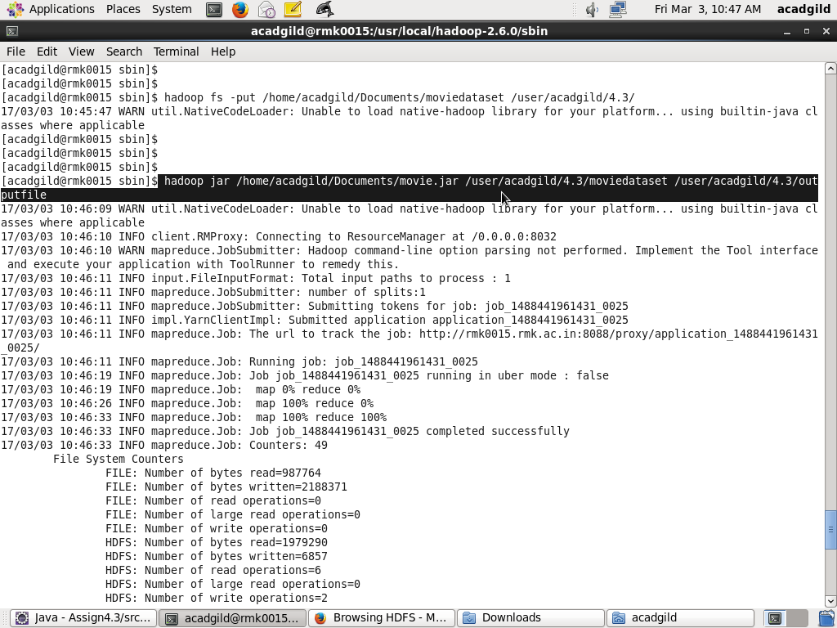

//Code

//MOVIE.JAVA CODE

package mapper.demo.movie;

import org.apache.hadoop.fs.Path;

import org.apache.hadoop.conf.\*;

import org.apache.hadoop.mapreduce.Job;

import org.apache.hadoop.mapreduce.lib.input.FileInputFormat;

import org.apache.hadoop.mapreduce.lib.input.TextInputFormat;

import org.apache.hadoop.mapreduce.lib.output.FileOutputFormat;

import org.apache.hadoop.mapreduce.lib.output.TextOutputFormat;

import org.apache.hadoop.io.\*;

public class Movie {

@SuppressWarnings("deprecation")

public static void main(String[] args) throws Exception {

Configuration conf = new Configuration();

Job job = new Job(conf, "Movie");

job.setJarByClass(Movie.class);

job.setMapOutputKeyClass(Text.class);

job.setMapOutputValueClass(IntWritable.class);

job.setOutputKeyClass(Text.class);

job.setOutputValueClass(IntWritable.class);

job.setMapperClass(MovieMapper.class);

job.setReducerClass(MovieReducer.class);

job.setInputFormatClass(TextInputFormat.class);

job.setOutputFormatClass(TextOutputFormat.class);

FileInputFormat.addInputPath(job, new Path(args[0]));

FileOutputFormat.setOutputPath(job,new Path(args[1]));

/\*

Path out=new Path(args[1]);

out.getFileSystem(conf).delete(out);

\*/

job.waitForCompletion(true);

}

}

//MOVIEMAPPER.JAVA CODE

package mapper.demo.movie;

import java.io.IOException;

import org.apache.hadoop.io.IntWritable;

import org.apache.hadoop.io.LongWritable;

import org.apache.hadoop.io.Text;

import org.apache.hadoop.mapreduce.Mapper;

public class MovieMapper extends Mapper<LongWritable, Text, Text, IntWritable> {

Text outkey = new Text();

IntWritable outValue = new IntWritable(1);

public void map(LongWritable key, Text value, Context context)

throws IOException, InterruptedException {

String[] str = value.toString().split("\t");

outkey.set(str[0]);

context.write(outkey, outValue);

}

}

//MOVIEREDUCER.JAVA CODE

package mapper.demo.movie;

import java.io.IOException;

import org.apache.hadoop.io.IntWritable;

import org.apache.hadoop.io.Text;

import org.apache.hadoop.mapreduce.Reducer;

public class MovieReducer extends Reducer<Text, IntWritable, Text, IntWritable>

{

IntWritable outValue = new IntWritable();

public void reduce(Text key, Iterable<IntWritable> values,Context context) throws IOException, InterruptedException

{

int count = 0;

for (IntWritable value : values) {

count += value.get();

}

outValue.set(count);

context.write(key, outValue);

}