//MAPPER.JAVA CODE

package mapreduce;

import java.io.IOException;

import org.apache.hadoop.io.IntWritable;

import org.apache.hadoop.io.LongWritable;

import org.apache.hadoop.io.Text;

import org.apache.hadoop.mapreduce.Mapper;

public class Mapper1 extends

Mapper<LongWritable, Text, Text, IntWritable> {

Text keyEmit = new Text("Total Count");

private final static IntWritable one = new IntWritable(1);

public void map(LongWritable key, Text value, Context context)

{

try {

context.write(keyEmit, one);

} catch (IOException e) {

// TODO Auto-generated catch block

e.printStackTrace();

System.exit(0);

} catch (InterruptedException e) {

// TODO Auto-generated catch block

e.printStackTrace();

System.exit(0);

}

}

}

//REDUCER.JAVA

package mapreduce;

import java.io.IOException;

import org.apache.hadoop.io.IntWritable;

import org.apache.hadoop.io.Text;

import org.apache.hadoop.mapreduce.Reducer;

public class Reduce extends

Reducer<Text, IntWritable, Text, IntWritable> {

public void reduce(Text key, Iterable<IntWritable> values, Context context)

{

int sum = 0;

for (IntWritable val : values) {

sum += val.get();

}

try {

context.write(key, new IntWritable(sum));

} catch (IOException e) {

// TODO Auto-generated catch block

e.printStackTrace();

System.exit(0);

} catch (InterruptedException e) {

// TODO Auto-generated catch block

e.printStackTrace();

System.exit(0);

}

}

}

//DRIVER.JAVA

package mapreduce;

import java.io.IOException;

import org.apache.hadoop.conf.Configuration;

import org.apache.hadoop.conf.Configured;

import org.apache.hadoop.fs.FileSystem;

import org.apache.hadoop.fs.Path;

import org.apache.hadoop.io.IntWritable;

import org.apache.hadoop.io.Text;

import org.apache.hadoop.mapreduce.Job;

import org.apache.hadoop.mapreduce.lib.input.TextInputFormat;

import org.apache.hadoop.mapreduce.lib.output.TextOutputFormat;

import org.apache.hadoop.util.Tool;

import org.apache.hadoop.util.ToolRunner;

public class Driver extends Configured implements Tool {

public static void main(String[] args) {

Configuration conf = new Configuration();

int res = 0;

try {

res = ToolRunner.run(conf, new Driver(), args);

} catch (Exception e) {

// TODO Auto-generated catch block

e.printStackTrace();

}

System.exit(res);

}

@Override

public int run(String[] args) {

if (args.length != 2) {

System.out.printf("Usage: Line count <input dir><output dir> \n");

System.exit(-1);

}

String source = args[0];

String dest = args[1];

Configuration conf = new Configuration();

Path in = new Path(source);

Path out = new Path(dest);

Job job = null;

try {

job = new Job(conf, "Deprecated");

} catch (IOException e) {

// TODO Auto-generated catch block

e.printStackTrace();

System.exit(0);

}

job.setJarByClass(Driver.class);

FileSystem fs = null;

try {

fs = FileSystem.get(conf);

} catch (IOException e1) {

// TODO Auto-generated catch block

e1.printStackTrace();

}

job.setMapOutputKeyClass(Text.class);

job.setMapOutputValueClass(IntWritable.class);

job.setOutputKeyClass(Text.class);

job.setOutputValueClass(IntWritable.class);

job.setMapperClass(Mapper1.class);

job.setReducerClass(Reduce.class);

job.setInputFormatClass(TextInputFormat.class);

job.setOutputFormatClass(TextOutputFormat.class);

try {

TextInputFormat.addInputPath(job, in);

} catch (IOException e) {

// TODO Auto-generated catch block

e.printStackTrace();

System.exit(0);

}

try {

if(fs.exists(out)){

fs.delete(out, true);

}

} catch (IOException e1) {

// TODO Auto-generated catch block

e1.printStackTrace();

}

TextOutputFormat.setOutputPath(job, out);

boolean success = false;

try {

success = job.waitForCompletion(true);

} catch (ClassNotFoundException e) {

// TODO Auto-generated catch block

e.printStackTrace();

System.exit(0);

} catch (IOException e) {

// TODO Auto-generated catch block

e.printStackTrace();

System.exit(0);

} catch (InterruptedException e) {

// TODO Auto-generated catch block

e.printStackTrace();

System.exit(0);

}

return (success ? 0 : 1);

}

}

//OUTPUT

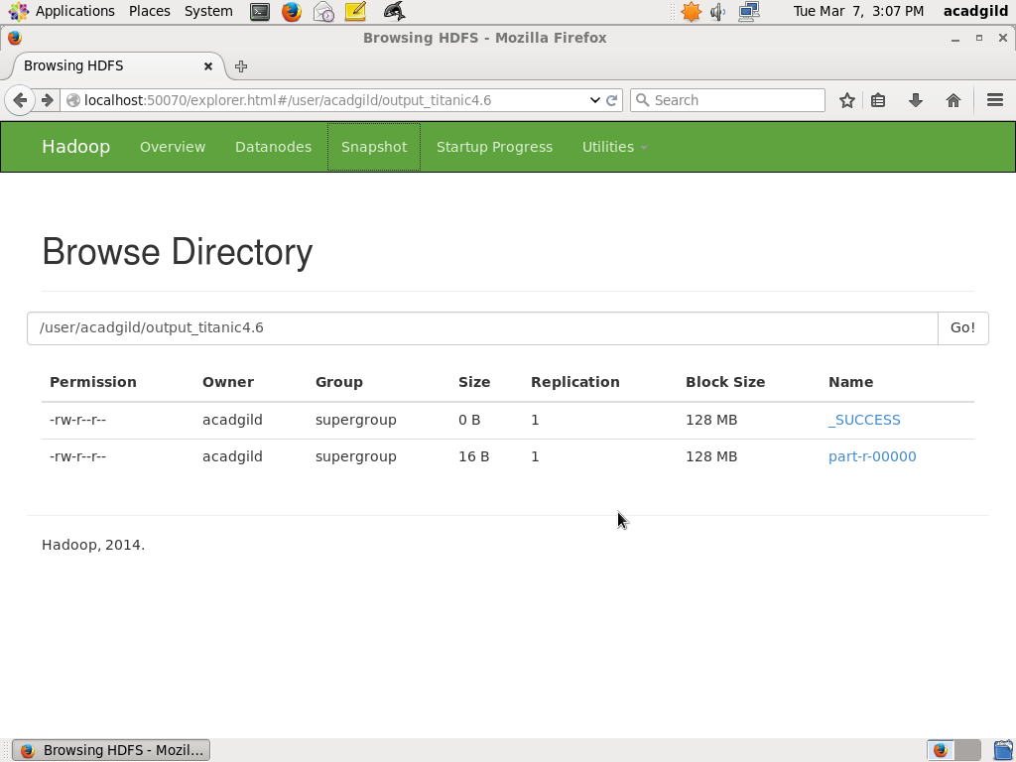

Total Count 891