1. Write a pig script to find the top 20 destination people travel the most.

//DATA LOAD

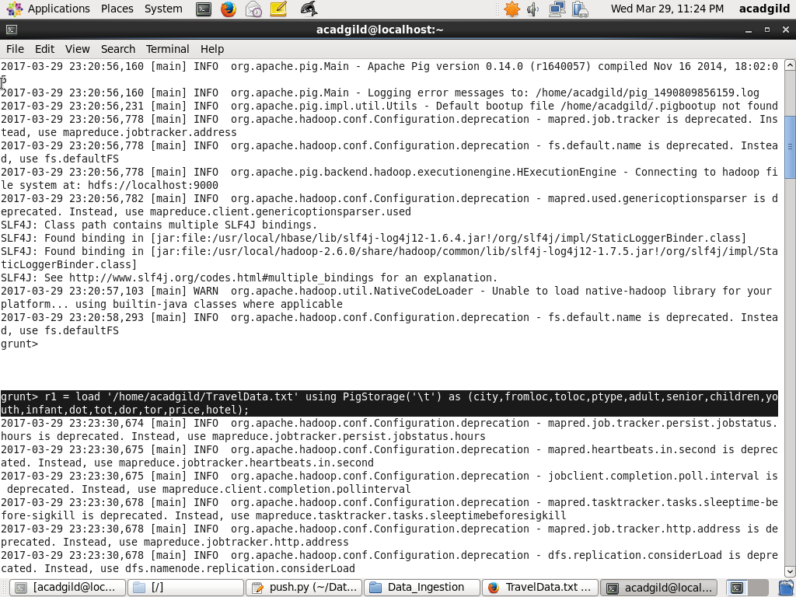

//GROUP BY DESTINATION

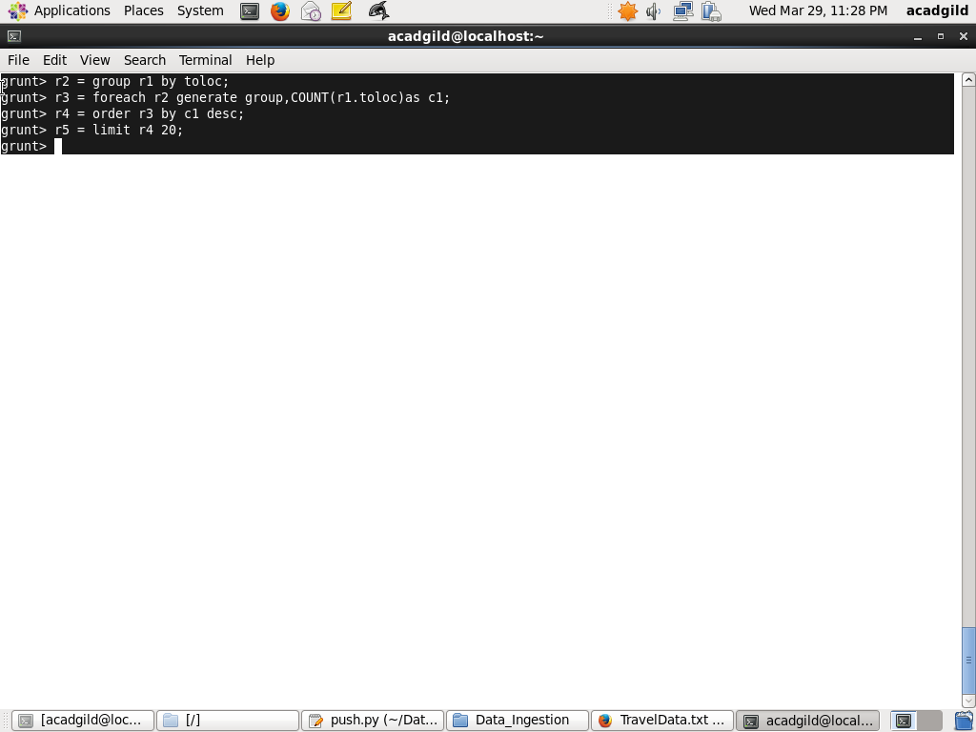

//COUNT OPERATION



//ORDER IN DESC



//LIMIT BY 20



// DUMP THE RESULT

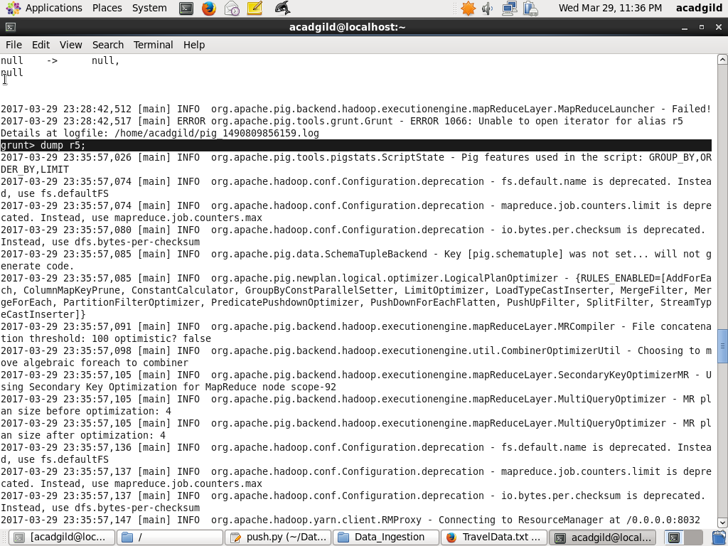

//RESULT

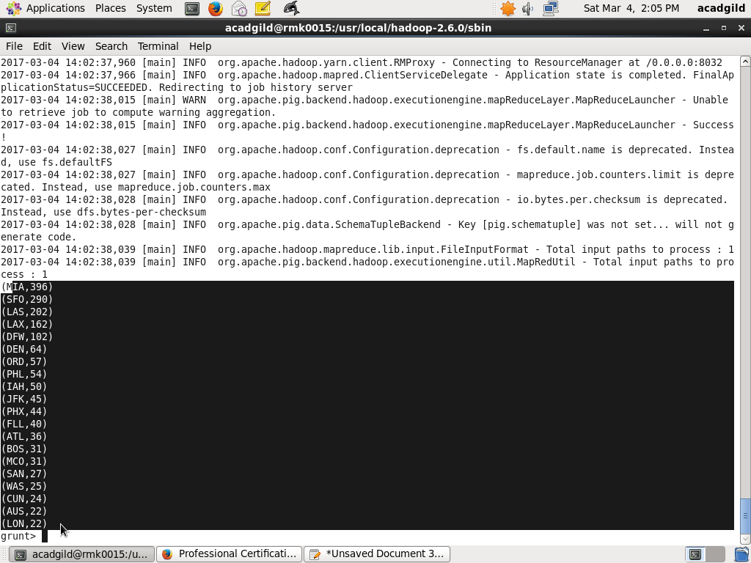

1. Write a pig script to find the top 20 locations from where people travel the most.

//DATA LOAD



//GROUP BY fromloc

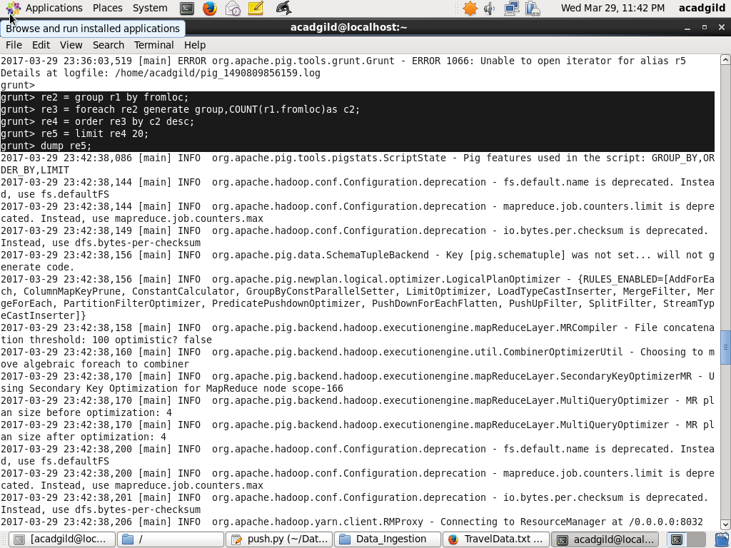

//COUNT OPERATION



//ORDER IN DESC



//LIMIT BY 20



//DUMP



//RESULT

