[Command Prompt]

[Command line for windows]

Rajkumar Jangid

Self-desinged

**Commands for cmd window**

* cls
* md
* cd/,cd..(only one directriy back)
* rem “New Name”
* dir(all files details)
* rd(Remove directriy)
* winver
* ipconfig
* color ?
* tree
* ping
* ping ip
* nslookup( know about IP and add.)
* tracert
* tree /f
* tree /a
* Ctrl+c(close tree)
* Tree |clip
* Tree /a/f |clip
* Tree ?
* mode size
* 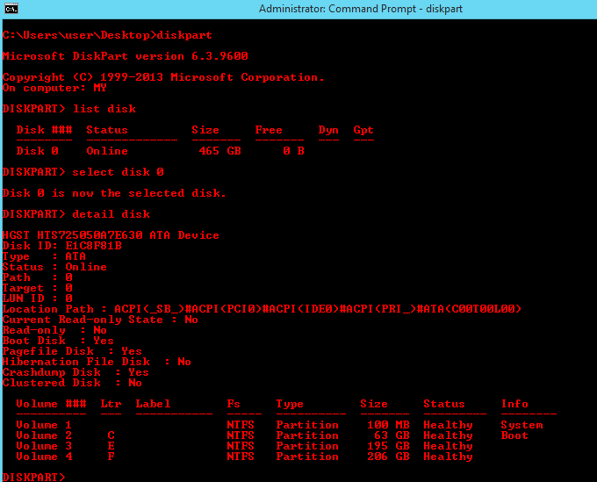
* 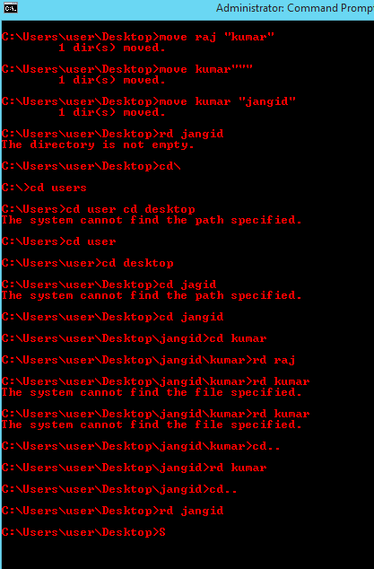
* Systeminfo
* 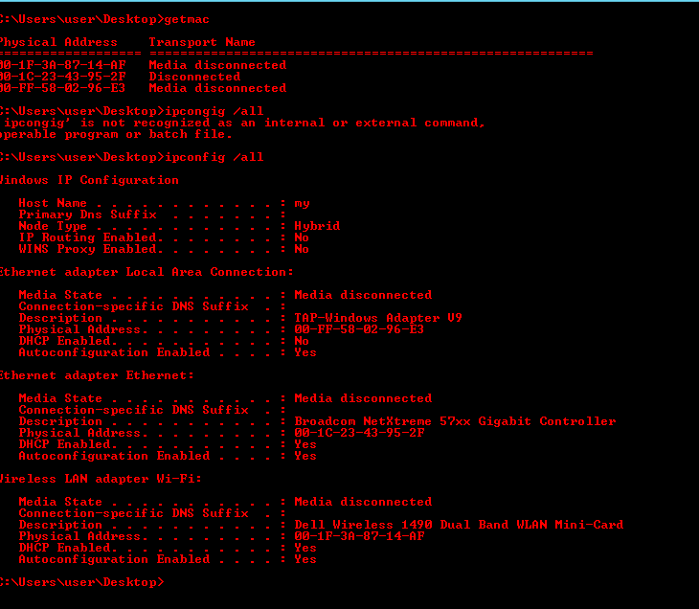
* netstat
* 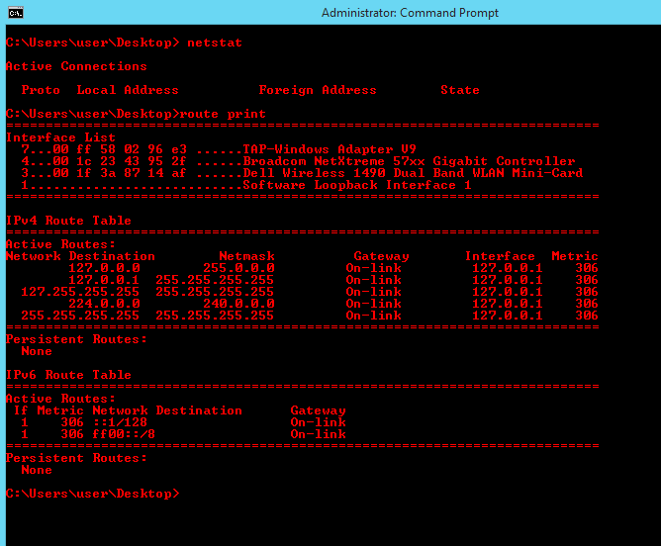
* help prompt(change first)
* title name
* telnet towel .blinkenlights.nl
* attrib +h +s +r folder name(hide folder)
* attrib –h –s –r folder name(unhide)
* command | clip(copy O\p )
* net share
* 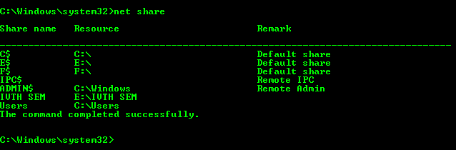
* 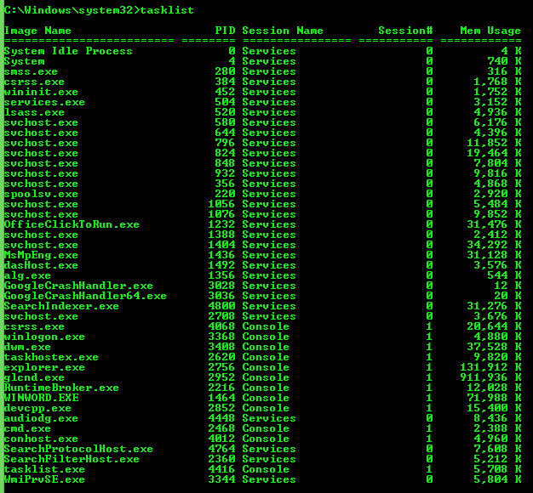tasklist

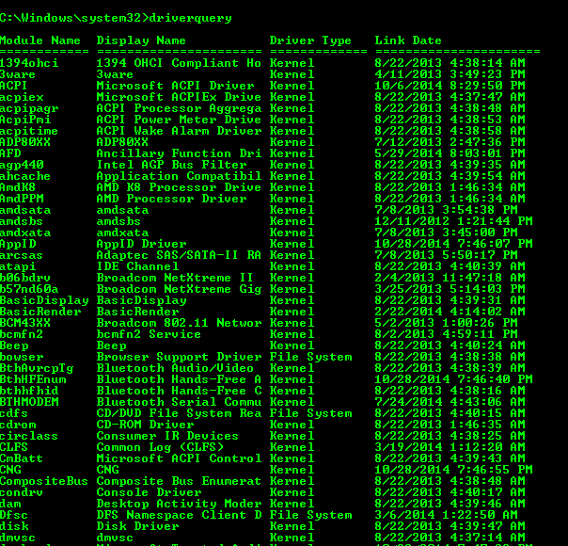

* driverquery

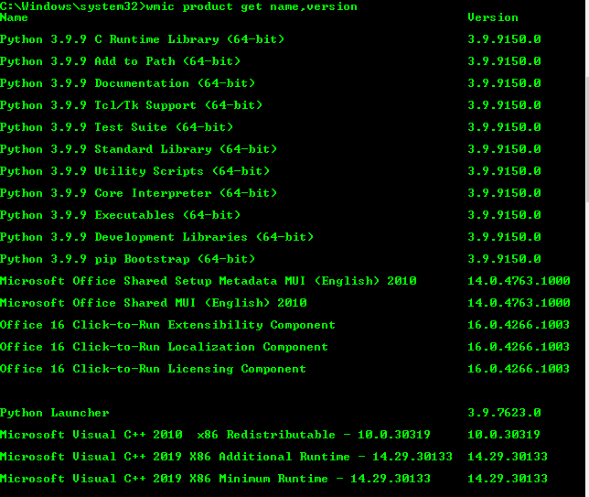

* wmic product get name,version
* 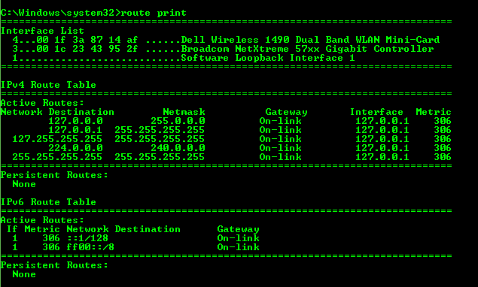route print