**Launching website from S3 Bucket:**

Create Test Bucket:

We can Create unique bucket ever in AWS as we are going to access from anywhere.

testbucketwebsite1 - Contains only lower cases

Creating with default permission of not accessing from public.



Adding the index file to the bucket as a file:

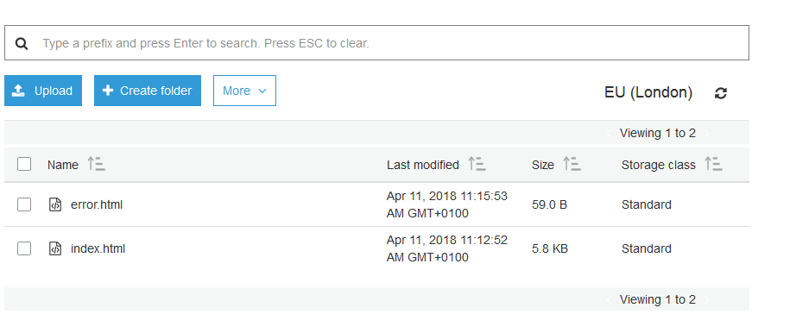

Granting permission to read only to public for both index and error elements:

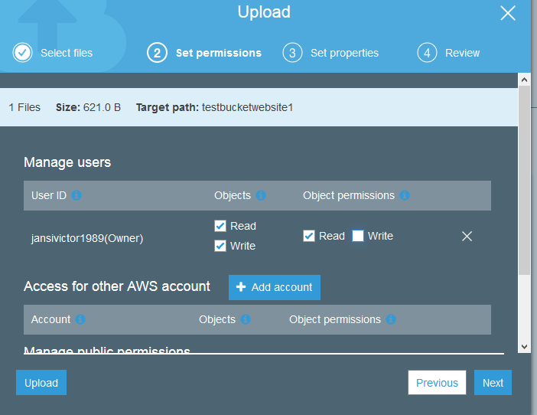

Launching the link from the index:

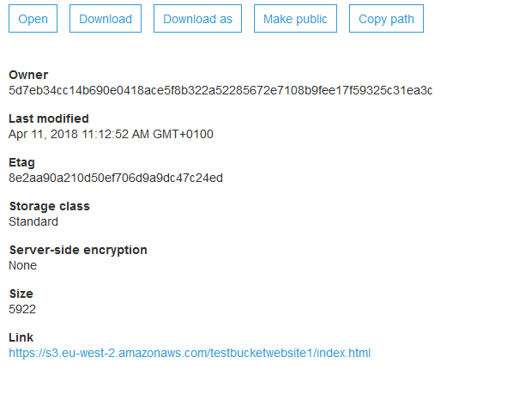

My website is launched:

