

Arden University
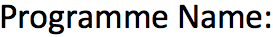

Msc in Data Science

BigData And Cloud Computing (COM7020)


BigData And Cloud Computing


24169752
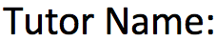
Ahmed Hassan
ahassan@arden.ac.uk

4847

Table of contents

- Introduction
- Overview of MES and its data environment
- Data requirements and big data challenges
- Ethical, legal, and regulatory considerations
- Evaluation of cloud models and processing approaches
- Recommended cloud architecture direction
- Proposed big data architecture with diagram
- Proof of Concept implementation
- Results and discussion of PoC
- Future recommendations
- Conclusion
- References
- Appendix, code, screenshots, or extra diagrams

1. Introduction
The energy industry globally is currently experiencing a digital revolution resulting from innovations and the need for more efficient and sustainable energy services. The traditional electrical grid system is being replaced using smart grids through the application of digital technology that ensures constant communication among energy providers, customers, and infrastructure. Besides, due to the increase in the use of renewables like solar and wind energy, EV charging stations and AMI, there is a lot of energy data created.
The aim of the current report is to investigate the data management needs of MES and analyse the technical, ethical, legal, and regulatory aspects in relation to big data management in the energy sector. The report will discuss the features and challenges of the data management environment of MES, such as data quality, scalability, integration, security, and governance. The report will also analyse the cloud computing service models – IaaS (Infrastructure as a Service), PaaS (Platform as a Service), SaaS (Software as a Service), batch processing, stream processing.
In addition to that, the report also suggests an architectural framework based on the cloud computing technology for dealing with big data in the MES environment, showcasing how new technologies like Apache Spark, and Lambda architecture can make the process more efficient and scalable. To test the effectiveness of the suggested solution, Proof of Concept (PoC) is developed based on the Smart Meter Dataset. PoC shows how PySpark can be used to preprocess and analyse smart meters' data to detect consumption trends, peak hours, and voltages' performance.

2. Overview of MES and Its Data Environment
The operations of MES (Metro Energy Solutions) are done in an environment that is highly digitized where a lot of information is being produced at any time from the customers, grid network, renewable energy facilities, and business software.

2.1 Data Sources within MES
MES collects data from several key systems and technologies:
Data Source | Data Generated
Smart Meters | Energy consumption, voltage, current, frequency readings
EV Charging Stations | Charging sessions, charging duration, energy demand patterns
Solar Installations | Electricity generation output, system performance metrics
IoT Sensors | Equipment condition, temperature, fault detection, maintenance indicators
Billing Systems | Customer information, payment history, account details, billing records
Weather APIs | Temperature, humidity, wind speed, and weather forecasts

2.2 Smart Meter Dataset
The smart meter data set is representative of a typical environment in MES. It comprises several key measurements that give insight into customer consumption behaviour and power quality in the electric grid.
Data set consists of:
- Timestamp: Contains the precise date and time at which the measurement was made.
- Energy consumption (kWh): It is the measure of electrical energy consumed over a certain period. This measurement is extremely important for demand forecasting, customer billing, and load management.
- Average Voltage: Denotes the average voltage delivered to the consumer. The measurements related to voltage indicate the quality of power and ensure that network stability is maintained.
- Average Current: It is a measurement that provides information about the electrical current flowing in the network. It can be used to determine any overload, abnormal behaviour and equipment stress.
- Frequency: Denotes the frequency at which the network is working. The normal range of frequency would be 50 Hz or 60 Hz depending upon the location of the network. If there is any change in frequency, then it indicates that the network might have become unstable.

2.3 Characteristics of MES Data: The Five Dimensions of Big Data
The MES data shows the five main features of Big Data known as the 5Vs:
1. Volume
MES creates massive amounts of data daily. There are millions of smart meter data points, sensor data points, charging stations data points, and billing operations recorded every day. The large amount of data implies reliable data storage systems and efficient processing technology.
2. Velocity
Data is created and transferred very fast. Information flows from smart meters and IoT devices almost in real time, and MES needs to handle and analyse data instantly to make operational decisions and detect faults.
3. Variety
There are various types of data from various sources handled by MES. It includes structured data (billing operations, smart meter data points), semi-structured data (API data, system logs), and unstructured data (maintenance reports, images, messages).
4. Veracity
There may be problems related to inaccuracies caused by faulty sensors, communication failure, absence of data, duplication of records, or any other errors in the process of collection of data. It is necessary that collected data must be accurate and reliable as the poor quality of data leads to wrong forecasts and decision-making processes.
5. Value
The main reason for which data must be collected is to add value to the business. The use of data analytics in MES allows improving the forecast of demand, optimizing grid operations, providing better customer service, reducing operational expenses, implementing renewable energy, and making business plans using data.
To conclude, it is worth mentioning that MES exists in a complicated environment characterized by the presence of big data. Various sources of information are used such as smart meters, renewable energy, IoT, customer management system, and external weather services.

3. Data Requirements and Big Data Challenges
Being an energy utility firm in the modern era, MES (Metro Energy Solutions) is heavily reliant on the consistent generation, storage, processing, and analysis of huge amounts of data that are collected from different systems operating within the business environment of the company.
3.1 Data Acquisition Requirements
Data Acquisition is a term used to denote the process of collection of data from several different sources and the transfer of the data collected into one central location.
The types of data which need to be obtained by MES include:
- Smart meters: provide continuous data on electrical consumption, voltage, current, and frequency readings of the residential, commercial and industrial consumers.
- EV charging stations: data regarding charging sessions, length of charging sessions, electricity demand, charging rates, and usage of charging stations.
- Solar monitoring systems: data on solar energy production, efficiency of inverters, energy produced and efficiency of the entire system.
- IoT devices and sensors: monitoring of equipment health, transformer temperature, network conditions, vibrations and faults.
- Billing platforms: customer accounts data, billing data, payments made, and consumption data.
- Weather feeds and APIs: external environmental data including temperature, humidity, rainfall, wind speeds, and weather forecast.
To properly control these different flows of data, MES needs automated processes for gathering, verifying and combining data from all systems involved, while minimizing manual efforts as much as possible.

3.2 Batch Data and Streaming Data Requirements
MES must provide functionality for both batch data processing and streaming data processing because various business operations need different methods of data processing.
Batch Data:
Batch data refers to bulk sets of data collected over time and processed periodically rather than immediately after they are produced.
Examples of batch data in MES are:
- Billing data
- Customer accounts
- Consumption history
- Reports
- Compliance reports
- Energy consumption reports
Data Streams:
Data streams are defined as information that is being produced continuously and sent in real time or near real time.
Examples of such data include:
- Measurements coming from smart meters every few seconds or minutes
- Grid fluctuations in voltage and frequency
- Fault warnings from equipment
- Charging session details for electric vehicles
- Information regarding solar generation
- IoT sensors' data
It is important to mention that data streams are necessary to ensure operational monitoring as they allow MES to respond instantly to any changes in the situation. For instance, MES will be able to notice immediately the voltage drops or transformer fault and deal with the problem in time to prevent any disruption of services.

3.3 Storage Requirements
Data Lake Architecture:
In a data lake, all structured, semi-structured, and unstructured data are stored in their native formats, making it ideal for dealing with energy data sets.
The MES data lake architecture can be based on three layers:
1. Raw Layer:
In the Raw Layer, the data is stored in its original form without any changes.
These include:
- Smart meter data in their original form
- Sensor logs
- API responses of weather data
- Billing data export
The raw layer acts as the main storage layer for audit purposes.
2. Processed Layer:
The Processed Layer holds cleansed, validated, and transformed data.
Tasks undertaken in this layer are:
- Removal of duplicated data entries
- Fixing data formatting problems
- Dealing with missing data
- Conversion to common measurement units
- Validation of data accuracy

3. Curated Layer:
The Curated Layer holds business-ready information that is optimized for reporting, dashboards, machine learning, and analytics.
Some examples of information in this layer are:
- Daily energy consumption statistics
- Customer segments
- Forecasted demand models
- Assets performance information
Advantages of Data Lakes
Data lakes provide some benefits to MES as follows:
- Scalability: Can handle increasing amounts of smart meter and IoT data easily.
- Flexibility: Provides support for different kinds of data and new data sources.
- Economical: Requires inexpensive storage systems than other databases.
- Machine Learning: Allows machine learning, prediction, and forecasting.

3.4 Processing Requirements
MES demands robust processing capacity in order to convert the raw data into meaningful information. Given the volume and velocity of the data being generated, both batch and stream processing platforms are essential.
Batch Processing
Batch processing is done to perform massive analyses on past data sets.
Useful applications are:
- Calculations of customer bills
- Past consumption analysis
- Reporting to the regulatory bodies
- Revenue analysis
- Demand forecasting for future

Stream Processing
Stream processing involves analysing the data while it is being received.
Useful applications are:
- Grid monitoring in real time
- Fault identification and alert generation
- Monitoring of power quality
- Equipment condition monitoring
- Demand response management
Distributed Computing through Apache Spark
For efficient processing of huge datasets, MES can implement distributed computing using Apache Spark which is a computing engine that is made for big data environments.
Apache Spark includes:
- Parallel Computing: Processing work on multiple servers at the same time.
- Fast Analytic Processing: Processing data in memory resulting in fast analysis of data.
- Scalability: Processing of increasing data without any changes to infrastructure.
- Predictive Analysis Support: Predictive models and forecasts.
This allows MES to analyze millions of smart meter records in an efficient manner.

3.5 Big Data Challenges
Data Silos
Regional systems, business segments, and operational platforms might collect data separately, thus forming separate data silos.
The problems include:
- Data sharing limitations
- Unreliable reporting
- Difficulties achieving a holistic picture of the organization
- Greater complexity of integration
The MES needs to develop data integration practices to build a unified and reliable data pool.

Data Quality Problems
Data quality is one of the most common problems related to utility analytics.
Such problems as:
- Lack of meter reading
- Data duplicates
- Sensor failures
- Non-uniformity of data formats
- Communications issues
Poor-quality data might impair decision making and influence the precision of forecasting and billing. Thus, data governance is critical.
Challenges in Scalling
Increased use of smart meters, EV chargers, and Internet of Things (IoT) devices causes an increase in data volume.
To be able to process increased data volume, MES has to guarantee:
- Availability of enough storage space
- High-performance processing systems
- Reliable networking
- Effective data retrieval

Challenges in Security and Privacy
Being one of the crucial energy infrastructure providers, MES must provide protection of its operational and customer data against potential cyber-attacks.
Potential security threats include:
- Unauthorized access to MES's system
- Data breaches
- Ransomware attacks
- Cyber-attacks on MES's network
- Infringement of customer privacy

4. Ethical, Legal, and Regulatory Considerations
4.1 Ethical Considerations
Consumption data of energy may seem innocuous at first; nevertheless, with advanced smart metering technology, highly personal information about individual customer activities can be extracted. By monitoring the pattern of electricity use, it is possible to tell when people are at home, sleep, work, or are away from home.
Transparency
Transparency is one of the basic ethical principles in managing personal information. Customers must be clearly aware of:
- What kind of data is collected.
- Why the data is being collected.
- How the data will be used.
- Who will have access to the data.
- The duration of data storage.
Fairness
MES needs to ensure that data analytics and decision-making processes are fair and not discriminatory. Predictive analytics models for the purpose of customer segmentation, forecasting demand or for service prioritization cannot give rise to discrimination in favour of some and discrimination against others. For instance, analytics decisions should not be

based on variables like age, race, gender or socio-economic profile unless there is a legal need to do so.

4.2 GDPR Compliance
As it is evident from the fact that MES operates in Europe, therefore, it needs to adhere to the rules laid down under the General Data Protection Regulation (GDPR), which is considered one of the best data protection laws around the world.
Lawfulness
MES must ensure what legal ground it has for collecting data of its customers. Some grounds can be contractual necessity, compliance with legal obligation, legitimate interest, and even consent of the customers.
Consent
If consent is used by MES for data collection, then the consent should be given freely, specific, and informed and in a clear manner. Customers must be able to understand fully what they are consenting for and their consent should be recorded by MES.
Data Minimization
Data minimization means that the organization will only collect the data that is required for achieving a specific purpose.
Access Rights
Under GDPR, clients have access rights to their personal information. MES has an obligation to provide copies of personal information requested by the clients and give a justification of why the information is processed.
Right to Erasure
This is commonly referred to as the “right to be forgotten.” It is a situation whereby the client can request for the erasing of personal information if there is no need for processing the information.

4.3 Security Requirements
Strong security measures must be used to safeguard the customer data and infrastructure of the organization from cyber-attacks.
Encryption
MES should use AES-256 encryption, which is an established industry practice for securing data. Encryption must be implemented for data stored in the database, data lake, backup solutions, and cloud services. Furthermore, the data transferred from device to device and system to system should be encrypted using communication protocols like TLS.
Access Control
MES should use Role-Based Access Control (RBAC) for giving access to the employees to only that amount of information that is required by them to perform their job functions.
Continuous Monitoring
To protect against any suspicious behavior, attempted unauthorized access, malware infections, and cyber-attacks, MES should have continuous monitoring of its security systems. This will require implementing security information and event management (SIEM) systems, intrusion detection, alerts, and security audits.

5. Evaluation of Cloud Models and Processing Approaches
This section reviews the three main cloud service models which include Infrastructure as a Service (IaaS), Platform as a Service (PaaS), and Software as a Service (SaaS). In addition, it explores batch processing, stream processing, and Lambda Architecture as possible data processing techniques for MES.
5.1 Infrastructure as a Service (IaaS)
Infrastructure as a Service (IaaS) entail providing access to virtualized computing infrastructure through the internet. In the cloud environment, the service provider offers access to servers, storage, networking, and virtualization, whereas the user handles operating systems, applications, database management, and security.

The following are some IaaS offerings:
- Amazon EC2 (AWS)
- Microsoft Azure Virtual Machines
- Google Compute Engine
Benefits of IaaS
1. Highest Flexibility
This cloud service is characterized by highest flexibility since MES can set up servers, storage system, operating system, and software according to the business needs. The feature is helpful when performing various operations such as analysing smart meter data, machine learning algorithms, and grid monitoring applications.
2. Control Over Infrastructure
MES has a high control over its IT infrastructure that includes adjusting security parameters, networking setup, storage system, and data processing environment. High control over infrastructure is essential for an organization dealing with critical infrastructure and sensitive information.
Limitations of IaaS
1. More Complex Management
Even though IaaS allows MES to have more control, the company has to manage its operating system, software updates, security patches, backups, and monitoring infrastructure. Therefore, some technical knowledge is required.
2. Operational Complexity
Operating cloud infrastructure is rather complicated especially when managing various applications and data processing environments.

5.2 Platform as a Service (PaaS)
In Platform as a Service (PaaS), developers have an environment to develop, deploy and run applications without the need to manage the infrastructure that supports them.
Some examples are:
- Microsoft Azure App Service
- Google App Engine
- AWS Elastic Beanstalk

Benefits of PaaS
1. Quick Deployment
The platform allows fast deployment since the cloud company takes care of the server, OS and runtime environment. The MES team doesn't have to think about infrastructure management and can concentrate on developing analytics software.
2. Decreased Maintenance
Tasks related to software maintenance and updates; infrastructure and system management and other routine things become a responsibility of the provider. It makes the process more efficient and decreases IT management expenses.
Drawbacks of PaaS
1. Less Control
In comparison with IaaS solution, MES has less control over the infrastructure setup and system configuration. Some customizations may be unavailable.
2. Vendor Lock-in
Some vendor-specific services can be used for application development, and it complicates moving to another platform.

5.3 Software as a Service (SaaS)
Software as a Service (SaaS) offers complete software applications that are hosted and managed via the Internet. The user accesses applications via the browser and is not responsible for management of infrastructure, maintenance, updates, and security.
Examples include:
- Salesforce
- Microsoft 365
- Google Workspace

Advantages of SaaS
1. Ease of Use
The adoption of SaaS solutions is easy since no complicated installation or configuration procedures are involved. Applications for communication, reporting, CRM, and business processes are available right away to MES.
2. Minimal Maintenance Required
As the software and all infrastructure are maintained by the service provider, the technical support is required minimally by MES.
Disadvantages of SaaS
1. Difficulty with Customization
The SaaS applications provide limited flexibility in comparison with IaaS or PaaS. MES may not find it possible to customize the software for its needs.
2. Questions of Data Ownership
Due to the external management of applications and data, there might be questions raised about data ownership and governance.

5.4 Comparison of Cloud Service Models
The three cloud models differ significantly in terms of flexibility, maintenance responsibilities, and scalability.
Criteria | IaaS | PaaS | SaaS
Flexibility | High | Medium | Low
Maintenance Responsibility | High | Medium | Low
Scalability | High | High | Medium
Infrastructure Control | High | Medium | Low
Deployment Speed | Medium | High | Very High
Customization | High | Medium | Low

5.5 Batch Processing
MES Applications that Suit Batch Processing
These include:
- Customer billing
- Monthly usage report generation
- Historical trend analysis
- Regulatory report generation
Advantages
- Quick data processing
- Low cost of data processing
- Suitable for non-critical processes
- Good historical data analysis capabilities
Disadvantages
- Data is processed after a delay
- Slow to detect operational problems
Batch processing is necessary for businesses but not sufficient for applications where immediate responses are needed.

5.6 Stream Processing
Stream processing involves the analysis of continuous data flow from the source systems.
MES Applications for Suitable Stream Processing
Stream processing should be used for the following purposes:
- Real-time grid monitoring
- Detecting faults and sending alerts
- Voltage and frequency monitoring
- Health monitoring of equipment
- Demand response management
- Monitoring the EV charging networks

Advantages
- Quick identification of problems
- Decision making in less time
- Grid reliability
Disadvantages
- Complex to implement
- High infrastructure cost
- Processing cost

5.7 Lambda Architecture
To effectively analyse both historical and live data, MES will utilize the concept of a Lambda Architecture.
The Lambda Architecture has three components:
1. Batch Layer
The batch layer contains and analyses all historical data sets. It undertakes thorough analyses on total data sets to produce reliable findings.
These include:
- Demand forecasting for past records
- Consumption analysis in the long term
- Behavioural analysis of customers
2. Speed Layer
This layer analyses data streams in real time before batch processing is done.
This includes:
- Fault alerting
- Detection of voltage anomalies
- Notifications of equipment failure

3. Serving Layer
This layer brings together findings from the batch layer and the speed layer and makes them available in dashboards, reports, and applications.
This includes:
- Operational dashboards
- Reports for management
- Customer portals
- Analytics applications

6. Recommended Cloud Architecture Direction
Considering the requirements of Metro Energy Solutions (MES), the most appropriate choice would be the Hybrid Cloud Architecture. This architecture includes the on-premises and public cloud service, which will help to meet all requirements and provide an optimal solution to the challenges of energy providers.
The first reason why the company should choose the hybrid cloud is legacy. As it was mentioned before, the MES has already developed its systems, including smart meters, billing system, IoT-enabled substations, and customers management application. It means that MES cannot replace all these systems due to the cost and complexity of the replacement process.
The second reason is the scalability. The number of smart meters, EV charging stations, and IoT sensors increases day by day, and a huge amount of data is generated every day. In case of hybrid clouds, cloud computing resources will automatically scale up at the moments of high load and scale down after this period.
Hybrid Cloud Architecture gives an ideal combination of flexibility, security, scalability, and reliability for MES. It can maintain legacy systems, allows real-time and big data processing, cuts down the cost, and increases the ability to cope with system failures.

7. Proposed Big Data Architecture with Diagram
The proposed architecture follows a layered approach consisting of:
- Data Source Layer
- Data Ingestion Layer
- Data Storage Layer
- Data Processing Layer
- Analytics Layer
- Visualization Layer
- Security & Governance Layer
- Monitoring Layer
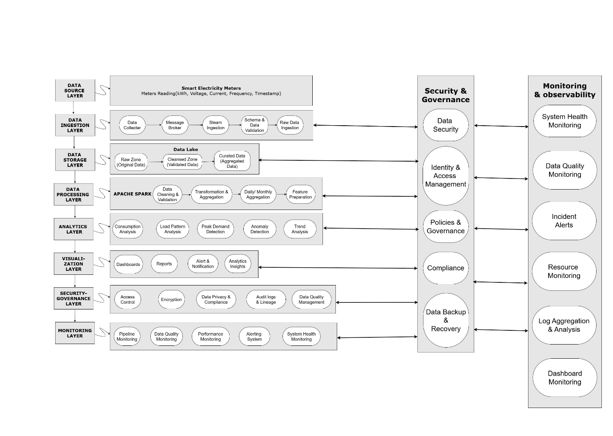
Fig1. Big Data Architecture Diagram

8. Proof of Concept Implementation
A Proof of Concept (PoC) has been created using the Bareilly Smart Meter Dataset to illustrate how the MES system can use big data technologies to analyze energy. The aim behind creating this PoC is to illustrate how the smart meters’ data can be processed, analyzed, and visualized using Apache Spark (PySpark).
The dataset contains operational measurements collected from smart meters and includes the following attributes:
- Timestamp – Date and time when the reading was recorded.
- kWh (Kilowatt-hour) – Energy consumption during the measurement period.
- Voltage – Average voltage supplied to the customer.
- Current – Average electrical current flowing through the circuit.
- Frequency – Power system frequency at the time of measurement.

Objectives of the Analysis
The main objectives of the Proof of Concept include:
1. Analysis of Trends in Electricity Consumption
- Understanding how energy consumption varies over time.
- Identification of patterns of increased or decreased consumption.
2. Identification of Peaks of Electricity Consumption
- Determining when electricity consumption peaks occur.
- Helping with load balancing and demand management techniques.
3. Analysis of Seasonal Trends
- Monthly analysis of electricity consumption trends.
- Impact of weather conditions on electricity consumption.

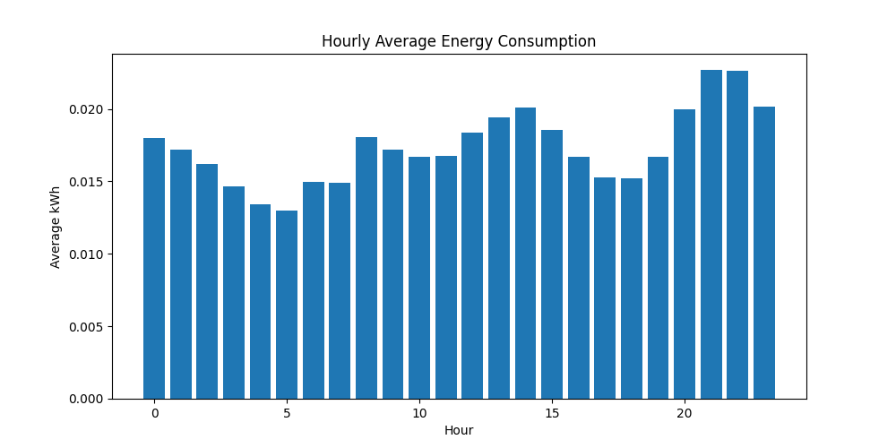
Fig2. hourly_consumption_chart

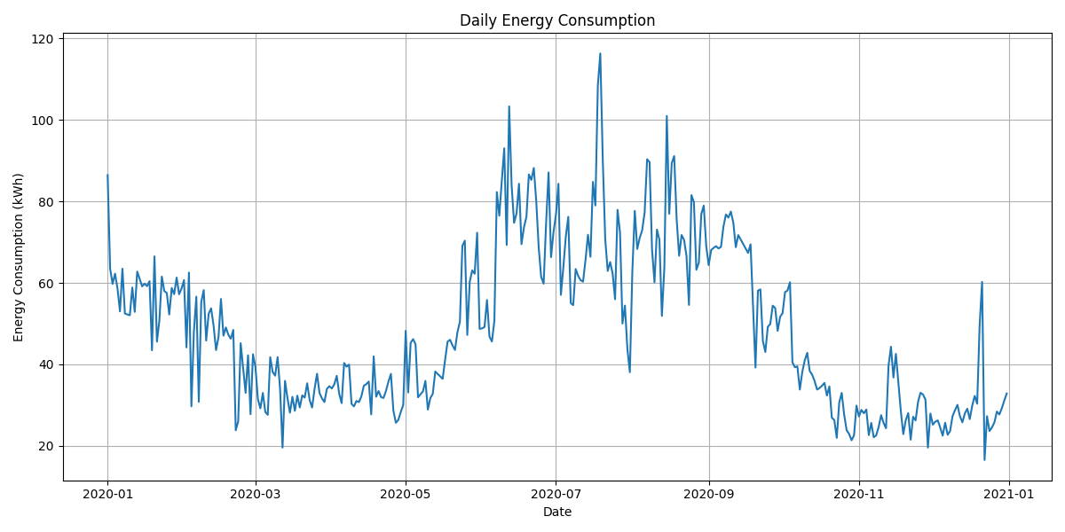
Fig3. Daily_consumption_chart

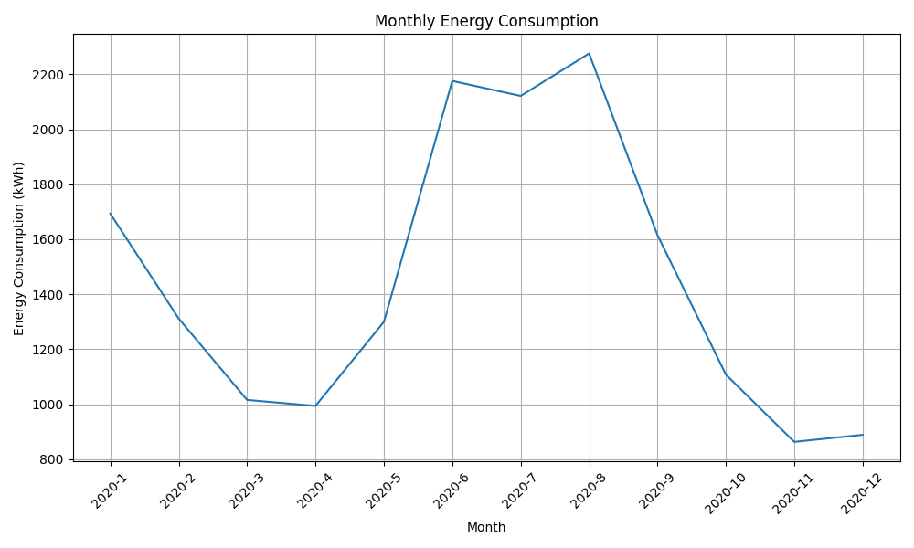
Fig4. Monthly_consumption_chart

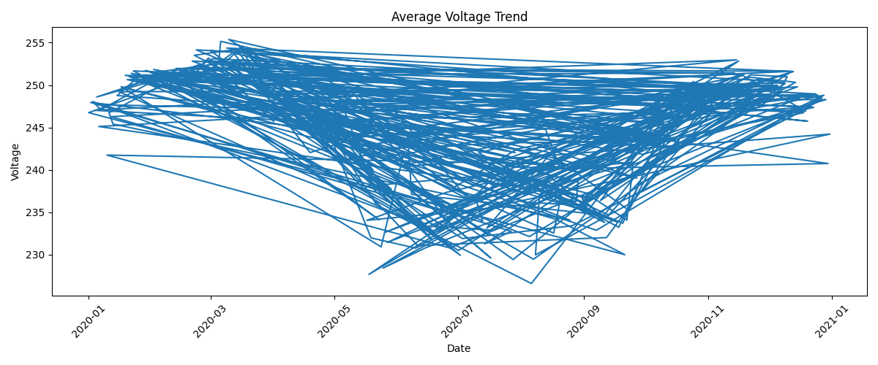
Fig5. Average_Voltage_Trend_chart

9. Results and Discussion of the Proof of Concept (PoC)
Through the Proof of Concept (PoC) carried out using Bareilly Smart Meter Dataset, it was seen how big data analytics could be used on the information from the smart meters to get insights that could prove beneficial to MES (Metro Energy Solutions). The analysis of data regarding energy consumption, voltage, current, and frequency done by PySpark helped to accomplish this.
Findings
Usage Trends:
During the daily energy consumption analysis, usage trends were identified. The daily aggregation shows that there is variation in electricity demand on a day-to-day basis. MES can use this information to get an idea about the customer consumption behaviour and determine peaks and lulls of energy consumption.
Peak Energy Demand:
As a result of the performed analysis, it was identified that peaks of electricity demand happen during periods of high energy consumption. That means that MES will have an opportunity to better manage their grid and electricity supply.

10. Future Recommendations
In addition to improving on its big data technology, MES is advised to do the following:
- Adopt Advanced Analytics: Deploy machine learning and artificial intelligence (AI) models to better the forecasting of demand, prediction of faults, and predictive maintenance.
- Real-Time Data Processing: Utilize platforms such as Apache Kafka and Spark Streaming in processing IoT and smart meter data in real-time.
- Data Governance: Develop clear data governance policies covering data quality, security, privacy, and compliance.

11. Conclusion
In summary, this report explains how the application of big data technology could enable MES to manage its energy management process more effectively. This could be achieved through collection of data from smart meters.
As shown by the big data architecture, cloud computing model, and the PoC using PySpark technology, the storage, processing, and analysis of large data sets could be done effectively. From the analysis of the Bareilly Smart Meter Dataset, it was possible to obtain useful insights into energy consumption, periods of peak demand, and stability of voltage.

12. References
- Armbrust, M., Fox, A., Griffith, R., Joseph, A.D., Katz, R.H., Konwinski, A., Lee, G., Patterson, D.A., Rabkin, A., Stoica, I. and Zaharia, M. (2010) ‘A view of cloud computing’, Communications of the ACM, 53(4), pp. 50–58
- Dean, J. and Ghemawat, S. (2008) ‘MapReduce: Simplified data processing on large clusters’, Communications of the ACM, 51(1), pp. 107–113
- Marr, B. (2023) Big Data in Practice: How 45 Successful Companies Used Big Data Analytics to Deliver Extraordinary Results. 2nd edn. Chichester: Wiley.
- Mell, P. and Grance, T. (2011) The NIST Definition of Cloud Computing. NIST Special Publication 800-145. Gaithersburg, MD: National Institute of Standards and Technology
- Shvachko, K., Kuang, H., Radia, S. and Chansler, R. (2010) ‘The Hadoop Distributed File System’, 2010 IEEE 26th Symposium on Mass Storage Systems and Technologies (MSST), pp. 1–10.

13. Appendix
from pyspark.sql import SparkSession
from pyspark.sql.functions import (
col,
to_timestamp,
to_date,
year,
month,
sum as spark_sum,
avg
)

import pandas as pd
import matplotlib.pyplot as plt

# STEP 1: Create Spark Session
spark = SparkSession.builder \
.appName("MES_Smart_Meter_Analytics") \
.getOrCreate()

# STEP 2: Load Dataset
file_path = "/content/Smart meter data.csv"
df = spark.read.csv(
file_path,
header=True,
inferSchema=True
)
print("Dataset Schema:")
df.printSchema()

print("Sample Records:")
df.show(5)

# STEP 3: Data Cleaning
from pyspark.sql.functions import trim, col, try_to_timestamp, lit
# Remove duplicates
df = df.dropDuplicates()
# Remove rows with missing values
df = df.dropna()

# Check if 'x_Timestamp' column exists before processing it
if "x_Timestamp" in df.columns:
# Trim x_Timestamp column to remove any leading/trailing spaces
df = df.withColumn("x_Timestamp", trim(col("x_Timestamp")))

# Convert Timestamp column using try_to_timestamp for robustness
df = df.withColumn(
"Timestamp",
try_to_timestamp(col("x_Timestamp"), lit("dd-MM-yyyy HH:mm"))
)
# Drop the original x_Timestamp column
df = df.drop("x_Timestamp")

# Remove invalid energy values
df = df.filter(col("t_kWh") >= 0)

# Voltage validation (example range)
df = df.filter(
(col("z_Avg Voltage (Volt)") >= 180) &
(col("z_Avg Voltage (Volt)") <= 260)
)

# Frequency validation
df = df.filter(
(col("y_Freq (Hz)") >= 49) &
(col("y_Freq (Hz)") <= 51)
)
print("Cleaned Data")
df.show(5)

# STEP 4: Create Date Attributes
df = df.withColumn(
"Date",
to_date(col("Timestamp"))
)
df = df.withColumn(
"Year",
year(col("Timestamp"))
)

df = df.withColumn(
"Month",
month(col("Timestamp"))
)

# STEP 5: Daily Consumption Aggregation
daily_consumption = df.groupBy("Date") \
.agg(
spark_sum("t_kWh").alias("Daily_kWh")
) \ .orderBy("Date")
print("Daily Consumption:")
daily_consumption.show()

# STEP 6: Monthly Consumption Aggregation
monthly_consumption = df.groupBy(
"Year",
"Month"
).agg(
spark_sum("t_kWh").alias("Monthly_kWh")
).orderBy(
"Year",
"Month"
)
print("Monthly Consumption:")
monthly_consumption.show()

from pyspark.sql.functions import max, desc, hour, col
# Add 'Hour' column
df_with_hour = df.withColumn("Hour", hour(col("Timestamp")))
peak = df_with_hour.groupBy("Hour") \
.agg(
max("t_kWh").alias("Peak_Energy_kWh")
) \
.orderBy(col("Peak_Energy_kWh").desc())
peak.show()

# STEP 7: Voltage Analysis
voltage_summary = df.groupBy("Date").agg(
avg("z_Avg Voltage (Volt)").alias("Average_Voltage")
)
print("Voltage Summary:")
voltage_summary.show()

# STEP 8: Peak Demand Analysis
peak_demand = daily_consumption.orderBy(
col("Daily_kWh").desc()
)
print("Top Peak Demand Days:")
peak_demand.show(10)

# STEP 9: Convert to Pandas for Visualization
daily_pd = daily_consumption.toPandas()
monthly_pd = monthly_consumption.toPandas()

# STEP 10: Daily Consumption Chart
plt.figure(figsize=(12,6))
plt.plot(
daily_pd["Date"],
daily_pd["Daily_kWh"]
)
plt.title("Daily Energy Consumption")
plt.xlabel("Date")
plt.ylabel("Energy Consumption (kWh)")
plt.grid(True)
plt.tight_layout()
plt.savefig("daily_consumption_chart.png")
plt.show()

# STEP 11: Monthly Consumption Chart
monthly_pd["Period"] = (
monthly_pd["Year"].astype(str)
+ "-"
+ monthly_pd["Month"].astype(str)
)

plt.figure(figsize=(10,6))
plt.plot(
monthly_pd["Period"],
monthly_pd["Monthly_kWh"]
)
plt.title("Monthly Energy Consumption")
plt.xlabel("Month")
plt.ylabel("Energy Consumption (kWh)")
plt.xticks(rotation=45)
plt.grid(True)
plt.tight_layout()
plt.savefig("monthly_consumption_chart.png")
plt.show()

#STEP 12: Calculate hourly average consumption
hourly_average_consumption = df_with_hour.groupBy("Hour") \
.agg(
avg("t_kWh").alias("Average_Consumption")
) \
.orderBy("Hour")
hourly_pd = hourly_average_consumption.toPandas()
plt.figure(figsize=(10,5))
plt.bar(
hourly_pd["Hour"],
hourly_pd["Average_Consumption"]
)

plt.title("Hourly Average Energy Consumption")
plt.xlabel("Hour")
plt.ylabel("Average kWh")
plt.savefig("hourly_consumption_chart.png")
plt.show()

#STEP 13: Calculate Peak Energy by Hour
peak_pd = peak.toPandas()
plt.figure(figsize=(10,5))
plt.bar(
peak_pd["Hour"],
peak_pd["Peak_Energy_kWh"]
)
plt.title("Peak Energy by Hour")
plt.xlabel("Hour")
plt.ylabel("Energy (kWh)")
plt.savefig("Peak_Energy_by_Hour.png")
plt.show()

#STEP 14: Average Voltage Trend
voltage_pd = voltage_summary.toPandas()
plt.figure(figsize=(12,5))
plt.plot(
voltage_pd["Date"],
voltage_pd["Average_Voltage"])

plt.title("Average Voltage Trend")
plt.xlabel("Date")
plt.ylabel("Voltage")
plt.xticks(rotation=45)
plt.tight_layout()
plt.savefig("Average_Voltage_Trend.png")
plt.show()

# STEP 15: Export Results
daily_consumption.coalesce(1).write.mode("overwrite") \
.option("header", True) \
.csv("output/Daily_consumption")
monthly_consumption.coalesce(1).write.mode("overwrite") \
.option("header", True) \
.csv("output/Monthly_consumption")
print("Analysis Completed Successfully")

# Stop Spark Session
spark.stop()

# Github Repository Link
https://github.com/rajkumar291/Big_Data_Analytics.git

