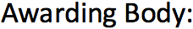
Arden University

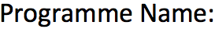
Msc Data Science

Advance Computing Project (COM7014)

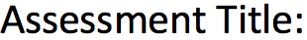
Dissertation (001)

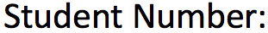
24169752

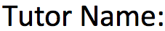
Jim Matthews
jmatthews@arden.ac.uk
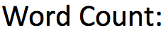
12896

Chapter 1: Introduction
1.1 Background of the Study
1.2 Used Car Market and Price Prediction
1.3 Problem Statement
1.4 Research Aim
1.5 Research Objectives
1.6 Research Questions
1.7 Scope of the Project
1.8 Significance of the Study
1.9 Machine Learning Approach

Chapter 2: Literature Review
2.1 Introduction
2.2 Used Car Price Prediction
2.3 Factors Affecting Used Car Prices
2.4 Machine Learning for Price Prediction
2.5 Regression Algorithms
2.6 Decision Tree Regression
2.7 Random Forest Regression
2.8 Ridge Regression
2.9 Hyperparameter Optimisation
2.10 Machine Learning Model Evaluation
2.11 Previous Studies on Used Car Price Prediction
2.12 Research Gap

2.13 Chapter Summary

Chapter 3: Dataset and Research Methodology
3.1 Introduction
3.2 Research Approach
3.3 Project Workflow
3.4 Dataset Description
3.5 Dataset Characteristics
3.6 Data Variables
3.7 Target Variable
3.8 Independent Variables
3.9 Data Collection and Source
3.10 Data Analysis Environment
3.11 Python Libraries and Tools
3.12 Machine Learning Workflow
3.13 Model Development Strategy
3.14 Model Evaluation Strategy
3.15 Chapter Summary

Chapter 4: Dataset Understanding and Exploratory Data Analysis
4.1 Introduction
4.2 Dataset Overview
4.3 Car Company Distribution
4.4 Car Model Distribution

4.5 Fuel Type Distribution
4.6 Car Colour Distribution
4.7 Odometer Reading Distribution
4.8 Body Style Distribution
4.9 Car Age Distribution
4.9 Car Age Distribution
4.11 Geographic Distribution
4.11.1 Dealer State Distribution
4.11.2 City Distribution
4.11.3 Dealer Distribution
4.12 Owner Type Distribution
4.13 Warranty Distribution
4.14 Quality Score Distribution
4.15 Chapter Summary

Chapter 5: Analysis of Factors Affecting Used Car Prices
5.1 Introduction
5.2 Car Company and Resale Price
5.3 Car Model and Resale Price
5.4 Fuel Type and Price
5.5 Car Colour and Price
5.6 Odometer Reading and Price
5.7 Body Style and Price

5.8 Car Age and Price
5.9 Location and Price
5.9.1 Dealer State and Price
5.9.2 City and Price
5.9.3 Dealer and Price
5.10 Owner Type and Price
5.11 Warranty and Price
5.12 Quality Score and Price
5.13 Summary of Price Determinants
5.14 Chapter Summary

Chapter 6: Data Preprocessing and Feature Engineering
6.1 Introduction
6.2 Data Cleaning
6.3 Removal of Irrelevant Variables
6.4 Handling of Categorical Variables
6.5 Removal of High-Cardinality Variables
6.6 Feature Encoding Using Label Encoding
6.7 Numerical Feature Preparation
6.8 Outlier Detection
6.9 Interquartile Range (IQR) Method
6.10 Outlier Removal
6.11 Correlation Matrix Analysis

6.12 Final Modelling Dataset
6.13 Chapter Summary

Chapter 7: Machine Learning Model Development
7.1 Introduction
7.2 Regression Problem Formulation
7.3 Feature Matrix and Target Variable
7.4 Train-Test Split
7.5 Candidate Regression Models
7.6 Decision Tree Regressor
7.6.1 Model Configuration
7.6.2 Model Training
7.7 Decision Tree Hyperparameter Tuning
7.7.1 GridSearchCV
7.7.2 Parameter Grid
7.7.3 Five-Fold Cross-Validation
7.7.4 Optimal Parameters
7.8 Random Forest Regressor
7.8.1 Model Configuration
7.8.2 Model Training
7.9 Random Forest Hyperparameter Tuning
7.9.1 GridSearchCV
7.9.2 Parameter Grid

7.9.3 Five-Fold Cross-Validation
7.9.4 Optimal Parameters
7.10 Ridge Regression
7.11 Chapter Summary

Chapter 8: Model Evaluation and Results
8.1 Introduction
8.2 Evaluation Methodology
8.3 Prediction Distribution Analysis
8.4 Decision Tree Regression Results
8.5 Random Forest Regression Results
8.6 Mean Squared Error (MSE)
8.7 Mean Absolute Error (MAE)
8.8 R² Score
8.9 Comparative Model Performance
8.10 Feature Importance Analysis
8.11 Most Important Predictors
8.12 Final Model Selection
8.13 Results Interpretation
8.14 Chapter Summary

Chapter 9: Discussion
9.1 Introduction
9.2 Summary of Exploratory Findings

9.3 Demand Versus Price Patterns
9.4 Effect of Car Age
9.5 Effect of Odometer Reading
9.6 Effect of Car Company and Model
9.7 Effect of Fuel Type
9.8 Effect of Body Style
9.9 Effect of Ownership and Warranty
9.10 Effect of Quality Score
9.11 Geographic Variation in Used Car Prices
9.12 Machine Learning Performance Discussion
9.13 Interpretation of Feature Importance
9.14 Comparison with Literature
9.15 Practical Implications
9.16 Limitations of the Study
9.17 Chapter Summary

Chapter 10: Conclusion and Future Work
10.1 Introduction
10.2 Summary of the Study
10.3 Achievement of Research Objectives
10.4 Key Findings
10.5 Best Performing Machine Learning Model
10.6 Contribution of the Study
10.7 Limitations

10.8 Recommendations for Future Work
10.8.1 Larger and More Diverse Dataset
10.8.2 Additional Machine Learning Algorithms
10.8.3 XGBoost and Gradient Boosting
10.8.4 Improved Feature Engineering
10.8.5 Advanced Categorical Encoding
10.8.6 Model Explainability
10.8.7 Web-Based Price Prediction Application
10.8.8 Model Deployment
10.9 Final Conclusion

Chapter 11: Reference
Chapter 12: Appendix

Chapter 1: Introduction
In this chapter, the Indian Used Car Price Prediction Project is presented, and its base is set up. It talks about the background of the used car market, price estimation problem, objective of the research, research questions, project scope, significance of the study, machine learning methodology, and report structure.
1.1 Background of the Study
The resale car industry has gained importance in the automotive industry in India because the resale cars offer customers an affordable means of procuring vehicles other than buying new vehicles. Estimating the right price of a resale car is difficult because of the various factors affecting the resale price such as brand, model, year of manufacture, number of kilometres driven, fuel used, gear, engine size, vehicle history, mileage, and vehicle condition.
Typical evaluation methods for resale cars depend on the experience of dealers in assessing prices, manual comparisons, and market knowledge and negotiations. These methods will provide 1.7 Scope of the Project
reasonable results but could also be subjective and inconsistent. Historical data on used cars present a possibility of developing an objective method of evaluation based on data.
Machine learning allows identifying relationships between different parameters and their impact on the selling price based on historical data. Thus, using machine learning, a computer can evaluate the selling price of a novel vehicle.

1.2 Used Car Market and Price Prediction
The price of used cars depends on several interrelated factors. One of them is that older cars have lower prices, but low mileage, well-known brand, better fuel consumption, and automatic gearbox can increase their resale price.
Thus, for making predictions of the price of used cars, a single factor cannot be used. A machine learning algorithm allows to consider several factors at once and to discover complicated dependencies from historical data.
The process of prediction can be described as follows:
“ Vehicle Features → Machine Learning Algorithm → Predicted Price of Used Car “
This approach will allow buyers to understand whether a car is worth its price and will also help sellers and dealers set competitive prices.

1.3 Problem Statement
Market value assessment for a used car is quite challenging since there is great variation in prices owing to the various aspects of the car and market dynamics. Manual evaluation may bring about subjective errors and not fully identify the relationship between the various variables involved.
The challenge that this project attempts to address is:
How can used-car data history and machine learning approaches be used to accurately predict the selling price of used cars in India?
This problem will be solved through the following steps in the project.

1.4 Research Aim
The main objective of the proposed project is:
Development of a machine learning model for prediction of prices of used cars in the Indian market based on the historical features of vehicles and prices.
Other objectives of the proposed project include:
1. Identification of the factors affecting the prices of used cars.
2. Identification of the best machine learning algorithm for the prediction task.

1.5 Research Objectives
The objectives of the project include the following:
- Acquisition and comprehension of a relevant Indian used car data set.
- Cleaning and preprocessing of the data by dealing with issues like missing values, duplicates, inconsistent values, and categorical variables.
- Exploratory data analysis to find patterns and relationships between various features and prices of the vehicles.
- Identification of the major factors that affect the prices of used cars.
- Creating suitable machine learning regression models.
- Model performance evaluation using metrics such as MAE, RMSE, MSE, and R².
- Comparison of different algorithms and finding the best-performing algorithm.
- Illustrating how the selected model can predict the price of an unknown used car.

1.6 Research Questions
These research questions will guide the study:
RQ1: What are the key factors affecting the prices of used cars in India?
RQ2: How well do machine learning algorithms predict the prices of used cars based on past vehicle records?
RQ3: What is the best performing machine learning regression algorithm?
RQ4: What impact does the preprocessing of data and feature engineering have on prediction performance?
RQ5: Can this model be used to estimate the market price of used cars?

1.7 Scope of the Project
The project involves historical used-car data from the Indian market. This covers data preprocessing, exploratory data analysis, feature engineering, machine-learning models building, model evaluation, algorithm comparison, and price prediction.
This research will cover those features of the vehicle that are available in the dataset such as make, model, year, miles driven, kilometres driven, fuel type, transmission, owner, and many more.
But it must be mentioned that this research is not concerned with physical inspection of the vehicles and also does not give a guaranteed valuation of any car. There might be issues in the cars like undetected mechanical issues, bargaining strategies, local conditions, etc.

1.8 Importance of the Research
The study is both practically and theoretically important.
To the buyers, the model can serve as another benchmark to be considered while assessing the price of the second-hand car. To the sellers, the study results will help to develop reasonable and competitive asking prices. Predictive models might help dealers to value cars, buy cars, manage inventory, and set prices.
Automotive web portals can use such predictive models in their practice to implement the vehicle valuation service.

From a theoretical standpoint, the research provides an example of the application of the whole machine learning cycle to a practical regression problem:
Data → Cleaning → Analysis → Feature Engineering → Modelling → Evaluation → Prediction

1.9 Machine Learning Approach
Car resale value prediction will be modelled as a supervised regression task, wherein the sale price is the outcome variable and vehicle features are the predictor variables.
The suggested process starts with collecting and preprocessing the dataset. Missing values, duplicate records, formatting issues, and unnecessary observations will be dealt with at this stage. Then exploratory data analysis will be carried out.
The feature engineering stage may consist of generating variables like:
Vehicle Age = Current Year - Year of Manufacturing
Categorical variables, like fuel type and transmission type, may be encoded into numeric variables.

Chapter 2: Literature Review
2.1 Introduction
In the literature review, past literature and knowledge concerning the pricing of used cars and machine learning is discussed. The pricing of used cars, how machine learning can be used to make predictions about the prices, and the algorithms used are outlined. This chapter will further discuss the Decision Tree, Random Forest, and Ridge Regression, model evaluation techniques, past studies, and the research gap in question.

2.2 Used Car Price Prediction
The used car price prediction problem is defined as finding the market price of the used car based on the features of the car. Features may include the age of the car, manufacturer, make, mileage, fuel type, transmission, body, and many other factors.

Conventional methods of pricing depend largely on subjective factors such as experience, demand for the product, and comparison with other similar products. The approach of machine learning helps in providing an objective way of finding out the relationship between features of cars and their prices and predicting prices based on this relationship.

2.3 Factors Affecting Used Car Prices
The following are the variables that play an essential role in determining the price of a used car. One such variable is the age of the car. It is vital for this reason because older cars tend to depreciate with age. The odometer reading is another factor that plays an essential role.
This is because higher odometer readings mean increased use and possible need for maintenance. Model and brand are other determinants of price. It is possible due to the popularity of some models or brands. Fuel type such as gasoline or diesel can also be a determinant of price.

2.4 Machine Learning for Price Prediction
Machine Learning is a sub-discipline of artificial intelligence which enables computers to derive some pattern and predict the result based on previous observations. Used car price prediction makes use of the historical data of cars to predict its selling price using machine learning.
In our case, we will employ supervised machine learning since there are known prices that will be used for training the model. Machine learning can handle multiple variables and determine the relationships that would be hard to recognize manually.

2.5 Regression Algorithms
Regression models are among the various machine learning models that are used to forecast continuous numeric values. Therefore, the nature of the car price, being numeric, makes regression applicable in this case.
Various types of regression have various merits. While simple linear regression relies on a relatively simplistic correlation between variables, there are other sophisticated algorithms that allow for capturing more complicated correlations. This study considers Decision Tree Regression, Random Forest Regression, and Ridge Regression.

2.6 Decision Tree Regression
The Decision Tree Regression uses decision rules to partition the data into smaller partitions to predict values. For instance, one can partition the cars based on their age first and then partition again either based on mileage or company.
One benefit of using the Decision Tree is that it is easy to interpret due to its structure. It can model the non-linear relationship between the features and the price. On the other hand, the downside is that the model tends to overfit when a single decision tree is used.

2.7 Random Forest Regression
Random Forest Regression builds an ensemble of multiple trees to come up with a prediction. Each tree uses a separate subset of data to learn from and analyses a different set of features.
Since there are multiple trees working together, Random Forest can overcome certain limitations of the decision tree by itself and model the complicated relationship present in the data. In addition, Random Forest can be especially helpful when there are multiple features both numeric and categorical present in the data.

2.8 Ridge Regression
The Ridge Regression is a form of linear regression which contains a regularization component. Regularization controls the magnitude of the coefficients and helps to avoid overfitting especially when the inputs are correlated.
The Ridge Regression is important for comparison with the tree-based approaches because it relies on the presence of more structured dependencies between the inputs and the price variable. Although it works well in case of linear dependencies between variables, it cannot capture complex non-linear dependencies.

2.9 Hyperparameter Optimisation
Learning models have what is known as hyperparameters, which are specified prior to training the model. These hyperparameters include the maximum depth of the Decision Tree, as well as the number of trees in the case of the Random Forest.

The hyperparameter optimization seeks for the correct configuration of these parameters to enhance performance. In this particular project, GridSearchCV could be used to try out different combinations of parameters of the Decision Tree.

2.10 Machine Learning Model Evaluation
Evaluation of models is conducted to establish the accuracy with which they predict prices of second-hand cars. Some of the regression metrics that are normally utilized include Mean Squared Error (MSE), Mean Absolute Error (MAE), and R² score.
Mean Squared Error is the mean of the sum of squared prediction differences. It weighs bigger mistakes heavier. Mean Absolute Error is the mean of absolute errors of the predictions. It is relatively easy to comprehend since the units are like those of the prices.

2.11 Previous Studies on Used Car Price Prediction
Machine Learning techniques have been proven in previous works to be capable of valuing used vehicles. Techniques that have been used for the purpose include Linear Regression, Decision Trees, Random Forest, Support Vector Regression, Gradient Boosting, among others.
In most cases, age of the vehicle, mileage, brand name, type, model of the car, fuel type, and many others have been found to have an impact on price predictions. However, performance of the model may depend on the data used and other factors.

2.12 Research Gap
However, although there have been a lot of research done concerning the price of used cars, due to the disparities in data sets used and in markets, it is difficult for results in one study to be directly used in another. In some research, the attention is paid only to a small set of features of vehicles or algorithms.
The current work aims to fill the gap through the analysis of a used-car data set featuring several car features, as well as different methods of regression.

2.13 Chapter Summary
This chapter has highlighted the major theories regarding used car price prediction. This chapter has focused on the elements which affect the price of the car and the use of machine learning and regression techniques in used car price prediction.

Chapter 3: Dataset and Research Methodology

3.1 Introduction
This chapter provides an overview of the data set and the methodology used in developing the Used Car Market and Price Prediction project. This chapter presents details on how the data set was collected, processed, analysed, and used to develop machine learning models to predict the prices of used cars. This chapter will also describe the variables, software environment, machine learning process, and model development approach used in this study.

3.2 Research Approach
The project uses the quantitative and experimental design approach. This is because quantitative research applies to the project since numerical data such as car price, miles, age, and other measurable attributes will be used in the process. Experimental design will involve the development and comparison of machine learning models to see their level of accuracy in predicting used car prices.
There will be various steps in conducting the research including: data collection, data cleaning, exploratory data analysis, pre-processing, modelling, and evaluation.

3.3 Project Workflow
The entire process flow can be defined through the below-listed phases:

Data Collection → Data Understanding → Data Cleansing → EDA → Data Preprocessing → Feature Selection → Train-Test Splitting → Model Building → Hyperparameter Tuning → Model Evaluation → Comparison & Interpretation
This process flow defines an organised process of creating a predictive model using raw data of used cars.

3.4 Dataset Description
The data used for this experiment comes from a dataset of Indian used cars that contains the description of various automobiles along with their resale prices. This dataset provides a wide range of used cars that can be found in the Indian automobile market. Thus, it is ideal for studying the factors affecting used car prices.

3.5 Dataset Characteristics
The dataset contains both categorical and numerical variables. Numerical variables represent measurable characteristics, while categorical variables describe groups or categories.
The dataset includes vehicles from multiple manufacturers and different types of cars. The exploratory analysis identified 23 car companies, with manufacturers such as Maruti Suzuki, Hyundai, Honda, Mahindra, and Tata appearing frequently. Commonly represented models include Honda City and Swift.
Before modelling, the dataset was examined for missing values, inconsistent information, duplicate records, and potential outliers. These checks helped improve the quality of the data used for machine learning.

3.6 Data Variables
The dataset contains several variables that describe the characteristics of each vehicle. Important variables include:
- Company – manufacturer of the vehicle.
- Model – specific vehicle model.
- Year/Age – information representing how old the vehicle is.

- Price – resale price of the vehicle.
- Fuel Type – petrol, diesel, CNG, LPG, etc.
- Kms Driven/Odometer – distance travelled by the vehicle.
- Body Type – type of vehicle body.
- Ownership – number or category of previous owners.
- Warranty – information concerning warranty availability.

3.7 Target Variable
The target attribute is the Price. The resale value of the second-hand car is what the machine learning algorithms try to estimate.
The estimation can be written in the following way:
Predicted Price = f(attributes of the vehicle)
where f is the function that is learned by the machine learning algorithms from the training set.

3.8 Independent Variables
The independent variables are those that help in predicting the target variable, which is the price. They include variables such as age of the car, make, body style, fuel type, mileage, owner type, warranty, and any other features related to the car.
The variable 'Model' was dropped while preprocessing due to the presence of a high number of categories. High cardinality can lead to high dimensionality, thus complexity of the model.

3.9 Data Collection and Source
The dataset was collected from a publicly available Indian used car dataset. This provides realistic data which can be used to analyse the used car market in India.
Collecting data from an already available source helped to focus more on the analysis of the data and the development of the models rather than collecting the data itself.

3.10 Data Analysis Environment
Python was used for the analysis and development of the machine learning model. The analysis can be run step-by-step in a notebook-style environment like Jupyter or Google Colab.
Python was chosen for the following reasons:
- it is rich in data manipulation, visualization, statistical analysis, and machine learning libraries.

3.11 Python Libraries and Tools
Several Python libraries support the project:
- Pandas – data loading, cleaning, and manipulation.
- NumPy – numerical calculations.
- Matplotlib – data visualisation.
- Seaborn – statistical graphs and exploratory visualisation.
- Scikit-learn – preprocessing, model development, GridSearchCV, and evaluation.
- Jupyter Notebook/Google Colab – coding and documenting the experiments.

3.12 Machine Learning Workflow
Data Cleaning Having cleaned the data, the categoric variables were changed to numeric through Label Encoding while the numeric variables were readied for modeling. Outliers in the data were examined using Interquartile Range (IQR).

3.13 Model Development Strategy
The project focuses mainly on Decision Tree Regression and Random Forest Regression. These algorithms were selected because they can model nonlinear relationships between vehicle characteristics and price.
A Decision Tree creates a series of decision rules to estimate the price. Random Forest combines multiple decision trees to produce a more robust prediction.

GridSearchCV with 5-fold cross-validation was used to optimise Decision Tree hyperparameters. The selected models were then trained and compared using the same evaluation framework.

3.14 Model Evaluation Strategy
The models were analysed based on three main regression metrics:
- Mean Squared Error (MSE): determines the mean squared deviation between actual prices and predicted ones. The lower value the better.
- Mean Absolute Error (MAE): determines the mean absolute deviation between actual prices and predicted ones. The lower value the better.
- R² score: determines how much variance in car prices can be explained by the model. The closer to 1 value the better.

3.15 Chapter Summary
This chapter covered the methodology behind the used car pricing prediction project. It discussed the dataset, variables, target and independent variables, data source, Python environment, preprocessing process, machine learning pipeline, model development, and evaluation metrics. The methodology serves as the backbone to the findings in the EDA and modelling chapter that will follow.

Chapter 4: Dataset Understanding and Exploratory Data Analysis

4.1 Introduction
This chapter introduces the dataset analysis and exploratory data analysis (EDA) performed in the course of used car price prediction project. EDA is one of the critical stages of the research since it allows discovering patterns, distributions, associations, and anomalies in the dataset prior to building predictive models. This analysis considers car brands, models, fuel type, colour, mileage, body type, car age, price, region, ownership, warranty, and quality score. The outcomes of the EDA give insight into the features of the used car market and can be useful for selecting predictor variables.

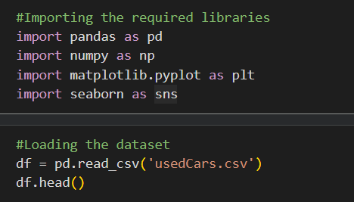
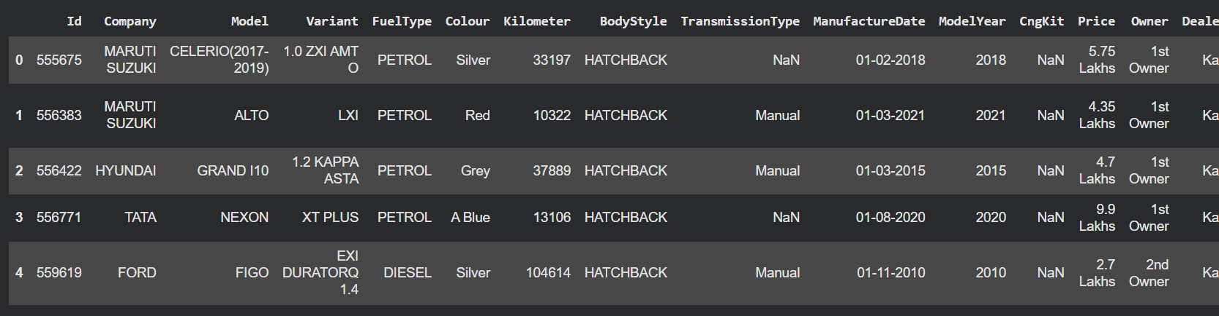
Fig 1. Library and data set import

4.2 Dataset Overview
The data set includes details of used cars and their attributes such as company, model, fuel, colour, kilometres run, body, age, price, dealership city, owner type, quality and warranty rating. The data set contains both categorical as well as numeric variables. The data set was explored through various statistical and visual methods such as bar chart, histogram, and distribution plot.

.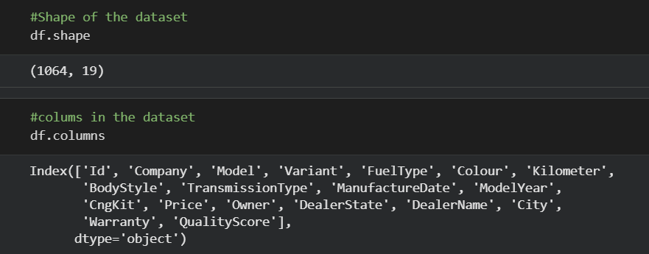
Fig 2. Dataset overview

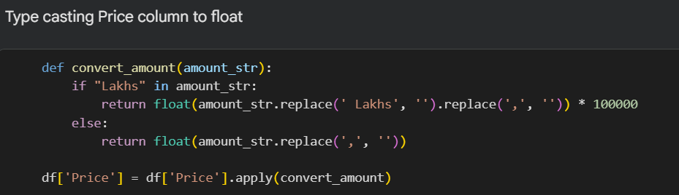
Fig 3. Drop unnecessary column and changing data type

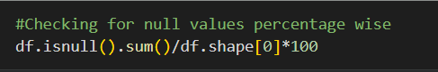
Fig 4. Checking for null values

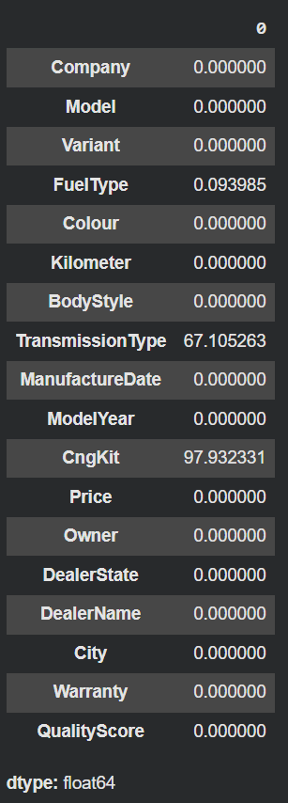
Fig 5. Result of null values

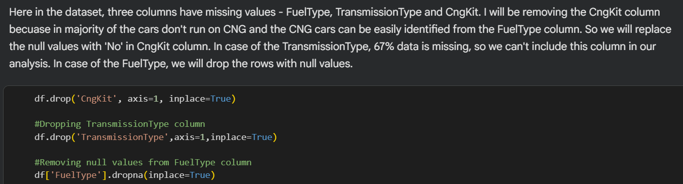
Fig 6. Drop column and replace values

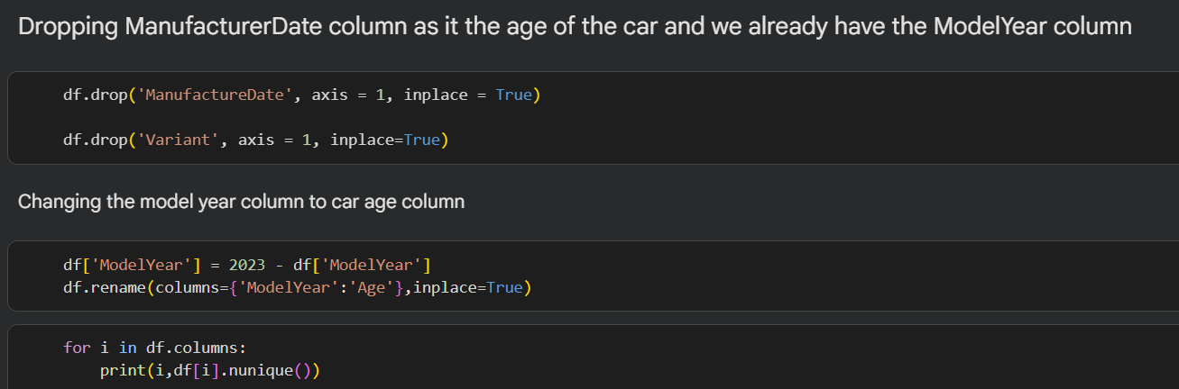
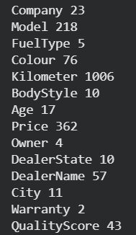
Fig 7. Drop Manufacture data column

4.3 Car Company Distribution
The dataset is comprised of vehicles from as many as 23 car manufacturers showing high diversity in the used car industry. Some of the most commonly observed car manufacturers include Maruti Suzuki, Hyundai, Honda, Mahindra, and Tata. The high occurrence of these car manufacturers clearly suggests that they have a large share in the dataset. Nevertheless, it does not imply that these car makers have the highest prices.
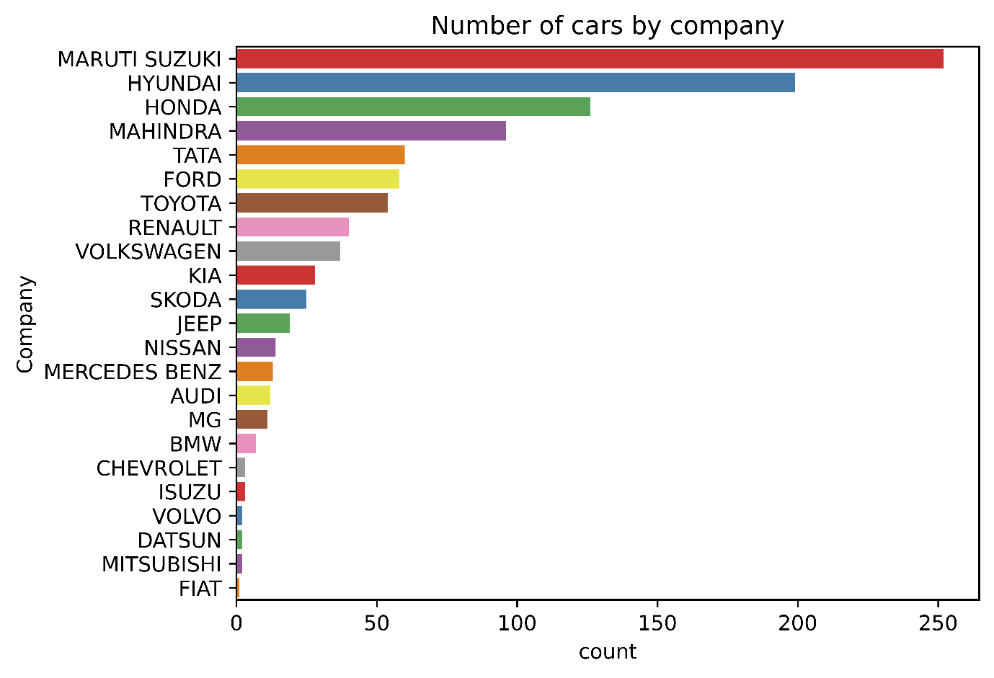
Fig 8. Number of cars by company

4.4 Car Model Distribution
Analysis of model shows the most common vehicle models. Some of the models which have good representation in the data are Honda City and Honda Swift. The commonality of some models might show good availability or demand of certain cars in the market. The Model field helps us to understand our data better; however, it was dropped from our pre-processed data due to high cardinality.
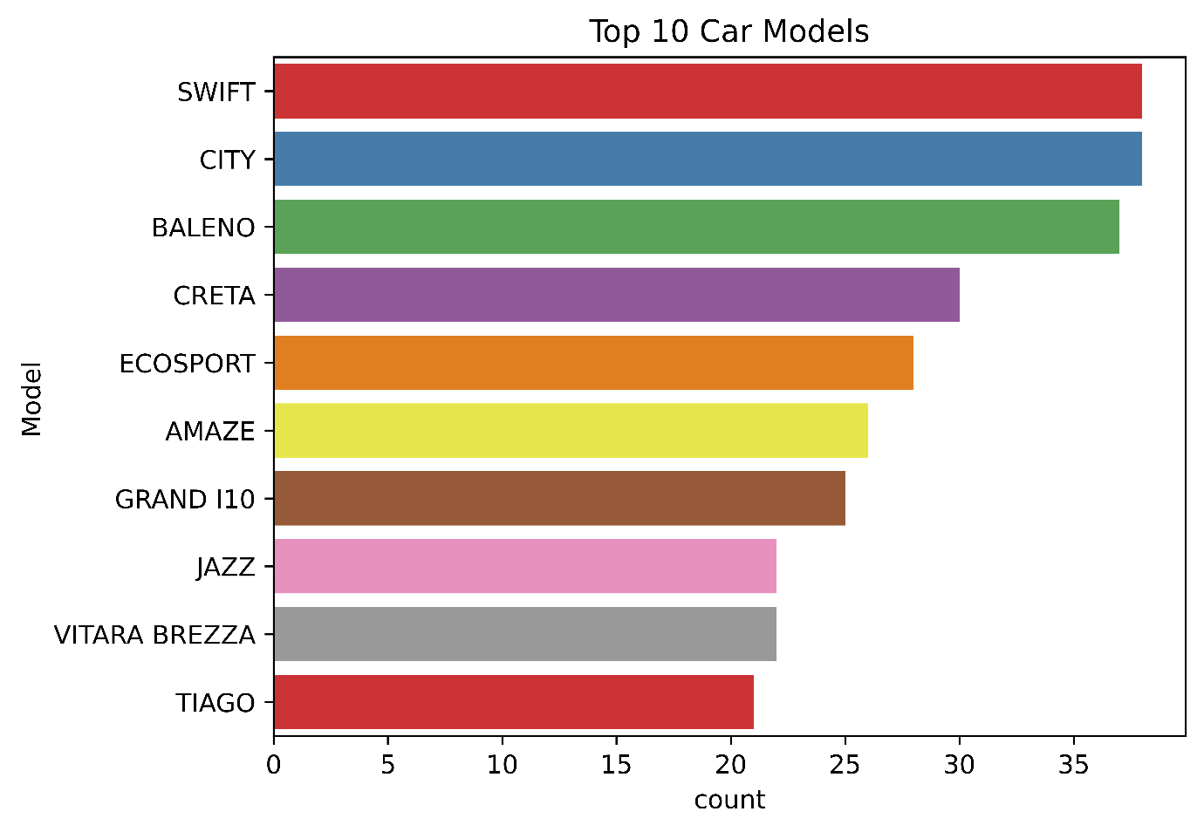
Fig 9. Top 10 car models

4.5 Fuel Type Distribution
Petrol, diesel, CNG, LPG, and hybrid cars are present in the dataset. Most of the cars in the dataset are petrol and diesel cars, whereas there are relatively few cars for other fuel categories. The presence of fuel types in the dataset is dependent on how many cars are in the dataset. Fuel type could affect the price of reselling the car.

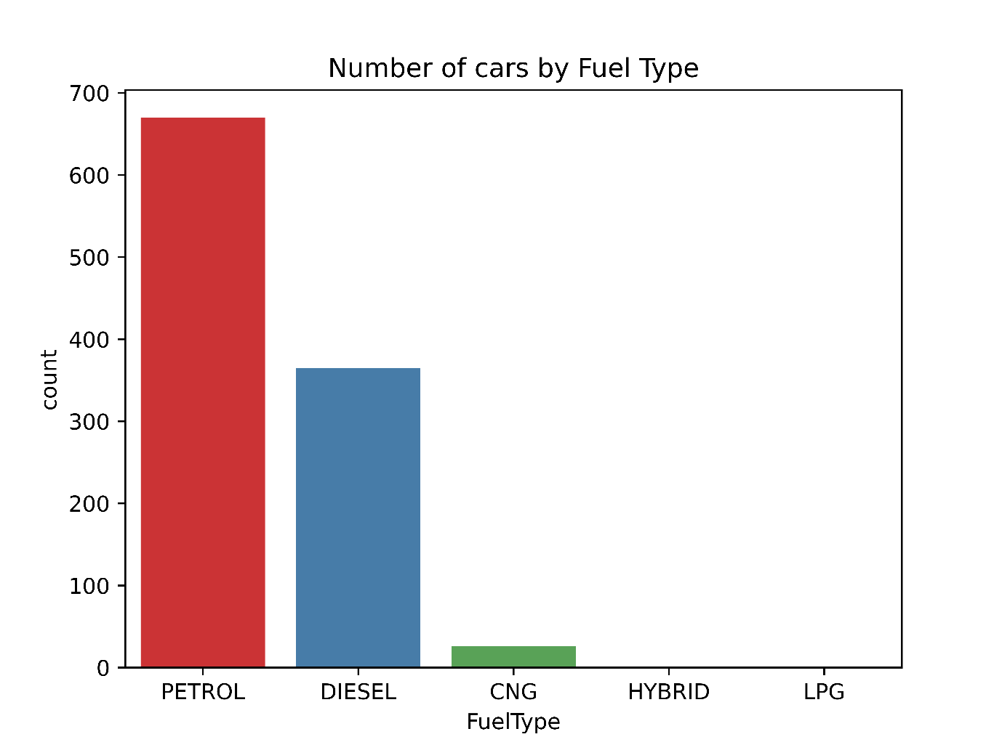
Fig 10. Number of cars by fuel type

4.6 Car Colour Distribution
According to colour analysis, some of the colours frequently observed include white, silver, grey, red, and black. It is also evident that the percentage of vehicles in this category is relatively high. This analysis gives us an idea of customer preferences and vehicle colour options available in the used car market. Colour, however, needs to be viewed cautiously due to its effect on price.

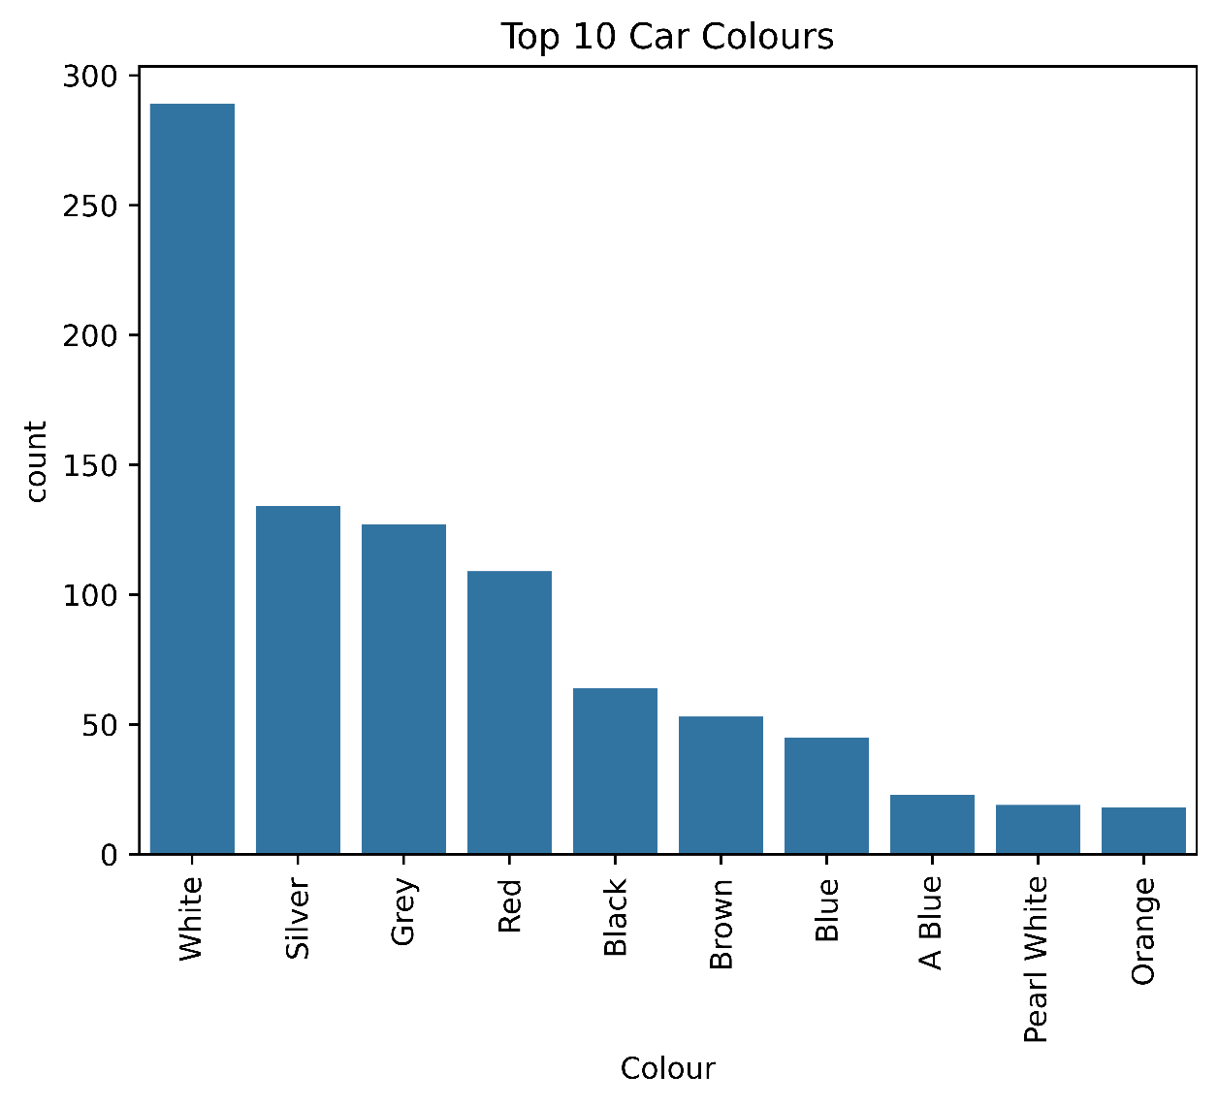
Fig 11. Top 10 car colours

4.7 Odometer Reading Distribution
Odometer analysis focuses on how far each car has driven. The vast majority of cars have driven less than 100,000 kilometres, and there is quite a large number of them with readings from about 30,000 to 50,000 kilometres. It means that there are a lot of moderately driven cars in the data set. Odometer readings are one of the most important car features.

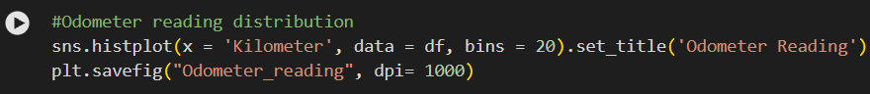
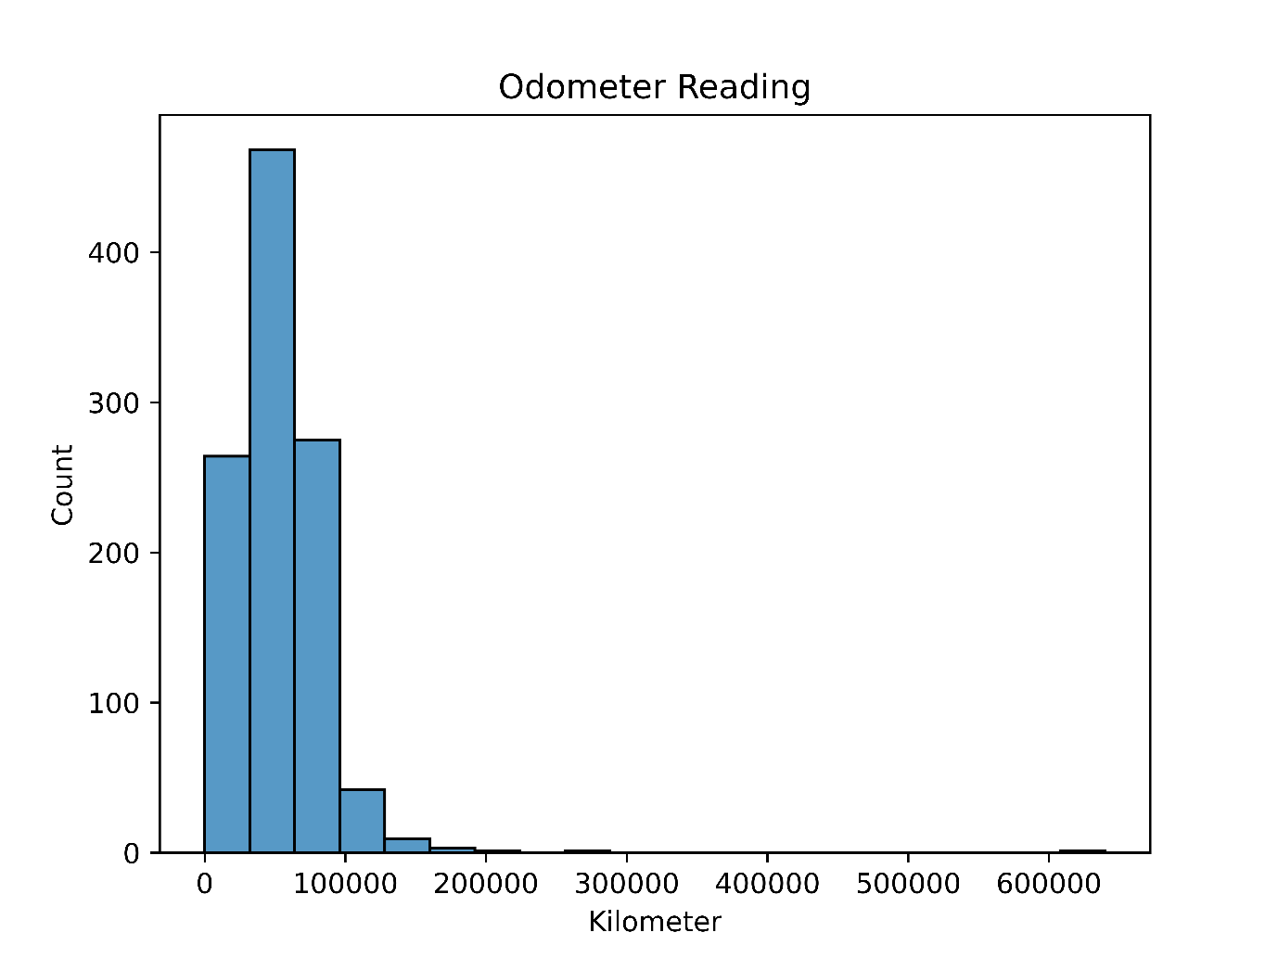
Fig 12. Odometer readings

4.8 Body Style Distribution
There is more than one type of car body styles such as hatchback, SUV, sedan, MPV and MUV among others. The distribution shows that the data set comprises various segments of cars. Comparison among these segments can be helpful since car body style may be linked to customer preference, size, utility, and resale price.

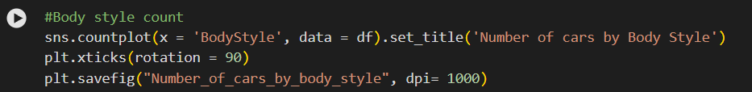
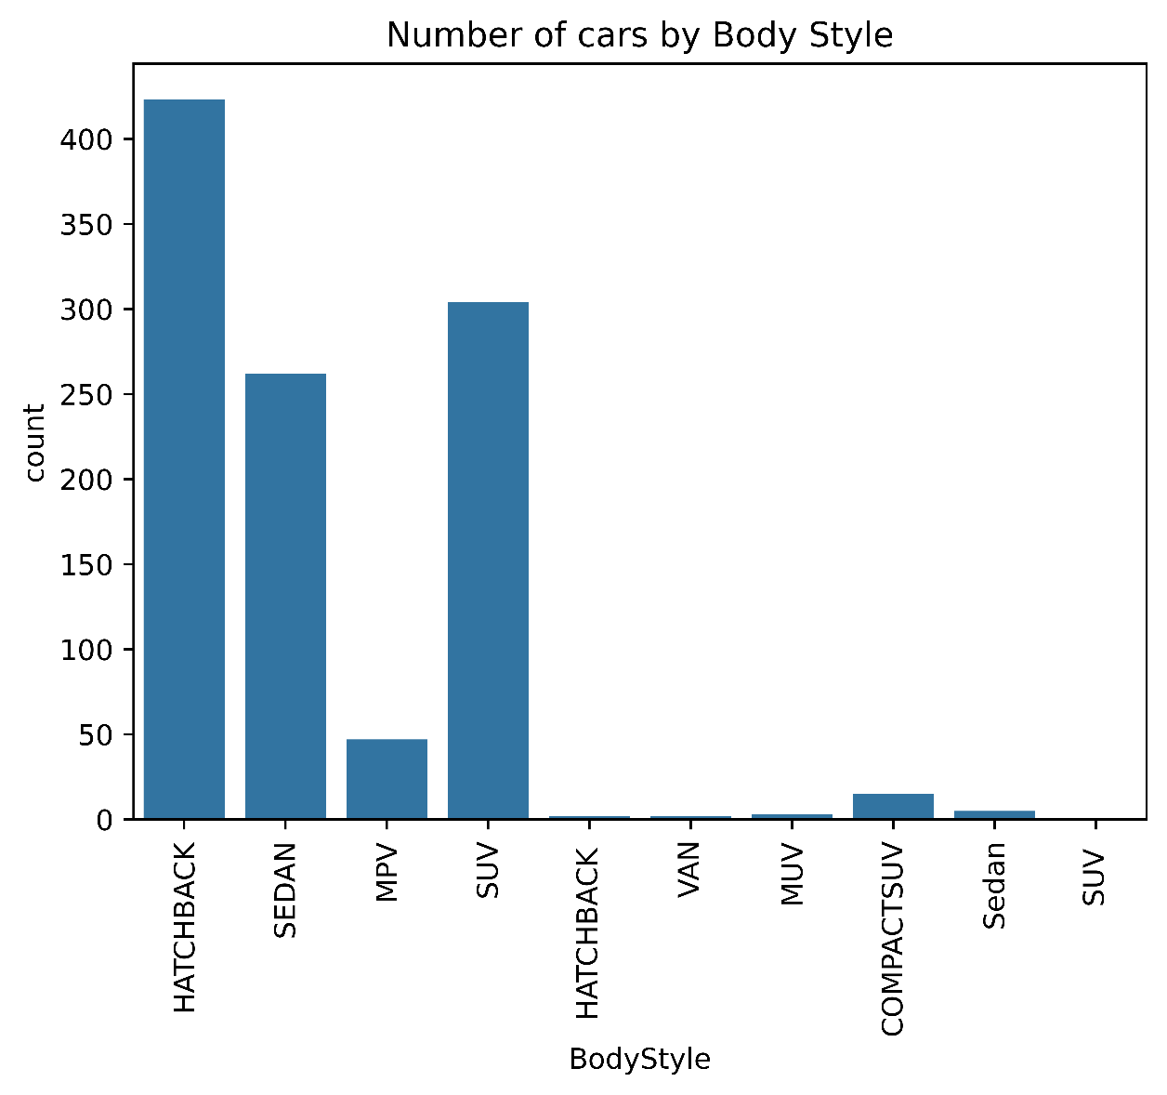
Fig 13. Numbers of cars by body style

4.9 Car Age Distribution
Another variable that is considered is the age of the car. The age of cars mostly ranges between 5-7 years, which means that the dataset includes many relatively mature used cars. There is an observation of a car that is nearly 20 years old, which may be considered an outlier. Older cars usually tend to be cheaper, but there may be exceptions.

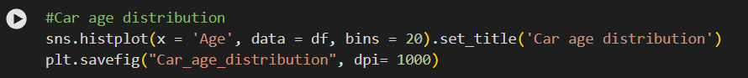
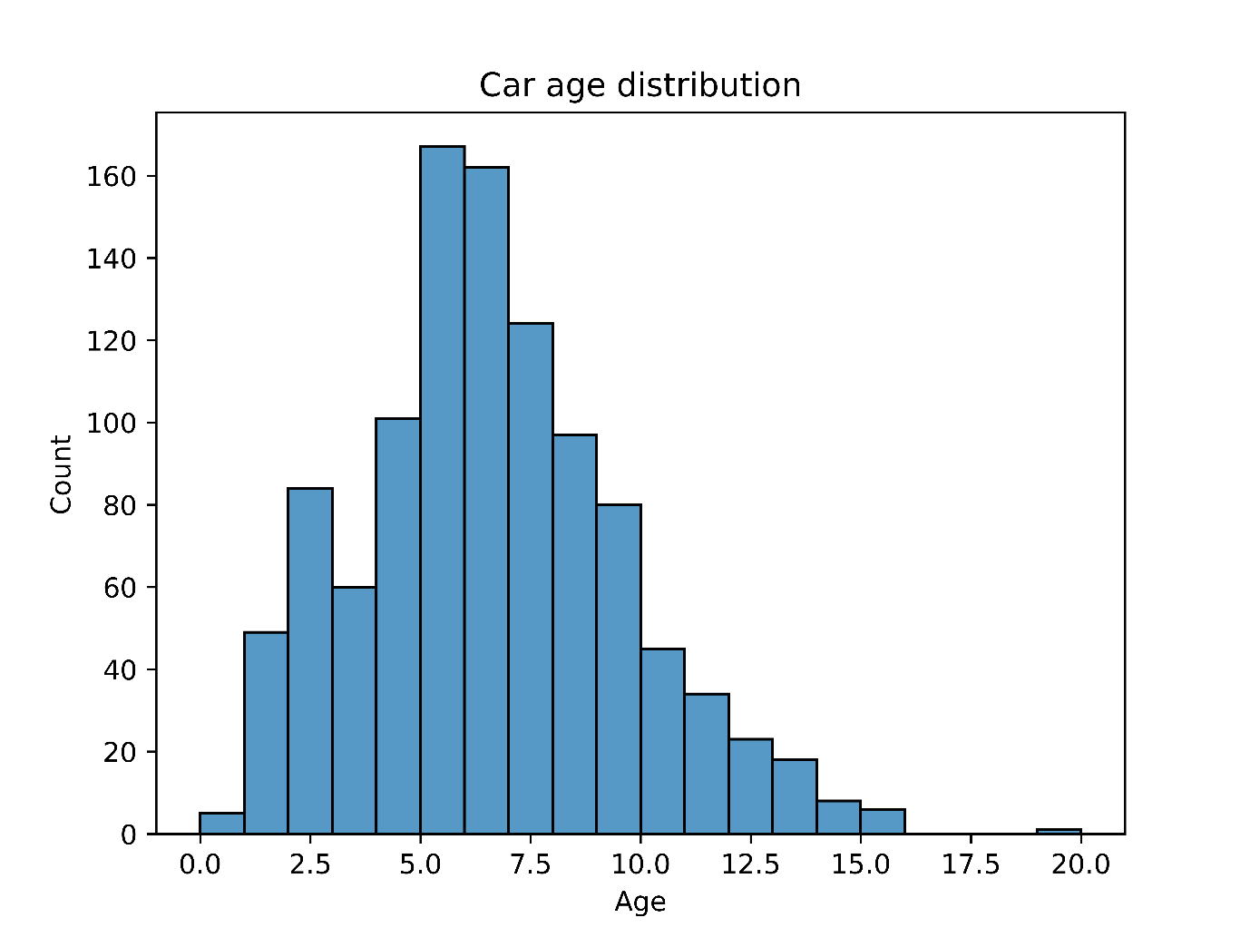
Fig 14. Car age distribution

4.10 Car Price Distribution
From the above distribution, we note that the majority of cars lie within the range of about 3 to 9 lakh. There are however certain observations where cars cost more than 20 lakh, forming a relatively small segment of higher-value cars. Such observations should be given special consideration since outliers might affect statistics and machine learning models.

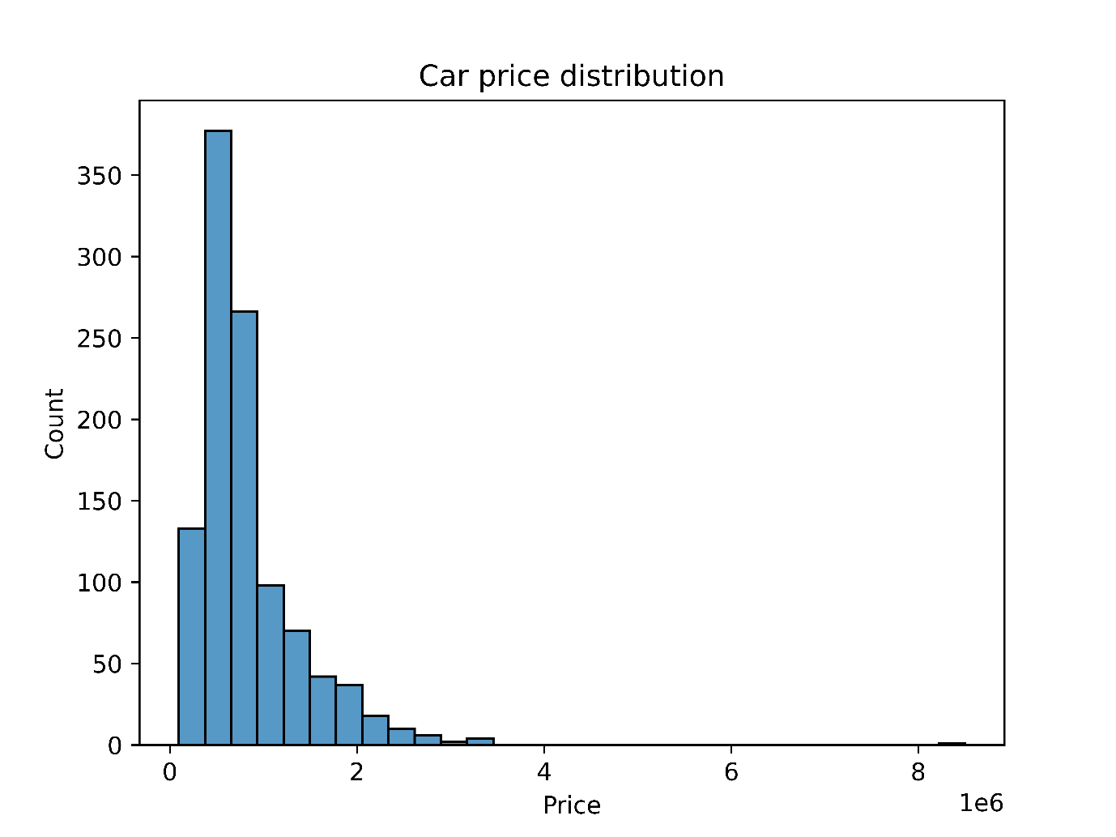
Fig 15. Car price distribution

4.11 Geographic Distribution
4.11.1 Dealer State Distribution
The data includes vehicles from various states of India. The states of Delhi and Maharashtra are well represented, implying that these states account for a substantial number of observations.
4.11.2 City Distribution
City level analysis gives an additional understanding of the geographic location of cars. Large cities provide a significant amount of observations, which demonstrates the significance of cities' used cars market.
4.11.3 Dealer Distribution
Dealer-level analysis identifies the distribution of vehicles across individual sellers. Differences in dealer representation should be considered when interpreting the dataset because a small number of highly represented dealers may influence the overall characteristics of the data.

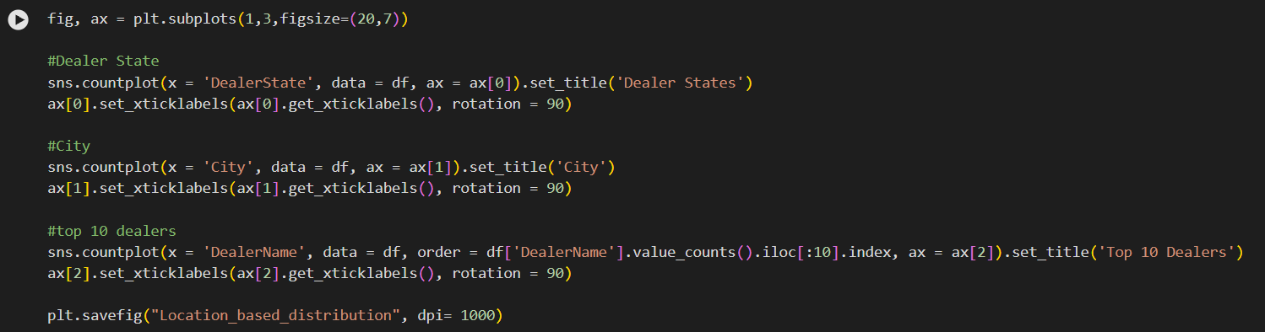

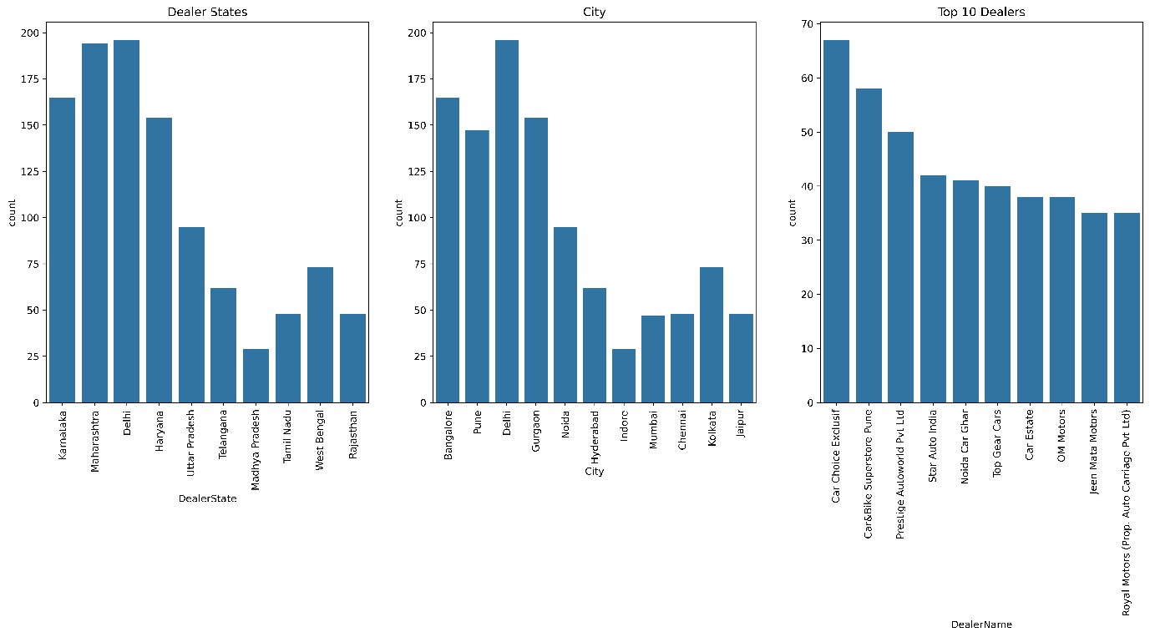
Fig 16. Location based price distribution

4.12 Owner Type Distribution
Type of owner is an attribute that refers to the past of the vehicle in terms of who owned it. In the analysis, there will be a comparison between different classes of owners such as first-owner and other-owner vehicles. The past of a vehicle might affect its resale value.

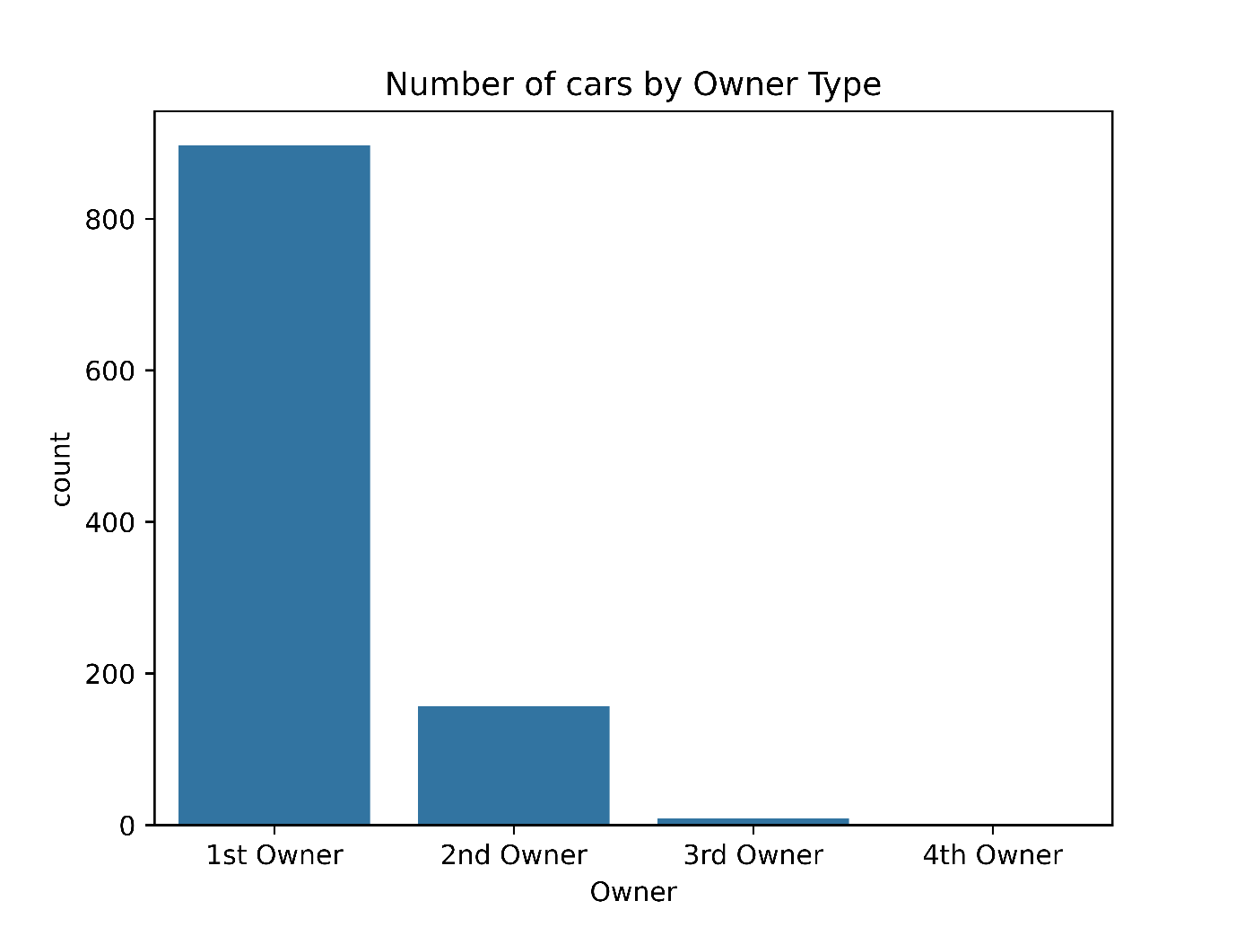
Fig 17. Number of cars by owner type

4.13 Warranty Distribution
Warranty status gives an indication of whether a car comes with a warranty or not. The availability of a warranty may affect the confidence of buyers or the perception of worthiness of a car. Warrantied cars may not be seen the same way as non-warranted cars.

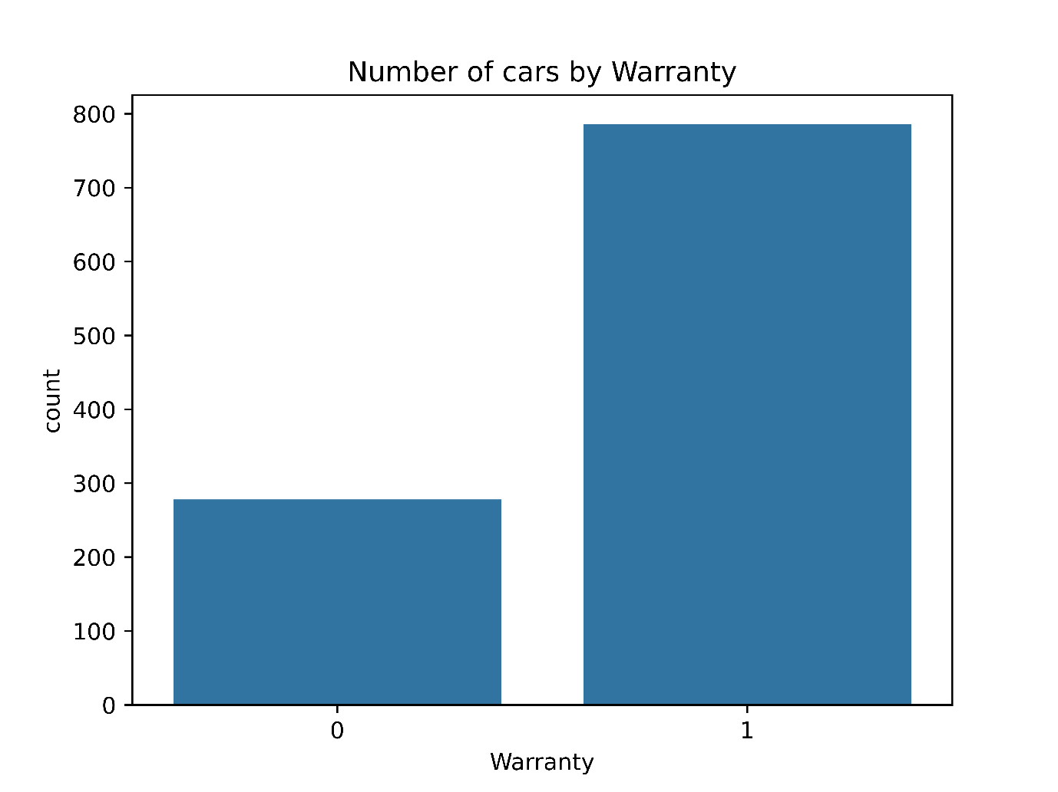
Fig 18. Number of cars by warranty

4.14 Quality Score Distribution
From the analysis of the quality score, it is evident that most cars have quality scores ranging from 7 to 8, which means that the overall quality scores of the cars are generally high in the dataset. Moreover, there is also a relationship between high quality scores and high resale prices of the car.

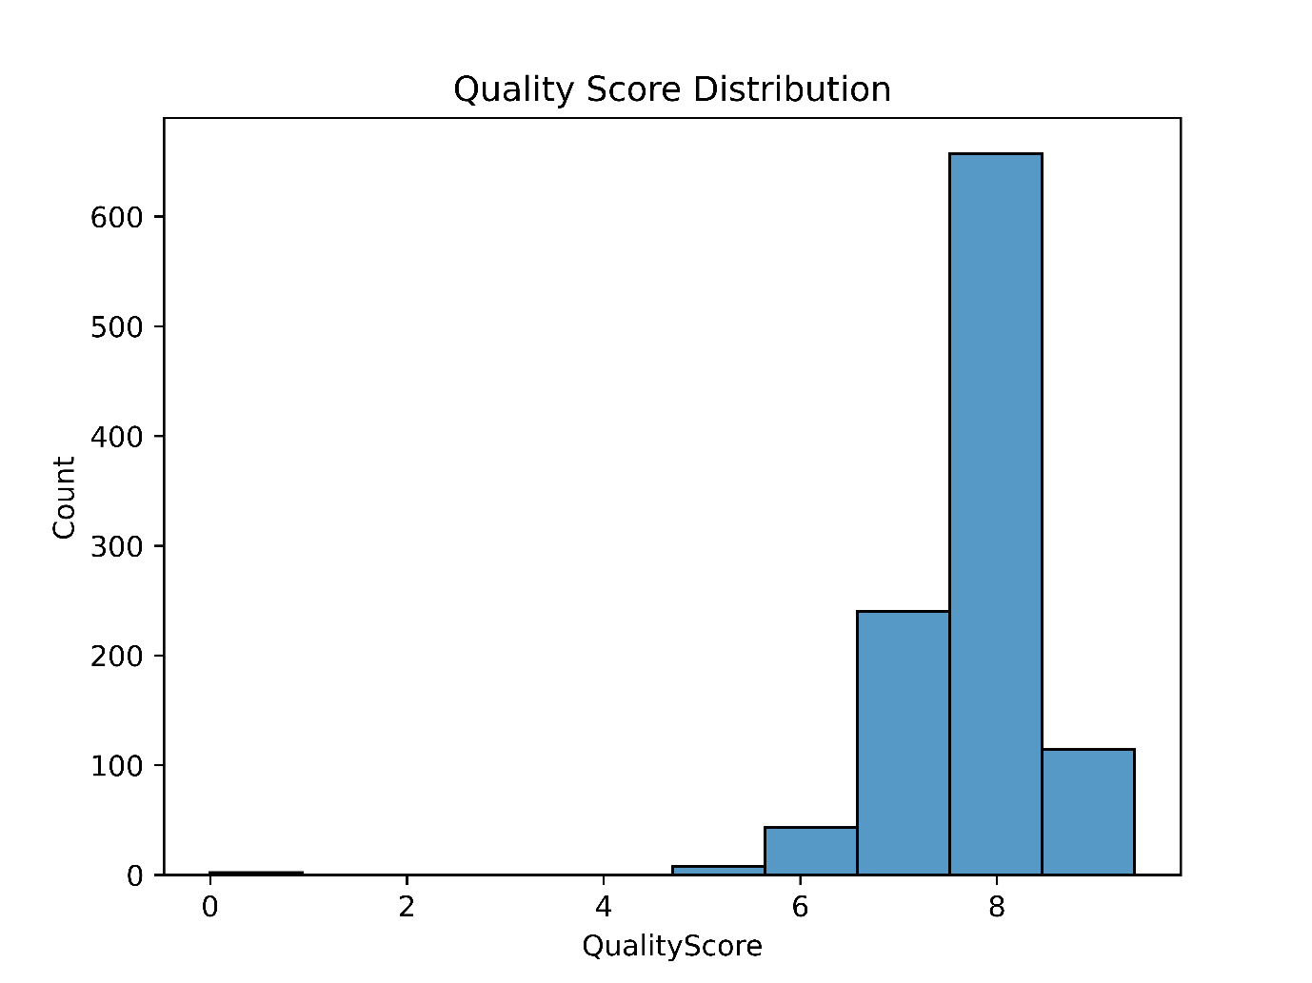
Fig 19. Quality score distribution

4.15 Chapter Summary
In this chapter, we have studied the important features of the used cars dataset using exploratory data analysis. The used cars dataset includes 23 car manufacturers and includes a variety of different cars with respect to models, fuels, colours, and body styles. Cars with petrol and diesel fuel options have been included more often in this dataset. Colours like white, silver, grey, red, and black are the most common. Cars in this dataset have used mileage of less than 100,000 kilometres and have an age of around 5-7 years.

Chapter 5: Analysis of Factors Affecting Used Car Prices

5.1 Introduction
The price of a second-hand car depends on many features concerning the car itself, its condition, its history of use, and location. It is crucial to understand these features because the same class of cars may differ greatly in their price based on their age, mileage, manufacturer, fuel type, body shape, and other features. This chapter studies the most important features that influence the price of second-hand cars based on patterns found in the data and exploratory analysis. These findings provide a basis for the models developed in later chapters.

5.2 Car Company and Resale Price
Car brand plays a crucial role in deciding resale price, as various brands have varying degrees of demand, brand value, car quality, and prices in which they were sold. The results from the analysis indicate that there are some variations in average resale prices based on the companies included in the sample.
Some of the car brands include MG, Mercedes-Benz, and BMW, whose average resale price is relatively high compared to others. Generally, luxury car brands are associated with higher prices due to the fact that their cars are initially placed in premium market segments and are fitted with expensive car accessories. On the contrary, car brands that manufacture mainly cheap and affordable cars have relatively lower resale prices.

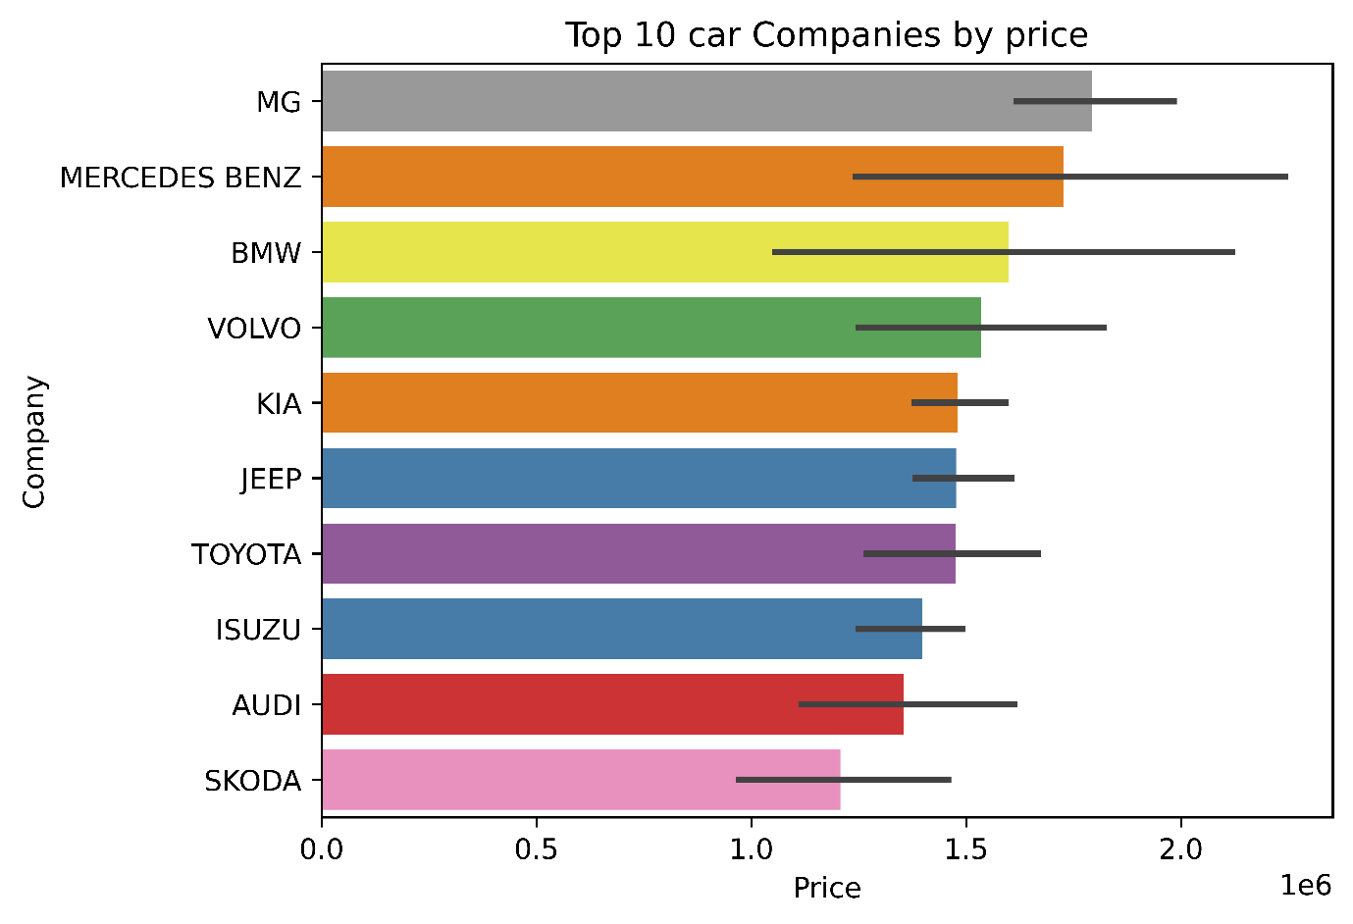
Fig 20. Top 10 car company by price

5.3 Car Model and Resale Price
There is also a significant correlation between the specific car model and its resale price. Various models of the same manufacturer can be priced at significantly different prices due to the variations in their size, engine type, popularity, and positioning.
Models like ML Class, Endeavour, and CLA Class fall into the category of relatively expensive cars. The reason for that is the fact that these models represent relatively premium or valuable vehicle categories. This shows that a brand of a car alone does not determine price variance.

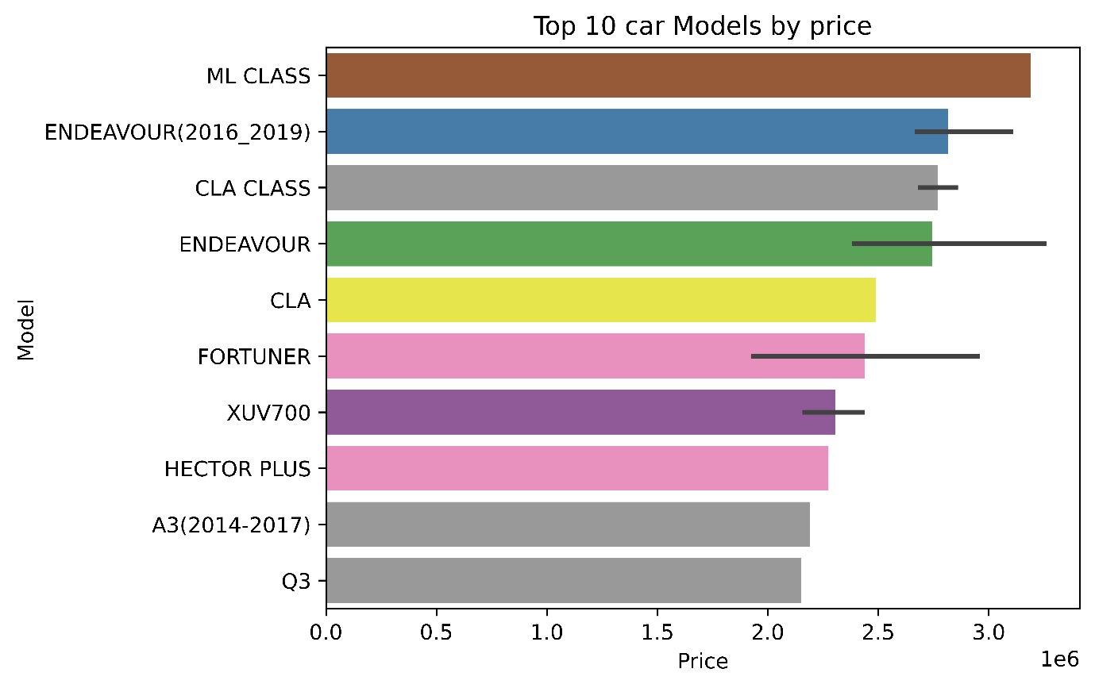
Fig 21. Top 10 car models by price

5.4 Fuel Type and Price
Fuel type also constitutes an element that is correlated with the resale prices. The data set includes cars fuelled by petrol, diesel, CNG and LPG. According to the data analysis, diesel cars tend to have resale prices that are higher than petrol, CNG and LPG cars in this data set.
This might be linked to various elements such as car type, engine, efficiency and preferences of buyers. Yet, one needs to take into consideration the fact that the presented correlation refers only to the given data set. There might be other factors affecting the prices, as well.

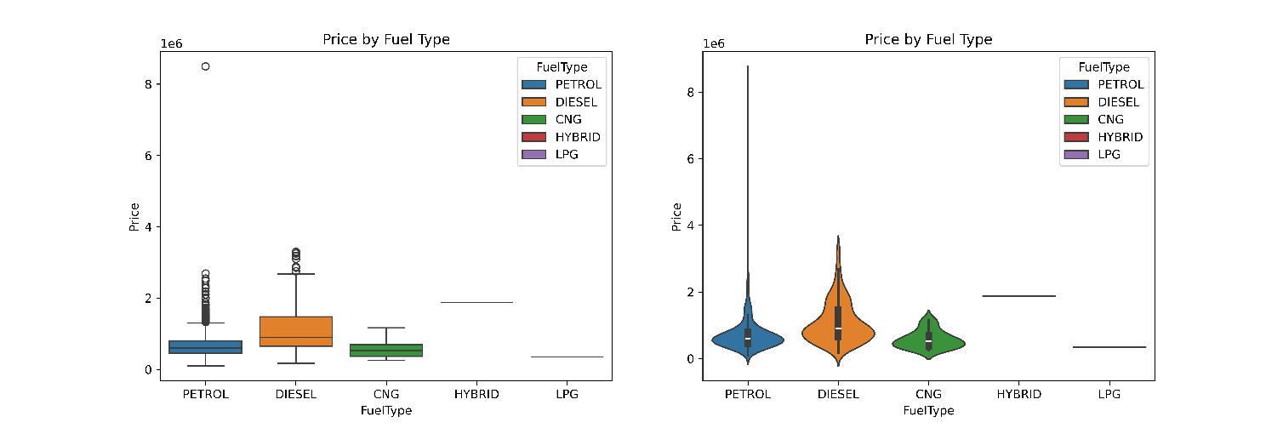
Fig 22. Car fuel type and price

5.5 Car Colour and Price
Although colour does not directly contribute to the mechanical status of the car, it can indirectly affect consumer taste and thereby resale price. Some of the colours that can be seen in the data set include white, silver, grey, red, and black.
In this study, Burgundy, Riviera Red, and Dark Blue have been noted as some of the colours that correspond to high average prices. This can be partly attributed to the specific types and brands of cars in those colours. Thus, it can be said that colour is an interesting categorical variable.
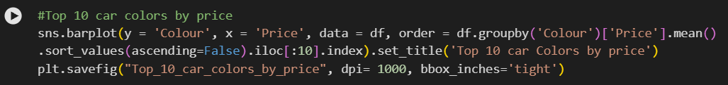

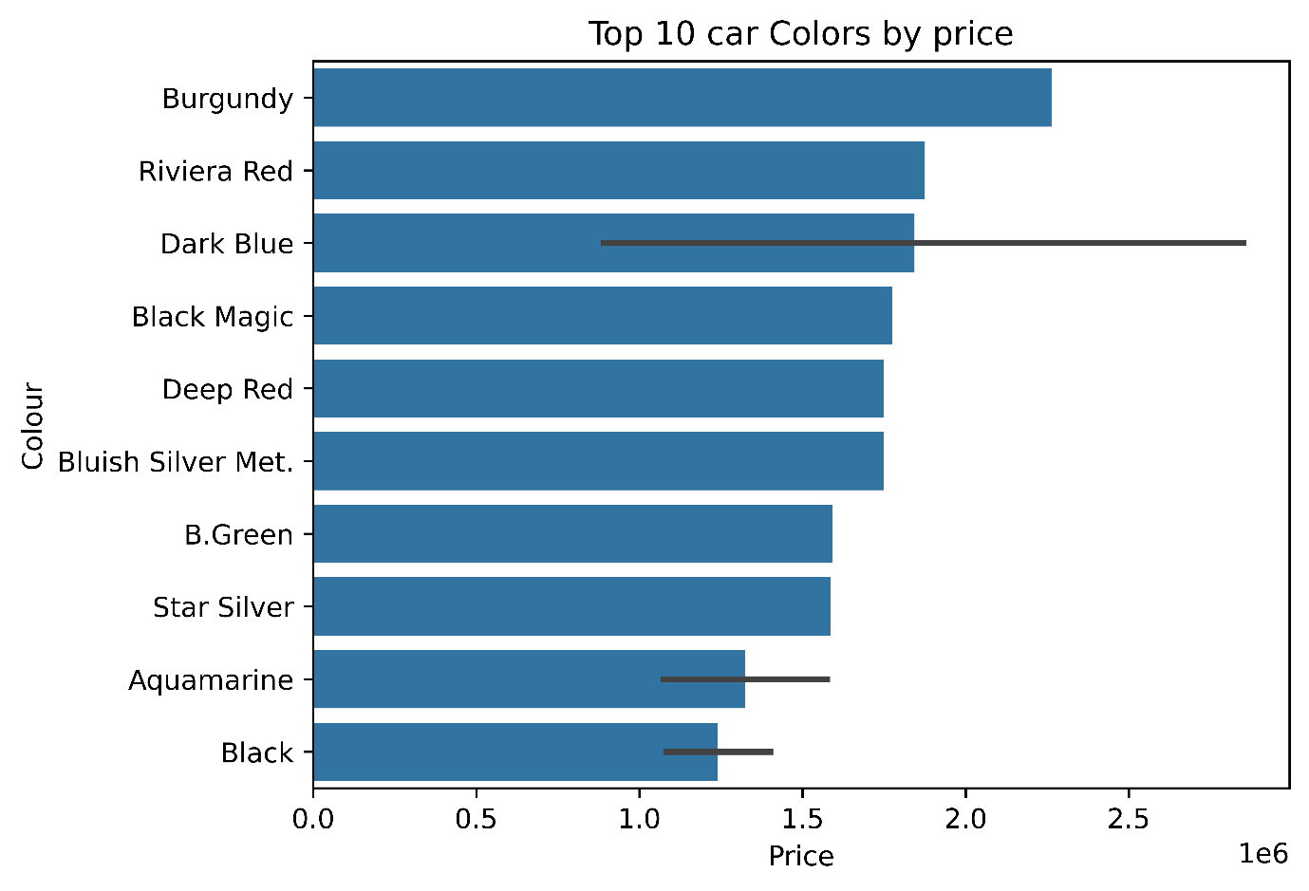
Fig 23. Top 10 car colours by price

5.6 Odometer Reading and Price
Odometer reading is the distance covered by the vehicle, and gives an estimate of how much the vehicle has been used. It has been shown from the analysis that there is a negative correlation between the mileage and the resale price of the vehicle. Vehicles with low mile readings usually sell at higher prices than those with high mile readings.
This is also evident from the scatter plot which shows that the price decreases as the mileage increases. Therefore, mileage is an important factor in determining the resale price of used cars.

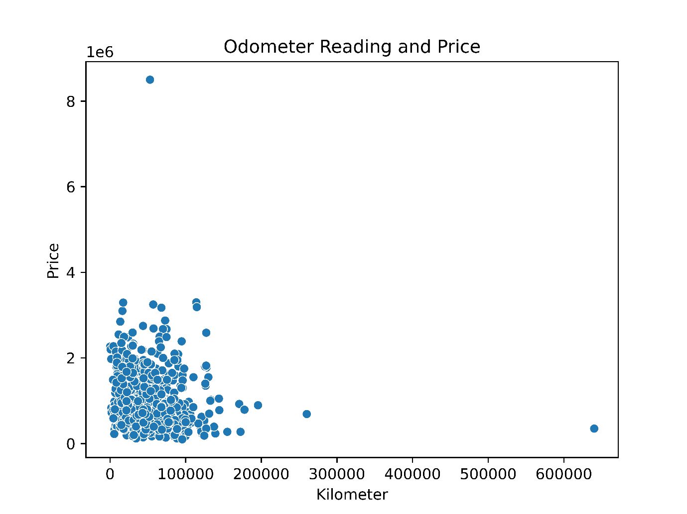
Fig 24. Odometer reading and price

5.7 Body Style and Price
Body type is also a factor in the variation of prices in used cars. There are different body types included in the dataset for comparing prices based on the type of the car.
From the analysis, it emerges that vehicles like MPV, SUV, and Sedan belong to the body types with relatively high prices. The large body types, such as MPV and SUV, may cost more due to various factors including body size, capacity, and demand in the market.

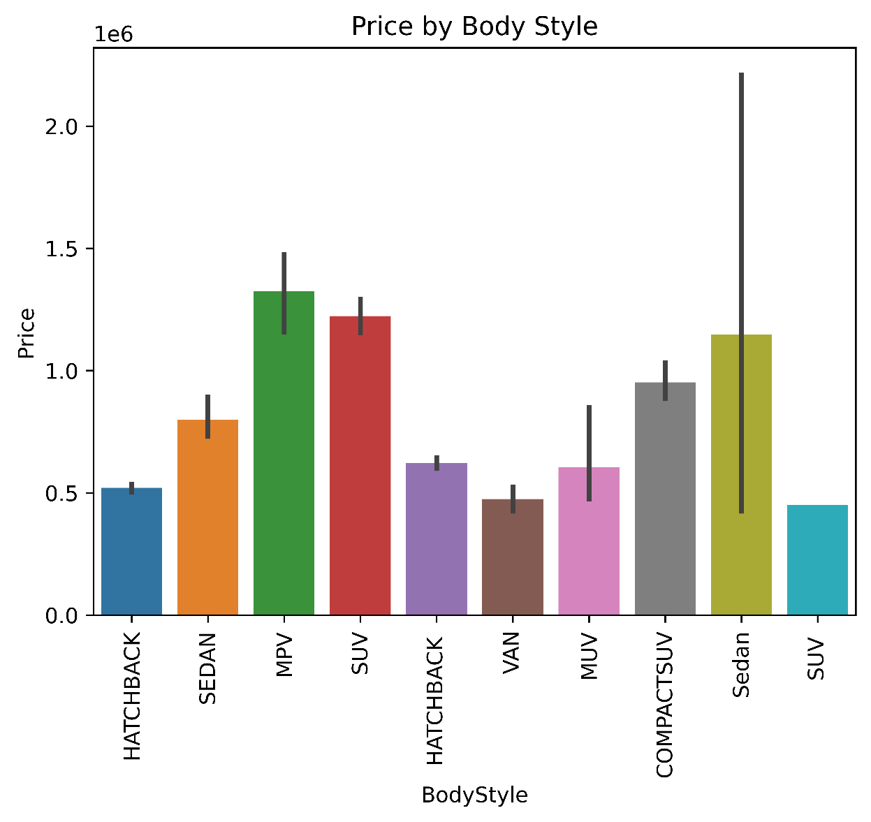
Fig 25. Price by body style

5.8 Car Age and Price
Age of the vehicle can be considered as one of the major determinants of resale price. The analysis shows that there exists a negative correlation between age and price of a vehicle. Older vehicles are usually sold at lower prices compared to newer ones.
It is due to the fact that the age of the vehicle implies depreciation. As the vehicle gets older, the degree of its wear and depreciation also increases.

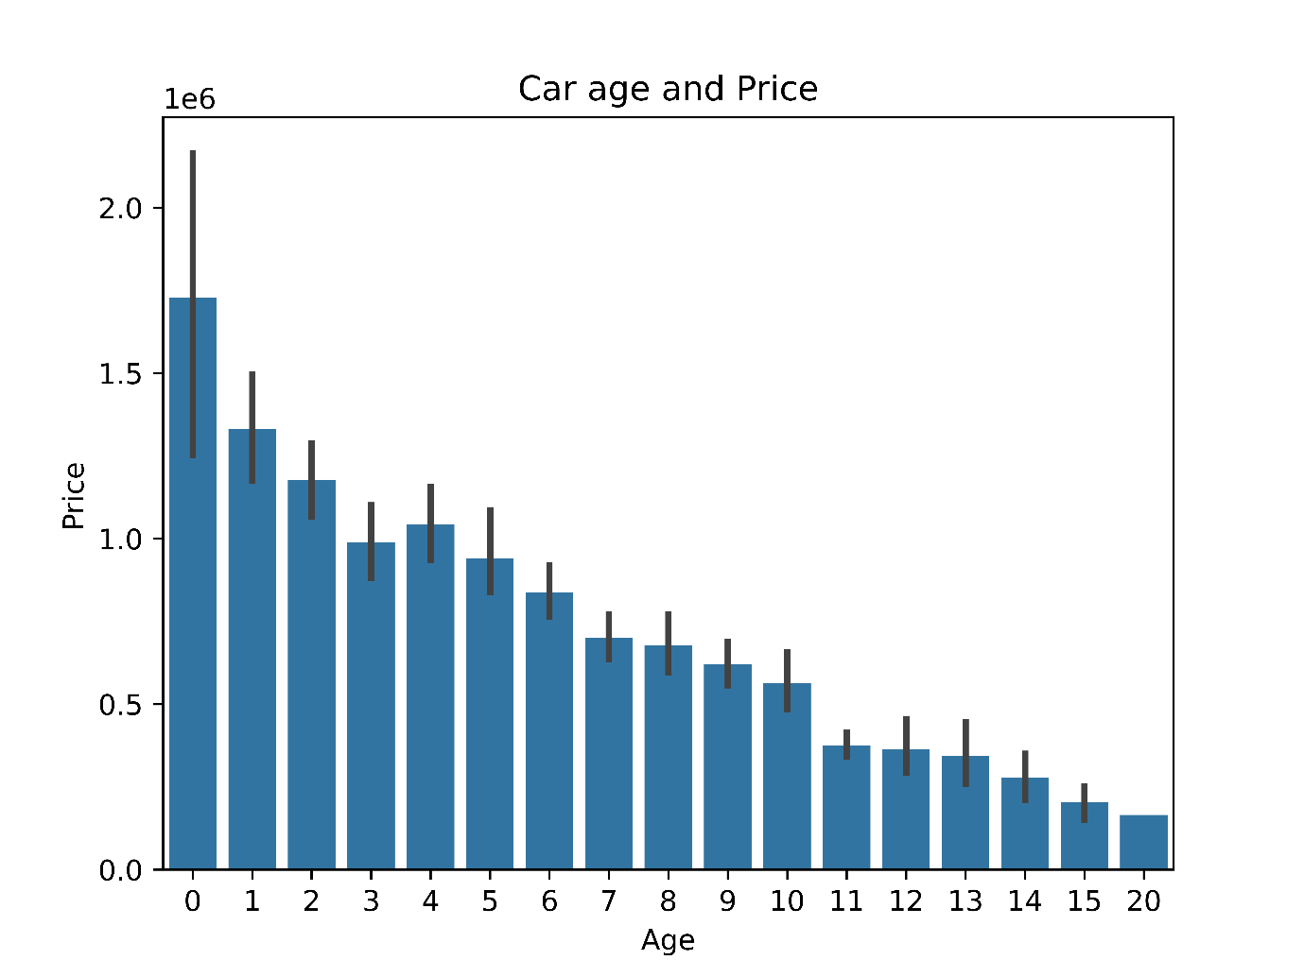
Fig 26. Car age and price

5.9 Location and Price
5.9.1 Dealer State and Price
The state in which a vehicle is sold can influence its price because of regional differences in demand, supply, economic conditions and vehicle preferences. The analysis compares different dealer states, including Rajasthan and Delhi, and identifies differences in average prices.

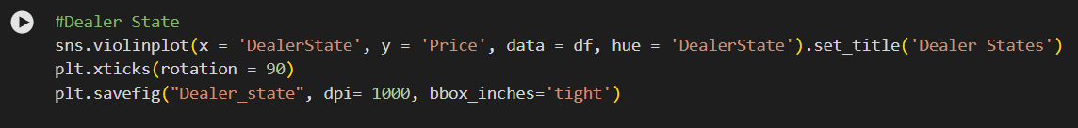
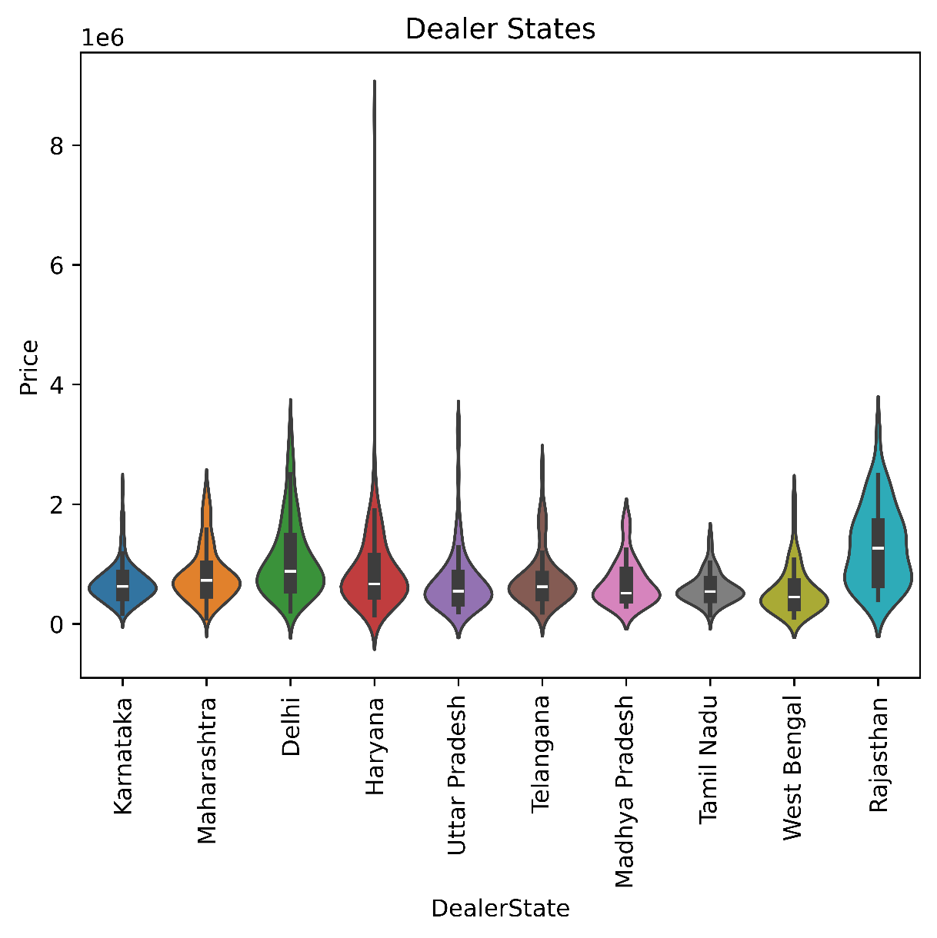
Fig 27. Dealer states

5.9.2 City and Price
It is also possible to have prices differ between cities. Big urban areas could have varying levels of demand and availability from small urban areas. Thus, city adds more geographical detail that can explain price differences.
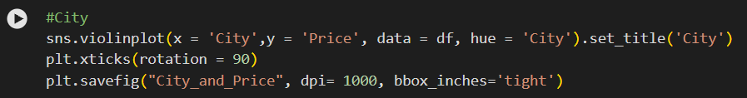
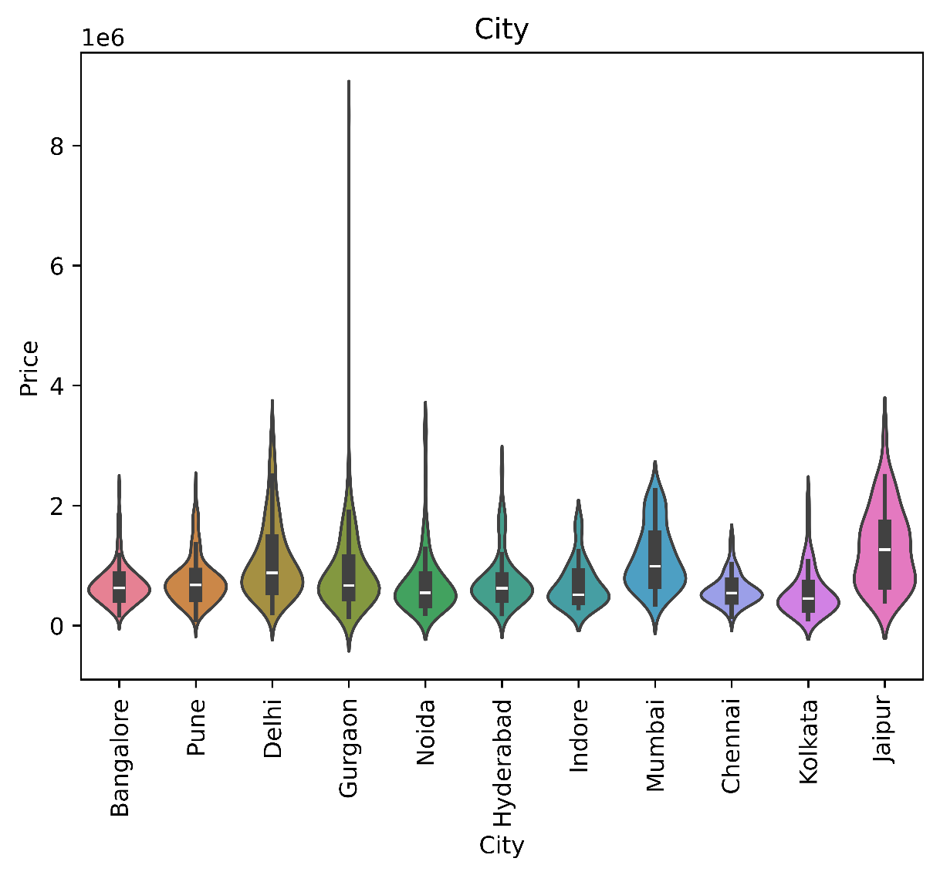
Fig 28. City and Price

5.9.3 Dealer and Price
There are also variations in the prices of vehicles sold by individual dealerships. This could be due to the type of vehicles sold, local market conditions, and inventory of the dealership. Information from dealerships would help explain price variations.
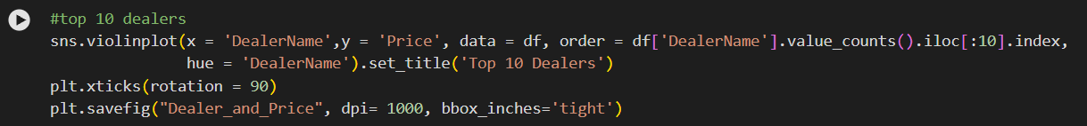
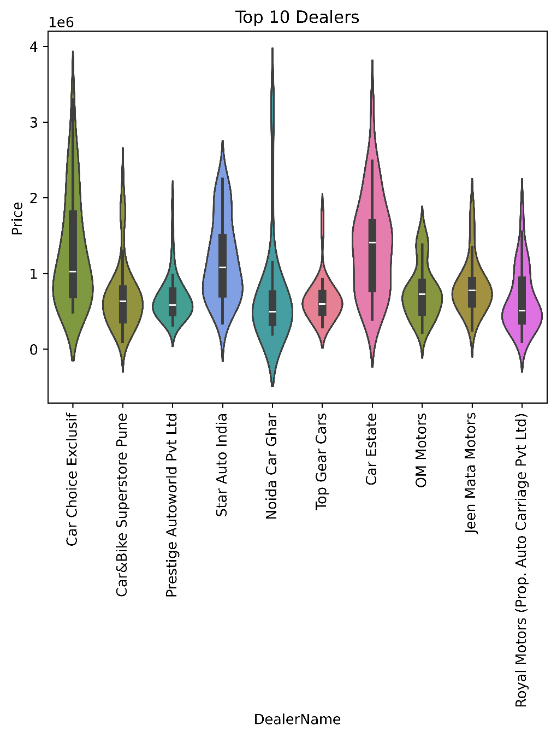
Fig 29. Top 10 Dealers

5.10 Owner Type and Price
Historical record of ownership is also one of the other factors used in the analysis. This means that the cars are classified based on whether they are owned by the first, second, third or the fourth person. Generally, cars which have less historical records of being owned by previous owners are considered better.
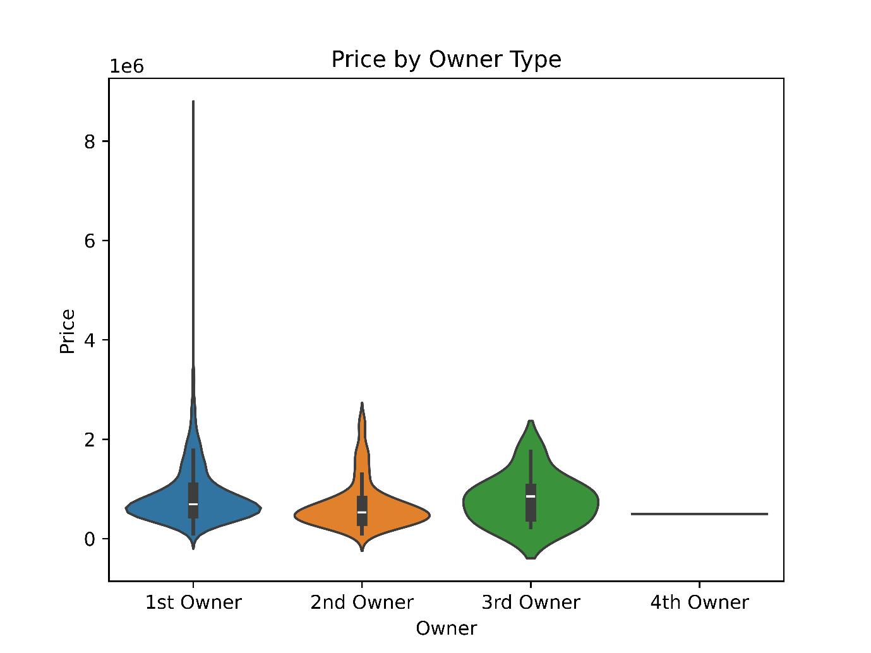
Fig 30. Price by owner type

5.11 Warranty and Price
Warranty coverage may provide consumers with more assurance regarding possible expenses on repairs. According to the results of the analysis, cars with warranty are relatively more expensive than cars without warranty. Therefore, warranty coverage may add value to cars.

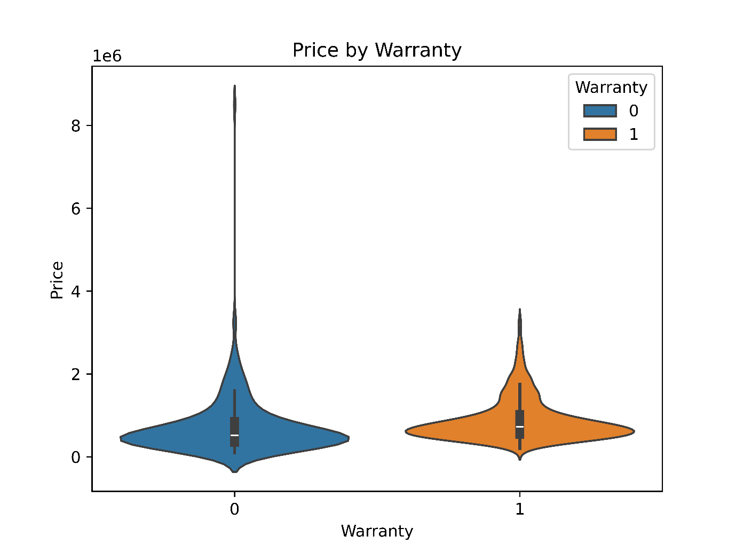
Fig 31. Price by warranty

5.12 Quality Score and Price
The quality score reflects the general state or quality level of the vehicle. Based on the findings, vehicles with high quality scores especially those with scores of 7 and above are associated with high prices. This means that the quality and condition of the vehicles are important factors in determining their price.

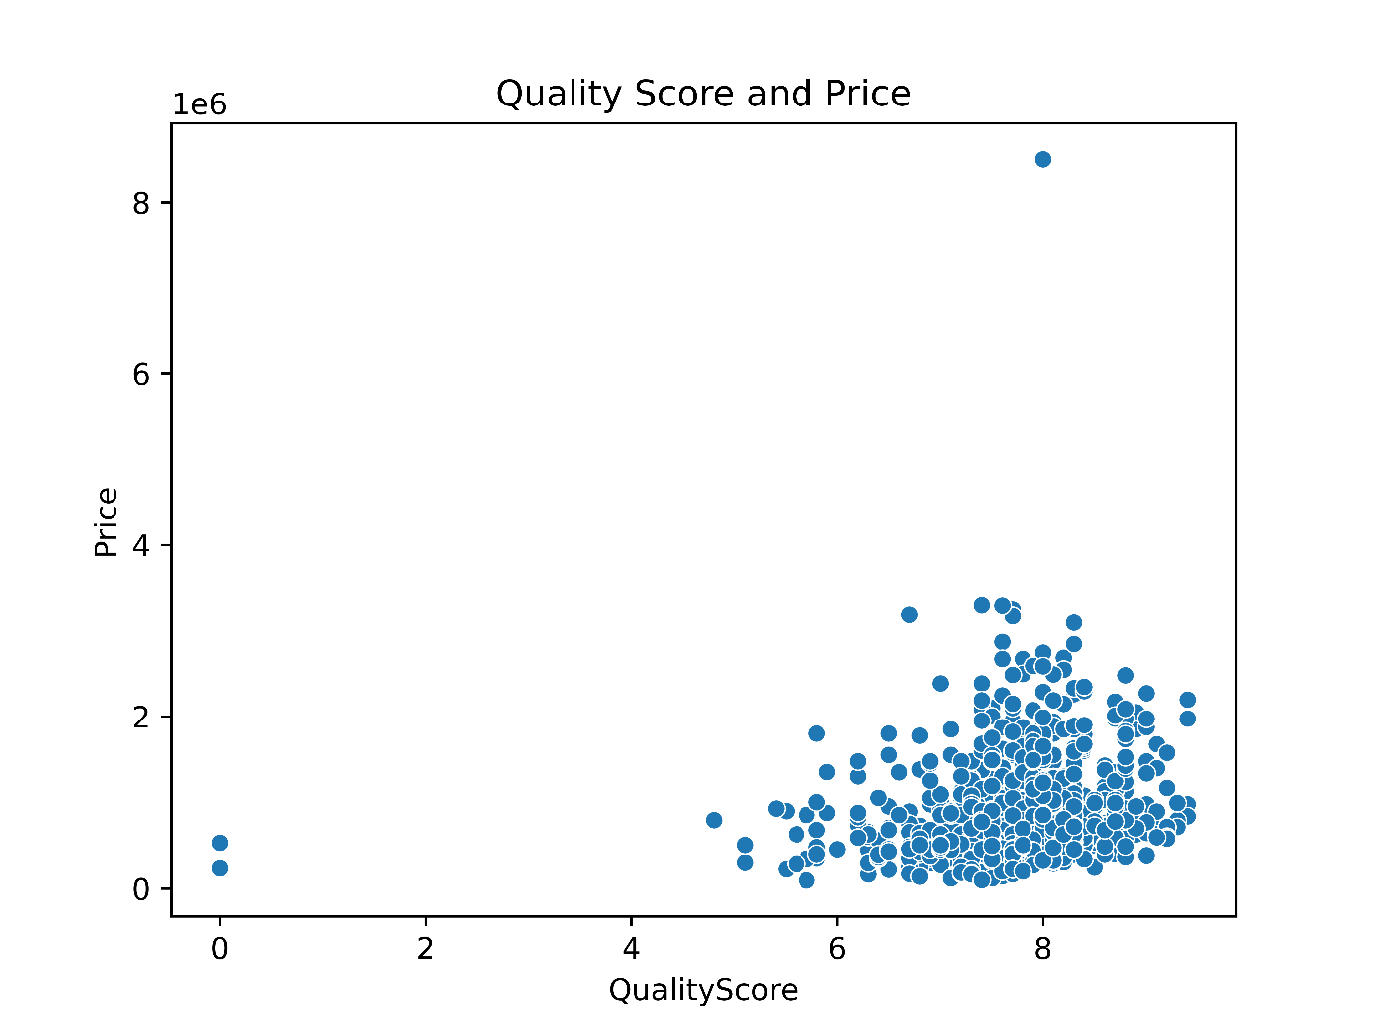
Fig 32. Quality score and price

5.13 Summary of Price Determinants
On the whole, there are many factors that impact the prices of the used cars instead of just one factor. The age and mileage of the car have important negative correlations with the price. Company name, model, body style, fuel type, region, warranty and quality rating are some of the other factors responsible for price variation. Luxury cars are usually found at higher price levels.

5.14 Chapter Summary
In this chapter, the most significant features related to used car prices have been considered. Differences in company/model led to price differentiation, as well as diesel cars that had higher

prices compared to other fuels. Colour and body type were also considered as factors affecting prices. It is worth mentioning that age and mileage were negatively correlated with prices, thus proving that these features should be included into the list of predictor variables. Location, ownership history, warranty, and quality score gave more information on price differentiation.

Chapter 6: Data Preprocessing and Feature Engineering

6.1 Introduction
Data preprocessing is an important stage in the used car price prediction project because raw datasets may contain irrelevant variables, categorical values, inconsistent formats, and extreme observations. Machine learning algorithms require data to be converted into a suitable numerical and structured form before training. In this project, preprocessing was performed to improve the quality of the dataset and prepare it for the Decision Tree and Random Forest regression models. The main processes included removing unnecessary and high-cardinality variables, encoding categorical features using LabelEncoder, preparing numerical variables, detecting and removing outliers using the Interquartile Range (IQR) method, and analysing relationships between variables using a correlation matrix.

6.2 Data Cleaning
The first phase entailed reviewing the data and preparing it for analysis. This included checking the various variables in the dataset for any irrelevant columns that did not assist in predicting used car prices. Data types were another important consideration since most of the machine learning algorithms require numerical inputs; hence, the need for conversion of categorical text columns into numerical columns.

6.3 Removal of Irrelevant Variables
Certain variables from the original data set were found to be irrelevant for the task of predicting the target variable and hence were omitted before developing any model. This was done to

include only those variables that might be useful for explaining the differences in prices of the used cars.
Omitting such variables from the data set would make it simpler while making sure that the machine learning models focus on the useful variables only.

6.4 Handling of Categorical Variables
There are various categorical data points within the dataset, which include the name of the car brand, fuel type, car body type, among other characteristics. The above categorical data points are text based and therefore cannot be fed into any algorithm for analysis.
As a result of the above problem, all the categorical data points have been encoded into numeric data points.

6.5 Removal of High-Cardinality Variables
Model was particularly dropped from the dataset due to the presence of many unique values in it. A variable for cars' model may have many categories hence it would be a high-cardinality variable.
The presence of this variable in the dataset would increase the complexity of the dataset and make the process of encoding difficult. Hence, the Model column was dropped before encoding the other categorical variables.

6.6 Feature Encoding Using Label Encoding
Upon dropping the column called Model, all categorical columns were converted to numbers using LabelEncoder. The Label Encoder helps to convert every category in a categorical column into a number.
For instance, Petrol, Diesel and CNG can take various integers. This is to facilitate the processing of information found in categorical variables by the regression models.

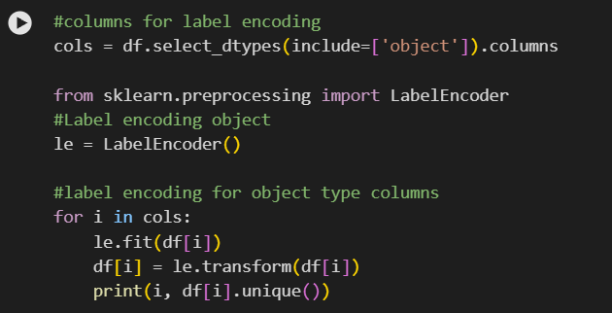
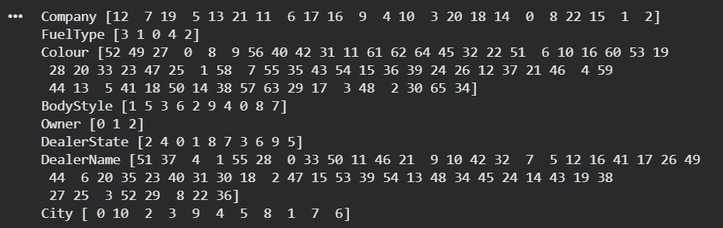
Fig 33. Label encoding

6.7 Numerical Feature Preparation
The numerical variables were kept numerical and made ready for further analysis. Some examples of numerical data in used car data would be age of the car, mileage and other such quantitative attributes.
Numerical data is significant because of the relationship that they have with the resale price. For instance, the age and mileage of the car may affect its market price.

6.8 Outlier Detection
An outlier is a data point that is quite distinct from other data points within the same dataset. In the case of a used car dataset, an outlying data point might be one with a very high or low price, or with extremely high mileage, or even any other unique numerical value.
Extreme data points such as outliers can affect the learning process of the machine learning algorithm. Therefore, an outlier detection step was incorporated into the project before model training.
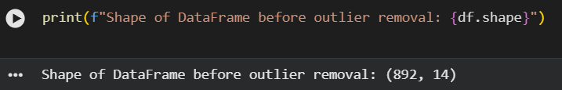
Fig 34. Outlier Detection

6.9 Interquartile Range (IQR) Method
Interquartile range (IQR) technique has been employed to detect the possible presence of outliers. The formula for calculating IQR is as follows:
IQR = Q3 − Q1
Where Q1 is the first quartile, while Q3 is the third quartile.
Lower and upper thresholds are usually calculated as follows:
Lower Threshold = Q1 − 1.5 × IQR
Upper Threshold = Q3 + 1.5 × IQR
Any value that falls beyond these thresholds can be considered as an outlier.

6.10 Outlier Removal
Once the outlier observations that fall outside of the IQR range have been identified, they have been eliminated from the dataset. The result is a cleaned dataset with reduced numbers of extreme observations.

The objective here is not just about reducing the number of records in the dataset; the goal is to produce a better-suited dataset for machine learning algorithms.

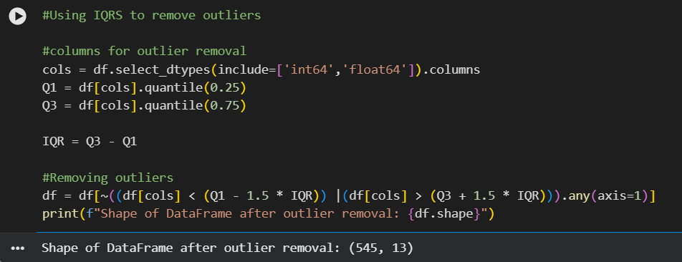
Fig 35. Remove Outlier Detection

6.11 Correlation Matrix Analysis
Correlation matrix was created to analyse the relationship of numerical attributes to the target attribute of Price. Correlation is the measure of the degree to which two numerical attributes relate to each other.
Correlation heat map is the visual tool for representing such relationship between the variables. Positive correlation means that two variables increase together, whereas negative correlation shows that one variable decreases when the other increases.
This analysis allowed us to find out which relationships might be interesting in the data set and get further insight into which attributes could be related to the used car price. However, correlation does not imply causation.

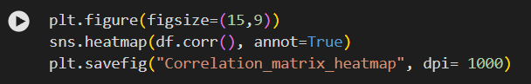
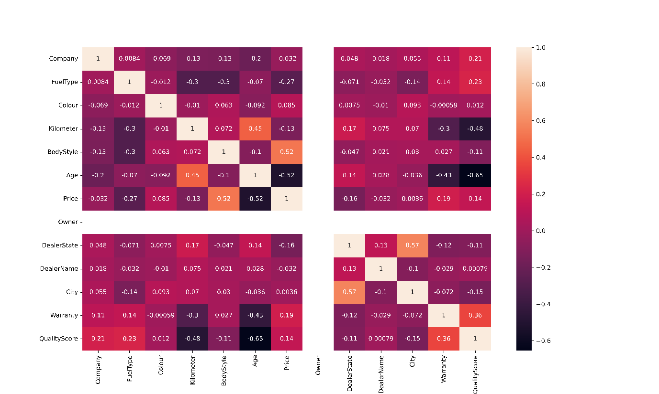
Fig 36. Correlation matrix heatmap

6.12 Final Modelling Dataset
After the preprocessing step, the data contained numeric features that were ready to be used in the machine learning models. Model column was dropped due to high cardinality, categorical features were transformed using the LabelEncoder, and the possible outliers were removed with the help of the IQR method.
Thus, the prepared dataset became more structured and could be used in the next step of the task – machine learning models' creation. The pre-processed features were then used to train and test the Decision Tree and Random Forest regression models.

6.13 Chapter Summary
This chapter talked about the preprocessing steps done before applying machine learning models. The irrelevant variables were eliminated and the high cardinality variable, Model, was dropped to avoid increasing the dimensionality of the dataset. Other categorical variables were then numerically encoded using LabelEncoder. Numerical features were also processed and outliers were detected and removed through the IQR technique. Lastly, a correlation matrix and heatmap were created to analyse the relationship between the variables. Preprocessing resulted in a neat numerical dataset, which served as the base for the upcoming chapter.

Chapter 7: Machine Learning Model Development

7.1 Introduction
In this chapter, the construction of machine learning models that predict the resale price of used cars is described. After performing the data pre-processing and exploratory data analysis discussed in the previous chapters, the processed dataset is ready for the application of supervised machine learning. The primary goal was to discover the relationship between vehicle features and the resale price as well as constructing regression models able to make accurate predictions of the price.
The target variable used for prediction was the Price. In terms of building models, this chapter mainly considered the Decision Tree Regression and Random Forest Regression models. This was done since these models can establish a non-linear relationship between vehicle features and the price. Hyperparameter tuning was also performed using GridSearchCV technique.

7.2 Regression Problem Formulation
Prediction of price for a used car is a case of supervised learning regression because the model is trained using past experiences where the real resale price is known. In this scenario, we seek to predict a numeric value, which is the price of a used car, from explanatory variables.
The general relationship can be represented as:
Price=f(X)+ϵ

Unlike in classification, which gives an output within certain categories, the output of regression takes on a numeric value. The regression problem of this study seeks to predict the resale price of each vehicle.

7.3 Feature Matrix and Target Variable
Two main parts were identified in the dataset:
Feature matrix (X) Target variable (y)
Target variable:
Price – resale price of the used car
Feature matrix consisted of the pre-processed independent variables that explained the difference in the prices. These consisted of various numeric and categorical variables of the car which remained in the dataset post-preprocessing. The Model variable was dropped in the preprocessing step due to the high cardinality of the feature.
All categorical variables were transformed to numeric format to be able to process them via machine learning algorithms.

7.4 Train-Test Split
The observations at hand were split into training and testing sets prior to training the models. While the training set was utilized by the algorithms to learn the correlations between the attributes of the vehicles and their price, the test set was held separately for measuring the predictive power.
This is necessary as the evaluation of a machine learning model on observations which were used for training may give too positive an assessment. The test set serves as a means for measuring the generalization ability of a trained model.
Fig 37. Train and Test split

7.5 Candidate Regression Models
In this project, regression methods for prediction of the used car prices were explored. The main regression methods, which were used in the visible analysis, included the following:
- Decision Tree Regressor
- Random Forest Regressor
It should be mentioned that both methods belong to tree-based algorithms and can capture non-linear relations. Moreover, the Ridge Regression method is noted in the visible analysis as one of the planned regression techniques.

7.6 Decision Tree Regressor
7.6.1 Model Configuration
A decision tree regressor is an algorithm that was initially created as one of the prediction models. The decision tree works by splitting data points based on their features to form different branches that lead to prediction nodes.
For regression, the data points that land on the prediction nodes will help calculate the predicted value of the numerical variable. This technique makes it possible for the model to capture the non-linear relationship among variables.
7.6.2 Model Training
Training was performed for the Decision Tree model using the training set. After that, predictions were made using the test data set. The results obtained from the predictions were then used to obtain regression performance metrics such as MSE, MAE, and R2.
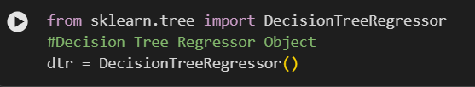
Fig 38. Decision Tree regressor

7.7 Decision Tree Hyperparameter Tuning
7.7.1 GridSearchCV
For improving the Decision Tree model, the GridSearchCV technique was used. Unlike a single manually defined set of parameters, GridSearchCV technique evaluates multiple sets of parameters in a systematic way.

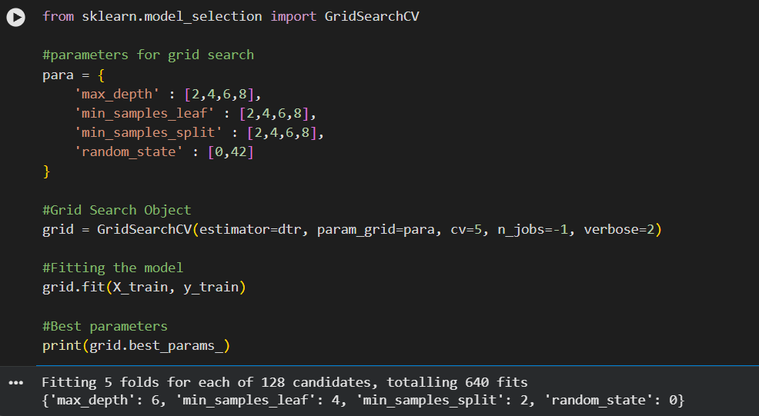
Fig 39. Grid search

7.7.2 Parameter Grid
A parameter grid having various Decision Trees parameters was passed to GridSearchCV. There were 128 combinations tried.
The methodology enabled the modelling process to find a combination whose cross-validation performance was better than that of the separate combinations tried.

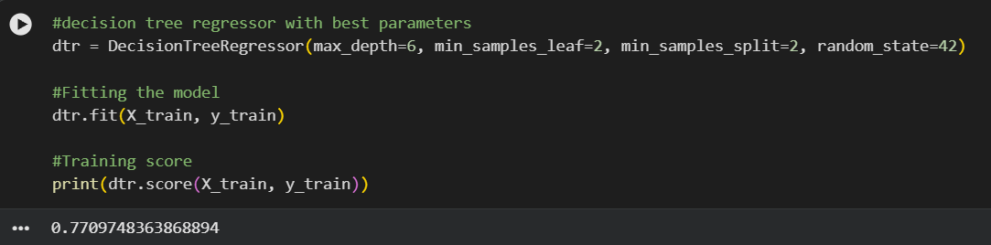
Fig 40. Best parameters and Training score

7.7.3 Five-Fold Cross-Validation
All combinations of parameters were analysed through five-fold cross validation. Data for training were partitioned into five parts. Four parts were utilized for training while one part was utilized for validation. This procedure was performed five times such that each part of the data was utilized for validation once.
7.7.4 Optimal Parameters
The decision tree that gave the best cross-validation performance was chosen as the best Decision Tree model. This fine-tuned decision tree model was used to predict on the testing set.

7.8 Random Forest Regressor
7.8.1 Model Configuration
The second important model used was the Random Forest Regressor. Random Forest is a technique of ensemble learning where a number of decision trees work together for making the prediction.
In this model, rather than relying on one single tree, the algorithm uses multiple trees with different data and features. The predictions of all of them are averaged to give the final prediction.
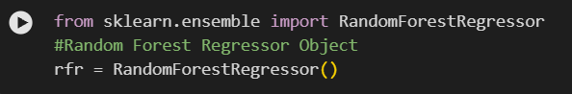
Fig 41. Random forest Regressor

7.8.2 Model Training
The Random Forest model was then trained on the pre-processed training dataset. After being trained, it produced predictions of the price values for the unseen test set. The same metrics of regression were used to evaluate the accuracy of predictions made by the Random Forest model.

7.9 Random Forest Hyperparameter Tuning
7.9.1 GridSearchCV
Also applied for Random Forest model tuning was GridSearchCV. Instead of choosing the parameters manually, various parameter combinations were systematically checked.
7.9.2 Parameter Grid
The set of parameters within the predetermined grid comprised different combinations of Random Forest. They were tested to find the best possible configuration.

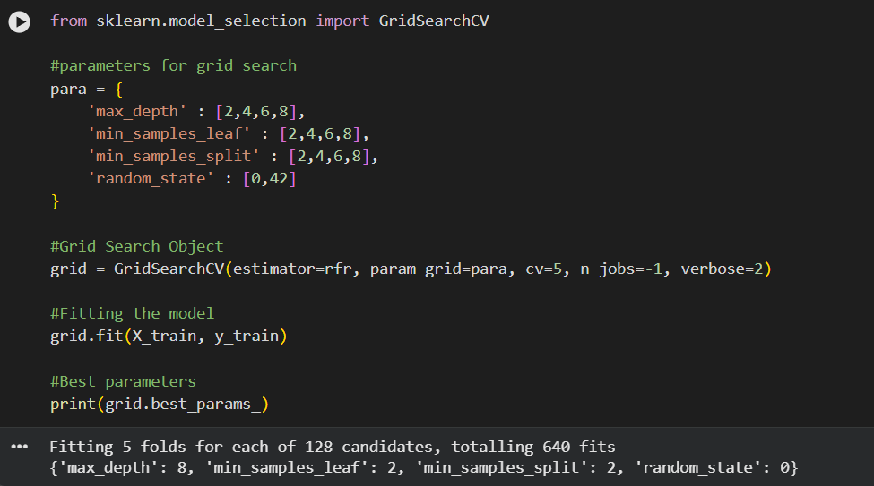
Fig 42. Grid search and fitting model

7.9.3 Five-Fold Cross-Validation
5-fold cross-validation was employed when the system was being optimized. This was done to minimize the risk that the selected setup was biased by a certain validation subset.
7.9.4 Optimal Parameters
The parameter values that gave the best performance in cross-validation were considered as the tuned Random Forest algorithm. This algorithm was then tested on the test dataset.

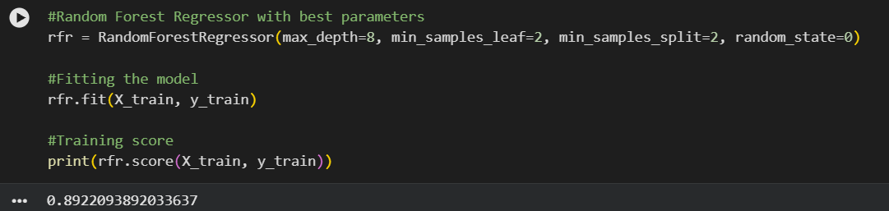
Fig 43. Best parameters and Training score

7.10 Ridge Regression
Another regression algorithm suitable for this project was found to be Ridge Regression. This is a regularized linear regression algorithm that penalizes large coefficients in the regression model.
Nevertheless, from the observed implementation, Ridge Regression training outcomes are not provided and the algorithm evaluation metrics are not specified. Hence, Ridge Regression remains a promising method in this chapter but not an experimentally evaluated algorithm.

7.11 Chapter Summary
This chapter introduced the machine learning design process used to make predictions about used car prices. The problem was framed as a supervised regression problem, whereby the target variable selected was Price, while the processed attributes of the cars were the explanatory variables. A train-test split of the data was performed to evaluate the models' prediction capabilities properly.

The Decision Tree Regression and the Random Forest Regression machine learning algorithms were adopted for use. Both machine learning models were analysed using GridSearchCV and cross-validation techniques to find the most efficient hyperparameters for each model. The Decision Tree algorithm had 128 combinations evaluated, whereas the Random Forest was similarly analysed.

Chapter 8: Model Evaluation and Results
8.1 Introduction
In this chapter, an evaluation of the machine learning models created for predicting the price of used cars is provided. Evaluation of models aims at assessing the level of accuracy with which trained models can predict the prices of used cars in new/unseen data. In this study, two regression algorithms are employed; they are Decision Tree Regressor and Random Forest Regressor.
Model evaluation is carried out using three regression metrics, namely Mean Squared Error (MSE), Mean Absolute Error (MAE), and R² score. The test results reveal that the Random Forest model performed better than the Decision Tree model in all three criteria.

8.2 Evaluation Methodology
Following the process of data pre-processing and feature engineering, the dataset was split into train and test sets. While the former set was used for creating regression models, the latter one was separated to measure the models' performance in making predictions on new data.
Three different measurements were used to compare model predictions with actual used car prices:
- MSE calculates the mean square of differences between actual and predicted prices.
- MAE calculates the mean absolute difference between actual and predicted prices.
- R² Score determines what part of variation in the target variable can be explained by the model.
In the case of MSE and MAE, the smaller number the better, while the larger number is better for R² Score.

8.3 Prediction Distribution Analysis
Analysis of the prediction distribution is useful when assessing the accuracy of the predicted values in relation to the real values. Predicted values in a good model should be distributed within the range of real values.
Both models used in this project were able to learn the relationship between the vehicle characteristics and resale price. Nevertheless, their prediction results were not the same according to the evaluation criteria. Random Forest made better predictions because it had fewer prediction errors.

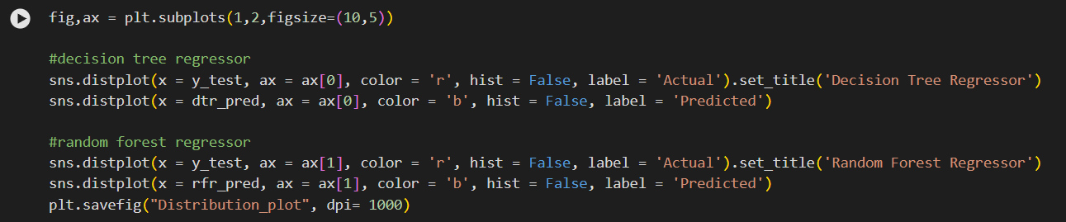
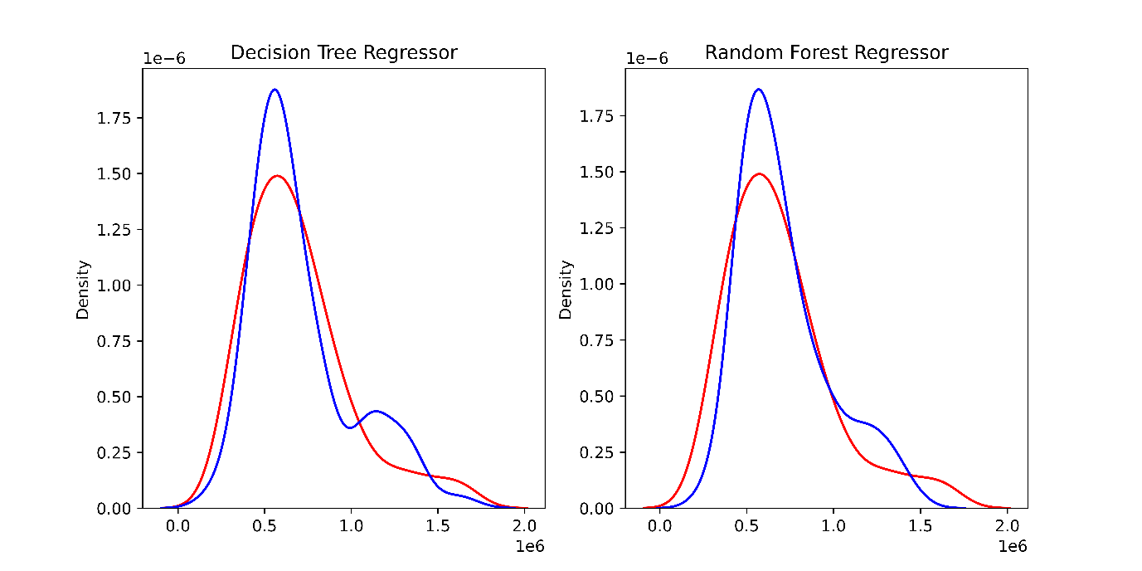
Fig 44. Model distribution plot

8.4 Decision Tree Regression Results
Here are the test results obtained from the Decision Tree Regressor algorithm:
- MSE: 35621770710.356476
- MAE: 140356.55954399044
- R²: 0.61
The R-Squared score of 0.61 tells us that 61% of variation in the prices of used cars was accounted for by the regression model in the test data set. Mean Absolute Error of 140356.55954399044 tells us that the average absolute error between actual and predicted values is 140356.55954399044.
The higher Mean Squared Error implies that some of the prediction errors were substantially larger than the rest.

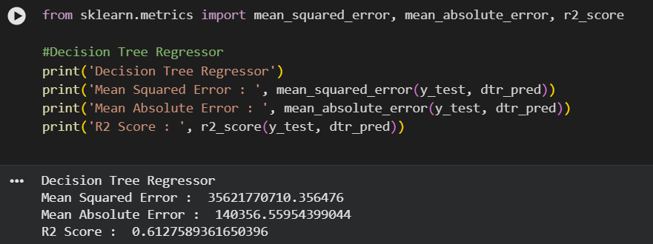
Fig 45. Decision Tree Regressor result

8.5 Random Forest Regression Results
The Random Forest Regressor achieved:
- MSE: 27525156332.62783
- MAE: 119317.30607051664
- R²: 0.70

The value of R² at 0.7047 shows that about 70.47% of variations in the prices of second-hand cars were captured by the Random Forest algorithm on the test data set. The MAE value for this algorithm was lower than that for the Decision Tree, indicating that it gave more accurate predictions.
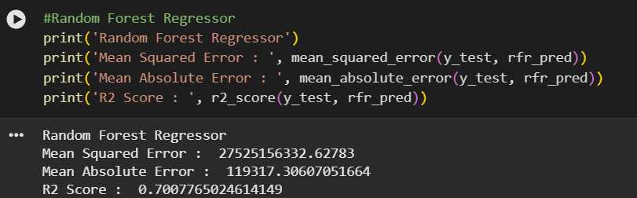
Fig 45. Random Forest Regressor result

8.6 Mean Squared Error (MSE)
MSE is computed as the average squared difference between the observed and estimated values. Since errors are squared, the impact of larger errors is higher for computing the final result.
Decision Tree obtained MSE of 35621770710.356476 whereas Random Forest got 27525156332.627. Thus, Random Forest performed better with respect to squared error means.
8.7 Mean Absolute Error (MAE)
The MAE is the average difference between predicted and actual values. It is easier to interpret than the MSE since MAE stays in the same units as the target variable.
The MAE achieved by the Decision Tree was 140356.5595439944, while the MAE achieved by the Random Forest was 119317.30607051664. Therefore, Random Forest gave better predictions compared to the Decision Tree.

8.8 R² Score
The R² measure shows the amount of variance in the used car price that is explained by the model. The Decision Tree had an R² of 0.61, while the Random Forest had an R² of 0.70.
This implies that the higher R² was because Random Forest had better ability to capture the relationship between vehicle attributes and resale price.

8.9 Comparative Model Performance
Model | MSE | MAE | R²
Decision Tree | 35621770710.356476 | 140356.55954399044 | 0.61
Random Forest | 27525156332.62783 | 119317.30607051664 | 0.70

Comparing the two, it can be seen that Random Forest yielded lower mean squared error and mean absolute error and a higher R² score compared to the Decision Tree.

8.10 Feature Importance Analysis
Variable feature importance technique was performed in order to find out what input variables had the highest contribution in predicting the model's outputs. It is essential since the price of used cars can depend on various features, such as car age, company, body style and others.

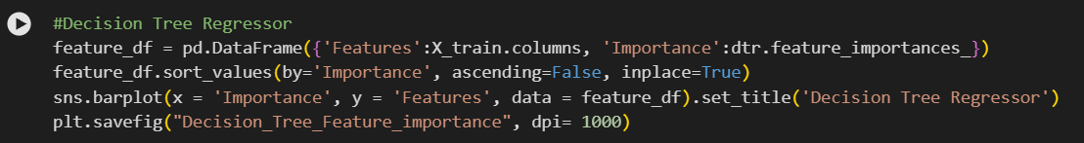

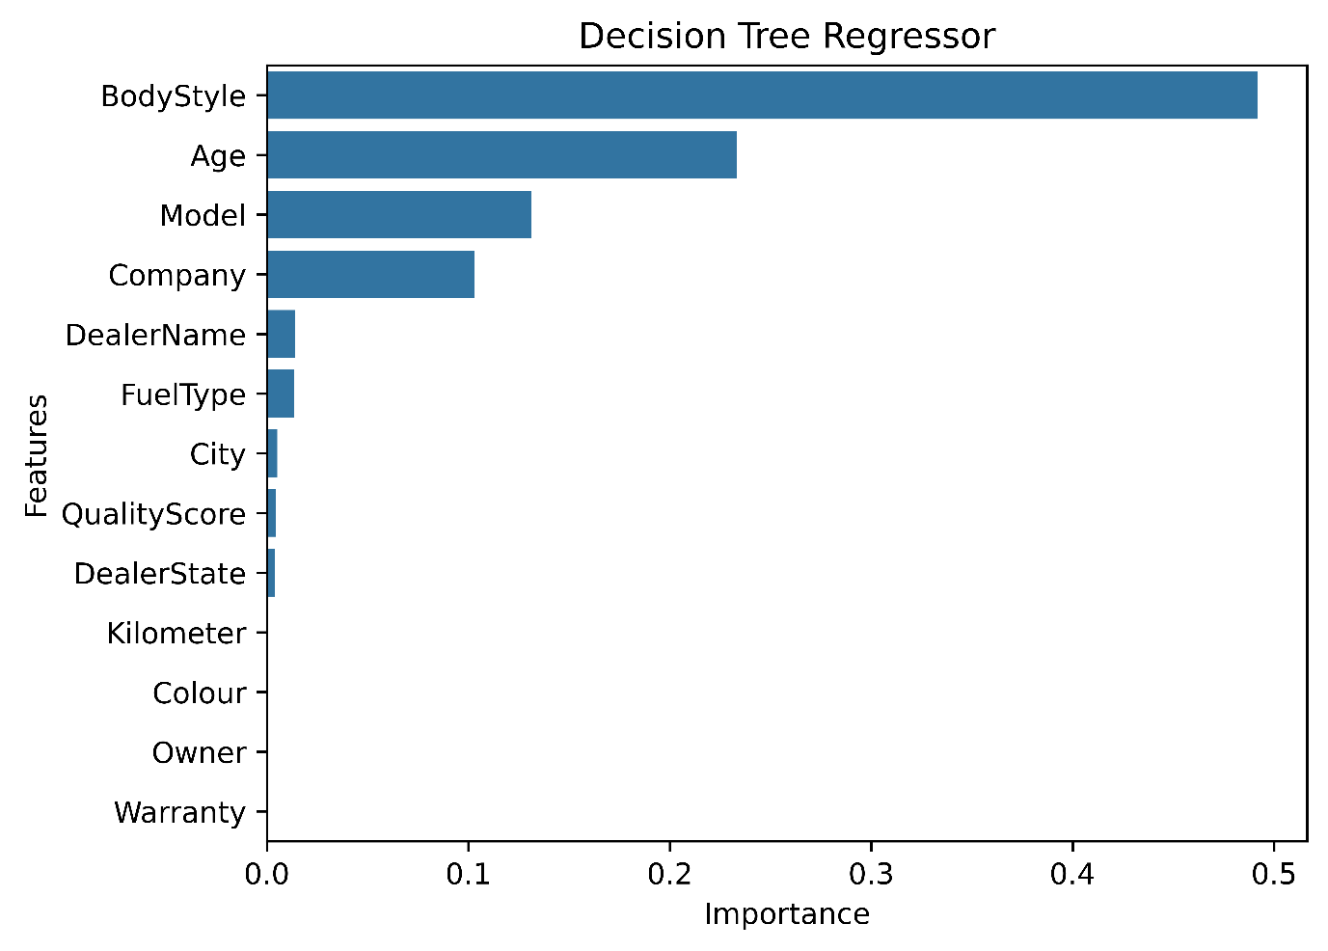
Fig 46. Decision Tree Regressor Feature importance

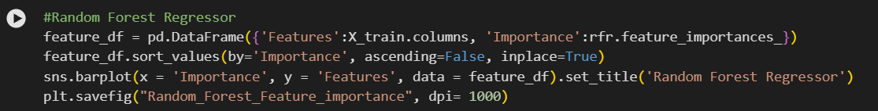

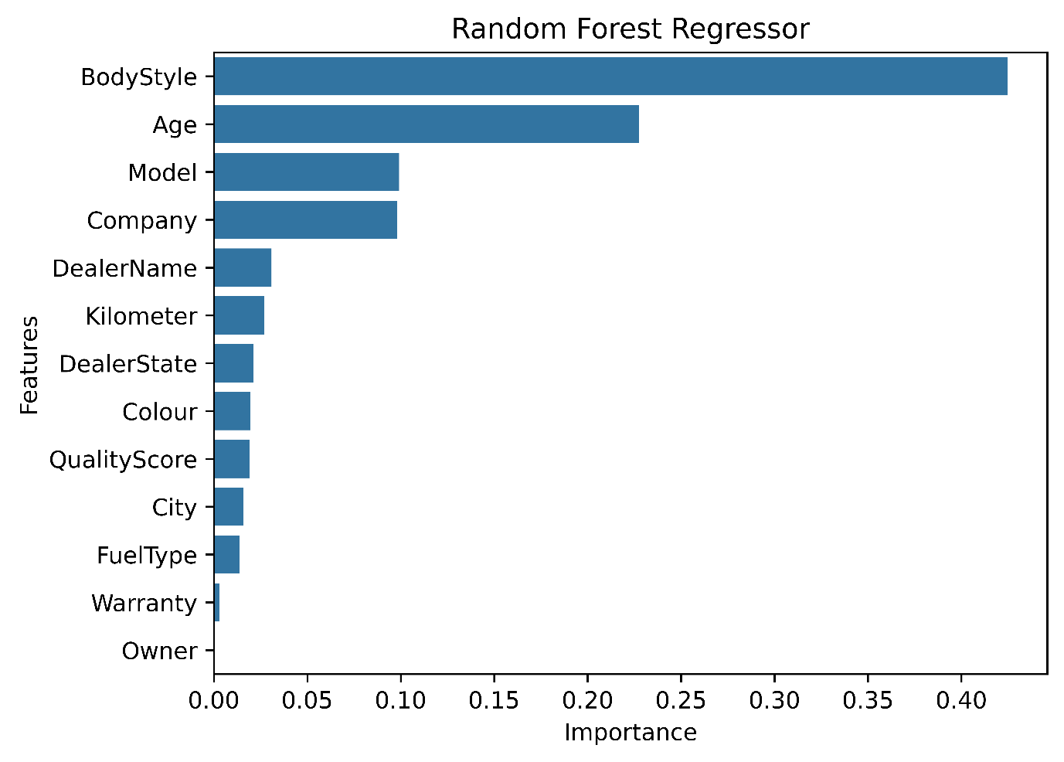
Fig 47. Random Forest Regressor Feature importance

8.11 Most Important Predictors
The age of the car is another crucial variable since used cars tend to have fluctuating market values depending on their age. The car manufacturer may be another determinant of the price since each car company has varying market position and re-sale values. Body type may also determine price due to demand differences in vehicle types.

8.12 Final Model Selection
Random Forest is used as the final model according to the performance from the test that was conducted. The algorithm performed better as compared to Decision Tree because it recorded low values of MSE and MAE but high values of R² score.

8.13 Results Interpretation
Results reveal that machine learning algorithms were able to detect relations between vehicle attributes and used cars prices. The discrepancy between both models reveals that Random Forest algorithm was better at detecting such relations compared to the single Decision Tree utilized in the current project.
The value of R² = 0.70 for the Random Forest model reveals that the large part of price variance was explained by the variables under consideration. At the same time, the unexplained part of variance shows that there might be some other factors affecting used cars prices.

8.14 Chapter Summary
Decision Tree and Random Forest regressions were analysed by their MSE, MAE, and R² in this chapter. The MSE for Decision Tree was 35621770710.356476 , the MAE was 140356.559543990 and R² is 0.61. For Random Forest, the MSE is 27525156332.62783, MAE is 119317.30607051664 and R² is 0.70.
From the test result of all models analysed, it can be seen that Random Forest performed better prediction compared to Decision Tree model. The analysis on feature.

Chapter 9: Discussion

9.1 Introduction
In this chapter, the key findings from the analysis of the used car dataset and the machine learning tests will be addressed. The aim here is not only to reiterate the findings from the previous chapters but also to understand what the findings entail in relation to the goals of the study. The analysis reveals that several factors affect the price of used cars, which include the car’s age, brand, model specifics, fuel, body style, distance travelled, and more.

9.2 Summary of Exploratory Findings
A lot of variations were found to exist in the used cars market according to the exploratory data analysis. There were cars of 23 brands in the data set with Maruti Suzuki, Hyundai, Honda, Mahindra and Tata being the most common. The popularity of cars like Honda City and Swift shows that there was demand for certain categories of cars in the market.
Furthermore, from the analysis carried out, it was established that high demand does not automatically translate into a high price. While some of the manufactures had numerous listings as well as relatively affordable prices, premium brands such as MG, Mercedes-Benz, and BMW had higher resale prices.

9.3 Demand Versus Price Patterns
The findings also show that there is a difference between market demand and value of the car. Popular cars will be listed more because they are common and cheap, while luxury cars will be listed fewer but their prices will be significantly higher. That means that popularity does not necessarily mean that the car is valuable.

9.4 Effect of Car Age
The age of the car is one of the critical factors that affect the resale price of a vehicle. Newer cars are usually more expensive because their depreciation is supposed to be lower, as well as the technology used. It was found out that older cars usually depreciate more.

9.5 Effect of Odometer Reading
Mileage is used to estimate the extent of utilization of a car. High mileage affects the resale value of a car negatively since the buyer will perceive high mileage as high utilization that leads to wear and future repair costs. But mileage alone cannot be used since it affects resale value differently.

9.6 Effect of Car Company and Model
Company and model characteristics were important sources of price variation. Premium manufacturers, particularly Mercedes-Benz and BMW, were associated with higher average prices in the analysed data. At the same time, frequently appearing models such as Honda City and Swift demonstrate strong representation in the market.

9.7 Effect of Fuel Type
The resale value of diesel cars was found to be relatively higher compared to that of petrol, CNG, and LPG cars within the studied sample. This could be due to the different attributes of the vehicles as well as their engines, which vary with each type of fuel used. It is important to note, however, that this does not mean a market-wide generalization.

9.8 Effect of Body Style
Body style also contributed to differences in price. Different vehicle types serve different consumer requirements, such as family transportation, urban driving or commercial use. Consequently, body style can influence both demand and resale value.

9.9 Effect of Ownership and Warranty
The buying decision can be affected by ownership history and warranty information. Cars that have fewer past owners or still have warranties available could be seen as safer buys. These elements can then be contributing to price disparity depending on the condition and manufacturer of the car.

9.10 Effect of Quality Score
Quality-related measures provide additional information about a vehicle's perceived condition and desirability. Higher-quality vehicles may maintain stronger resale values because buyers are generally willing to pay more for vehicles perceived to be reliable and well maintained.

9.11 Geographic Variation in Used Car Prices
The pricing of used cars can also be influenced by geographic factors due to the different levels of demand, incomes, and supply of vehicles in the area and the preferences of that region. Thus, the model built based on one market cannot necessarily be applied to another market.

9.12 Machine Learning Performance Discussion
The outcomes of machine learning show a significant difference between the two regression methods used. For Decision Tree, the R² value was 0.61. In case of Random Forest, the R² value was 0.70.
The above findings show that Random Forest is more capable of explaining the variations in the prices of the vehicles and has smaller errors for prediction compared to the other algorithms. This is because of the way it operates in which multiple decision trees can help predict.

9.13 Interpretation of Feature Importance
The model results suggest that the variables linked to age, type, and manufacturer of cars have a significant impact on the results obtained. This shows that the used car pricing is not a result of a single variable but is a result of many factors.

9.14 Comparison with Literature
The conclusions drawn are in line with earlier research which has demonstrated that age, mileage, make and model of vehicle are significant variables when predicting the price of a used car. The results also indicate the effectiveness of machine learning regression in developing predictive models. It is noteworthy that Random Forest performed better than the Linear Regression model.
9.15 Practical Implications
These results can be beneficial for buyers, sellers and car manufacturers. Buyers can consider such aspects as the age of the car, mileage, company and body type in order to evaluate whether the price is justified. For sellers, they can see which features of their cars affect resale value.

9.16 Limitations of the Study
Limitations of the research are as follows: the dataset might not include all of the used cars market; geographical scope is also limited; the analysis has neglected to consider certain variables, such as the overall state of the car and its accident history, among other things. Only Decision Tree and Random Forest models have been analysed. Thus, the results must be understood through the prism of the selected methodology.

9.17 Chapter Summary
In general, from the analysis, it is seen that used cars’ prices are affected by both vehicle factors as well as market factors. It was found out that high demand does not automatically mean higher prices, but rather, factors like age, mileage, company, and body style play an important role in making up the price. From the machine learning comparative analysis, it can be concluded that Random Forest performs better as compared to the Decision Tree model.

Chapter 10: Conclusion and Future Work

10.1 Introduction
The current chapter marks the end of the research work related to the analysis of used car markets and used car price prediction using machine learning. The study identified the factors that affect the pricing of used cars and built the regression model for predicting the price of the used cars. The exploratory data analysis, data preprocessing, feature transformation and machine learning algorithms were utilized for analysis and assessing predictive performance.

10.2 Summary of the Study
The key objective of the research was to analyse the market of used cars and find out whether the techniques of machine learning could be applied to predict the prices of vehicles. In the provided dataset there were different characteristics of the used vehicles that included such features as the name of the company, the model, type of fuel, the body type, age, mileage and other attributes of the car.

10.3 Achievement of Research Objectives
Objectives of the research were met through the process of analysis and model construction. Firstly, the study found key factors influencing used car prices. Secondly, exploratory analysis was performed in order to find differences between various companies, fuels, body styles, and car ages. Thirdly, machine learning models for price prediction were constructed. Finally, performance of the models was estimated with the help of regression metrics.

10.4 Key Findings
Some of the variables identified to influence the variation of prices on second-hand cars included: age of the car; the age of the car is important as it is associated with the changes in the resale price. Car make and the body type were also identified as having varying average prices. There were also some variations based on the type of fuel, the mileage and other car features.
Exploratory analysis of the data also revealed that manufacturers like MG, Mercedes-Benz, and BMW have high average prices. But note that these are only the trends found from the existing data set and not the universal rules of the market.

10.5 Best Performing Machine Learning Model
Two different models were created in the analysis, and they showed different prediction efficiencies. The Decision Tree showed the MSE of 35621770710.356476, MAE of 140356.55684399044 and R² of 0.61. The Random Forest showed the MSE of 27525156332.62783, MAE of 119317.30607051664 and R² of 0.70.
From the results above, Random Forest showed better efficiency than Decision Tree. This was evident by the fact that Random Forest had smaller prediction errors and a higher value of R² compared to Decision Tree.

10.6 Contribution of the Study
This research shows an example of using machine learning to predict the prices of used cars, and describes a step-by-step process in terms of EDA, data pre-processing, feature selection and modelling. Additionally, the research suggests that using ensemble regression is more effective than using a Decision Tree for such a dataset.

10.7 Limitations
A number of limitations must be identified. The data set may fail to capture the full spectrum of the used car market, and the size and geography of the data set can limit the extent of generalization. In addition, the exclusion of the high cardinality Model variable implies the loss of certain valuable model-specific information.

10.8 Recommendations for Future Work
10.8.1 Larger and More Diverse Dataset
Future research needs to be based on larger data sets involving different manufacturers and models.
10.8.2 Additional Machine Learning Algorithms
Other algorithms, including Gradient Boosting and XGBoost, might be considered along with the existing models.
10.8.3 XGBoost and Gradient Boosting
XGBoost and Gradient Boosting have the capacity to identify non-linear associations between the features of the vehicle and its price.
10.8.4 Improved Feature Engineering
Other factors such as mileage of the car per annum, age groups of cars, engine attributes, and price ratios could be created.
10.8.5 Advanced Categorical Encoding
Alternatives to label encoding may be considered, such as target encoding, frequency encoding, or even one-hot encoding.

10.8.6 Model Explainability
Other approaches like SHAP and feature importance could offer better insights into the impact of individual features on prediction.
10.8.7 Web-Based Price Prediction Application
The trained model can be embedded in a web application wherein people input details about their cars and get the predicted price.
10.8.8 Model Deployment
In future research, the model can be deployed using the cloud/web platform, and mechanisms for measuring its performance based on new market data can be developed.

10.9 Final Conclusion
Conclusion
In summary, the experiment has illustrated the use of machine learning in predicting the prices of used cars. The study suggests that car age, body type, and manufacturer are some of the significant features involved in price variability in the data used in this research work. From the model comparisons conducted, Random Forest was able to produce a higher test score (R²=0.7047) compared to the Decision Tree (R²=0.5661).
Generally, this research project can be seen as a basis for developing automated used car price estimation systems.

Chapter 11: References
- Breiman, L., Friedman, J.H., Olshen, R.A. and Stone, C.J. (1984) Classification and Regression Trees. Belmont, CA: Wadsworth.
- Hastie, T., Tibshirani, R. and Friedman, J. (2009) The Elements of Statistical Learning: Data Mining, Inference, and Prediction. 2nd edn. New York: Springer.
- Provost, F. and Fawcett, T. (2013) Data Science for Business: What You Need to Know about Data Mining and Data-Analytic Thinking. Sebastopol, CA: O'Reilly Media.
- Pratt, M.D. and Stahler, A. (2012) ‘Estimating the price of used cars using machine learning techniques’, Proceedings of the International Conference on Data Mining
- Hunter, J.D. (2007) ‘Matplotlib: A 2D graphics environment’, Computing in Science & Engineering
- Tukey, J.W. (1977) Exploratory Data Analysis. Reading, MA: Addison-Wesley.
- Wickham, H. and Grolemund, G. (2017) R for Data Science. Sebastopol, CA: O'Reilly Media
- Han, J., Kamber, M. and Pei, J. (2012) Data Mining: Concepts and Techniques. 3rd edn. Waltham, MA: Morgan Kaufmann.
- Kuhn, M. and Johnson, K. (2013) Applied Predictive Modelling. New York: Springer
- Pedregosa, F. et al. (2011) ‘Scikit-learn: Machine learning in Python’, Journal of Machine Learning Research
- Chicco, D., Warrens, M.J. and Jurman, G. (2021) ‘The coefficient of determination R-squared is more informative than SMAPE, MAE and RMSE in regression analysis evaluation’, PeerJ Computer Science

Chapter 12: Appendix
#Importing the required libraries
import pandas as pd
import numpy as np
import matplotlib.pyplot as plt
import seaborn as sns

#Loading the dataset
df = pd.read_csv('usedCars.csv')
df.head()

#Shape of the dataset
df.shape

#colums in the dataset
df.columns

#dropping column ID, as it is a identifier and not required for analysis
df.drop('Id',axis=1,inplace=True)

#Column Data Types
df.dtypes

#Type casting Price column to float
def convert_amount(amount_str):
if "Lakhs" in amount_str:
return float(amount_str.replace(' Lakhs', '').replace(',', '')) * 100000
else:
return float(amount_str.replace(',', ''))
df['Price'] = df['Price'].apply(convert_amount)
#Checking for null values percentage wise
df.isnull().sum()/df.shape[0]*100

df.drop('CngKit', axis=1, inplace=True)

#Dropping TransmissionType column
df.drop('TransmissionType',axis=1,inplace=True)
#Removing null values from FuelType column
df['FuelType'].dropna(inplace=True)

df.drop('ManufactureDate', axis = 1, inplace = True)
df.drop('Variant', axis = 1, inplace=True)

df['ModelYear'] = 2023 - df['ModelYear']
df.rename(columns={'ModelYear':'Age'},inplace=True)

for i in df.columns:
print(i,df[i].nunique())

df.describe()

# Exploratory Data Analysis

#Number of cars by company
sns.countplot(df['Company'],order=df['Company'].value_counts().index, palette = 'Set1').set_title('Number of cars by company')
plt.savefig("Number_of_cars_by_company", dpi= 1000, bbox_inches='tight')

#Top 10 cars models by number
sns.countplot(df['Model'],order=df['Model'].value_counts().iloc[:10].index, palette = 'Set1').set_title('Top 10 Car Models')
plt.savefig("Top_10_car_models", dpi= 1000, bbox_inches='tight')

#Cars count by fuel type
sns.countplot(x = 'FuelType', data = df, palette = 'Set1').set_title('Number of cars by Fuel Type')
plt.savefig("Number_of_cars_by_fuel_type", dpi= 1000)

#Top 10 colors of cars
sns.countplot(x = 'Colour', data = df, order = df['Colour'].value_counts().iloc[:10].index).set_title('Top 10 Car Colours')
plt.xticks(rotation = 90)
plt.savefig("Top_10_car_colours", dpi= 1000, bbox_inches='tight')

#Odometer reading distribution
sns.histplot(x = 'Kilometer', data = df, bins = 20).set_title('Odometer Reading')
plt.savefig("Odometer_reading", dpi= 1000)

#Body style count
sns.countplot(x = 'BodyStyle', data = df).set_title('Number of cars by Body Style')
plt.xticks(rotation = 90)
plt.savefig("Number_of_cars_by_body_style", dpi= 1000, bbox_inches='tight')

#Car age distribution
sns.histplot(x = 'Age', data = df, bins = 20).set_title('Car age distribution')
plt.savefig("Car_age_distribution", dpi= 1000)

#Car price Distribution
sns.histplot(x = 'Price', data =df, bins = 30).set_title('Car price distribution')
plt.savefig("Car_price_distribution", dpi= 1000)

fig, ax = plt.subplots(1,3,figsize=(20,7))

#Dealer State
sns.countplot(x = 'DealerState', data = df, ax = ax[0]).set_title('Dealer States')
ax[0].set_xticklabels(ax[0].get_xticklabels(), rotation = 90)

#City
sns.countplot(x = 'City', data = df, ax = ax[1]).set_title('City')
ax[1].set_xticklabels(ax[1].get_xticklabels(), rotation = 90)

#top 10 dealers
sns.countplot(x = 'DealerName', data = df, order = df['DealerName'].value_counts().iloc[:10].index, ax = ax[2]).set_title('Top 10 Dealers')
ax[2].set_xticklabels(ax[2].get_xticklabels(), rotation = 90)

plt.savefig("Location_based_distribution", dpi= 1000, bbox_inches='tight')

#Car Owner Type
sns.countplot(x = 'Owner', data = df).set_title('Number of cars by Owner Type')
plt.savefig("Number_of_cars_by_owner_type", dpi= 1000)

#Warranty
sns.countplot(x = 'Warranty', data = df).set_title('Number of cars by Warranty')
plt.savefig("Number_of_cars_by_warranty", dpi= 1000)

#Quality Score Distribution
sns.histplot(x = 'QualityScore', data = df, bins = 10).set_title('Quality Score Distribution')
plt.savefig("Quality_score_distribution", dpi= 1000)

#Top 10 car companies by price
sns.barplot(y = 'Company', x = 'Price', data = df, order = df.groupby('Company')['Price'].mean().sort_values(ascending=False).iloc[:10].index,
hue = 'Company', palette= 'Set1').set_title('Top 10 car Companies by price')
plt.savefig("Top_10_car_companies_by_price", dpi= 1000, bbox_inches='tight')

#Top 10 car models by price
sns.barplot(y = 'Model', x = 'Price', data = df, order = df.groupby('Model')['Price'].mean().sort_values(ascending=False).iloc[:10].index,
hue = 'Model', palette= 'Set1').set_title('Top 10 car Models by price')
plt.savefig("Top_10_car_models_by_price", dpi= 1000, bbox_inches='tight')

#Car Fuel Type and Price
fig, ax = plt.subplots(1,2,figsize=(15,5))
sns.boxplot(x = 'FuelType', y = 'Price', data = df, ax = ax[0], hue = 'FuelType').set_title('Price by Fuel Type')
sns.violinplot(x = 'FuelType', y = 'Price', data = df, ax = ax[1], hue = 'FuelType').set_title('Price by Fuel Type')
plt.savefig("Car_fuel_type_and_price", dpi= 1000)

#Top 10 car colors by price
sns.barplot(y = 'Colour', x = 'Price', data = df, order = df.groupby('Colour')['Price'].mean()
.sort_values(ascending=False).iloc[:10].index).set_title('Top 10 car Colors by price')
plt.savefig("Top_10_car_colors_by_price", dpi= 1000, bbox_inches='tight')

#Odometer Reading and Price
sns.scatterplot(x = 'Kilometer', y = 'Price', data = df).set_title('Odometer Reading and Price')
plt.savefig("Odometer_reading_and_price", dpi= 1000)

#Body Style and Price
sns.barplot(x = 'BodyStyle', y = 'Price', data = df, hue = 'BodyStyle').set_title('Price by Body Style')
plt.xticks(rotation = 90)
plt.savefig("Price_by_body_style", dpi= 1000, bbox_inches='tight')

#Car Age and Price
sns.barplot(x = 'Age', y = 'Price', data = df).set_title('Car age and Price')
plt.savefig("Car_age_and_price", dpi= 1000)

#Dealer State
sns.violinplot(x = 'DealerState', y = 'Price', data = df, hue = 'DealerState').set_title('Dealer States')
plt.xticks(rotation = 90)
plt.savefig("Dealer_state", dpi= 1000, bbox_inches='tight')

#City
sns.violinplot(x = 'City',y = 'Price', data = df, hue = 'City').set_title('City')
plt.xticks(rotation = 90)
plt.savefig("City_and_Price", dpi= 1000, bbox_inches='tight')

#top 10 dealers
sns.violinplot(x = 'DealerName',y = 'Price', data = df, order = df['DealerName'].value_counts().iloc[:10].index,
hue = 'DealerName').set_title('Top 10 Dealers')
plt.xticks(rotation = 90)
plt.savefig("Dealer_and_Price", dpi= 1000, bbox_inches='tight')

#Car Owner Type
sns.violinplot(x = 'Owner', y = 'Price', data = df, hue = 'Owner').set_title('Price by Owner Type')
plt.savefig("Price_by_owner_type", dpi= 1000)

#Warranty and Price
sns.violinplot(x = 'Warranty', y = 'Price', data = df, hue = 'Warranty').set_title('Price by Warranty')
plt.savefig("Price_by_warranty", dpi= 1000)

#Quality Score and Price
sns.scatterplot(x = 'QualityScore', y = 'Price', data = df).set_title('Quality Score and Price')
plt.savefig("Quality_score_and_price", dpi= 1000)

#Label Encoding
#columns for label encoding
cols = df.select_dtypes(include=['object']).columns

from sklearn.preprocessing import LabelEncoder
#Label encoding object
le = LabelEncoder()

#label encoding for object type columns
for i in cols:
le.fit(df[i])
df[i] = le.transform(df[i])
print(i, df[i].unique())

#Outlier Detection
print(f"Shape of DataFrame before outlier removal: {df.shape}")

#Using IQRS to remove outliers

#columns for outlier removal
cols = df.select_dtypes(include=['int64','float64']).columns
Q1 = df[cols].quantile(0.25)
Q3 = df[cols].quantile(0.75)

IQR = Q3 - Q1

#Removing outliers
df = df[~((df[cols] < (Q1 - 1.5 * IQR)) |(df[cols] > (Q3 + 1.5 * IQR))).any(axis=1)]
print(f"Shape of DataFrame after outlier removal: {df.shape}")

#Correlation matrix
plt.figure(figsize=(15,9))
sns.heatmap(df.corr(), annot=True)
plt.savefig("Correlation_matrix_heatmap", dpi= 1000)

#Train and Split
from sklearn.model_selection import train_test_split
X_train, X_test, y_train, y_test = train_test_split(df.drop('Price',axis=1), df['Price'], test_size=0.2, random_state=42)

#Decision Tree Regressor
from sklearn.tree import DecisionTreeRegressor
#Decision Tree Regressor Object
dtr = DecisionTreeRegressor()

#Hyperparameter Training
from sklearn.model_selection import GridSearchCV

#parameters for grid search
para = {
'max_depth' : [2,4,6,8],
'min_samples_leaf' : [2,4,6,8],
'min_samples_split' : [2,4,6,8],
'random_state' : [0,42]
}

#Grid Search Object
grid = GridSearchCV(estimator=dtr, param_grid=para, cv=5, n_jobs=-1, verbose=2)

#Fitting the model
grid.fit(X_train, y_train)

#Best parameters
print(grid.best_params_)

#decision tree regressor with best parameters
dtr = DecisionTreeRegressor(max_depth=6, min_samples_leaf=2, min_samples_split=2, random_state=42)

#Fitting the model
dtr.fit(X_train, y_train)

#Training score
print(dtr.score(X_train, y_train))

#Prediction
dtr_pred = dtr.predict(X_test)

#Randim Forest Regressor
from sklearn.ensemble import RandomForestRegressor
#Random Forest Regressor Object
rfr = RandomForestRegressor()

from sklearn.model_selection import GridSearchCV

#parameters for grid search
para = {
'max_depth' : [2,4,6,8],
'min_samples_leaf' : [2,4,6,8],
'min_samples_split' : [2,4,6,8],
'random_state' : [0,42]
}

#Grid Search Object
grid = GridSearchCV(estimator=rfr, param_grid=para, cv=5, n_jobs=-1, verbose=2)

#Fitting the model
grid.fit(X_train, y_train)

#Best parameters
print(grid.best_params_)

#Random Forest Regressor with best parameters
rfr = RandomForestRegressor(max_depth=8, min_samples_leaf=2, min_samples_split=2, random_state=0)

#Fitting the model
rfr.fit(X_train, y_train)

#Training score
print(rfr.score(X_train, y_train))

#Prediction
rfr_pred = rfr.predict(X_test)

fig,ax = plt.subplots(1,2,figsize=(10,5))

#decision tree regressor
sns.distplot(x = y_test, ax = ax[0], color = 'r', hist = False, label = 'Actual').set_title('Decision Tree Regressor')
sns.distplot(x = dtr_pred, ax = ax[0], color = 'b', hist = False, label = 'Predicted')

#random forest regressor
sns.distplot(x = y_test, ax = ax[1], color = 'r', hist = False, label = 'Actual').set_title('Random Forest Regressor')
sns.distplot(x = rfr_pred, ax = ax[1], color = 'b', hist = False, label = 'Predicted')
plt.savefig("Distribution_plot", dpi= 1000)

#Decision Tree Regressor
feature_df = pd.DataFrame({'Features':X_train.columns, 'Importance':dtr.feature_importances_})
feature_df.sort_values(by='Importance', ascending=False, inplace=True)
sns.barplot(x = 'Importance', y = 'Features', data = feature_df).set_title('Decision Tree Regressor')
plt.savefig("Decision_Tree_Feature_importance", dpi= 1000, bbox_inches='tight')

#Random Forest Regressor
feature_df = pd.DataFrame({'Features':X_train.columns, 'Importance':rfr.feature_importances_})
feature_df.sort_values(by='Importance', ascending=False, inplace=True)
sns.barplot(x = 'Importance', y = 'Features', data = feature_df).set_title('Random Forest Regressor')
plt.savefig("Random_Forest_Feature_importance", dpi= 1000, bbox_inches='tight')

