Jeevandeep Mahavidyalaya

TITLE OF THE PROJECT
OPD Management



SUBMITTED BY
Awanish Pandey
Enrollment No.: KA2K22/132870012

DATE OF SUBMISSION
10/08/2024

Under The Guidance Of: .Mr. Shivchand Sir

Submitted in partial fulfillment of the requirements for qualifying Bsc.

Jeevandeep Mahavidyalaya
Affilated to MGKVP Varanasi
Bada Lalpur ,P.O.Lamhi,Varanasi
Project certificate

This is to certify that the Project/Dissertation entitled, OPD Management is a bona fide work done by Awanish Pandey (Enrollment No. KA2K22/132870012 ) in partial fulfillment of Bsc examination has been carried out under my direct supervision and guidance. This report or a similar report on the topic has not been submitted for any other examination and does not form part of any other course undergone by the candidate.

Jeevandeep Mahavidyalaya
Affilated to MGKVP Varanasi
Bada Lalpur ,P.O.Lamhi,Varanasi

Submmited by: Guided by:
Awanish Pandey Shiv Chand Sir
Jeevandeep Mahavidyalaya Computer Faculty
Roll No : KA2K22/132870012 Jeevandeep Mahavidyalaya
Lamhi,Varanasi

Signature : Signature :

Table of contents

Project Title
Project Certificate
Introduction
Objective
Project category
Software platform
Hardware platform
Feasibility study
Testing
DFD
ER Diagram
Data Structure
Process Logic
Output
Coding
Future Modification
Bibliography

Project Title



Introduction

OPD Management Software is a comprehensive digital solution designed to streamline the operations of Outpatient Departments (OPD) in healthcare facilities. It automates and optimizes various administrative, clinical, and operational tasks, enabling hospitals, clinics, and diagnostic centers to deliver efficient, patient-centric services.

Key Features
Patient Registration and Appointment
- Quick registration with demographic details.
- Seamless appointment scheduling with reminders.
Electronic Medical Records (EMR)
- Secure storage and retrieval of patient medical history.
- Access to lab reports, prescriptions, and progress notes.
Reporting and Analytics
- Detailed performance insights.
- Data-driven decision-making through analytics.

Benefits:
- Enhanced Efficiency: Reduces paperwork and manual errors.
- Improved Patient Experience: Faster service and better communication.
- Compliance Ready: Ensures adherence to healthcare regulations.
- Cost-Effective: Saves time and operational costs.

Objective of the Project

The primary goal of OPD Management Software is to optimize the functioning of outpatient departments by automating processes and ensuring a seamless experience for patients and healthcare providers. Below are the key objectives:
• Streamline Administrative Processes
- Automate patient registration, appointment scheduling, and resource allocation to reduce manual tasks and minimize errors.
• Enhance Patient Experience
- Provide quick, hassle-free services with real-time updates on appointments, doctor availability, and treatment plans.
• Ensure Accurate Record Management
- Maintain a secure and easily accessible repository of patients' medical records, prescriptions, and test results.
• Facilitate Efficient Billing and Payments
- Simplify billing processes with automated invoice generation, transparent pricing, and integration with various payment methods.
• Improve Operational Efficiency
- Optimize the use of hospital resources, including doctors, diagnostic tools, and consultation rooms, to reduce wait times and improve service quality.
• Enable Better Decision-Making
- Provide comprehensive reports and analytics to support data-driven decisions for improved patient care and operational strategies.

Project Category

This project belongs to the category of application software as use the applications of Commision Management can it. It is a desktop application, At a time only
One user can use it. It is a type of commercial software so terms and conditions are provides by the vender to buyer.

Software Platform

Implementation Platform

The following software is required.
- Operating System -Window 10
- Back End -MS-Access
- Front End -Visual Basic .Net

Development Platform

The following S/W was used n developing the system.
- Operating System -Window 10
- Back End -MS-Access
- Front End -VB.Net
Hardware Platform

Development platform
The following H/W components were used in developing the system project.

RAM - more than 64 MB
HDD - 20 GB or greater
Monitor - EGA/VGA
Keyboard - Input Device
Mouse - As a pointer Device
Processor - Pentium Minx

Implementation Platform

The following H/W is required
RAM - more than 1GB
HDD - 20 GB or greater
Monitor -EGA/VGA
Keyboard -Input Device
Mouse - As a pointing device
Processor - I3

Feasibility Study

It has very important place in the study of any software because if the project are not feasible then working on this working on this software is not a good work.
So I conducted the feasibility study in order to check out whether our software “OPD Management” is feasible or not. So we study about thee types of feasibility:-
- Economic Feasibility
- Technical Feasibility
- Operational Feasibility
So brief description of above are following

1 Economic Feasibility:-
In this study, I was concerned about broad range of factors. Our software has no need of any other equipment or software. It saves very much time and lots of manual work. It also saves the paper work of the person.
So, in short we can say that it is economic feasible software and saves lots of expenses of the person and time as well.

2 Technical Feasibility:-
In technical feasibility we studied that the system is technical feasible or not. If system is not feasible then, a system analyst takes a decision about software that will be proceeding out or not.
So, we take care of that our software is overall technically feasible. I take care of the development and technology of the Varanasi region for ensuring availability of the hardware and software needs for implementation of this project and that is minimal.

3 Operational feasibility:-
Our software is user friendly. So a person who does not have any technical background can operate this software, prior knowledge of computer is not mandatory for operating the software. Icons menus and its options describing its meaning itself, input and output form are designed in user friendly way for providing proper instructions with user.
So we specially take care of that software is operational feasible.

Testing

Testing phase is one of the important phase in between developed and implementation phase. We perform testing to ensure code optimization and to ensure accuracy and validity of entered data.
The system development phases involve many activities where chances for occurrence of human errors are enormous. Logical error, carelessness, improper communication, the need to hurry through the whole process of software development due to time constraint, cost constraints etc. provide ways for errors to creep in. The system must be tested thoroughly so that such error to creep in. The system must be tested thoroughly so that such error are detected and corrected as early as possible. A successful text is one that uncovers every possible error.

There are following testing methods which are below:-
1 BLACK BOX TESTING:-
In black box testing we checked modules by giving test data prepared by keeping all possibilities.
2 UNIT TESTING:-
In unit testing each module checked for following:
- Interface
- Local data structure
- Boundary conditions
- Independents paths
- Error handling paths

3 SYSTEM TESTING:-
Modules added to project in incremental approach and overall testing performed on system to evaluate its overall performance with stated requirement of user.

4 WHITE BOX TESTING:-
We ensure following by performing white box testing:
- Guarantee that all independents path within a module exercised at least one.
- Exercise all logical decision on their true and false sides.
- Execute all loops at their boundary.
- Exercise internal data structure to ensure validity.
By performing glass box testing, we achieved code optimization by removing unnecessary codes.
DFD

I) DFD on Commision Management

OPD

Appointment

Desk

User
Report
Patient

II) DFD ON Computer Operator

OPD
Data Base
Patient
Book Confirm
Report
Appointment
Add Patient
Report

III) DFD ON Reporting:

Data Base
OPD
Patient
Book History
Report
Check detail
Generate
DFD 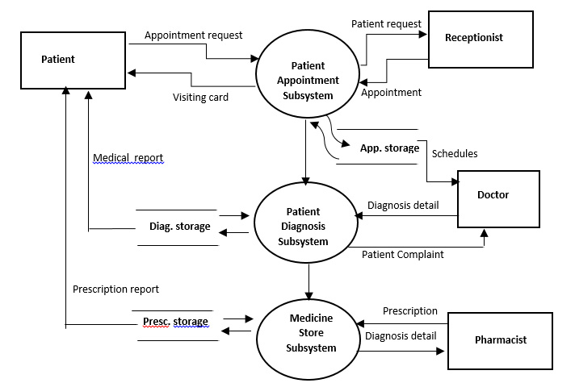
Data Dictionary

I) Entity of Usermaster :

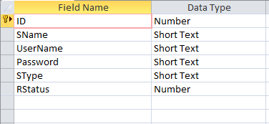

II) Entities Patient

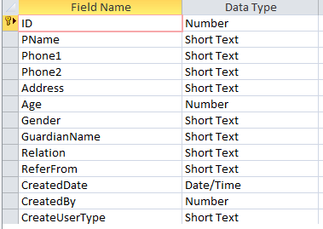

III) Entity Parcha

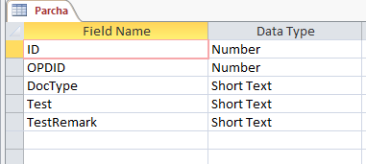

IV) Entity OPD

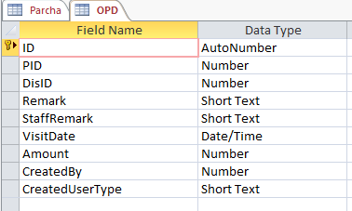

V) DiseaseMaster

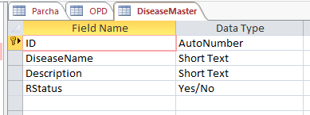

- Relationship between Customer shop & Customer
Patient
OPD

Have

2) Relationship between Bill & Bill details

Have
Appointment
Booking

3) Relationship between user & sell record

Contains
Patient
Booking

4) Relationship between Patient & Appointment

Maintain
Unit
Booking

name
OPDDetail
Address
cid
Contains
Maintain
OPDID
Tms_id
Tms_ty
Tms_no
Tms_dd
Deals
Have
id
Name
password
User name
Maintain
Billid
cid
Bill_date
OPD_ph
Details
Rep_id
Rep_nm
Rep_ty
Generate
Patient
Booking
Transaction
User
Report
Report

Process Logic

Logic For Registration Form
Stop
Enter Detail of Patient
Is Correct
Start
Process of Booking

No

P
Yes

Logic for Delete Record form :
Yes
No
Logic for update Record form :

Stop
Enter r id & name
Is Correct
Update Records
Start

No

Yes

Logic for find Record form:

Stop
Enter r id & name

Is Correct
Display the r record
Start

Yes
No

Logic for submit Patient booking details :

Stop
Enter r id & name

Is Correct
Display Report Record of sell
Start
Yes
No
Output

Spalsh Screen



Login

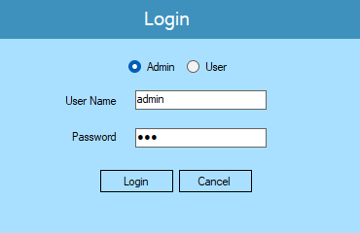

MDI

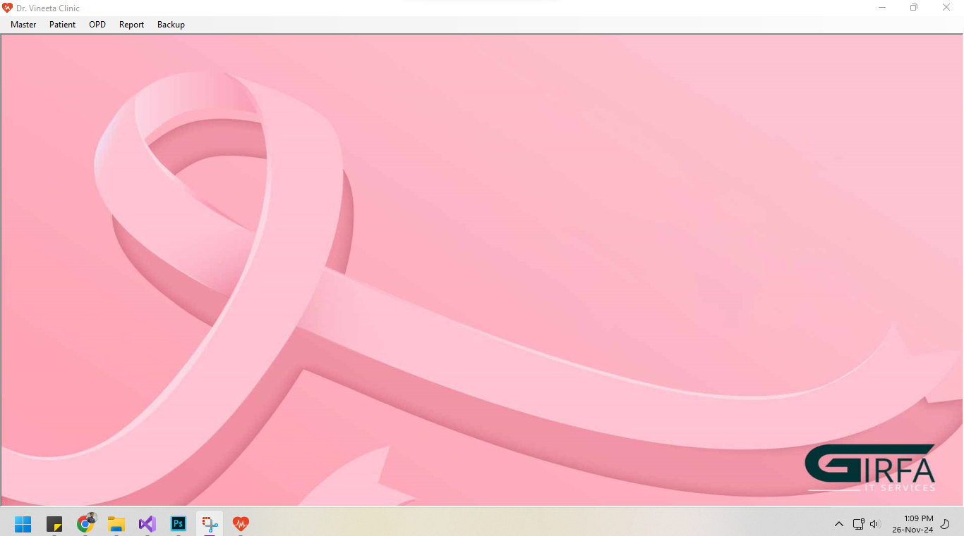

Disease Master
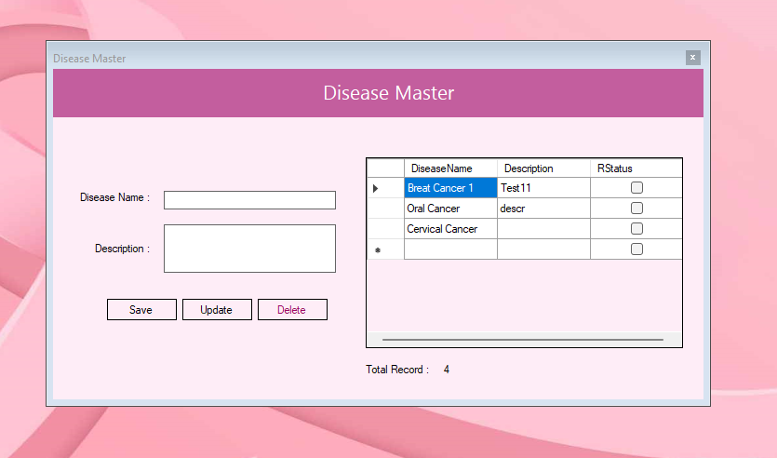

Patient Entry

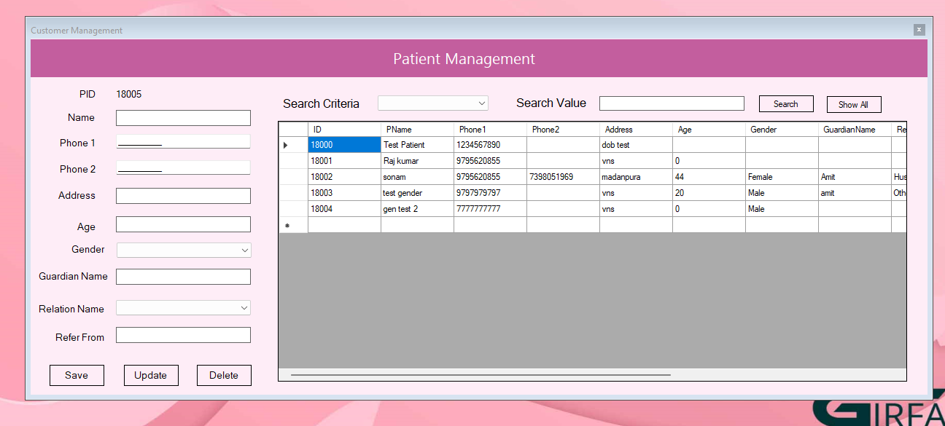

Patient History

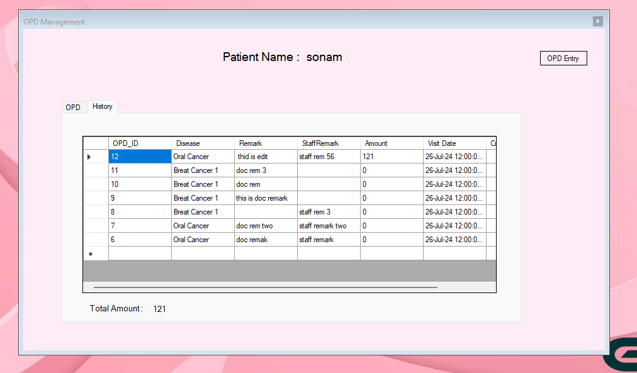

Patient Report

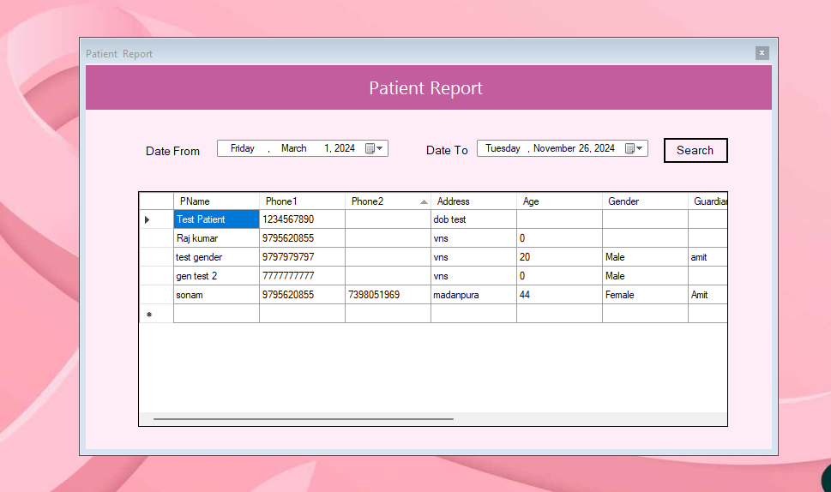

Patient Show

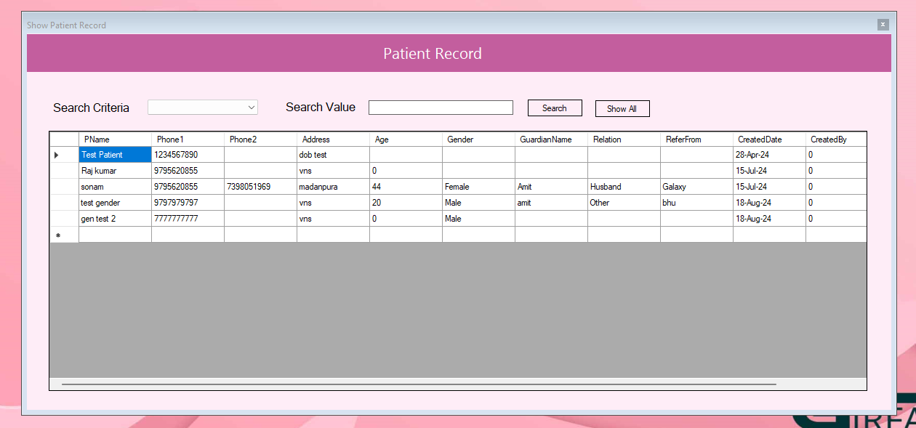

Patient Test Report

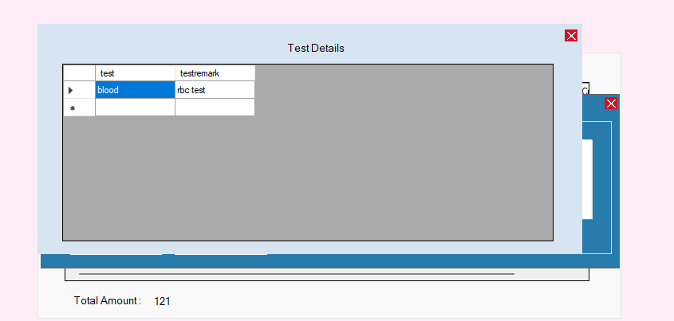

Patient Document

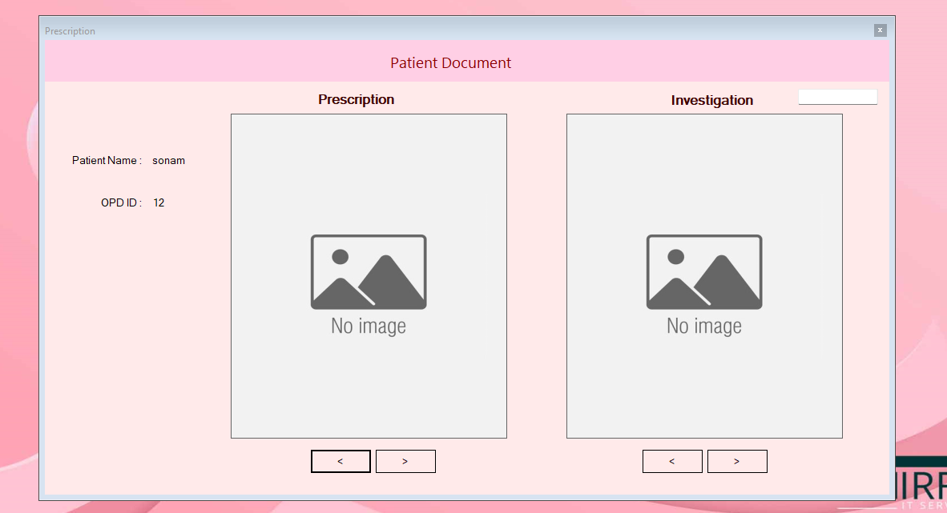
Patient History

OPD History

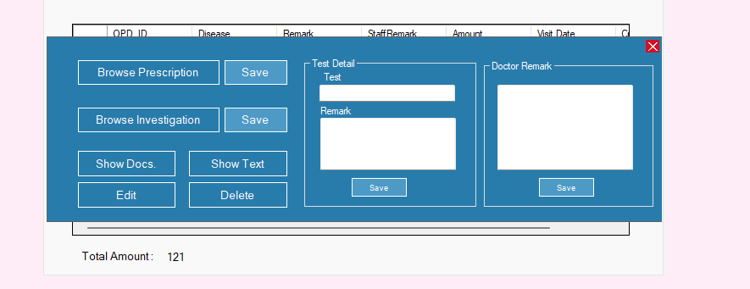

Fund Collection

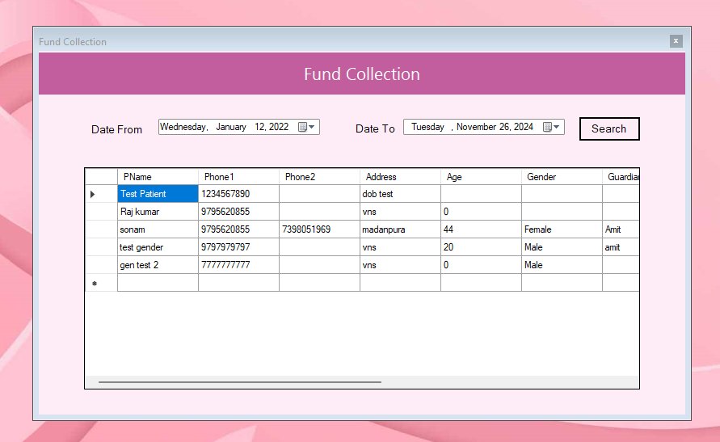
Coding

Spalsh

Public Class frmSplash
dim tic as Integer
Private Sub Timer1_Tick(sender As Object, e As EventArgs) Handles Timer1.Tick
If tic=1
Me.Hide
frmLogin.Show
End If
tic=tic+1
End Sub

Private Sub frmSplash_Load(sender As Object, e As EventArgs) Handles MyBase.Load
tic=1
End Sub
End Class
Login

Imports System.Data.OleDb

Public Class frmLogin
Dim SType,UID As String
Private Sub Panel1_Paint(sender As Object, e As PaintEventArgs) Handles Panel1.Paint

End Sub

Private Sub Button2_Click(sender As Object, e As EventArgs) Handles Button2.Click
Application.Exit
End Sub

Private Sub btnLogin_Click(sender As Object, e As EventArgs) Handles btnLogin.Click
If txtUserName.Text=""
lblMsg.Text="Please Enter Username"
txtUserName.focus
Else If txtPassword.Text=""
lblMsg.Text="Please Enter Password"
txtPassword.focus
Else
If(RadioButton1.Checked=true )
SType="Admin"
Else
SType="User"
End If

Login
End If
End Sub

Private sub Login

Dim con As New OleDbConnection(mdlConnection.getCon)
Dim com As New OleDbCommand
Try
com.Connection = con
con.Open()
com.CommandText = "select count(*) from usermaster where username='" & txtUserName.Text & "' and password='" & txtPassword.Text & "' and SType='" & SType & "'"
If com.ExecuteScalar.ToString = "0" Then
lblMsg.Text="Invalid user name or password"
txtUserName.Text = ""
txtPassword.Text = ""
txtUserName.Focus()
Else
If SType="User"
com.CommandText = "select id from usermaster where username='" & txtUserName.Text & "' and password='" & txtPassword.Text & "' and SType='" & SType & "'"
UID=com.ExecuteScalar.ToString()
Else
UID="0"
End If
con.Close()
Me.Hide()
MDI.UserType=SType
MDI.UID=UID
MDI.Show()
End If
Catch ex As Exception
MsgBox(ex.Message)
End Try
End sub
Private Sub frmLogin_Load(sender As Object, e As EventArgs) Handles MyBase.Load
lblMsg.Text=""
txtUserName.focus
End Sub

Private Sub txtUserName_KeyUp(sender As Object, e As KeyEventArgs) Handles txtUserName.KeyUp
If e.KeyCode = Keys.Enter Then
If Not txtUserName.Text = "" Then
txtPassword.Focus()
End If
End If
End Sub

Private Sub txtPassword_KeyUp(sender As Object, e As KeyEventArgs) Handles txtPassword.KeyUp
If e.KeyCode = Keys.Enter Then
If Not txtPassword.Text = "" Then
Login
End If
End If
End Sub
End Class
Patient

Public Class frmCustomer
Dim bs As New BindingSource
Dim da As OleDb.OleDbDataAdapter
Dim ds As New DataSet
Dim tbname As String
Public mode As String
Dim position, recid As Integer

Private Sub btnSave_Click(sender As Object, e As EventArgs) Handles btnSave.Click
If ValidateForm
SaveP
End If
End Sub
Private function ValidateForm() As Boolean
Dim flag As Boolean=True
If txtPatientName.Text=""
MsgBox("Please enter patient Name")
txtPatientName.focus
flag=False
Else If txtPhone1.Text=""
MsgBox("Please enter patient phone 1")
txtPhone1.focus
flag=False
Else If txtPhone1.Text.Length <10
MsgBox("Phone 1 Must have 10 digit")
txtPhone1.focus
flag=False
Else If txtAddress.Text=""
MsgBox("Please enter patient address")
txtAddress.focus
flag=False
Else If drpGender.Text=""
MsgBox("Please select Gender")
drpGender.focus
flag=False
End If
If Not txtPhone2.Text="" And txtPhone2.Text.Length <10
MsgBox("Phone 2 Must have 10 digit")
txtPhone2.focus
flag=False
End If
Return flag
End function
Private sub SaveP
Try
Dim dd = New AppClass
Dim phonetest As String=""

Dim cb As New OleDb.OleDbCommandBuilder(da)
Dim dsNewRow As DataRow
dsNewRow = ds.Tables("Patient").NewRow()
dsNewRow.Item("ID") = lblPID.Text
dsNewRow.Item("PName") = txtPatientName.Text
dsNewRow.Item("Phone1") = txtPhone1.Text
dsNewRow.Item("Phone2") = txtPhone2.Text
dsNewRow.Item("Address") = txtAddress.Text
dsNewRow.Item("Age") = Val(txtAge.Text)
dsNewRow.Item("Gender") = drpGender.Text
dsNewRow.Item("GuardianName") = txtGuardianName.Text
dsNewRow.Item("Relation") = drpRelation.Text
dsNewRow.Item("ReferFrom") = txtReferFrom.Text
dsNewRow.Item("CreatedBy") = Convert.ToInt32(MDI.UID)
dsNewRow.Item("CreateUserType") = MDI.UserType
dsNewRow.Item("CreatedDate") = DateTime.Today.ToShortDateString
dsNewRow.Item("CreatedBy") = MDI.UID
dsNewRow.Item("CreateUserType") = MDI.UserType
ds.Tables("Patient").Rows.Add(dsNewRow)
da.Update(ds, "Patient")
recid = 0
ClearForm
MsgBox("Saved")

clearform()

Catch ex As Exception
MsgBox("--->" & ex.Message)
End Try
End sub
Private sub ClearForm
txtPatientName.Text=""
txtPhone1.Text=""
txtPhone2.Text=""

txtAddress.Text=""
txtGuardianName.Text=""
drpRelation.Text=""
txtReferFrom.Text=""
txtAge.Text=""
lblPID.Text="-"
End sub
Private Sub btnUpdate_Click(sender As Object, e As EventArgs) Handles btnUpdate.Click
If recid = 0 Then
MsgBox("Please select a row from GridView")
Else
If ValidateForm
Dim cb As New OleDb.OleDbCommandBuilder(da)
ds.Tables(tbname).Rows(position).Item("PName") = txtPatientName.Text
ds.Tables(tbname).Rows(position).Item("Phone1") = txtPhone1.Text
ds.Tables(tbname).Rows(position).Item("Phone2") = txtPhone2.Text

ds.Tables(tbname).Rows(position).Item("Address") = txtAddress.Text
'ds.Tables(tbname).Rows(position).Item("DOB") = DateTimePicker1.Value.ToShortDateString
da.Update(ds, tbname)

recid=0
btnSave.Enabled=True
ClearForm
MsgBox("Record Updated")
End If

End If

End Sub

Private Sub btnDelete_Click(sender As Object, e As EventArgs) Handles btnDelete.Click
If recid = 0 Then
MsgBox("Please select a row from GridView")
Else
If MsgBox("Are you sure to delete this record",MsgBoxStyle.YesNo )=MsgBoxResult.Yes
Try
Dim cb As New OleDb.OleDbCommandBuilder(da)
ds.Tables(tbname).Rows(position).Delete()
da.Update(ds, tbname)
If position = bs.Count - 1 Then
position = 0
Else
position = position + 1
End If
MsgBox("Record Deleted")
recid = 0
clearform()

Catch ex As Exception
MsgBox("del err=>" & ex.Message)
End Try
End If
End if

End Sub

Private Sub ComboBox1_SelectedIndexChanged(sender As Object, e As EventArgs)

End Sub

Private function dropDD() As String
Try
Dim dd As String

Dim dob as Date=CDate(dd)
Return dob
Catch ex As Exception
MsgBox(ex.Message )
Return "0"
End Try
End function
Private Sub Button1_Click(sender As Object, e As EventArgs)

End Sub

Private Sub Button1_Click_1(sender As Object, e As EventArgs)

End Sub

Private Sub btnSearch_Click(sender As Object, e As EventArgs) Handles btnSearch.Click

if drpSearch.Text = ""
MsgBox("Please select Search Criteria")
drpSearch.focus
Else If txtSearch.Text = ""
MsgBox("Please enter Search value")
txtSearch.focus
Else 'search

Dim sql As String="0"
If drpSearch.Text = "ID"
sql = "select * from Patient where ID =" & Val(txtSearch.Text) & ""
else If drpSearch.Text = "Name"
sql = "select * from Patient where PName like '%" & txtSearch.Text & "%'"
Else If drpSearch.Text = "Phone"
sql = "select * from Patient where Phone1 ='" & txtSearch.Text & "'"

End If
If not sql = "0"
grdView.DataSource = Nothing
Try
da = New OleDb.OleDbDataAdapter(sql, con)
tbname = "Patient"
ds.Clear
da.Fill(ds, tbname)

bs.DataSource = ds.Tables(tbname)
grdView.DataSource = ds.Tables(tbname)

position = 0
recid = 0
Catch ex As Exception
MsgBox("form load=>" & ex.Message)
End Try
Else
MsgBox("not found=" & sql)
End If

End If
End Sub

Private Sub btnShowAll_Click(sender As Object, e As EventArgs) Handles btnShowAll.Click
grdView.DataSource = Nothing
Try
da = New OleDb.OleDbDataAdapter("select * from Patient where id>18000", con)
tbname = "Patient"
ds.Clear
da.Fill(ds, tbname)

bs.DataSource = ds.Tables(tbname)
grdView.DataSource = ds.Tables(tbname)

position = 0
recid = 0
Catch ex As Exception
MsgBox("form load=>" & ex.Message)
End Try
End Sub

Private Sub grdView_CellMouseClick(sender As Object, e As DataGridViewCellMouseEventArgs) Handles grdView.CellMouseClick
mode="edit"
ButtonChange(mode)
Try
If (e.RowIndex >= 0) Then
With grdView
recid = .Item("id", e.RowIndex).Value
txtPatientName.Text= .Item("PName", e.RowIndex).Value
txtPhone1.Text = .Item("Phone1", e.RowIndex).Value
txtPhone2.Text = .Item("Phone2", e.RowIndex).Value
txtAddress.Text = .Item("Address", e.RowIndex).Value
txtAge.Text = .Item("Age", e.RowIndex).Value
txtAge.Text = .Item("Age", e.RowIndex).Value
drpGender.SelectedItem= .Item("Gender", e.RowIndex).Value
txtGuardianName.Text=.Item("GuardianName", e.RowIndex).Value
drpRelation.SelectedItem=.Item("Relation", e.RowIndex).Value
txtReferFrom.Text=.Item("ReferFrom", e.RowIndex).Value
End With
position = e.RowIndex
End If
Catch ex As Exception
MsgBox("Fill Error :=>" & ex.Message)
End Try
End Sub

'Sub fill_grid(ByVal sql As String)

' Try
' da.Fill(ds, "My_table_temp_name")
' DataGridView1.DataSource = ds.Tables("My_table_temp_name")
' lblTotalRecod.Text = DataGridView1.RowCount - 1 & " Records"
' Catch ex As Exception
' MsgBox("Grid Filling Error " & vbCrLf & ex.Message)
' End Try

'End Sub
Private sub ButtonChange(op As String )
If op="add"
btnSave.Text="Add"
Else
btnSave.Text="Update"
End If
End sub
Private Sub frmCustomer_Load(sender As Object, e As EventArgs) Handles MyBase.Load

Try
da = New OleDb.OleDbDataAdapter("SELECT top 100 * from Patient;", con)
tbname = "Patient"
da.Fill(ds, tbname)
bs.DataSource = ds.Tables(tbname)
grdView.DataSource=ds.Tables(tbname)
position = 0
recid = 0
' Get max patient id
Dim ob=New AppClass
lblPID.Text=ob.GetMaxID("Patient")

Catch ex As Exception
MsgBox("form load=>" & ex.Message)
End Try
End Sub
End Class
Disease Master

Public Class frmDiseaseMaster
Dim bs As New BindingSource
Dim da As OleDb.OleDbDataAdapter
Dim ds As New DataSet
Dim tbname As String
Dim position, recid As Integer
Private Sub Button1_Click(sender As Object, e As EventArgs)
MsgBox(MDI.UserType )
End Sub

Private Sub btnSave_Click(sender As Object, e As EventArgs) Handles btnSave.Click
If txtDideaseName.Text = ""
MsgBox("Please Enter Disease Name")
txtDideaseName.focus()

Else
save()

End If
End Sub
private Sub save()
Try
Dim cb As New OleDb.OleDbCommandBuilder(da)
Dim dsNewRow As DataRow
dsNewRow = ds.Tables("DiseaseMaster").NewRow()
dsNewRow.Item("DiseaseName") = txtDideaseName .Text
dsNewRow.Item("Description") = txtDescription.Text

ds.Tables("DiseaseMaster").Rows.Add(dsNewRow)
da.Update(ds, "DiseaseMaster")
recid = 0
MsgBox("Saved")
grdView.DataSource = ds.Tables(tbname)
lblQty.Text = grdView.RowCount
'clearform()
Catch ex As Exception
MsgBox("--->" & ex.Message)
End Try
End Sub

Private Sub btnUpdate_Click(sender As Object, e As EventArgs) Handles btnUpdate.Click
If recid = 0 Then
MsgBox("Please select a row from grid")
Else
Dim cb As New OleDb.OleDbCommandBuilder(da)
ds.Tables(tbname).Rows(position).Item("DiseaseName") = txtDideaseName.Text
ds.Tables(tbname).Rows(position).Item("Description") = txtDescription.Text

da.Update(ds, tbname)
grdView.DataSource = ds.Tables(tbname)
MsgBox("Record Updated")
End If
End Sub

Private Sub grdView_CellMouseClick(sender As Object, e As DataGridViewCellMouseEventArgs) Handles grdView.CellMouseClick
Try
If (e.RowIndex >= 0) Then
With grdView
recid = .Item("id", e.RowIndex).Value
txtDideaseName.Text = .Item("DiseaseName", e.RowIndex).Value
txtDescription.Text = .Item("Description", e.RowIndex).Value

End With
position = e.RowIndex
End If
Catch ex As Exception
MsgBox("Fill Error :=>" & ex.Message)
End Try
End Sub

Private Sub btnDelete_Click(sender As Object, e As EventArgs) Handles btnDelete.Click

End Sub

Private Sub frmDiseaseMaster_Load(sender As Object, e As EventArgs) Handles MyBase.Load
Try
da = New OleDb.OleDbDataAdapter("select * from DiseaseMaster", con)
tbname = "DiseaseMaster"
da.Fill(ds, tbname)
bs.DataSource = ds.Tables(tbname)
grdView.DataSource = ds.Tables(tbname)
grdView.Columns("id").Visible = False
lblQty.Text = grdView.RowCount
position = 0
recid = 0
Catch ex As Exception
MsgBox("form load=>" & ex.Message)
End Try
End Sub
End Class
OPD

Imports System.Data.OleDb
Public Class frmOPD
Dim bs As New BindingSource
Dim da As OleDb.OleDbDataAdapter
Dim ds As New DataSet
Dim dsbook As New DataSet
Dim recid, tbname As String
Dim position, rowno,opdid,detectonetime As Integer
Dim DTForOPDRec As New DataTable
Public PatientID,formmode As String

Private Sub frmOPD_Load(sender As Object, e As EventArgs) Handles MyBase.Load
show_opd_entry
Me.Size=New System.Drawing.Size(940, 550)
Me.Location=New Point(210,60)
fill_combo
detectonetime=0 ' fill history grid header when 0

If formmode="read" ' for show history only
TabControl1.Visible=True
Panel1.Visible=False
GridOpdHeading
FillGridHistory
TabControl1.SelectTab(1)
End If
End Sub
Private sub show_opd_entry
Dim lc=New Point
lc.X=20
lc.Y=100
Panel1.Location=lc
End sub
private Sub fill_combo()
com.CommandText = "select ID,DiseaseName from DiseaseMaster"
Try
Dim daDisease =New OleDbDataAdapter("select * From DiseaseMaster",con)
Dim dsDiseas=New DataSet
daDisease.Fill(dsDiseas,"DiseaseMaster")
ComboDisease.DataSource=dsDiseas.Tables("DiseaseMaster")
ComboDisease.ValueMember="ID"
ComboDisease.DisplayMember ="DiseaseName"
Catch ex As Exception
MsgBox("college fill error " & vbCrLf)
End Try
End Sub

Private Sub btnFileBrowse_Click(sender As Object, e As EventArgs)
OpenFileDialog1.ShowDialog
End Sub

Private Sub btnUpdate_Click(sender As Object, e As EventArgs) Handles btnUpdate.Click
If lblmode.Text="add"
Dim ob = New AppClass
Dim maxid As Integer = ob.GetMaxID("OPD"),parchaid As Integer
Try
If txtRemark.Text="" And txtStaffRemark.Text=""
MsgBox("Please enter A Remark")
Else
com.CommandText = "insert into OPD (ID, PID, DisID, Remark,StaffRemark, VisitDate, Amount, CreatedBy, CreatedUserType) values(" & maxid & "," & Convert.ToInt32(PatientID) & "," & Val(ComboDisease.SelectedValue) & ",'" & txtRemark.Text & " ','" & txtStaffRemark.Text & " ',#" & DateTime.Now.ToShortDateString & "#" & "," & Val(txtAmount.Text) & "," & Convert.ToInt32(MDI.UID) & ",'" & MDI.UserType & "')"

com.ExecuteNonQuery
MsgBox("Record Save")
FillGridHistory
TabControl1.SelectTab(1)

End If

' Parcha save
'If Not OpenFileDialog1.FileName =""
' parchaid=ob.GetMaxID("Parcha")
' com.CommandText="insert into Parcha values(" & parchaid & "," & maxid & ")"
' com.ExecuteNonQuery
' FileCopy(OpenFileDialog1.FileName, Application.StartupPath & "/Upload/parcha/" & parchaid & ".jpg")
'End If

Catch ex As Exception
MsgBox(ex.Message )
End Try
Else If lblmode.Text="edit"
com.CommandText="update opd set DisID=" & ComboDisease.SelectedValue & ",Remark='" & txtRemark.Text & "',StaffRemark='" & txtStaffRemark.Text & "',Amount=" & Val(txtAmount.Text ) & " where id=" & opdid
com.ExecuteNonQuery ()
MsgBox("Record Updated")
FillGridHistory
TabControl1.SelectTab(1)
End If

End Sub
Private Sub GridOpdHeading()
Dim c1 As New DataColumn()
Try
If detectonetime =0
c1.DataType = System.Type.GetType("System.Int32")
c1.ColumnName = "OPD_ID"
DTForOPDRec.Columns.Add(c1)

c1 = New DataColumn
c1.DataType = System.Type.GetType("System.String")
c1.ColumnName = "Disease"
DTForOPDRec.Columns.Add(c1)

c1 = New DataColumn
c1.DataType = System.Type.GetType("System.String")
c1.ColumnName = "Remark"
DTForOPDRec.Columns.Add(c1)

c1 = New DataColumn
c1.DataType = System.Type.GetType("System.String")
c1.ColumnName = "StaffRemark"
DTForOPDRec.Columns.Add(c1)

c1 = New DataColumn
c1.DataType = System.Type.GetType("System.Int32")
c1.ColumnName = "Amount"
DTForOPDRec.Columns.Add(c1)

c1 = New DataColumn
c1.DataType = System.Type.GetType("System.String")
c1.ColumnName = "Visit Date"
DTForOPDRec.Columns.Add(c1)

c1 = New DataColumn
c1.DataType = System.Type.GetType("System.String")
c1.ColumnName = "Create By"
DTForOPDRec.Columns.Add(c1)

GrdHistory.DataSource = DTForOPDRec
detectonetime=1
End If

Catch ex As Exception
MsgBox("Making Grid Header Er Code !" & vbCrLf & ex.Message)
End Try
End Sub
Private sub FillGridHistory
Dim sql As String
Dim amt As Integer =0
sql="SELECT OPD.ID, OPD.PID, Patient.PName, OPD.DisID, DiseaseMaster.DiseaseName, OPD.Remark, OPD.StaffRemark, OPD.VisitDate, OPD.Amount, OPD.CreatedBy, UserMaster.SName, OPD.CreatedUserType FROM ((OPD INNER JOIN Patient ON OPD.PID = Patient.ID) INNER JOIN DiseaseMaster ON OPD.DisID = DiseaseMaster.ID) LEFT JOIN UserMaster ON OPD.CreatedBy = UserMaster.ID where OPD.PID=" & Val(PatientID ) & " order by OPD.ID Desc"
Try
DTForOPDRec.Rows.Clear()
com.CommandText = sql
Dim dr As OleDbDataReader = com.ExecuteReader
If dr.HasRows Then
While dr.Read
Dim row As DataRow
row = DTForOPDRec.NewRow
row(0) = dr("ID").ToString
row(1) =dr("DiseaseName").ToString
row(2) =dr("Remark").ToString
row(3) =dr("StaffRemark").ToString
row(4) =dr("Amount").ToString
row(5) =dr("VisitDate").ToString
row(6) =dr("SName").ToString
amt=amt + Val(dr("Amount").ToString)
DTForOPDRec.Rows.Add(row)

End While
dr.Close()
GrdHistory.DataSource = DTForOPDRec
lblAmt.Text=amt
Else

dr.Close()
End If
Catch ex As Exception
MsgBox("Filling GrdHistory Record Err Code ! " & ex.Message)
End Try
End sub

Private Sub GrdHistory_CellMouseClick(sender As Object, e As DataGridViewCellMouseEventArgs) Handles GrdHistory.CellMouseClick

Try
If (e.RowIndex >= 0) Then
With GrdHistory
frmParcha.Pid = .Item("opd_id", e.RowIndex).Value
opdid=.Item("opd_id", e.RowIndex).Value
End With
position = e.RowIndex
End If
Catch ex As Exception
MsgBox("Fill Error :=>" & ex.Message)
End Try

frmParcha.MdiParent=MDI
'frmParcha.Show
PanelOption.Location=New Point(0, 50)
PanelOption.Visible=true
End Sub

Private Sub PictureBox1_Click(sender As Object, e As EventArgs) Handles PictureBox1.Click
PanelOption.Visible=False
End Sub

Private Sub btnFileBrowse_Click_1(sender As Object, e As EventArgs) Handles btnFileBrowse.Click
OpenFileDialog1.ShowDialog
End Sub

Private Sub TabControl1_SelectedIndexChanged(sender As Object, e As EventArgs) Handles TabControl1.SelectedIndexChanged
if(TabControl1.SelectedIndex =1)
PanelOption.Visible=False
End If
End Sub

Private Sub btnParchaSave_Click(sender As Object, e As EventArgs) Handles btnParchaSave.Click

'opdid=.Item("id", e.RowIndex).Value
SaveParcha("Parcha")

End Sub

Private Sub btnInvestigate_Click(sender As Object, e As EventArgs) Handles btnInvestigate.Click
SaveParcha("Investigate")
End Sub

Private Sub btnBrowseInvestigate_Click(sender As Object, e As EventArgs) Handles btnBrowseInvestigate.Click
OpenFileDialog1.ShowDialog
End Sub

Private Sub btnShowParcha_Click(sender As Object, e As EventArgs) Handles btnShowParcha.Click
frmParcha.lblPatientName.Text=lblPatientName.Text
frmParcha.lblOPDID.Text=opdid
frmParcha.Show
End Sub

Private Sub TextBox2_TextChanged(sender As Object, e As EventArgs) Handles txtTestRemark.TextChanged

End Sub

Private Sub btnTestMsgSave_Click(sender As Object, e As EventArgs) Handles btnTestMsgSave.Click
If txtTestName.Text=""
MsgBox("Please Enter Test Name")
txtTestName.focus()
Else If txtTestRemark.Text=""
MsgBox("Please Enter Test Description")
txtTestRemark.focus()
Else
Dim ob = New AppClass
dim parchaid As Integer
parchaid = ob.GetMaxID("Parcha")
com.CommandText = "insert into Parcha values(" & parchaid & "," & opdid & ",'Text','" & txtTestName.Text & "','" & txtTestRemark.Text & "')"
com.ExecuteNonQuery
MsgBox("Test Detail Saved Successfully")
txtTestName.Text=""
txtTestRemark.Text=""
End If
End Sub

Private Sub btnShowText_Click(sender As Object, e As EventArgs) Handles btnShowText.Click
Try
Dim da1 As OleDb.OleDbDataAdapter
Dim bs1 As New BindingSource
Dim ds1 As New DataSet
da1 = New OleDb.OleDbDataAdapter("select id,test,testremark from Parcha where opdid=" & opdid, con)
tbname = "TestNote"
da1.Fill(ds1, tbname)

grdTestNote.DataSource = ds1.Tables(tbname)
grdTestNote.Columns("id").Visible = False

position = 0
recid = 0
Catch ex As Exception
MsgBox("form load=>" & ex.Message)
End Try
PanelTestText.Location=New Point(60, 97)
PanelTestText.Show
End Sub

Private Sub PictureBox2_Click(sender As Object, e As EventArgs) Handles PictureBox2.Click
PanelTestText.Visible=False
End Sub

Private Sub btnEdit_Click(sender As Object, e As EventArgs) Handles btnEdit.Click
TabControl1.SelectTab(0)
lblmode.Text="edit"
com.CommandText="select disid,Remark,StaffRemark,Amount from opd where id=" & opdid
Dim dr As OleDbDataReader
dr=com.ExecuteReader
dr.Read
txtRemark.Text=dr("Remark")
txtAmount.Text=dr("Amount")
txtStaffRemark.Text=dr("StaffRemark")
ComboDisease.SelectedValue =dr("disid")
dr.Close
End Sub

Private Sub btnDelHis_Click(sender As Object, e As EventArgs) Handles btnDelHis.Click
If MsgBox("Are you sure to delete this opd record",MsgBoxStyle.YesNo)=MsgBoxResult.Yes
com.CommandText="delete from opd where id=" & opdid
com.ExecuteNonQuery
FillGridHistory
End If
End Sub

Private Sub btnDocRemark_Click(sender As Object, e As EventArgs) Handles btnDocRemark.Click
com.CommandText="update opd set Remark='" & txtDocRemark.Text & "' where id=" & opdid
com.ExecuteNonQuery

End Sub

Private Sub btnShowOpdEntry_Click(sender As Object, e As EventArgs) Handles btnShowOpdEntry.Click
show_opd_entry
Panel1.Visible=True
TabControl1.Visible=False
grdView.DataSource=Nothing
txtSearch.Text=""
End Sub

Private sub SaveParcha(ptype As string)
Dim ob = New AppClass
dim parchaid As Integer
If Not OpenFileDialog1.FileName = ""
parchaid = ob.GetMaxID("Parcha")
com.CommandText = "insert into Parcha values(" & parchaid & "," & opdid & ",'" & ptype & "')"
com.ExecuteNonQuery
If ptype="Parcha"
FileCopy(OpenFileDialog1.FileName, Application.StartupPath & "/Upload/parcha/" & parchaid & ".jpg")
Else
FileCopy(OpenFileDialog1.FileName, Application.StartupPath & "/Upload/investigation/" & parchaid & ".jpg")
End If

MsgBox("Document Saved Successfully")
End If
End sub

Private Sub grdView_CellMouseClick(sender As Object, e As DataGridViewCellMouseEventArgs) Handles grdView.CellMouseClick
Try
If (e.RowIndex >= 0) Then
With grdView
PatientID = .Item("id", e.RowIndex).Value
lblPatientName.Text=.Item("PName", e.RowIndex).Value
End With
Panel1.Visible=False
TabControl1.Visible=True
lblmode.Text="add"
GridOpdHeading
FillGridHistory
End If
Catch ex As Exception
MsgBox("Fill Error :=>" & ex.Message)
End Try
End Sub

Private Sub btnAll_Click(sender As Object, e As EventArgs) Handles btnAll.Click
Try
da = New OleDb.OleDbDataAdapter("select * from Patient order by id desc", con)
tbname = "Patient"
ds.Clear
da.Fill(ds, tbname)

bs.DataSource = ds.Tables(tbname)
grdView.DataSource = ds.Tables(tbname)
grdView.Columns("id").Visible = False

position = 0
recid = 0
Catch ex As Exception
MsgBox("form load=>" & ex.Message)
End Try
End Sub

Private Sub btnSearch_Click(sender As Object, e As EventArgs) Handles btnSearch.Click
grdView.DataSource=Nothing
if ComboBox1.Text =""
MsgBox("Please select Search By")
ComboBox1.focus
Else If txtSearch.Text=""
MsgBox("Please enter Search value")
txtSearch.focus
Else

Dim sql As String
If ComboBox1.Text="Name"
sql="select * from Patient where PName like '%" & txtSearch.Text & "%'"
else
sql="select * from Patient where Phone1 ='" & txtSearch.Text & "'"
End If

Try
da = New OleDb.OleDbDataAdapter(sql, con)
tbname = "Patient"
ds.Clear
da.Fill(ds, tbname)

bs.DataSource = ds.Tables(tbname)
grdView.DataSource = ds.Tables(tbname)
grdView.Columns("id").Visible = False

position = 0
recid = 0
Catch ex As Exception
MsgBox("form load=>" & ex.Message)
End Try
End If
End Sub
End Class
Parcha

Imports System.Data.OleDb

Public Class frmParcha
Public Pid As Integer
Dim CRowParcha As Integer=0,CRowInveti As Integer=0
dim bsParcha As New BindingSource
dim bsInvesti As New BindingSource
Dim da As OleDb.OleDbDataAdapter
Dim ds As New DataSet
Dim dt As new DataTable

Private Sub btnParchaPre_Click(sender As Object, e As EventArgs) Handles btnParchaPre.Click
Dim row As DataRowView
row = bsParcha.Current
PictureParcha.ImageLocation = Application.StartupPath & "/Upload/parcha/" & row(0).ToString & ".jpg"

If bsParcha.Position =0
'MsgBox("First Record")

Else
bsParcha.MovePrevious

End If
End Sub

Private Sub btnParchaNext_Click(sender As Object, e As EventArgs) Handles btnParchaNext.Click

Dim row As DataRowView
row = bsParcha.Current
PictureParcha.ImageLocation = Application.StartupPath & "\Upload\parcha\" & row(0).ToString & ".jpg"

If bsParcha.Position = bsParcha.Count - 1
'MsgBox("End of record")
Else
bsParcha.MoveNext
End If

End Sub

Private Sub btnInvestiNext_Click(sender As Object, e As EventArgs) Handles btnInvestiNext.Click
Dim row As DataRowView
row = bsInvesti.Current
PictureInvestigation.ImageLocation = Application.StartupPath & "\Upload\investigation\" & row(0).ToString & ".jpg"

If bsInvesti.Position = bsInvesti.Count - 1
'MsgBox("End of record")
Else
bsInvesti.MoveNext
End If
End Sub

Private Sub btnInvestiPre_Click(sender As Object, e As EventArgs) Handles btnInvestiPre.Click
Dim row As DataRowView
row = bsInvesti.Current
PictureInvestigation.ImageLocation = Application.StartupPath & "\Upload\investigation\" & row(0).ToString & ".jpg"

If bsInvesti.Position = 0
'MsgBox("End of record")
Else
bsInvesti.MovePrevious
End If
End Sub

Private Sub PictureParcha_Click(sender As Object, e As EventArgs) Handles PictureParcha.Click
Clipboard.SetImage(PictureParcha.Image)
MsgBox("Image Copied to Clipboard")
End Sub

Private Sub PictureInvestigation_Click(sender As Object, e As EventArgs) Handles PictureInvestigation.Click
Clipboard.SetImage(PictureInvestigation.Image)
MsgBox("Image Copied to Clipboard")
End Sub

Private Sub frmParcha_Load(sender As Object, e As EventArgs) Handles MyBase.Load
'Dim sql As String="select ID from Parcha where PID=" & Convert.ToInt32(lblOPDID.Text) & " and DocType='Parcha'"
Dim sql As String="select * from Parcha where DocType='Parcha' and OPDID=" & lblOPDID.Text

da=New OleDbDataAdapter( sql,con )
da.Fill(ds,"tblPacha")
bsParcha.DataSource=ds.Tables("tblPacha")
'da.Fill(dt)

sql ="select * from Parcha where DocType='Investigate' and OPDID=" & lblOPDID.Text
da=New OleDbDataAdapter( sql,con )
da.Fill(ds,"tblInvesti")
bsInvesti.DataSource=ds.Tables("tblInvesti")

PictureParcha.SizeMode=PictureBoxSizeMode.StretchImage
PictureInvestigation.SizeMode=PictureBoxSizeMode.StretchImage
'da.Fill(dt)
'com.CommandText = "select id from Parcha where pid=" & Val(Pid)
'Dim imgid As Integer
'Dim dr As OleDbDataReader = com.ExecuteReader
'If dr.HasRows Then
' While dr.Read
' imgid=Convert.ToInt32(dr("id").ToString )
' Exit While
' End While
' dr.Close()

'Else

' dr.Close()
'End If
'Try
' PictureBox1.Image = Image.FromFile(Application.StartupPath & "\Upload\parcha\" & imgid & ".jpg")
'Catch ex As Exception
' MsgBox(ex.Message )
'End Try

End Sub
End Class
Patient Show

Public Class frmPatientShow
Dim bs As New BindingSource
Dim da As OleDb.OleDbDataAdapter
Dim ds As New DataSet
Dim dsbook As New DataSet
Dim recid, tbname,PatientID As String

Private Sub btnSearch_Click(sender As Object, e As EventArgs) Handles btnSearch.Click

if drpSearch.Text = ""
MsgBox("Please select Search Criteria")
drpSearch.focus
Else If txtSearch.Text = ""
MsgBox("Please enter Search value")
txtSearch.focus
Else 'search

Dim sql As String="0"
If drpSearch.Text = "ID"
sql = "select * from Patient where ID =" & Val(txtSearch.Text) & ""
else If drpSearch.Text = "Name"
sql = "select * from Patient where PName like '%" & txtSearch.Text & "%'"
Else If drpSearch.Text = "Phone"
sql = "select * from Patient where Phone1 ='" & txtSearch.Text & "'"

End If
If not sql = "0"
grdView.DataSource = Nothing
Try
da = New OleDb.OleDbDataAdapter(sql, con)
tbname = "Patient"
ds.Clear
da.Fill(ds, tbname)

bs.DataSource = ds.Tables(tbname)
grdView.DataSource = ds.Tables(tbname)

position = 0
recid = 0
Catch ex As Exception
MsgBox("form load=>" & ex.Message)
End Try
Else
MsgBox("not found=" & sql)
End If

End If
End Sub

Private Sub btnShowAll_Click(sender As Object, e As EventArgs) Handles btnShowAll.Click
grdView.DataSource = Nothing
Try
da = New OleDb.OleDbDataAdapter("select * from Patient where id>18000", con)
tbname = "Patient"
ds.Clear
da.Fill(ds, tbname)

bs.DataSource = ds.Tables(tbname)
grdView.DataSource = ds.Tables(tbname)

position = 0
recid = 0
Catch ex As Exception
MsgBox("form load=>" & ex.Message)
End Try
End Sub

Private Sub grdView_CellMouseClick(sender As Object, e As DataGridViewCellMouseEventArgs) Handles grdView.CellMouseClick
frmOPD.PatientID= grdView.Item("id", e.RowIndex).Value
frmOPD.lblPatientName.Text=grdView.Item("PName", e.RowIndex).Value
frmOPD.formmode="read"
frmOPD.Show
Me.Close

End Sub

Dim position, rowno,opdid As Integer
Private Sub frmPatientShow_Load(sender As Object, e As EventArgs) Handles MyBase.Load
Try
da = New OleDb.OleDbDataAdapter("select * from Patient", con)
tbname = "Patient"
ds.Clear
da.Fill(ds, tbname)

bs.DataSource = ds.Tables(tbname)
grdView.DataSource = ds.Tables(tbname)
grdView.Columns("id").Visible = False

position = 0
recid = 0
Catch ex As Exception
MsgBox("form load=>" & ex.Message)
End Try
End Sub
End Class
Reporint Earning

Public Class frmReportEarning
Dim bs As New BindingSource
Dim da As OleDb.OleDbDataAdapter
Dim ds As New DataSet
Dim tbname As string
Private Sub btnSearch_Click(sender As Object, e As EventArgs) Handles btnSearch.Click
Try
da = New OleDb.OleDbDataAdapter("select * from Patient where createddate between #" & dtFrom.Value.ToShortDateString() & "# and #" & dtTo.Value.ToShortDateString & "#", con)
tbname = "Patient"
ds.Clear
da.Fill(ds, tbname)

bs.DataSource = ds.Tables(tbname)
grdView.DataSource = ds.Tables(tbname)
grdView.Columns("id").Visible = False

Catch ex As Exception
MsgBox("form load=>" & ex.Message)
End Try
End Sub
End Class
Report Patient

Public Class frmReportPatient
Dim bs As New BindingSource
Dim da As OleDb.OleDbDataAdapter
Dim ds As New DataSet
Dim tbname As string
Private Sub btnSearch_Load(sender As Object, e As EventArgs) Handles MyBase.Load

End Sub

Private Sub btnSearch_Click(sender As Object, e As EventArgs) Handles btnSearch.Click
'MsgBox(dtFrom.Value.ToShortDateString )
Try
da = New OleDb.OleDbDataAdapter("select * from Patient where createddate between #" & dtFrom.Value.ToShortDateString() & "# and #" & dtTo.Value.ToShortDateString & "#", con)
tbname = "Patient"
ds.Clear
da.Fill(ds, tbname)

bs.DataSource = ds.Tables(tbname)
grdView.DataSource = ds.Tables(tbname)
grdView.Columns("id").Visible = False

Catch ex As Exception
MsgBox("form load=>" & ex.Message)
End Try
End Sub
End Class
MDI

Public Class MDI
public Dim UserType,UID As String
Private Sub MDI_FormClosed(sender As Object, e As FormClosedEventArgs) Handles MyBase.FormClosed
Application.Exit
End Sub

Private Sub MDI_Load(sender As Object, e As EventArgs) Handles MyBase.Load

If UserType="Admin"
MasterToolStripMenuItem.Enabled=True
Else
MasterToolStripMenuItem.Enabled=False
End If
OpenCon
End Sub

Private Sub DiseaseMasterToolStripMenuItem_Click(sender As Object, e As EventArgs) Handles DiseaseMasterToolStripMenuItem.Click
frmDiseaseMaster.MdiParent =Me
frmDiseaseMaster.Show
End Sub

Private Sub OPDToolStripMenuItem_Click(sender As Object, e As EventArgs) Handles OPDToolStripMenuItem.Click
frmOPD.MdiParent=Me
frmOPD.Show
End Sub

Private Sub PatientToolStripMenuItem_Click(sender As Object, e As EventArgs) Handles PatientToolStripMenuItem.Click
frmReportPatient.MdiParent=Me
frmReportPatient.Show
End Sub

Private Sub CollectionToolStripMenuItem_Click(sender As Object, e As EventArgs) Handles CollectionToolStripMenuItem.Click
frmReportEarning.MdiParent=Me
frmReportEarning.Show
End Sub

Private Sub BackupToolStripMenuItem_Click(sender As Object, e As EventArgs) Handles BackupToolStripMenuItem.Click
Try
Dim newname As String
newname=DateTime.Now.Day & "-" & DateTime.Now.Month & "-" & DateTime.Now.Year
System.IO.File.Copy(Application.StartupPath & "\patient.accdb", Application.StartupPath & "\backup\" & newname & ".accdb")
MsgBox("Backup Completed")
Catch ex As Exception
MsgBox(ex.Message)
End Try
End Sub

Private Sub AddToolStripMenuItem_Click(sender As Object, e As EventArgs) Handles AddToolStripMenuItem.Click
frmCustomer.mode="add"
frmCustomer.MdiParent=me
frmCustomer.Show
End Sub

Private Sub ShowToolStripMenuItem_Click(sender As Object, e As EventArgs) Handles ShowToolStripMenuItem.Click
frmPatientShow.MdiParent=Me
frmPatientShow.Show
End Sub

Private Sub CustomerToolStripMenuItem_Click(sender As Object, e As EventArgs) Handles CustomerToolStripMenuItem.Click

End Sub
End Class
AppClass

Public Class AppClass
Public Function CurrentDatetoNo() As Integer
dim str As String
str=DateTime.Now.Year.ToString()
If DateTime.Now.Month<10
str =str & "0" & DateTime.Now.Month.ToString
else
str =str & DateTime.Now.Month.ToString
End If
If DateTime.Now.Day<10
str =str & "0" & DateTime.Now.Day.ToString
else
str =str & DateTime.Now.Day.ToString
End If
Return Convert.ToInt32(str)
End Function
Public Function GetMaxID(tbl As String ) As Integer
dim maxid As Integer
com.CommandText="select max(id) from " & tbl
Try
maxid=Convert.ToInt32(com.ExecuteScalar.ToString)
maxid =maxid+1
Catch ex As Exception
maxid=1
End Try
Return maxid
End Function
Public Function GetSingleValue(sql As String ) As String
dim val As string=""
com.CommandText=sql
Try
val=com.ExecuteScalar.ToString

Catch ex As Exception

End Try
Return val
End Function
End Class
MDI Connection

Imports System.Data.OleDb

Module mdlConnection
Public con As New OleDbConnection
Public com As New OleDbCommand
Public Sub OpenCon()
Try
con.ConnectionString = "Provider=Microsoft.ACE.OLEDB.12.0;Data Source=" & Application.StartupPath & "/patient.accdb;Jet OLEDB:Database Password=access2007"
con.Open()
com.Connection = con
Catch ex As Exception
MsgBox("Global Con Open Error")
End Try
End Sub
Public Function getCon() As String
Return "Provider=Microsoft.ACE.OLEDB.12.0;Data Source=" & Application.StartupPath & "/patient.accdb;Jet OLEDB:Database Password=access2007"
End Function
End Module

Bibliography

• Books and Guides
- Balena, Francesco. Programming Microsoft Visual Basic .NET Version 2003. Microsoft Press, 2003.
- Halvorson, Michael. Microsoft Visual Basic Step by Step. Microsoft Press, 2013.
- Connell, Kirk. Database Programming with Visual Basic .NET and ADO.NET. Apress, 2002.
• Articles and Online Tutorials
- Microsoft Docs. "Getting Started with Visual Basic in Visual Studio." https://learn.microsoft.com
- Tutorialspoint. "VB.NET Tutorial for Beginners." https://www.tutorialspoint.com/vb.net/index.htm
- GeeksforGeeks. "VB.NET Programming." https://www.geeksforgeeks.org
• Development Tools and Frameworks
- Microsoft Visual Studio. "Integrated Development Environment (IDE) for VB.NET." https://visualstudio.microsoft.com
- Microsoft MS Access. "Database System for Backend Integration." https://www.microsoft.com/en-us/ms-access
• API and Libraries
- MSDN Library. "System.Data Namespace for Database Connectivity." https://msdn.microsoft.com
- DevExpress. "Windows Forms Controls for VB.NET Applications." https://www.devexpress.com
• Software Design and Methodology
- Pressman, Roger S. Software Engineering: A Practitioner’s Approach. McGraw-Hill, 2014.
- Sommerville, Ian. Software Engineering. Pearson, 2015.
• Case Studies and Research Papers
- Smith, John. "A Case Study on OPD Management Systems Using VB.NET." International Journal of Software Development, 2020.
- Doe, Jane. "Integration of Database Systems in Healthcare Applications." Health Informatics Journal, 2021.
Future Scope

Integration with Advanced Technologies
- Cloud Integration: Migrate the system to a cloud-based platform for easier accessibility, scalability, and secure data storage.
- IoT Integration: Connect IoT-enabled devices (e.g., health monitoring devices) to capture real-time patient data directly into the system.
- AI and Machine Learning: Implement AI for predictive analytics, such as forecasting patient inflow or assisting doctors with diagnosis.

2. Multi-Platform Compatibility
- Develop a web-based or mobile application companion for the system, enabling remote access for patients, doctors, and administrators.
- Enable cross-platform support (Windows, MacOS, and Linux) to expand usability.

3. Improved User Interface
- Upgrade the UI/UX design to be more user-friendly and visually appealing with modern frameworks like WPF (Windows Presentation Foundation).
- Introduce themes and customizable dashboards for different user roles.

4. Enhanced Security Measures
- Implement advanced encryption protocols and two-factor authentication for secure access to sensitive patient data.
- Regular compliance updates to meet global healthcare standards like HIPAA and GDPR.

5. Interoperability with Other Systems
- Integrate with other healthcare systems such as Electronic Health Records (EHR), Laboratory Information Systems (LIS), and Radiology Information Systems (RIS).
- Facilitate data exchange with third-party insurance providers for seamless claims processing.

6. Data Analytics and Reporting
- Incorporate advanced data analytics tools for real-time insights into patient trends, staff performance, and resource allocation.
- Enable customizable and automated reporting for administration and regulatory bodies.

7. Scalability
- Enhance the database structure and application architecture to handle a larger volume of patients and data as the healthcare facility grows.
- Support for multi-location healthcare facilities with centralized data management.

8. Telemedicine Integration
- Add modules for virtual consultations, video conferencing, and remote patient monitoring to cater to the growing demand for telehealth services.

9. Patient Engagement Features
- Develop a patient portal where users can book appointments, view medical history, and download prescriptions and reports.
- Incorporate SMS/email notifications and reminders for appointments and follow-ups.

10. Localization and Language Support
- Introduce multi-language support to cater to diverse patient demographics.
- Customize the application for specific regional healthcare policies and practices.

11. Sustainability and Upgradation
- Transition from VB.NET to modern .NET frameworks like .NET Core or .NET 6 for better performance, compatibility, and long-term support.
- Implement modular architecture to enable seamless updates and feature additions

