**Exercise 2.4.1a**

R1 := σspeed ≥ 3.00 (PC)

R2 := πmodel(R1)

|  |
| --- |
| model |
| 1005 |
| 1006 |
| 1013 |

**Exercise 2.4.1b**

R1 := σhd ≥ 100 (Laptop)

R2 := Product  (R1)

R3 := πmaker (R2)

|  |
| --- |
| maker |
| E |
| A |
| B |
| F |
| G |

**Exercise 2.4.1c**

R1 := σmaker=B (Product  PC)

R2 := σmaker=B (Product  Laptop)

R3 := σmaker=B (Product  Printer)

R4 := πmodel,price (R1)

R5 := πmodel,price (R2)

R6: = πmodel,price (R3)

R7 := R4  R5  R6

|  |  |
| --- | --- |
| model | price |
| 1004 | 649 |
| 1005 | 630 |
| 1006 | 1049 |
| 2007 | 1429 |

**Exercise 2.4.1d**

R1 := σcolor = true AND type = laser (Printer)

R2 := πmodel (R1)

|  |
| --- |
| model |
| 3003 |
| 3007 |

**Exercise 2.4.1e**

R1 := σtype=laptop (Product)

R2 := σtype=PC(Product)

R3 := πmaker(R1)

R4 := πmaker(R2)

R5 := R3 – R4

|  |
| --- |
| maker |
| F |
| G |

**Exercise 2.4.1f**

R1 := ρPC1(PC)

R2 := ρPC2(PC)

R3 := R1  (PC1.hd = PC2.hd AND PC1.model <> PC2.model) R2

R4 := πhd(R3)

|  |
| --- |
| hd |
| 250 |
| 80 |
| 160 |

**Exercise 2.4.1g**

R1 := ρPC1(PC)

R2 := ρPC2(PC)

R3 := R1  (PC1.speed = PC2.speed AND PC1.ram = PC2.ram AND PC1.model < PC2.model) R2

R4 := πPC1.model,PC2.model(R3)

|  |  |
| --- | --- |
| PC1.model | PC2.model |
| 1004 | 1012 |

**Exercise 2.4.1h**

R1 := πmodel(σspeed ≥ 2.80(PC))  πmodel(σspeed ≥ 2.80(Laptop))

R2 := πmaker,model(R1  Product)

R3 := ρR3(maker2,model2)(R2)

R4 := R2  (maker = maker2 AND model <> model2) R3

R5 := πmaker(R4)

|  |
| --- |
| maker |
| B |
| E |

**Exercise 2.4.1i**

R1 := πmodel,speed(PC)

R2 := πmodel,speed(Laptop)

R3 := R1  R2

R4 := ρR4(model2,speed2)(R3)

R5 := πmodel,speed (R3  (speed < speed2 ) R4)

R6 := R3 – R5

R7 := πmaker(R6  Product)

|  |
| --- |
| maker |
| B |

**Exercise 2.4.1j**

R1 := πmaker,speed(Product  PC)

R2 := ρR2(maker2,speed2)(R1)

R3 := ρR3(maker3,speed3)(R1)

R4 := R1  (maker = maker2 AND speed <> speed2) R2

R5 := R4  (maker3 = maker AND speed3 <> speed2 AND speed3 <> speed) R3

R6 := πmaker(R5)

|  |
| --- |
| maker |
| A |
| D |
| E |

**Exercise 2.4.1k**

R1 := πmaker,model(Product  PC)

R2 := ρR2(maker2,model2)(R1)

R3 := ρR3(maker3,model3)(R1)

R4 := ρR4(maker4,model4)(R1)

R5 := R1  (maker = maker2 AND model <> model2) R2

R6 := R3  (maker3 = maker AND model3 <> model2 AND model3 <> model) R5

R7 := R4  (maker4 = maker AND (model4=model OR model4=model2 OR model4=model3)) R6

R8 := πmaker(R7)

|  |
| --- |
| maker |
| A |
| B |
| D |
| E |

**Exercise 2.4.3a**

R1 := σbore ≥ 16 (Classes)

R2 := πclass,country (R1)

|  |  |
| --- | --- |
| class | country |
| Iowa | USA |
| North Carolina | USA |
| Yamato | Japan |

**Exercise 2.4.3b**

R1 := σlaunched < 1921 (Ships)

R2 := πname (R1)

|  |
| --- |
| name |
| Haruna |
| Hiei |
| Kirishima |
| Kongo |
| Ramillies |
| Renown |
| Repulse |
| Resolution |
| Revenge |
| Royal Oak |
| Royal Sovereign |
| Tennessee |

**Exercise 2.4.3c**

R1 := σbattle=Denmark Strait AND result=sunk(Outcomes)

R2 := πship (R1)

|  |
| --- |
| ship |
| Bismarck |
| Hood |

**Exercise 2.4.3d**

R1 := Classes  Ships

R2 := σlaunched > 1921 AND displacement > 35000 (R1)

R3 := πname (R2)

|  |
| --- |
| name |
| Iowa |
| Missouri |
| Musashi |
| New Jersey |
| North Carolina |
| Washington |
| Wisconsin |
| Yamato |

**Exercise 2.4.3e**

R1 := σbattle=Guadalcanal(Outcomes)

R2 := Ships  (ship=name) R1

R3 := Classes  R2

R4 := πname,displacement,numGuns(R3)

|  |  |  |
| --- | --- | --- |
| name | displacement | numGuns |
| Kirishima | 32000 | 8 |
| Washington | 37000 | 9 |

**Exercise 2.4.3f**

R1 := πname(Ships)

R2 := πship(Outcomes)

R3 := ρR3(name)(R2)

R4 := R1  R3

|  |
| --- |
| name |
| California |
| Haruna |
| Hiei |
| Iowa |
| Kirishima |
| Kongo |
| Missouri |
| Musashi |
| New Jersey |
| North Carolina |
| Ramillies |
| Renown |
| Repulse |
| Resolution |
| Revenge |
| Royal Oak |
| Royal Sovereign |
| Tennessee |
| Washington |
| Wisconsin |
| Yamato |
| Arizona |
| Bismarck |
| Duke of York |
| Fuso |
| Hood |
| King George V |
| Prince of Wales |
| Rodney |
| Scharnhorst |
| South Dakota |
| West Virginia |
| Yamashiro |

**Exercise 2.4.3g**

From 2.3.2, assuming that every class has one ship named after the class.

R1 := πclass(Classes)

R2 := πclass(σname <> class(Ships))

R3 := R1 – R2

|  |
| --- |
| class |
| Bismarck |

**Exercise 2.4.3h**

R1 := πcountry(σtype=bb(Classes))

R2 := πcountry(σtype=bc(Classes))

R3 := R1 ∩ R2

|  |
| --- |
| country |
| Japan |
| Gt. Britain |

**Exercise 2.4.3i**

R1 := πship,result,date(Battles  (battle=name) Outcomes)

R2 := ρR2(ship2,result2,date2)(R1)

R3 := R1  (ship=ship2 AND result=damaged AND date < date2) R2

R4 := πship(R3)

No results from sample data.

4.1.3

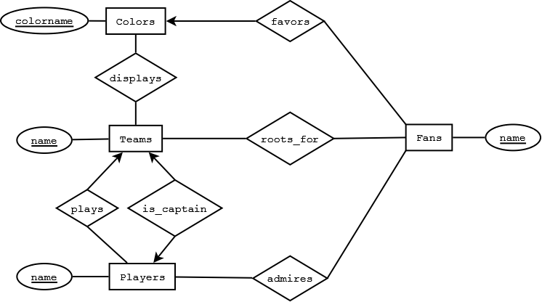

4.1.4

a)

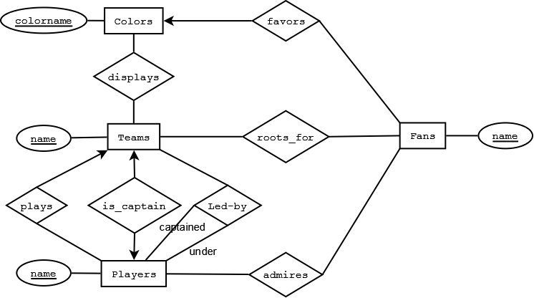

b)

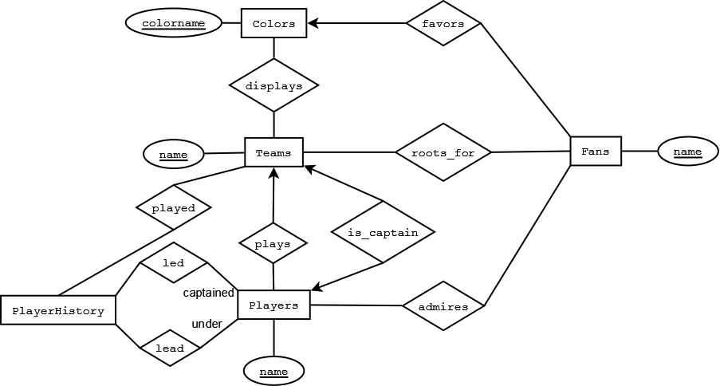

c)

The relationship "played" between Teams and Players is similar to relationship "plays" between Teams and Players.