**Midterm Exam**

EECS 3421

Winter 2017

First Name:

Last Name:

Student Number:

**Question 1** (4 points)

The Nova Scotia Board of Fisheries (NSBF) oversees fishing stocks and licences fishing companies for how much they can haul; that is, catch of a given type of fish in a given region (a given area of the sea). They also keep track of companies’s hauls, so that they can ensure companies are in compliance with their licences.

A company has a number of boats. A boat is owned by one company. We know a company by its chartered company name. For a company, we also keep the harbour, the town in which the company is chartered. A boat has a unique registration number (b#); and we need to know its capacity (how many tonnes of fish it can haul) and its usual number of crew (#crew).

NSBF licences a company for a certain type of fish to be hauled from a given region. A licence records when the license was issued, the agent who gave the licence, and a limit (the number of tonnes in total the licence allows the company to haul of that type of fish from that region). A company can have more than one licence for a given region, allowing them to fish for more than one type of fish there. They can have licences to fish for a given type of fish in more than one region. And, of course, more than one company may have licences for a given type of fish in a given region. NSBF only keeps track of current licences issued, not old ones that have expired.

NSBF tracks whenever a boat makes a haul of a type of fish in a region. For a haul, we record the date the weight (in tonnes), and, of course, the type of fish. (A given haul only involves one type of fish.)

NSBF also keeps track of how much fish of a given type that they estimate to be in each region. This is to be recorded in a field called stock (the value of which measures the estimated tonnage of fish of that type in the region).

Devise an entity-relationship (E-R) diagram to model NSBF’s Licencing & Hauls as described above. In your E-R, do not add any entity unless absolutely needed. Do not forget attributes, and show all keys.

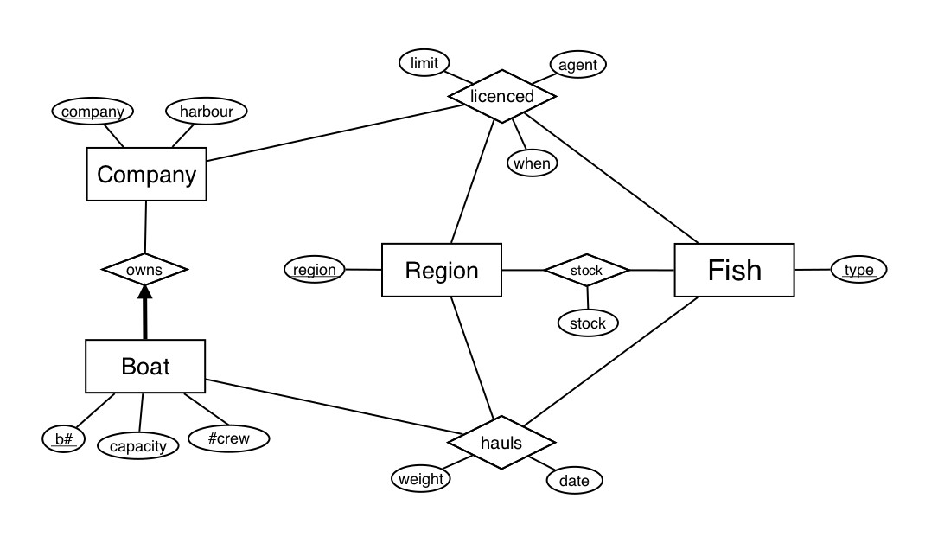

2pts Got the requisite entities: Company, Boat, Region, Fish

2pts Captured the requisite rel-ships: owns, hauls, stock, licenced

3pts Modelled M-M’s and 1-M’s correctly

* & mandatory participation
* recognized “licenced” and “hauls” to be ternary

1pt Keys are correct

Have attributes requested

**Question 2.** (4 points) Convert the E/R diagram below to a database schema. Underline primary keys and mark foreign keys with a star.

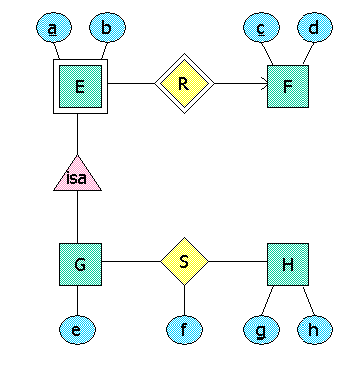

The database schema is E(a,b,c*), F(c,d), G(a,c,e), H(g,h), and S(a*,c*,f,g*).

**Question 3.** (3 pts.) Using (some of) the relations:

Animals(idNumber, type, cageNumber)

Cages(cageNumber, maxAnimals)

write an expression to find all pairs of animals of two different types in the same cage. For each pair of animals satisfying this requirement, your expression should return each animal's idNumber and type, as well as the cageNumber of the cage they are in. For example, if Animal 1 of type Zebra and Animal 2 of type Monkey are both in cage 10, then the result of your expression should include a tuple (1, Zebra, 2, Monkey, 10) (the attributes could be in a different order). The same animal pair should not appear twice in your result.

 One possible correct sequence of relational algebra expressions is:

Animals2(idNum2, type2, cageNumber) := Animals

AllPairs := Animals2 JOIN Animals

Answer := SELECT_{type2 < type} (AllPairs)

**Question 4.** (6 points) Consider table R with attributes A, B, C, D, E, F, & G, and the set of functional dependencies:

BG → AC

ABG → DF

A → G

D → E

E → C

1. Is AD a candidate key? Prove your answer.

The attribute closure of AD is ACDEG, which does not include all attributes. Therefore AD is not a key.

1. Is BDG a superkey? Prove your answer.

The attribute closure of BG consists of all the attributes; hence, BG is key and BDG is superkey.

1. Does ADC → F logically follow from the set of functional dependencies? Prove your answer.

The attribute closure of ADC is ADCGE. This does not contain F. Therefore the answer is no.

**\*\*\*\*\*\*\*\*\*\*\*\*\*\*\*\*\*\*\*\*\*\*\*\*\*\*\*\*\*\*\*\*\*\*\*\*\*\*\*\*\*\*\*\*\*\*\*\*\*\*\*\*\*\*\*\*\*\*\*\*\*\*\*\*\***

**All remaining questions (1 point each) are multiple choice. Only one answer is correct.**

**Question 5.** Let R(A, B, C) satisfy the following functional dependencies (FDs): AB -> C,

BC -> A, and AC -> B. The closure of A (i.e., A+) is

1. A
2. AB
3. AC
4. ABC

A

**Question 6.** Which of the following statements are correct?

I. All relations in 3NF are also in BCNF.

II. All relations with only two attributes are in BCNF.

III. For any relation schema, there is a dependency-preserving decomposition into 3NF.

1. I only
2. III only
3. II and III
4. I and III

C

**Question 7.** Which of the following statements about E/R models is/are correct?

I. Many-to-many relationships cannot be represented in E/R-diagrams

II. Relationship sets can have attributes of their own.

III. All many-to-one relationships are represented by a relationship between a weak and a non-weak entity set.

1. II only.
2. III only.
3. II and III only.
4. I and II only.

A

**Question 8**. In the following relational algebra expressions, R and S have the same schema, which includes attribute a, but the schemas are otherwise arbitrary.

Q1: πa(R) - πa(S)

Q2: πa (R - S)

1. Q1 and Q2 produce the same answer.
2. The answer to Q1 is always contained in the answer to Q2.
3. The answer to Q2 is always contained in the answer to Q1.
4. Q1 and Q2 produce different answers.

B

**Question 9**. A weak entity

1. is an entity with no attributes besides its key.
2. inherits part of its key from the “parent” entities to which it is related.
3. is the same thing as ISA in E-R.
4. is never mapped to a table in conversion to a relational schema.

B

**Question 10.** Consider table R with attributes A, B, C, D, and E. How many possible candidate keys are there for R?

1. 5
2. 10
3. 31
4. 365

C

**Question 11.** Consider relation R(A,B,C,D) with the only FD: B→CD. The minimal basis for the relation is:

1. B→CD
2. B→D, B→C
3. B→ABCD
4. The relation with the given FD has no minimal basis

**B**

**Question 12**. For the relation and FD in Question 11, the decomposition into 3NF is:

1. AB, BC, BD
2. BCD, AB
3. AB, AC, AD
4. The relation is already in 3NF, hence no decomposition is needed

A