Abstract

Designing an interactive system for Pollax Home.

Assignment - 03

Muhammad Abdullah

213799994

Rajkumar Balakrishnan Lakshmi

213141197

**Conceptual Model**

**Home Screen**

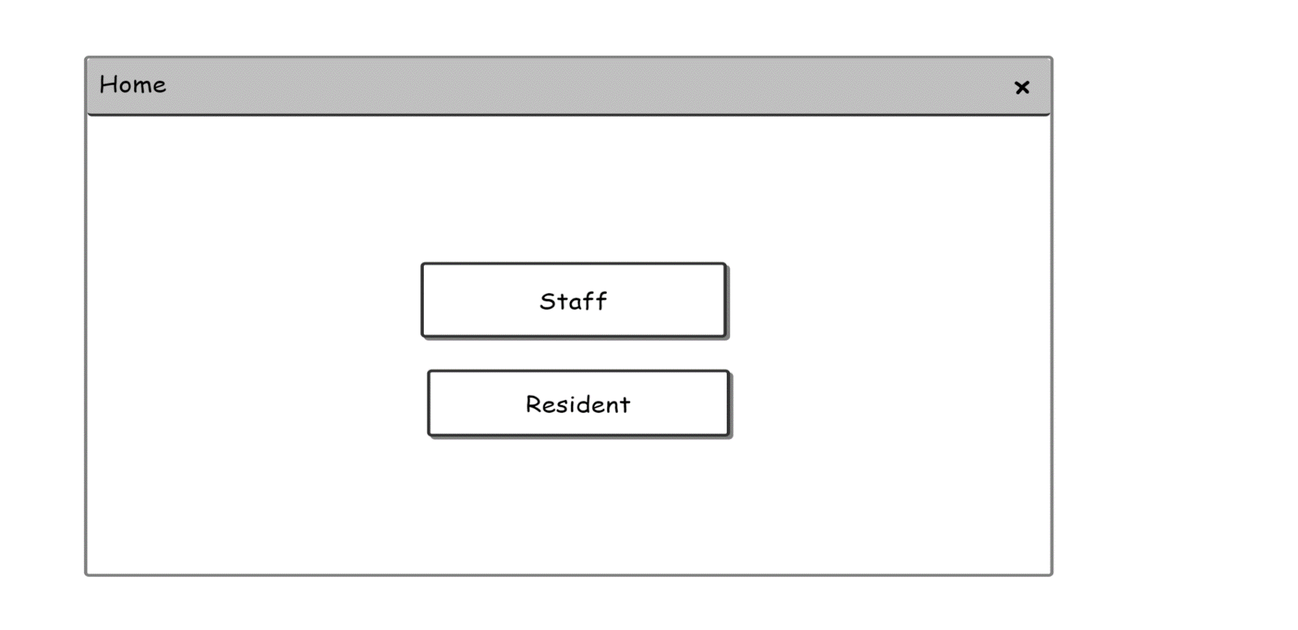

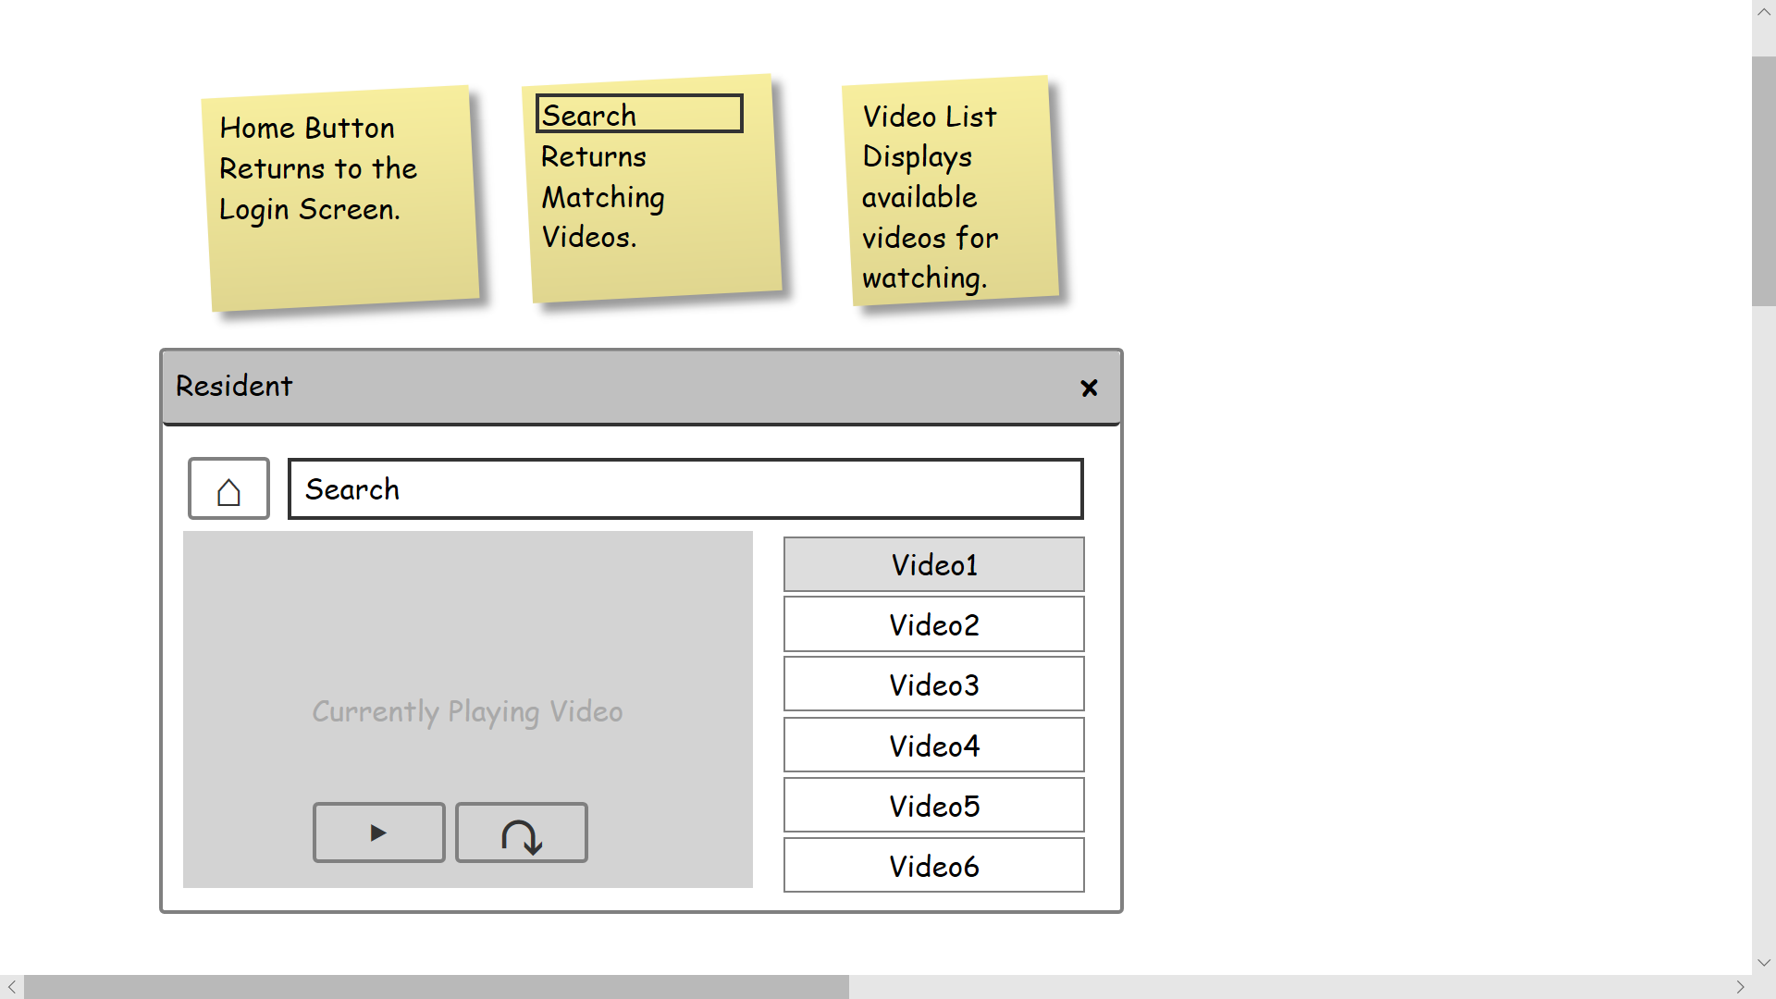**Resident Mode**

home

**Staff Mode**

home