A product prototype is the initial version of your product, showcasing how it should look and what it can do. Through the prototype, you can identify any flaws in your concept and make improvements to create the best possible version of your product. a product prototype gradually evolves into a near-complete version of the final product. Prototypes can serve different purposes depending on the development stage and requirements — whether it’s a visual model to showcase the product’s appearance or a functional model to demonstrate how it operates.
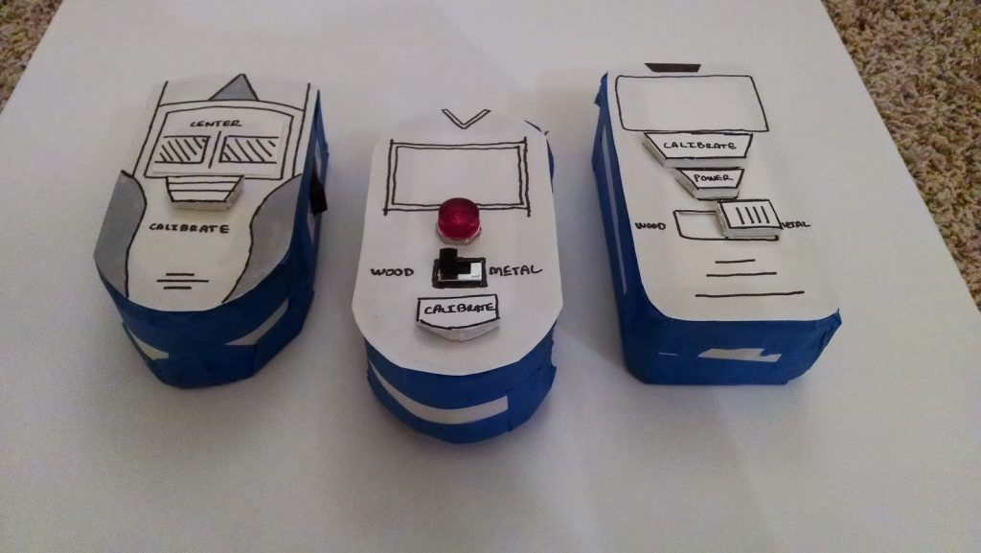

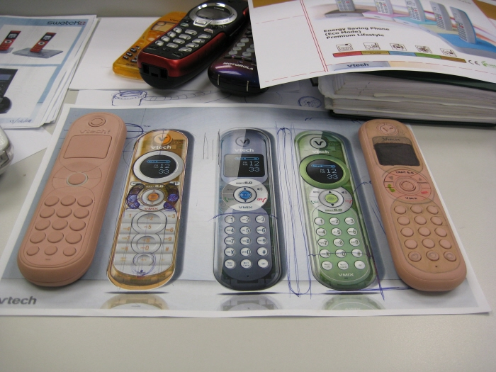

we understand the importance of prototyping in the product development lifecycle. Our experienced designers and engineers can guide you through every stage of the prototyping process, from ideation to final testing. We offer a range of prototyping services, including:
- Custom Prototyping Solutions: Tailored prototypes aligning with your product goals and user needs.
- User Testing and Feedback: Comprehensive testing services to effectively gather user insights and refine your prototype.
- Iterative Design Support: We help you navigate the iterative process, ensuring each prototype improves upon the last and meets your evolving requirements.
- Integration of Advanced Technologies: Utilising the latest tools and techniques, including 3D printing and digital prototyping, to create high-quality, functional models.
Our commitment to delivering innovative solutions means we can help you bring your product ideas to life, ensuring that your final product resonates with users and stands out in the market. We offer services like

Proof of concept
the realm of product design, prototyping is an essential step that bridges the gap between concept and reality. POC for short are a type of prototype. They stand out for their simplicity and efficiency. They are used in the initial stages of the design process. Designers use these simple, often hand-drawn models which allow them to explore and evaluate ideas quickly and they do so without needing substantial amounts of resources or time. Low-fidelity prototypes focus on broad concepts and overall structure. They help with early exploration, fast iteration, and clear team and stakeholder communication.
What are poc
Low-fidelity (low fi) prototyping in product design uses simple, quick sketches. Designers create these with basic materials like paper, cardboard, or digital tools. They focus on big-picture ideas, not details. This method encourages experimentation and teamwork, and it allows for fast testing and improvement of ideas. Designers can easily modify prototypes which makes this perfect for brainstorming and refining early concepts. It simplifies the design process, making feedback and changes quick as well as ensuring that key design principles are explored before moving to more complex stages
Why it is importatnt
Designers use low-fidelity prototyping as it relatively rapid and cost effective exploration and sharing of ideas. They can do this without needing much time or many resources. The prototypes focus on broad concepts, not fine details which allow for large changes to be made fast based on feedback. This helps find potential design flaws and usability issues early, as well as that it ensures that big problems are fixed before the later and more costly development stages. Also, rough prototypes help teams work together and talk to clients. They align everyone’s vision early in the process. Low-fidelity prototyping is simple and flexible, yet it is an invaluable tool for brainstorming, testing, and refining concepts early in product design.

Diplay only prototype
In today’s fast-paced world of product development, efficiency and precision are critical. High-fidelity (high fi prototypes, for short) prototypes have become a vital tool in this process. These prototypes are detailed and interactive, they represent the final product and go beyond basic sketches, CAD models and early stage low fidelity prototypes.
High-fidelity prototypes are used for many products from small toys to large machines. They bridge the gap between developed concepts and the final product. They have many benefits that improve the final outcome.

What
High-fidelity prototypes are detailed, interactive models of a product. They closely resemble the final version in design, functionality, and user experience. Low-fidelity prototypes whereas are often card models or rough prototypes that prove just one element of the design, high-fidelity ones offer a realistic model. They have accurate colours, materials, textures, and realistic functionality. This level of detail allows stakeholders to interact with the product as if it were fully developed. They can do so thoroughly and collect detailed feedback.

Why
Why use high-fidelity prototypes? They show a realistic version of the final product. This facilitates thorough usability testing and early identification of design flaws. Stakeholders can use the product as if it were fully developed. This allows for more accurate feedback on its functionality, design, and user experience. Early feedback is crucial. It enables needed adjustments before full production. It reduces costs and time by halting expensive revisions.
Also, high-fidelity prototyping (or high fi prototyping) improve communication. They do this among team members, stakeholders, and clients. They do it by offering a clear and aligned vision of the product. This clarity is key. It helps secure stakeholder buy-in and investment. It shows the product’s potential and feasibility in a clear and convincing way. Additionally, the iterative process is supported by detailed prototypes. It encourages continuous improvement and innovation. This leads to a more refined and successful final product.

Functional prototype

A functional prototype is a sample or model of a product built to test a concept or process or to act as a visual prop to be replicated, improved, and learned from. It is a term used in a variety of contexts, including semantics, design, electronics, and software programming, but is most common in product development. A visual prototype is designed to test and try a new design to enhance precision by inventors, investors, and potential consumer users. Visual prototyping serves to provide a visual product impact instead of an individual imagined view. Functional prototypes are the step between the mental formalization and the actual look, feel, and basic function of an idea, invention, or new product.
What
A functional prototype is the most basic working prototype built to validate a product design. Additionally, it is an integral part of the assembly, testing, piloting, and market research process that evaluates design, materials, strength, tolerances, assembly, work mechanisms, manufacturability. Manufactured with several prototyping techniques and engineering-grade materials, functional prototypes are alternatives to finished products, allowing examination and testing on form, fitness, and functionality under extreme working conditions to improve designs.

Why
- Facilitate design testing, evaluation, and improvement in the product development process.
- Validate product performance to ensure quality standards.
- Identify and eliminate potential problems before investing in expensive production tooling.
- Ensure manufacturing feasibility and timely product delivery.
- Share ideas with stakeholders on time to showcase product value to customers and potential investors.
- Patent inventions to protect intellectual property

The benefits of functional prototypes are multifold; significantly contributing to successful product development:
- User Experience Testing: These prototypes facilitate real-time user testing and feedback, allowing for prompt adjustments to improve the overall user experience.
- Early Detect Design Flaws: By identifying issues at an early stage, functional prototypes reduce costs associated with product development and continuous iteration of the product.
- Trim down Time to Market: Examining functional prototypes early in the development process speeds up the detection and correction of issues, which shortens the time it takes to get the final product to market.
- Cost Reduction: Functional prototypes assist in recognizing and addressing issues early on, which minimizes the risk of expensive modifications or changes after the product has advanced to the production stage.
- Enhanced Communication: Functional prototypes serve as tangible representations that enhance communication among stakeholders, enabling better understanding and alignment throughout the development process.

8 lessons after years prototyping
Here are some insider tips for effective physical product prototyping:
- Start Simple: Begin with low-fidelity prototypes (like sketches, basic models, or foam versions) to test basic form and function before investing in high-fidelity models.
- Use the Right Materials: Choose materials that closely mimic the final product, particularly for high-fidelity prototypes, as this helps in testing durability and appearance more accurately.
- Focus on Key Features First: Prioritise prototyping the most critical functions and features, as this allows you to assess usability and user experience without over-investing in non-essential elements.
- Rapid Iteration is Key: Quickly refine your prototype based on feedback, using methods like 3D printing or modular components to make adjustments fast and affordably.
- Test with Real Users: Always involve potential users early in the prototyping stage to gather genuine feedback on usability and appeal, identifying issues that might not be apparent to the design team.
- Document Everything: Record materials, techniques, and user feedback throughout the process to create a clear development history, making it easier to troubleshoot or refine designs.
- Consider Manufacturing Constraints: Design your prototype with the final production method in mind, ensuring the design can be efficiently scaled for manufacturing without extensive reworking.
- Work with an Experienced Prototype Specialist: Partnering with a specialist or a professional prototyping team can offer valuable insights, helping you avoid common pitfalls and ensuring a smoother transition to the production stage.
These strategies ensure a prototype that’s not only functional but also efficient to produce and reflective of the final product.

