1.Write one sample Multi-Stage Dockerfile.
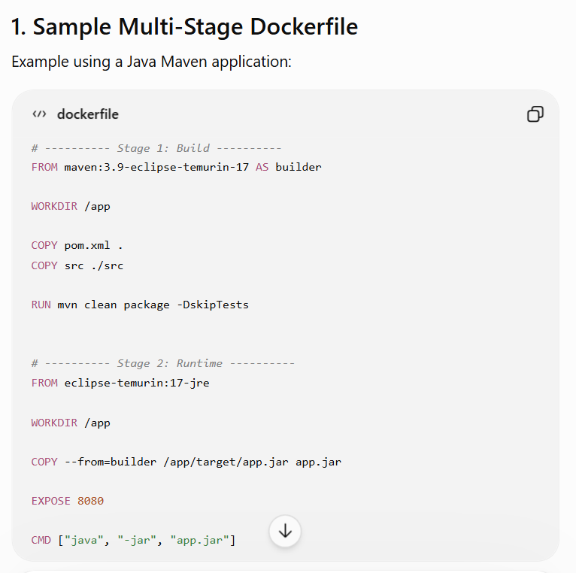
Explanation
Build Stage
↓
Maven + JDK + Source Code
↓
app.jar
↓
COPY --from=builder
↓
Runtime Stage
↓
JRE + app.jar
The final image doesn't need Maven, source code, or other build tools.
Main benefit: smaller and cleaner production image.
2. Write one sample Dockerfile for a Java application.
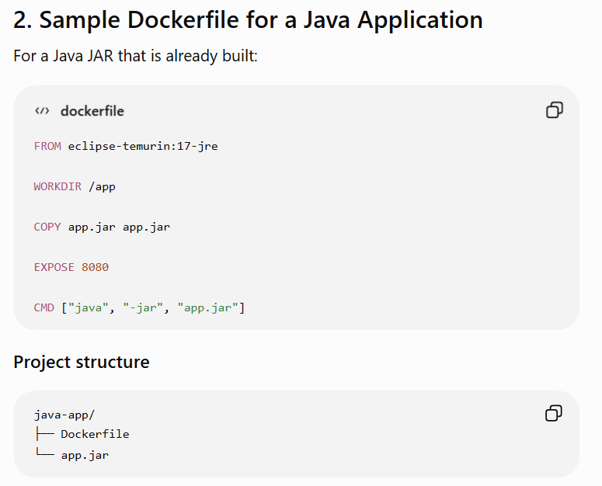
Build
docker build -t java-app:1.0 .
Run
docker run -d --name java-container -p 8080:8080 java-app:1.0
3.Write one sample Dockerfile for a Python application.
3. Sample Dockerfile for a Python Application
Suppose your application has:
python-app/
├── Dockerfile
├── requirements.txt
└── app.py
app.py
print("Hello from Python Docker Application!")
requirements.txt
requests

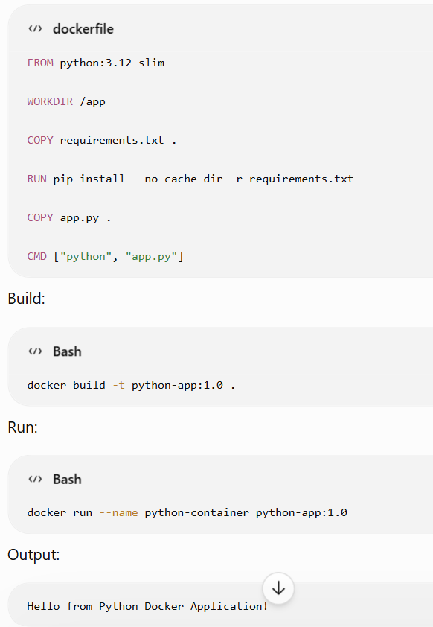
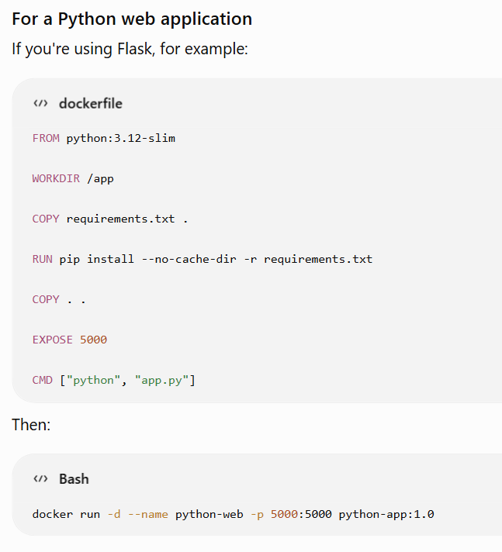
4.Write a simple docker-compose.yml to run a multi-container application.
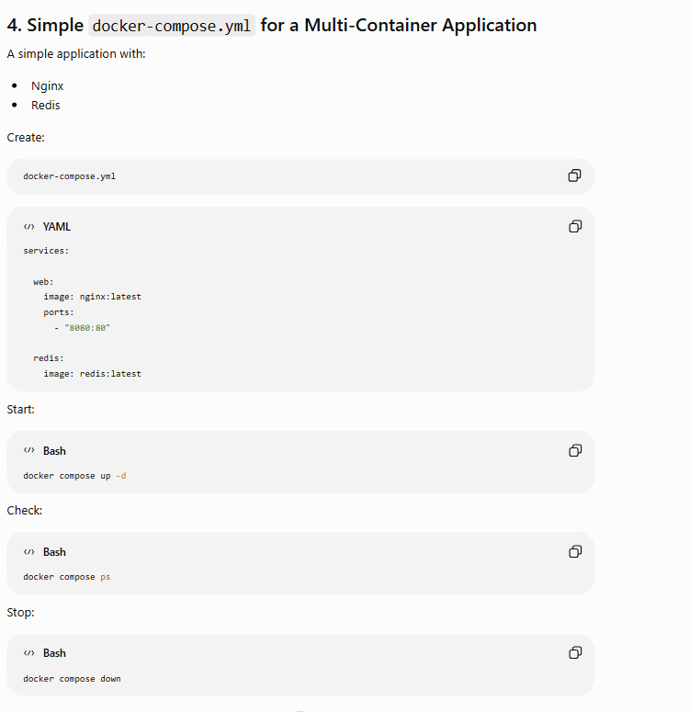
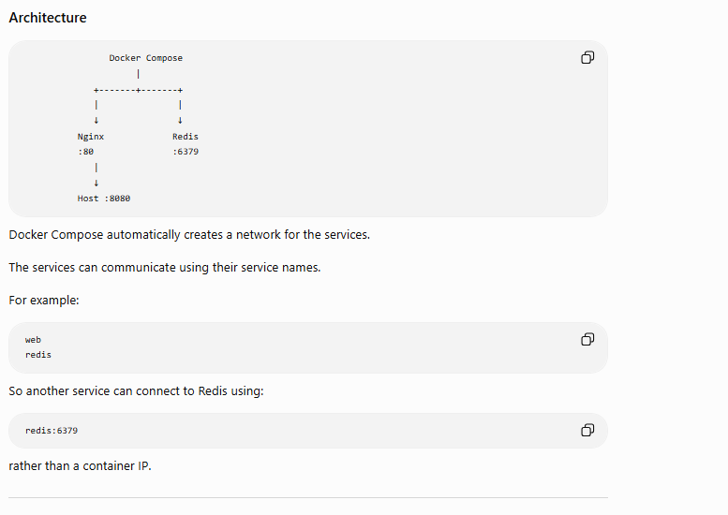
5. Write a Dockerfile using Alpine Linux as the base image.
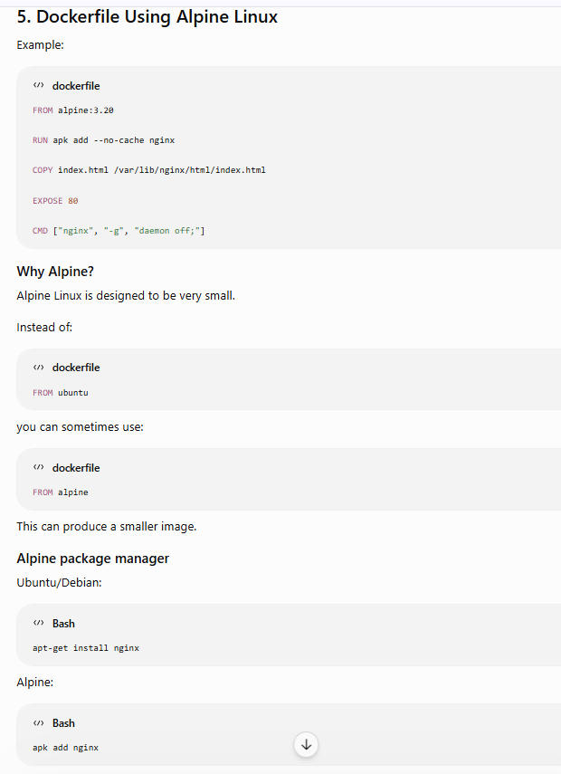
6.Docker – commands with description.
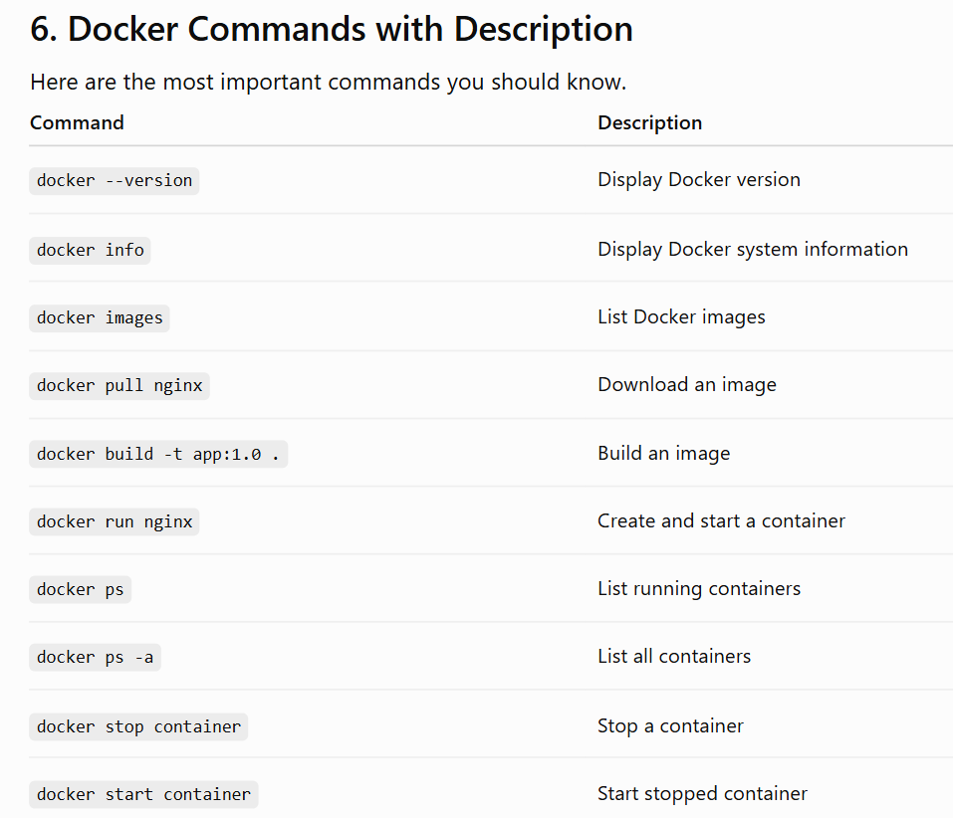
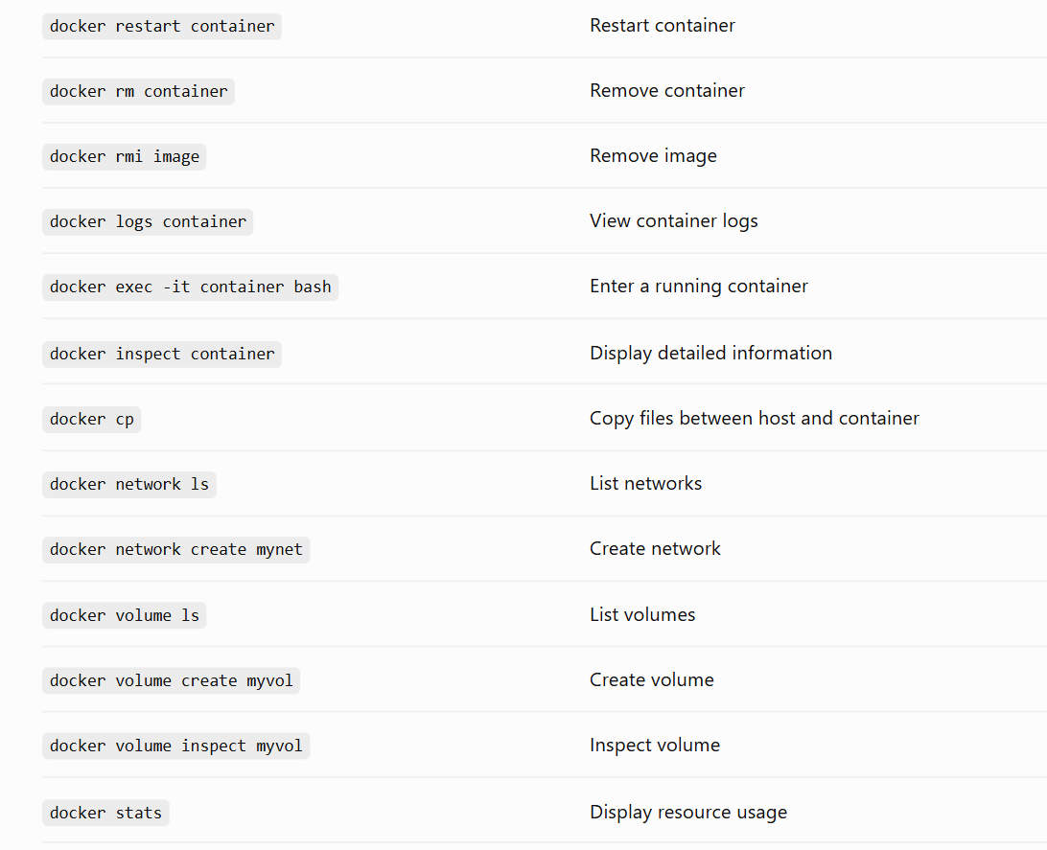
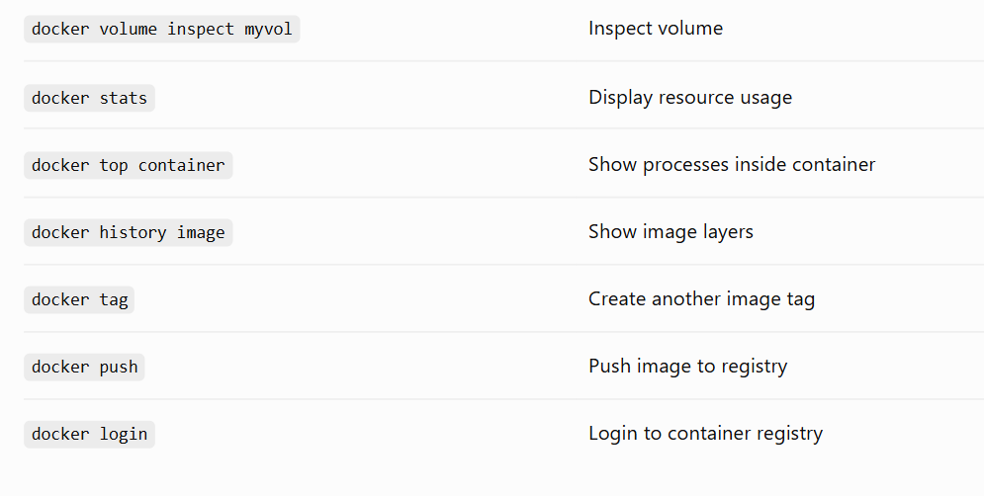
7.Write a command to build a Docker image from a Dockerfile.
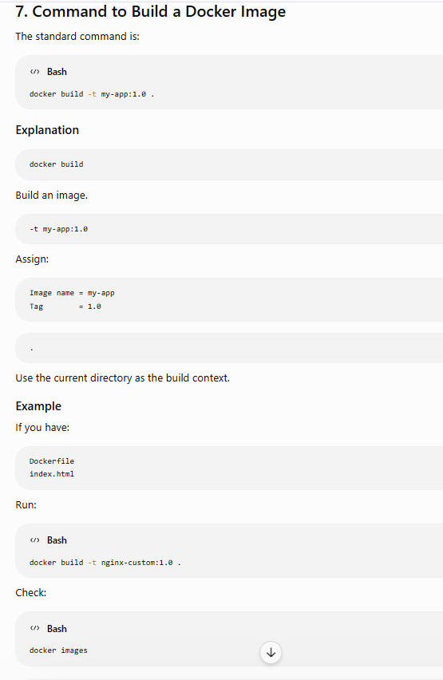
8.Write a command to run a container from an image.
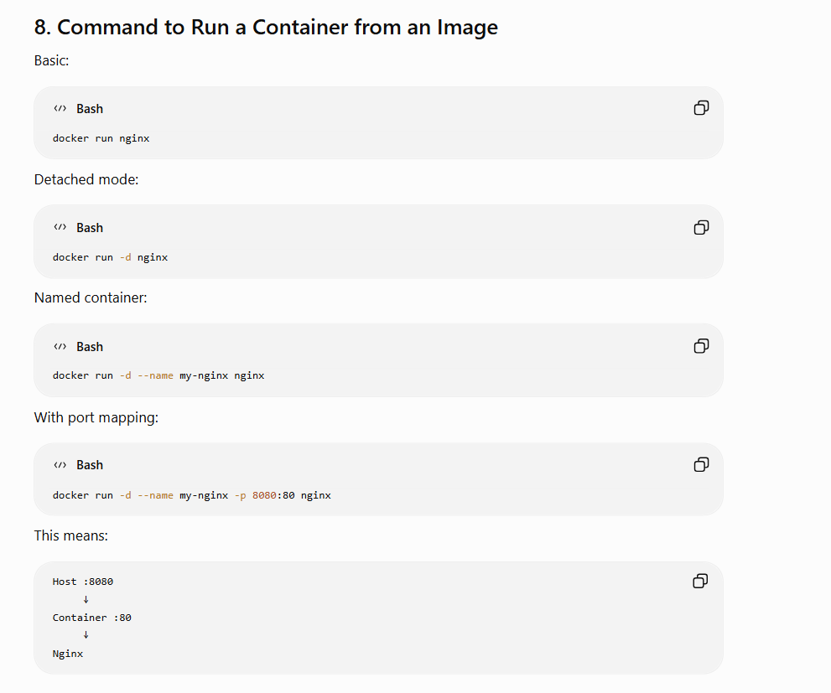
9.Write a command to list all running containers.
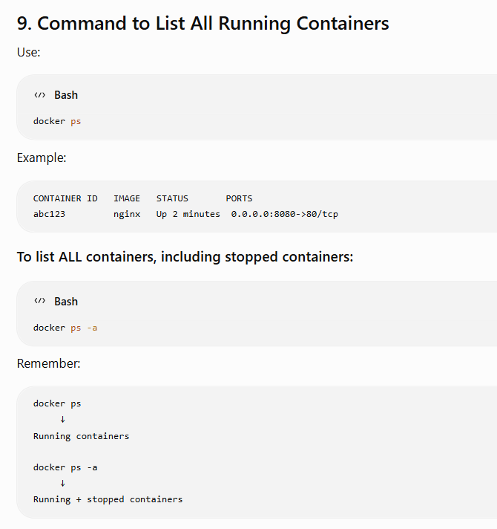
10. Write a command to stop and remove a container.
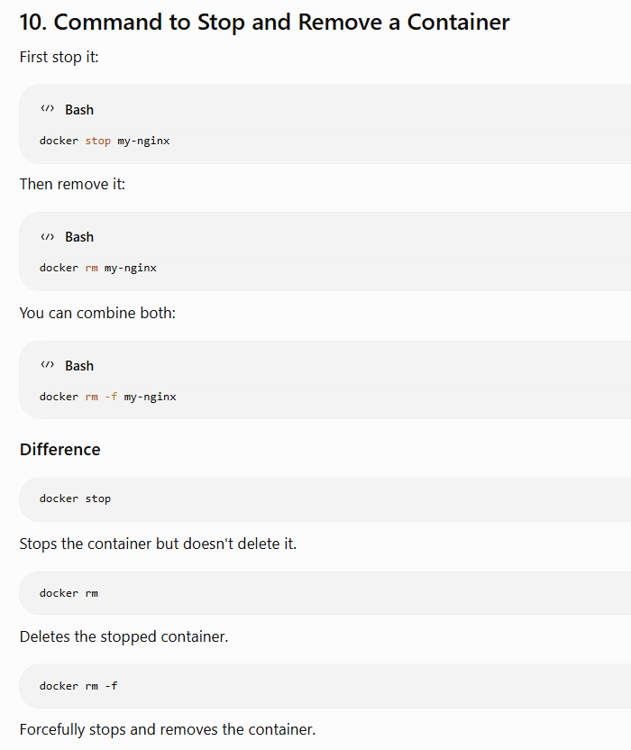
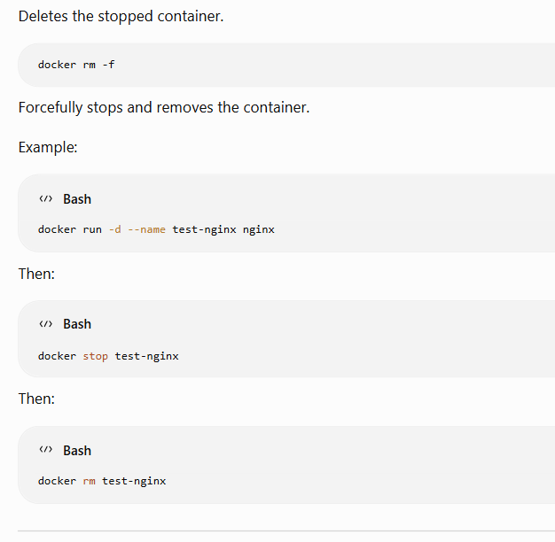
11.Write a command to create and mount a volumeto a container.
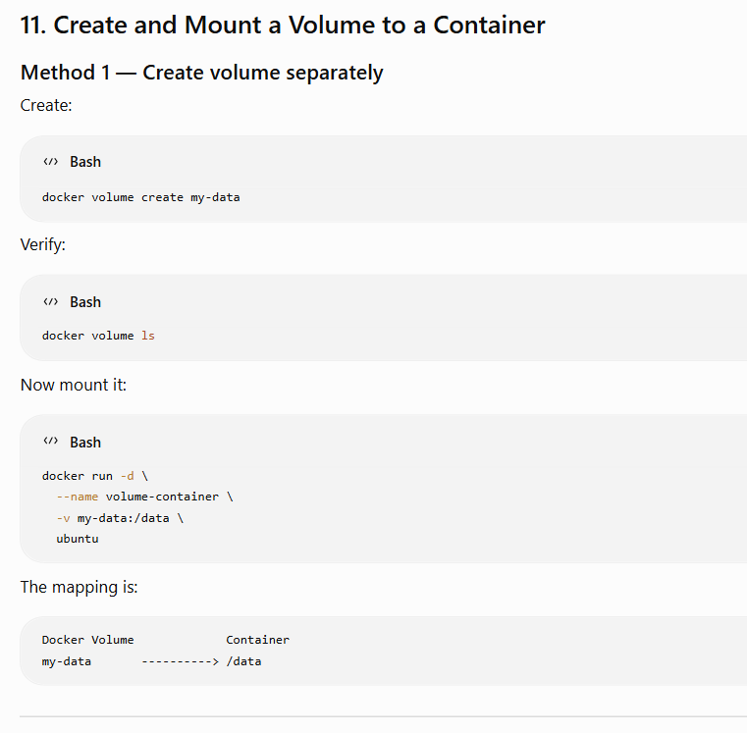
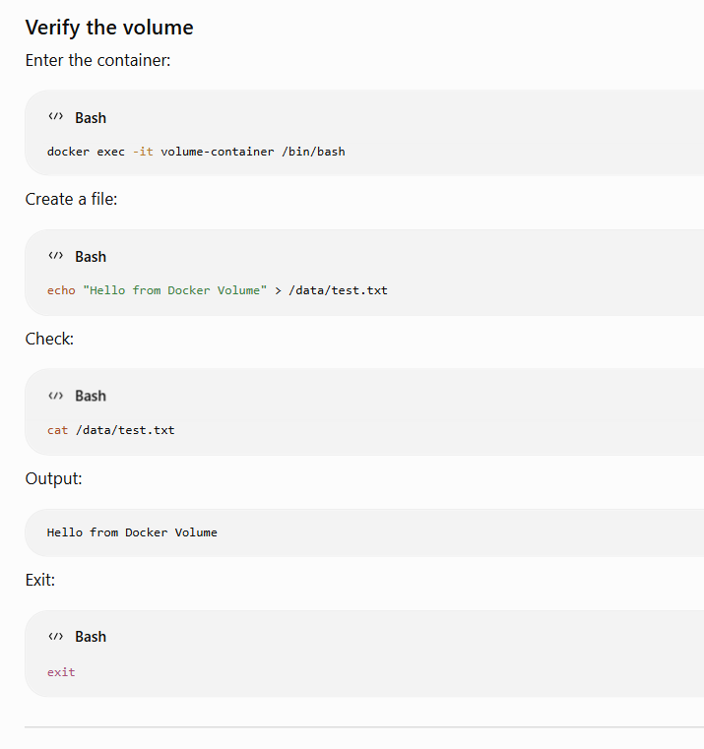
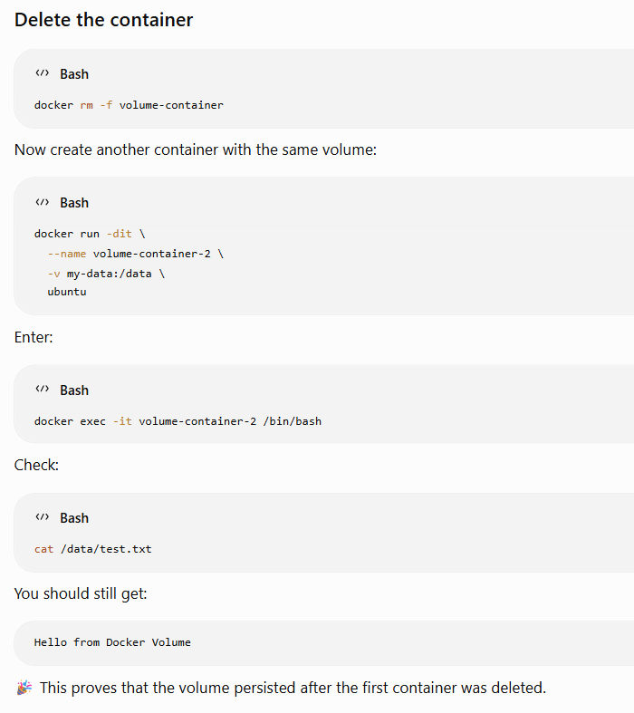
Important Docker Commands Cheat Sheet
Images
docker images
docker pull nginx
docker build -t myapp:1.0 .
docker rmi myapp:1.0
docker history myapp:1.0
Containers
docker run -d nginx
docker ps
docker ps -a
docker stop container
docker start container
docker restart container
docker rm container
docker rm -f container
Troubleshooting
docker logs container
docker logs -f container
docker inspect container
docker stats
docker top container
docker exec -it container /bin/bash
Networks
docker network ls
docker network create my-network
docker network inspect my-network
docker network connect my-network container
docker network disconnect my-network container
Volumes
docker volume ls
docker volume create my-volume
docker volume inspect my-volume
docker volume rm my-volume
Docker Compose
docker compose up -d
docker compose ps
docker compose logs
docker compose down
docker compose restart

