Practical Docker Tasks
- Run a container and access it
  - Run an Ubuntu container in detached mode.
  - Enter the container and verify the OS details.
  - Exit without stopping the container.
Run an Ubuntu Container and Access It
Objective
We need to:
- Pull an Ubuntu image.
- Run an Ubuntu container in detached mode.
- Enter the running container.
- Verify the OS details.
- Exit the container without stopping it.
- Verify that the container is still running.
Step 1: Check Docker installation
On your Docker server/EC2 instance, run:
docker --version
Expected output will look similar to:
Docker version 25.0.14, build ...
Also check whether Docker is running:
sudo systemctl status docker
You should see:
Active: active (running)
If Docker isn't running:
sudo systemctl start docker
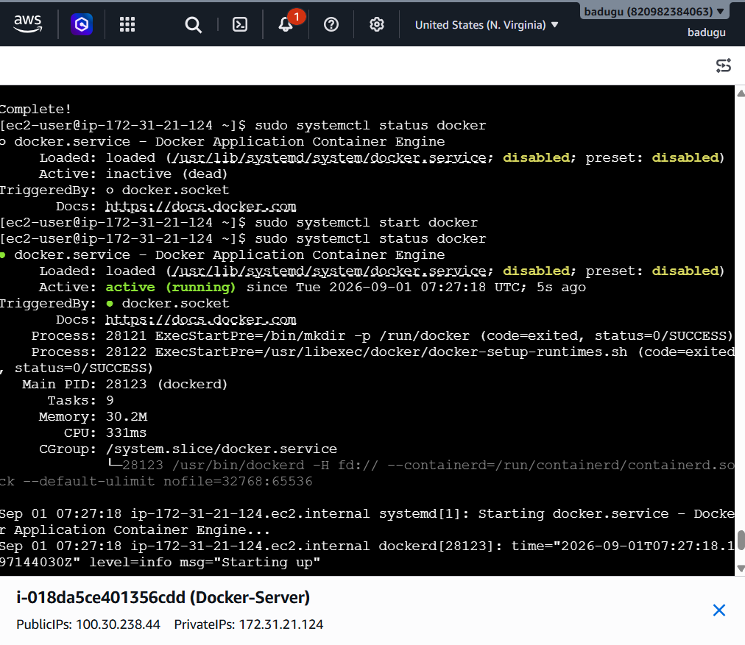
Step 2: Download the Ubuntu image
Run:
docker pull ubuntu
This downloads the Ubuntu image from Docker Hub.
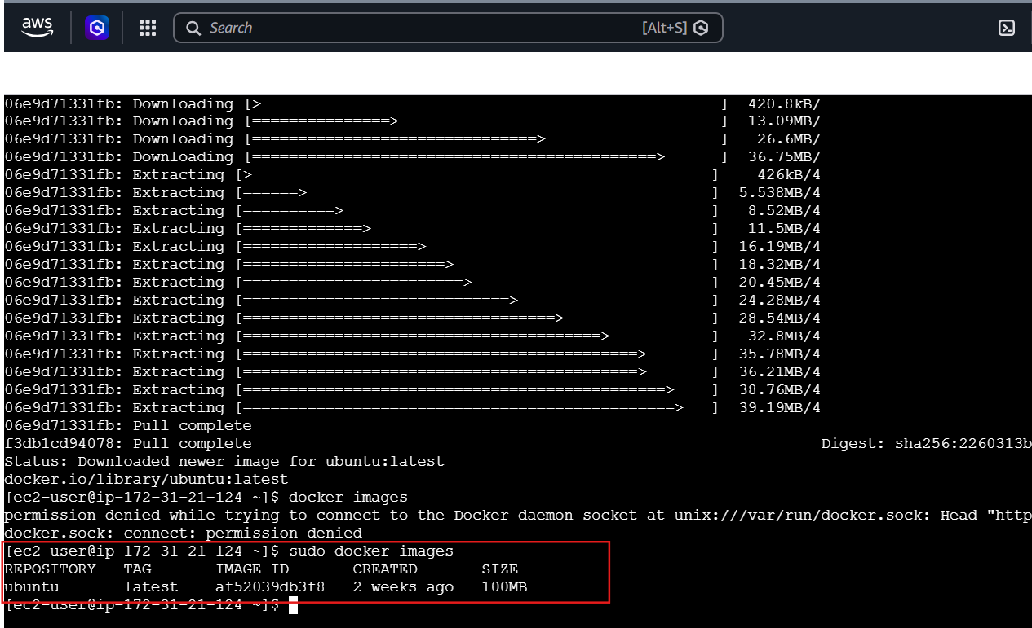
Step 3: Run Ubuntu in detached mode
Run:
docker run -dit --name ubuntu-container ubuntu
Understand the command
docker run
Creates and starts a new container.
-d
Runs the container in detached mode.
The container runs in the background.
-i
Keeps STDIN open.
-t
Allocates a terminal (TTY).
--name ubuntu-container
Gives the container a meaningful name.
ubuntu
Specifies the image to use.
So:
docker run -dit --name ubuntu-container ubuntu
means:
Create an Ubuntu container, keep its terminal available, run it in the background, and call it ubuntu-container.

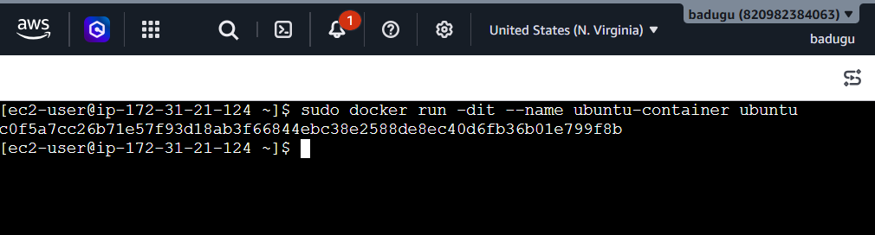Step 4: Check whether the container is running
Run:
docker ps
Step 5: View all containers
You can also run:
docker ps -a
Difference:
docker ps
shows running containers only.
docker ps -a
shows running + stopped containers.

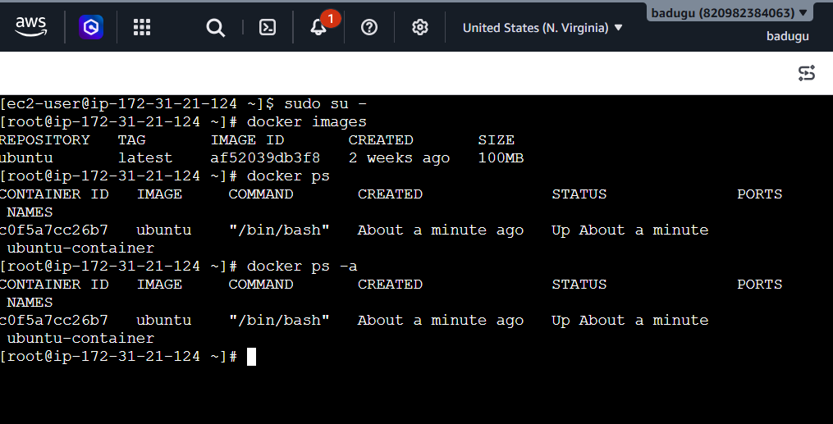

Step 6: Enter the Ubuntu container
Now use:
docker exec -it ubuntu-container /bin/bash
Step 7: Verify the OS details
Inside the container, run:
cat /etc/os-release
Step 8: Check kernel information
Run:
uname -a
Step 9: Check the hostname
Inside the container:
hostname
Step 10: Check running processes
Run:
ps
If ps isn't available in the minimal Ubuntu image, you can use:
ls /proc
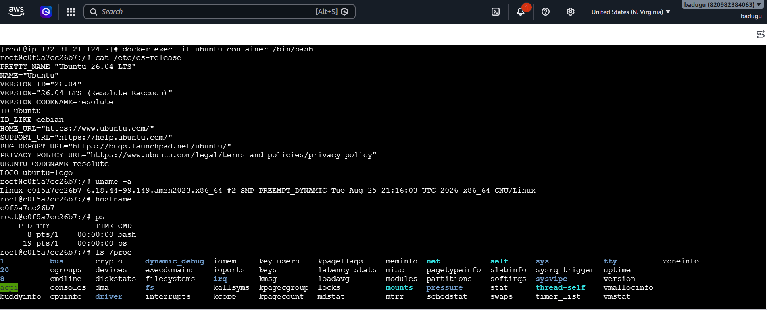
Step 11: Exit without stopping the container
This is very important for your task.
Inside the container, run:
exit
Step 12: Verify the container is still running
Run:
docker ps
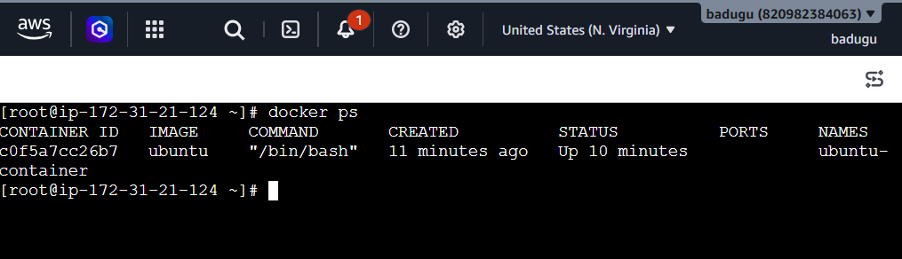
2.Container troubleshooting
- Start an Nginx container.
- Make the container stop unexpectedly.
- Find out why it stopped using Docker commands.
Objective
We will:
- Start an Nginx container.
- Verify it is running.
- Make it stop unexpectedly.
- Check its status.
- Find the exit code.
- Check the container logs.
- Inspect the container.
- Determine the root cause.
Step 1: Pull the Nginx image
Run:
docker pull nginx
Verify:
docker images
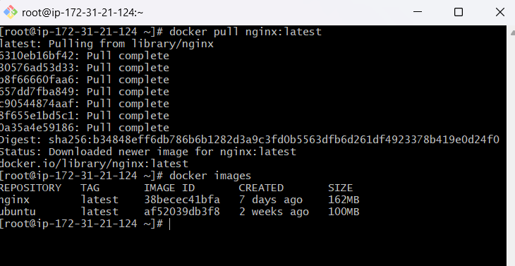
Step 2: Start an Nginx container
Run:
docker run -d --name nginx-troubleshoot -p 8080:80 nginx
Understand this command
docker run
Create and start a container.
-d
Run in detached/background mode.
--name nginx-troubleshoot
Give the container a name.
-p 8080:80
Map:
Host port 8080 → Container port 80
nginx
Use the Nginx image.
Step 3: Verify that Nginx is running
Run:
docker ps
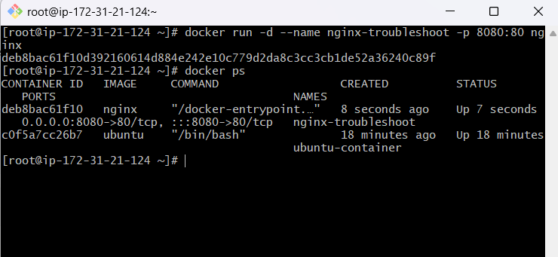
Step 4: Test Nginx
From the Docker host, run:
curl http://localhost:8080

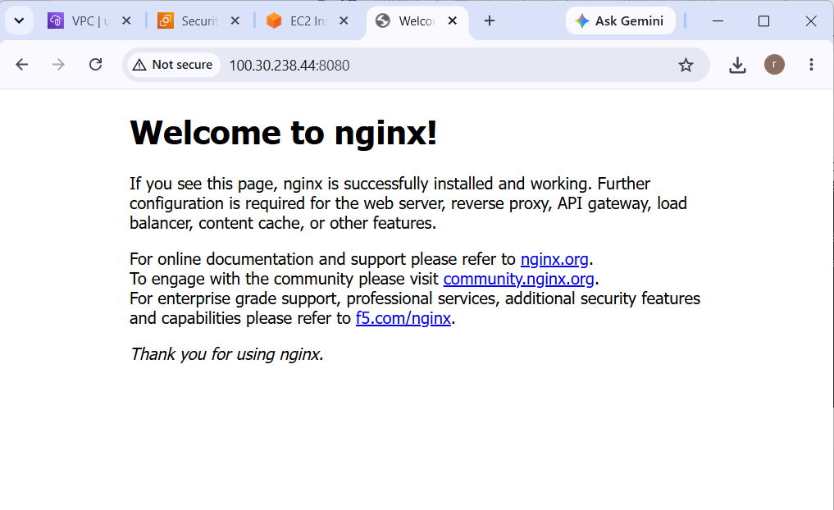
Step 5: Check the Nginx logs BEFORE stopping it
Run:
docker logs nginx-troubleshoot
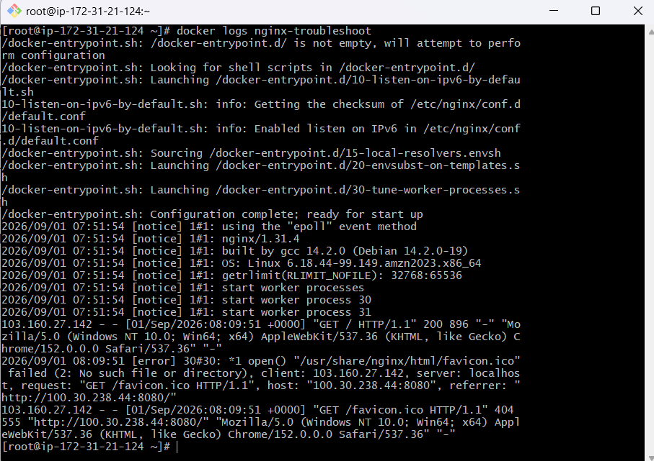
Step 6: Intentionally make the container stop
Now we'll simulate an unexpected application failure.
Enter the container:
docker exec -it nginx-troubleshoot /bin/bash
Now stop the main Nginx process:
kill 1
Why 1?
Inside a Docker container, the main application process is normally PID 1.
tep 7: Check whether the container is running
Back on the Docker host:
docker ps
You won't see the container because it has stopped.
Now run:
docker ps -a
You should see something similar to:
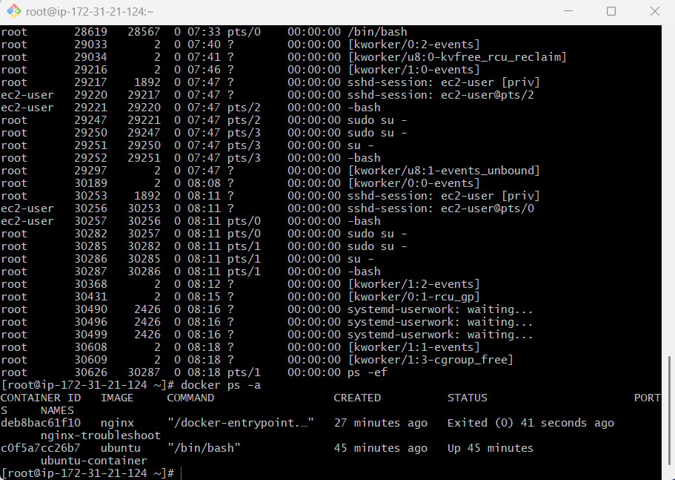
Step 8: Check the exit code directly
Run:
docker inspect nginx-troubleshoot --format='{{.State.ExitCode}}'
You may get:
137
What does exit code 137 mean?
Exit code 137 generally means:
128 + 9 = 137
Signal 9 is:
SIGKILL
So:
137 → process terminated by SIGKILL
In our lab, we intentionally killed PID 1, so this is expected.
Important: Exit code 137 is often associated with SIGKILL, and in real production incidents it is commonly caused by an OOM kill, but 137 by itself does not prove an out-of-memory condition. You need additional evidence.
Step 9: Check the container state
Run:
docker inspect nginx-troubleshoot

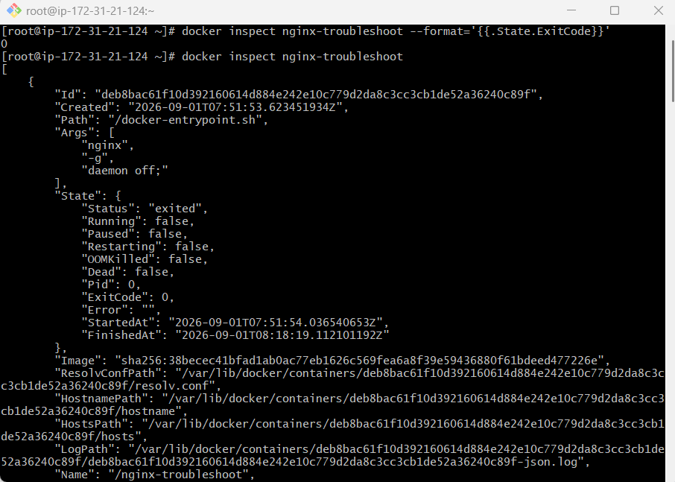
Step 10: Check the container logs
Run:
docker logs nginx-troubleshoot
Or:
docker logs --tail 100 nginx-troubleshoot
You can also check timestamps:
docker logs -t nginx-troubleshoot
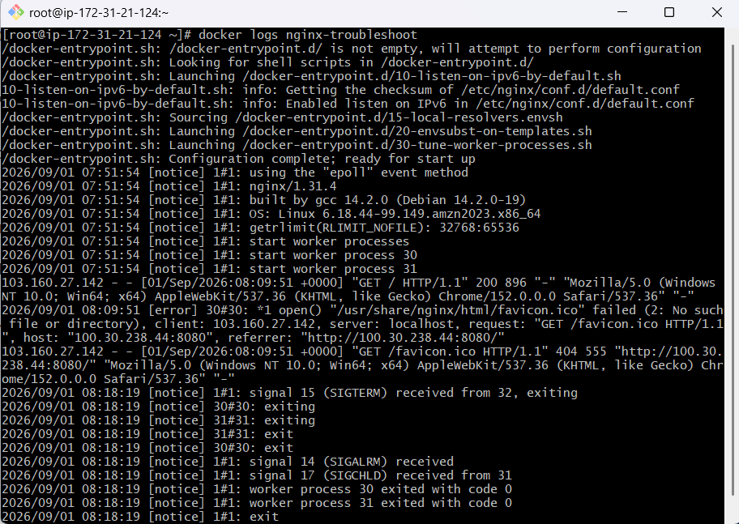
Step 11: Check whether Docker detected an OOM kill
This is particularly important when you see exit code 137.
Run:
docker inspect nginx-troubleshoot --format='OOMKilled: {{.State.OOMKilled}}'
If you see:
OOMKilled: false
Step 12: Check the last state
A very useful command during troubleshooting is:
docker inspect nginx-troubleshoot --format='{{json .State}}'
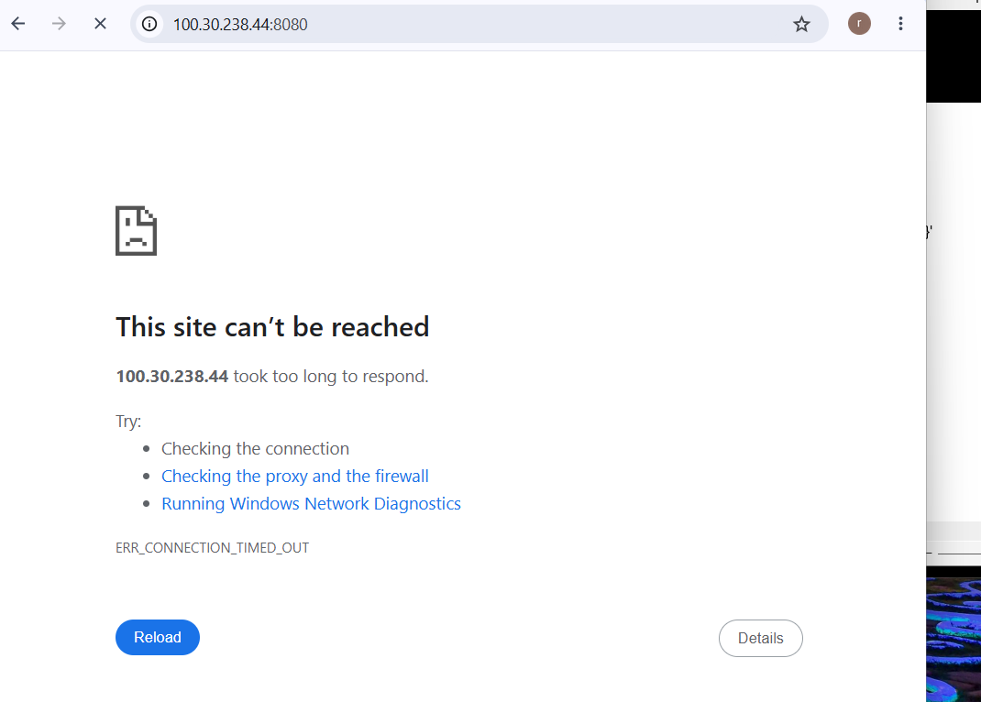
Step 15: Restart the container
After troubleshooting, you can start it again:
docker start nginx-troubleshoot
Check:
docker ps
You should see:
nginx-troubleshoot Up ...
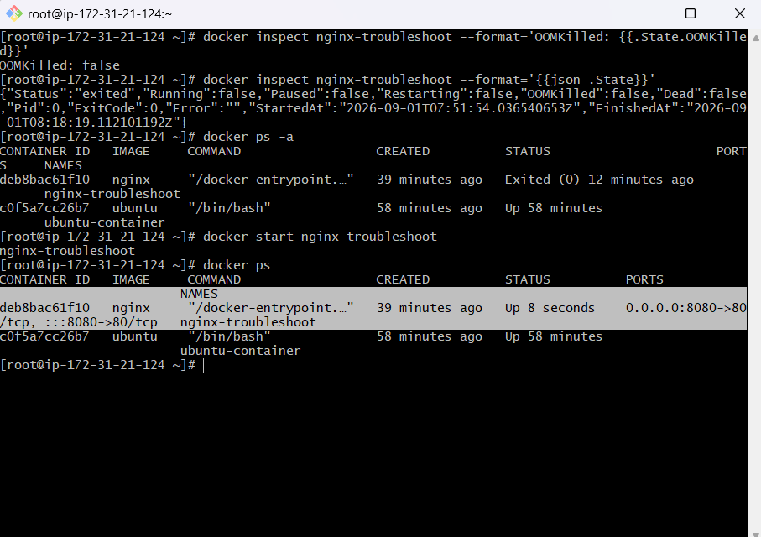
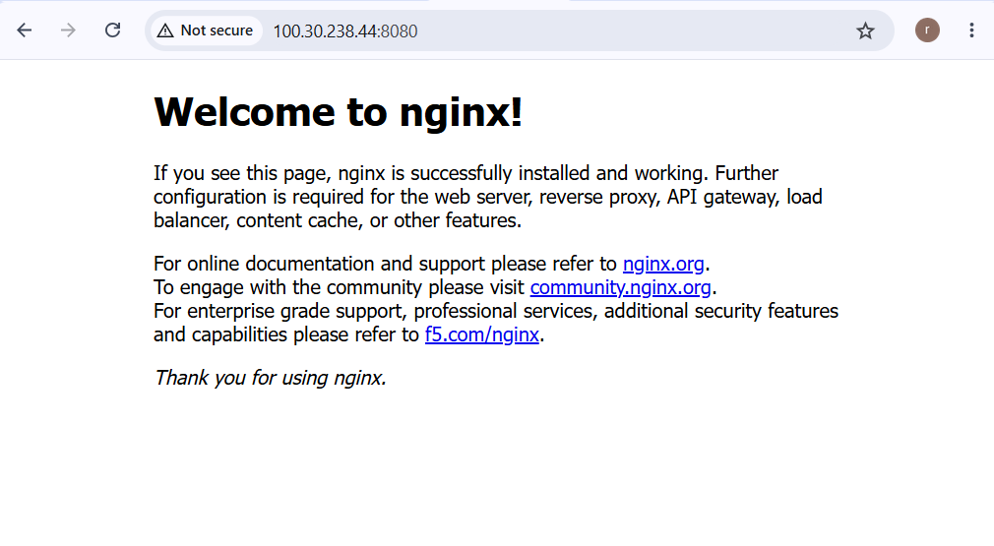
3.Port mapping
- Run an Nginx container.
- Access it from the host using port 8080.
- Explain the difference between container port 80 and host port 8080.
Objective
We need to:
- Run an Nginx container.
- Make Nginx listen on container port 80.
- Map host port 8080 to container port 80.
- Access Nginx using http://localhost:8080.
- Understand the difference between host port and container port.
Step 1: Check whether Nginx image exists
Run:
docker images
Look for:
nginx
If you don't have it, download it:
docker pull nginx
Step 2: Run Nginx with port mapping
Run:
docker run -d --name nginx-port-demo -p 8080:80 nginx
This is the most important command in this task.
The syntax is:
-p HOST_PORT:CONTAINER_PORT
Therefore:
-p 8080:80
means:
Host port 8080
|
↓
Container port 80
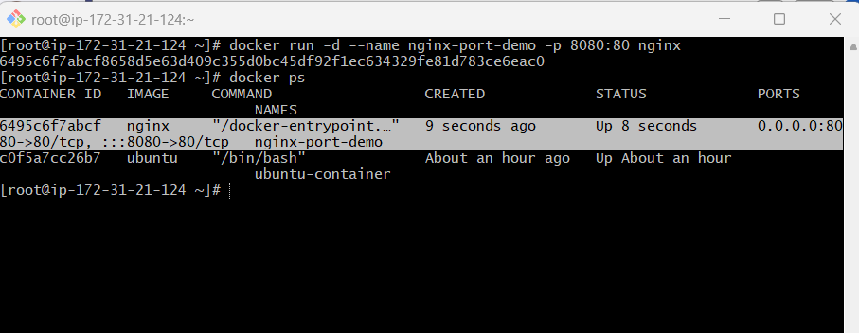
Step 3: Check the container
Run:
docker ps
Step 4: Access Nginx from the host
If you're running Docker directly on your Linux server/EC2 instance, run:
curl http://localhost:8080
Step 5: Access from your browser
If Docker is running on an EC2 instance and the instance has a public IP:
http://<EC2-PUBLIC-IP>:8080
Step 6: Make sure the AWS Security Group allows port 8080
If you're using EC2, your Security Group must allow inbound TCP 8080.
For example:
Type: Custom TCP
Port: 8080
Source: Your IP / 0.0.0.0/0
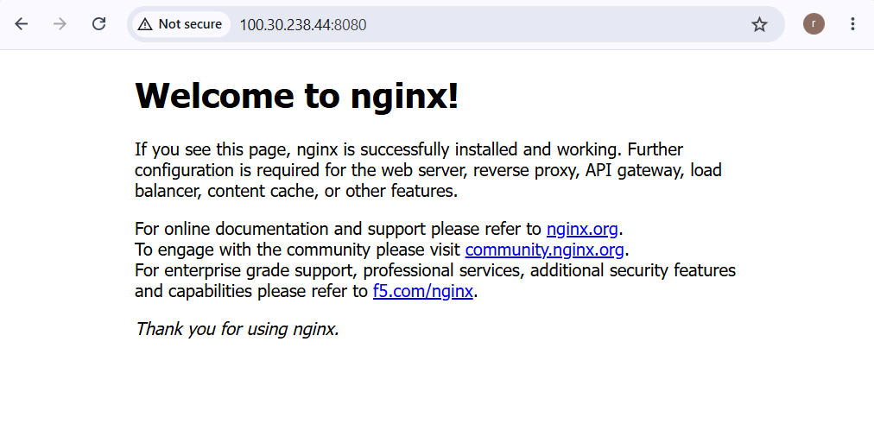
4.Create your own Docker image
- Create a Dockerfile that installs Nginx.
- Add a custom index.html.
- Build the image and run it.
Step 1: Create a project directory
On your Docker server, run:
mkdir nginx-custom
Go inside:
cd nginx-custom
Check:
pwd
You should see something similar to:
/root/nginx-custom

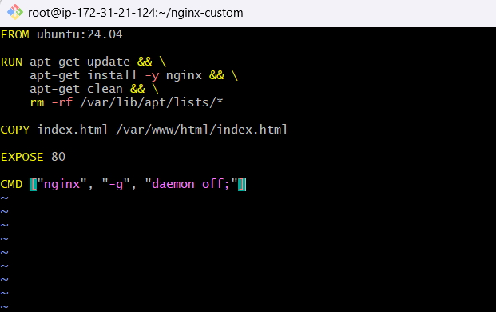
Step 4: Create custom index.html
Now create:
vi index.html

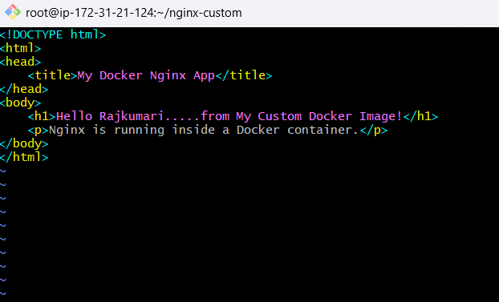
Step 5: Build your Docker image
Now build the image:
docker build -t my-nginx-image:1.0

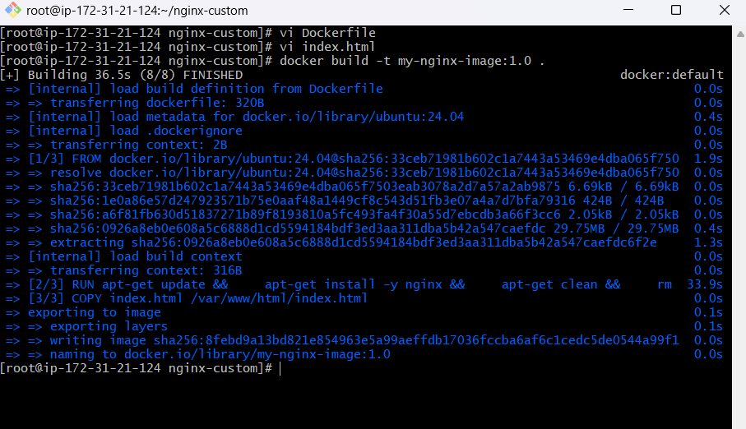
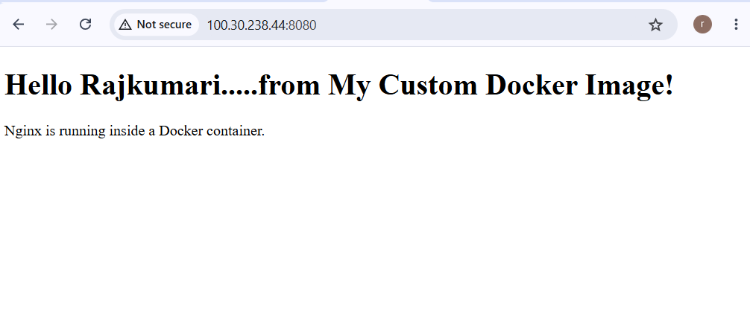
5.Multi-stage Dockerfile
  - Create a simple application.
  - Build it in one stage.
  - Copy only the required application artifact into a smaller runtime image.
  - Compare the sizes of the images.
Objective
We will:
- Create a simple Java application.
- Create a multi-stage Dockerfile.
- Use Maven in the build stage.
- Generate a .jar file.
- Copy only the .jar into the runtime stage.
- Build the final Docker image.
- Run the application.
- Compare image sizes.
- Understand why multi-stage builds are useful
Step 1: Create project directory
Run:
mkdir multi-stage-demo
cd multi-stage-demo
Create the required directories:
mkdir -p src/main/java/com/example
Your structure will be:
multi-stage-demo/
└── src/
└── main/
└── java/
└── com/
└── example/
Step 2: Create Java application
Create:
vi src/main/java/com/example/App.java

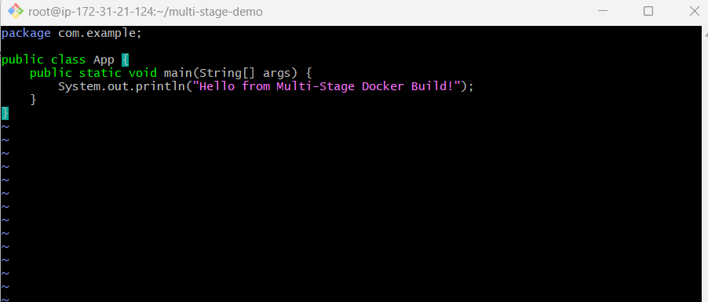
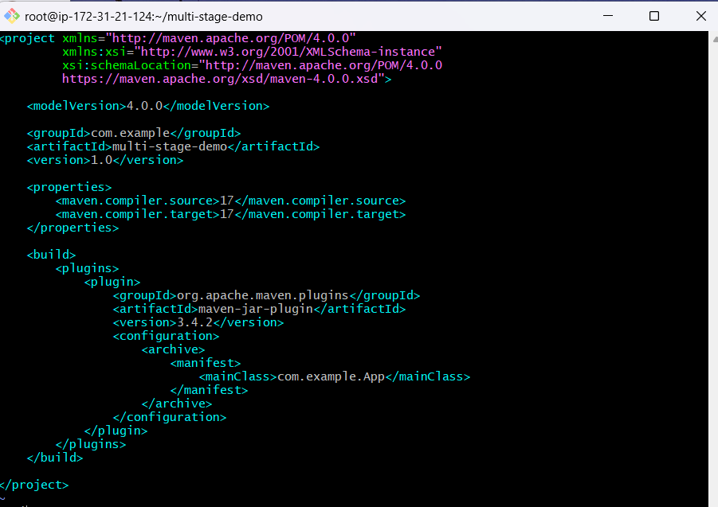
Step 5: Create the Multi-stage Dockerfile
Create:
vi Dockerfile

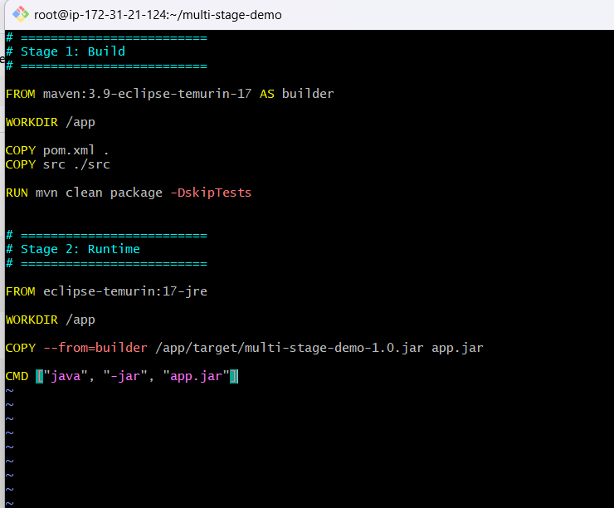
Step 8: Build the multi-stage image
Run:
docker build -t multi-stage-demo:1.0 .
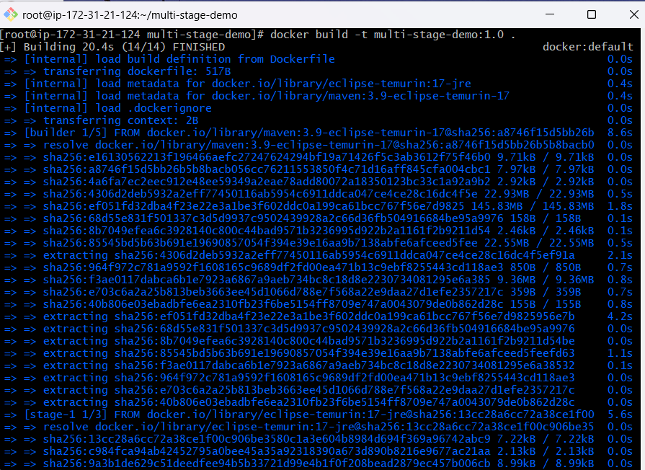
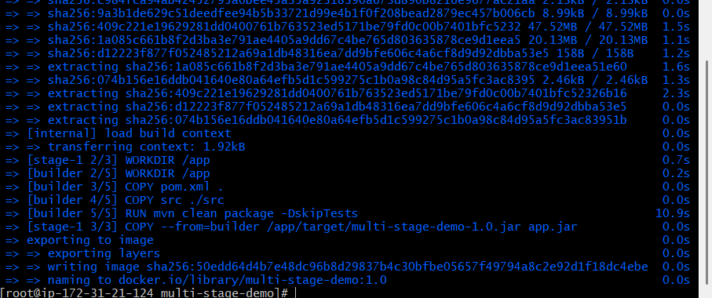
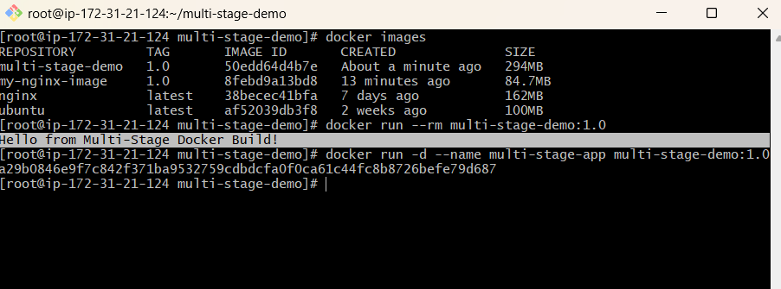
6.Docker volume
- Create a named volume.
- Mount it to a container.
- Create a file inside the container.
- Delete the container.
- Start another container using the same volume and verify the file still exists.
Step 1: Check existing volumes
Run:
docker volume ls
You may see:
DRIVER VOLUME NAME
local some-existing-volume
Don't worry if you have existing volumes.
Step 2: Create a named volume
Create a volume called:
my-data
Run:
docker volume create my-data
Step 3: Inspect the volume
Run:
docker volume inspect my-data

Step 4: Create the first container
We'll use Ubuntu.
Run:
docker run -dit \
--name volume-container-1 \
-v my-data:/data \
ubuntu
Step 5: Verify the container
Run:
docker ps
Step 6: Enter the container
Run:
docker exec -it volume-container-1 /bin/bash
Step 7: Check the mounted directory
Inside the container:
ls
You should see:
bin
boot
data
dev
etc
...
Step 8: Create a file inside the container
Run:
echo "This file is stored in Docker volume" > /data/test.txt
Now check:
cat /data/test.txt
Expected:
This file is stored in Docker volume
Step 9: Verify the file
Run:
ls -l /data
You should see:
-rw-r--r-- 1 root root ... test.txt
You can also check:
cat /data/test.txt
Step 10: Exit the container
Run:
exit
Step 11: Delete the first container
This is the important part.
Run:
docker rm -f volume-container-1
This deletes the container.
Now verify:
docker ps -a
You should no longer see:
Step 12: Create another container using the same volume
Now create a second Ubuntu container:
docker run -dit \
--name volume-container-2 \
-v my-data:/data \
ubuntu
Notice that we use the same volume:
Step 13: Enter the second container
Run:
docker exec -it volume-container-2 /bin/bash
Step 14: Check the file
Run:
ls -l /data
You should see:
test.txt
Now:
cat /data/test.txt
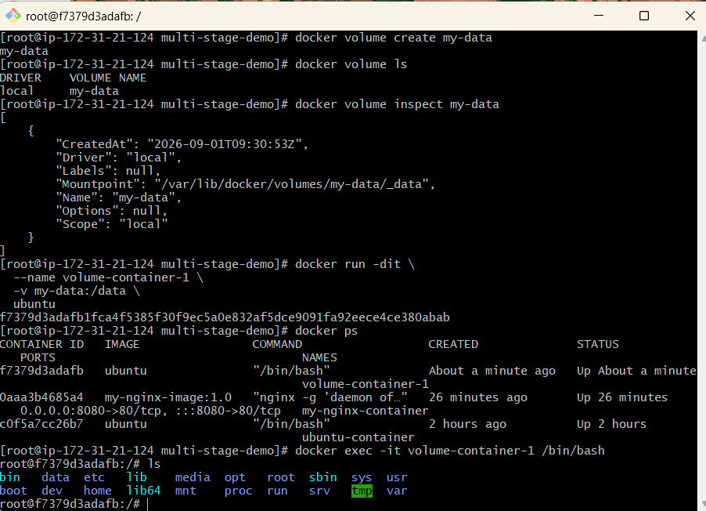

7.Container networking
- Create a custom Docker network.
- Run two containers on the network.
- Make one container communicate with the other using the container name instead of an IP address.
Step 1: Check existing networks
Run:
docker network ls
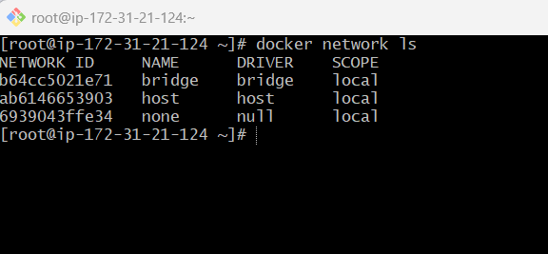
Step 2: Create a custom Docker network
Run:
docker network create my-network
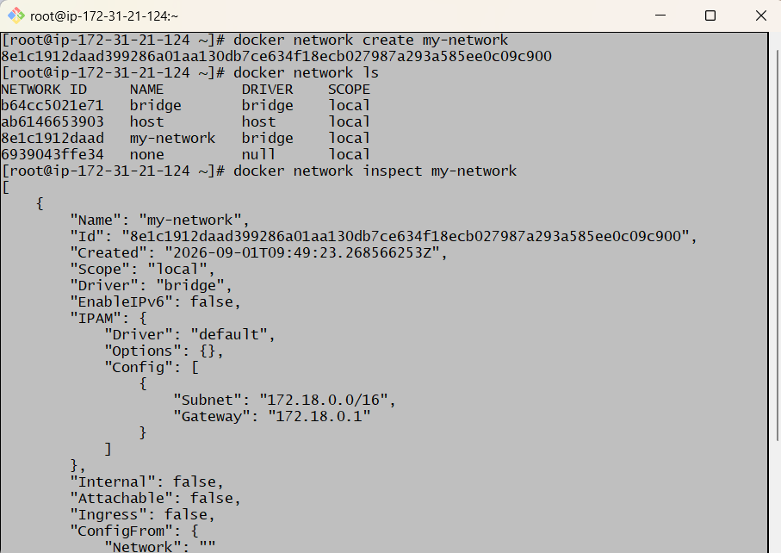
Step 4: Run the first container
We'll use Nginx as the web server.
Run:
docker run -d --name nginx-server --network my-network nginx
Let's understand:
docker run
Create and start a container.
-d
Run in background.
--name nginx-server
Give the container the name:
nginx-server
--network my-network
Connect the container to our custom network.
nginx
Use the Nginx image.
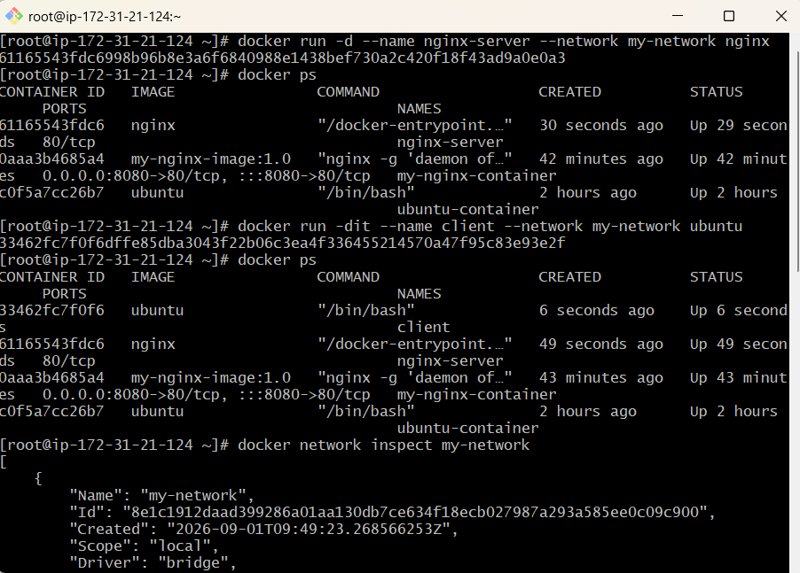
Step 6: Run the second container
We'll use Ubuntu as our client container.
Run:
docker run -dit --name client --network my-network ubuntu
Verify:
docker ps
You should now have:
CONTAINER ID IMAGE NAMES
xxxxxxxx nginx nginx-server
xxxxxxxx ubuntu client
Both containers are connected to:
my-network

Step 7: Check the network
Run:
docker network inspect my-network
Now you'll see both containers listed.
Conceptually:
my-network
172.x.x.x network
|
+-------+-------+
| |
↓ ↓
nginx-server client
Nginx Ubuntu

Step 8: Enter the client container
Run:
docker exec -it client /bin/bash
You should see:
root@xxxxxxxx:/#
Now we're inside the client container.

Step 9: Try communicating using the container name
From inside the client container, run:
curl http://nginx-server
You should receive the Nginx HTML page.
For example:
<!DOCTYPE html>
<html>
<head>
<title>Welcome to nginx!</title>
</head>
...
</html>
🎉 This is the main objective of the task.
The client communicated with Nginx using:
nginx-server
instead of:
172.x.x.x

🔥 What happened behind the scenes?
You typed:
curl http://nginx-server
Docker's embedded DNS resolved:
nginx-server
↓
Container IP address
↓
Nginx container
↓
Port 80
Conceptually:
client
|
|
curl http://nginx-server
|
↓
Docker Embedded DNS
|
↓
nginx-server
|
↓
Container IP
|
↓
Nginx
:80
You don't need to know the IP address.

Step 10: Verify the container's IP
You can see the IP with:
docker inspect nginx-server
Or more simply:
docker inspect nginx-server --format='{{range .NetworkSettings.Networks}}{{.IPAddress}}{{end}}'
You might get:
172.18.0.2
But notice:
curl http://nginx-server
works without using:
172.18.0.2
That's the advantage of Docker's DNS-based service discovery on user-defined networks.

Step 11: Test using the IP
You can test it for comparison:
curl http://172.18.0.2
It should also work.
But don't depend on the IP.
Why?
Because container IP addresses can change when containers are recreated.
For example:
Container deleted
↓
New container created
↓
New IP
But the name can remain:
nginx-server
Therefore:
❌ Hard-coded IP
✅ Container name

Step 12: Check DNS resolution directly
Inside the client container, try:
getent hosts nginx-server
You should get something similar to:
172.18.0.2 nginx-server
This proves that Docker's DNS is resolving:
nginx-server → IP address
If getent isn't available in your Ubuntu image, you can continue using:
curl http://nginx-server

Step 13: Check Nginx logs
Exit the client:
exit
Now check:
docker logs nginx-server
You should see a request from the client.
For example:
172.18.0.3 - - [01/Sep/2026:...] "GET / HTTP/1.1" 200 ...
This confirms:
client
↓
nginx-server
↓
HTTP request
↓
200 OK

Step 14: Do we need -p?
Notice that we started Nginx with:
docker run -d --name nginx-server --network my-network nginx
We did not use:
-p 8080:80
And communication still works.
Why?
Because -p is for publishing a container port to the host.
Our communication is:
Container → Container
on the same Docker network.
Therefore we don't need host port mapping.
client
|
| Docker network
↓
nginx-server:80
No host port is required.

⭐ Container-to-Container vs Browser Access
This distinction is very important.
Container-to-container
client → nginx-server:80
No -p required.
Host/browser-to-container
Browser → Host:8080 → Container:80
You need:
-p 8080:80
So:
Internal communication:
nginx-server:80

External access:
localhost:8080

Step 15: Make the Nginx page custom
Let's make the example more interesting.
Create a custom HTML file on the host:
mkdir docker-network-demo
cd docker-network-demo
Create:
vi index.html
Add:
<!DOCTYPE html>
<html>
<head>
<title>Docker Networking</title>
</head>
<body>
<h1>Hello from nginx-server!</h1>
<p>This page is being accessed through a Docker custom network.</p>
</body>
</html>
Save it.
Then remove the old Nginx container:
docker rm -f nginx-server
Create a new one with the HTML mounted:
docker run -d \
--name nginx-server \
--network my-network \
-v "$(pwd)/index.html:/usr/share/nginx/html/index.html:ro" \
nginx
Now enter the client:
docker exec -it client /bin/bash
Run:
curl http://nginx-server
You should see:
<h1>Hello from nginx-server!</h1>
<p>This page is being accessed through a Docker custom network.</p>

🧠 Important: Why Use a Custom Network?
Docker has a default bridge network.
But for application containers, a user-defined bridge network is generally better because Docker provides built-in DNS-based service discovery between containers attached to that network.
For example:
my-network
|
+---- frontend
|
+---- backend
|
+---- database
The frontend can communicate with:
backend
and backend can communicate with:
database
using names rather than manually managing IP addresses.

⭐ Real-World Example
Imagine you have a 3-tier application:
User
|
↓
Frontend
|
↓
Backend
|
↓
Database
Docker network:
my-app-network
|
+---------------+---------------+
| | |
↓ ↓ ↓
frontend backend database
| | |
| | |
+---------- DNS names ----------+
Backend can connect to the database using:
database:3306
rather than:
172.18.0.5:3306
If the database container is recreated and gets a different IP, the application can still use:
database:3306

🔥 Your Practical Test
Run exactly these commands:
1. Create network
docker network create my-network
2. Create Nginx
docker run -d --name nginx-server --network my-network nginx
3. Create client
docker run -dit --name client --network my-network ubuntu
4. Enter client
docker exec -it client /bin/bash
5. Communicate using container name
curl http://nginx-server
6. Verify DNS
getent hosts nginx-server
7. Exit
exit
8. Inspect network
docker network inspect my-network

🎯 Expected Result
You should be able to demonstrate:
$ curl http://nginx-server

<!DOCTYPE html>
<html>
...
<title>Welcome to nginx!</title>
...
</html>
And:
client
|
| HTTP request
| http://nginx-server
↓
Docker DNS
|
↓
nginx-server
|
↓
Nginx :80

⭐ Interview Answer
If an interviewer asks:
"How can two Docker containers communicate without using IP addresses?"
Answer:
"I create a user-defined Docker network and attach both containers to it. Docker provides embedded DNS-based service discovery on user-defined networks, so one container can communicate with another using its container name. For example, if the container is named nginx-server, another container on the same network can use curl http://nginx-server instead of hard-coding the container IP."
Remember these three things:
1. docker network create my-network
2. --network my-network
3. curl http://nginx-server
The key concept is: container name → Docker DNS → container IP → application.

