**Annexure**

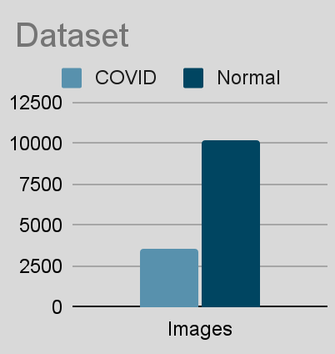

Figure 1. Dataset - Class distribution

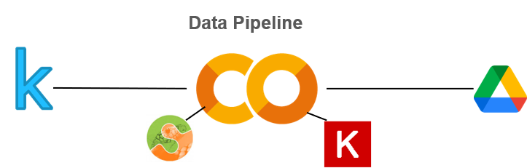

Figure 2. Data pipeline

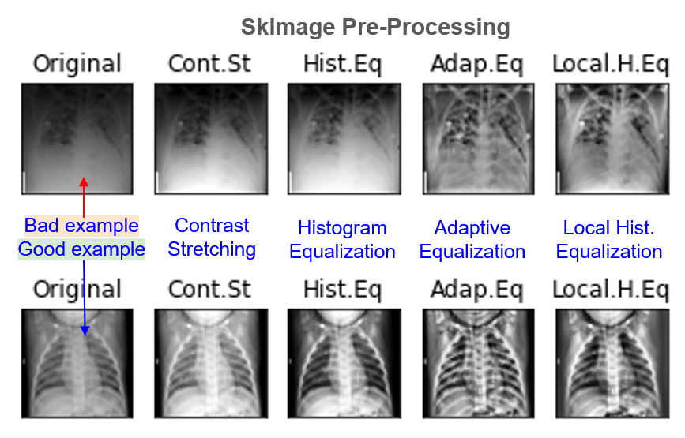

Figure 3. Image pre-processing using scikit-image

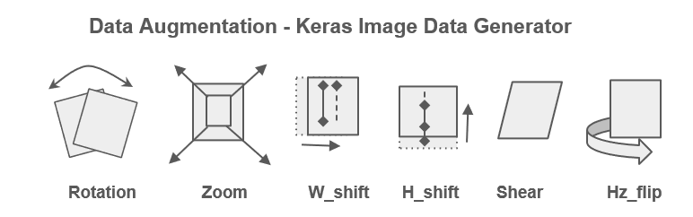

Figure 4. Data Augmentation using Keras image data generator

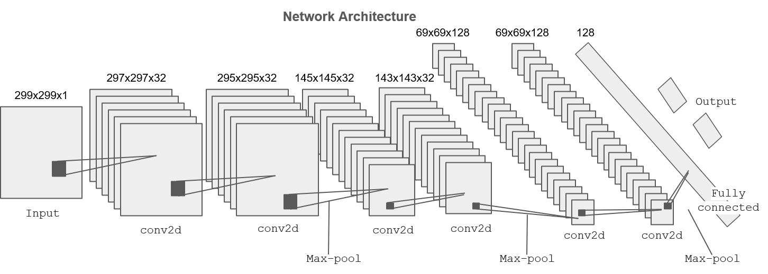

Figure 5. CNN Architecture

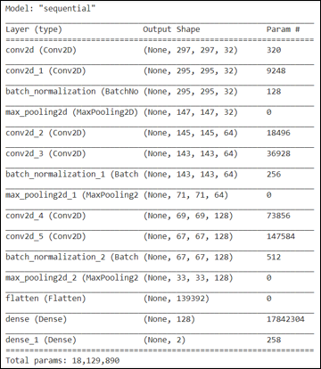

Figure 6. CNN model summary

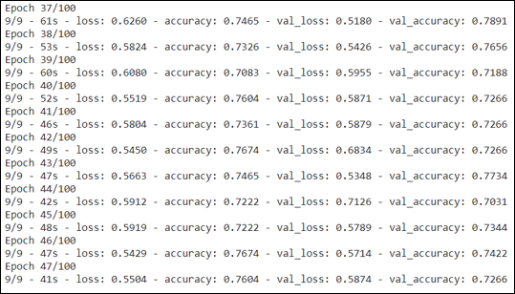

Figure 7. Training log – Early Stopping

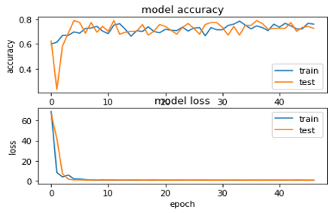

Figure 8. Training - Model learning curve

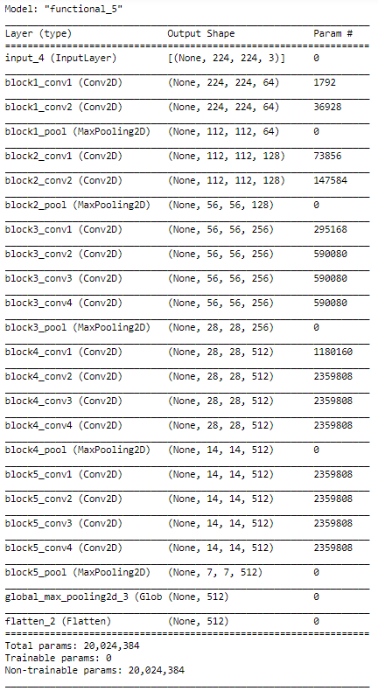

Figure 9. Reference model - Summary of VGG19 used in the background

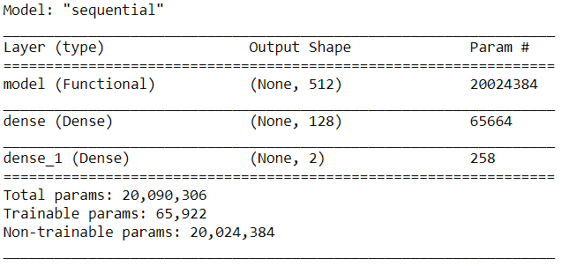

Figure 10. Reference Model - Summary with untrainable VGG19

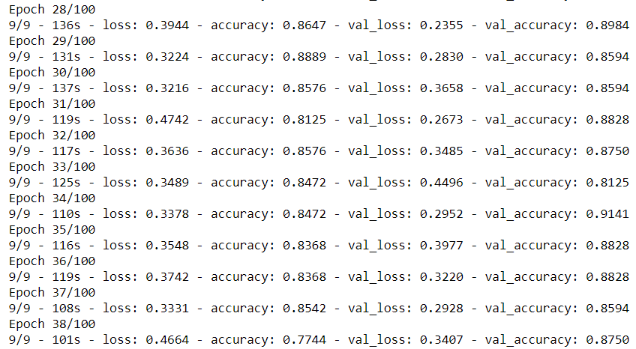

Figure 11. Reference Model - Training log

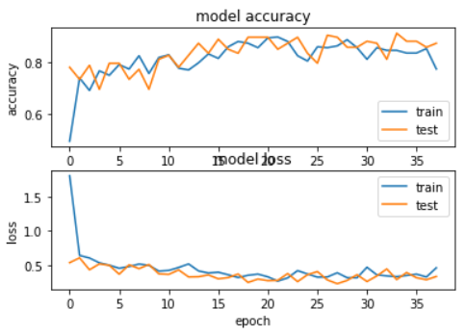

Figure 12. Reference Model - Learning curve