GCS ANALYTICS | GLOBAL GAMING MARKET INTELLIGENCE
Global Gaming Market Intelligence
Video Game Sales Analytics | Power BI • DAX • Power Query | Prepared by GCS Analytics
$6.61B  Global sales | $95.7M  Dominant publisher metric | $0.51M  Average yield | 39  Active consoles
Source: VGChartz video game sales dataset, release years 1977-2020

GCS Analytics
Global Gaming Market Intelligence – Video Game Sales Report
This report presents insights from the Global Gaming Market Intelligence dashboard developed by GCS Analytics using the VGChartz video game sales dataset (release years 1977–2020). It summarizes console performance, release-year trends, regional sales, and genre-level patterns.
Inside you will find five sections:
- Key Performance Indicators
- Console Performance
- Sales Trend by Release Year
- Regional Sales Analysis
- Console & Genre Breakdown and Key Takeaways

1 Key Performance Indicators
The top of the dashboard shows four headline cards:
Metric | Value
Global Sales | $6.61B
Dominant Publisher Metric | $95.7M
Average Yield | $0.51M
Active Consoles Count | 39 systems

Across all 39 consoles in the dashboard, total sales reach $6.61 billion, with an average yield of about $0.51M per record.

2 Console Performance
The bar chart ranks consoles by total sales (in millions):
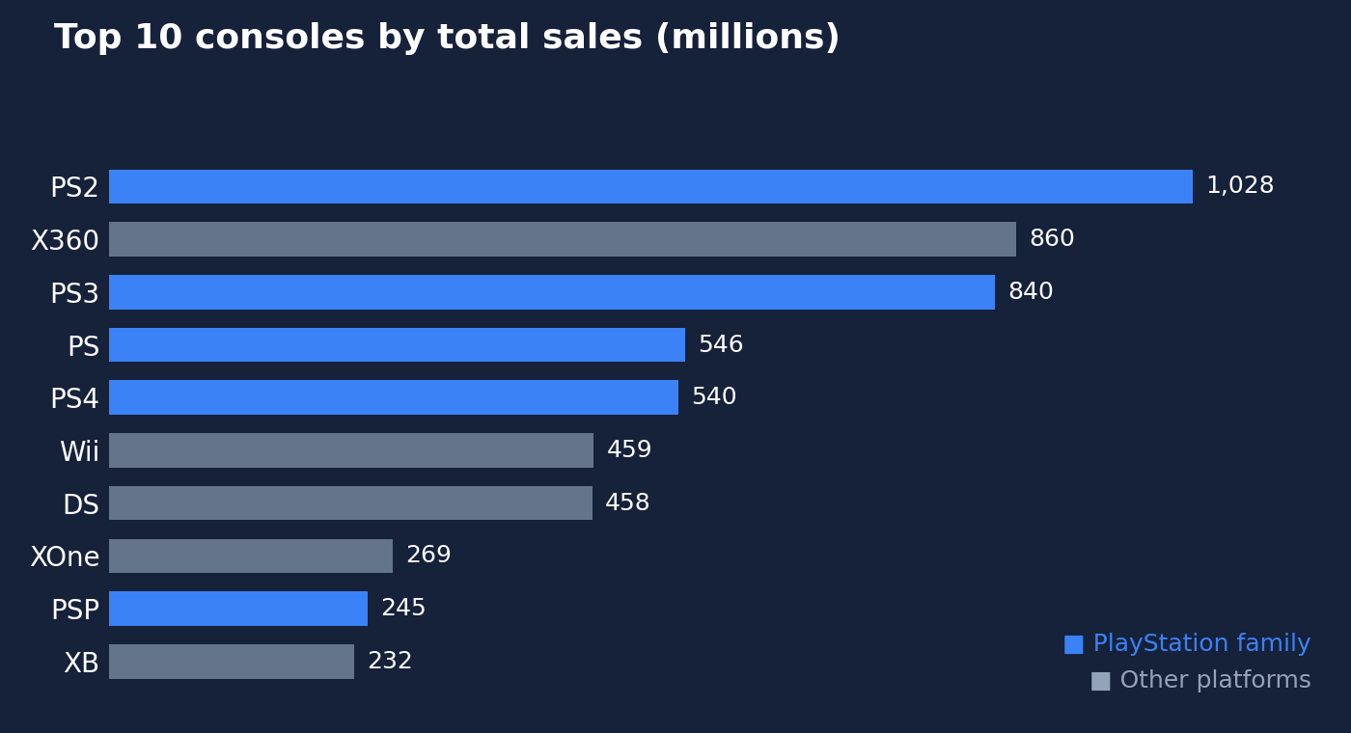
Figure 1. PlayStation systems (blue) take five of the top ten places.
Rank | Console | Sales (M)
1 | PS2 | 1,028
2 | X360 | 860
3 | PS3 | 840
4 | PS | 546
5 | PS4 | 540
6 | Wii | 459
7 | DS | 458
8 | XOne | 269
9 | PSP | 245
10 | XB | 232

Insight: The PlayStation family (PS2, PS3, PS, PS4, PSP) dominates the top ten, and the PS2 leads clearly with over 1 billion in sales.

3 Sales Trend by Release Year
The area chart shows total sales by release year from 1977 to 2020.
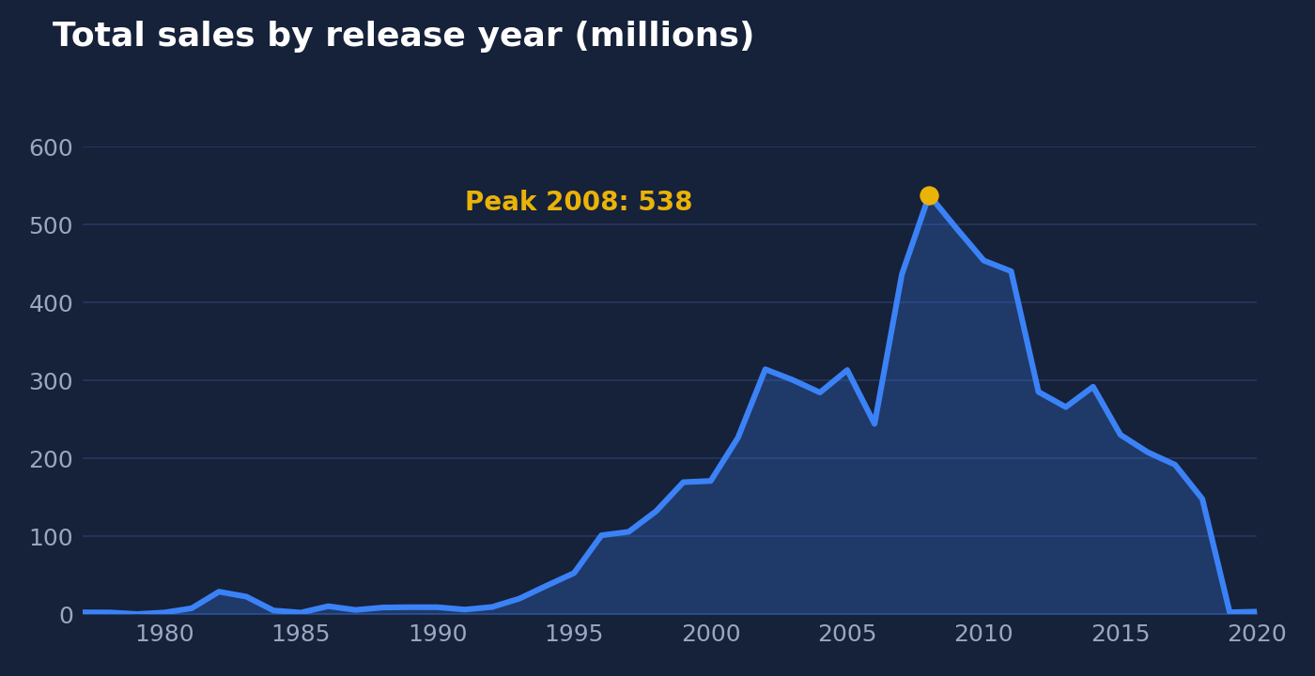
Figure 2. Yearly sales rise from the late 1990s and peak in 2008.
- Sales stay very low through the 1980s and early 1990s.
- Growth begins in the late 1990s and reaches an early high of about 314 in 2002, with about 313 again in 2005.
- The all-time peak is about 538 in 2008.
- After a dip to about 244 in 2006 and a drop to about 266 in 2013 (with a brief recovery to about 292 in 2014), sales decline steadily and then fall sharply to about 3 by 2019–2020, likely reflecting incomplete data for the final years.

4 Regional Sales Analysis
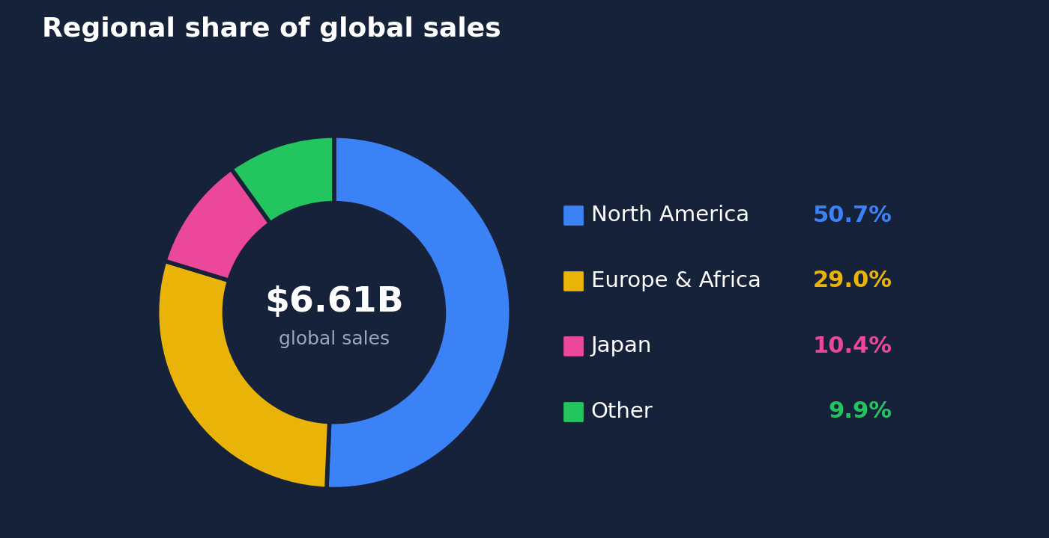
Figure 3. North America alone accounts for just over half of global sales.
Region | Sales | Share
North America | $3.35B | 50.68%
Europe and Africa (PAL) | $1.92B | 29.04%
Japan | $687.9M | 10.42%
Other countries | $651.1M | 9.86%

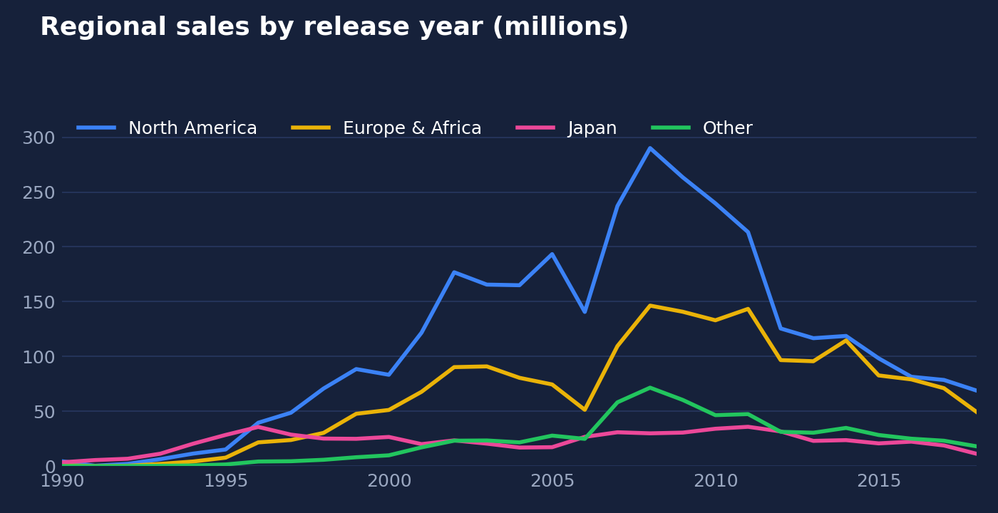
Figure 4. All regions follow the same 2008-era peak and later decline.
Insights:
- North America alone accounts for just over half of all global sales.
- Europe and Africa is the second-largest market at nearly 30%.
- Japan and the rest of the world are each roughly 10%.
- In the regional line chart, North America peaks at about 290, with PAL peaking at about 146, and all regions follow the same 2008-era peak and later decline.

5 Console & Genre Breakdown and Key Takeaways
The detail table combines console, genre and regional sales. Selected rows:
Console | Genre | Global | N. America | Japan | Europe & Africa | Other
PS2 | Platform | $59.6M | $30.7M | $1.2M | $18.3M | $9.5M
PS2 | Fighting | $66.8M | $31.7M | $7.0M | $19.6M | $8.5M
PS3 | Racing | $52.0M | $18.3M | $1.3M | $24.0M | $8.5M
XOne | Shooter | $90.3M | $56.0M | $0.2M | $25.9M | $8.3M
PS3 | Misc | $57.6M | $25.6M | $4.0M | $20.1M | $8.0M
PS4 | Action-Adventure | $51.2M | $17.3M | $2.2M | $23.7M | $7.9M
Wii | Sports | $92.2M | $58.9M | $2.4M | $23.0M | $7.8M
DS | Simulation | $89.0M | $55.5M | $4.9M | $21.0M | $7.5M
Total |  | $6.61B | $3.35B | $687.9M | $1.92B | $651.1M

Across the full dataset, three genres lead total sales by a wide margin:
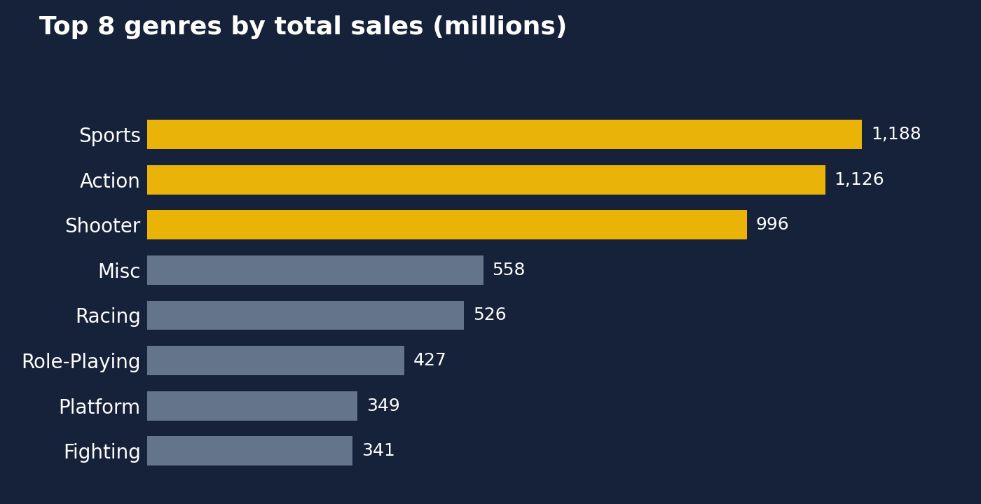
Figure 5. Sports, Action and Shooter (gold) together account for roughly half of all sales.

Dashboard Controls
- Genre slicer: filter every visual by one or more genres (Action, Action-Adventure, Adventure, Board Game and more).
- Release_Year slider: limit the view to a range between 1977 and 2020.
- Reset Slicers button: clears all filters at once.

Key Takeaways
- The PS2 is the best-selling console, and Sony consoles dominate the top ranks.
- Sales peaked around 2008, driven by the PS3, Xbox 360 and Wii era.
- North America is the most important market at over 50% of sales.
- Shooter and Sports titles on newer consoles (XOne, Wii) post some of the highest individual console-genre totals.
- Japan is a small share overall, but it responds strongly to specific genres such as Fighting.

