**SET – 1 Solutions**

**1 Solution:**

The Inclusion-exclusion principle states that in order to find the number of elements in the union of two sets A and B, we need to include(add) the elements that are present in the two sets A and B, and exclude(subtract) the common elements of the sets as they would be added twice from both the sets.

The formula (equation) of the inclusion-exclusion principle:

n(A ∪ B) = n(A) + n(B) – n(A **∩** B)

where n(AUB) = number of elements in the set AUB

similarly, n(A) = number of elements in set A

n(B) = number of elements in set B

n(A **∩** B) = number of elements in set A **∩** B.

from the given problem,

let H – set of Hindi speaking people

let E – set of English-speaking people

Given: n(H ∪ E) = 50 , n(H) = 35 , n(H **∩** E) = 25

1. People who speak only English and not Hindi = n(E) – n(H **∩** E)

From inclusion-exclusion principle:

n(H ∪ E) = n(H) + n(E) – n(H **∩** E)

⸫ n(E) – n(H **∩** E) = n(H ∪ E) - n(H)

People who only speak English and not Hindi = 50 – 35 = **15**

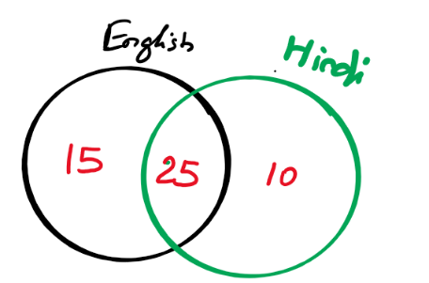

1. People who speak English,



n(E) = n(H **∩** E) + n(H ∪ E) - n(H)

= 25 + 50 – 35 = 40

⸫ Number of people who can speak English = **40**

**2 Solution: 2a** 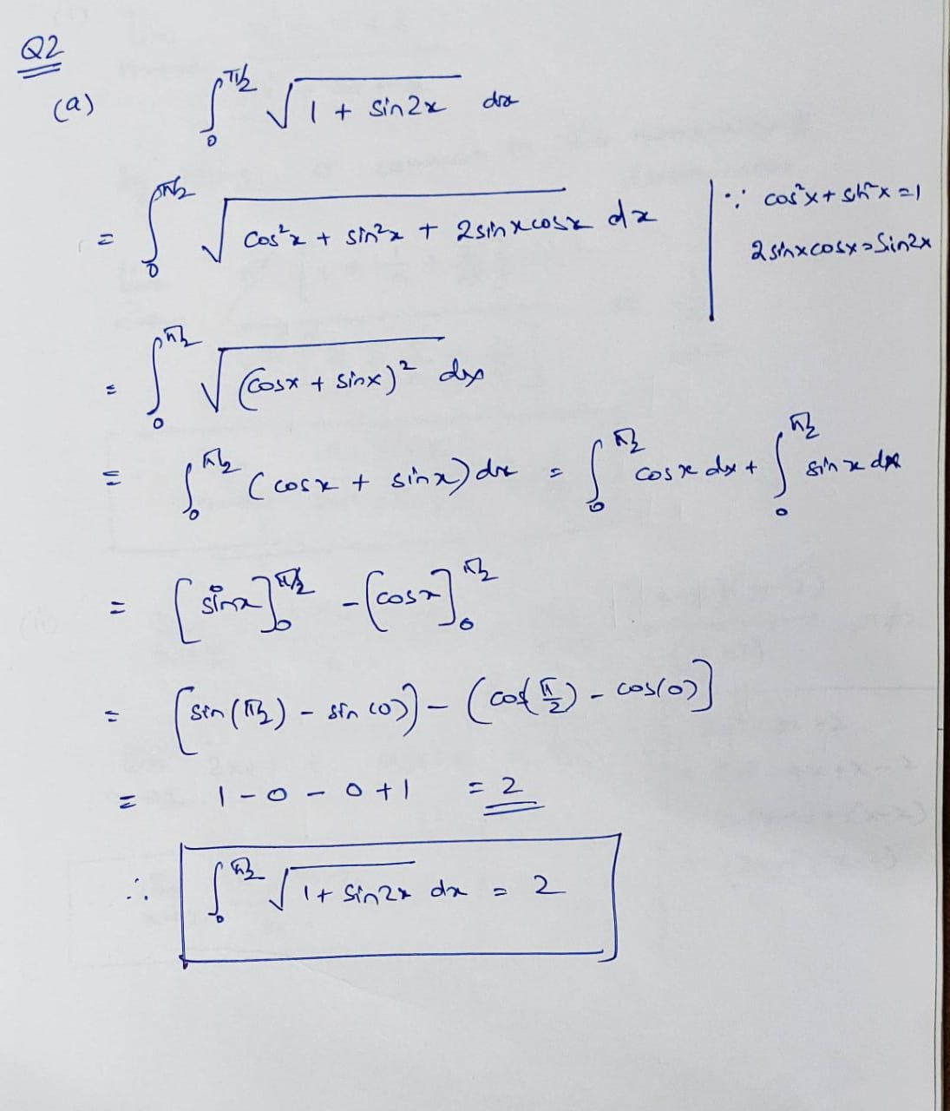

**2b** 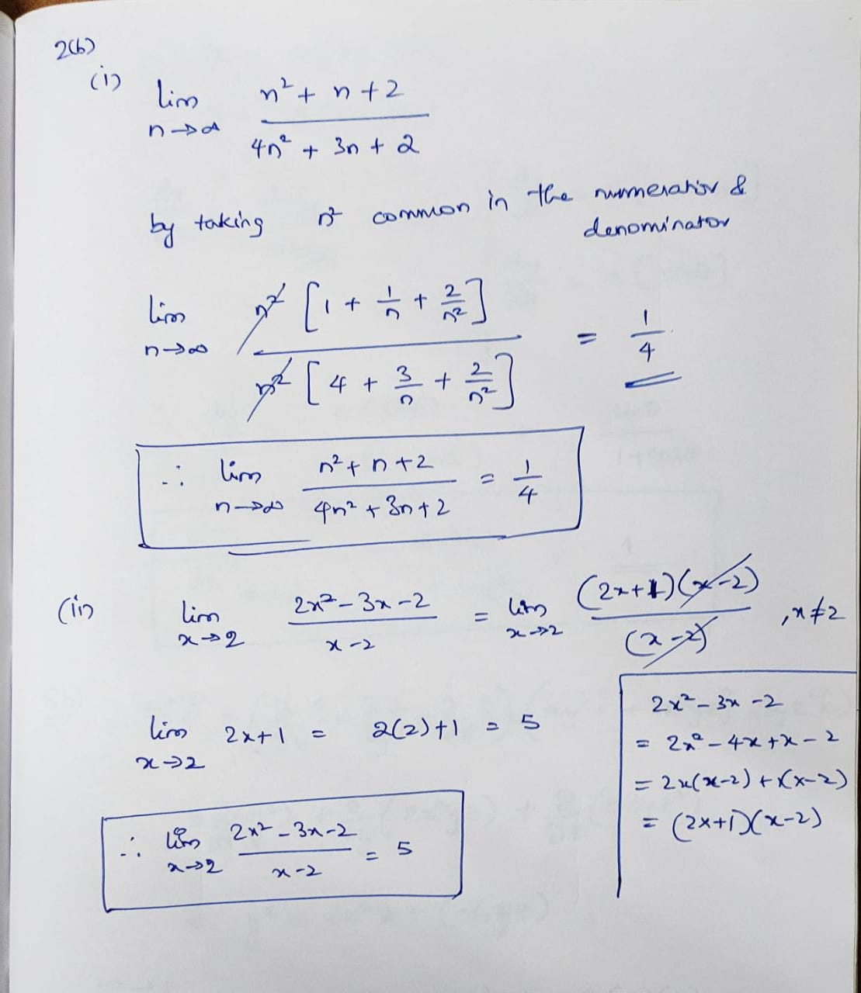

**3 Solution:** 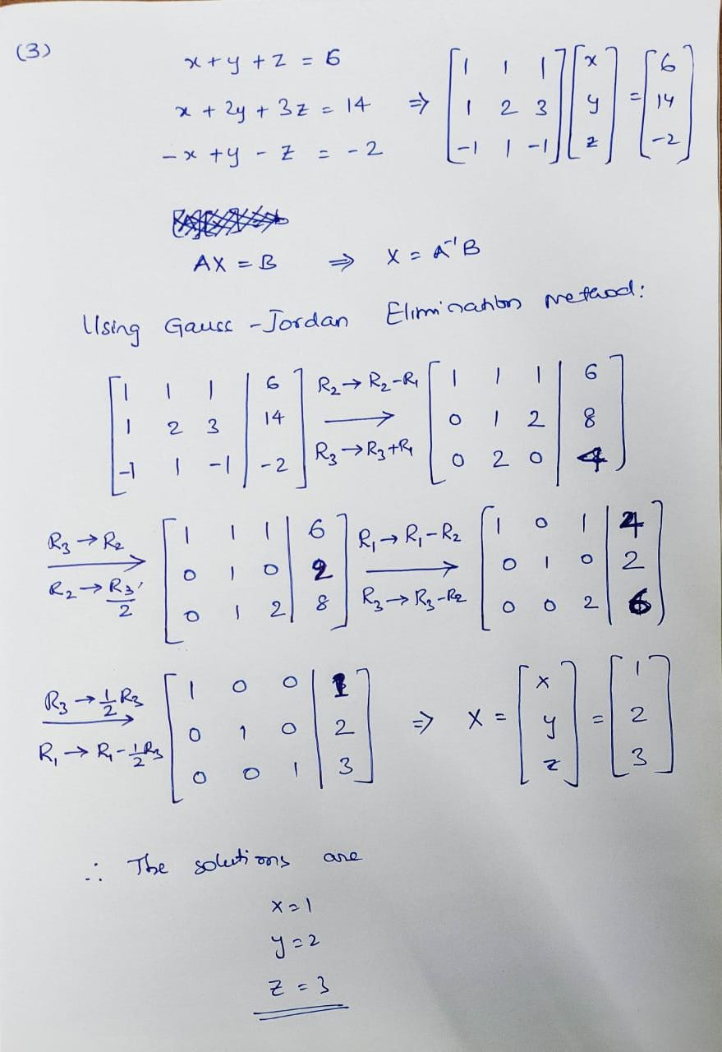

**SET – 2 Solutions**

**4a solution:**

Two propositions are said to be logically equivalent when they get the same outputs for the same inputs.

The truth table for **~(p˄q)**

|  |  |  |  |
| --- | --- | --- | --- |
| **p** | **q** | **p˄q** | **~(p˄q)** |
| **F** | **F** | **F** | **T** |
| **F** | **T** | **F** | **T** |
| **T** | **F** | **F** | **T** |
| **T** | **T** | **T** | **F** |

The truth table for **~p˅~q**

|  |  |  |  |  |
| --- | --- | --- | --- | --- |
| **p** | **q** | **~p** | **~q** | **~p˅~q** |
| **F** | **F** | **T** | **T** | **T** |
| **F** | **T** | **T** | **F** | **T** |
| **T** | **F** | **F** | **T** | **T** |
| **T** | **T** | **F** | **F** | **F** |

From the above truth tables for the same inputs of p and q we are same outputs for both ~**(p˄q)** and **~p˅~q**

**⸫ ~(p ˄ q)** ≡ **~p˅~q**

**4b Solution:**

**5 Solution:** 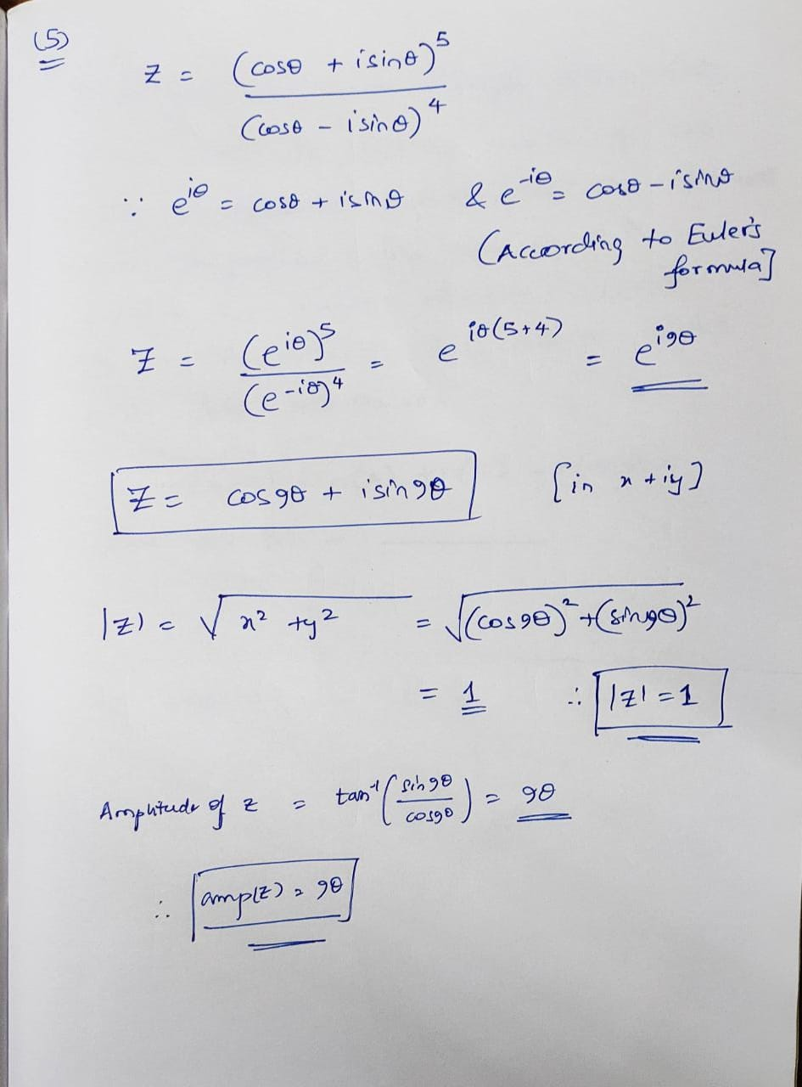

**6 Solution:** 