HanuAI ML Assessment – Task 2
Advanced EDA and Text Mining of Automotive Infotainment Complaints
Prepared from the supplied Hanuai_task2_assignment.csv (1,000 records).

1. Executive summary
The supplied file contains 1,000 records and 20 original columns. The Opened date field spans 2019-08-27 to 2021-06-01. The most frequent causal code is “Module/Component-No/Incorrect Communication” (377 rows), and the most frequent complaint category is “Audio/Entertainment/Navigation - Audio” (337 rows). The records mainly describe audio/infotainment, display, and radio communication problems. Narrative tagging and clustering are exploratory text-mining aids, not confirmed engineering diagnoses.

2. Dataset overview and data quality
- Rows: 1,000; original columns: 20.
- Exact duplicate rows: 0. Duplicate Event id values: 0.
- Opened date range: 2019-08-27 to 2021-06-01.
- MODLYR unique values: 1; dominant value: 2020.
- Date columns were parsed as dates; text fields were whitespace-normalized; blank strings were converted to missing values where applicable.
- Original narrative fields are retained. New fields include joined/cleaned narrative text, word count, heuristic issue tags, inferred fix strategy, and text cluster.
Missing values in original columns (non-zero only):
- Failure Component: 995 missing (99.5%)
- Fix Component: 995 missing (99.5%)
- Trigger: 995 missing (99.5%)
- Additional Context: 995 missing (99.5%)
- Failure Condition: 995 missing (99.5%)
- Fix Condition: 995 missing (99.5%)
- CAUSAL_CD_DESC: 3 missing (0.3%)
- CAUSAL_VERBATIM: 1 missing (0.1%)
- IN_USE_DATE: 1 missing (0.1%)
Important limitation: the structured fields Trigger, Failure Component, Failure Condition, Additional Context, Fix Component, and Fix Condition are populated in only a small number of rows in this file. Therefore, text narratives are the main source for issue tagging, and structured tag comparisons should be interpreted cautiously.

3. Descriptive EDA
Top causal code descriptions:
- Module/Component-No/Incorrect Communication: 377 (37.7% of all rows)
- Module/Component-Shorted: 237 (23.7% of all rows)
- Module/Component-Registers Incorrectly: 121 (12.1% of all rows)
- Wiring/Electrical/Sensors-No/Incorrect Communication: 50 (5.0% of all rows)
- Module/Component-Broken: 41 (4.1% of all rows)
- Wiring/Electrical/Sensors-Shorted: 23 (2.3% of all rows)
- Other-Follow operation: 22 (2.2% of all rows)
- Other-Campaign/ Tech Bulletin: 22 (2.2% of all rows)
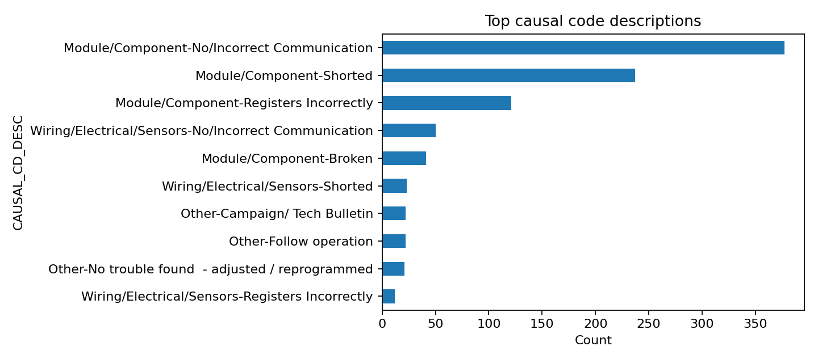
Top complaint categories:
- Audio/Entertainment/Navigation - Audio: 337 (33.7% of all rows)
- Audio/Entertainment/Navigation - Other issues: 263 (26.3% of all rows)
- Audio/Entertainment/Navigation - Communication: 194 (19.4% of all rows)
- Audio/Entertainment/Navigation - Video: 103 (10.3% of all rows)
- Features/Controls/Displays - Other issues: 47 (4.7% of all rows)
- Audio/Entertainment/Navigation - Navigation: 32 (3.2% of all rows)
- Features/Controls/Displays - Gauges/Warning Lights: 12 (1.2% of all rows)
- Audio/Entertainment/Navigation - Abnormal Noise: 11 (1.1% of all rows)
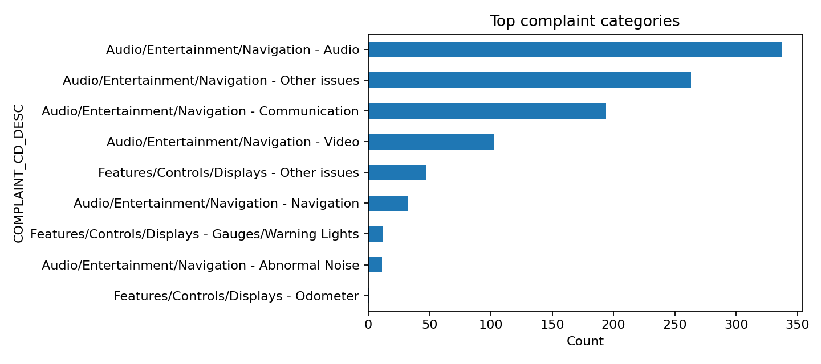
Records by build plant (top plants):
- Fort Wayne: 217 (21.7%)
- Flint: 208 (20.8%)
- Silao: 199 (19.9%)
- Spring Hill - Truck: 169 (16.9%)
- Lansing Delta: 142 (14.2%)
- Ramos Arizpe: 39 (3.9%)
- Fairfax II: 16 (1.6%)
- Lansing - LGR: 10 (1.0%)
Records by make:
- ThunderVolt: 488 (48.8%)
- NovaSprint: 335 (33.5%)
- NebulaCruiser: 125 (12.5%)
- TurboFlux: 52 (5.2%)

4. Text mining: issue tagging and entities
A transparent keyword/rule approach tags narrative records into overlapping issue themes. Because a record may contain multiple symptoms, tag counts are multi-label and can exceed the number of records. The rules are intended as a baseline that can be reviewed and refined with domain experts.
- Software/update/programming: 474 tagged records (47.4% of rows; multi-label)
- USB/SD/navigation: 363 tagged records (36.3% of rows; multi-label)
- Audio/radio inoperative: 330 tagged records (33.0% of rows; multi-label)
- Display/black screen: 241 tagged records (24.1% of rows; multi-label)
- Electrical/wiring: 165 tagged records (16.5% of rows; multi-label)
- Connectivity/integration: 149 tagged records (14.9% of rows; multi-label)
- Other/unclear: 142 tagged records (14.2% of rows; multi-label)
- Communication/network: 119 tagged records (11.9% of rows; multi-label)
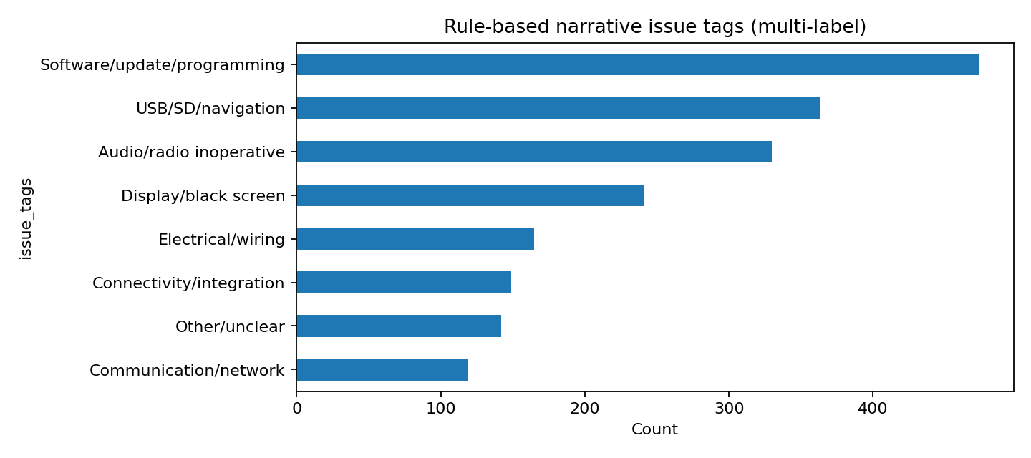
Entity-like extraction in this baseline is represented by the existing structured fields (component, condition, fix, make, model, plant) plus keyword themes in narratives. A production version should add a validated component/error-code dictionary and preserve source spans.

5. Fix strategy patterns
- Component replacement: 889 records (88.9%)
- Programming/software: 47 records (4.7%)
- Other/unclear: 46 records (4.6%)
- Wiring/connector repair: 14 records (1.4%)
- Reset/reinitialization: 3 records (0.3%)
- Unable to reproduce/monitor: 1 records (0.1%)
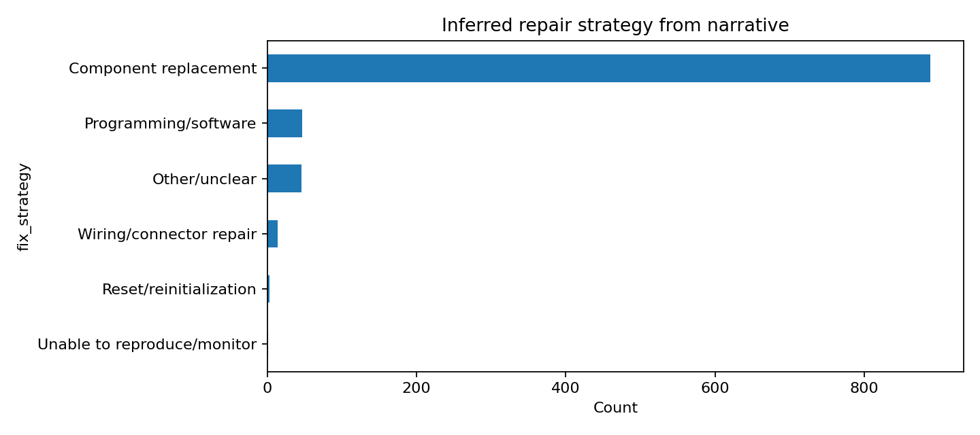
Fix strategy is inferred from narrative wording, not taken as a verified repair outcome. Replacement is often described in these records, but a recommendation or attempted replacement may not mean the issue was permanently resolved.

6. Topic modelling / clustering
TF-IDF vectorization with unigram/bigram features and K-Means (k=5, random_state=42) was used to group similar narratives. The clusters are exploratory; they should be named by reading representative records rather than treating the algorithm's output as ground truth.
- Cluster 0 — 313 records (31.3%); representative terms: replaced, replaced radio, customer, states, internal, customer states, xm, programmed, screen, states radio
- Cluster 1 — 235 records (23.5%); representative terms: update, usb, tac, vehicle, phone, customer, performed, programming, software, case
- Cluster 2 — 302 records (30.2%); representative terms: replace, screen, replace radio, check, program, display, ok, codes, communication, test
- Cluster 3 — 104 records (10.4%); representative terms: camera, rear, coax, camera inop, video, code, cable, backup, backup camera, inop
- Cluster 4 — 46 records (4.6%); representative terms: card, sd, sd card, error, navigation, error code, nav, message, usb, replaced
Recommended next step: review 10–20 records per cluster, assign human-readable labels, then evaluate stability across different k values.

7. Time and trend analysis
Monthly record counts are available in the notebook; busiest month in the supplied sample: 2020-02 (69 records).
The dataset is a supplied sample, not necessarily a complete population of all vehicle complaints. Counts by month, plant, make, or model should not be interpreted as failure rates without exposure denominators (e.g., vehicles sold or in service).

8. Business implications
- Prioritize diagnosis of audio/infotainment and radio communication complaints because these dominate the recorded complaint categories.
- Use recurring phrases such as black/blank screen, no sound, lost communication, update/programming failure, and navigation/SD-card errors to route cases to specialized diagnostic workflows.
- Build a structured symptom-to-component dictionary and standardize error-code capture; many narrative descriptions contain redacted or blank DTC identifiers.
- Track repeat visits and repair recurrence by Event id/vehicle identifier if available; the present file does not provide enough evidence to calculate recurrence rates reliably.
- Avoid comparing plant quality using raw counts alone; normalize by production volume and vehicle-in-service exposure.

9. Technical learnings and improvements
- Add automated schema checks, date parsing validation, missingness reports, and uniqueness checks to the ingestion pipeline.
- Replace keyword-only tagging with a reviewed taxonomy and annotate a stratified sample for precision/recall evaluation.
- Use a domain dictionary for components, symptoms, DTC/error codes, software versions, and repair actions; preserve original text for auditability.
- Evaluate clustering quality and stability across multiple k values and compare with topic models such as LDA or BERTopic when environment/dependencies permit.
- Create a dashboard showing complaint trends, top symptoms, fix actions, and drill-down to individual event records.

10. Limitations
- Some narrative fields contain redactions, missing technical values, spelling errors, and encoding artifacts.
- The data contains no explicit numeric rating or customer sentiment label; sentiment scores were not invented.
- Issue tags and fix strategies are heuristic and should not be presented as validated ground truth.
- No causal claims can be made about manufacturing plants, models, or fixes without denominators and controlled analysis.

