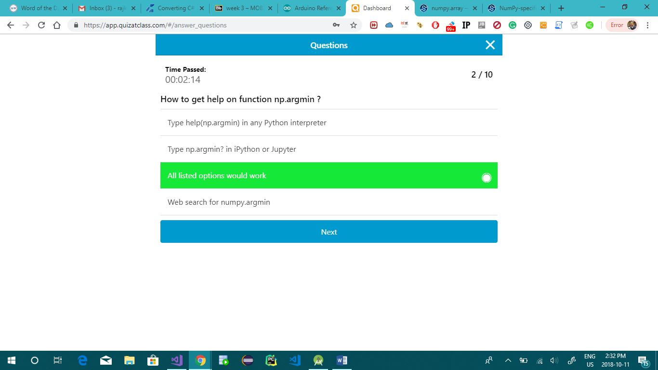

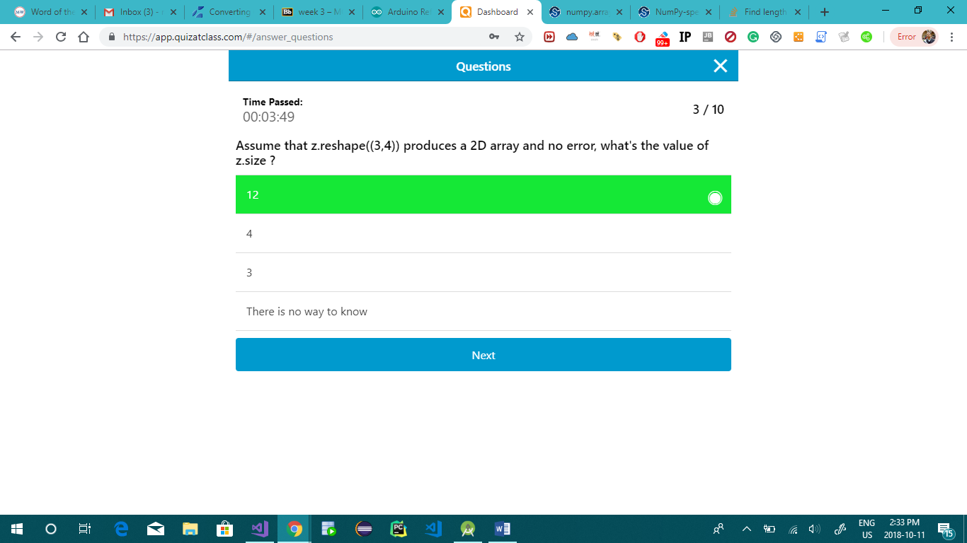

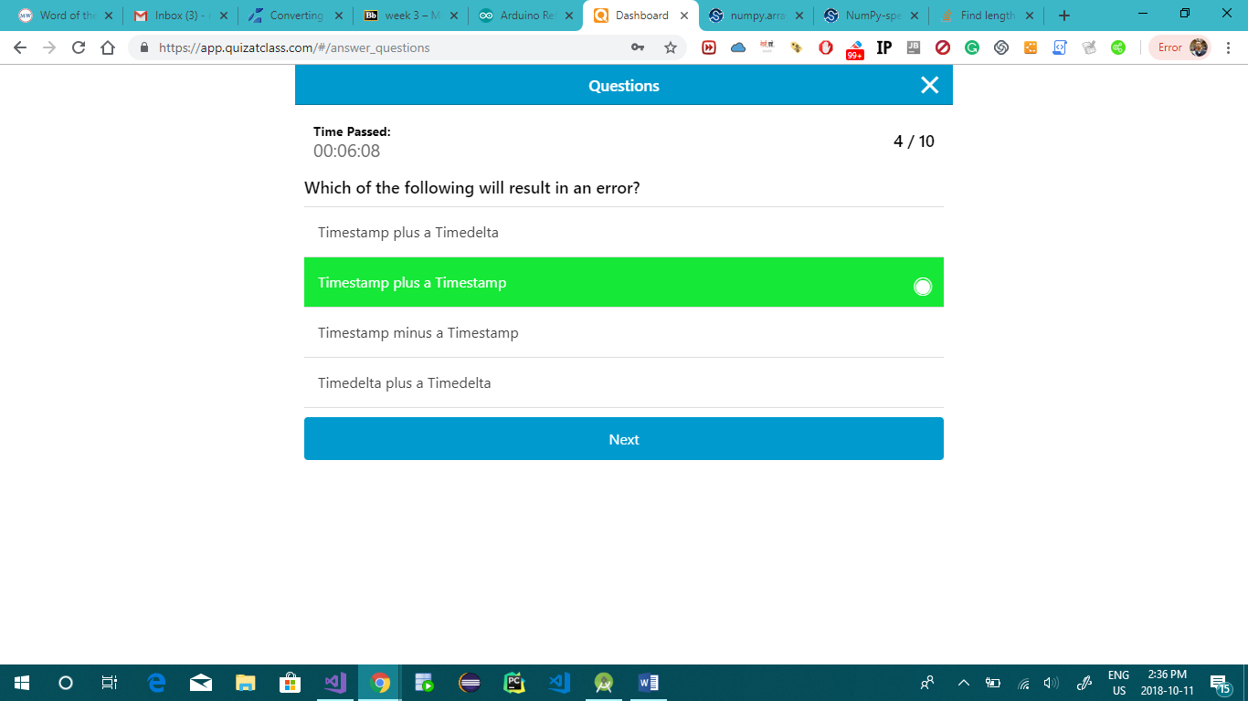

Week_02

* Vectorized computation vs. Python loops
* Slicing NumPy arrays
* NumPy broadcasting)
* More on plotting

Week_03

* Introduction to Pandas
* Working with public datasets, introduction to Kaggle
* Handling Missing Data
* Scraping data

Week_04

* NaN and missing data and scientific notation like 1e6
* Date and time
* Hierarchical Indexes
* Concat & Merging
* Pivot tables?
* More on Pandas and visualization
* Exploring data with descriptive statistics
* Correlation and linear fitting
* Advanced DataFrame manipulations

Week_05

* recap about canlendars and time and what you actully need to know about it all

Week-06

* Patterns
* The concept of "distance"
* Clustering
* Projections and dimensionality reduction