PROJECT TOPIC: Health Navigator: Doctor Appointments and Consultation

Group No.: 21
Project Group Members:
1. Rajkumar Singh (B-27 / 2384200165) 2. Pulkit Bansal (B-24 / 2384200158)
3. Pratap Kumar (B-20 / 2384200152)

Project Supervisor: Mr. Gagan Rajput (Trainer),
Mrs. Ruchi Sharma (Assistant Professor).

About the Project:
The Health Navigator: Doctor Appointment and Consultation project is an online platform that allows users to book appointments with doctors based on their specialties. Users can filter doctors, select available time slots within a 7-day window, and confirm bookings with ease. The system features separate dashboards for admins and doctors. Admins can manage bookings and doctor profiles, while doctors can update their availability, view appointments, and track earnings. The frontend is built using React JS and Tailwind CSS for a responsive interface, and the backend uses Node.js, Express, and MongoDB for secure data handling. The project aims to improve healthcare accessibility, streamline appointment scheduling, and provide an efficient experience for both patients and healthcare providers.

Motivation:
The motivation behind the Health Navigator project is to simplify and digitalize the process of booking doctor appointments. In today's fast-paced world, patients often face difficulties in scheduling timely consultations. By providing an online platform, this system minimizes wait times, improves access to healthcare professionals, and ensures better time management for both doctors and patients. The goal is to make healthcare services more efficient, accessible, and user-friendly through modern web technologies.

Innovation:
- Specialty-Based Filtering – Users can easily find doctors by filtering based on their medical specialties.
- 7-Day Time Slot Booking – Appointments can be booked within a flexible 7-day time window with real-time slot availability.
- Dual Dashboards – Separate, role-specific dashboards for both doctors and admins enhance functionality and usability.
- Full Stack Integration – Modern tech stack using React.js, Tailwind CSS, Node.js, Express, and MongoDB ensures smooth frontend-backend communication.
- Scalable & User-Friendly Design – The platform is built for scalability with a clean, intuitive interface optimized for various devices.

Project Timeline:
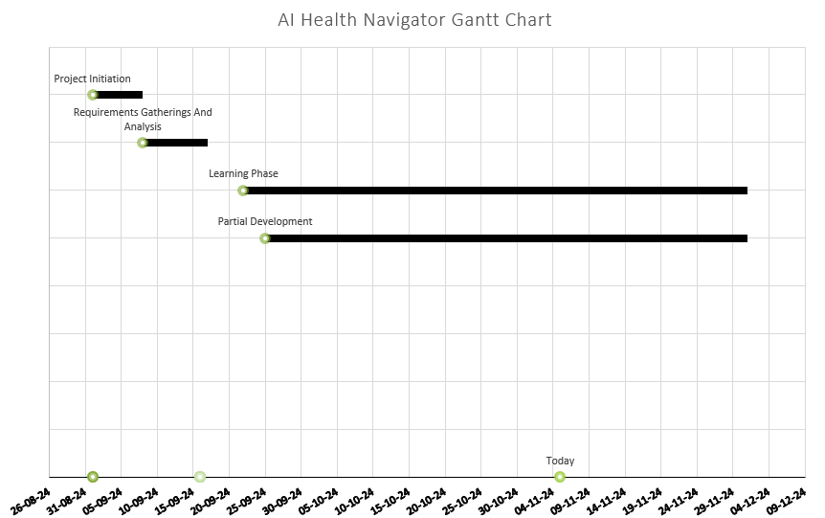

Tools required:
Development Environment:
  - IDE/Text Editor: Visual Studio Code
  - Version Control: Git for version control and collaboration.
Programming Languages:
- Frontend: HTML,Tailwind CSS, JavaScript, React
- Backend: MongoDB, Cloudinary;

Development Machine:
- Processor: Minimum dual-core processor; recommended quad-core or better for efficiency.
- RAM: At least 8GB; 16GB or more is preferable for smoother multitasking.
- Storage: SSD with at least 256GB of space for faster read/write speeds; additional storage for databases may be needed.
- Server Requirements (for deployment):
- Processor: Multi-core processor for handling multiple requests.

Signature of Project Supervisor:

