**ASSESSMENT OF COAL THROUGH ANALYSIS OF VARIOUS PROPERTIES OF COAL SAMPLE AND PROGNOSIS OF CALORIFIC VALUE BY ARTIFICIAL NEURAL NETWORK**

A dissertation submitted in partial fulfillment of the requirements for the award of the degree of

**MASTER OF ENGINEERING**

**IN**

**CIVIL ENGINEERING**

With Specialization in **MINING ENGINEERING**

By

**Ramdeni Santhosh**

**(Roll No: 1005-18-493115)**

Supervisor

**Prof. A.V.Raghuram**



**DEPARTMENT OF CIVIL ENGINEERING**

**UNIVERSITY COLLEGE OF ENGINEERING (Autonomous)**

**OSMANIA UNIVERSITY, HYDERABAD**

**June-2019**



**Department Of Civil Engineering**

University College Of Engineering

Osmania University, Hyderabad-500007

**CERTIFICATE**

The research work embodied in this thesis titled **“assessment of coal through analysis of various properties of coal sample and prognosis of calorific value by artificial neural network”** submitted by Mr. Ramdeni Santhosh, bearing Roll No.1005-18-493115 towards partial fulfillment for the award of Master Degree in Civil Engineering with specialization in Mining Engineering from University College of Engineering (Autonomous), Osmania University, Hyderabad, is original and bona fide record of research work carried out by me under the supervision of A V RAGHU RAM, Associate Professor, Mining Department, College of Technology and Engineering. The content of the thesis, either partially or fully have not been submitted or will not be submitted to any other institute or university for the award of any degree and diploma.

Signature of the supervisor Signature of Head of the Department

## Prof. A.V.Raghuram Prof. M. Anjaneya Prasad

## Professor & Supervisor Professor & Head



Name of the Candidate : Ramdeni Santhosh

Roll No : 1005-18-493115

Specialization : Mining Engineering

Date of External Viva voice :

Grade :

Signature of the External Examiner :

Signature of Supervisor Signature of the Chairman, BOS

Signature of HEAD

**DECLARATION**

I do hereby declare that the dissertation work reported in the present project seminar titled

**“ASSESSMENT OF COAL THROUGH ANALYSIS OF VARIOUS PROPERTIES OF COAL SAMPLE AND PROGNOSIS OF CALORIFIC VALUE BY ARTIFICIAL NEURAL NETWORK”** is a record of work done by me in the Department of Civil Engineering, University College of Engineering (Autonomous), Osmania University, Hyderabad. No part of the work is copied from books/journals/internet and wherever the portion is taken, the same has been duly referred in the text. The report is based on the project work done entirely by me and not copied from any other source.

**Ramdeni Santhosh**

**ACKNOWLEDGEMENT**

I am immensely pleased to place on record my profound gratitude and heartfelt thanks to my supervisor, **Prof. A.V.Raghuram**, of Civil Engineering Department, for his invaluable advice, guidance, motivation, enthusiasm, and immense knowledge in the field of Civil Engineering. I would like to express my sincere thanks to **Prof. M. Anjaneya Prasad**, Head of Civil Engineering Department, for his patience, valuable support and advice during the preparation of the dissertation.

I am grateful to **Prof. M.A. Prasad**, Chairman, BOS for his valuable suggestions and encouragement in doing the dissertation work.

My special thanks to **Prof. M. Kumar**, Principal, University College of engineering, for his valuable suggestions and encouragement in doing the dissertation work.

I express my sincere thanks to all the academic staff of the Construction Engineering and Management program at University College of Engineering for their support and encouragement. I am wholeheartedly thankful to all my friends for their continual support during this study and also deeply thankful to all of them for their motivations, interest and affection.

I would like to give heartfelt appreciation to **My Parents** for their endless support, great sacrifices, never-ending love and encouragement not only during my thesis study, but also throughout my life.

I express my gratitude to everyone who has contributed to the successful completion of the project.

.

**Ramdeni santhosh**

**ABSTRACT**

The quality control plays a very important role in the balancing the profits and output of coal. For the processing cost of the determination of calorific value of the fossil fuels is extensively high, as it required plenty of instrumentation and skilled analyst to perform the experiment, proximate analysis information will be obtained simply victimization a standard muffle chamber compared to calorific value. Multivariate analysis and artificial neural network analysis strategies are introduced to change the task and conjointly scale back the price of research. A trial had created during this gift study to access the relevancy of that correlation and artificial neural network with an abstraction emphasize on study area. Artificial neural network model helps in designed to predict the gross calorific value of coals belonging to different mines in the study area. The 50 samples were collected from different coal samples in the study area. The intrinsic properties were determined by carrying out proximate analysis and calorific value by using bomb calorimeter.

Correlation analysis was carried out to on the individually of moisture, volatile matter, ash, fixed carbon on the gross calorific value (GCV). It is observed that moisture, ash have unfavorable impact and down steps the gross calorific value (GCV). Fixed carbon and volatile matter as positive impact and increase the gross calorific value (GCV). Present study also compares the experimental results to formal given by CIMFR and create by model created by using multivariable linear regression and artificial neural network. The formulae developed by multivariable linear regression is

GCV = -125.481M-115.448A-43.145VM-29.483FC+1152.203

Where GCV in Kcal/kg and moisture, ash, volatile matter, fixed carbon in air-dried percentage basis.

The study from the comparison between CIMFR GCV, Multivariable regression model and ANN model with Experimental GCV observed that all three models predict the calorific value accurately. However, the ANN model gives better prediction than the other models. Therefore, prediction of gross calorific value by ANN model could be a better option than experimentation in the laboratory. The ANN model consider the intrinsic properties determine by proximate analysis as input parameters, which is regular task in the field as these are required to determine the grade of coals and hardly demand any costly experimental setup.

**LIST OF TABLES**

|  |  |  |
| --- | --- | --- |
| **S. No.** | **Particulars** | **Page No.** |
| 1.1 | The Indian and International values of coal | 3 |
| 3.1 | Results of Proximate analysis | 21 |
| 3.2 | Experimental value of Bomb Calorimeter | 27 |
| 3.3 | Experimental Equilibrium value of Gross Calorific Value | 29 |
| 3.4 | Randomly selected Experimental GCV values for the test | 31 |
| 3.5 | Predicted values of Multivariable regression GCV | 33 |
| 3.6 | Predicted values of Artificial Neural Network model | 34 |
| 4.1 | Comparison between Experimental GCV and Predicted GCV by Formula proposed by CIMFR | 41 |
| 4.2 | Comparison between Experimental GCV and Predicted GCV by multivariable regression method | 43 |
| 4.3 | Comparison between Experimental GCV and Predicted GCV of Artificial Neural Network Analysis | 45 |
| 4.4 | Regression value for the different relationship | 46 |

**LIST OF FIGURES**

|  |  |  |
| --- | --- | --- |
| **S. No.** | **Particulars** | **Page No.** |
| 1.1 | Schematic diagram of Artificial Neural Network | 11 |
| 3.1 | Location Ravindhrakhani CHP | 11 |
| 3.2 | Sealed bags of coal samples | 12 |
| 3.3 | Pulverize of the coal samples | 13 |
| 3.4 | Oven to determine moisture content | 15 |
| 3.5 | Muffle furnace to determine moisture content | 16 |
| 3.6 | Bomb calorimeter | 24 |
| 3.7 | Developed Artificial Neural Network model | 30 |
| 4.1 | Relationship between moisture and GCV by Experiment | 37 |
| 4.2 | Relationship between Ash content and GCV by Experiment | 38 |
| 4.3 | Relationship between volatile matter and GCV by Experiment | 39 |
| 4.4 | Relationship between GCV by Experiment and Fixed carbon | 40 |
| 4.5 | Relationship between GCV of CIMFR and GCV by Experiment | 42 |
| 4.6 | Relationship between GCV by Experiment and GCV by Regression. | 44 |
| 4.7 | Relationship between GCV by Experiment and GCV by ANN | 46 |
| 4.8 | Relationship between predicted Regression value GCV and Predicted GCV of Artificial Neural Network Analysis | 47 |
| 4.9 | Comparison between GCV of Experimental, GCV of CIMFR GCV, Regression GCV, ANN GCV values. | 48 |

**LIST OF ABBREVIATIONS**

|  |  |  |
| --- | --- | --- |
| ANN. | : | Artificial Neural Network |
| C.T.A.E | : | College of Technology and Engineering |
| M% | : | Moisture% |
| A% | : | Ash% |
| VM% | : | Volatile Matter % |
| FC | : | Fixed Carbon % |
| Dept. | : | Department |
| e.g. | : | For example |
| AI | : | Artificial Intelligence |
| Fig. | : | Figure |
| Gm | : | Gram |
| GCV | : | Gross Calorific Value |
| KOH | : | Posstium Hydroxide |
| CaSO4 | : | calcium sulfate |
| SO­2 | : | Sculpture dioxide |
| SO3 | : | Sulphur trioxide |
| M | : | Meter |
| Mic. | : | Micron |
| mm. | : | Millimeter |
| ASTM | : | American Standard for Testing and Material |
| HHV | : | High Heat Value |
| O | : | Oxygen |
| CHP | : | Coal Handling Plant |
| Ad | : | Air-dried |
| Eq | : | Equilibrium |
| BSS | : | British Standard Sieve |
| Psi | : | Pound per square inch |
| ml/min | : | Milliliter/minute |
| Kcal/Kg | : | Kilocalorie/Kilogram |
| R2 | : | Regression |
| CIMFR | : | Central Institute for Mineral and Fuel Research |
| MPUAT | : | Maharana Pratap University of Agriculture and Technology |
| Min. | : | Minutes |
| S. No. | : | Serial number |

**CONTENT**

|  |  |  |
| --- | --- | --- |
| **S. No.** | **PARTICULARS** | **PAGE**  **No.** |
| i | List of Tables | I |
| ii | List of Figures | ii |
| iii | List of Abbreviation | iii-iv |
| **I** | **INTRODUCTION** | **1 – 5** |
| 1.1 | General | 1 |
| 1.2 | Coal | 2 |
| 1.3 | Artificial Neural Network | 3 |
| 1.4 | Importance of the Study | 4 |
| 1.5 | Objectives | 4 |
| 1.6 | Outline of the Thesis | 5 |
| **II** | **REVIEW OF LITERATURE** | **6 - 10** |
| 2.1 | General | 6 |
| **III** | **FIELD AND LABORATORY INVESTIGATIONS** | **12 -35** |
| 3.0 | General | 12 |
| 3.1 | About Study Area | 11 |
| 3.2 | Procedure of Sample Collection | 13 |
| 3.2.1 | Sample preparation | 14 |
| 3.3 | Analysis of coal | 15 |
| 3.3.1 | Apparatus applicable | 15 |
| 3.3.1.1 | Oven | 16 |
| 3.3.1.2 | Muffle Furnace | 16 |
| 3.3.2 | Proximate analysis | 17 |
| 3.3.2.1 | Determination of moisture (%) | 18 |
| 3.3.2.2 | Determination of ash (%) | 20 |
| 3.3.2.3 | Determination of volatile matter (%) | 20 |
| 3.3.2.4 | Determination of fixed carbon (%) | 21 |
| 3.4 | Determination of Gross Calorific Value | 25 |
| 3.4.1 | Bomb Calorimeter | 26 |
| 3.5 | Multivariable Regression Analysis | 32 |
| 3.6 | Artificial Neural Network model | 34 |
| **IV** | **RESULTS AND DISCUSSION** | **36 - 48** |
| 4.0 | General Discussion | 36 |
| 4.1 | Parameter that Affects Calorific Values of Coal | 36 |
| 4.2 | Relation between Moisture, Ash content, Volatile matter, Fixed Carbon and Experimental GCV | 37 |
| 4.3 | Relationship between Experimental GCV and predicted CIMFR GCV | 40 |
| 4.4 | Relationship between Multivariable Regression with the Parameter of GCV Experimental GCV | 42 |
| 4.5 | Relationship between Experimental value and Artificial Neural Network Analysis | 44 |
| 4.6 | Relationship between Predicted GCV of Multivariable Regression Analysis and Predicted GCV of Artificial Neural Network Analysis | 47 |
| 4.7 | Relationship between GCV of Experimental, GCV of CIMFR, GCV with Multivariable Regression Analysis and Predicted GCV with Artificial Neural Network Analysis | 48 |
| **V** | **CONCLUSIONS AND RECOMMENDATION** | **49-50** |
| 5.1 | Conclusions | 46 |
| 5.2 | Future Scope of Research Work | 47 |
| **VI** | **REFERENCES** | **51-53** |

**CHAPTER I**

**INTRODUCTION**

**1.1 General**

India is the third-largest producer and shopper of coal within the world. Coal finds wide usage in several industries. Thermal plants are the foremost users of coal. Coal is a very advanced material and exhibits a large variety of physical properties and chemical properties. The quickly increasing use of kind of coal at this time created it necessary to plan an acceptable technique for coal analysis.

As a part of the coal analysis, new ways of approaches are endless developed to extend the accuracy, cut back the time of study and price. The data considered the basic composition of coal is incredibly necessary from the look, operational and environmental points of the reading. However, the proximate analysis is time-consuming process. To beat this limitation several empirical formulae devised. The correlation between the gross level composition (i.e. proximate analysis) and therefore the elemental level composition (i.e. Final analysis) is nonlinear, whereas the obtainable empirical formulae are supported linear assumptions, which can cause estimations. Hence, the empirical formulae primarily based on incorrect estimations cause variation within the combustion behavior and thereby resulting in the performance of the boilers. To realize higher maintenance on the boilers and thereby to achieve better performance, the correct computation of elemental composition needed. During this research, a technique devised to calculate ultimate analysis based on the proximate analysis information using an Artificial Neural Network model (ANN).

Around 50 lab analysis data-points on coal for which proximate information is available had been used to Multivariable regression model and ANN model. The composition of proximate analysis is represented by Ash (per cent), Fixed Carbon (per cent), Moisture (per cent) and Volatile Matter (per cent). Based on the collected data set in the following sections, the model architecture of the developed ANN model and the results obtained discussed briefly. The basic need of the proposed model is to predict the elemental composition of overall composition information of the proximate analysis.

**1.2 Coal**

The coal by its nature occurs the most valuable mineral. A world trade creates profits contribution to the worldwide economy. The consumption is project to double by the year 2030 to fulfill the challenge of property development and growing demand for energy. The International Energy Agency predicts that world energy demand can grow around sixtieth over the following thirty years, most of it in developing countries.

For powerhouse and industrial application, it's a standard follow to assess the standard of coals by exploitation Calorific value, proximate analysis, and ultimate analysis. Calorific value is that the quantity of warmth evolved by their complete combustion and through an experiment it is determined by bomb calorimeter, This methodology of determination is price and needs subtle instrumentality and additionally trained chemist equally final analysis of coal also wants terribly pricey equipment and trained analyst. Whereas Moisture (M), ash (A), Volatile matter (VM), and Fixed Carbon (FC) are proximate analysis of coal by exploitation easy muffle chamber and it's comparatively cheaper than the bomb and moderately trained chemist is often performed. The energy demand of the whole world is increasing recently and are principally remunerated by the fossil-based mostly fuels like fossil fuel.

Coal is an extremely crucial energy source for several countries, among the fossil fuels, that manufacture heat and power by distinct technologies to meet our lifestyle needs. Thus the prediction of coal quality is an important task and primarily reveals the mean of the origin of data regarding its chemical and physical constitution.

In the present study, a model was developed by multivariable simple regression. 50 samples of the study area are used for model development and validation or checking purpose information samples. Straightforward simple regression conjointly will not to analyze the individual result of wetness, ash, volatile matter and stuck carbon on the Calorific value of coal. The neural network may be a new mathematical technique introduced and wide employed in analysis areas of business processes.

The Indian and international values of coal given in Table 1.1

**Table 1.1: The Indian and International values of coal**

|  |  |  |  |
| --- | --- | --- | --- |
| Characteristics | Indian | Indonesian | South African |
| Total Moisture % | 10 – 20 | 10-30 | 8 |
| Ash % | 25 – 50 | 10-15 | 15-17 |
| Volatile Matter % | 16 – 30 | 25-35 | 23 |
| Fixed carbon % | 24- 40 | 45 | 51 |
| Carbon % | 30 – 55 | 60 | 70-80 |
| Hydrogen % | 2 – 4 | 4.5 | 4-5% |
| Nitrogen % | 0.7- 1.15 | 1 | 2-2.5% |
| Sulphur % | 0.3 - 0.8 | about 1% | Up to 1% |
| Oxygen % | 4-8 | 12 | 8-9% |
| GCV kcal/kg | 2800-5000 | 5500 | 6500 |

**1.3 Artificial Neural Network (ANN)**

ANN empirical modeling tool, Galvanized by the behavior of biological neural structures. ANN builds the process of the behavior changes of different objective goods and components. The occurrence of the substance, meanwhile done by the selection of outputs and inputs.

Neural networks are powerful tool have skills to spot underlying extremely advanced relationships and connections from input-output information. The artificial neural network model developed using treatment 50 samples and 15 used for validation.

Artificial Intelligence tools have been using from years in a good deal of mining-related applications. Expert and knowledge-based nature of systems, probably the most popular AI tools, have found their way into several computer-based sources of applications supporting everyday mining operations as well as the production scale of mining equipment. In recent years, AI has provided tools for optimizing operations and equipment selection, problems involving large amounts of information that human being cannot easily manage with the process of decision-making. These AI systems together with an ever-increasing number of sophisticated purpose-built computer software packages had created.

Fig 1.1 schematic diagram of ANN

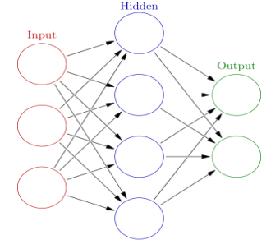

**Fig: 1.1 Shows schematic diagram of Artificial Neural Network**

**1.4 Importance of the Study**

The present study introduces the forecasting of coal analysis series using previous methods. Besides, the role of neural networks in the coal analysis is discussed along with their advantages over previous methods. It explains various designs and preparing the experiment to be conducted. Output on empirical analysis and correlation between every event is examined by the Regression. Designing the experiments and performing statistical analysis for finding significant factors and the results in a graphical way of exhibits the correlation exactly. Up-gradation of the analysis, methods take place smoothly and accurately.

**1.5 Objective**

* Assessment of different parameters that affect the calorific value of coal.
* Determination of intrinsic properties of the coal samples using proximate analysis and bomb calorimetry.
* Prediction of gross calorific value of coal by proximate analysis data using multivariable linear regression.
* Develop the artificial neural network model for prediction of gross calorific value and comparison of multivariable regression and artificial neural network models.

**1.6 Outline of the Thesis**

Chapter 1 Introduction. This chapter mainly focus on various categories required for the study and the scope of the categories for the research work.

Chapter 2 Literature Review. This chapter provides a brief introduction on forecasting of coal analysis series using previous methods. In addition, the role of neural networks in the coal Analysis was discussed along with their advantages over previous methods.

Chapter 3 Field and laboratory investigation. This chapter provides a brief explain various designing and preparing the experiment to be conducted and output on empirical analysis on different samples which makes to elaborated the analysis

Chapter 4 Result and discussion. This chapter the concept of designing experiments and performing statistical analysis for finding significant factors and the results in graphical way of exhibits the correlation exactly.

Chapter 5 Conclusion and recommendation. This chapter covers the steps as performed and necessary advantage to the present and future studies.

**CHAPTER II**

**REVIEW OF LITERATURE**

**2.1 General**

The study of many authors explains the application of ANN in different fields emerging the reduction of time and errors. The calorific value and empirical value in different ways of approach. The various samples from different mines of the study area can be validated by the initial step to the final step repeatedly performed for a long time. The availability of the source can be properly managed.

Bhattacharya (1971) carried out laboratory experiments to live the rates of warmth unharness from totally different coals by a measuring instrument throughout the action of vapor in equal conditions. It had been determined that the speed of warmth generation particularly coal will increase with the equilibrium wetness deficiency of the coal. With the distinction of equilibrium wetness of air and coal. To consider coal, the speed of warmth generation takes to chemical reaction has been found to be negligible compared thereupon due to action of vapor. A tiny low peak at the start of the speed curves has been determined throughout the tests with dry coals, with the exception of anthracite; explanations for this development are tried. The results conjointly show that below a given check condition the characteristic rate of warmth unharnesses depends on the sort of coal, its particle size, and its weathering.

Elder (1983)conductedproximate analysis of solid fossil fuels and connected matter. Classical proximate analysis is time intense and tedious and doesn't lend itself to the speedy determination of one sample and required sample size (10 g) are relatively big. Thermal gravity analysis (TGA) may well be a straight forward, speedy and yield precise, and required sample of little sizes (1to 10 g) vary and its utility once results on one sample are directly needed. Three different programs were used during the study. Each step was made public in term of a tough and quick quantity. It was command to 300oC for 5 minute, which cause the sample to lose absorbed wet. In step a try of the sample was heated to 1100oC in thirty seconds and command isothermally for an additional 5 minute, to cause the removal of absorbed water. Then the sample is heated over a 5-minute quantity at the temperature either 900⁰ or 950⁰C and command isothermally at this higher limit for any 5 minutes to allow the removal of volatile matter.

Buckley (1991) studied to evaluate the applicability of some existing equations to calculate GCV of Indonesian coal and to develop new equations that more accurate to predict the calorific value of Indonesian coal. Ten new GCV formulas based on proximate analysis data of Indonesian coal were generated using SPSS software. They include three (3) equations with one independent variable, four (4) equations with two independent variables, two (2) equations with three independent variables and one (1) equation with four independent variables. The best equation has the following form: GCV= 25.284 (M) + 30.572 (Ash) + 62.127 (VM) + 138.117 (FC) - 2890.095. The result is in agreement with previous work that equation involving four independent variables i.e. moisture (M), ash, volatile matter (VM) and fixed carbon (FC) provides the most accurate estimation of GCV.

Kok *et al*. (2001)carried out the experimental analysis of coal thermal behavior. They took 10 coal samples of various origins for his study. They applied complicated thermal analysis techniques for the determination of the gross calorific value of coals of distinct origin. The most analysis of coal mistreatment thermal analysis contains the characteristics of upper pressure application to coal chemical process, chemical change effects by inorganic substances, combustion, shift and, kinetic study. The thermal analysis may be a convenient tool to work out the proximate analysis of the coal samples giving comparable results to those of ASTM common place ways. Coal samples were ready mistreatment ASTM standards and their particle size was sixty mesh. Curves were obtained mistreatment atmosphere-nitrogen, air of rate 50 ml/min, 10 mg sample, heating rate 100 ml/min and temperature range 20 to 800oC. Experiment results by thermal analysis technique are mentioned with adiabatic bomb mistreatment of the quality ASTM methodology.

Charatuwai *et al.* (2002) described the coal with critical ethanol/KOH during a semi-continuous reactor. A two-level factorial style was applied, and the method variables investigated were reaction temperature, pressure, and latency and KOH concentration. The consequences of method variables on coal yield, furthermore as on ash reduction and total sulfur reduction, are analyzed exploitation analysis of variance. Among the four variables, temperature associate in nursing KOH concentration was found to be important factors for an estimate of total sulfur.

Parikh *et al*. (2005) developed general correlation for estimating GCV on dry basis as GCV= 0.3536(FC) + 0.1559(VM) – 0.0078(ash) wherever FC, VM and ash were in weight % on dry basis and therefore the unit of GCV was on mJ/kg. The correlation termed as ‘general’ since it had been derived supported an outsized variety of knowledge points having wide varied proximate compositions and encompassing all classes of solid carbonic materials together with coals, lignite, every type of biomass material, and character.

Shieh (2006) stated “It is not well understood that the underlying probability distribution function of r is complicated in form, under the classical assumption that the two variables follow a bivariate normal distribution. The complexity of the huge propagation can be done.

Riley (2007) investigated that within the preparation of ash samples for analysis, Show burning of coal samples in necessary to stop the retention of sulphur as calcium sulfate (CaSO4) in coal ash is expounded to high quantity of carbonates or pyrites in the coal and ashing temperature to that it's subjected. Fool's gold is oxidisation to sulphur oxides and iron oxides at temperature of around 450-5000C. Iron oxides fashioned throughout oxidisation of pyrites contribute to the chemical action sulphur oxide (SO) to sulphur oxide (SO3), that reacts with metal to make calcium sulfate (CaSO4) throughout the ashing method. If the speed of burning is just too speedy, a number of the sulphur oxides made from burning fool's gold might react with metal oxides to make stable sulphates. The results are that indefinite amounts of sulphur are maintained, that introduces a slip-up into all the analytical results unless all different oxides are corrected to the SO3 free basis.

Majumdar *et al.* (2008) carried out the experiments of 250 coal samples taken from field of central Bharat (well referred to as south coalfield restricted SECL). HHV (high heating values) and proximate analysis of coal samples are rigorously determined. Moisture, ash, volatile matter and stuck carbon were determined victimisation ASTM-D5142 proximate analyser by thermo-gravimetric analysis (TGA). Bomb calorimeter model AC-350 was used for determined HHV of those samples following ASTM procedure. Out of 250 information 164 were designated to come up with the correlation and 86 were unbroken separate for validation functions. For the model development multiple linear regressions has been adopted. It helps within the modelling relationship between 2 or additional informative variables. The results obtained were rigorously examined the impacts of wet, ash, volatile matter and stuck carbon on the HHV of coal. It had been discovered that wet and ash have negative result and volatile matter and stuck carbon have positive impact on the HHV of the coals. They projected an equation by victimization multiple statistical regression analysis and recommended that there's a real basis to just accept it for HHV estimation of coal as a result of it deals with all the foremost variables moving HHV. The typical absolute error between foretold and experimental information was found quite low and established the validity of the projected equation.

Mesroghli et al. (2009)carried out the study of assessment of properties of 4045 US coal samples from 25 states with references to GCV and achievable variation with final and proximate analysis exploitation multivariable regression, SPSS code package and ANN, MATLAB structure package. GCV is very important property and indicated the useful energy content by coal and its price as a fuel. Type of equations are developed for the prediction of gross hot worth (GCV) exploitation the proximate or end. The inform body the determined proximate and supreme analysis and hot as received basis. They compared the anticipated GCV and actual GCV and status and ash conjointly also used as a result of the fore most reliable inputs for the prediction of gross hot worth of coal exploitation multivariable regression and also the deviation and error from the through an experiment finished GCV in ANN isn't much better or fully totally different from regression.

Sharif *et al.* (2011) studied that the field of ANN consists of a large collection of models and techniques originally inspired by biological nervous systems such as the human brain. Neural networks are based around simplified models of biological neurons. ANN is one of the powerful Artificial Intelligence (AI) techniques that have the capability to learn and memorise a set of data and construct weight matrices to represent the learning patterns. ANN is a mathematical model which emulates the activity of biological neural networks in the human brain.

Sharma *et al*. (2012) carried out the study of coal samples collected from the various north Japanese Indian coalfields by adapting customary sampling strategies. Petrographic study, proximate analysis and sulphur analysis are done by victimization proximate instrument sulphur determinator and therefore the share of O was calculated by distinction. Hot values of coal samples had been determined by victimization automatic bomb. The link between gross calorific valuess (GCV) and macerals contents of those coal samples had been investigated by multi variable regression toward the mean analysis. Multivariate analysis is that the statically tool wont to investigate the link between variables. The maceral analysis indicated that north Japanese coal samples had high vitrinite contents (80.07%), moderate to low liptinite (10.23%) and an occasional inertinite (9.3%). From their investigation, the put down correlation between GCV of coals and maceral analysis showed that with the rise in interinite contents in coal, there's decrease in GCV and therefore the higher vitrinite and liptinite in coal may result in higher GCV.

Krishnaiah *et al*. (2012)carried out the study for around a hundred and fifty research lab analysis info of every proximate and supreme information accustomed train and also the ANN model end is that the tactic to grasp elemental composition of coal. Composition are numerable that's understood as proximate analysis. Calculated by pattern traditional empirical formulae supported the gross level and nature of compositions of coal. Relationship between the essential composition and gross level composition was on linear. The prediction of ANN model and empirical models were compared and set that ANN prediction is good with research lab info than the predictions of empirical model.

Singh *et al.* (2013) examined the low-quality coals have high ash, high sulphur, and high element contents. Due to tight environmental laws, varied physical, chemical, and microbiological ways are developed to resolve the risky impact of those substances on the atmosphere.

Swarupa (2013) has identified certain management activities and provided stakeholders with information regarding the practices that will result in their plant performance enhancement using regression analysis technique. In this they specified that the objectives of the organization can be measured as effectiveness, so it becomes important to identify factors that influences in getting the desired income and their influence on the economic performance of the organization.

So far, the study associated with assessment of coal through analysis of assorted properties of coal sample and prognosis of hot worth by artificial neural network isn't being dispensed in particular study area. Hence, I actually have determined to conducted analysis study associated with it.

**CHAPTER III**

**FIELD AND LABORATORY INVESTIGATIONS**

**3.0 General**

This chapter involves in the study of geological topography of the investigation area and Experimental area. A detailed study carried out of samples collected, the nomenclature of each sample, application of the Mat lab tool i.e. Artificial Neural Network for analyzing the different coal samples in the study area.

**3.1 About Study Area**

Ravindhrakhani is a small village in Mandamarri Mandal in Adilabad District of Telangana State, India. It comes under Kyethanpalle Panchayath. It belongs to Telangana region. It is located 150 km towards East from District headquarters Adilabad, 1 km from Mandamarri, which is situated at 19° 4′ 17.6″ N, 79° 29′ 28.22″ E. The samples from different mines in the Mandhamari area had collected in CHP of Ramakrishnapur and dispatches to area laboratory for the examination of various properties and contribution and examining of different samples had been conducted in the laboratory. The location of the Ravindhrakhani CHP is shown in fig 3.1

Three regional Laboratories at Kothagudem, Ramagundam, Mandamarri and 2 space laboratories at Manuguru and Bhopalpalli within the department to cater to the coal quality beside Mine Air analysis and different analytical desires. One laboratory is acting at Central Work look &amp; one laboratory at RG OC III is functioning to cater scientific discipline analysis and Oil analysis desires severally. Field laboratories at CHPs/ OCPs are functioning to cater daily watching of coal quality. SCCL laboratories are equipped with progressive instrumentality within the analytical front. Advising on washing coal for coal mineral processing etc. by providing technical data and support coal mineral processing etc. by providing technical data and support.

The laboratory analysis of different coal samples makes to understand the nature, grade, calorific value, washability index of coal carries at Regional Lab of Coal Testing Mandhamari area SCCL Ravindhrakhani.

The fieldwork conducted in laboratory and data collected from the sample examined. The calorific values from the experiment are analysis and then artificial neural network values predicted using mat lab tool and compared the data.

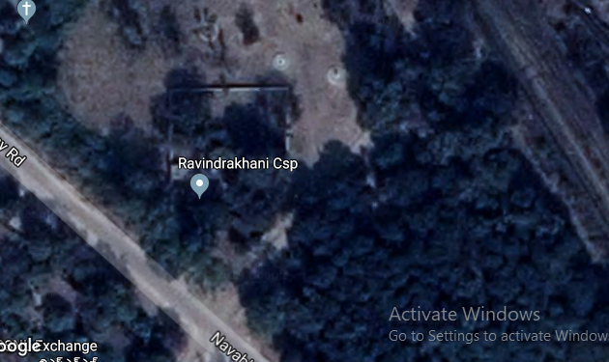

**Fig 3.1: Loaction of Ravindhrakhani CHP**

**3.2 Procedure of Sample Collection**

Coal from the different area of Singareni like Bellampalle, Mandhamarri, Srirampur, are send to Ravindhrakhani Coal Handling plant for transporting to the different companies.

Coal dispatch by road, samples of coal are going to be collected at the delivery point/dispatch location throughout the day between 6.00 am of time to 6.00 pm of time solely from the trucks of the purchasers opted for third party sampling

(i) The first sample of coal was collected from the first truck at the delivery point belonging to a purchasers opting for sampling. The same process be repeated to the remaining truck thereafter.

(ii) Before collecting the sample, the spot at the top of the truck be leveled and at least 25 cm of coal surface be removed/scrapped from the top and the place be leveled for an area of 50 cm by 50 cm for collection of sample. Before transporting, the coal samples are collected through truck sampling, coning cording and belt conveyor sampling techniques and send to the nearest Regional Coal Testing Laboratory.

(iii) About 30 kg of the sample be collected from each truck by drawing 6 increments of approximate 5 kg each with the help of shovel/scoop.

(iv) All the samples collected from every selected truck/sub-lot be mixed together to form a gross sample.

The samples are packed in the ploythen wiper and sealed and then sends through mazdoor to the laboratory, then sample is weighed and kept for Air dried. The next day allow sealed bags Fig 3.2 sample to crush to continue the process for pulverized powdered.

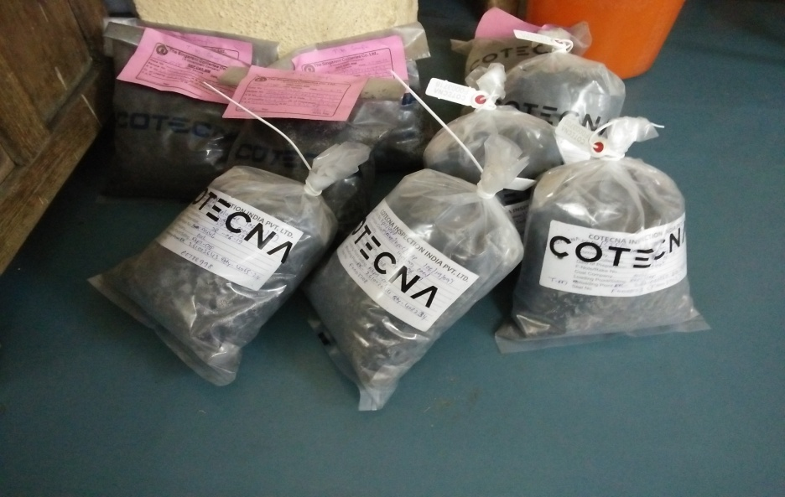

**Fig: 3.2: Sealed bags of coal samples**

**3.2.1 Sample preparation**

In this process the gross sample collected at the delivery point was reduced to laboratory samples in the size of 12.5 mm for total moisture and 212 microns IS Sieve (Top Size) for testing and analysis. The preparation of lab samples was done at coal company preparation rooms located at the dispatch area. The preparation consists of following steps:

a) The gross sample collected is feed to primary crusher and the coal size is reduced to 12.5mm size with heap of mechanical crushing. After Primary crushing of coal sample, one portion (one fourth of the gross sample) called Part-1 will be used for determination of total moisture and the other portion (three fourth of the gross sample) called Part-2 be used for testing and analysis.

b) After primary crushing of coal, Part-2 of the coal sample was sent to secondary crusher, coning and quartering of coal sample was carried out at secondary crusher and the sample was further reduced to 3.35 mm of size.

c) Coning and quartering of coal sample was done and pulveriser Fig.3.3 reduce the coal sample to powdered form and the top size of 212 Micron is attained. Precaution has been taken so that further sieving and pulverising is not needed at the time of testing.

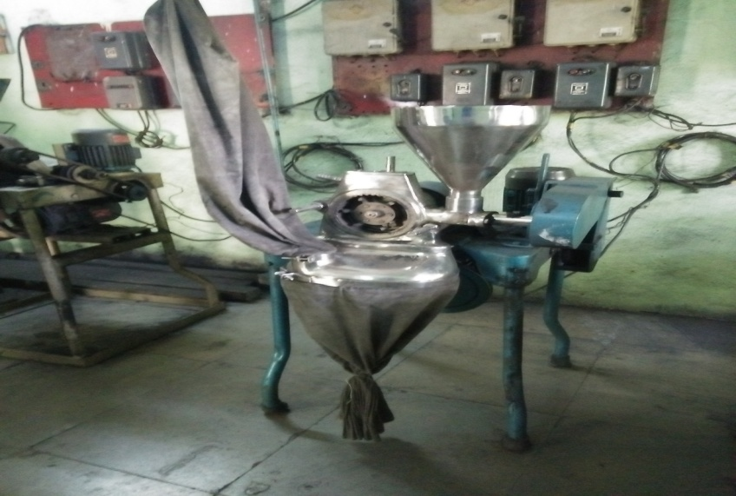

**Fig. 3.3 Pulveriser of the coal samples**

**3.3 Analysis of Coal**

Analysis is long term process conducted in laboratory for long duration of the time and by the nature and quality control of the ore can be determine. This data helps in the transparency between sellers and buyers.

**3.3.1 Apparatus applicable**

Main the important apparatus useful for the finding out the moisture, ash and volatile matter are given below 3.3.1.1 and 3.3.1.2

**3.3.1.1 Oven**

A minimum free space oven capable of maintain a temperature of 200 ± 5oC

**3.3.1.2 Muffle Furnace**

Capable of giving a substantially uniform zone of 500°C in 30 minutes from cold of being raised to 815 ± 10°C, in future 30 to 60 minutes and maintaining this temperature up to the end of run of period. The furnace should be capable of being raised to a temperature of 850 ± 10°C, if necessary.

* Moisture content can be determine by the Oven Fig 3.4 and

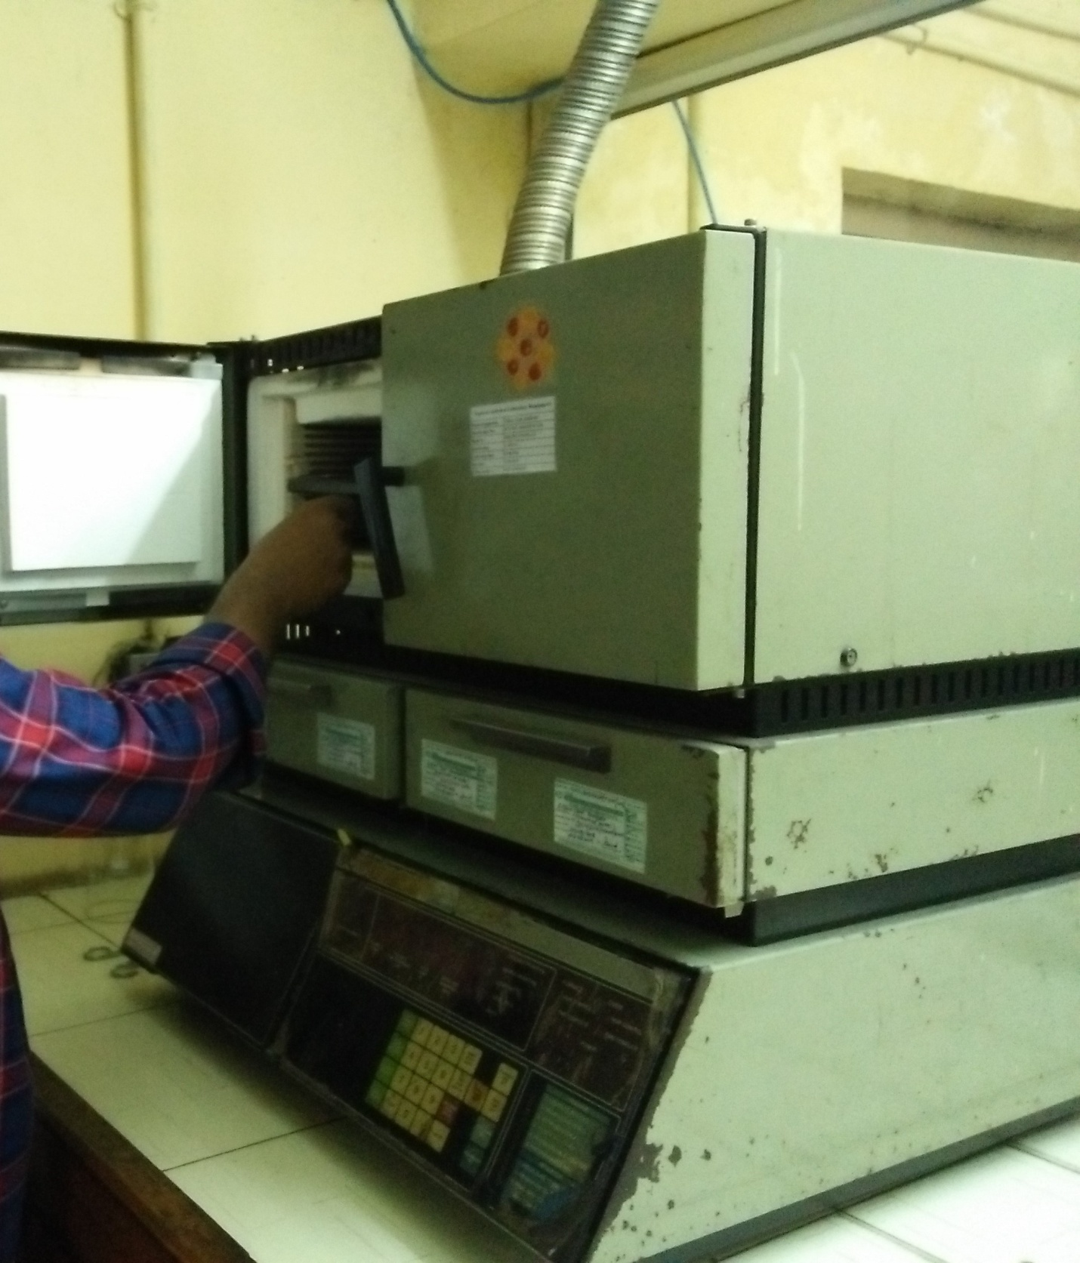

**Fig. 3.4 Oven to determine moisture content**

* Ash and Volatile matter can be determine by the Muffle furnace Fig 3.5

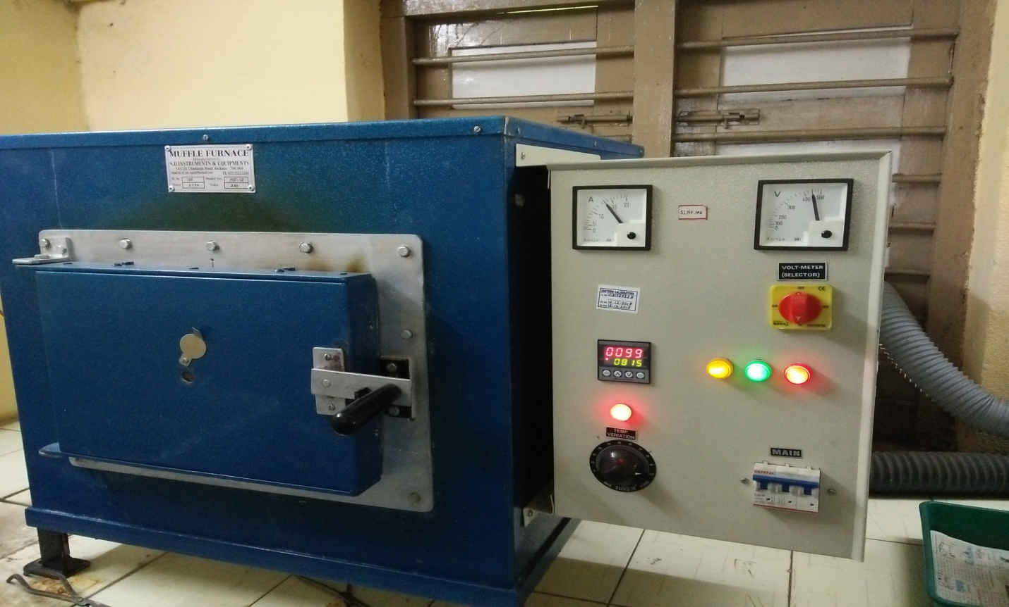

**Fig. 3.5 Muffle furnace to determine ash and volatile matter**

**3.3.2 Proximate analysis**

Proximate analysis of coal is a laboratory technique for crucial the elements of coal, obtained once the coal sample is heated (pyrolysis) underneath such as conditions. The coal sample is extracted from a core and placed quickly in a very canister to preserve the maximum amount gas as attainable.

Coals. especially those of low rank. are hygroscopic to various degrees. and absorb or lose moisture according to the humidity and temperature to which they are exposed. In principle any moisture determination which is carried out without reference to a standard humidity and temperature is, to a degree. The results of proximate analysis are generally recorded percentage of the air-dried material. The ash may be expressed on dry' basis, Volatile matter and fixed carbon may be expressed on dry' basis. ‘dry ash-free' basis or 'dry mineral free.

1. **Moisture**
2. Equilibrium Moisture or Relative humidity moisture

The moisture content retained at equilibrium in an atmosphere over a saturated solution of potassium sulfate at 30 degrees C, and 96% to 97% relative humidity. When the sample, before such equilibrium, contains total moisture at or above the equilibrium moisture, the equilibrium moisture may considered as equivalent to inherent or bed moisture and any excess may considered as extraneous moisture.

1. Total moisture – The coal that has been exposed to contact with water in the seam or coal wetted by rain within the material. Is referred as total moisture
2. Moisture in coal equilibrated at 60 percent relative humidity and 40oC. The moisture determine under these conditions shall be taken as reference moisture for all-purpose.
3. Moisture in air-dried laboratory analysis sample of coal It is the moisture in coal which has been air dried under the laboratory atmospheric condition prior to analysis and the portions of proximate for analysis are weighted under approximately the same conditions of humidity. Once determination of moisture will same conditions of humidity, on determine of moisture will suffice, but a check is desirable with high moisture coals.

b) Ash content

c) Volatile matter

d) Fixed carbon

**3.3.2.1 Determination of moisture (%)**

**i) Moisture on Air-dried basis**

1 g of coal sample of 212 microns was kept in a petri dish. Petri dish with coal sample was placed in the oven at a temperature of 110°C for 1.5 hours. After 1.5 hours, allowed the sample to cool to room temperature by placing it in a desiccator and weigh the sample. The loss of weight was the moisture content in a coal sample.

The moisture was calculated by using the following formula:

Moisture (%) = × 100%

Moisture = (Y-Z/Y-X) *100

Where, X= weight of empty crucible, g

Y= weight of crucible and coal sample before heating, g

Z= weight of crucible and coal sample after heating, g

**ii) Moisture at 96 Percent Relative Humidity and 40oC**

The conditioner is used for equilibrium is desiccator type vessel containing a saturated solution of potassium sulphate. About 5-6 grams of laboratory sample of coal, ground pass 212 micros, in a beaker or conical flask of 100ml capacity. Pour about 20ml of hot water on the sample and wet the coal by gently swirling the beaker or flask. Put the beaker or flask on an asbestos centered wire gauze and apply a small flame underneath, and allow the contents to boil very slowly for about 15 minutes. Filter off the water using a qualitative filter paper and then remove the visible water as far as possible by pressing the wet coal in between folds of filter paper. Take about 1.5g of the wet coal in previously heated, cooled and weighted silica or glass capsule with ground flange type lid and spread the coal in a uniformly thin layer so that the mass of coal per cm2. Uncover the moisture dish in drying oven and heat at the temperature of 108±2oC until there is no further loss in mass. This normally takes 1 to 1.5 hours. Replace the cover; cool the dish in a desiccator for about 20 minutes and weight.

Moisture (%) in equilibrated sample = ×100

X = mass in g of the equilibrated sample taken in the dish,

Y= mass in g of the dish and sample after drying and

Z= mass in g of the empty dish

**3.3.2.2 Determination of ash (%)**

**i) Ash on Air-dried basis**

1g of coal sample of 212 microns’ size was kept in a silica crucible and placed it in a muffle furnace at a temperature of 450°C for 30 minutes and then the temperature of the furnace was raised to 850°C and kept it for 1 hour. Placed the sample in a desiccator to cool to room temperature and weigh the sample.

Ash was calculated as per the subsequent formula:

Ash (%) = × 100%

Ash (%) = (Z-X/Y-X) *100

Where, X = weight of empty crucible in g

Y = weight of coal sample and crucible in g (Before heating)

Z = weight of coal sample and crucible in g (After heating).

Ash (% ) in equilibrated sample =

**3.3.2.3 Determination of Volatile matter (%)**

1 g of coal sample of 212 microns’ size was kept in a crucible and placed in a muffle furnace at a temperature of 925°C for 7 minutes. After 7 minutes, allowed the sample to cool to room temperature by placing it in a desiccator and weigh the sample.

The volatile matter was calculated by using the following formula:

Volatile matter (%) = × 100%

Volatile Matter = (Y-Z/Y-X) *100 – % Moisture

Where, X = weight of empty crucible, g

Y = weight of crucible and coal sample before heating, g

Z = weight of crucible and coal sample after heating, g

**3.3.2.4 Determination of Fixed Carbon (%)**

It was obtained by subtracting the percentage of moisture, volatile matter and ash from 100.

Fixed Carbon, % = 100 – (M + VM + A)

The Equivalent Gross Colorific Value GCV had evaluated by the various parameter.

The results of proximate analysis for Moisture (%), Ash (%), Volatile Matter (%) and Fixed Carbon (%) have been determined in Table 3.1.

**Table 3.1: Results of Proximate analysis**

|  |  |  |  |  |  |  |  |
| --- | --- | --- | --- | --- | --- | --- | --- |
| **Sample No** | **Sample Code** | **Moisture (ad)** | **Ash (ad)** | **Volatile Matter (%)** | **Fixed Carbon (%)** | **Moisture** | **Ash Content (%) (Eq)** |
| **(%) (Eq)** |
| 1. | SCCL/RAL.MM/(2019-20)-1058 | 5.5 | 34.26 | 21.85 | 38.39 | 5.72 | 34.18 |
| 2. | SCCL/RAL.MM/(2019-)20)-1059 | 4.7 | 37.57 | 22.5 | 35.23 | 5.48 | 37.26 |
| 3. | SCCL/RAL.MM/(2019-20)-1060 | 5.34 | 26.63 | 20.42 | 47.61 | 6.17 | 26.39 |
| 4. | SCCL/RAL.MM/(2019-20)-1061 | 4.46 | 30.94 | 26.21 | 38.39 | 5.91 | 30.48 |
| 5. | SCCL/RAL.MM/(2019-20)-1062 | 4.49 | 39.1 | 22.54 | 33.87 | 5.39 | 38.74 |
| 6. | SCCL/RAL.MM/(2019-20)-1089 | 6.93 | 40.29 | 19.84 | 32.94 | 6.74 | 40.38 |
| 7. | SCCL/RAL.MM/(2019-20)-1090 | 6.48 | 45.52 | 23.56 | 24.44 | 6.31 | 45.6 |
| 8. | SCCL/RAL.MM/(2019-20)-1091 | 6.57 | 46.97 | 22.89 | 23.57 | 6.42 | 47.05 |
| 9. | SCCL/RAL.MM/(2019-20)-1092 | 6.15 | 42.15 | 24.18 | 27.52 | 6.11 | 42.17 |
| 10. | SCCL/RAL.MM/(2019-20)-1093 | 6.42 | 41.3 | 21.23 | 31.05 | 6.29 | 41.36 |
| 11. | SCCL/RAL.MM/(2019-20)-1112 | 4.99 | 30.63 | 25.12 | 39.26 | 5.94 | 30.33 |
| 12. | SCCL/RAL.MM/(2019-20)-1113 | 4.67 | 31.35 | 22.84 | 41.14 | 5.9 | 30.95 |
| 13. | SCCL/RAL.MM/(2019-20)-1114 | 5.26 | 24.83 | 26.12 | 43.79 | 6.26 | 24.56 |
| 14. | SCCL/RAL.MM/(2019-20)-1115 | 4.61 | 28.46 | 25.41 | 41.52 | 6.06 | 28.03 |
| 15. | SCCL/RAL.MM/(2019-20)-1116 | 4.48 | 32.54 | 19.84 | 43.14 | 5.82 | 32.08 |
| 16. | SCCL/RAL.MM/(2019-20)-1161 | 6.34 | 39.98 | 21.85 | 31.83 | 6.21 | 40.04 |
| 17. | SCCL/RAL.MM/(2019-20)-1162 | 5.45 | 45.04 | 21.28 | 28.23 | 5.36 | 45.09 |
| 18. | SCCL/RAL.MM/(2019-20)-1163 | 5.36 | 49.42 | 20.45 | 24.77 | 5.22 | 49.5 |
| 19. | SCCL/RAL.MM/(2019-20)-1164 | 5.97 | 42.81 | 23.72 | 27.5 | 5.51 | 43.01 |
| 20. | SCCL/RAL.MM/(2019-20)-1165 | 6.08 | 42.11 | 21.58 | 30.23 | 5.93 | 42.18 |
| 21. | SCCL/RAL.MM/(2019-20)-1166 | 6.58 | 41.16 | 22.45 | 29.81 | 6.32 | 41.27 |
| 22. | SCCL/RAL.MM/(2019-20)-1167 | 6.87 | 41.95 | 19.5 | 31.68 | 6.63 | 42.06 |
| 23. | SCCL/RAL.MM/(2019-20)-1168 | 6.18 | 43.62 | 20.65 | 29.55 | 6.11 | 43.65 |
| 24. | SCCL/RAL.MM/(2019-20)-1169 | 6.67 | 36.87 | 22.41 | 34.05 | 6.21 | 37.06 |
| 25. | SCCL/RAL.MM/(2019-20)-1170 | 6.02 | 41.9 | 23.84 | 28.24 | 5.74 | 42.02 |
| 26. | SCCL/RAL.MM/(2019-20)-1172 | 4.2 | 32.15 | 24.63 | 39.02 | 5.85 | 31.6 |
| 27. | SCCL/RAL.MM/(2019-20)-1173 | 4.12 | 33.02 | 24.85 | 38.01 | 5.79 | 32.45 |
| 28. | SCCL/RAL.MM/(2019-20)-1174 | 4.53 | 27.21 | 20.19 | 48.07 | 6.14 | 26.75 |
| 29. | SCCL/RAL.MM/(2019-20)-1175 | 4.3 | 27.72 | 21.51 | 46.47 | 6.11 | 27.2 |
| 30. | SCCL/RAL.MM/(2019-20)-1176 | 4.28 | 25.18 | 20.63 | 49.91 | 6.25 | 24.66 |
| 31. | SCCL/RAL.MM/(2019-20)-1209 | 4.39 | 35.27 | 22.85 | 37.49 | 5.65 | 34.81 |
| 32. | SCCL/RAL.MM/(2019-20)-1210 | 4.48 | 33.62 | 19.85 | 42.05 | 5.175 | 33.17 |
| 33. | SCCL/RAL.MM/(2019-20)-1211 | 4.58 | 33.64 | 20.95 | 40.83 | 5.76 | 33.23 |
| 34. | SCCL/RAL.MM/(2019-20)-1212 | 6.86 | 38.06 | 23.06 | 32.02 | 6.43 | 38.24 |
| 35. | SCCL/RAL.MM/(2019-20)-1213 | 6.84 | 41.6 | 22.56 | 29.54 | 6.21 | 41.88 |
| 36. | SCCL/RAL.MM/(2019-20)-1214 | 6.53 | 38.79 | 24.15 | 30.53 | 6.39 | 38.85 |
| 37. | SCCL/RAL.MM/(2019-20)-1215 | 7.41 | 32.51 | 21.22 | 38.86 | 6.77 | 32.73 |
| 38. | SCCL/RAL.MM/(2019-20)-1219 | 3.82 | 42.04 | 24.7 | 29.44 | 5.18 | 41.45 |
| 39. | SCCL/RAL.MM/(2019-20)-1220 | 4.75 | 26.24 | 21.62 | 47.39 | 6.18 | 25.84 |
| 40. | SCCL/RAL.MM/(2019-20)-1221 | 4.56 | 27.1 | 19.55 | 48.79 | 6.15 | 26.65 |
| 41. | SCCL/RAL.MM/(2019-20)-1224 | 4.82 | 28.29 | 22.76 | 44.13 | 6.09 | 27.91 |
| 42. | SCCL/RAL.MM/(2019-20)-1225 | 4.47 | 35.7 | 26.21 | 33.62 | 5.62 | 35.27 |
| 43. | SCCL/RAL.MM/(2019-20)-1226 | 4.77 | 33.72 | 21.94 | 39.57 | 5.75 | 33.38 |
| 44. | SCCL/RAL.MM/(2019-20)-1227 | 4.03 | 41.67 | 23.61 | 30.69 | 5.89 | 40.86 |
| 45. | SCCL/RAL.MM/(2019-20)-1228 | 6.59 | 35.16 | 25.19 | 33.06 | 6.42 | 35.22 |
| 46. | SCCL/RAL.MM/(2019-20)-1229 | 6.13 | 37.18 | 22.74 | 33.95 | 6.08 | 37.2 |
| 47. | SCCL/RAL.MM/(2019-20)-1230 | 6.16 | 42.25 | 23.95 | 27.64 | 5.96 | 42.34 |
| 48. | SCCL/RAL.MM/(2019-20)-1271 | 5.88 | 35.68 | 21.55 | 36.89 | 5.63 | 35.77 |
| 49. | SCCL/RAL.MM/(2019-20)-1272 | 5.56 | 34.66 | 19.64 | 40.14 | 5.68 | 34.62 |
| 50 | SCCL/RAL.MM/(2019-20)-1273 | 5.73 | 30.07 | 17.45 | 46.75 | 5.97 | 29.99 |

**3.4 Determination of Gross Calorific Value**

The calorific value of coal is the quantities of mechanical energy in coal which will be become actual heating ability. The worth may be calculable and compared with totally different grades of coal or maybe different materials. Materials of various grades can turn out differing quantities of warmth for a given mass. The hot worth of coal is often determined by the calorimeter methodology. This equipment consists of a cylindrical chamber called bomb and it's created from chrome steel. This chamber is supplied with an airtight cowl which may be screwed on the chamber. There are 3 terminals; 2 for sparking and one for the entry of oxygen. When forcing the oxygen into the chamber the enactment may be blocked by mutual intercourse within the third terminal.

**Gross Calorific Value (GCV)**

* Amount of coal: 1 g coal
* Size of coal: 212 microns’ size
* Heating time: 30 minutes at 40°C
* Oxygen flow rate: 2068 to 2757 KPa

**3.4.1 Bomb calorimeter**

On the opposite aspect of the duvet, there are two bent rods connected to 2 ends. The bent rods have small holes through that 2 fuse wires are connected. There by the availability for golf shot the vessel containing the pellet tied to the fuse wire by suggests that of cotton thread.

About 1g of air-dried coal sample is taken by advisement during a balance of 212 Microns (-72 mesh BSS). A pellet is created with the coal and weighed. The measuring system cowl was taken and concerning 10 ml/min of water is poured into it. The pellet within the vessel is brought involved with the fuse wire by means that of a thread. The duvet is then tightened. Oxygen is then admitted into the measuring system at a pressure of concerning 300 – 400 psi atmospheres. Then 2L of water was placed into the larger vessel. Necessary electrical connections are created and the stirrer is adjusted within the adjusted position. The stirring is done softly for 5 minutes. The initial temperature reading is then taken. Sparking and combustion of coal has taken place within the measuring system once the fireplace of the bomb. The utmost reached temperature was then detected. The bomb was removed and therefore the pressure exhausted. The bomb internal is examined for unburnt or jet-black deposits. If such material is found, then take a look at is discarded.

Figure 3.6 shows the Bomb Calorimeter.

The calorific value of coal was calculated by:

Calorific value = (T2 – T1) * Water equivalent / Weight of the pellet

T1 – Initial temperature, T2 – Final Temperature.

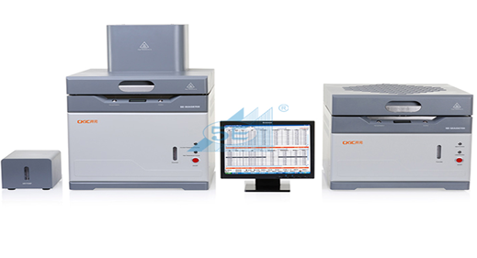

**Fig 3.6 Bomb calorimeter**

The Gross calorific values determined in laboratory are given in Table 3.2

**Table 3.2 Experimental value of Bomb Calorimeter**

|  |  |  |  |  |
| --- | --- | --- | --- | --- |
| **S. No** | **Sample code** | **Bomb no** | **Sample weight** | **Air dried GCV Kcal/kg** |
|  | SCCL/RAL.MM/(2019-20)-1058 | 352 | 0.9999 | 4551 |
|  | SCCL/RAL.MM/(2019-)20)1059 | 347 | 0.9988 | 4344 |
|  | SCCL/RAL.MM/(2019-20)-1060 | 353 | 0.9983 | 5177 |
|  | SCCL/RAL.MM/(2019-20)-1061 | 354 | 0.9975 | 4743 |
|  | SCCL/RAL.MM/(2019-20)-1062 | 352 | 0.9930 | 4183 |
|  | SCCL/RAL.MM/(2019-20)-1089 | 353 | 0.9971 | 3718 |
|  | SCCL/RAL.MM/(2019-20)-1090 | 354 | 0.9988 | 3404 |
|  | SCCL/RAL.MM/(2019-20)-1091 | 352 | 0.9984 | 3229 |
|  | SCCL/RAL.MM/(2019-20)-1092 | 347 | 0.9976 | 3606 |
|  | SCCL/RAL.MM/(2019-20)-1093 | 353 | 0.9991 | 3750 |
|  | SCCL/RAL.MM/(2019-20)-1112 | 354 | 0.9986 | 4807 |
|  | SCCL/RAL.MM/(2019-20)-1113 | 352 | 0.9990 | 4767 |
|  | SCCL/RAL.MM/(2019-20)-1114 | 347 | 0.9973 | 5247 |
|  | SCCL/RAL.MM/(2019-20)-1115 | 353 | 0.9983 | 5010 |
|  | SCCL/RAL.MM/(2019-20)-1116 | 354 | 0.9971 | 4709 |
|  | SCCL/RAL.MM/(2019-20)-1161 | 353 | 0.9977 | 3865 |
|  | SCCL/RAL.MM/(2019-20)-1162 | 354 | 0.9987 | 3465 |
|  | SCCL/RAL.MM/(2019-20)-1163 | 352 | 0.9995 | 3110 |
|  | SCCL/RAL.MM/(2019-20)-1164 | 347 | 0.9990 | 3671 |
|  | SCCL/RAL.MM/(2019-20)-1165 | 353 | 0.9999 | 3693 |
|  | SCCL/RAL.MM/(2019-20)-1166 | 354 | 0.9994 | 3674 |
|  | SCCL/RAL.MM/(2019-20)-1167 | 352 | 0.9998 | 3539 |
|  | SCCL/RAL.MM/(2019-20)-1168 | 347 | 0.9974 | 3532 |
|  | SCCL/RAL.MM/(2019-20)-1169 | 353 | 0.9987 | 4308 |
|  | SCCL/RAL.MM/(2019-20)-1170 | 354 | 0.9986 | 3638 |
|  | SCCL/RAL.MM/(2019-20)-1172 | 347 | 0.9992 | 4703 |
|  | SCCL/RAL.MM/(2019-20)-1173 | 353 | 0.9984 | 4673 |
|  | SCCL/RAL.MM/(2019-20)-1174 | 354 | 0.9983 | 5222 |
|  | SCCL/RAL.MM/(2019-20)-1175 | 352 | 0.9957 | 5094 |
|  | SCCL/RAL.MM/(2019-20)-1176 | 347 | 0.999 | 5271 |
|  | SCCL/RAL.MM/(2019-20)-1209 | 352 | 0.9986 | 4564 |
|  | SCCL/RAL.MM/(2019-20)-1210 | 347 | 0.9981 | 4729 |
|  | SCCL/RAL.MM/(2019-20)-1211 | 353 | 0.9992 | 4764 |
|  | SCCL/RAL.MM/(2019-20)-1212 | 354 | 0.9990 | 3945 |
|  | SCCL/RAL.MM/(2019-20)-1213 | 352 | 0.9985 | 3622 |
|  | SCCL/RAL.MM/(2019-20)-1214 | 347 | 0.9991 | 3891 |
|  | SCCL/RAL.MM/(2019-20)-1215 | 353 | 0.9981 | 4435 |
|  | SCCL/RAL.MM/(2019-20)-1219 | 353 | 0.9981 | 4023 |
|  | SCCL/RAL.MM/(2019-20)-1220 | 354 | 0.9970 | 5275 |
|  | SCCL/RAL.MM/(2019-20)-1221 | 352 | 0.9991 | 5247 |
|  | SCCL/RAL.MM/(2019-20)-1224 | 352 | 0.9978 | 4476 |
|  | SCCL/RAL.MM/(2019-20)-1225 | 347 | 0.9998 | 4678 |
|  | SCCL/RAL.MM/(2019-20)-1226 | 353 | 0.9979 | 3958 |
|  | SCCL/RAL.MM/(2019-20)-1227 | 354 | 0.9980 | 4065 |
|  | SCCL/RAL.MM/(2019-20)-1228 | 352 | 0.9988 | 3980 |
|  | SCCL/RAL.MM/(2019-20)-1229 | 347 | 0.9994 | 3559 |
|  | SCCL/RAL.MM/(2019-20)-1230 | 353 | 0.9999 | 4361 |
|  | SCCL/RAL.MM/(2019-20)-1271 | 352 | 0.9991 | 4361 |
|  | SCCL/RAL.MM/(2019-20)-1272 | 347 | 0.9994 | 4472 |
|  | SCCL/RAL.MM/(2019-20)-1273 | 353 | 0.9993 | 4914 |

By Proximate Analysis (PA) ash (Muffle furnace), moisture (Moisture Oven), VM (VM Oven) are determined. For arriving at the FC, these three are summed up and subtracted from 100.

Proximate Analysis is found out by two methods commonly:

* Air dried sample basis and
* Equilibrated conditions basis

GCV is determined through an equipment called Bomb Calorimeter;

first GCV is determined by air-dried basis…then Moisture is determined by equilibrated basis and substituted in the following formulae for arriving at Eq. GCV:

* Eq. GCV =

The Experiment Equilibrium value of Gross Calorific Value given in Table 3.3

**Table 3.3 Experimental Equilibrium Gross Calorific Values of samples**

|  |  |  |
| --- | --- | --- |
| **S. No** | **Sample code** | **EQ**  **GCV Kcal/kg** |
|  | SCCL/RAL.MM/(2019-20)-1058 | 4540 |
|  | SCCL/RAL.MM/(2019-)20)1059 | 4308 |
|  | SCCL/RAL.MM/(2019-20)-1060 | 5132 |
|  | SCCL/RAL.MM/(2019-20)-1061 | 4671 |
|  | SCCL/RAL.MM/(2019-20)-1062 | 4144 |
|  | SCCL/RAL.MM/(2019-20)-1089 | 3726 |
|  | SCCL/RAL.MM/(2019-20)-1090 | 3410 |
|  | SCCL/RAL.MM/(2019-20)-1091 | 3234 |
|  | SCCL/RAL.MM/(2019-20)-1092 | 3608 |
|  | SCCL/RAL.MM/(2019-20)-1093 | 3755 |
|  | SCCL/RAL.MM/(2019-20)-1112 | 4759 |
|  | SCCL/RAL.MM/(2019-20)-1113 | 4706 |
|  | SCCL/RAL.MM/(2019-20)-1114 | 5191 |
|  | SCCL/RAL.MM/(2019-20)-1115 | 4934 |
|  | SCCL/RAL.MM/(2019-20)-1116 | 4643 |
|  | SCCL/RAL.MM/(2019-20)-1161 | 3870 |
|  | SCCL/RAL.MM/(2019-20)-1162 | 3468 |
|  | SCCL/RAL.MM/(2019-20)-1163 | 3115 |
|  | SCCL/RAL.MM/(2019-20)-1164 | 3689 |
|  | SCCL/RAL.MM/(2019-20)-1165 | 3699 |
|  | SCCL/RAL.MM/(2019-20)-1166 | 3684 |
|  | SCCL/RAL.MM/(2019-20)-1167 | 3548 |
|  | SCCL/RAL.MM/(2019-20)-1168 | 3535 |
|  | SCCL/RAL.MM/(2019-20)-1169 | 4329 |
|  | SCCL/RAL.MM/(2019-20)-1170 | 3649 |
|  | SCCL/RAL.MM/(2019-20)-1172 | 4622 |
|  | SCCL/RAL.MM/(2019-20)-1173 | 4591 |
|  | SCCL/RAL.MM/(2019-20)-1174 | 5134 |
|  | SCCL/RAL.MM/(2019-20)-1175 | 4998 |
|  | SCCL/RAL.MM/(2019-20)-1176 | 5162 |
|  | SCCL/RAL.MM/(2019-20)-1209 | 4504 |
|  | SCCL/RAL.MM/(2019-20)-1210 | 4666 |
|  | SCCL/RAL.MM/(2019-20)-1211 | 4705 |
|  | SCCL/RAL.MM/(2019-20)-1212 | 3963 |
|  | SCCL/RAL.MM/(2019-20)-1213 | 3647 |
|  | SCCL/RAL.MM/(2019-20)-1214 | 3897 |
|  | SCCL/RAL.MM/(2019-20)-1215 | 4466 |
|  | SCCL/RAL.MM/(2019-20)-1219 | 3966 |
|  | SCCL/RAL.MM/(2019-20)-1220 | 5196 |
|  | SCCL/RAL.MM/(2019-20)-1221 | 5143 |
|  | SCCL/RAL.MM/(2019-20)-1224 | 5047 |
|  | SCCL/RAL.MM/(2019-20)-1225 | 4422 |
|  | SCCL/RAL.MM/(2019-20)-1226 | 4630 |
|  | SCCL/RAL.MM/(2019-20)-1227 | 3881 |
|  | SCCL/RAL.MM/(2019-20)-1228 | 4072 |
|  | SCCL/RAL.MM/(2019-20)-1229 | 3982 |
|  | SCCL/RAL.MM/(2019-20)-1230 | 3567 |
|  | SCCL/RAL.MM/(2019-20)-1271 | 4373 |
|  | SCCL/RAL.MM/(2019-20)-1272 | 4467 |
|  | SCCL/RAL.MM/(2019-20)-1273 | 4901 |

Samples are randomly selected for the experimental GCV and given in form below in Table 3.4

**Table 3.4 Randomly selected Experimental GCV values for the test**

|  |  |  |
| --- | --- | --- |
| **Sample No** | **Sample code** | **Experimental GCV in Kcal/kg** |
| 1 | SCCL/RAL.MM/(2019-20)-1060 | 5132 |
| 2 | SCCL/RAL.MM/(2019-20)-1090 | 3410 |
| 3 | SCCL/RAL.MM/(2019-20)-1176 | 5162 |
| 4 | SCCL/RAL.MM/(2019-20)-1165 | 3699 |
| 5 | SCCL/RAL.MM/(2019-20)-1163 | 3115 |
| 6 | SCCL/RAL.MM/(2019-20)-1173 | 4591 |
| 7 | SCCL/RAL.MM/(2019-20)-1212 | 3963 |
| 8 | SCCL/RAL.MM/(2019-20)-1215 | 4466 |
| 9 | SCCL/RAL.MM/(2019-20)-1272 | 4467 |
| 10 | SCCL/RAL.MM/(2019-20)-1225 | 4422 |
| 11 | SCCL/RAL.MM/(2019-20)-1213 | 3647 |
| 12 | SCCL/RAL.MM/(2019-20)-1211 | 4705 |
| 13 | SCCL/RAL.MM/(2019-20)-1170 | 3649 |
| 14 | SCCL/RAL.MM/(2019-20)-1115 | 4934 |
| 15 | SCCL/RAL.MM/(2019-20)-1091 | 3234 |

**3.5 Multivariable Regression Analysis**

Multivariable regression is an extension of simple linear regression. It is used to predict the value of a variable based on the value of two or more other variables. The predict variable is called the dependent variable

The linear regression (Y’) is

* Y’ = a + b X

Where,

Y’ = A predicted value of Y (which is a dependent variable)

a = the value of Y when X is equal to zero. This is also called the “Y Intercept”.

b = the change in Y for each 1 increment change in X

X = an X score (X is Independent Variable) for which you are trying to predict a value of Y.

The Multiple Regression (Y’) is

* Y’ = a + b1X1 + b2X2

Y’ = A predicted value of Y (which is your dependent variable)

a = the “Y Intercept”.

b1 = the change in Y for each 1 increment change in X1

b2 = the change in Y for each increment change in X2

X1 = an X score on your first independent variable for which you are trying to predict the value of Y

X2 = an X score on your second independent variable for which you are trying to predict a value of Y

In order to find the correlation between Multiple linear regression value for the different variables the Independent and dependent variables. The nature of the equation shows the behavior of the variables either positive or negative action.

GCV = -125.481M-115.448A-43.145VM-29.483FC+1152.202.

Here these equations of the multivariable regression or multiple linear regression obtain by the 50 Samples are acts different way. This equation uses to predict the values form random 15 samples selected from the 50 samples. The coordinate plot is laid. The values predicted by Multivariable regression equation are in table 3.5

**Table 3.5: Predicted values of Multivariable regression GCV**

|  |  |
| --- | --- |
| **Sample no** | **Multivariable regression Predicted GCV(Kcal/kg)** |
| 1 | 5123 |
| 2 | 3347 |
| 3 | 5347 |
| 4 | 3705 |
| 5 | 3162 |
| 6 | 4630 |
| 7 | 3958 |
| 8 | 4408 |
| 9 | 4422 |
| 10 | 4348 |
| 11 | 3647 |
| 12 | 4586 |
| 13 | 3698 |
| 14 | 4968 |
| 15 | 3223 |

**3.6 Artificial Neural Network Model**

Artificial Neural Network is a significant model developed form the unique idea of the connection between different nerves of the biological neural system are used in order to develop the function depends on large number of inputs. Like ways, the interconnection between different neural inputs are computed and exhibited the analysis.

In the present study the values of 15 is negotiated out of 50 samples including proximate values and calorific values used for artificial neural network model development. This development model helpful in comparing the predicted calorific value and compare with the experimental gross calorific value.

To exhibit ANN Model development, the ANN tool of MATLAB R2018b software is used. Feed back drop neural network connection is used. It comprises various numbers of neurons simple nerves like inbuilt layers are organized. Every unit in a layer is connected to each and unit of the previous layer. The units in the neural network are also called nodes.

The given input and output data passes through different layers of the system and arrives out as output values. These values are as predicted values of ANN. The comparison of predicted ANN values and Experimental values has been presented on Generated values of Artificial Neural Network and experimental values are shown in Table 3.6

|  |  |
| --- | --- |
| **Sample no** | **Artificial Neural**  **Network predicted GCV(Kcal/Kg)** |
| 1 | 5117 |
| 2 | 3517 |
| 3 | 5122 |
| 4 | 3671 |
| 5 | 3487 |
| 6 | 4669 |
| 7 | 3945 |
| 8 | 4556 |
| 9 | 4505 |
| 10 | 4381 |
| 11 | 3683 |
| 12 | 4624 |
| 13 | 3687 |
| 14 | 4986 |
| 15 | 3477 |

**Table 3.6: Predicted values of Artificial Neural Network model**

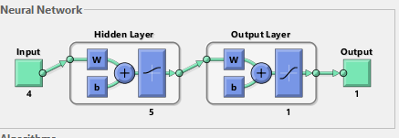

**Fig: 3.7 Developed Artificial Neural Network model**

**CHAPTER IV**

**RESULTS AND DISCUSSION**

**4.0 General Discussion**

In present study 50 run up samples collected from the different mines of the study area using the bulk sampling procedure. Then, the Moisture (%), Ash content (%), Volatile matter (%), Fixed carbon (%) were determined in the laboratory using proximate analysis technique according to Indian standard method of coal testing using empirical formulae.

GCV is also being determined by Bomb calorimeter technique and compared with calculated GCV from the empirical formulae. Prediction of gross calorific value of coal by proximate analysis data using multivariable regression analysis and artificial neural network (ANN) model carried out and compared values. The GCV value also compared with calculated from CIMFR and Experimental.

**4.1 Parameter That Affects Calorific Values of Coal**

* The process of occurring data from various mines in the study area able to under coal quality variants and quality. The optimum relationship between calorific value and elemental properties, correlation study is conducted in order to available data.
* The major course of analysis explains the behavior of various properties with gross calorific value that obtained value make the coordination and beneficiary action for the grading can be done before utilization of the product.

The values moisture content of coal sample varied from 3.82 % (sample 38) to 7.41% (sample 37), The ash content of the coal sample varied from 24.83% (sample 13) to 49.42% (sample 18), The volatile matter of the coal sample varied from 17.45 (sample 50) to 26.21 (sample 4), The fixed carbon of the coal sample varied from 23.64 (sample 8) to 38.25 (sample 1).

**4.2: Relationship between Moisture, Ash content, Volatile matter and Fixed Carbon and Experimental GCV**

The comparison plots below explain clearly the view of the change the gross calorific value with dependence of various parameters. And also easy understand of the coal nature particularly in the study area.

The relationship plot between moisture (%), Ash content (%), Volatile matter (%) and Fixed carbon (%) with experimental GCV is shown in Fig. 4.1, Fig 4.2, Fig.4.3, Fig 4.4 respectively

**Fig 4.1: Relationship between Moisture and GCV by Experiment**

R2 value of 0.3574 in Fig 4.1 impels the effect of moisture on the GCV of study area. The regression value of the plot explains that the moisture has less impact on the GCV. It shows the influence of moisture is less in the coal sample collected. Hence, the moisture content should be managed for the further process.

**Fig 4.2: Relationship between Ash content and GCV by Experiment**

R2 value of 0.9653 in Fig 4.2 impels the effect of ash content on GCV. The regression value of the plot explains that the Ash % has strong correlation with experiment effects on the GCV. It shows the influence of is more in the coal sample collected. Hence, the ash content should managed for the further process.

**Fig 4.3: Relationship between volatile matter and GCV by Experiment**

R2 value of 0.0037 in Fig 4.3 impels the effect of volatile matter on GCV. The regression value of the plot explains that the volatile matter has negative effects on the GCV. It shows the influence of is less in the coal sample collected. Hence, the volatile matter should manage for the further process.

**Fig 4.4: Relationship between Fixed carbon and GCV by Experiment**

R2 value of 0.9273 in Fig 4.4 impels the effect of Fixed carbon GCV. The regression value shows strong correlation between GCV by experiment and Fixed carbon %.

**4.3 Relationship between Experimental GCV and predicted CIMFR GCV**

Central Institute of Mining and Fuel Research (CIMFR) developed following formulae to determine GCV based on moisture %. The equilibrium moisture and equilibrium ash is considered for the predicting CIMFR GCV

* For low moisture coals, M < = 2%

CGV = 91.71 F + 75.6 (V-0.2A) - 60 M

* For high moisture coals, M > = 2%

CGV = 85.6(100 – (1.1 A + M)) – 60M

Where: M, V, A, F denote Moisture %, Volatile Matter %, Ash % and Fixed Carbon%, on present air-dried basis,

Table 4.1 shows the comparison between experimental GCV and predicted CIMFR GCV

**Table 4.1: Comparison between Experimental GCV and Predicted CIMFR GCV**

|  |  |  |  |
| --- | --- | --- | --- |
| **Sample no** | **Experimental GCV in Kcal/kg** | **CMFIR**  **GCV(Kcal/kg)** | **Difference** |
| 1 | 5132 | 5174 | -42 |
| 2 | 3410 | 3346 | 64 |
| 3 | 5162 | 5326 | -164 |
| 4 | 3699 | 3732 | -24 |
| 5 | 3115 | 3138 | -23 |
| 6 | 4591 | 4660 | -69 |
| 7 | 3963 | 4021 | -58 |
| 8 | 4466 | 4490 | -24 |
| 9 | 4467 | 4471 | -4 |
| 10 | 4422 | 4418 | 4 |
| 11 | 3647 | 3711 | -64 |
| 12 | 4705 | 4590 | 115 |
| 13 | 3649 | 3766 | -117 |
| 14 | 4934 | 5036 | -102 |
| 15 | 3234 | 3194 | 40 |

**Fig 4.5: Relationship between GCV of CIMFR and GCV by Experiment**

R2 value of 0.9907 in Fig. 4.5 impels the comparison study between Experimental GCV and GCV of CIMFR value. Hence, the regression value shows strong coordination between the two above values

**4.4 Relationship between Experimental GCV and predicted GCV by Multivariable Regression**

The GCV by multivariable regression predicted using following equation based on Moisture %, Ash %, Volatile Matter %, Fixed Carbon is

GCV = -125.481M-115.448A-43.145VM-29.483FC+1152.203

Predicted values are given in table 4.2 and compared with experimental GCV. The Moisture % and Ash%, have less impact and Fixed Carbon and Volatile Matter have more impact on GCV a

**Table 4.2: Comparison between Experimental GCV and Predicted GCV by multivariable regression method**

|  |  |  |  |
| --- | --- | --- | --- |
| **Sample no** | **Experimental GCV in Kcal/kg** | **Multiple regression predicted GCV(Kcal/kg)** | **Difference** |
| 1 | 5132 | 5123 | 51 |
| 2 | 3410 | 3347 | 63 |
| 3 | 5162 | 5347 | 185 |
| 4 | 3699 | 3705 | 6 |
| 5 | 3115 | 3162 | 47 |
| 6 | 4591 | 4630 | 39 |
| 7 | 3963 | 3958 | 4 |
| 8 | 4466 | 4408 | 58 |
| 9 | 4467 | 4422 | 45 |
| 10 | 4422 | 4348 | 74 |
| 11 | 3647 | 3648 | 2 |
| 12 | 4705 | 4586 | 119 |
| 13 | 3649 | 3698 | 49 |
| 14 | 4934 | 4968 | 34 |
| 15 | 3234 | 3223 | 11 |

**Fig 4.6: Relationship between GCV by Experiment and GCV by Regression.**

From the figure, R2 value of 0.9898 impels the comparison study between Experimental GCV and GCV of Regression. Hence, it shows more coordination between the two quantities.

**4.5 Relationship between Experimental GCV and Predicted GCV of Artificial Neural Network Analysis**

The Experimental GCV and predicted GCV using Artificial Neural Network Analysis given in Table 4.3

**Table 4.3: Comparison between Experimental GCV and Predicted GCV of Artificial Neural Network Analysis**

|  |  |  |  |
| --- | --- | --- | --- |
| **Sample no** | **Experimental GCV in Kcal/kg** | **Artificial Neural Network predicted GCV(Kcal/kg)** | **Difference** |
| 1 | 5132 | 5111 | 63 |
| 2 | 3410 | 3294 | 116 |
| 3 | 5162 | 5162 | 0 |
| 4 | 3699 | 3685 | 14 |
| 5 | 3115 | 3209 | -94 |
| 6 | 4591 | 4599 | -8 |
| 7 | 3963 | 3979 | -16 |
| 8 | 4466 | 4376 | 90 |
| 9 | 4467 | 4515 | -48 |
| 10 | 4422 | 4378 | 44 |
| 11 | 3647 | 3614 | 33 |
| 12 | 4705 | 4618 | 87 |
| 13 | 3649 | 3712 | -63 |
| 14 | 4934 | 5009 | -75 |
| 15 | 3234 | 3252 | -18 |

**Fig 4.7: Relationship between GCV by Experiment and GCV by ANN**

The R2 value of 0.9918 impels the comparison between Experimental GCV and predicted GCV of ANN. Regression value of the plot shows that the calorific value of the experimental and predicted by Artificial Neural Network have strong relationship.

The value of R2 (Table 4.4) shows strong relationship between regression value for the relationship between experimental GCV with predicted by CIMFR, Multivariable regression and ANN.

**Table 4.4: Regression value for the different relationship**

|  |  |  |
| --- | --- | --- |
| S. No | Relationship | R2 |
| 1 | Experimental GCV v/s CMFIR value | 0.9907 |
| 2 | Experimental GCV v/s Multivariable Regression GCV | 0.9898 |
| 3 | Experimental GCV v/s ANN GCV | 0.9918 |

**4.6 Relationship between Predicted GCV of Multivariable Regression Analysis and Predicted GCV of Artificial Neural Network Analysis**

The relationship between predicted regression GCV and predicted Artificial Neural Network (ANN) GCV is shown in Fig 4.8. It shows more coordination between these two prediction values.

**Fig. 4.8 Relationship between predicted GCV with Multivariable regression analysis and Predicted GCV of Artificial Neural Network Analysis**

Hence, both models are well applicable in the study area.

**4.7 Relationship between GCV of Experimental, GCV of CIMFR, GCV with Multivariable Regression Analysis and Predicted GCV with Artificial Neural Network Analysis**

The relationship between GCV of Experimental, GCV of CIMFR**,** predicted regression GCV and predicted Artificial Neural Network (ANN) GCV is shown in Fig 4.9. It shows more coordination between these four values.

**Fig. 4.9 Comparison between GCV of Experimental, GCV of CIMFR GCV, Regression GCV, ANN GCV values.**

**CHAPTER V**

**CONCLUSIONS AND RECOMENDATIONS**

**5.1 Conclusion**

Coal is utilized for heating applications. Proximate analysis and Bomb calorimeter analysis are common and used to assess the quality of coals. Due to non-availability of consistent power offer, industries are selecting coal laid-off captive power plants, Hence quick assessment of coal quality is important to run the boilers with efficiency using statistical method and artificial neural network analysis. This research study in been conducted and following conclusions are drawn:

1. The moisture (%), ash (%), volatile matter (%) and fixed carbon (%) parameters affect the Gross Calorific Value (GCV). Fixed carbon and Ash have more content in coal sample of the study area than the moisture and volatile matter.
2. Analysis of regression coefficient reveals that ash% and fixed carbon% have strong correlation with GCV.
3. The equilibrium GCV calculated from the Bomb calorimeter i.e. experimental GCV have strong correlation with calculated CIMFR formulae.
4. Predicted GCV from the multiple regression method and Artificial Neural Network (ANN) have also sound correlation with the experimental GCV. Hence, the both model are useful for the analysis the quality of coal and helps in assessment of coal quality to run the boilers with effeicency.
5. The developed correlation put efforts to understand the effects of all the major variables affecting the calorific value of coals. Statistical procedure results showed that the multivariate analysis model is seen because of the simplest model

**5.2 Recommendations**

There are few areas deserve attention for future research work:

1. Predicting the spontaneous heating can openness of the seams and accordingly plan the mining activities and precautionary measures to deal with problems in mines.
2. Implemented statical way of analysis very useful for the analysts in handling huge database.
3. Complexity of the quality control can be decrease by active part of these studies.
4. Spotting the danger zones in the coal mining.
5. Effective handling of coal yards.

**CHAPTER VI**

**REFERENCE**

Akkaya, A.V., 2009. Proximate analysis based multiple regression models for higher heating value estimation of low rank coals. *Fuel Processing Technology* **90** : 165-170.

Bhattacharya, K.K. 1971. The role of sorption of water vapour in the spontaneous heating of coal, *Fuel* **50**: 367- 380.

Buckley, T.J. 1991. Calculation of higher heating value of biomass materials and waste components from elemental analyses*. Resources Conservation and Recycling* **5** : 329- 341.

Burchill, P. Howarth., 1991. Studies of inorganic elements in coals and combustion residues. *Fuel* **70** : 361- 366.

Charutawai, K., Ngamprasertsisith, S., Prasassarakich, P. 2003. Supercritical sulfurization of low rank coal with ethanol. *Fuel Process* **84** : 207- 216.

Chou, CL. 1990. Geochemistry of Sulfur in Coal, *Geochemistry of Sulfur in Fossil Fuel* **2** : 30- 52.

Donahue, J., Rais A. 2009. Proximate analysis of coal. *Journal of chemical education* **86** : 222- 224.

Elliot, Martin, ed., 1981. Chemistry of coal utilization, New York, Wiley lnterscience. **2** : 386-391

George, G.N., Gorbaty, M.L., Kelemen, S.R. and Sonsone, M., 1991. Direct determination and quantification of sulfur forms in coals from the Argonne premium sample program. *Energy Fuel* **5**: 93-97.

G. Speight. 2005. by [Handbook](https://Handbook) of Coal Analysis John Wiley & Sons. 254- 257.

Johnson, R., Sellers, G., & Fleming, S. 1989. Methods for sampling and inorganic anlaysis of coal. from USGS Bulletin 1823, USGS Publications Retrieved October 22, 2013.

Huggins, F.E 2002.Overview of analytical methods for inorganic constituents in coal *International Journal of Coal Geology.* 169- 214.

Indian Standard: 1350 Part II, 1970, Methods of Test for Coal and Coke: Determination of Calorific Value Bureau of Indian Standards, New Delhi. James,

Kok, M.V., Keskin. 2001. Calorific value determination of coals by DTA and ASTM methods, *Journals of thermal analysis calorimetry.* **64**: 1265 – 1270.

Kramlich, J.C, J.A. Cole, J.M. McCarthy, W.S. Lanier and J.A. McSorley, 1989. Mechanisms of nitrous oxide formation in coal flames, *International Journal of Coal Geolog*y **77**: 373.

Majumder, A.K., Jain, R., Banerjee, P., Barnual, J.P. 2008. Development of a new proximate analysis based corelation to predict calorific value of coal. *Fuel* **87** : 3077- 3081.

Ma X., Zhang C. and Chen X.F. 2013. A method combined principal component analysis and BP artificial neural network for coal bed methane (CBM) wells to predict productivity. *Journal of Science Technology and Industry* **13** : 97- 100.

Mesroghli,S.H., Jorjani, E. and Chelgani, S.C. 2009, Estimation of gross calorific value based on coal analysis using regression and artificial neural network. *Internaational Journal of Coal Geology* **79** : 49-54.

Nandy D.K, Banerjee D.D and Chakravorty R.N, 1972. Application of crossing point temperature for determining the spontaneous heating characteristics of coal, J. Mines Met. *Fuels* **20** : 41–48.

Parikh, J., Channilwala, S.A. and Ghosal, G.K. 2005. A correlation for calculating HHV from proximate analysis of solid fuels. *Fuel* **84** : 487- 494.

Riley, J. T. 2007. Routine coal and coke analysis collection, interpretation, and use of analytical data. West Conshohocken, PA, USA, *ASTM International*.104 - 106 .

Sivirikaya O., Acikkar M. 2018. Prediction of gross calorific value of coal based on proximate analysis using multiple linear regression. *Turkish Journal of Electrical Engineering and computer science* **26**: 2541- 2552.

Singh T.N., Monjezi, M. 2010. Intelligent prediction of heating value of coal, *Indian Journal of Earth Science* **2**: 32- 38.

Sharma, A., Saikia, K., Baruah, P., Maceral. 2012. Contents of tertiary Indian Coals and their relationship with calorific values. *International Journal of innovative Research and Development* **1**: 199- 203.

Shieh, G. 2006. Exact interval estimation, power calculation, and sample size determination in normal correlation analysis. Psychometrika, **71**: 529-540.

Singh, P.K., Singh, A.L., Kumar, A., Singh, M.P. 2013. Control of different pyrite forms on desulfurization of` coal with bacteria. *Fuel* **106**: 876–879.

Swarupa L., 2013, Regression Analysis of Operational Efficiency Variables on Management Practices of Thermal Power Plants. *Industrial engineering journal* **10** : 15 -18

Tan P., Zhang C, Xia J., Fang, Q.Y., Chen G. 2015. Estimation of higher heating value of coal based on proximate analysis using support vector regression. *Fuel process Technology* **138 :** 298- 304.

Upadhyay, M. 2014. Assessment of coal properties in Korba district, *Indian Journal of Pharmaceutical Science and Research* **4** : 116- 118.