**Framework:**

A software framework, in computer programming, is an abstraction in which common code providing generic functionality can be selectively overridden or specialized by user code providing specific functionality.

**DotNet Framework:**

It is a platform that provides tools and technologies you need to build Networked Applications as well as Distributed Web Services and Web Applications. The .Net Framework provides the necessary **compile** **time** and **run-time** foundation to **build** and **run** any **language** that conforms to the Common Language Specification **(CLS).**

The main two components of .Net Framework are

Common Language Runtime (CLR) and

.Net Framework Class Library (FCL).

The Common Language Runtime (CLR) is the runtime environment of the .Net Framework, that executes and manages all running code like a Virtual Machine.

The .Net Framework Class Library (FCL) is a huge collection of language-independent and type-safe reusable classes.

The .Net Framework Class Libraries (FCL) is arranged into a logical grouping according to their functionality and usability is called **Namespaces**.

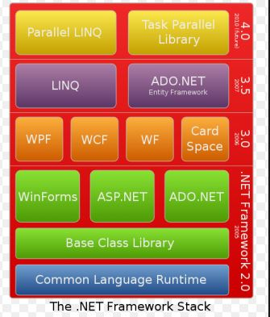

**Fig:1**

**Execution of Application or file in DotNet**

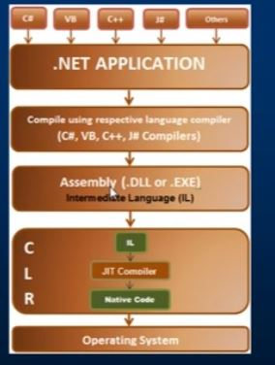

**MSIL**:

MSIL stands for Microsoft Intermediate language. When we run a Dot net Application or a program execution happens in two steps.

1. High level language(C#, VB, c++, F#) gets converted into the Assembly language by respective language compiler; this Assembly language is intermediate code and is **called Microsoft Intermediate language or Common Intermediate language or managed code.**

It cannot run directly on operating system it has to be converted to platform specific native code.

1. MSIL gets converted into Native code.

**CLR:**

CLR stands for Common Language Runtime Environment.

It’s a part of .Net framework, CLR provides different kinds of JIT (Just In Time Compiler) each works on different architecture with respect to the operating system, because of this (availability of various JITS ) MSIL can execute on any operating system without rewriting the source code

It also handles garbage collection.

**JIT:**

JIT stands for “Just In Time Compiler”, it’s part of **CLR** and performs conversion of Intermediate language into platform specific native code (machine understandable code), which can run on any operating system.

Just In Time (JIT) compilation preserves memory and save time during application initialization.

Just In Time (JIT) compilation is used to run at high speed, after an initial phase of slow interpretation.

Just In Time Compiler (JIT) code generally offers far better performance than interpreters.

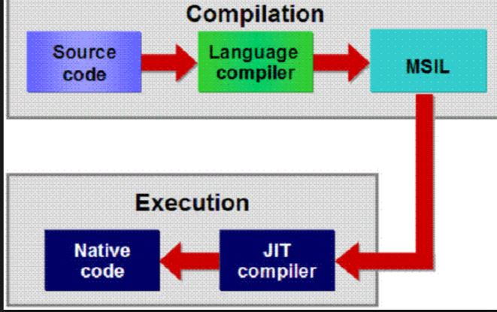

**Portability in Dotnet:**

Dotnet can be portable because of following reason.

In Dotnet execution happens in two steps. Initially high-level language gets converted into MISL (Intermediate language) by respective compiler. Later MISL is converted into Native code by JIT of the CLR. Availability of JIT for all the operating systems makes portability very easy without rewriting the source code provided Platform respective .net framework is installed in the system.

**GAC:**

The **Global Assembly Cache** is a folder in Windows directory to store the .NET assemblies that are specifically designated to be shared by all applications executed on a system, without having to copy the assemblies locally.

Assemblies can be shared among multiple applications on the machine by registering them in global Assembly cache(GAC).

**DLL:**

DLL file is a **dynamic link library** which can be used in exe files and other dll files.

 DLLs are not directly executable

DLL hasn't got an entry point and EXE does

An application may contain many dlls and can be shared with other applications

**EXE:**

EXE file is an executable file which runs in a separate process which is managed by OS.

When loading an executable, no export is called, but only the module entry point.

When a system launches new executable, a new process is created

The entry thread is called in context of main thread of that process.

An Application contains one exe and cannot be shared with other applications.