**V.Rajkumar**

**22CS132**

**Assignment 1**

**DAA**

1) What does f(2000,3) return??

f(m,n) {

ans = 1;

count = 0;

while (ans &lt;= m) {

count = count + 1;

ans = ans * n;

}

return(count)

}

**ANS:**

Anser is 7

2)

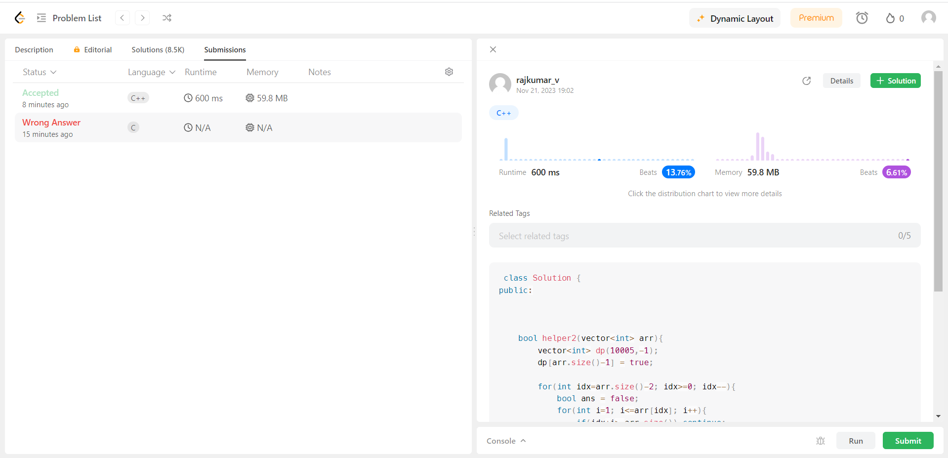

3)

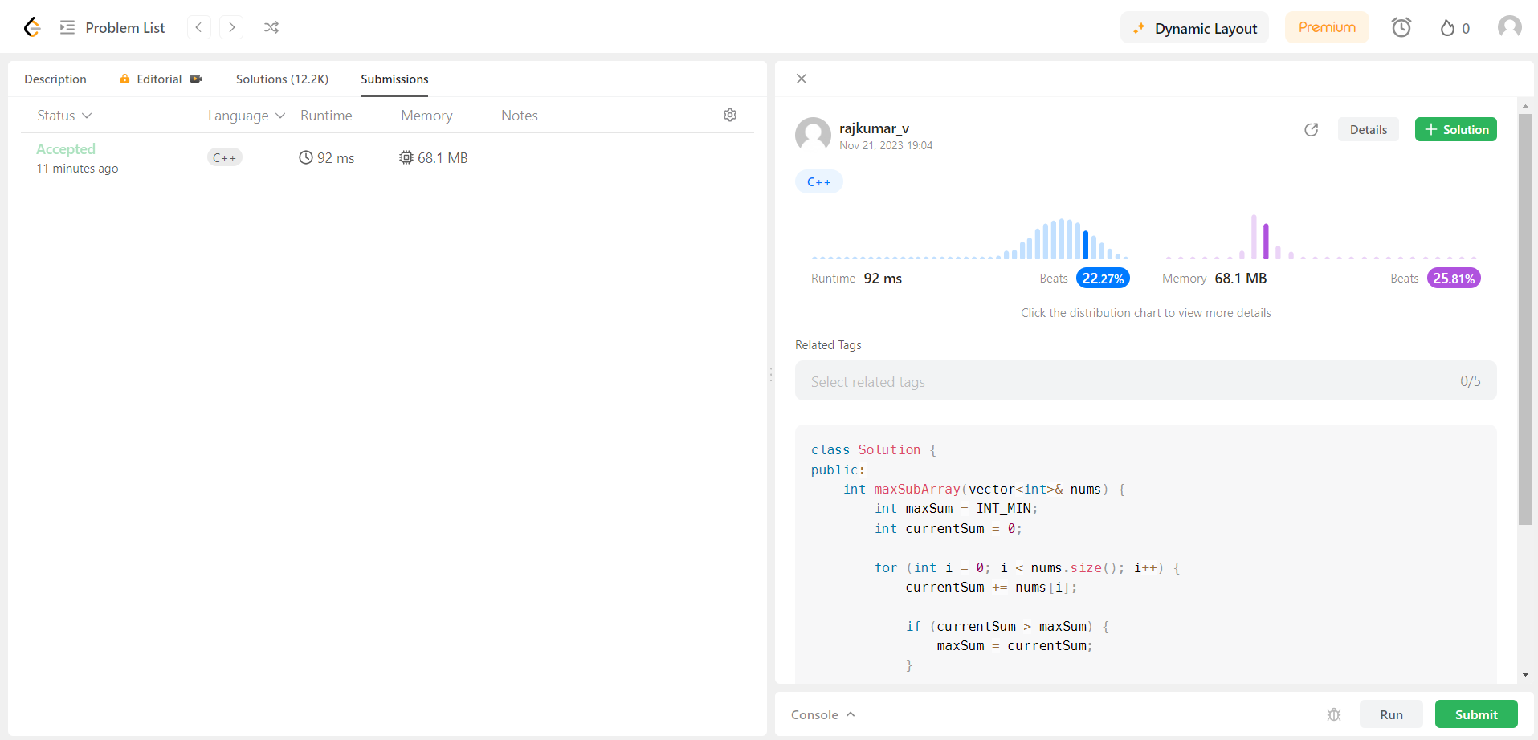

4)

